|  |
| --- |
| CEA LIST |
| New Child |
| [Tapez le sous-titre du document] |

|  |
| --- |
| TESSIER Patrick  19/11/2013 |



Sommaire

Introduction 3

Requirements 3

Use Cases 4

1. UseCreateMenu 4

2. Create or modify ElementCreationModel 4

3. Generate "ElementCreationModel" from a profile 4

4. Hide, change order or add submenus 4

5. Create or modify ElementCreationModel at runtime thanks to a GUI 4

6. Add post actions 4

Solution proposal 4

Perspectives 4

Test 4

References 4

# Introduction

The goal of this document is to explain the functionality “New Child” of Papyrus?

# Requirements

* **AddNewChild** Papyrus shall add in the menu new child for new customized element by using extended type
* **HideElement** Papyrus shall not display all UML or SysML element creation
* **newChildFromProfile** Papyrus shall add the creation of new element from a subset of profile
* **newChildMenuDisplay** Papyrus shall be able to associated icons to folder or creation menu
* **RoleAndElementCreation** When an element can created from several roles for a container, Papyrus shall let the possibility to choose the role or to let to the possibility to be created from all role.

# Use Cases

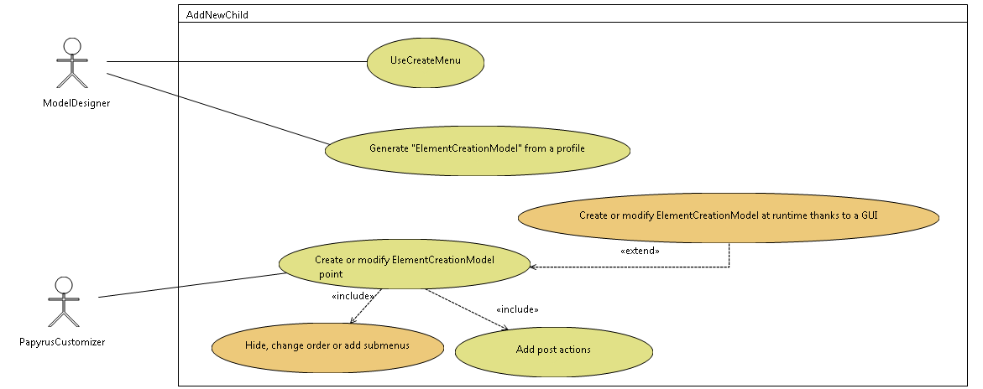

Figure : Use Cases

## UseCreateMenu

The Papyrus user uses this functionality form the model explorer in order to create elements in the model.

All this menus are based on a model: “ElementCreationMenuModel”.

## Create or modify ElementCreationModel

An advanced user is able to create of modify this model. This model references the model of Element types.

It can decide to display or not this element creation

## Generate "ElementCreationModel" from a profile

From a stereotyped profile, a model of element type and an ElementCreationMenuModel can be generated.

## Hide, change order or add submenus

The User can modify bay adding submenus; order about new child menu, precise if the role must be displayed.

## Create or modify ElementCreationModel at runtime thanks to a GUI

The User can edit the ElementCreationMenuModel and the elementType model by using a GUI as the palette functionality

# Solution proposal

ElementType can be an ID or a referenceto the element Type

# Perspectives

# Test

# References

[1] “Help - Platform Plug-in Developer Guide - Eclipse Platform.” [Online]. Available: http://help.eclipse.org/juno/index.jsp?topic=%2Forg.eclipse.platform.doc.isv%2Freference%2Fmisc%2Fbundle_manifest.html. [Accessed: 19-Nov-2013].

[2] O. Alliance, “OSGi Service Platform, Core Specification, Release 5,” aQute, Mar. 2012.