PROJECT CINQUE — EDUCATOR STUDY
Explainable AI and Teacher Trust in At-Risk Student Detection
Participant Booklet — Group B
Thank you for taking part. You will review a small number of student cases produced by an AI early-warning tool and decide what support, if any, you would offer. There are no right or wrong answers — we are evaluating the tool, not you. All student cases are de-identified and synthetic. You may skip any item or stop at any time. Please complete the booklet in order.

About you
Participant code (assigned by facilitator):

Role: ☐ Lecturer ☐ Academic advisor ☐ Teaching assistant ☐ Other: __________
Years teaching or advising:

Prior use of AI tools: ☐ None ☐ A little ☐ Moderate ☐ A lot
Department (optional):

The Student Cases
For each student, review the system's output, decide what you would do, then answer the questions on that page.

Student 1
Low risk estimated probability 1%
Why this estimate — main contributing factors:
Factor | What it suggests / possible action
Score-improvement trend | Flat or declining trajectory — arrange early academic counselling.
Grade views | Rarely checks grades — encourage monitoring of progress and feedback.
Score consistency | Uneven performance across modules — identify the weakest modules for focused support.
Total attempts | Repeated attempts may indicate difficulty — offer concept reinforcement.
Month 3 attempts | Weak performance in month 3 attempts — targeted review of that module.
Programme: Computer Science | Contextual factor — interpret with care; not a direct lever for intervention.
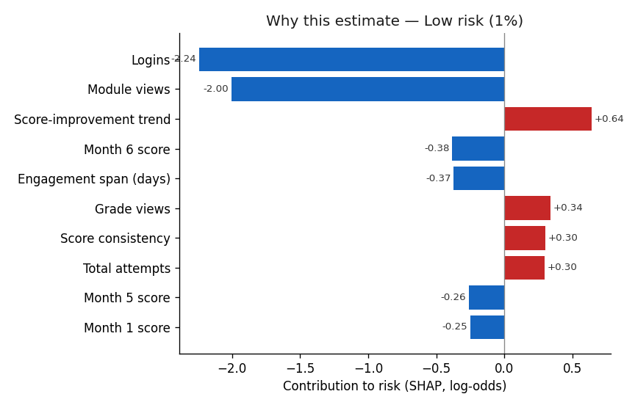
Your response — Student 1
What would you do for this student? (tick all that apply)
☐ Monitor only
☐ Schedule a check-in
☐ Confirm LMS / material access
☐ Recommend tutoring
☐ Refer to counselling
☐ Follow up on incomplete work
☐ No action
☐ Other: ____________________
Briefly, why?

Statement | 1 | 2 | 3 | 4 | 5
The system's risk estimate for this student is appropriate. | ☐ | ☐ | ☐ | ☐ | ☐
I would trust this estimate enough to act on it. | ☐ | ☐ | ☐ | ☐ | ☐
I am confident in my decision for this student. | ☐ | ☐ | ☐ | ☐ | ☐
1 = Strongly disagree · 2 = Disagree · 3 = Neutral · 4 = Agree · 5 = Strongly agree

Student 2
Moderate risk estimated probability 34%
Why this estimate — main contributing factors:
Factor | What it suggests / possible action
Score-improvement trend | Flat or declining trajectory — arrange early academic counselling.
Month 2 score | Weak performance in month 2 score — targeted review of that module.
Grade views | Rarely checks grades — encourage monitoring of progress and feedback.
Avg quiz duration | Unusual quiz durations — explore whether the student is rushing or struggling.
Month 4 score | Weak performance in month 4 score — targeted review of that module.
Month 3 score | Weak performance in month 3 score — targeted review of that module.
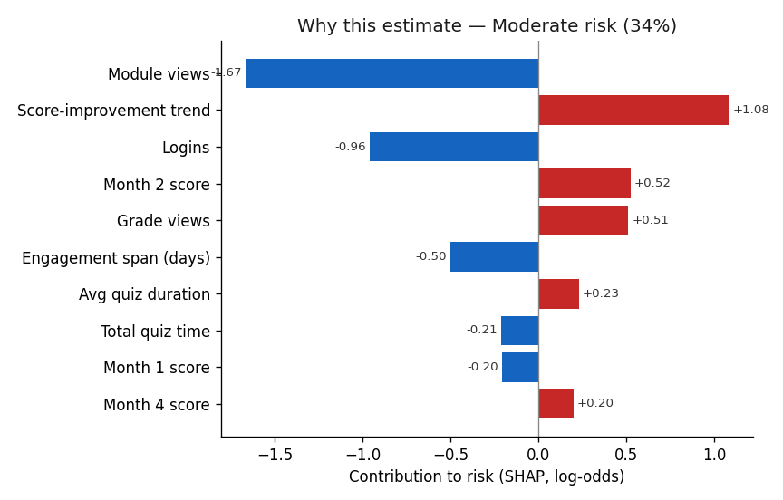
Your response — Student 2
What would you do for this student? (tick all that apply)
☐ Monitor only
☐ Schedule a check-in
☐ Confirm LMS / material access
☐ Recommend tutoring
☐ Refer to counselling
☐ Follow up on incomplete work
☐ No action
☐ Other: ____________________
Briefly, why?

Statement | 1 | 2 | 3 | 4 | 5
The system's risk estimate for this student is appropriate. | ☐ | ☐ | ☐ | ☐ | ☐
I would trust this estimate enough to act on it. | ☐ | ☐ | ☐ | ☐ | ☐
I am confident in my decision for this student. | ☐ | ☐ | ☐ | ☐ | ☐
1 = Strongly disagree · 2 = Disagree · 3 = Neutral · 4 = Agree · 5 = Strongly agree

Student 3
Moderate risk estimated probability 56%
Why this estimate — main contributing factors:
Factor | What it suggests / possible action
Score-improvement trend | Flat or declining trajectory — arrange early academic counselling.
Grade views | Rarely checks grades — encourage monitoring of progress and feedback.
Avg quiz duration | Unusual quiz durations — explore whether the student is rushing or struggling.
Month 5 score | Weak performance in month 5 score — targeted review of that module.
Total score | Low overall performance — recommend targeted tutoring and review of foundational topics.
Month 2 score | Weak performance in month 2 score — targeted review of that module.
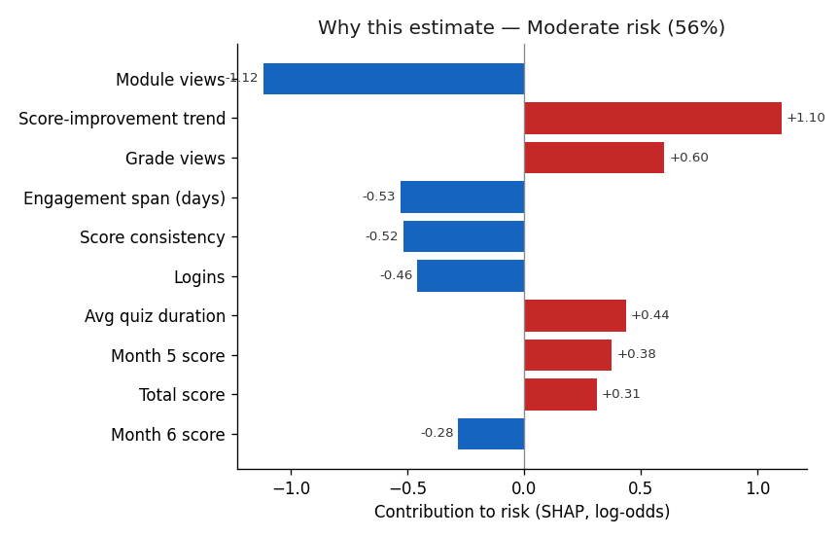
Your response — Student 3
What would you do for this student? (tick all that apply)
☐ Monitor only
☐ Schedule a check-in
☐ Confirm LMS / material access
☐ Recommend tutoring
☐ Refer to counselling
☐ Follow up on incomplete work
☐ No action
☐ Other: ____________________
Briefly, why?

Statement | 1 | 2 | 3 | 4 | 5
The system's risk estimate for this student is appropriate. | ☐ | ☐ | ☐ | ☐ | ☐
I would trust this estimate enough to act on it. | ☐ | ☐ | ☐ | ☐ | ☐
I am confident in my decision for this student. | ☐ | ☐ | ☐ | ☐ | ☐
1 = Strongly disagree · 2 = Disagree · 3 = Neutral · 4 = Agree · 5 = Strongly agree

Student 4
High risk estimated probability 93%
Why this estimate — main contributing factors:
Factor | What it suggests / possible action
Score-improvement trend | Flat or declining trajectory — arrange early academic counselling.
Avg quiz duration | Unusual quiz durations — explore whether the student is rushing or struggling.
Month 5 score | Weak performance in month 5 score — targeted review of that module.
Grade views | Rarely checks grades — encourage monitoring of progress and feedback.
Month 2 score | Weak performance in month 2 score — targeted review of that module.
Total score | Low overall performance — recommend targeted tutoring and review of foundational topics.
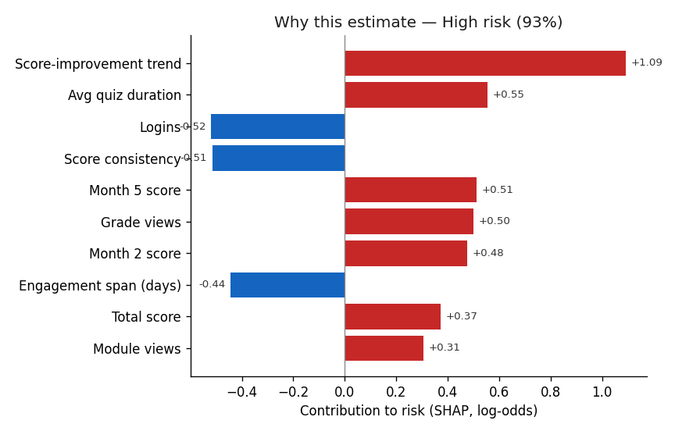
Your response — Student 4
What would you do for this student? (tick all that apply)
☐ Monitor only
☐ Schedule a check-in
☐ Confirm LMS / material access
☐ Recommend tutoring
☐ Refer to counselling
☐ Follow up on incomplete work
☐ No action
☐ Other: ____________________
Briefly, why?

Statement | 1 | 2 | 3 | 4 | 5
The system's risk estimate for this student is appropriate. | ☐ | ☐ | ☐ | ☐ | ☐
I would trust this estimate enough to act on it. | ☐ | ☐ | ☐ | ☐ | ☐
I am confident in my decision for this student. | ☐ | ☐ | ☐ | ☐ | ☐
1 = Strongly disagree · 2 = Disagree · 3 = Neutral · 4 = Agree · 5 = Strongly agree

Student 5
High risk estimated probability 98%
Why this estimate — main contributing factors:
Factor | What it suggests / possible action
Module views | Low platform engagement — confirm the student can access the LMS/materials and schedule a check-in.
Score-improvement trend | Flat or declining trajectory — arrange early academic counselling.
Month 3 score | Weak performance in month 3 score — targeted review of that module.
Logins | Infrequent logins — check for access barriers and set a weekly-engagement expectation.
Grade views | Rarely checks grades — encourage monitoring of progress and feedback.
Total attempts | Repeated attempts may indicate difficulty — offer concept reinforcement.
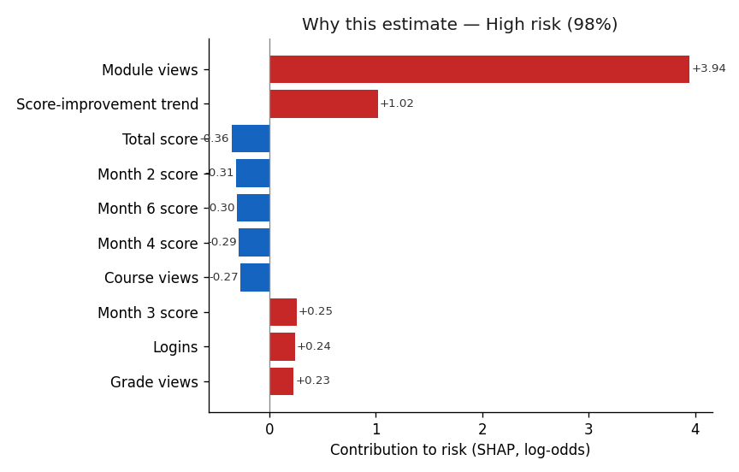
Your response — Student 5
What would you do for this student? (tick all that apply)
☐ Monitor only
☐ Schedule a check-in
☐ Confirm LMS / material access
☐ Recommend tutoring
☐ Refer to counselling
☐ Follow up on incomplete work
☐ No action
☐ Other: ____________________
Briefly, why?

Statement | 1 | 2 | 3 | 4 | 5
The system's risk estimate for this student is appropriate. | ☐ | ☐ | ☐ | ☐ | ☐
I would trust this estimate enough to act on it. | ☐ | ☐ | ☐ | ☐ | ☐
I am confident in my decision for this student. | ☐ | ☐ | ☐ | ☐ | ☐
1 = Strongly disagree · 2 = Disagree · 3 = Neutral · 4 = Agree · 5 = Strongly agree

Overall Questionnaire
Now that you have reviewed all the cases, please rate your overall impression of the system.

A. Trust in the system
Statement | 1 | 2 | 3 | 4 | 5
I am suspicious of the system's risk estimates. (R) | ☐ | ☐ | ☐ | ☐ | ☐
I am wary of relying on the system. (R) | ☐ | ☐ | ☐ | ☐ | ☐
The system's outputs could be misleading. (R) | ☐ | ☐ | ☐ | ☐ | ☐
I am cautious about trusting the system. (R) | ☐ | ☐ | ☐ | ☐ | ☐
The system's risk estimates are dependable. | ☐ | ☐ | ☐ | ☐ | ☐
The system is reliable. | ☐ | ☐ | ☐ | ☐ | ☐
I can trust the system to support my decisions. | ☐ | ☐ | ☐ | ☐ | ☐
I am confident in the system's risk estimates. | ☐ | ☐ | ☐ | ☐ | ☐
1 = Strongly disagree · 2 = Disagree · 3 = Neutral · 4 = Agree · 5 = Strongly agree

B. Your sense of competence
Statement | 1 | 2 | 3 | 4 | 5
I feel capable of identifying at-risk students when using this system. | ☐ | ☐ | ☐ | ☐ | ☐
I think I made good support decisions using this system. | ☐ | ☐ | ☐ | ☐ | ☐
I feel competent using this system to support students. | ☐ | ☐ | ☐ | ☐ | ☐
I am satisfied with the decisions I made using this system. | ☐ | ☐ | ☐ | ☐ | ☐
1 = Strongly disagree · 2 = Disagree · 3 = Neutral · 4 = Agree · 5 = Strongly agree

C. Your sense of autonomy
Statement | 1 | 2 | 3 | 4 | 5
I felt free to make my own judgement while using the system. | ☐ | ☐ | ☐ | ☐ | ☐
The decisions felt like my own, not dictated by the system. | ☐ | ☐ | ☐ | ☐ | ☐
The system supported, rather than replaced, my professional judgement. | ☐ | ☐ | ☐ | ☐ | ☐
I had a real choice in the actions I selected. | ☐ | ☐ | ☐ | ☐ | ☐
1 = Strongly disagree · 2 = Disagree · 3 = Neutral · 4 = Agree · 5 = Strongly agree

D. Usefulness
Statement | 1 | 2 | 3 | 4 | 5
Using this system would improve my ability to identify at-risk students. | ☐ | ☐ | ☐ | ☐ | ☐
This system would make student support more effective. | ☐ | ☐ | ☐ | ☐ | ☐
This system would be useful in my work. | ☐ | ☐ | ☐ | ☐ | ☐
Using this system would help me act sooner on at-risk students. | ☐ | ☐ | ☐ | ☐ | ☐
1 = Strongly disagree · 2 = Disagree · 3 = Neutral · 4 = Agree · 5 = Strongly agree

E. Ease of understanding and use
Statement | 1 | 2 | 3 | 4 | 5
The system's output was clear and understandable. | ☐ | ☐ | ☐ | ☐ | ☐
It was easy to interpret the risk estimate. | ☐ | ☐ | ☐ | ☐ | ☐
I found the system easy to use. | ☐ | ☐ | ☐ | ☐ | ☐
Learning to use this system would be easy for me. | ☐ | ☐ | ☐ | ☐ | ☐
1 = Strongly disagree · 2 = Disagree · 3 = Neutral · 4 = Agree · 5 = Strongly agree

F. In your own words
Which part of the information (the risk level, the contributing factors, the suggested actions) was most useful, and why?

Was anything unclear, misleading, or that you would not trust?

Did seeing the reasons change what you would do for a student? How?

What one change would make this more useful in your work?

Thank you. Please return the booklet to the facilitator.

