**Marcus Farstad**

**Drop in the Ocean**

**Project Proposal**

**26/09/21**

**Literacy Learning Smartphone Site**

**Context:**

Dråpen i Havet (Drop) is an NGO working with displaced persons. Drop provides direct and immediate support inside and outside refugee camps with services such as non-formal education. At Nea Kavala in Northern Greece, Drop is providing three English classes totalling 26 students (16/08/21) at a self-classified 0.1 level. These classes target students with limited literacy skills and aim to achieve three different elements [see Introduction to 0.1 Classes].

Students in these classes are mixed gender, typically older than 40, primarily Farsi or Arabic speaking. They also own smartphones but many have a low level of technological literacy. This project will also target literacy students served by other NGOs including IHA, Northern Lights and Lifting Hands (all part of the Northern Greece Educator’s Cafe collective), students in the waiting list and further illiterate persons inside and outside of refugee camps.

**Overview**:

The goal of the project is to provide an online literacy learning resource supporting students beyond the classroom. This would take the form of a smart-phone friendly website. A site teaching particularly monotonous aspects of the curriculum including letter formation as well as the memorisation of letter names. There is exciting potential for interactivity with buttons, sound, animations and other screen-driven features to pursue further parts of the curriculum. The target audience should be consulted during the development process to produce an accessible and engaging experience.

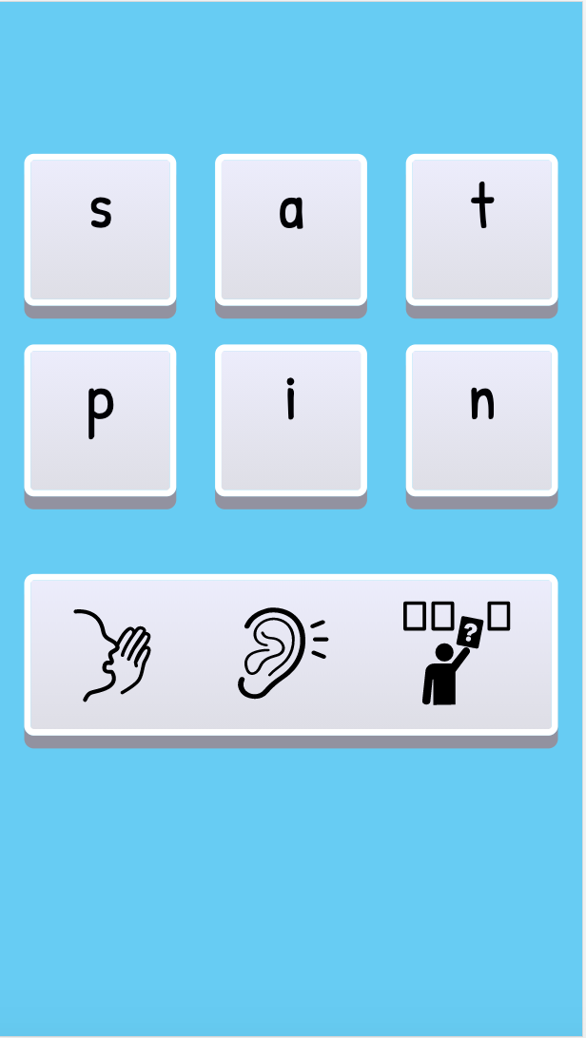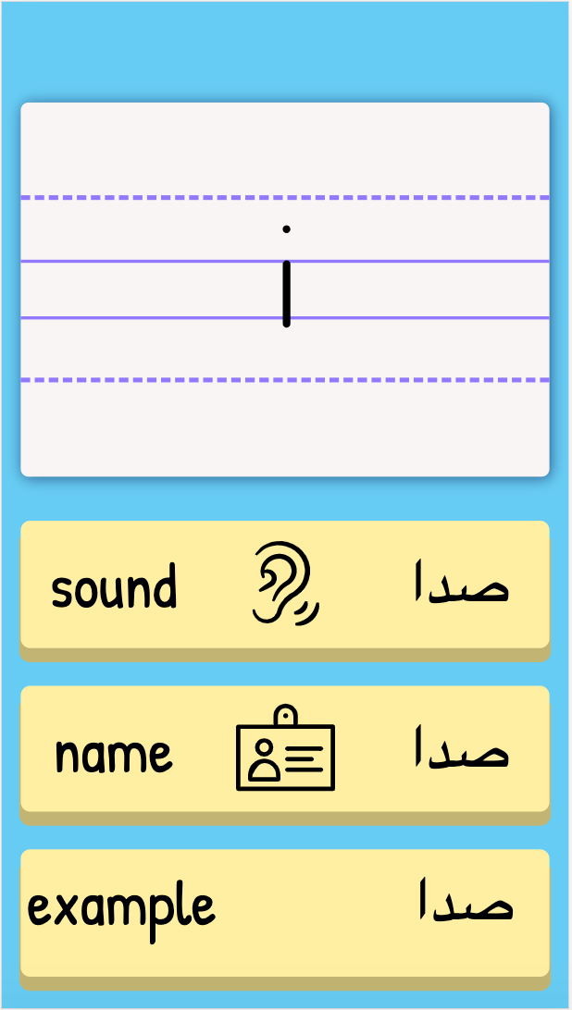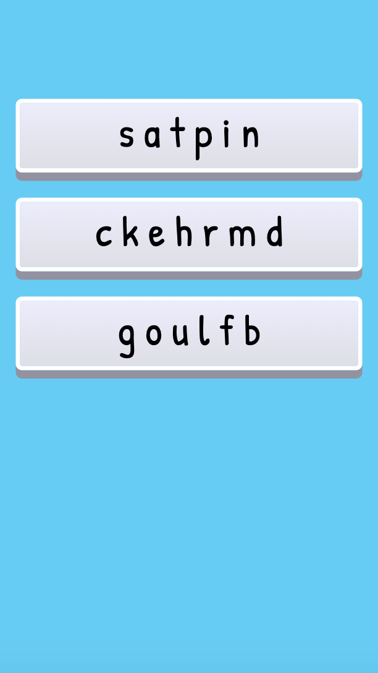

**Future Developments**:

The site can expand beyond basic literacy activities to include activities teaching conversational skills, vocabulary and reading practice.

**Introduction to 0.1 Classes:**

*At the beginning of this course most students are unable to sound out three or four letter English words. Some are literate in their own language while others are only proficient in spoken language. Drop’s guidance for 0.1 literacy classes outlines three elements:

*“1. Parts of whole’ approach, learning the letter names and sounds, letter formation and learning to sound out words. For this we can use our material which follow the Jolly Phonics method of letter groups and word banks, adapted for the adult ESOL learner   
2. ’Language experience’ approach and use of sight words. Here students learn to recognise the word as a whole rather than sounding it out. We can take advantage of any vocabulary that the learner already has to help them build literacy.   
3. Increasing spoken English. This provides balance to the lessons, is empowering and motivating in its immediate relevance, and as the vocabulary is mastered verbally it can be brought in as a sight word / with the language experience approach. ”*