Codebook for beer_breweries_data

Autogenerated data summary from dataMaid

2020-02-27 20:04:29

# Data report overview

The dataset examined has the following dimensions:

|  |  |
| --- | --- |
| Feature | Result |
| Number of observations | 2410 |
| Number of variables | 10 |

# Codebook summary table

|  |  |  |  |  |  |
| --- | --- | --- | --- | --- | --- |
| Label | Variable | Class | # unique values | Missing | Description |
|  | **Brewery_id** | integer | 558 | 0.00 % |  |
|  | **Brewery** | factor | 2304 | 0.00 % |  |
|  | **City** | integer | 2410 | 0.00 % |  |
|  | **State** | numeric | 75 | 2.57 % |  |
|  | **Beer** | integer | 108 | 41.70 % |  |
|  | **Beer_ID** | factor | 100 | 0.00 % |  |
|  | **ABV** | numeric | 7 | 0.00 % |  |
|  | **IBU** | factor | 551 | 0.00 % |  |
|  | **Style** | factor | 384 | 0.00 % |  |
|  | **Ounces** | factor | 51 | 0.00 % |  |

# Variable list

## Brewery_id

|  |  |
| --- | --- |
| Feature | Result |
| Variable type | integer |
| Number of missing obs. | 0 (0 %) |
| Number of unique values | 558 |
| Median | 206 |
| 1st and 3rd quartiles | 94; 367 |
| Min. and max. | 1; 558 |

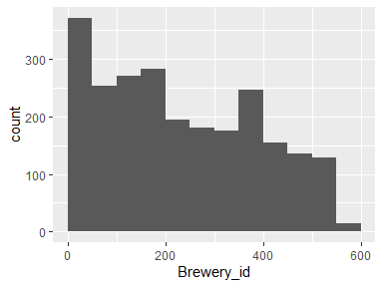

## Brewery

|  |  |
| --- | --- |
| Feature | Result |
| Variable type | factor |
| Number of missing obs. | 0 (0 %) |
| Number of unique values | 2304 |
| Mode | “Nonstop Hef Hop” |
| Reference category | #001 Golden Amber Lager |

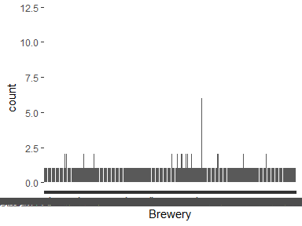

## City

|  |  |
| --- | --- |
| Feature | Result |
| Variable type | integer |
| Number of missing obs. | 0 (0 %) |
| Number of unique values | 2410 |
| Median | 1453.5 |
| 1st and 3rd quartiles | 808.25; 2075.75 |
| Min. and max. | 1; 2692 |

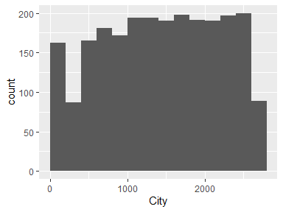

## State

|  |  |
| --- | --- |
| Feature | Result |
| Variable type | numeric |
| Number of missing obs. | 62 (2.57 %) |
| Number of unique values | 74 |
| Median | 0.06 |
| 1st and 3rd quartiles | 0.05; 0.07 |
| Min. and max. | 0; 0.13 |

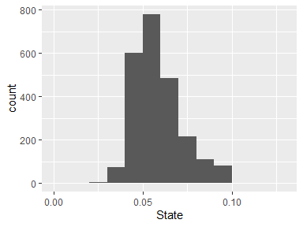

## Beer

|  |  |
| --- | --- |
| Feature | Result |
| Variable type | integer |
| Number of missing obs. | 1005 (41.7 %) |
| Number of unique values | 107 |
| Median | 35 |
| 1st and 3rd quartiles | 21; 64 |
| Min. and max. | 4; 138 |

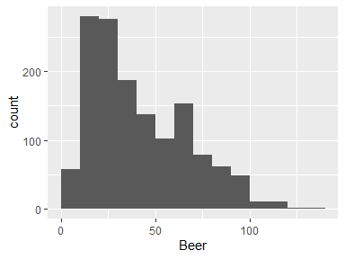

## Beer_ID

|  |  |
| --- | --- |
| Feature | Result |
| Variable type | factor |
| Number of missing obs. | 0 (0 %) |
| Number of unique values | 100 |
| Mode | “American IPA” |
| Reference category |  |

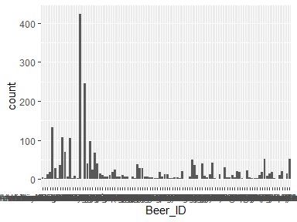

## ABV

|  |  |
| --- | --- |
| Feature | Result |
| Variable type | numeric |
| Number of missing obs. | 0 (0 %) |
| Number of unique values | 7 |
| Median | 12 |
| 1st and 3rd quartiles | 12; 16 |
| Min. and max. | 8.4; 32 |

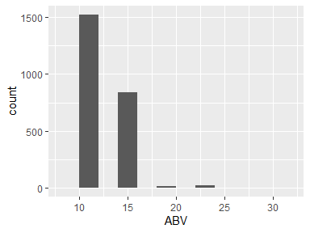

## IBU

|  |  |
| --- | --- |
| Feature | Result |
| Variable type | factor |
| Number of missing obs. | 0 (0 %) |
| Number of unique values | 551 |
| Mode | “Brewery Vivant” |
| Reference category | 10 Barrel Brewing Company |

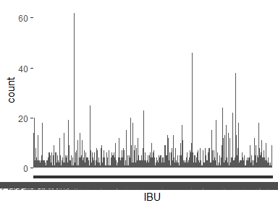

## Style

|  |  |
| --- | --- |
| Feature | Result |
| Variable type | factor |
| Number of missing obs. | 0 (0 %) |
| Number of unique values | 384 |
| Mode | “Grand Rapids” |
| Reference category | Abingdon |

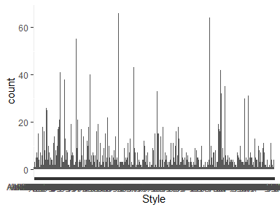

## Ounces

|  |  |
| --- | --- |
| Feature | Result |
| Variable type | factor |
| Number of missing obs. | 0 (0 %) |
| Number of unique values | 51 |
| Mode | “CO” |
| Reference category | AK |

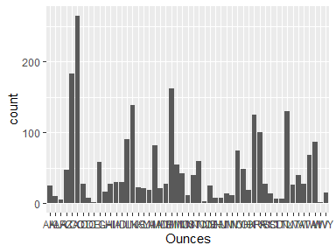

* Observed factor levels: "AK", "AL", "AR", "AZ", "CA", "CO", "CT", "DC", "DE", "FL", "GA", "HI", "IA", "ID", "IL", "IN", "KS", "KY", "LA", "MA", "MD", "ME", "MI", "MN", "MO", "MS", "MT", "NC", "ND", "NE", "NH", "NJ", "NM", "NV", "NY", "OH", "OK", "OR", "PA", "RI", "SC", "SD", "TN", "TX", "UT", "VA", "VT", "WA", "WI", "WV", "WY".