​
​
Vendor Lifecycle App User Manual
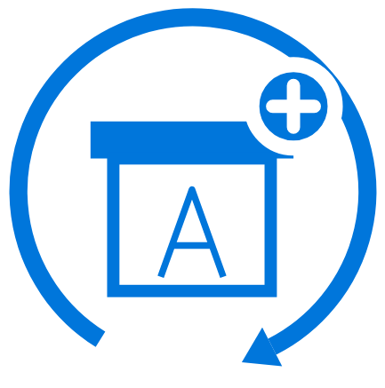
Vendor Lifecycle Application - Auriga IT Consulting Pvt. Ltd.

1. Introduction
The Vendor Lifecycle app helps organizations manage the entire vendor relationship, from the initial application and onboarding process through active business operations to a structured exit when the relationship ends.
Instead of keeping vendor information scattered across emails, spreadsheets, and paper files, the app centralizes everything in one place and guides each vendor through a consistent set of processes, including registration, identity and background verification, compliance and safety checks, product or service sample evaluation, and final sign-off before activation. Once a vendor becomes active, the app helps your team monitor ongoing performance, collect regular satisfaction feedback, and maintain up-to-date compliance records. If the business relationship needs to end, the app provides a structured, checklist-based deboarding (offboarding) process rather than simply deactivating the supplier.
The app is designed to support organizations across industries and countries. Country-specific fields, such as PAN and GSTIN, appear only when the vendor's country is set to India. Vendors in other countries do not see these fields.
This manual follows the app's sidebar and home page structure, shown below, to help you navigate its features and understand each stage of the vendor lifecycle.
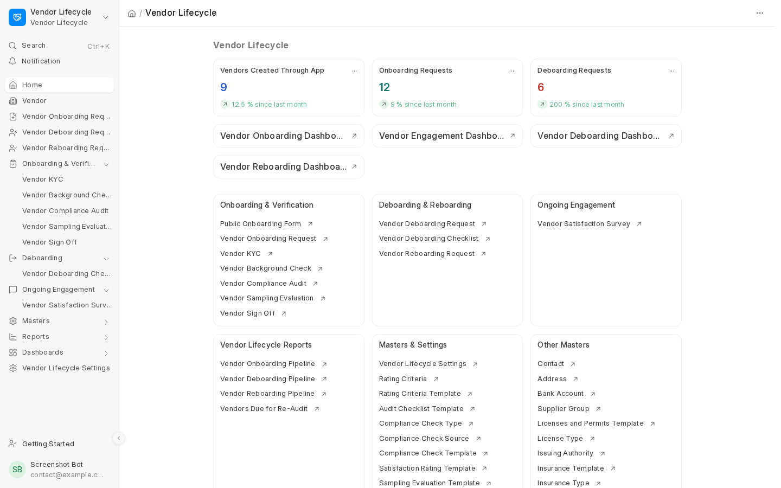
Figure 1: The Vendor Lifecycle workspace - every screen described in this manual is reachable from here

2. Who Uses the App
There are two roles built specifically for this app, on top of the standard System Manager role.

Vendor Lifecycle Manager
This full-access role can create and approve records at every stage, manage settings, override failed stages with valid reasons, and access all reports and dashboards. It is typically assigned to vendor management supervisors. Only this role and the System Manager can mark deboarding as failed or temporarily reactivate a deboarded vendor.

Vendor Lifecycle User
The day-to-day role can create and manage operational records but cannot access or modify system Settings. Ideal for users who regularly process vendors without controlling system-wide configurations.

System Manager
This is the standard Frappe/ERPNext administrator role. It has full access to everything, including the ability to fix data problems or reconfigure the app if something goes wrong.

Vendors Themselves
Vendors have limited portal access to view and complete assigned satisfaction surveys. They cannot access internal records such as Background Checks or Compliance Audits. See Section 8 for details.

3. The Vendor Journey (Overview)
Every vendor that comes through this app follows the same overall path, shown in the diagram below.
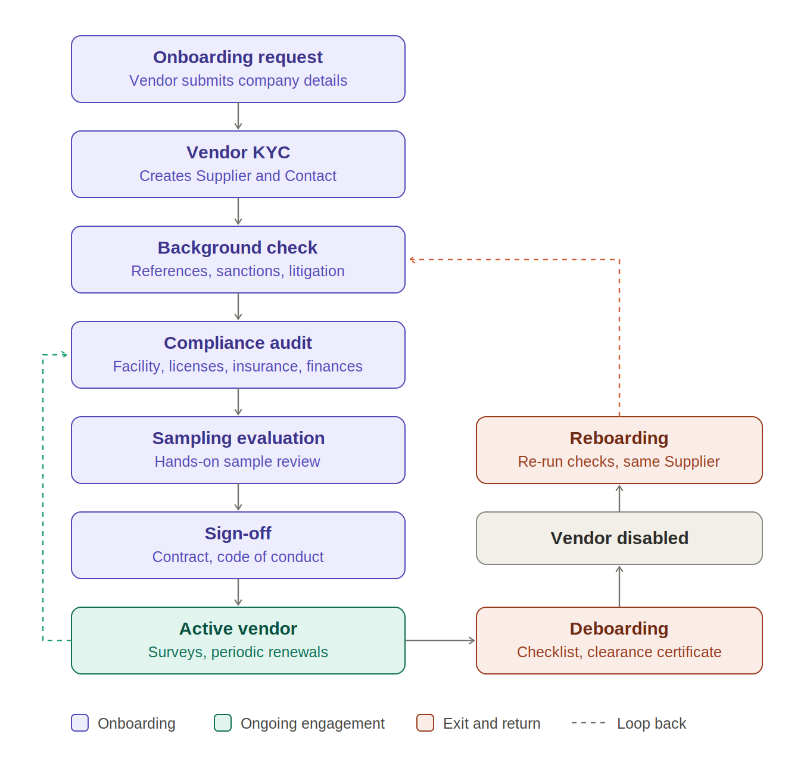
Figure 2: Vendor lifecycle - onboarding, ongoing engagement, deboarding and reboarding
- Onboarding Request - The vendor, or a team member acting on their behalf, completes a form with the company’s details.
- Vendor KYC - Once the request is deemed legitimate, your team initiates a detailed identity and verification form for the vendor, which also creates their Supplier and Contact records.
- Background Check - Conducting reference checks and compliance screenings, including sanctions list searches, litigation checks, and other relevant due diligence.
- Compliance Audit - Verifying the vendor’s facilities, licenses, insurance coverage, and financial stability.
- Sampling Evaluation - Conducting a hands-on evaluation of the vendor’s product or service samples, where applicable.
- Sign-off - A final step in which the vendor signs the contract and Code of Conduct before being formally activated.
- Active Vendor / Ongoing Engagement - Once activated, the vendor can receive regular satisfaction surveys, while periodic Compliance Audits or Sign-off Renewals can be conducted to ensure their checks remain up to date.
- Deboarding - When a vendor relationship ends, the Deboarding Request and Checklist guide the closure process, including obtaining a signed clearance certificate before disabling the vendor.
- Reboarding - A deboarded (or otherwise disabled) vendor can be brought back into service through a Vendor Reboarding Request, which runs the required checks again on the same Supplier record.
Not every stage is required for every vendor. The Settings page (Section 5) determines which stages are mandatory. Any optional stage can be skipped, allowing the vendor to proceed directly to the next stage.
The stages must also be completed in the correct order. The app enforces the following rules and displays a clear message whenever a rule is violated:
- Failed stages must be resolved first. If a Background Check, Compliance Audit, or Sampling Evaluation has failed, no subsequent stage can be started until the failure is either cancelled or Force Overridden. The app displays the message: "X failed - cancel or force-override it before starting Y". The Create buttons for subsequent stages remain hidden until the issue is resolved.
- Earlier stages cannot be added after later stages have started. For example, a Sampling Evaluation cannot be added once the Sign-off stage has been started.
- Earlier stages cannot be cancelled while later stages exist. If a subsequent stage has been submitted, the app displays "Cancel X first". If it is still a draft, the message reads "Delete the draft X first".
- A passing Sign-off cannot be submitted while any stage failure remains unresolved.
- Cancelling a passed stage or deleting a draft stage restores the vendor's previous status.
- The same rules apply during re-boarding.
Each stage is maintained as a separate record in the system. Except for the initial Onboarding Request in some configurations, every stage record is linked to the vendor's KYC record. This provides a single place to trace the vendor's complete history. The KYC record's Connections tab lists every stage record created from it.

Vendor Stage and Status
Every Supplier handled by the app carries two extra fields that show at a glance where the vendor stands:
- Vendor Lifecycle Stage: Provides a high-level overview of the vendor's position in the lifecycle: Onboarding in Process, Onboarding Failed, Onboarded, Deboarding in Process, Deboarding Failed, Deboarded, Reboarding in Process, Reboarding Failed, or Reboarded.
- Vendor Lifecycle Status: Shows the vendor's specific status within the current stage. Examples include KYC Verified, Background Check In Progress, Background Verified, Compliance Audit Failed, Sampling Approved, Sign Off In Progress, Sign Off Failed, Active, Deboarding Initiated, Deboarding Failed, Temporarily Enabled, and Disabled. During reboarding, the corresponding statuses are prefixed with "Re-", such as Re-Background Check In Progress and Re-Sign Off Failed.
- Compliance Audit Expired / Contract Expired: Indicates that the vendor has been disabled because their Compliance Audit or contract has expired, or the corresponding renewal has failed. This applies only when the relevant Settings option is configured to disable the vendor in such cases.

4. Step-by-Step: Each Screen You'll Use

4.1 Vendor Onboarding Request
This is the first form filled out for a new vendor. It can be submitted directly by the vendor through a public web form or entered internally by your staff.
What it captures:
- Company details: Company or firm name and business type, such as Manufacturer, Trader, Service Provider, Contractor, Logistics, Freelancer, Raw Material Supplier, Equipment Supplier, Technology Vendor, Facility Services, or Other.
- Contact and address: Contact person, phone number, email, website. Full address, including country-specific fields (GSTIN only appears for India).
- Business-specific details: Additional questions based on the selected Business Type. For example, Traders are asked about the brands they distribute, while Logistics companies provide details about their fleet size and coverage area.
- Optional file attachments: a business/capability profile, a product/service catalogue, and one more general attachment.
The form must be submitted, not merely saved as a draft, before the request can proceed to the next stage.
If a new request uses an email address or contact number already associated with another request, the app handles the duplicate according to the setting configured in Settings: it can display a warning, block the request, or ignore the duplicate.
Once your team has verified that the request is legitimate, click the Start KYC button on the form. This creates a new Vendor KYC record pre-filled with the information already collected, eliminating the need to enter the same details again.
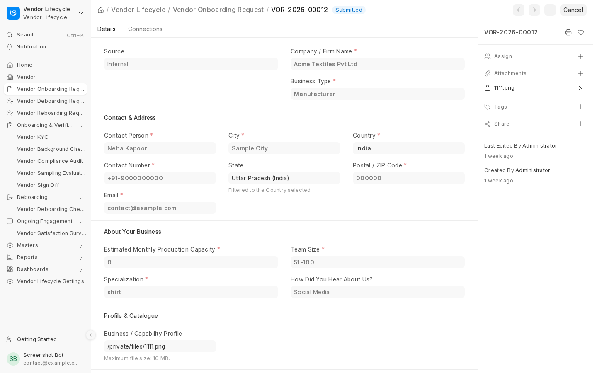
Figure 3: A submitted Vendor Onboarding Request

4.2 Vendor KYC
The detailed verification form, and it's the record every later stage (Background Check, Compliance Audit, Sampling Evaluation, Sign-off) links back to. It's organized into tabs:
- Contact - the contact person's name, phone, and official email (all required), plus a reference contact.
- Address - full address details.
- Business Details - Capture the legal entity type (e.g., Sole Proprietorship, Partnership, LLP, Company, Non-Profit, Government Entity, or Other) and the relevant business-type-specific questions from the Onboarding Request.
- Tax & Compliance - Capture the Tax ID and, for India, PAN, GSTIN, MSME/Udyam registration, and Import-Export Code. The Fetch Address from GSTIN button retrieves the registered address from the GST database, provided the India Compliance app is installed and configured.
- Bank Details - bank account details, plus IBAN/SWIFT for international transfers.
The Verification section records whether KYC was verified internally or by an external agency. External verification requires the agency’s contact details and proof-of-visit documentation.
Settings-driven checks apply automatically:
- If you fill in any one bank field, you may be required to fill in all four (Bank, Account No., IFSC/Branch Code, Account Name).
- Similarly for address fields (Address, City, State, Country, Postal Code).
- PAN Card (for vendors in India) is mandatory only when "Require PAN Card (India)" is ticked in Settings (on by default), and Tax ID (for vendors in any other country) only when "Require Tax ID (Outside India)" is ticked (off by default). Whenever either is filled in, its format is still checked.
When the KYC is submitted, the app automatically creates the vendor's actual Supplier record in the background, along with the associated Contact, Address, and Bank Account records. These records do not need to be created separately.
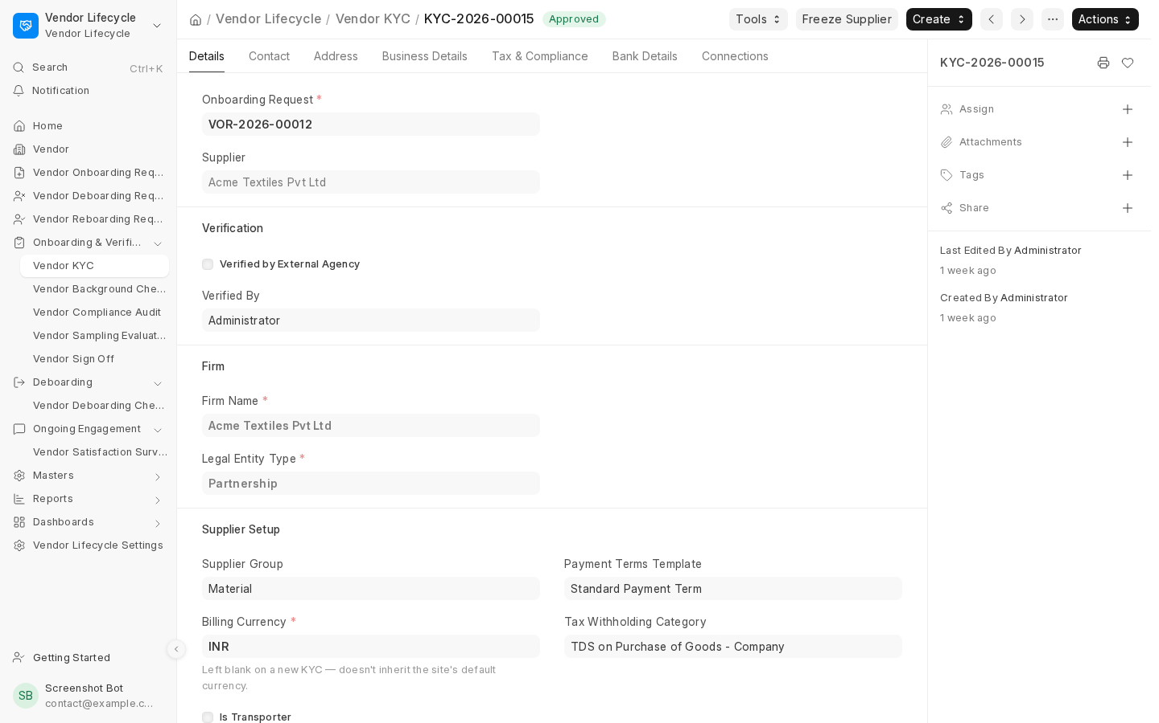
Figure 4: The Vendor KYC form - Details tab, showing the linked Onboarding Request, Supplier, and Verification section

4.3 Vendor Background Check
The Background Check stage verifies the vendor's references and runs compliance screenings, such as sanctions checks and litigation history, based on the checks defined in the selected Compliance Check Template.
- Select a Compliance Check Template to load the required checks. Each check can be assigned a status and an optional supporting document. Some checks may require evidence to be attached before they can be completed.
- Add one or more References as separate linked records (each Reference has its own contact details, ratings against a Rating Criteria Template, and its own Pass/Fail/Needs Review result).
- Record Ultimate Beneficial Owner (UBO) details for anti-money-laundering purposes.
The overall result is automatically calculated: Fail if the combined Reference result or any compliance check fails, and Pass only if both pass. The status remains Needs Review until all references are fully scored.
If a Background Check fails, the Supplier record is automatically disabled and an email notification is sent if enabled. A Vendor Lifecycle Manager can use Force Override with a mandatory reason to re-enable the Supplier when justified, without changing the failed result.
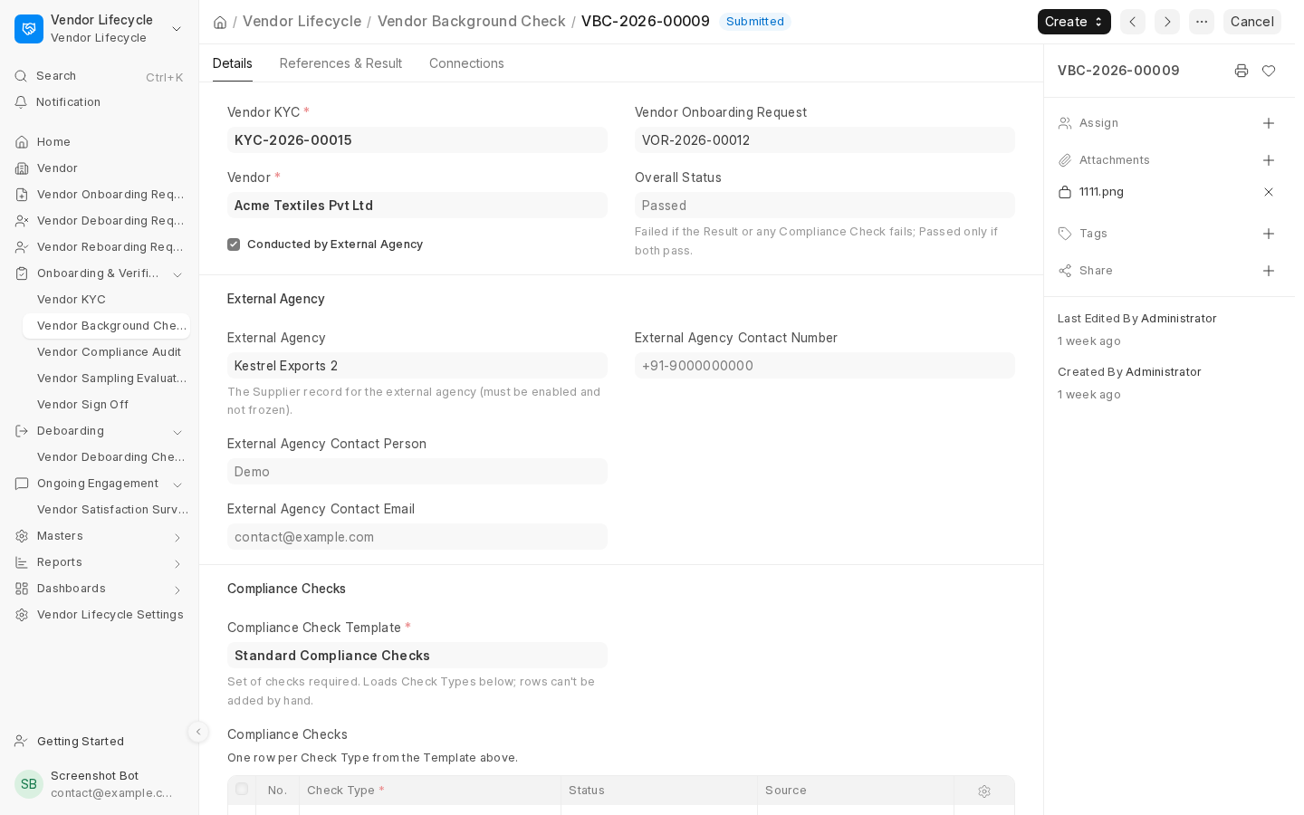
Figure 5: A Vendor Background Check record

4.4 Vendor Compliance Audit
This stage assesses the vendor’s facility, licenses, insurance, and financial stability through four tabs:
- Checklist: Evaluate items as Pass/Fail/N/A, with required evidence and failure reasons where applicable.
- Licenses & Permits: Record required licenses, issuing authorities, validity dates, and applicable regions.
- Insurance Certificates: Capture policy details, insurers, coverage amounts, expiry dates, and coverage breakdowns.
- Financial Stability: Mark the vendor Stable/Unstable and attach supporting documents. Unstable requires notes and fails the audit.
For a Passed or Force Overridden audit, set the validity date manually or use the default based on Settings. This date drives the Vendors Due for Re-Audit report. A Failed audit disables the Supplier, but a Manager can override it with a mandatory reason.
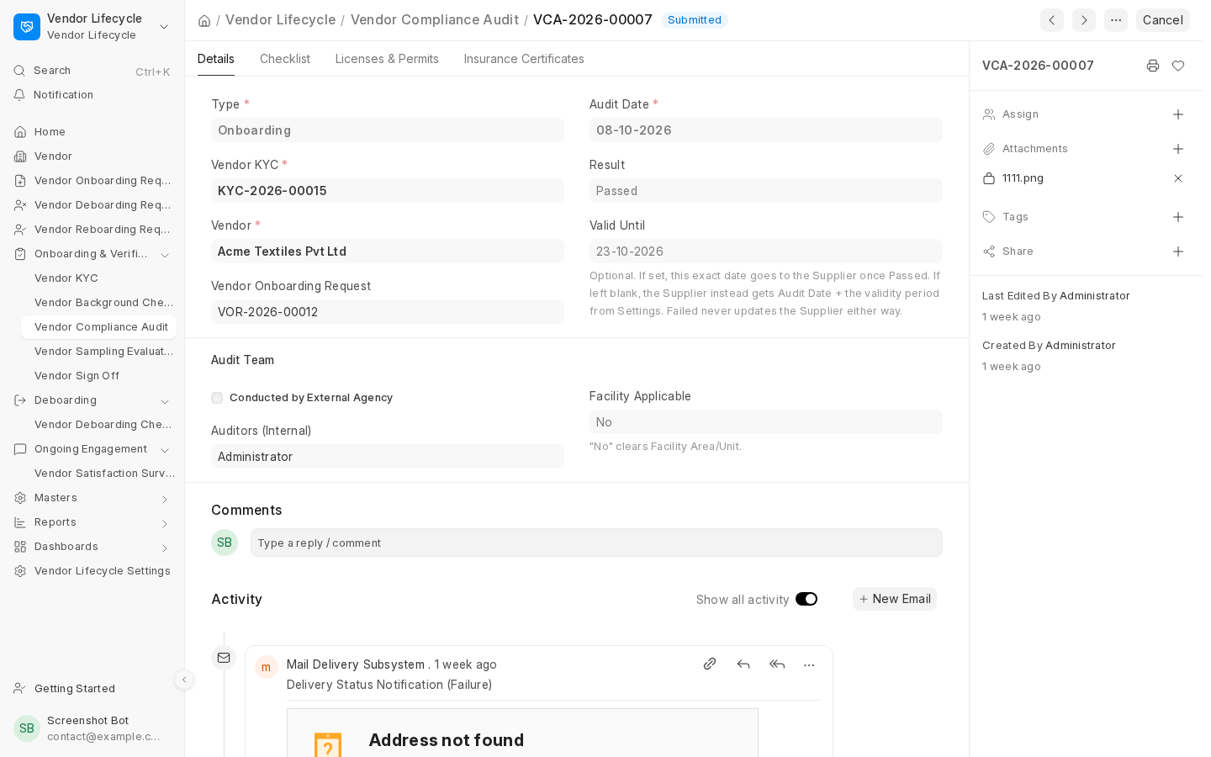
Figure 6: A Vendor Compliance Audit record

Compliance Audit Renewals
A Compliance Audit Renewal can be created directly from the Vendor Compliance Audit list for active vendors by selecting Renewal as the Type. It uses the same four audit tabs but is not linked to KYC or onboarding pipelines.
- Settings: Control whether failed or expired renewals disable the Supplier. Separate email reminders can notify users of upcoming renewals and unfinished drafts.
- Eligibility: Renewals and Ad-hoc Sampling Evaluations are allowed only for eligible vendor stages and are revalidated on submission.
- Reactivation: Vendors disabled due to an expired or failed compliance renewal can undergo a new Renewal. Passing it re-enables the Supplier with Active status.
- Status handling: Renewal and Ad-hoc results do not independently keep a vendor disabled once the underlying issue is resolved.
- Audit trail: Upcoming-renewal reminder emails are recorded on the Supplier’s timeline.

4.5 Vendor Sampling Evaluation
This stage evaluates a vendor’s products or work samples, particularly for manufacturers and raw material suppliers. Whether it’s mandatory depends on Settings.
- Samples: Link existing Items or describe samples, track their status, and record quality and cost details.
- Evaluation Criteria: Optionally load an Evaluation Template with specific criteria to score.
- Outcome: Mark the evaluation as Approved or Rejected; the status remains Not Reviewed until decided.
- Supplier Status: A Rejected outcome disables the Supplier, but a Manager can use Force Override with a mandatory reason.
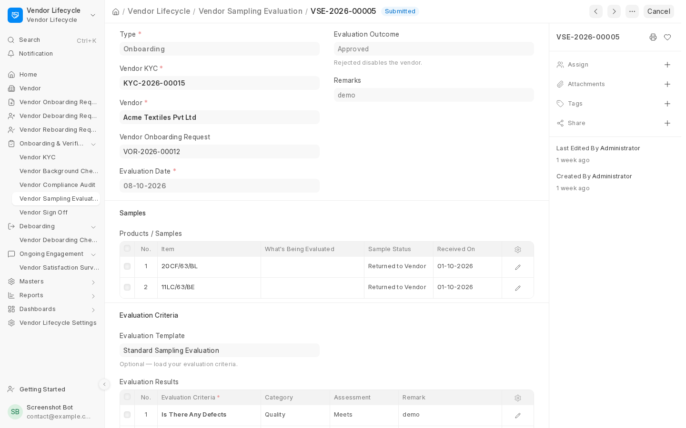
Figure 7: A Vendor Sampling Evaluation record
Sampling Evaluations also support standalone Ad-hoc checks for existing vendors, such as evaluating a new product before acceptance. Select Ad-hoc as the Type when creating the record. These checks are for record-keeping only and never affect the Supplier’s status, regardless of the outcome. Vendor eligibility follows the same rules as Renewals (Section 4.4).

4.6 Vendor Sign-off
The final onboarding stage ensures the vendor formally agrees to the contract and Code of Conduct before activation.
- Documents: Attach the unsigned Contract and Code of Conduct/Anti-Bribery Policy.
- Email: Send documents to the vendor using automatically populated contact details. Add an additional recipient or select a Company for email details if needed.
- Signed Documents: Signed copies are automatically attached from vendor email replies where possible, or staff can upload them manually if needed.
- Failed Sign-Off: Record the failure reason using Sign Off Failed. The Supplier remains disabled, and signed documents are not required.
- Activation: Submitting the completed sign-off record activates the Supplier for normal operations, including Purchase Orders.

Retrying a Failed Sign-off
A failed Sign-off can be retried using Retry Sign-off from the failed record, KYC, or Reboarding Request. The new record links to the failed one to preserve history.
- Successful Retry: Re-enables and unfreezes the Supplier unless another issue prevents activation.
- Cancelled Retry: Returns the vendor to the failed state.
- Cancellation Rules: The failed Sign-off cannot be cancelled while a retry exists. Delete a draft retry or cancel a submitted one first. Deleting a draft restores Sign Off Failed.

Sign-off Renewals
Sign-off supports standalone Renewals for periodic re-confirmation or expiring contracts. Select Renewal as the Type; it is not linked to onboarding or re-boarding.
- Settings: Control whether failed or expired renewals disable the Supplier. Upcoming-renewal and unfinished-draft reminder emails can be enabled independently.
- Contract Expiry: If Disable Vendor on Contract Expiry/Failure is enabled, an expired contract or failed Renewal disables the vendor with Contract Expired status.
- Reactivation: A new Sign-off Renewal is allowed for disabled vendors and re-enables the Supplier when it passes.
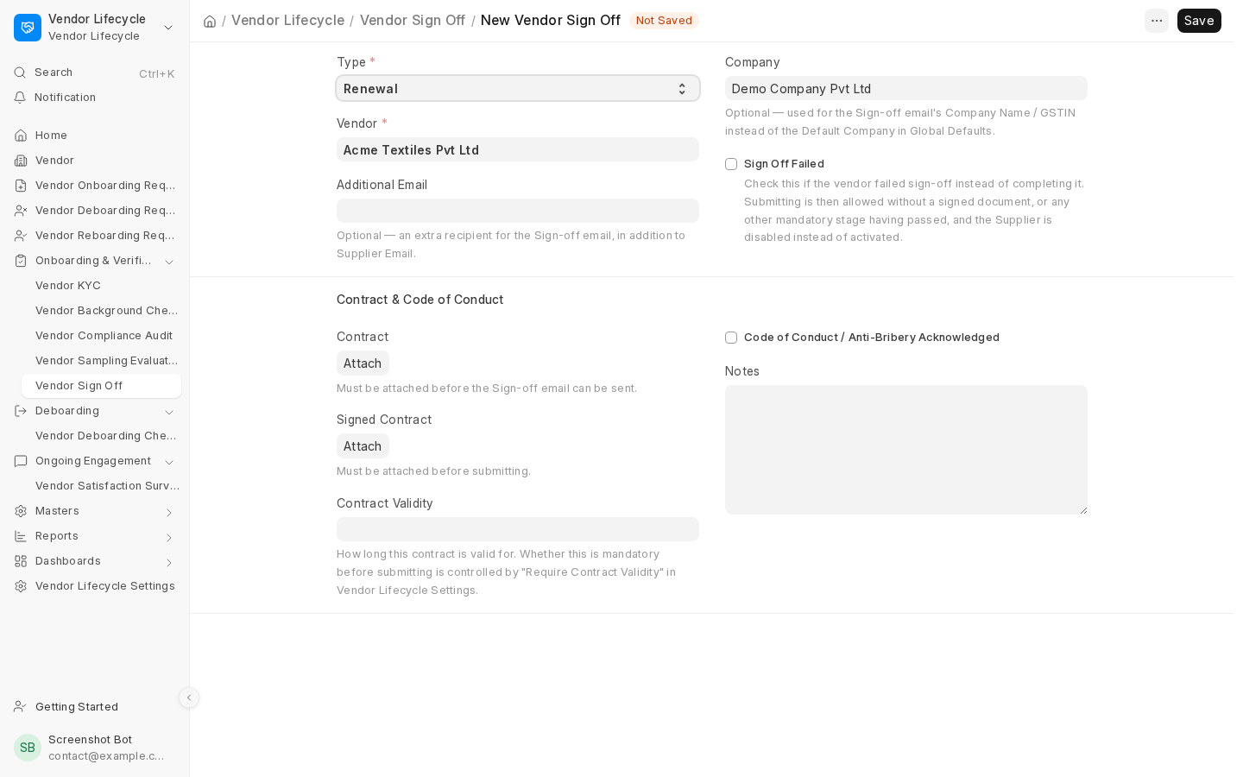
Figure 8: A Vendor Sign-off created as a standalone Renewal

4.7 Vendor Satisfaction Survey
The app automatically generates recurring vendor satisfaction surveys (Monthly, Quarterly, Half-Yearly, or Yearly) based on Settings. Surveys can be created manually using the Add button on the list page. Automatic survey generation can be disabled for a specific supplier from the More Info tab of the Supplier record. You can also select a different survey template for that supplier instead of using the globally configured default. Surveys aren't auto-created for deboarded vendors or temporarily enabled re-boarding vendors.
Each survey includes star-rated criteria from the vendor’s Rating Template or the default template, plus Areas of Concern and Suggestions for Improvement fields.
Survey statuses: Open, In Progress, Ratings Given, and Completed.
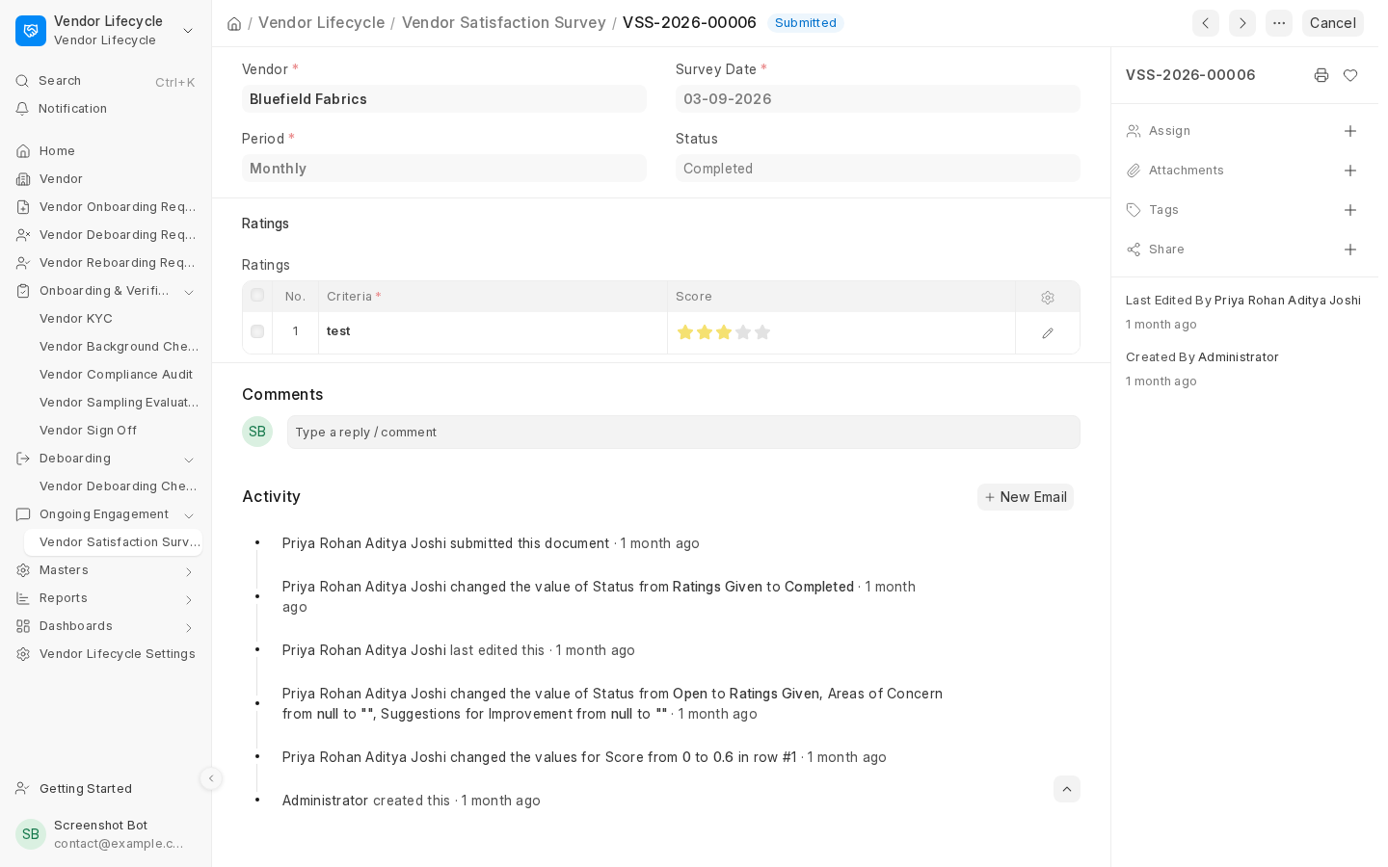
Figure 9: A Vendor Satisfaction Survey record

4.8 Vendor Deboarding Request
This is where the deboarding (offboarding) process begins, usually raised when there's a reason to end the relationship with a vendor.
- Request Details: Select the Supplier, provide the reason, indicate whether the issue is resolvable, and optionally rate the vendor using the Deboarding Rating Template.
- Open Transactions: Displays outstanding purchase orders, unpaid invoices, and other transactions for information only; these do not block deboarding.
- Approval: The request must be Approved to proceed or can be Rejected. Other statuses include Deboarding Failed and Cancelled.
- Eligibility: Requests are restricted based on the vendor’s current stage, and duplicate active or approved requests are prevented.
- Cancellation: Allowed only before a Deboarding Checklist exists. The vendor’s previous active status is restored, and any freeze applied by the request is removed.
Once Approved, a Vendor Deboarding Checklist is created for the actual close-out work.
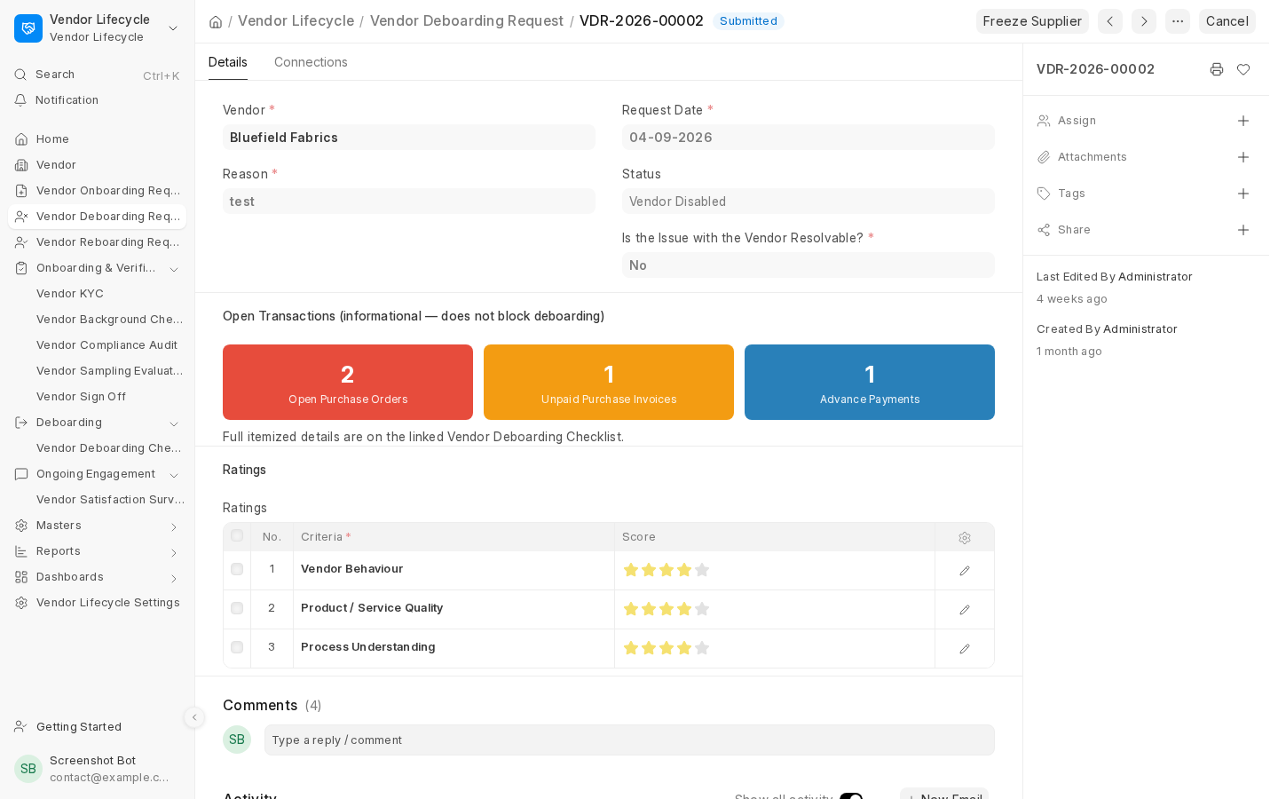
Figure 10: A Vendor Deboarding Request record

4.9 Vendor Deboarding Checklist
The Vendor Deboarding Checklist manages the tasks required to close a vendor relationship.
- Checklist Tasks: Load tasks from the template, assign up to two people per task, and track progress. Invalid and Unable to Complete require written remarks.
- Open Transactions: View outstanding transactions for reference during the close-out process.
- Clearance Certificate: Attach a signed clearance certificate or select No Clearance Certificate Available with a reason. Send the certificate to the vendor’s recorded contact emails, avoiding duplicate recipients.
- Signed Certificate: The vendor’s signed copy is automatically attached from email replies where possible, or uploaded manually if needed.
- Supplier Deactivation: Submitting the completed checklist disables the Supplier.
- Temporary Access: Use Temporarily Enable Supplier to allow transactions for a limited period. You can disable the Supplier early using the same toggle, or it will be disabled automatically when the period expires. The same button will be visible on the same supplier as in the checklist.
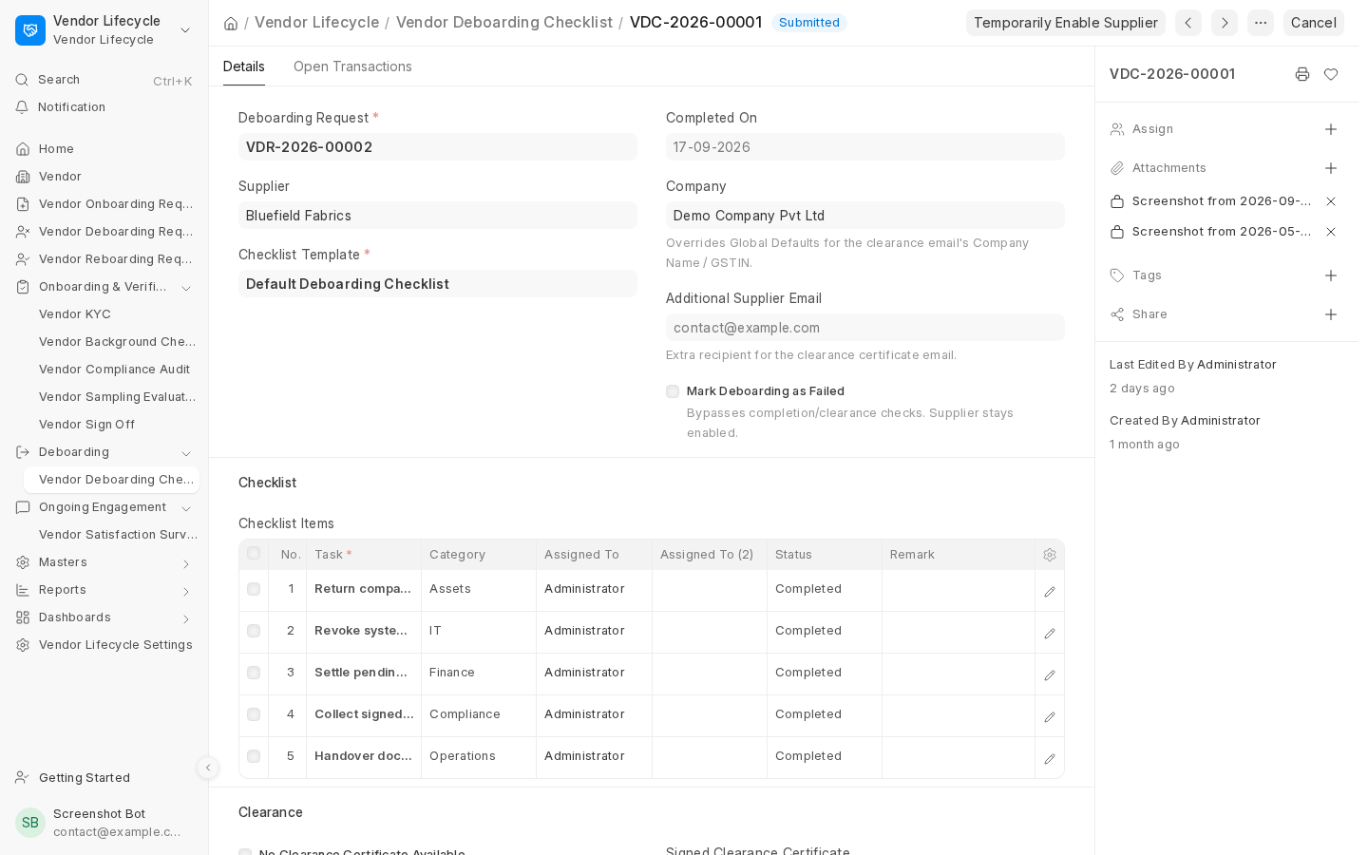
Figure 11: A submitted Vendor Deboarding Checklist. While it is still a draft, the Send Clearance Certificate and Send Follow-up buttons appear in the same place

Temporarily Enable Supplier - the rules
- Access: Only Vendor Lifecycle Managers and System Managers can use the button on a submitted, non-failed Deboarding Checklist or eligible Supplier record.
- Duration: The Temporary Enable Days setting controls the window (default 7 days); changes also affect active windows.
- Audit Trail: Every enable/disable action records who performed it, the expiry time, and where it was initiated.
- Automatic Disable: A nightly job at 2 AM disables the Supplier when the window expires, provided the vendor remains in an eligible stage.
- Reboarding: The button toggles Supplier access without changing the reboarding status. A reboarding Sign-off, whether passed or failed, closes any active temporary-enable window.

Marking Deboarding as Failed
If deboarding cannot be completed, a Vendor Lifecycle Manager or System Manager can select Mark Deboarding as Failed and provide a mandatory failure reason.

Cancelling a Submitted Deboarding Checklist
It restores the vendor to Deboarding in Process / Deboarding Initiated and the request to Approved, allowing a new checklist to be created. The Supplier is re-enabled only if no other restriction applies. It cannot be used once the vendor moves to another stage, such as re-boarding. If multiple checklists exist, they must be reset newest first.

4.10 Vendor Reboarding Request
Reboarding restores a previously deboarded vendor using their existing Supplier record. Create a Vendor Reboarding Request to begin.
- Verification Stages: Settings determine whether Background Check, Compliance Audit, and Sampling Evaluation are mandatory for reboarding, independently of onboarding requirements. Sign-off is always the final stage.
- Connections: Links to all stage records created from the request.
- Pipeline Progress: Displays each required stage’s status—Not Started, In Progress, Completed, Forcefully Passed, or Failed/Rejected/Skipped—with colour-coded indicators.
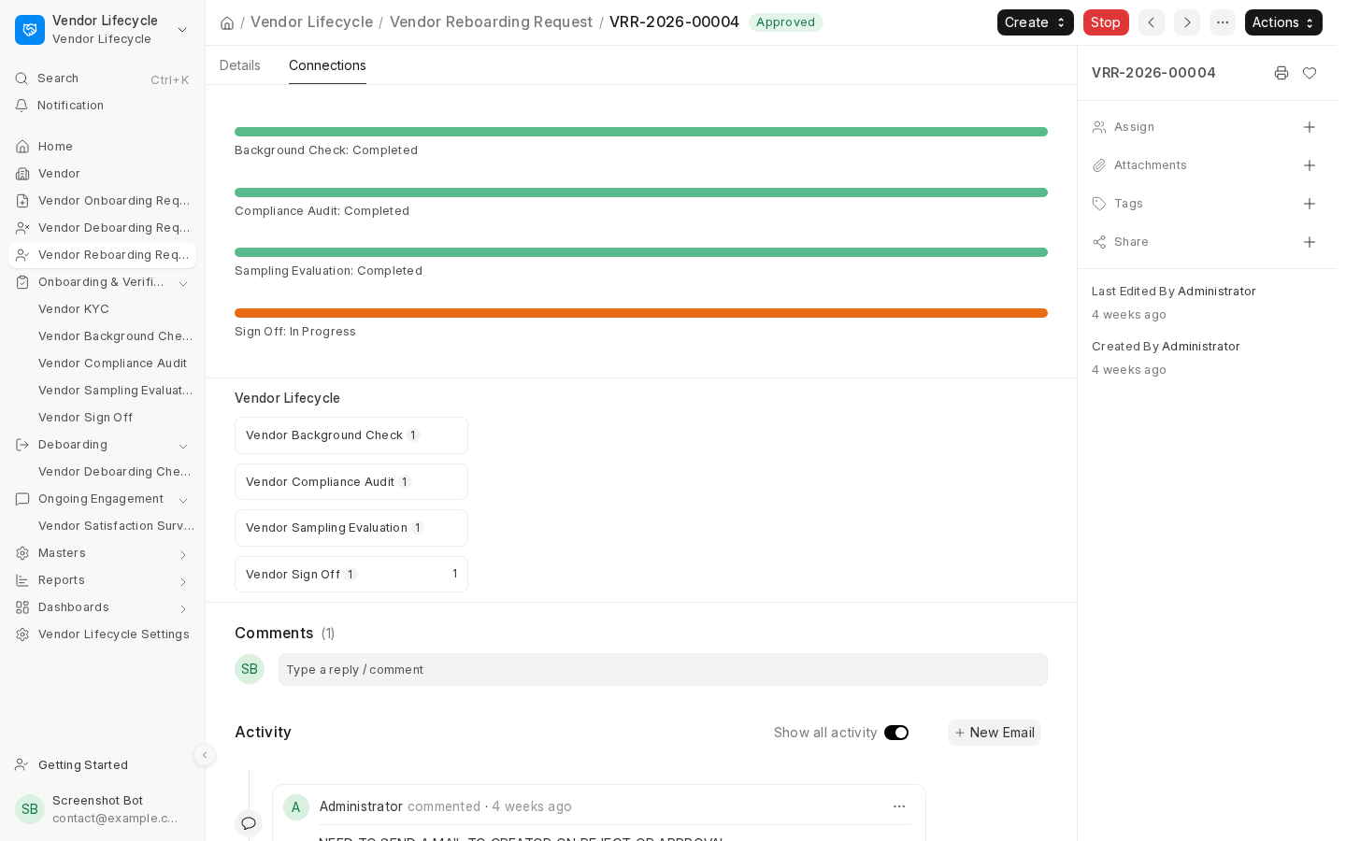
Figure 12: A Vendor Reboarding Request's Pipeline Progress panel, on its Connections tab
A Reboarding Request requires approval by a Vendor Lifecycle Manager after submission by a Vendor Lifecycle User. Once approved and all mandatory stages pass or are force overridden, the Supplier is reactivated.
- Approval: A Manager can Approve, Reject, or Cancel the request.
- Stop/Re-open: Pause or resume the request with a reason. While stopped, all related stage records are blocked from being created, saved, submitted, or cancelled.
- Duplicate Prevention: A second request is allowed only after the previous one is stopped or resolved.

5. The Settings Page
Vendor Lifecycle Settings is a single page (found under Masters & Settings) controlling how the whole app behaves. It's organized into four tabs.

5.1 Onboarding
The Settings page controls the following:
- Duplicate Detection: Choose how duplicate Onboarding Requests and duplicate KYCs for the same request are handled: warn the user, block the action, or disable duplicate checks.
- KYC Creation Rules: Decide whether KYC can only be initiated from an approved Onboarding Request or can also be created directly.
- Bank and Address Validation: Configure whether bank details and address details must be completed in full when any field within the respective section is entered.
- Tax and Compliance Requirements: Set whether a PAN Card is mandatory for vendors in India (Require PAN Card (India), enabled by default) and whether a Tax ID is mandatory for vendors outside India (Require Tax ID (Outside India), disabled by default).
- Supplier–KYC Linking: Determine whether every new Supplier must be linked to a Vendor KYC record.
- Mandatory Stages: Configure whether Background Check and Compliance Audit are mandatory stages in the onboarding process.
- Pass/Fail Calculation: Define how the overall Background Check and Compliance Audit results are calculated across multiple references or criteria.
- Reference Rating Threshold: Set the minimum average rating required to pass when a Reference does not have its own template-specific pass/fail threshold.
- Compliance Audit Validity: Specify how many months a passed Compliance Audit remains valid before a new audit is required.
- Sampling Evaluation Requirements: Select the Business Types for which Sampling Evaluation is mandatory. Business Types not explicitly listed are treated as optional for this stage.
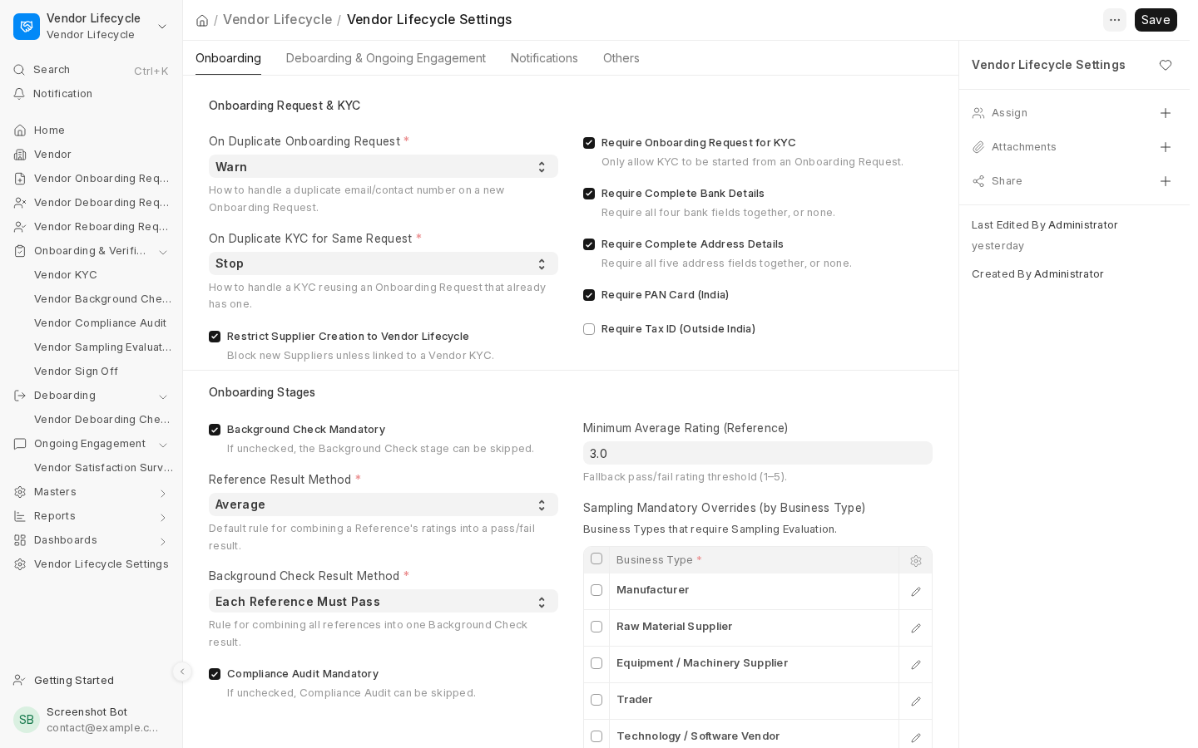Figure 13: Vendor Lifecycle Settings - Onboarding tab

5.2 Deboarding & Ongoing Engagement
- Default Deboarding Templates: Configure which Rating Template and Checklist Template are used by default for new Deboarding Requests and Deboarding Checklists.
- Temporary Enable Days: Specify how many days a deboarded vendor remains enabled when the Temporarily Enable Supplier option is used. This field is required, must be at least 1 day, and defaults to 7 days.
- Automatic Satisfaction Surveys: Configure whether satisfaction surveys are automatically generated for active vendors, how frequently they are created, and which Rating Template is used by default.
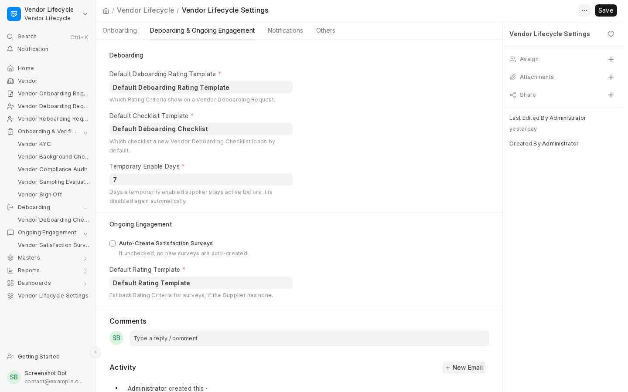Figure 14: Vendor Lifecycle Settings - Deboarding & Ongoing Engagement tab

5.3 Notifications
- Global Email Notifications: A master on/off switch that controls all automated emails sent by the app.
- Email Type Settings: Separate on/off switches for each category of email, including onboarding, verification, renewal reminders, deboarding, satisfaction surveys, checklist reminders, clearance certificate follow-ups, and reboarding.
- Sender Email Account: Select the Email Account used to send all automated emails.
- Default CC Recipients: Specify email addresses that should always be copied (CC'd) on every Vendor Lifecycle email, in addition to all Vendor Lifecycle Managers.
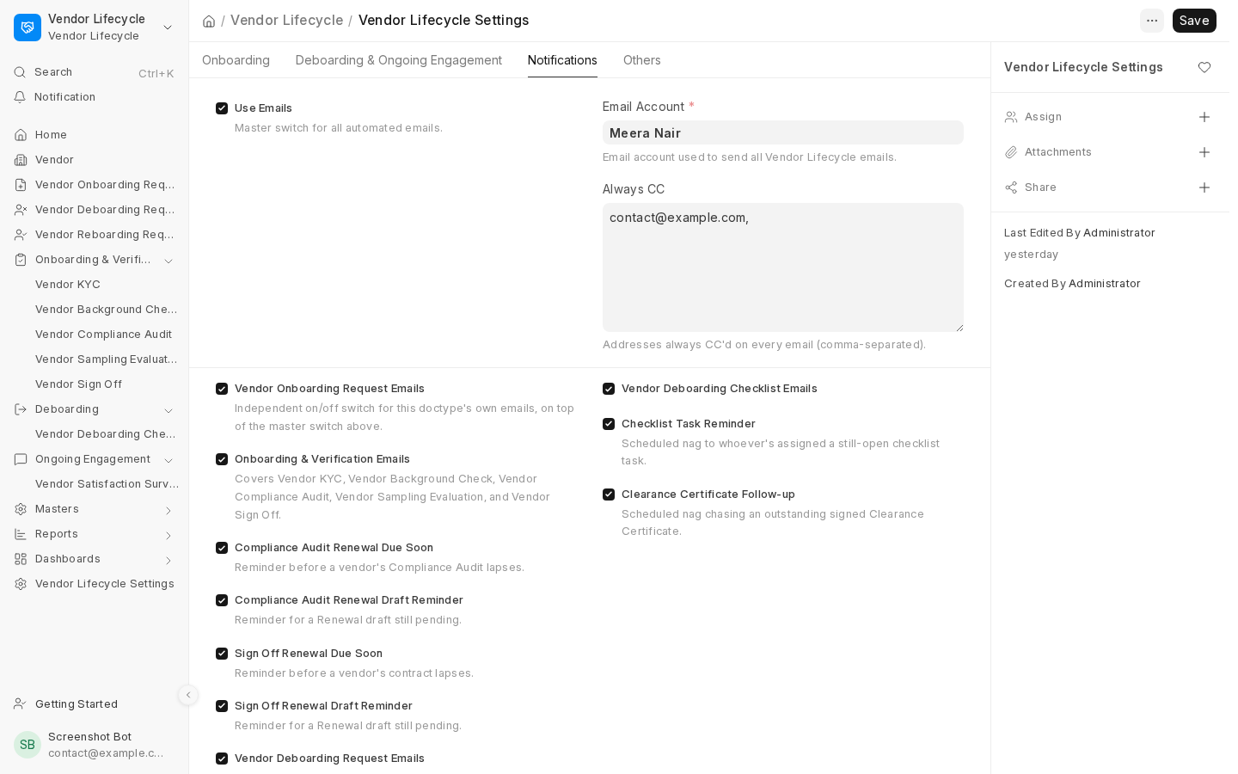Figure 15: Vendor Lifecycle Settings - Notifications tab

5.4 Others
Two additional settings areas cover configurations that don't fit neatly under the other three tabs:
- Reboarding: Configure which stages—Background Check, Compliance Audit, Sampling Evaluation—are mandatory when reactivating a deboarded vendor. These requirements are independent of the onboarding-stage settings.
- Renewals: Configure whether standalone Compliance Audit and Sign-off Renewals are enabled, set the Compliance Audit validity period, and determine whether a failed or expired renewal automatically disables the vendor using the Disable Vendor on Compliance Audit Expiry/Failure and Disable Vendor on Contract Expiry/Failure settings.

6. Dashboards & Reports

6.1 Dashboards
Four dashboards provide an overview of the vendor lifecycle, each with summary cards and charts:
- Vendor Onboarding Dashboard: Tracks draft requests, pending verification stages, vendors created through the app, and KYC and audit outcomes.
- Vendor Engagement Dashboard: Shows survey statuses, response rates, average satisfaction scores, overdue surveys, and criterion-wise ratings over the last 12 months.
- Vendor Deboarding Dashboard: Tracks draft or rejected requests, pending clearance certificates, draft checklists, temporarily re-enabled suppliers, and deboarding statuses.
- Vendor Reboarding Dashboard: Displays reboarding request statuses, pending Sign-offs, and successfully reboarded vendors.
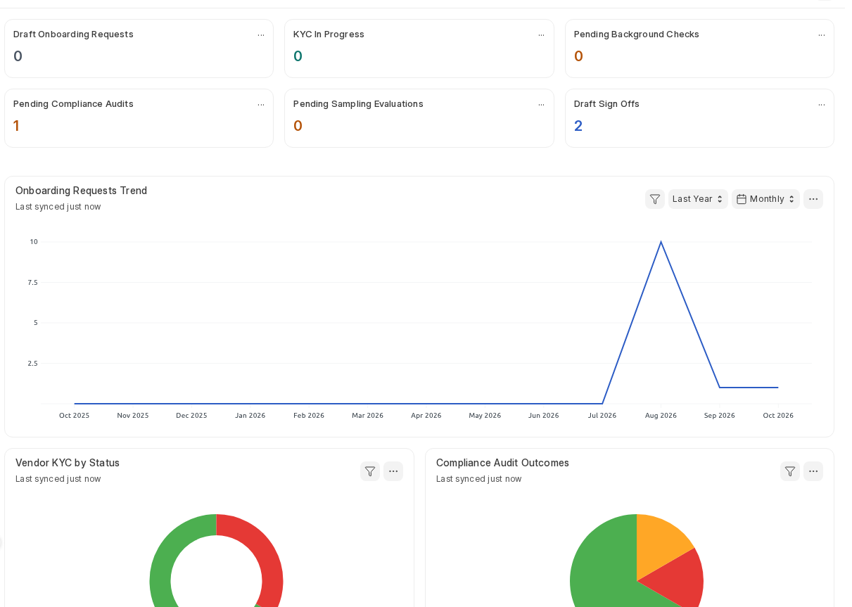
Figure 16: Example- The Vendor Onboarding dashboard

6.2 Reports
Four detailed reports provide stage-by-stage visibility into the vendor lifecycle:
- Vendor Onboarding Pipeline: Shows each vendor’s status across KYC, Background Check, Compliance Audit, Sampling Evaluation, and Sign-off. Choose View By (Onboarding Request or Vendor KYC). The request view includes vendors who haven’t started KYC, while the KYC view provides a fuller stage-by-stage overview.
- Vendor Reboarding Pipeline: Tracks vendors progressing through reboarding after deboarding.
- Vendor Deboarding Pipeline: Tracks vendors progressing through deboarding.
- Vendors Due for Re-Audit: Lists vendors whose compliance validity has expired or is approaching expiry, based on the Supplier’s stored expiry date.
​
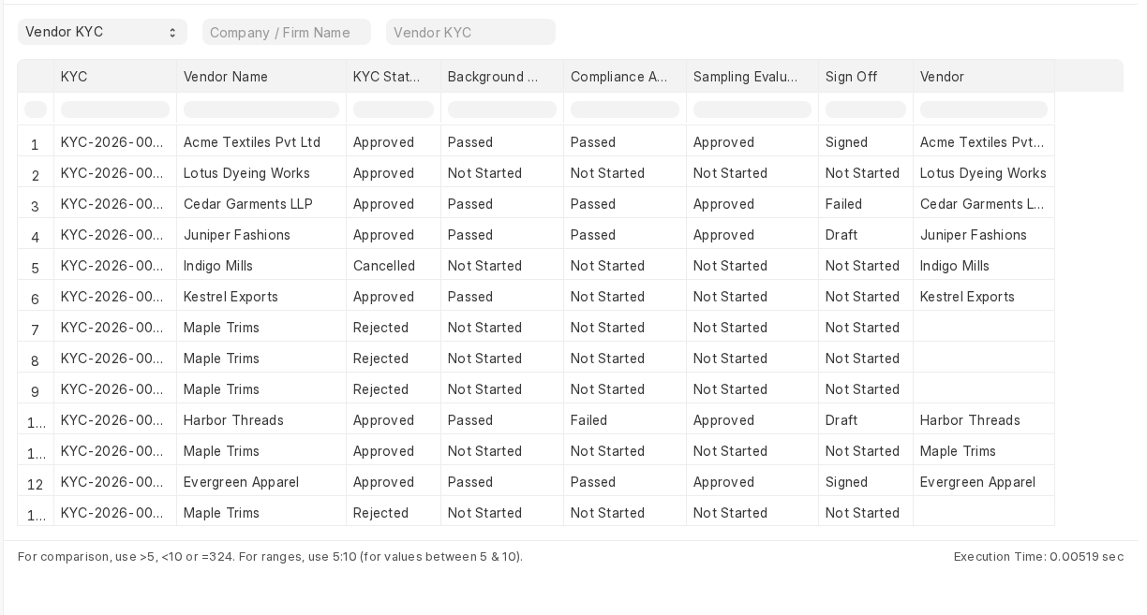
Figure 17: The Vendor Onboarding Pipeline report, viewed by Vendor KYC

7. Email Notifications
When Use Emails is enabled, the app automatically sends emails using editable, pre-built templates available in the Email Template list.
- Onboarding: Acknowledges vendor requests and notifies the internal team of new requests.
- Verification: Notifies vendors of Background Check, Compliance Audit, and Sampling Evaluation results, including failure reasons.
- Sign-off: Sends contract and Code of Conduct documents for signature, with automatic reminders.
- Satisfaction Surveys: Notifies vendors when surveys are created and sends reminders for overdue responses.
- Deboarding: Sends notifications for request creation, approval, rejection, task assignments, and overdue tasks.
- Clearance Certificates: Requests signatures and sends follow-up reminders.
- Email Matching Issues: Notifies the team and record creator when replies cannot be matched automatically, requiring manual document attachment.
- Renewals: Sends reminders for upcoming Compliance Audit or Sign-off Renewals and unfinished renewal drafts.
- Attachment Failures: Notifies the record creator when a signed file cannot be saved, so it can be attached manually.

8. Vendor-Facing Pages
Vendors access a secure, limited portal requiring a login; no public access is available.
- Satisfaction Surveys: Vendors can view their assigned surveys and update ratings, Areas of Concern, and Suggestions for Improvement while a survey is in draft.
Access is restricted to their own vendor records. Vendors cannot view other vendors’ surveys or internal records such as KYC and Background Checks

9. Frequently Asked Questions
Q: What happens if a vendor fails their Background Check?
A: The vendor's Supplier record is automatically disabled, preventing it from being used in new Purchase Orders. If email notifications are enabled, the vendor receives an email explaining the outcome. If there is a valid business reason to proceed, a Vendor Lifecycle Manager can use Force Override, providing a written reason.
Q: Can a stage be skipped?
A: Yes. A stage can be skipped if it is not marked as mandatory in Settings. Background Check, Compliance Audit, and Sampling Evaluation each have their own mandatory setting. Sampling Evaluation can also be made mandatory only for specific Business Types.
Q: What if a vendor doesn't respond to a Sign-off or Clearance Certificate email?
A: The system automatically sends a follow-up reminder after a period of no response. Staff can also contact the vendor directly and manually attach the signed document to the relevant record.
Q: How do I deboard a vendor?
A: Raise a Vendor Deboarding Request explaining the reason for deboarding and obtain approval. Then complete the Vendor Deboarding Checklist created for that request. Before submitting the checklist, collect the signed clearance certificate or record why it is unavailable. Submitting the checklist disables the vendor.
Q: Can a deboarded vendor be reinstated?
A: Yes. Raise a Vendor Reboarding Request (Section 4.10). The system reruns the checks marked as mandatory for reboarding in Settings, followed by Sign-off. Once the required stages are successfully completed, the vendor's existing Supplier record is reactivated.
Q: What if the vendor forwards the Sign-off or Clearance Certificate email instead of replying directly, or attaches multiple files?
A: Automatic document matching works only when the vendor sends a direct reply with a single attachment. If the email is forwarded or contains multiple attachments, the system notifies your team and the record's creator by email so the document can be attached manually. No information is lost; only the automatic attachment process is unavailable in these cases.
Q: Why can't I start the next stage?
A: This usually happens because an earlier stage has failed. Cancel the failed record or use Force Override before proceeding. The app displays a message identifying the stage that needs to be resolved.
You also cannot add an earlier stage once a later stage already exists. For more details, see The Vendor Journey in Section 3.
Q: Why can't I cancel this stage?
A: A later stage already exists. Cancel the later stage first, or delete it if it is still a draft. Once the later stage has been removed, you can cancel the earlier stage.
Q: A Sign-off failed. How do we try again?
A: Click Retry Sign-off on the failed record to initiate another attempt. You do not need to cancel the failed record; it remains in the system as part of the vendor's history.
Q: How do I temporarily re-enable a deboarded vendor?
A: A Vendor Lifecycle Manager or System Manager can click Temporarily Enable Supplier on the submitted Deboarding Checklist or the Supplier form.
The Supplier remains enabled for the number of days configured in Settings under Temporary Enable Days. Once that period expires, the system automatically disables the Supplier during its overnight process. You can also disable the Supplier earlier using Disable Supplier.
Q: Why is PAN or Tax ID mandatory—or not mandatory—on a KYC?
A: The requirement depends on two Settings options:
- Require PAN Card (India): Controls whether a PAN Card is mandatory for vendors in India. This is enabled by default.
- Require Tax ID (Outside India): Controls whether a Tax ID is mandatory for vendors outside India. This is disabled by default.
Even when these fields are optional, any value entered must still pass the applicable format validation.

