

本科生毕业设计（论文）

外文科技文献译文

译文题目 | 低质量 QR 码的图像增强及快速识别
(外文题目) | Image enhancement and fast recognition of low-quality QR codes
学 院 | 电子信息工程学院
专 业 | 通信工程
学 号 | 1656038
学生姓名 | 斯提凡
日 期 | 2020年 3月 28日

- Graduation Project - Topic Background, including Literature Review
In some areas, QR (Quick Response) codes have replaced classic barcodes. Mobile phones use QR codes to support many services, such as transportation, marketing, advertising, games, social networking, payment methods, receipt management, and more. The QR code is used by Gravity Forms (GF) because a typical barcode can only hold up to 20 digits, while a QR code can hold up to 7,089 characters, providing strong diversity and scalability, which makes the use of QR codes more attractive than barcodes. Statistically speaking, QR codes can encode the same amount of data in about one-tenth of the space of traditional barcodes. An important feature of the QR code is that it does not need to be scanned from a specific angle to recognize it. This is because the corner of the QR code scanner contains three specific square symbols and alignment blocks.
QR codes were originally used by car manufacturers to track parts, and after a while, the company began to see various applications for QR codes. Today, the most popular commercial use of QR codes is in the telecommunications industry. With the continuous development of smartphones, especially in the field of mobile Internet access, the popularity of smartphones has greatly promoted the popularity of QR codes, making them a fast and effective tool for users to communicate URLs. This also allows offline media (such as magazines, newspapers, business cards, public transport, logos, T-shirts or any other media that can accept QR code printing) to become a vehicle for online product advertising.
The ability to scan quickly is another feature of QR codes. Let us take a look at how a QR code response is usually used to embed a message: we first embed the information into the QR code, and then no matter how we want to read the information, there is no need to make a server request. This means that if you visit the website by scanning the QR code, the step of scanning the QR code does not need to wait for the server to respond, so the website can be opened quickly.
The QR code consists of black squares arranged in a square grid on a white background, which can be read by an imaging device (such as a camera) and processed using Reed-Solomon error correction until the image can be interpreted correctly. The required data is then extracted from the patterns present in the horizontal and vertical components of the image.

- Graduation Design (Thesis) Scheme Introduction - Main Contents
- Convolutional Neural Network Model (Tensorflow)
A Convolutional Neural Network (CNN) is a special kind of linear operation. It is a simple neural network that uses convolutions in at least one of its layers instead of general matrix multiplication.
The components of CNN are an input layer, an output layer, and multiple hidden layers. The hidden layer of CNN usually consists of a series of convolutional layers convolved with multiplication or other dot products. The activation function is usually the RELU layer, followed by other convolutions, such as the pooling layer, the fully connected layer and the normalization layer, called the hidden layer, because their inputs and outputs are masked by the activation function and the final convolution.
The convolutional layer is the core component of CNN. The parameters of a layer consist of a set of learnable filters (or kernels) that have a small receiving field but extend to the entire depth of the input volume. During the forward pass, each filter convolves on the width and height of the input volume, calculates the dot product between the filter entry and the input, and generates a two-dimensional activation map of the filter. As a result, the network learns the filters that are activated when certain spatial types of features are detected in the input.
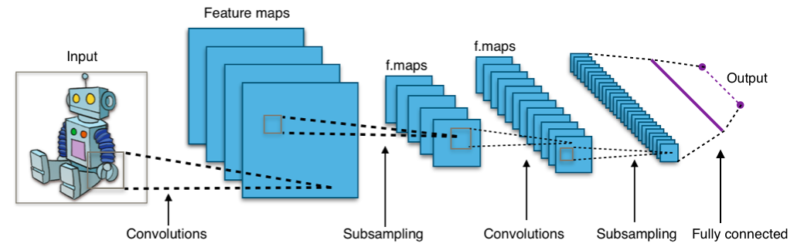
Figure 1.1 Typical CNN Architecture
Stacking the activation maps of all filters along the depth dimension results in the full output of the convolutional layer. Therefore, each entry in the output can also be interpreted as the output of a neuron, which looks at a small area of the input and shares parameters with neurons in the same activation graph.

Using the structure of an auto-encoder, the TensorFlow toolkit can be used to train self-generated images. It takes an image with poor resolution and quality as an input and outputs a clear, noise-free image of the same QR code. The output of the CNN can then be used to decode the data of the QR code by any preferred decoding algorithm.
- Dynamic Control Flow for CNN
TensorFlow supports advanced machine learning algorithms that contain conditional and iterative control flow. Recurrent neural network (RNN) such as LSTM (long short-term memory) can generate predictions from sequential data. Google’s Neural Machine Translation system uses TensorFlow to train a deep LSTM that achieves state-of-the-art performance on many translation tasks. The core of an RNN is a recurrence relation, where the output for sequence elements is a function of a state that accumulates across the sequence. In this case, dynamic control flow enables iteration over sequences that have variable lengths, without unrolling the computation to the length of the longest sequence. TensorFlow uses deferred execution via the dataflow graph to offload larger chunks of work to accelerators. Therefore, to implement RNNs and other advanced algorithms, we add conditional (if statement) and iterative (while loop) programming constructs in the dataflow graph itself. We use these primitives to build higher-order constructs, such as map(), fold(), and scan(). For this purpose, we borrow the Switch and Merge primitives from classic dynamic dataflow architectures. Switch is a demultiplexer: it takes a data input and a control input, and uses the control input to select which of its two outputs should produce a value. The Switch output not taken receives a special dead value, which propagates recursively through the rest of the graph until it reaches a Merge operation. Merge is a multiplexer: it forwards at most one non-dead input to its output or produces a dead output if both of its inputs are dead. The conditional operator uses Switch to execute one of two branches based on the runtime value of a boolean tensor, and Merge to combine the outputs of the branches. The while loop is more complicated, and uses Enter, Exit, and Next Iteration operators to ensure that the loop is well-formed.
- Visualizing Dataflow Graphs of Deep-Learning Models in TensorFlow
TensorBoard is Tensorflow’s dashboard tool, which allows users to visualize their TensorFlow models, plot quantitative metrics about their execution, and show additional data like images that pass through the models. The TensorFlow Graph Visualizer is included as the Graph View in TensorBoard. Besides the Graph Visualizer, TensorBoard provides other views for inspecting scalar, histogram, images, and audio data. To log data in the models, users can add summary operations that take the operation they desire to log as inputs. To visualize the graphs, users can include dataflow information for the GraphVisualizer in the log data. Users can also optionally include the addition almeta data about runtime statistics including total memory usage, total compute time, and tensor shapes.
- The Scalars dashboard shows how the loss and metrics change with every epoch. You can also use it to track training speed, learning rate, and other scalar values.
- The Graph’s dashboard helps you visualize your model. In this case, the Keras graph of layers is shown which can help you ensure it is built correctly.
- The Distributions and Histograms dashboards show the distribution of a Tensor over time. This can be useful to visualize weights and biases and verify that they are changing in an expected way.
- Raspberry Pi 3 B+
In the "Design and Implementation of a Scanner Connected to Reader.py" document, users can log in to the browser through a PC or mobile phone to directly view the real-time video surveillance of the terminal camera. The terminal includes a Raspberry PiB board, a DHT11 sensor module that can acquire temperature and humidity, a human body infrared sensing module, a flame sensor module, and a camera module for photographing and video monitoring. It obtains accurate data through transmission with a check code. In "Research on Key Technologies of Wireless Video Surveillance System Based on Raspberry Pi", the reader.py development board is used to connect the hardware platform of a video surveillance system consisting of a USB camera and a USB wireless network card, and a Reader.py development platform which is established wirelessly via a WiFi network socket communication between PCs. In "Design of Elevator Color Screen Display System Based on Reader.py", considering the beauty of LCD screen graphical interface controls and free and open source continuous upgrades etc., the QTE / Qt5 graphic development platform was chosen to display the current elevator operation. Status and basic data, such as atmospheric temperature, date and time. In the "Smart Planting Monitoring System Based on Internet of Things Technology", the system collects plant growth factors such as soil, air temperature and humidity, light and carbon dioxide content through sensing devices, and sends the data to Reader.py for storage and processing in real-time and then combines the corresponding software. By connecting Reader.py to the Internet under WiFi to achieve data and database storage links, finally, according to user needs, you can log in to a server in the Internet environment to achieve real-time remote monitoring of data and viewing of historical data recording.
The above application of Reader.py is based on the functions required by sensors to collect data information, and can verify, monitor, beautify and store data. It is evaluated in different simulations to obtain a success rate of approximately + 100%. Low-quality QR code images (two-dimensional codes) are correctly decoded. Reader.py is a small and powerful computer, its rich interface has advantages in using it to process and display external information. This question attempts to use these features to make community outdoor service equipment. Environmental monitoring is just one of them. More intelligent services can be extended.
In addition, field experiments have shown that it helps increase the decoding success rate of QR codes by about +100% when utilizing low-resolution, cheap camera sensors. Raspberry Pi 3B+, but powerful board will be running in Linux and support TensorFlow and others Machine-Learning Frameworks.

- Image Pre-Processing Algorithm of QR Code

A lot of algorithms may be used for image binarization. Binarization is the base of QR code decoding and directly influences the fast recognition rate of QR codes. However, it keeps the balance between real-time and effect of the aim to implement dynamic iterator methods, use two-dimensional histogram static for inputting grey scale image data, and obtain the optimal threshold value. Then, this threshold value can be used to implement the binarization processing for image of the QR code. T(i) as a new separator threshold value, V 1 (i) as the mean gray value of pixels where gray values are less than T(i), and V 2 (i) as the mean gray value of pixels where gray values are more than T(i), its iteration processing includes the following steps:
• T(0)=128;
• T(i+1)=[V 1 [T(i)+V 2 [T(i)]]/2;
• Return prior step. If T(i+1)=[V 1 [T(i+1)+V 2 [T(i+1)]]/2, then exit this iterations processing, where T(i) is the calculated optimal threshold value for binarissation.

- Expected Results
As mentioned above, the aim of this research is to construct a fast system to enhance the quality of QR code images to improve the decoding success rate, hence decreasing the time required to read the data contained in 2D bar codes. The system is a Convolutional Neural Network (CNN) with the structure of an auto-encoder, trained with a TensorFlow toolkit on self-generated images. The input is an image with a poor resolution and quality and the output is a clear, noiseless picture of the same QR code. The output of the CNN can then be used to decode the QR code’s data with any preferred decoding algorithm. However, for the final result of our Convolutional Neural Network the system will be deployed on the Raspberry Pi 3B+ and evaluated in different simulations obtaining an increase of about +100% success rate of correct decoding of low-quality QR cCode images. decoding of low-quality QR Code images.
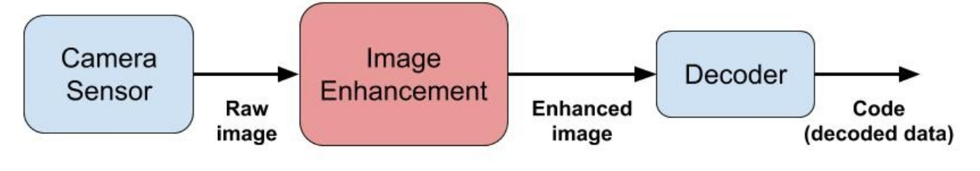
Figure 2.2 Framework of the overall decoding system. focused on the central blockimage enhancement
The system structure is presented in Figure 2.2 The main advantage of such an approach is that it does not influence the decoder’s algorithm, allowing everyone to enhance their already-existing decoding system regardless the approach or application they used. In addition, the image enhancement mechanism is also independent of the standard of the QR codes.
- Image De-Blur and Enhacement
The purpose of the image enhancement system is to take a low-quality image, process it to obtain a more readable image and finally input it in the decoder. The low quality of the image could be the result of different reasonscauses:
- Low image resolution. [2.2]
- Not ideal light conditions.
- Distortion.
- Noise [2.3]
- Motion blur, as approached in [3].
The system should be flexible enough to work under all these circumstances, without focusing on a single source. In addition, the system should run on real time, i.e. should not be time costly. This requirement is important because image processing algorithms can require much time if not designed otherwise. The input and output of the system are presented in Figure 3.
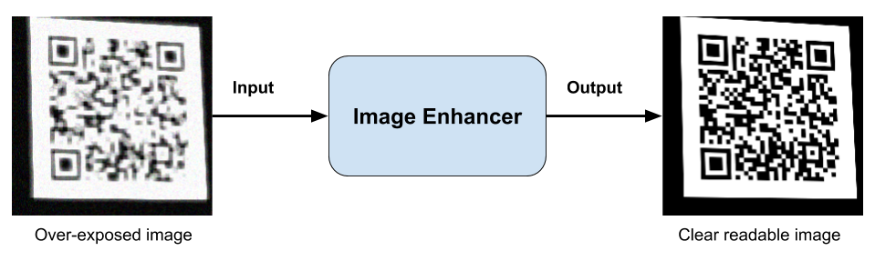
Figure 3.3 Enhancer Input-Output

