DO Portal — USIF Bug Test Observations (QAT)
Environment: QAT — https://testportaludc.aurionpro.com/
Dealer: Armstrong Prestige Wellington
User: DEEPAK.PARAMANICK
Run date: 19 August 2026
Duration: 32.4 minutes
Overall: 2 passed, 3 failed (exit code 1 — expected for open bug repro tests)

Executive Summary
Five automated USIF defect regression tests were executed on QAT DO Portal with one worker and manual MFA. Three tests failed as expected (bug still reproducible). USIF-421 passed via test.fail while the defect remains open. USIF-420 passed — manual verification recommended as the left-nav shift may be fixed on QAT.
Ticket | Result | Verdict | Duration
USIF-405 | Failed | Bug reproduced | 8.8 min
USIF-420 | Passed | No repro on QAT (review) | 16.2 s
USIF-421 | Passed (test.fail) | Bug still open (masked) | 4.9 min
USIF-425 | Failed | Bug reproduced | 9.3 min
USIF-431 | Failed | Bug reproduced | 7.6 min

USIF-405 — Decimal amount field deletion / caret at decimal (Home Ownership)
Jira: https://aurionprofintechsolutions.atlassian.net/browse/USIF-405
Test file: tests/do-portal/doSanityTest/jira tickets/USIF-405-decimalAmountDeletion.test.ts
Result: Failed
Verdict: Bug reproduced
Duration: 8.8 min
Error / assertion: USIF-405: backspace at decimal changed integer (9999999999 → 999999999)
Observation: After entering Home Ownership amount 9999999999.99, backspace at the decimal position changed the integer from 9999999999 to 999999999 instead of removing only a fractional digit. UI showed $999,999,999.90 after failure. Confirms USIF-405 Issue 1.
Screenshot:
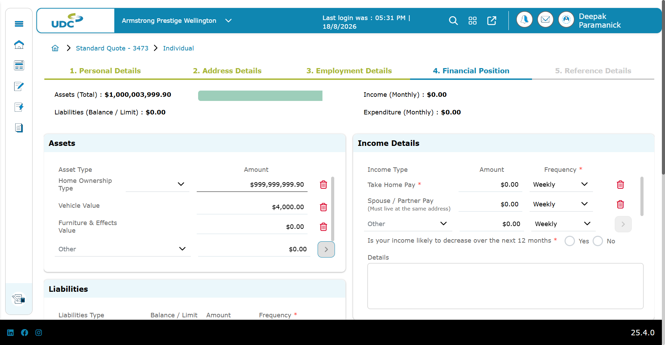

USIF-420 — Left nav shifts when browser zoom 100% → 80%
Jira: https://aurionprofintechsolutions.atlassian.net/browse/USIF-420
Test file: tests/do-portal/doSanityTest/jira tickets/USIF-420-leftNavBrowserZoom.test.ts
Result: Passed
Verdict: No repro on QAT (review)
Duration: 16.2 s
Observation: Left icon navigation X position drift and overlap with app-dashboard were within tolerance when zoom changed 100% → 80% via CDP. Test passed on QAT — defect may be fixed in this environment or assertion thresholds may need review.
Screenshot:
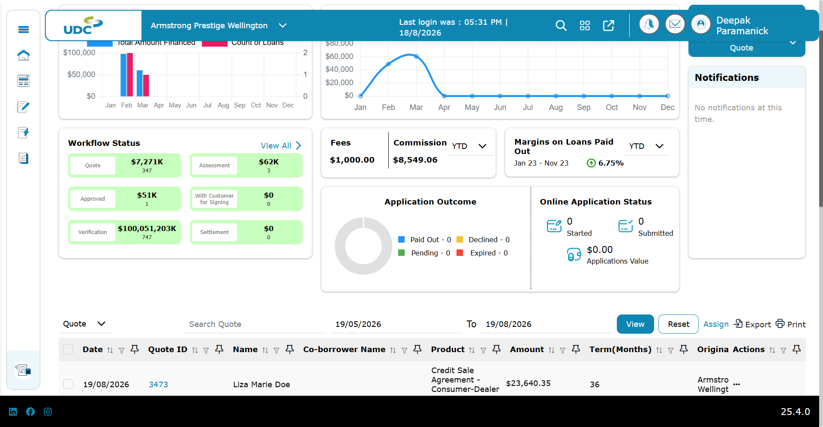

USIF-421 — Trade Amount not populating Asset Value on Add Trade
Jira: https://aurionprofintechsolutions.atlassian.net/browse/USIF-421
Test file: tests/do-portal/doSanityTest/jira tickets/USIF-421-tradeAmountAssetValue.test.ts
Result: Passed (test.fail)
Verdict: Bug still open (masked)
Duration: 4.9 min
Error / assertion: Internal assertion failed — masked by test.fail
Observation: Test uses test.fail(USIF_421_OPEN=true). Assertion failed internally (Asset Value not auto-populated from Trade Amount $5,000) but runner reports pass. Remove test.fail when USIF-421 is fixed.
Screenshot:
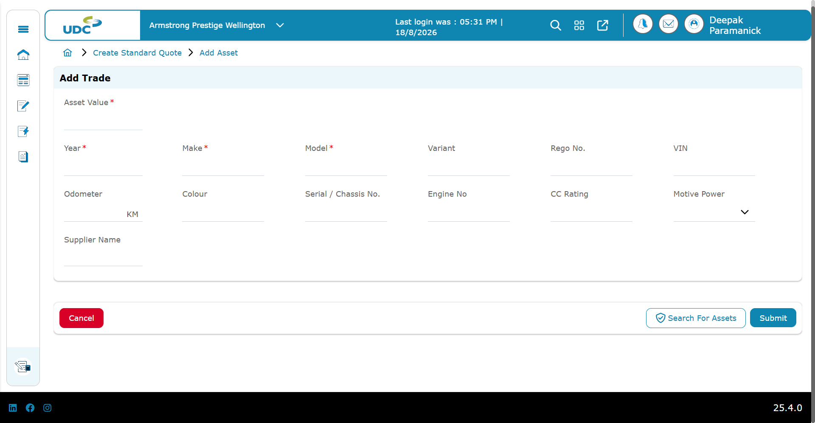

USIF-425 — Copy Primary Borrower Address corrupts Street Type (Road → Broadway)
Jira: https://aurionprofintechsolutions.atlassian.net/browse/USIF-425
Test file: tests/do-portal/doSanityTest/jira tickets/USIF-425-copyPrimaryBorrowerStreetType.test.ts
Result: Failed
Verdict: Bug reproduced
Duration: 9.3 min
Error / assertion: Expected postal Street Type /^Road$/i — received "Broadway"
Observation: Primary borrower physical and postal addresses set to Street Type Road (manual Zephyr/Wellington). After co-borrower Copy primary borrower = Yes, physical Street Type remained Road but postal Street Type became Broadway. Confirms USIF-425.
Screenshot:
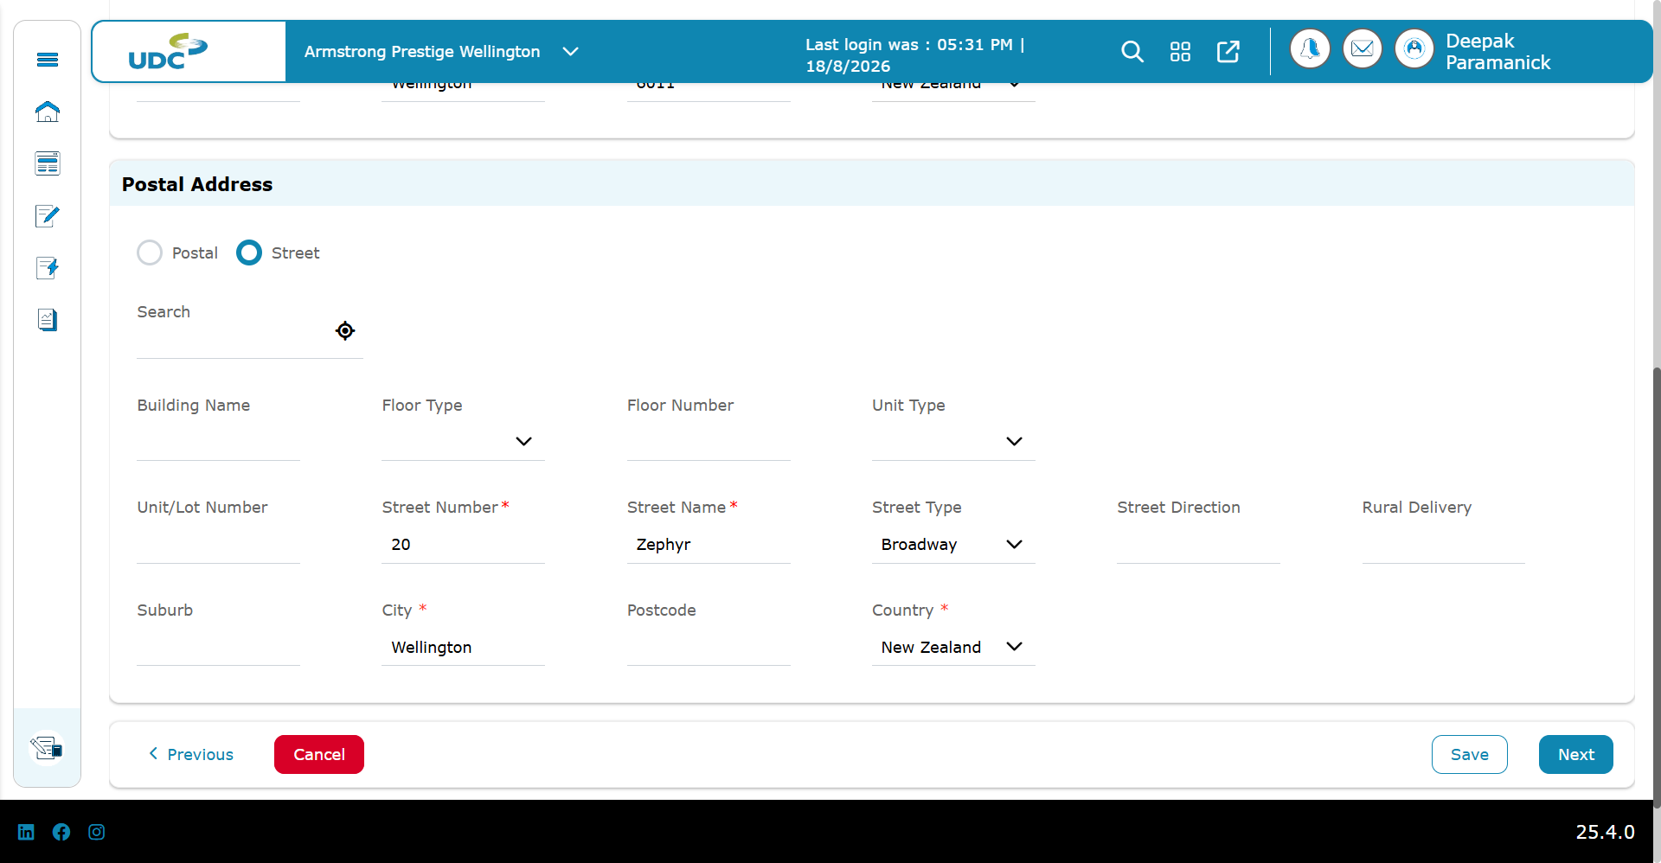

USIF-431 — Time at Employment mandatory for Retired / Beneficiary / Unemployed / Unknown
Jira: https://aurionprofintechsolutions.atlassian.net/browse/USIF-431
Test file: tests/do-portal/doSanityTest/jira tickets/USIF-431-timeAtEmployment.test.ts
Result: Failed
Verdict: Bug reproduced
Duration: 7.6 min
Error / assertion: getByText(/Time with Employe[e]?r is required/i) — element not found
Observation: For Retired / Beneficiary / Unemployed / Unknown occupations, employer name was optional but Save did not show mandatory validation for Time with Employer. Message 'Time with Employer is required' was not visible. Confirms USIF-431.
Screenshot:
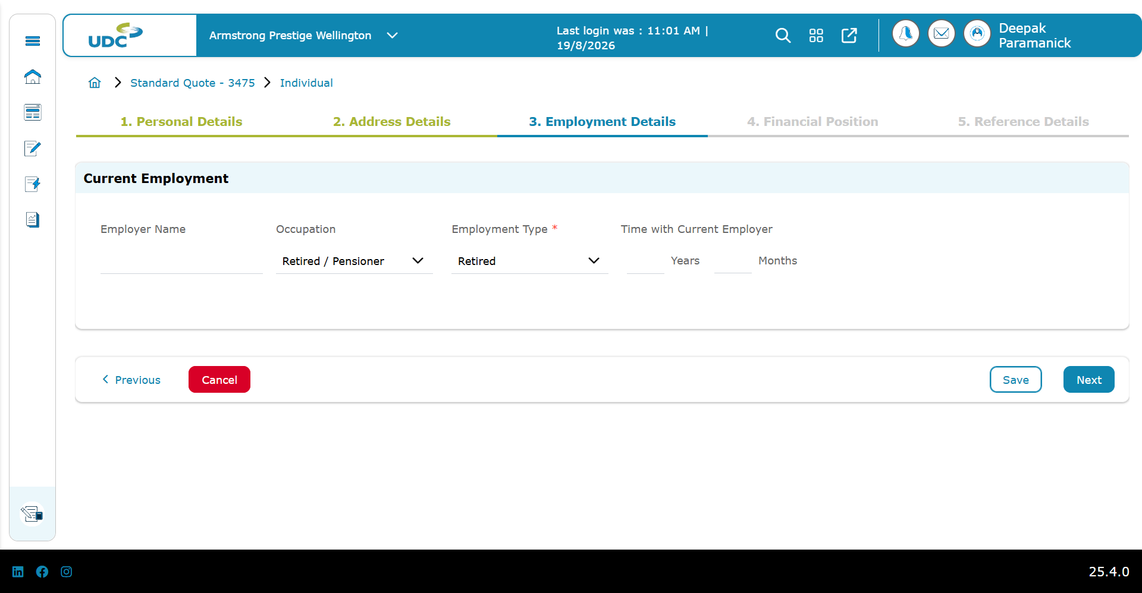

Interpretation Guide
• Failed on USIF-405, 425, 431 = defect still reproducible; automation is working as designed.
• Passed on USIF-421 = defect still open but masked by test.fail — remove flag when fixed.
• Passed on USIF-420 = no repro on QAT; confirm manually or tighten assertions if bug persists elsewhere.
• When a Jira is resolved, the corresponding test should pass without test.fail.

Expected in jira ticket:

Summary

<one line: what breaks + who is affected>

Where dealer goes (portal / entry)

Portal: do | rss | css

Start: <URL or menu path to first screen>

Preconditions

<env, user/role, test data or "create new …">

Steps to reproduce

1. …

2. …

Screenshot / reference

<image, video, or link>

Acceptance criteria

- … (each line = something visible/assertable in UI)

