CASA0011_CW2 Submission

- Student Number: 24054679
- Word Count: 1052

1. Partial ODD Description
1.1 Purpose and patterns
Purpose
This model shows how sheepdogs chase sheep and drive them to the fence by modelling reality behaviours and divide them to different status like collecting, driving, flanking, balancing, and final push affect(Jadhav et al., 2024), explicitly encoding agent-agent interactions among sheep (separate distribution, weak cohesion, feeble alignment) (Couzin, 2009) and agent dog interactions (avoidance pressure plus strategy-dependent positioning) (Strömbom et al., 2014). By integrating both backgrounds, the model serves as a predictive tool to answer:
How do alternative dog strategies and the number of dogs change herding efficiency and the flock’s crowd behaviours?
Sub-questions include: (1) the effect on group indicators while switching strategies, (2) how group metrics respond to dog pressure while changing parameter, and (3) what gains multi-dog coordination offers relative to a single dog.
Pattern
Flocks tend to disperse at the absence of dogs, but sheep would gather when sheepdogs start to collect. Afterwards, the sheepdogs switch to Z-shaped lateral sweeping driving to push sheep to the pen while performing occasional wing corrections brief flanking manoeuvres that realign the flock when the left- or right-wing drifts. That is why flocks will be driven to the pen at last under the pressure of dogs. This pattern cause consistently rise cohesion, decrease elongation, and increases polarization during coordinated motion and collapses to zero after penning when movement ceases. Correspondingly, the PDFs of speed and polarization shift from mid-range activity during driving to a sharp mass near zero by the end.
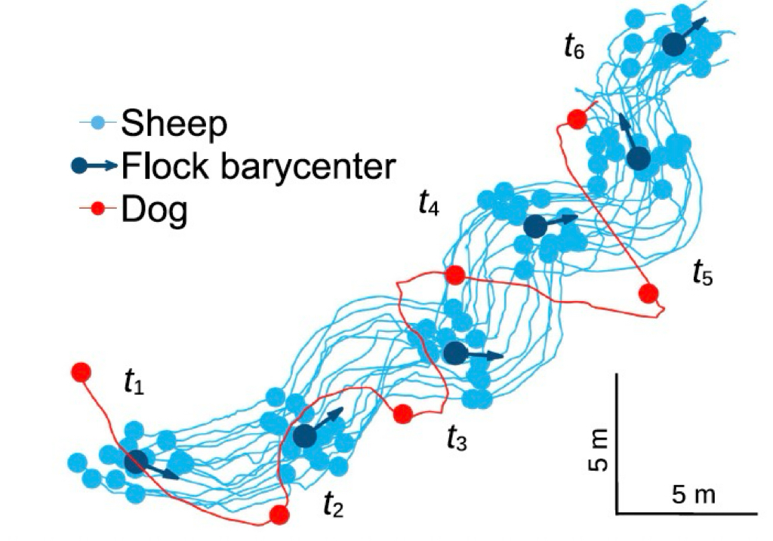
Figure 1 Sheepdog pushing movement
1.2 Entities, state variables, and scales
Sheep (N agents)
Table 1 Sheep agent parameters
State Variable | NetLogo Name | Class | Description | Range / Unit
Velocity x | vx | Float | The x-component of the current speed of the sheep | ℝ (patch/tick)
Velocity y | vy | Float | The y-component of the current speed of the sheep | ℝ (patch/tick)
Speed (limit) | sheep-speed | Float | Speed limit for cutting off movement | ≥0 (patch/tick)
Instant speed | sqrt(vx^2+vy^2) | Derived | Instant speed size (calculated by vx,vy) | ≥0 (patch/tick)
In pen? | in-pen? | Boolean | True if this patch lies inside a pen (based on Toroidal distance) | $$\{true,false\}$$
Local neighborhood | other sheep in-radius r | Derived | List of local neighborhood sheep (temporarily calculated by radius) | List

Dogs (M agents)
Table 2 Dogs agent parameters
State Variable | NetLogo Name | Class | Description | Range / Unit
Mode | mode | Enum | Current sheepdogs’ strategy period | {collecting, driving, fixing, flanking, balancing, final-push, patrolling}
Target sheep | target-sheep | Agent ref | Target single sheep (used for single sheep chasing/organizing) | a-sheep / none
Dog speed (base) | dog-speed | Float | Movement speed of sheepdog (based on basic speed regulation) | ≥0 (patch/tick)
Velocity x/y | vx, vy | Float | The current speed component of the dog used for smooth movement | ℝ (patch/tick)
Patrol angle | patrol-angle | Float | The polar corner of the circle patrol | [0,360) (deg)
Target position | target-x, target-y | Float | The next target coordinates of the planning | ℝ (patch)
Identity | dog-id | Int | The individual dog's number (behavioral de-synchronization) | ℤ≥0
Phase offset | phase-offset | Float | The phase shift of the zigzag/swing | ℝ (deg)
Assigned sector | assigned-sector | Float | Initial sector Angle (used for multi-dog distribution) | [0,360) (deg)
Sweep state | zigzag-phase,zigzag-direction,sweep-width,sweep-step | Mix | Internal state machine Variable for Z-shaped sweeping | —
Response wait | waiting-for-response,last-move-time,response-check-start | Mix | The timing control of "waiting for the response of the flock after advancing" | —

Environment
Table 3 Environment parameters
State Variable | NetLogo Name | Class | Description | Range (Unit)
World topology | — | Categorical | Toroidal (wrap-around) world; edges connect so agents crossing a boundary re-enter from the opposite side | $$\{torus\}$$
Pen center | goal-location | Patch ref | Patch handle at the center of the circular pen (destination) | Patch
Pen radius | goal-radius | Float | Radius of the pen (patch units) adaptively set from flock size | ≥ 0 (patch)
Torus width/height | torus-world-width/height | Int | Effective width and height of the toroidal world used for shortest-path (“torus”) distance calculations | ℤ ≥ 1 (patch)
Sheep cohesion radius | sheep-cohesion-radius | Float | Perception radius for weak sheep–sheep attraction (cohesion) | ≥ 0 (patch)
Sheep–dog perception radius | sheep-dog-perception-radius | Float | Perception radius within which sheep respond to dogs (avoidance/pressure) | ≥ 0 (patch)
Driving distance | driving-distance | Float | Threshold on centroid–to–pen distance; when exceeded, dogs enter the driving phase | ≥ 0 (patch)
Collection threshold | collection-threshold | Float | Radius used to flag scattered individuals/small clusters relative to the outside-flock centroid | ≥ 0 (patch)
Forces (weights) | alignment-strength, separation-strength, cohesion-strength, avoidance-strength | Float | Non-negative gains that scale the corresponding behavioral rules (alignment, separation, cohesion, avoidance) | ≥ 0 (dimensionless)
Group metrics | current-polarization, current-elongation, current-cohesion, barycentre-speed | Float | Instantaneous flock indicators: alignment (0–1), shape stretching (≥0), compactness (1/mean distance; ≥0), and centroid speed (≥0). | ℝ
Interactions
There is main three interactions on the whole. Firstly, Sheep-sheep mode is mainly separated in the tranquil situation, while supplemented by slight condensation and weak alignment when being drove; Sheep-dogs interaction avoids the canine distance within the perceived radius, and then sheepdogs’ pressure and push promotes the clustering and turning; As for dog-dog mode, sheepdogs perform in a light alignment, especially in driving and final-push mode, which always act in different sectors and maintains minimum spacing. If necessary, dog-dog mode conducts temporary leader-player division to avoid conflicts.
Scale
Space world-size is represented as a discrete grid of 22$×$22 patches. Time advances in discrete ticks, each tick treated as one single decision. As for baseline, it runs start with N=100 sheep and M=3 sheepdogs (can shift number by changing slides), and this model records the completion time via task-completion-time (tick when the last sheep enters the pen).
1.3 Process overview and scheduling
'Go' scheduling sequence
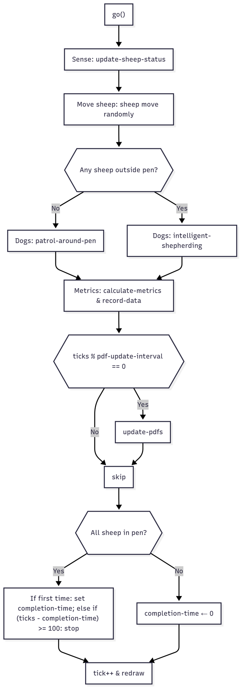
Figure 2 ‘Go’ flow chart
(1) Sense: recalculate the neighbourhood and identify whether the flocks are in the circle.
(2) Sheep update: the dominant movement is sheep moves outward in the case of dog avoidance, then they have move requirements on short distance separation, weak cohesion, small random term and a speed cap; sheep in the pen gradually settle.
(3) Sheepdog decision & movement: the finite state controller triggers collection → driving (Z-shaped lateral sweep, brief wing correction) → flank → balance, and the last few people make the final push; The conversion depends on dispersion, diffusion, and distance to the pen.
(4) Metrics Calculate & record: plots indicators (polarization, elongation, cohesion, barycentre speed) and show the finish ticks when the last sheep get into the pen.

1.4 Initialisation
The center point (pen) is placed at (0,0), the radius of the centre is strongly correlated with the initial number of sheep with r =$\sqrt{1.2N/π }$, clipped to [3,12]. The flock (N) was uniformly placed outside the fence ($>$ 5 patches), with $≥$2.5 from neighbors. Dog (M) at the beginning with a ring (r+8), sector-spaced. Load default parameters, fix the random seed, and reset the tick.

1.5 Input Data
No external input data is used in this model.

1.6 Submodels
Sheep
Use lightweight Boids like separate/align/condense and speed limit at casual time. However, as long as the dog enters the sensing radius $r_{d}$, sheep’ behaviour will be affected by adding the avoidance term $η(x_{i}-x_{d})/d$, and the overall velocity is updated as $v_{i}←clip(v_{i}+αf_{sep}+βf_{align}+γf_{coh}+ηf_{dog})$, which helps the flocks’ movement move as a whole under pressure with no congestion but jointly.
Dogs
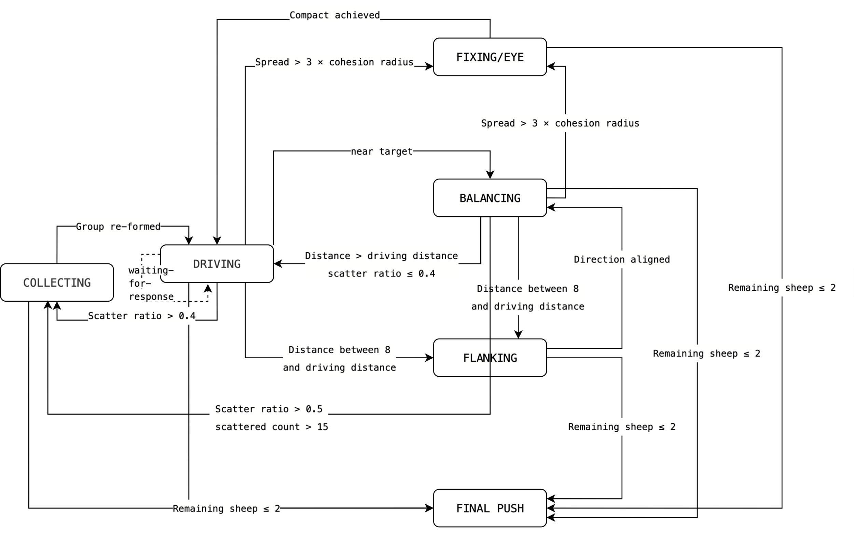
Figure 3 Dog model flow chart
The distance of torus $d(c,g)$, and the distribution proportion $ρ=\frac{n_{scattered}}{n_{out}}, n_{outside}=\left|\left\{i∈Sheep:not in-pen\right\}\right|, n_{scattered}=|\{i∈Sheep:not in-pen, d\left(i,c\right)>T_{col}\}|$ and the diffusion degree ($c=\frac{1}{n}\sum_{i}{x_{i}}, spread=\max_{i}{d_{T}(x_{i},c)}$) are three main factors to decide sheepdogs’ mode. If the distance is far but not highly disperse ($d>D_{drive},ρ≤0.4$), sheepdogs will start driving mode to z zigzag swing to push as well as have so called group reaction based on Sector Angle $cos∠\left(∆c,g-c\right)>θ$, and the flocks will be adjusted if there’s something wrong in the process ($8<d<D_{drive}$) , but they are going to collect if sheep spread in a degree of dispersed $(ρ>0.5, n_{scat}>15)$. While sheep spread too scattered $(spread>3*$sheep-cohesion-radius$)$, sheepdogs then start to Fixing/Eye to compact the flocks together. At last, when sheep close to the pen, the sheepdogs will schedule balancing to lightly adjust and tend to Final-push if only less than 3 sheep left.
Metrics
Table 4 quantitive analysis indicators overview
Name | Equation | Description
Polarization | 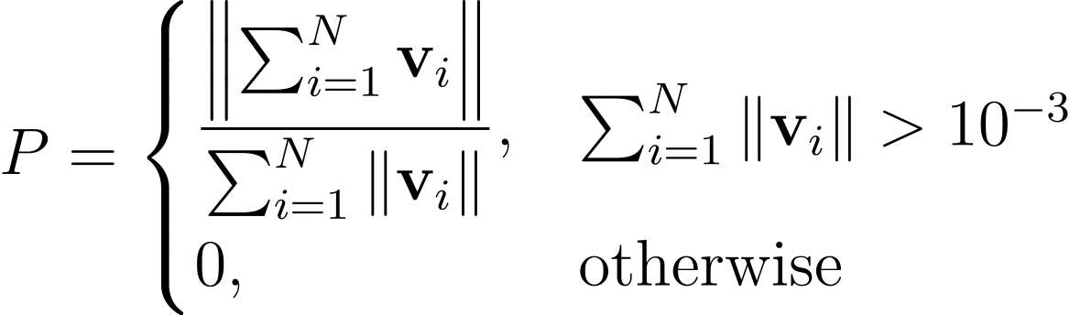 | Degree of directional alignment
Cohesion | 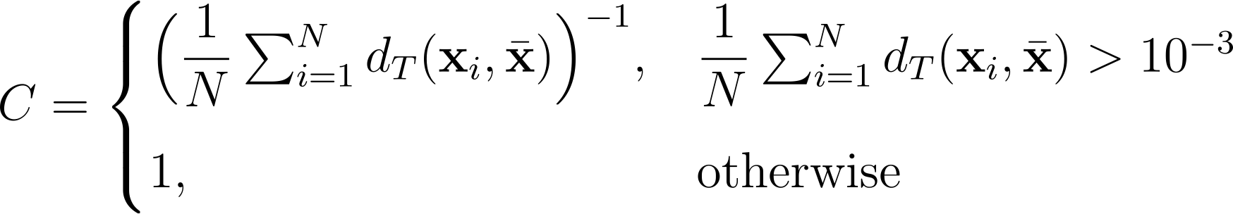 | Compactness of the flock
Elongation | 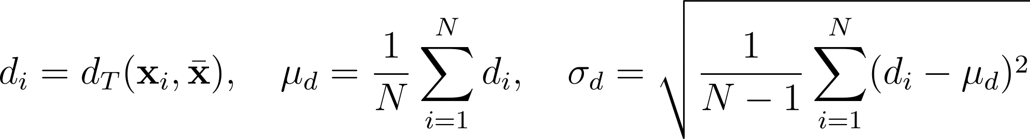 | Shape anisotropy measured as the coefficient of variation of distances to the barycentre (σᵈ/μᵈ)
 | 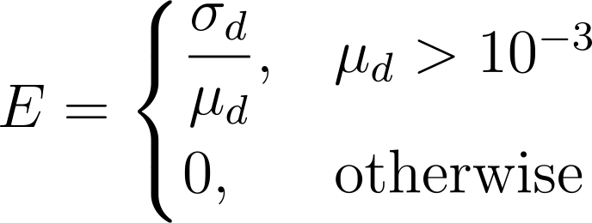 | Barycentre speed
Speed | 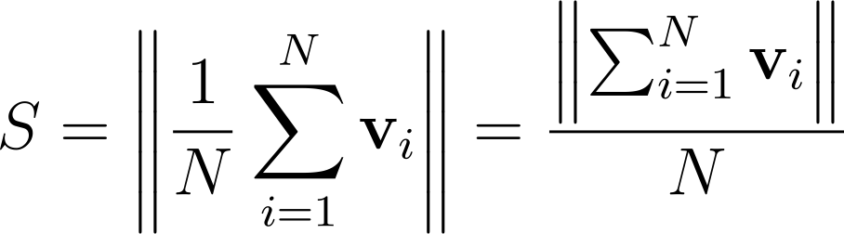
2. Situation of Model Within the Literature
The basic principles of the model is using Boids three rules Superimposed "dog repellency" as a local rule, which means the group spontaneously close up and get into the pen by formation and batch, embodying the emergence from individual to the whole (Reynolds, 1987). And the interaction only happens in the infinite sensing radius with eye field which means exists occlusion, picturing sheep-sheep, sheep-dog and dog-dog three functions following the sensing structure of Rejection/Orientation/Attraction (Couzin et al., 2002). The sheepdogs aim at the shortest completing time based on the switching adaptively among group of pitch, diffusion and discrete percentage in COLLECTING/ DRIVING/ FLANKING/ FIXING/FINAL and FINAL-PUSH (Nabeel et al., 2023) and have different strategies for only one sheepdog or multiple sheepdogs(Lien et al., 2005). For the purpose of avoiding occasional phenomenon, the initial position, phase disturbance and slight random walk provide noise to test robustness in different random seeds(Aldana et al., 2007). The indexes like elongation/polarization/barycentre speed and completeness ticks to demonstrate the group situation and changes which being recorded and pictured for replicating experiment (Ballerini et al., 2008).
Compare to former related literatures, the novelty of the model lies in its five stages mode rather than common “collect/push” two stages model (Nabeel et al., 2023) with recordable quantitative index(Strömbom et al., 2014) and replicate test by using clear shift logic(Van Havermaet et al., 2024).

Bibliography
ALDANA, M., DOSSETTI, V., HUEPE, C., KENKRE, V. & LARRALDE, H. 2007. Phase transitions in systems of self-propelled agents and related network models. Physical review letters, 98, 095702.
BALLERINI, M., CABIBBO, N., CANDELIER, R., CAVAGNA, A., CISBANI, E., GIARDINA, I., ORLANDI, A., PARISI, G., PROCACCINI, A. & VIALE, M. 2008. Empirical investigation of starling flocks: a benchmark study in collective animal behaviour. Animal behaviour, 76, 201-215.
COUZIN, I. D. 2009. Collective cognition in animal groups. Trends in cognitive sciences, 13, 36-43.
COUZIN, I. D., KRAUSE, J., JAMES, R., RUXTON, G. D. & FRANKS, N. R. 2002. Collective memory and spatial sorting in animal groups. Journal of theoretical biology, 218, 1-11.
JADHAV, V., PASQUA, R., ZANON, C., ROY, M., TREDAN, G., BON, R., GUTTAL, V. & THERAULAZ, G. 2024. Collective responses of flocking sheep (Ovis aries) to a herding dog (border collie). Communications Biology, 7, 1543.
LIEN, J.-M., RODRIGUEZ, S., MALRIC, J. & AMATO, N. M. Shepherding behaviors with multiple shepherds. Proceedings of the 2005 IEEE international conference on robotics and automation, 2005. IEEE, 3402-3407.
NABEEL, A., JADHAV, V., RAJ, D., SIRE, C., THERAULAZ, G., ESCOBEDO, R., IYER, S. K. & GUTTAL, V. 2023. Data-driven discovery of stochastic dynamical equations of collective motion. Physical Biology, 20, 056003.
REYNOLDS, C. W. Flocks, herds and schools: A distributed behavioral model. Proceedings of the 14th annual conference on Computer graphics and interactive techniques, 1987. 25-34.
STRÖMBOM, D., MANN, R. P., WILSON, A. M., HAILES, S., MORTON, A. J., SUMPTER, D. J. & KING, A. J. 2014. Solving the shepherding problem: heuristics for herding autonomous, interacting agents. Journal of the royal society interface, 11, 20140719.
VAN HAVERMAET, S., KHALUF, Y. & SIMOENS, P. 2024. Reactive shepherding along a dynamic path. Scientific Reports, 14, 14915.

