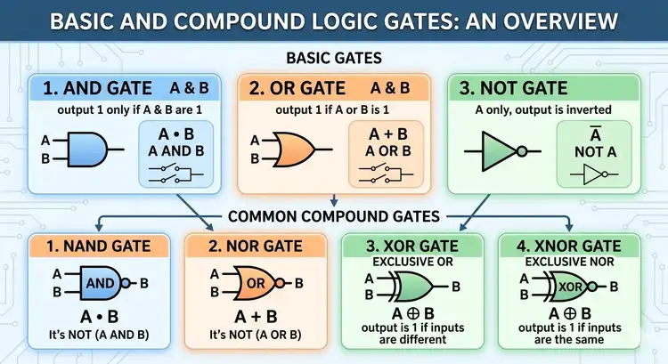
图片 1：基本门和常用复合门的关系
提示词：
A nanobanana-style cheerful educational infographic, designed as a construction workshop, explaining the relational build between Basic Logic Gates and Common Compound Gates. The title is "基本门和常用复合门的关系" (The Relational Build of Basic and Compound Gates). On the left, a row of basic gates: AND, OR, NOT (with symbols, names, and personified icons). In the center, a building area shows step-by-step constructions. E.g., for NAND, it shows an AND gate followed immediately by a NOT gate, connected with an arrow and a "build" icon, leading to the final NAND symbol. Similar step-by-step constructions are shown for NOR (OR + NOT), and stylized internal gate configurations (using AND, OR, NOT) for XOR and XNOR, alongside their external symbols. Clear connections, glowing energy paths, and small miniature characters help with the build. The whole image has decorative, swirling nanobanana borders.
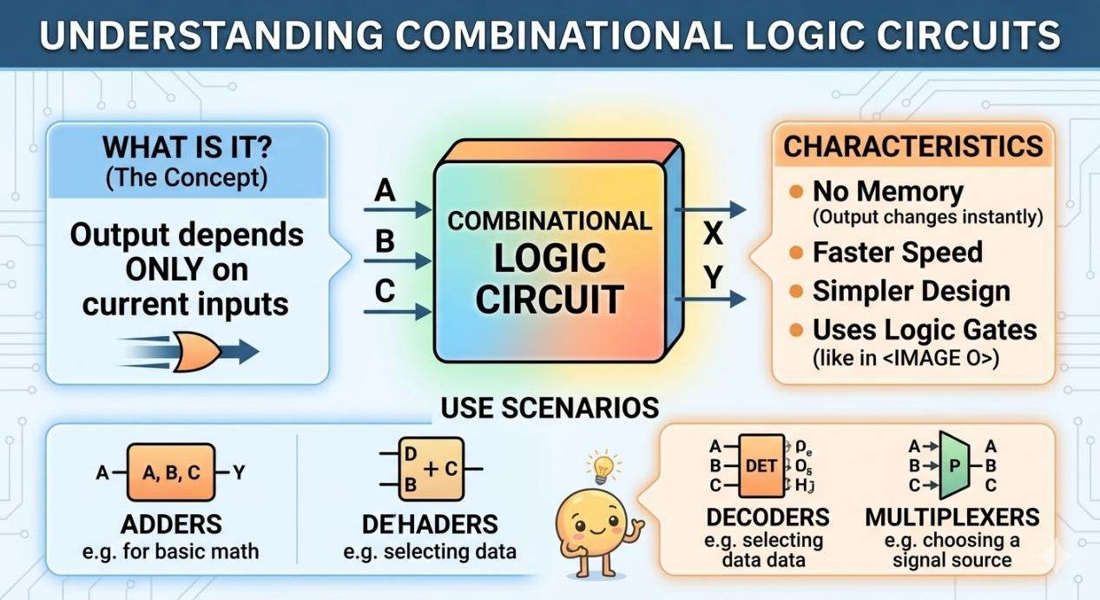
图片 2：什么是组合逻辑电路
提示词：
A nanobanana-style illustrated diagram explaining Combinational Logic as a purely feed-forward system. The title reads "什么是组合逻辑电路?" (What is Combinational Logic Circuit?). The main illustration shows a clear flow: multiple inputs (labeled arrows A, B, C) enter a block, which has a static internal thought-bubble showing only basic gates (AND, OR, NOT from Image 1) directly connected. A single output (OUT) comes immediately from the other side. Large text callout: "输出仅取决于当前输入" (Output only depends on current input). Below the main block, illustrations and icons with text list common applications: "ALU" (Arithmetic Logic Unit), "加法器 (A+B=C)" (Adder), "编码器" (Encoder). There are no memory elements or feedback loops present, emphasizing a linear flow. Tiny figures operate the switches and observe the immediate lights.
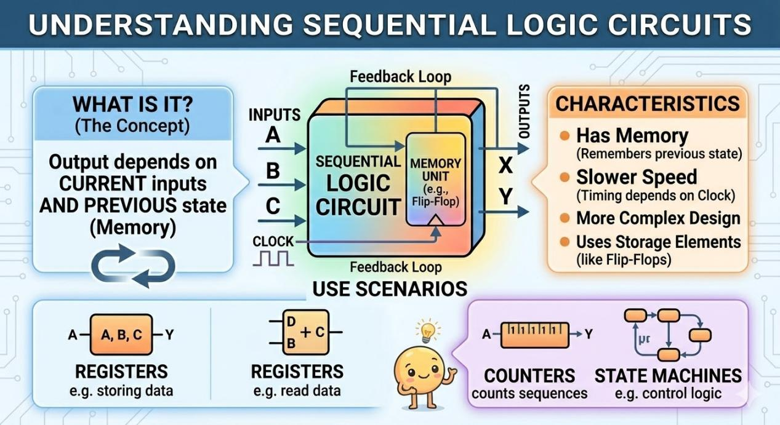
图片 3：什么是时序逻辑电路
提示词：
A nanobanana-style illustrated educational diagram explaining Sequential Logic with an integrated internal structure. The title reads "什么是时序逻辑电路?" (What is Sequential Logic Circuit?). The main diagram shows a block with inputs, but inside, it is split into two connected parts: a logic gate network and a distinct, labeled "记忆元件" (Memory Element), explicitly built from cross-coupled gates (like an SR flip-flop from basic gates). A prominent circular feedback path is shown, looping from the final output (OUT) back into the gate network input. A cheerful ticking clock signal icon (CLK) feeds into the memory element. Large text callout: "输出取决于当前输入 和 过去的状态" (Output depends on current input AND past state). Below, icons and text list applications: "计数器 (0-1-2-3...)" (Counter), "寄存器" (Register), "状态机" (State Machine). Small characters interact with the memory ball and the clock, highlighting the cyclical and stored nature.

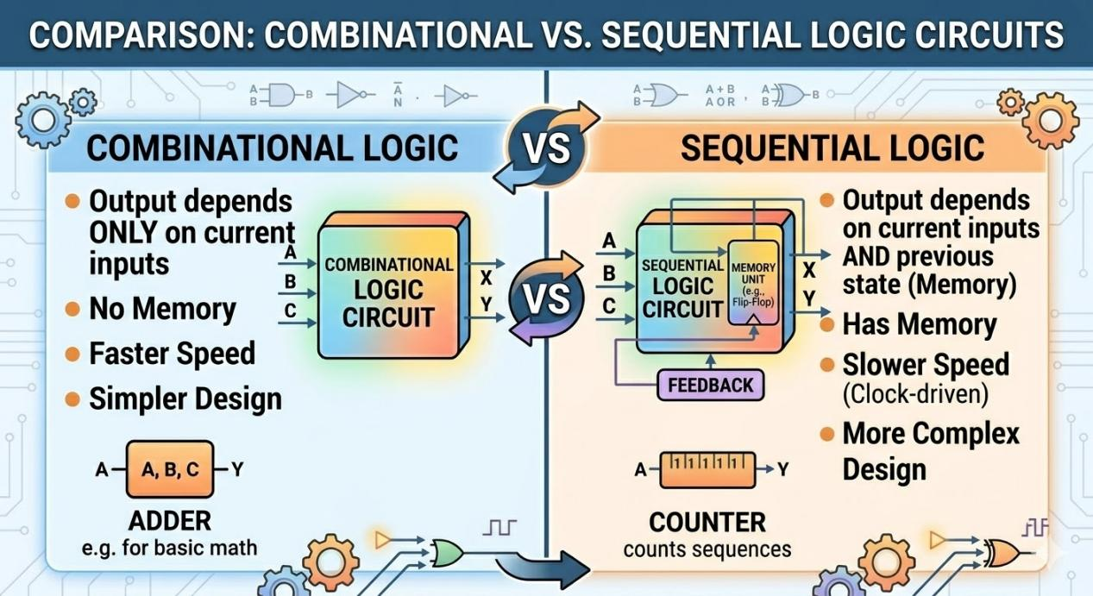
图片 4：对比组合逻辑电路和时序逻辑电路
提示词：
A detailed educational nanobanana-style comparison infographic table between Combinational and Sequential Logic, presented in a friendly and precise layout. The title is "对比组合逻辑电路和时序逻辑电路" (Structural Comparison). A clean, cheerful two-column table with a header row. Column 1: "组合逻辑电路 (Combinational Logic)". Column 2: "时序逻辑电路 (Sequential Logic)". Row titles with clear icons and text compare them across: 1. 记忆元件 (Memory Elements) (None vs. Has Brain/Storage Box), 2. 反馈回路 (Feedback Loops) (Straight Feed vs. Circular Loop), 3. 时钟控制 (Clock Control) (Not controlled vs. Controlled by Clock), 4. 内部结构 (Internal Structure) (Direct gate network vs. Gate Network + Memory + Feedback), 5. 示例 (Scenarios) (ALU/Adder vs. Counter/CPU/Register). The visual styles and icons are consistent with Image 2 and Image 3, integrated for recognition. The entire image has swirling nanobanana decorative borders.

