面向视觉-语言攻击的对抗性演化三角及其迁移能力优化
摘要
Vision-language pre-training (VLP) models excel at interpreting both images and text but remain vulnerable to multimodal adversarial examples (AEs). Advancing the generation of transferable AEs, which succeed across unseen models, is key to developing more robust and practical VLP models. Previous approaches augment image-text pairs to enhance diversity within the adversarial example generation process, aiming to improve transferability by expanding the contrast space of image-text features.
视觉语言预训练 （VLP） 模型擅长解释图像和文本，但仍容易受到多模态对抗示例 （AE） 的影响。推进可迁移性 AE 的生成，这些 AE 在未见模型中取得成功，是开发更稳健和更实用的 VLP 模型的关键。以往的方法会对图文对进行数据增强，从而在生成对抗样本的过程中提升多样性。其目标是通过扩展图文特征的对比空间，来增强对抗样本的迁移能力
However, these methods focus solely on diversity around the current AEs, yielding limited gains in transferability. To address this issue, we propose to increase the diversity of AEs by leveraging the intersection regions along the adversarial trajectory during optimization. Specifically, we propose sampling from adversarial evolution triangles composed of clean, historical, and current adversarial examples to enhance adversarial diversity. We provide a theoretical analysis to demonstrate the effectiveness of the proposed adversarial evolution triangle.
然而，这些方法仅关注当前 AE 的多样性，这导致它们在提升迁移能力方面的效果有限。为了解决这个问题，我们提出可以在优化过程中利用实现对抗路径上的交叉区域来增加 AE 的多样性。具体来说，我们建议从由干净的、历史生成过的和当前的对抗性示例组成的对抗性演化三角进行采样，以增强对抗性多样性。我们提供了一个理论分析来证明所提出的对抗进化三角形的有效性。
Moreover, we find that redundant inactive dimensions can dominate similarity calculations, distorting feature matching and making AEs modeldependent with reduced transferability.
此外，我们发现冗余的无效维度可能主导相似度计算，从而扭曲特征匹配，并使AE变得依赖于模型，并导致其迁移能力降低。

Hence, we propose to generate AEs in the semantic image-text feature contrast space, which can project the original feature space into a semantic corpus subspace. The proposed semantic-aligned subspace can reduce the image feature redundancy, thereby improving adversarial transferability. Extensive experiments across different datasets and models demonstrate that the proposed method can effectively improve adversarial transferability and outperform state-of-the-art adversarial attack methods.
因此，我们提出在语义图文特征对比空间中生成AE，该空间能够将原始特征空间映射到一个语义语料库的子空间。所提出的语义对齐子空间可以减少图像特征冗余，从而提高对抗性迁移能力。跨不同数据集和模型的大量实验表明，这种方法能够有效提高对抗性迁移能力，并优于最先进的对抗攻击方法。
The code is released at https://github.com/jiaxiaojunQAQ/SA-AET.
该代码于 https://github.com/jiaxiaojunQAQ/SA-AET 发布
一、简介
VISION-language pre-training (VLP) models achieve excellent performance across various downstream Visionand-Language tasks, such as visual entailment [51], visual grounding [32], image captioning [25], and image-text retrieval [30]. However, they have been found to be vulnerable to adversarial examples [66; 42; 21; 22; 9; 43; 16]. Exploring adversarial vulnerabilities can inspire additional research dedicated to developing more robust and applicable VLP models.
视觉语言预训练（Vision-Language Pre-training, VLP）模型在多种下游视觉-语言任务中展现出卓越性能，例如视觉蕴含（visual entailment）[51]、视觉定位（visual grounding）[32]、图像描述生成（image captioning）[25]以及图文检索（image-text retrieval）[30]。然而，已有研究表明，这类模型仍然易受对抗样本（adversarial examples）的攻击 [66, 42, 21, 22, 9, 43, 16]。对 VLP 模型的对抗脆弱性展开系统研究，有助于推动更稳健、可应用的 VLP 模型的发展。

Previous works mainly concentrate on exploring generating adversarial examples for VLP models in a white-box setting, in which the attacker can access model internal information, such as model parameters, etc. Some studies [18] have shown that adversarial examples generated on a victim model can successfully attack unseen target models, a phenomenon known as adversarial transferability.
之前的工作主要集中在探索在白盒环境下为 VLP 模型生成对抗性示例，攻击者可以在其中访问模型内部信息，例如模型参数等。一些研究[18]表明，在受害模型上生成的对抗性示例可以成功攻击未见的目标模型，这种现象被称为对抗迁移性。
Given the limited access to detailed model structures in real-world scenarios, it is crucial to investigate the transferability of multimodal adversarial examples [70; 72]. A series of works focus on generating adversarial examples with high transferability for VLP models. For example, Lu et al. [42] propose to improve adversarial transferability for VLP models by introducing input diversity through data augmentation.
鉴于在现实场景中对详细模型结构的访问权限有限，研究多模态对抗示例的迁移能力至关重要[70;72]。一系列工作侧重于为 VLP 模型生成具有高可迁移性的对抗性示例。例如，Lu等[42]提出通过数据增强引入输入多样性来提高VLP模型的对抗性迁移能力。
Although previous works have achieved some effectiveness in boosting adversarial transferability in vision-language attacks, they mainly focus on maximizing the contrastive loss function in the image-text feature space to generate adversarial examples and increasing their diversity along the optimization path to improve adversarial transferability. While these methods predominantly enhance diversity in online adversarial examples, they still have a lot of room for improvement in improving adversarial transferability.
尽管先前的工作在增强视觉语言攻击中的对抗性迁移能力方面取得了一定的效果，但其主要思路仍集中于在图文特征空间中最大化对比损失函数以生成AE，并通过在优化路径上增加样本多样性来提升迁移能力。然而，这些方法在本质上主要增强了在线生成对抗样本的多样性，在进一步提升对抗性迁移能力方面仍有较大改进空间。

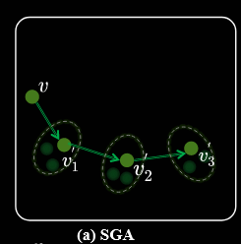
Specifically, as shown in Figure 1, during each optimization iteration of the attack, previous works [42; 22] perform data augmentation on the generated adversarial examples (i.e., online adversarial image) to improve transferability. This adversarial strategy increases the variety of adversarial examples throughout the optimization pathway,consequently yielding improvements in their transferability. Nonetheless, the strategy still risks overfitting the victim model due to the heavy reliance on examples from the adversarial trajectory, which results in reduced attack success rates when the adversarial examples are transferred to other VLP models.
具体而言，如图 1 所示，在攻击的每次优化迭代中，已有研究 [42; 22] 会对生成的对抗样本（即在线对抗图像）进行数据增强，以提升其迁移能力。该策略通过在整个优化路径中增加对抗样本的多样性，从而在一定程度上改善了迁移效果。然而，由于过度依赖对抗轨迹上的样本，该方法仍存在对受害模型过拟合的风险，导致在将对抗样本迁移至其他 VLP 模型时，攻击成功率显著下降。
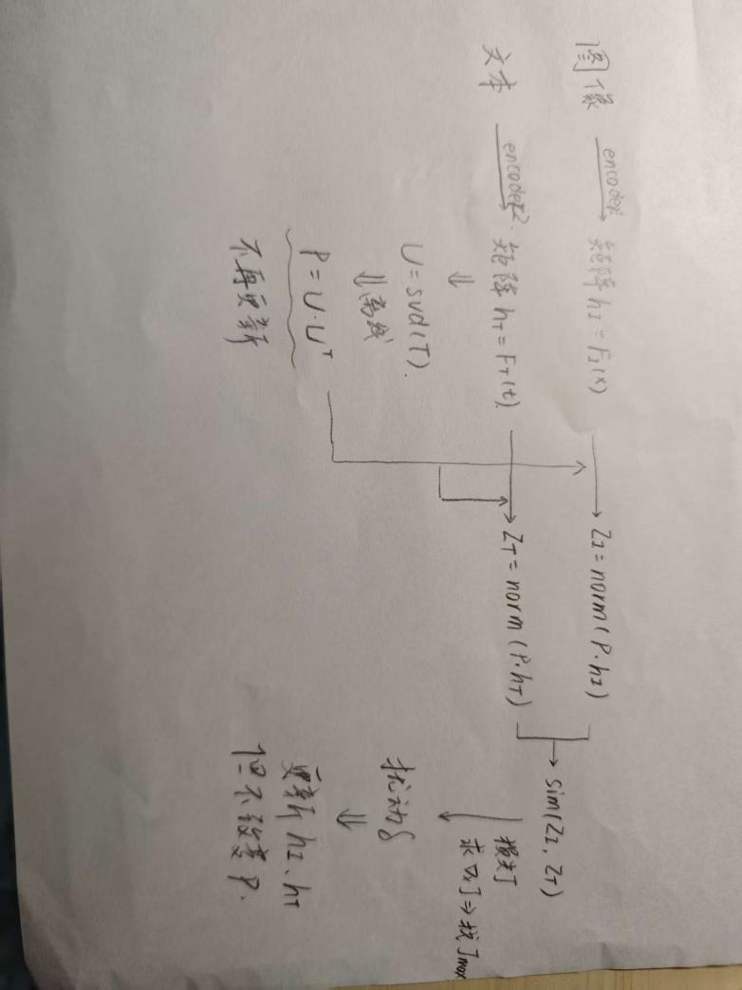

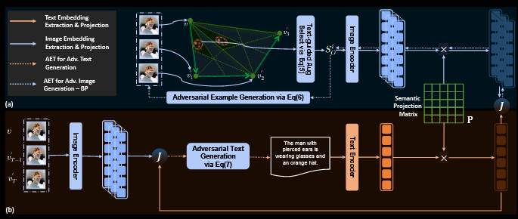
To address these issues, as shown in Figure 2 (a) and (b), we first propose adopting the intersection evolution triangles along the adversarial trajectory to enhance the diversity of adversarial examples during optimization. Specifically, in each attack iteration, we propose constructing an adversarial evolution triangle that incorporates the original image, the adversarial image from the previous step, and the current adversarial image.
为了解决这些问题，如图 2（a）和（b）所示，我们首先提出在对抗轨迹上采用交集演化三角形，以提高优化过程中对抗样本的多样性。具体而言，我们提出在每次攻击迭代中构建一个对抗演化三角形，该三角形包含原始图像、前一步生成的对抗图像以及当前的对抗图像。
Then, we propose to circumvent overfitting by strategic sampling within this evolution triangle, thereby avoiding excessive focus on adversarial example diversity only around adversarial images. We explore the impact of different adversarial evolution sub-triangle sampling on adversarial transferability and propose to sample from the adversarial evolution sub-triangle close to clean examples and previous adversarial examples. After obtaining the sampling samples, we generate the adversarial perturbations on the samples to stay away from the text.
随后，我们提出通过在这一演化三角形内进行策略性采样来规避过拟合，从而避免仅仅围绕对抗图像多样化进行过度聚焦。我们进一步探索不同对抗演化子三角形采样对对抗转移性的影响，并提出优先从靠近原始图像和之前的对抗图像的子三角形中进行采样。采样得到样本后，我们在这些样本上生成对抗扰动，使其尽可能远离文本。

Subsequently, we apply these perturbations to current adversarial examples and select the one that diverges most significantly from the text. We also propose generating adversarial text that deviates from the previous adversarial evolution triangle along the optimization path rather than being distant from the last adversarial image example. We provide a theoretical analysis to illustrate the effectiveness of the proposed adversarial evolution triangle.
接下来，我们将这些扰动应用到当前的对抗样本中，并选择那些与文本最大程度偏离的扰动作为最优样本。我们还提出生成对抗性文本，它不仅沿着优化路径从之前生成过的对抗图像偏离，更是与上一轮对抗性演化三角偏离。此外，我们还提供了理论分析，以说明所提出的对抗演化三角形的有效性。
In addition, image feature embeddings usually contain much information irrelevant to text features [39; 71; 26]. In the original image-text contrast space, only a limited number of feature dimensions in the image features may be activated, while the remaining dimensions remain inactive and redundant. These redundant dimensions may dominate the similarity calculation, potentially distorting the feature matching of images and texts. This feature distortion makes the generated adversarial examples highly dependent on the victim model, reducing their transferability.Hence, generating adversarial examples within the native image-text feature contrast space increases the likelihood of overfitting the victim model, diminishing the examples’ transferability. To overcome this limitation, we propose generating adversarial examples within the semantic image-text feature contrast space, which maps the original feature space into a semantic corpus subspace.
此外，图像特征嵌入通常包含大量与文本特征无关的信息【39; 71; 26】。在原始的图像-文本对比空间中，只有有限数量的图像特征维度可能被激活，而其余的维度则无效且冗余。这些冗余的维度可能主导相似度计算，导致图像和文本特征匹配的扭曲。这种特征扭曲使得生成的对抗样本过拟合于受害模型，降低了其迁移能力。因此，在原始的图像-文本特征对比空间内生成对抗样本会增加过拟合源模型的可能性，从而降低样本的迁移能力。为了解决这一问题，我们提出在语义图文特征对比空间内生成对抗样本，该空间将原始特征空间映射到一个语义子空间。

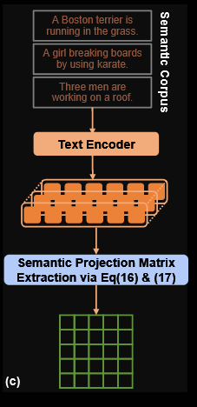
Specifically, as shown in Figure 2 (c), we construct a semantic subspace through a series of independent text descriptions and project the image features of the original space into the semantic subspace. Then, we maximize the contrast loss between images and text in the semantic subspace to generate adversarial perturbations.
具体来说，如图2（c）所示，我们通过一系列独立的文本描述构建一个语义子空间，并将原始空间的图像特征投影到语义子空间中。然后，我们最大化语义子空间中图像和文本之间的对比度损失，以产生对抗性扰动。
By assembling the proposed methods, we conduct our vision-language attack by exploiting semantically aligned adversarial evolution triangle, i.e., SA-AET. We conduct a series of experiments to evaluate the effectiveness of the proposed method on the two widely used multimodal datasets, consisting of Flickr30K [47] and MSCOCO [41].
综合上述组件，我们提出用于视觉—语言攻击的语义对齐对抗演化三角（SA-AET）。我们在两个广泛使用的多模态基准数据集 Flickr30K [47] 与 MSCOCO [41] 上开展了一系列实验，以验证其有效性。

The evaluation experiments are also conducted on three vision-and-language downstream tasks, which include image-text retrieval (ITR), visual grounding (VG), and image captioning (IC). The experimental results indicate that the proposed method can significantly improve the transferability of multimodal adversarial examples, surpassing the state-of-the-art adversarial attack methods. Furthermore, when adversarial examples generated from ITR by the proposed method are applied to other vision-andlanguage downstream tasks, attack performance is significantly enhanced.
我们还在三项视觉-语言下游任务上进行评测，包括图文检索（ITR）、视觉定位（VG）和图像描述（IC）。实验结果表明，SA-AET 能显著提升多模态对抗样本的迁移能力，优于当前最先进的对抗攻击方法。此外，由 SA-AET 在 ITR 任务上生成的对抗样本在迁移到其他下游任务时（如 VG、IC）同样表现出显著的攻击性能提升。

Our main contributions are in five aspects:
• We propose enhancing the diversity of adversarial ex amples during optimization by leveraging the intersection evolution triangle of adversarial trajectories, thereby improving the transferability of multimodal adversarial examples against VLP models. Furthermore, we provide a theoretical analysis to support the proposed adversarial evolution triangle.
• We investigate how sampling from different adversarial evolution sub-triangles affects adversarial transferability and propose sampling from the evolution sub-triangle that is close to clean examples and previous adversarial examples.
• We propose to generate the adversarial text by deviating from the final adversarial evolution triangle along the optimization trajectory rather than the final adversarial example, minimizing overfitting on the surrogate model to improve its transferability.
• To further enhance the transferability of adversarial examples, we propose generating them in the semantic imagetext feature contrast space by mapping the original feature space onto a subspace defined by a semantic corpus.
• Our extensive experiments across various network architectures and datasets demonstrate that the proposed method significantly enhances the transferability of multimodal adversarial examples and outperforms state-of the-art multimodal transfer adversarial attack methods.
我们的贡献有五个方面：
提出对抗性演化三角：在优化过程中利用对抗轨迹的交汇点提升样本多样性，从而增强对 VLP 模型的迁移能力，并给出相应的理论分析。
系统研究不同演化子三角的采样对迁移能力的影响，提出从更接近干净样本与上一轮对抗样本的子三角中进行采样。
对抗文本的生成不依赖最终对抗样本，而是沿优化路径相对最终演化三角进行偏移，以降低对替代模型的过拟合并提升迁移能力。
在语义图文对比特征空间中生成对抗样本：将原始特征映射到由语义语料定义的子空间，进一步增强迁移能力。
在多种网络架构与数据集上的大规模实验表明：该方法显著提升多模态对抗样本的迁移能力，整体优于现有最先进的多模态迁移攻击方法。

This paper is a journal extension of our conference paper [17] (called DRA). Compared to the preliminary conference version, we have made significant improvements and extensions in this version. The main differences are in four aspects:
- In addition to sampling the intersection evolution triangle of adversarial trajectories proposed in the previous version, we explore the impact of different sampling strategies and propose to sample adversarial evolution triangles close to clean examples and previously generated adversarial examples in Section III-B. This can further improve the transferability of multimodal adversarial examples. We add a theoretical analysis to demonstrate the effectiveness of the proposed adversarial evolution triangle in Section III-D.
- We propose to generate the adversarial examples in the semantic imagetext feature contrast space in Section III-E, which can reduce reliance on victim models, thereby improving transferability.
- We conduct more experiments and analyses, which include comparisons with state-of-the-art methods, ablation studies, and performance analyses. We adopt some state-ofthe-art adversarial attack methods as the new comparison in Section IV-C. We add the ablation study versus the different proposed elements in Section IV-F. We analyze the effective performance of the proposed method in Section IV-G.
- We have thoroughly revised the abstract, introduction, method, experiment, and conclusion sections to offer a more detailed overview of our motivation and approach. Furthermore, we have updated all figures and tables to enhance clarity and presentation.
本文是我们会议论文 [17]（DRA）的期刊扩展版，主要改进体现在四个方面：
(1) 在先前提出的对抗轨迹交汇演化三角采样基础上，系统比较多种采样策略，提出从更接近干净样本与上一轮对抗样本的演化子三角中采样（见 Sec. III-B），并补充对对抗演化三角的理论分析（见 Sec. III-D）。
(2) 在语义图文对比特征空间中生成对抗样本（见 Sec. III-E），以降低对替代（受害）模型的依赖，从而进一步提升可迁移性。
(3) 显著扩展实验与分析：加入更强的 SOTA 基线对比（见 Sec. IV-C）、对各组件的消融实验（见 Sec. IV-F）以及性能分析（见 Sec. IV-G）。
(4) 全面修订摘要、引言、方法、实验与结论，并更新全部图表以提升清晰度与呈现质量。

二、相关工作
In this section, we begin by discussing the existing research on vision-language pre-training models. Subsequently, we explore the studies related to downstream vision and language tasks. Finally, we introduce the research concerning the transferability of multimodal adversarial examples for vision-language pre-training models.
本节首先回顾现有的图文预训练模型研究，接着探讨与下游图像语言任务相关的研究，最后介绍关于图文预训练模型中多模态对抗样本迁移能力的研究。
- 视觉语言预训练模型
Vision-language pre-training (VLP) models enhance various Vision-and-Language (V+L) tasks by using multimodal learning from extensive image-text pairs [33]. Initially, VLP models heavily relied on pre-trained object detectors to generate multimodal representations [8; 37; 68; 56; 52]. However, recent developments have seen a shift towards employing end-to-end image encoders such as the Vision Transformer (ViT) [13; 53; 64], which provide faster inference speeds. Consequently, some recent studies suggest replacing the computationally intensive object detectors with these more efficient image encoders [14; 33; 34; 55; 61]. The learning visionlanguage representations in VLP models can be divided into two categories: the fused architecture and the aligned architecture. Fused VLP models, such as ALBEF [34] and TCL [61], first adopt two separate unimodal encoders to extract features from text and images. These features are combined using a multimodal encoder to create a joint representation. On the other hand, aligned VLP models, like CLIP [48], aim to harmonize the feature spaces of different unimodal encoders, significantly enhancing performance in downstream tasks [1]. In this paper, we focus on assessing our proposed method using various popular fused and aligned VLP models.
VLP模型通过从大量图文对中学习，提升了在各种视觉语言任务中的表现 [33]。早期的 VLP 模型主要依赖于预训练的物体检测器生成多模态表示 [8; 37; 68; 56; 52]，然而，最近的发展趋势是使用端到端的图像编码器，如视觉变换器（ViT） [13; 53; 64]，以提高推理速度。因此，近年来有研究建议用更高效的图像编码器替代计算开销较大的物体检测器 [14; 33; 34; 55; 61]。VLP 模型在学习图文表示时可分为两类：融合架构和对齐架构。融合模型，如 ALBEF [34] 和 TCL [61]，首先使用两个独立的单模态编码器提取文本和图像特征，再通过多模态编码器将这些特征融合形成联合表示。而对齐模型，如 CLIP [48]，则致力于对不同单模态编码器的特征空间进行对齐，显著提升下游任务的性能 [1]。本文主要评估我们提出的方法在流行的融合和对齐 VLP 模型中的表现。

B. 下游视觉和语言任务
The downstream vision-and-language tasks can be divided into three categories: Image-text Retrieval (ITR), Visual Grounding (VG), and Image Captioning (IC).
Image-text Retrieval (ITR): it involves retrieving relevant information, both textual and visual, in response to queries presented in a different modality [7; 10; 59; 69]. Typically, it includes two sub-tasks: image-to-text retrieval and text-to-image retrieval. Specifically, for aligned VLP models, the Text Retrieval (TR) and Image Retrieval (IR) tasks utilize ranking based on the similarity between text and image embeddings. For fused VLP models, similarity scores are computed for all image-text pairs to identify the Top-N candidates since the embedding spaces of unimodal encoders are not aligned. The multimodal encoder then processes these candidates, calculating matching scores to determine the final ranking.
Visual Grounding (VG): Identifying and mapping out specific areas within a visual scene corresponding to entities or concepts described in natural language. For example, in VLP models, ALBEF enhances Grad-CAM [49] by leveraging the resulting attention map to prioritize the detected proposals.
Image Captioning (IC): It involves creating a textual description that accurately reflects or conveys the content of a given visual input, usually through generating captions for images. To evaluate the performance of image captioning models, metrics such as BLEU [45], METEOR [6], ROUGE [40], CIDEr [54] and SPICE [3] are commonly used. These metrics measure the quality and relevance of the generated captions by comparing them to reference captions.
下游视觉-语言任务通常分为三类：图文检索（ITR）、视觉定位（VG）和图像描述（IC）。
ITR：给定一种模态的查询，在另一模态中检索相关项 [7, 10, 59, 69]，包括文-搜-图（IR）与图-搜-文（TR）。对齐型模型直接依据图文嵌入的相似度排序；融合型模型因单模态嵌入空间未对齐，先对所有图文对计算相似度获得 Top-N 候选，再用多模态编码器计算匹配分数进行重排序。
VG：将自然语言短语/句子指代的目标在图像中定位。VLP 系统常利用注意力图（如 Grad-CAM 风格）来提升候选提案的优先级，如 ALBEF 使用该类注意力引导定位 [49]。
IC：为给定图像生成文本描述，常用 BLEU、METEOR、ROUGE、CIDEr、SPICE 等指标评估，与参考描述对比其质量与相关性 [45, 6, 40, 54, 3]。
C. 对抗性迁移能力
Adversarial attack methods [28; 20; 19; 23; 18] can be divided into two categories: white-box attacks [29; 27] and black-box attacks [5; 46]. The white-box attacks indicate that the attacker has full access to the model (e.g., model parameters and architecture), while the black-box attacks cannot. An increasing number of researchers focus on black-box attacks, as they are more practical for real-world applications where model information is often limited. In the context of image classification tasks, data augmentation techniques like TIM [12], ADMIX [57], and PAM [67] are employed to enhance the transferability of adversarial examples. Recent works [42; 22; 11; 15] have begun to explore improving the transferability of multimodal adversarial examples for VLP models. One common method involves integrating unimodal adversarial attacks [44; 35] from each modality. For example, Sep-Attack [42] directly combines BERT-Attack [35] for text and PGD [44] for image attacks. Zhang et al. [66] develop a white-box attack, called Co-Attack, to attack popular VLP models by considering cross-modal interactions. Building on this foundation, Lu et al. [42] propose the SGA method to boost the transferability of multimodal adversarial examples by expanding a single image-text pair into diverse sets to increase adversarial example variety. However, SGA predominantly considers diversity near adversarial examples throughout the optimization, which may elevate the likelihood of overfitting to the targeted model and reduce the adversarial transferability. Consequently, this work aims to thoughtfully broaden the diversity of adversarial examples without excessively concentrating on diversity solely around adversarial images.
对抗攻击方法 [28, 20, 19, 23, 18] 通常分为白盒 [29, 27] 与黑盒 [5, 46]。白盒攻击假设可完全访问模型内部（如参数与结构），而黑盒攻击则无法获得此类信息。由于现实应用中模型信息往往受限，黑盒环境愈发受到关注。在图像分类领域，基于数据增强的策略（如 TIM [12]、ADMIX [57]、PAM [67]）被用于提升对抗样本的迁移能力。近来，有研究 [42, 22, 11, 15] 开始探索图文预训练（VLP）模型的可迁移性对抗攻击。一类方法将两种模态的单模态攻击进行结合，例如 Sep-Attack [42] 直接将文本侧 BERT-Attack [35] 与图像侧 PGD [44] 组合；另一类方法显式考虑跨模态交互，如 Zhang 等 [66] 提出的白盒 Co-Attack。在此基础上，Lu 等 [42] 提出的 SGA 通过把单个图文对扩展为多样集合来提升迁移能力。然而，SGA 在优化过程中主要在对抗样本附近追求多样性，可能加剧对目标模型的过拟合，从而弱化迁移效果。对此，本文旨在更有针对性地拓展多样性，避免仅围绕对抗图像邻域进行多样化带来的风险。

三、方法提出
A. 动机
Adversarial attacks on VLP models typically cause a mismatch between adversarial images and their corresponding adversarial text while conforming to predefined limits on perturbations in both the image and text domains. Let (xI , xT ) ∈ D denote an image-text pair extracted from a multimodal dataset D. (x~I,x~T) represents the corresponding adversarial image-text pair in the image-text searching spaces B [xI , εI ] and B [xT , εT ], where εI represents the maximal perturbation bound for the image, and εT represents the maximal number of changeable words in the caption. FI (·) and FT (·) represent the image and text encoders of VLP models, respectively. The multimodal adversarial examples are generated by maximizing the loss function J of VLP models. The objective function can be defined as:
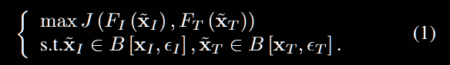
对视觉-语言预训练模型（VLP）的对抗攻击，通常在同时满足图像域与文本域扰动约束的前提下，诱导生成的对抗图像与其对应的对抗文本发生语义错配。设 (xI,xT)∈D为多模态数据集 D 中的一对图文对样本，(x~I,x~T)为其在各自搜索空间B [xI , εI ] 与 B[xT,εT]中得到的对抗样本对，其中 εI是图像侧的最大扰动半径，εT是文本侧允许更改的词数上限。FI (·) and FT (·) 分别表示 VLP 模型的图像编码器与文本编码器。多模态对抗样本通过最大化模型损失 J 获得，其目标函数为：
（如上）

We adopt J(x~I,xT) to represent J(FI(x~I), FT(xT)). Previous works for improving the transferability of multimodal adversarial examples, specifically SGA [42], employ augmented image-text pairs to enhance the diversity of adversarial examples throughout the optimization process. During the generation of adversarial images, let x~I(i) denote the adversarial image generated at the i-th step. In the next step (i + 1), the SGA procedure begins by performing data augmentation (resize images to different scales) on x~I(i), producing n augmented examples {x~I,1(i),x~I,2(i),…,x~I,n(i)}. The whole process can be formulated as follows:
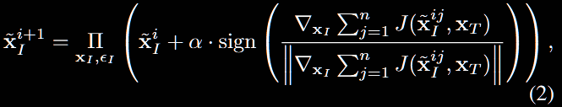
where α represents the step size and ΠxI,εI is to constrain adversarial examples xI to stay within an εI -radius of the clean image under the L∞ norm.
我们将 J(x~I,xT)作为J(FI(x~I), FT(xT))的简记。为提高多模态对抗样本的可迁移性，先前工作（如SGA[42]）会在优化过程中引入增强的图文对，以提升对抗样本的多样性。生成对抗图像时，记第 i步得到的对抗图像为 x~I(i)。在随后的第i+1 步中，SGA 会先对 x~I(i)进行数据增强（例如将图像缩放到不同尺度），从而得到 n个增强样本 {x~I,1(i),x~I,2(i),…,x~I,n(i)}。整个过程可表述如下：
（如上）
其中α为步长，ΠxI,εI为约束算子，用于将更新后的对抗样本限制在以原始图像（干净图像） xI为中心、L∞范数半径为 εI的可行域内。

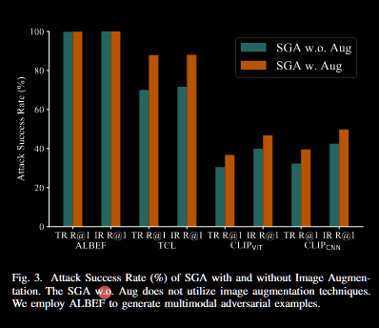
To better understand the role of image augmentation during the optimization phase in SGA, ALBEF is used as a surrogate model to generate multimodal adversarial examples. The generated adversarial examples are then applied to attack target VLP models, such as TCL and CLIP, to evaluate the transferability of the multimodal adversarial examples. The experimental results are shown in Figure 3. It can be observed that SGA can significantly boost the transferability of multimodal adversarial examples for VLP models, with improvements ranging from 6.14% to 17.81%. However, it is important to note that the attack success rates of the target models are still considerably lower than the source model. This discrepancy is mainly due to SGA’s focus on promoting diversity around the adversarial example ̃xi I during optimization while insufficiently accounting for the diversity of adversarial examples relative to the clean image. This can lead to overfitting on the victim model, thereby reducing adversarial transferability.
为更好理解 SGA 在优化阶段中图像增强的作用，我们采用 ALBEF 作为替代模型（surrogate）来生成多模态对抗样本；随后将这些样本用于攻击目标 VLP 模型（如 TCL 与 CLIP），以评估其迁移能力。实验结果见图 3：SGA 能显著提升多模态对抗样本在 VLP 模型间的迁移能力，提升幅度为 6.14%–17.81%。然而，目标模型上的攻击成功率依然明显低于源模型。其根因在于 SGA 在优化过程中主要促进了围绕当前对抗样本 x~I(i) 的局部多样性，而对“相对干净图像”的对抗多样性考虑不足，易对受害模型（源模型）过拟合，进而削弱跨模型的迁移能力。

To improve adversarial transferability, we propose to sample from adversarial evolution triangles composed of clean examples, historical adversarial examples, and current adversarial examples to boost the diversity of adversarial examples. Besides, we investigate the impact of various sampling strategies within adversarial evolution triangles on adversarial transferability and propose sampling from evolution triangles near clean examples and previously generated adversarial examples.
Additionally, as for the text adversarial perturbations, our goal is to generate the adversarial perturbation by deviating from the adversarial image and adversarial evolution triangle, thereby reducing overfitting the source model and boosting the adversarial transferability.
Moreover, we propose generating adversarial examples within the semantic image-text feature contrast space. This approach projects the original feature space into a semantically aligned subspace, reducing dependency on source models. The semantically coherent subspace enhances adversarial transferability across VLP models.
为提升对抗迁移性，我们提出从由干净样本、历史对抗样本与当前对抗样本构成的对抗演化三角中进行采样，以增强对抗样本的多样性。与此同时，我们考察不同的三角内采样策略对迁移性的影响，并主张优先从靠近干净样本与先前对抗样本的演化三角中采样。
在文本侧扰动方面，我们的目标是使其相对对抗图像与对抗演化三角产生偏离，从而减轻对源模型的过拟合并提升迁移性。
此外，我们在语义图文对比特征空间内生成对抗样本：将原始特征空间投影至语义对齐子空间，以降低对源模型的依赖；该语义一致子空间可进一步增强跨 VLP 模型的对抗迁移能力。

B. 用于对抗性图像生成的对抗性演化三角
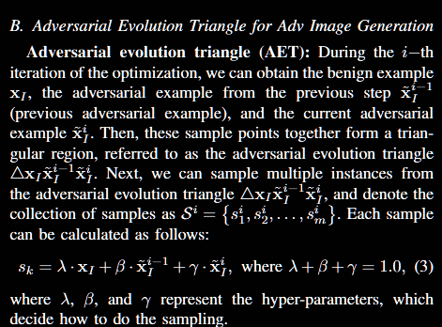
对抗性演化三角 (Adversarial Evolution Triangle, AET)：在优化的第 i 次迭代中，我们可以获得三个关键样本：良性（原始）样本 xI​、前一步生成的对抗样本 x~Ii−1​（即“历史对抗样本”）以及当前生成的对抗样本 x~Ii​ 。这三个样本点共同构成一个三角区域，我们称之为对抗性演化三角 △xI xIi−1 xIi。接下来，我们可以从这个对抗性演化三角区域内采样多个实例，并将采样集合表示为 Si={s1i​,s2i​,...,smi​} 。每个样本 可通过以下公式计算：
这里的 λ, β, 和 γ 是决定采样方式的超参数 。
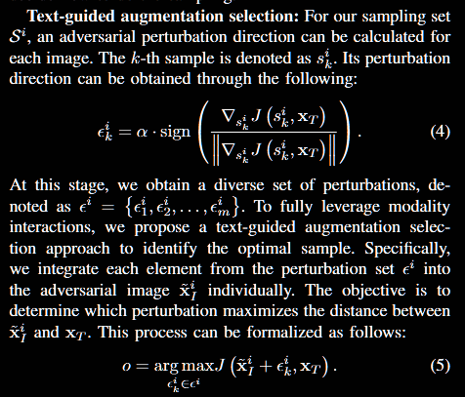
文本引导的增强选择：对于我们通过采样得到的集合 Si，我们可以为其中的每一张图片计算一个对抗性扰动方向。对于第 k 个样本 ski​，其扰动方向 ϵki​ 可通过以下公式获得：
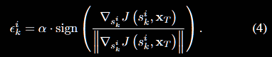
完成这一步后，我们便获得了一个包含多种扰动方向的集合，记为 ϵi={ϵ1i​,ϵ2i​,...,ϵmi​}。为了充分利用不同模态间的交互信息，我们提出一种文本引导的增强选择方法来确定最优样本。具体来说，我们将扰动集 ϵi 中的每一个扰动方向分别与当前的对抗图片 x~Ii​相结合，并评估哪一个组合能最大化图片 x~Ii​ 与文本 xT之间的距离（即不匹配程度）。这个筛选过程可由以下公式表示：
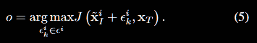
在这时，soi代表的是最优样本。
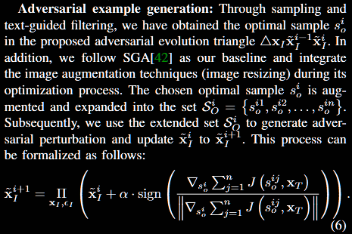
对抗性样本生成：通过采样和文本引导的筛选，我们已经在对抗性演化三角 △xI xIi−1 xIi中找到了最优样本 soi。此外，我们遵循基线方法SGA[42]的策略，在其优化过程中集成了图像增强技术（即图像大小调整）。
我们将选出的最优样本 soi进行增强处理，将其扩展为一个集合 SOi​={soi1​,soi2​,...,soin}。随后，我们利用这个扩展后的集合 SOi来生成对抗性扰动，并将当前的对抗图片 x~Ii更新为下一步的 x~Ii+1​。这个过程可由以下公式表示：
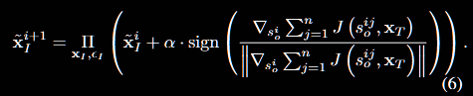

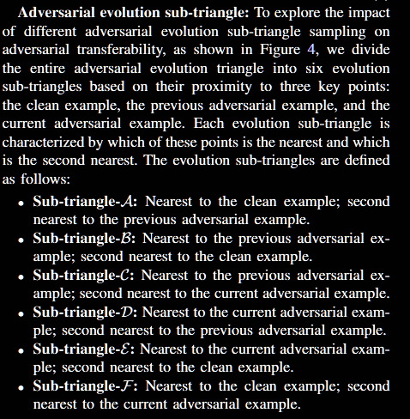
为了探究从不同对抗性演化子三角区域进行采样对可迁移性的影响，我们如图4所示，将完整的对抗性演化三角划分成了六个演化子三角 。划分的依据是采样点与三个关键点——即干净样本、历史对抗样本和当前对抗样本——的相对距离 。
每个演化子三角的特征由其“最近点”和“次近点”来定义 。这六个演化子三角的具体定义如下 ：
子三角A (Sub-triangle-A): 距离干净样本最近；距离历史对抗样本次近 。
子三角B (Sub-triangle-B): 距离历史对抗样本最近；距离干净样本次近 。
子三角C (Sub-triangle-C): 距离历史对抗样本最近；距离当前对抗样本次近 。
子三角D (Sub-triangle-D): 距离当前对抗样本最近；距离历史对抗样本次近 。
子三角E (Sub-triangle-E): 距离当前对抗样本最近；距离干净样本次近 。
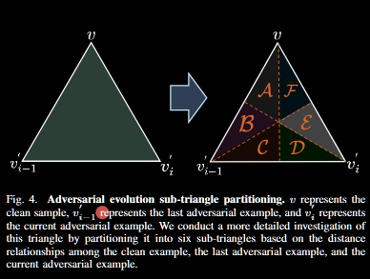
子三角F (Sub-triangle-F): 距离干净样本最近；距离当前对抗样本次近 。
We partition the adversarial evolution triangle into six distinct evolution sub-triangles by adjusting the hyperparameters β, γ, and λ. Specifically, these evolution sub-triangles are defined by all possible strict orderings of the three parameters: sub-triangle-A is defined by γ < β < λ, sub-triangle-B by γ < λ < β, sub-triangle-C by λ < γ < β, sub-triangle-D by λ < β < γ, sub-triangle-E by β < λ < γ, and sub-triangle-F by β < γ < λ. To study the impact of the adversarial evolution sub-triangles on adversarial transferability, we adopt ALBEF as the source model to generate multimodal adversarial examples and evaluate the adversarial transferability on other VLP models. The experiment results are shown in Figure 5. Analyses are as follows. Different adversarial evolution subtriangles can achieve different performances of adversarial transferability. Specifically, the transferability performance of sub-triangle-C is the lowest among all, while sub-triangle-A demonstrates higher transferability performance compared to both the whole triangle and the other sub-triangles. The results indicate that focusing sampling efforts on the sub-triangle near clean and previous adversarial examples significantly enhances adversarial transferability.
我们通过调整超参数 β, γ, 和 λ 来将对抗性演化三角划分为六个不同的演化子三角 。具体来说，这些子三角由这三个参数所有可能的严格排序来定义 ：
子三角A: 由 γ<β<λ 定义 。子三角B: 由 γ<λ<β 定义 。
子三角C: 由 λ<γ<β 定义 。子三角D: 由 λ<β<γ 定义 。
子三角E: 由 β<λ<γ 定义 。子三角F: 由 β<γ<λ 定义 。
为了研究不同演化子三角对可迁移性的影响，我们采用ALBEF作为源模型来生成多模态对抗样本，并在其他VLP模型上评估其迁移能力 。
实验结果如图5所示，分析如下：不同的对抗性演化子三角可以实现不同水平的可迁移性 。具体而言，子三角C的可迁移性表现最差，而子三角A的表现则优于整个三角区域以及其他所有子三角 。这一结果表明，将采样集中在靠近干净样本和历史对抗样本的子三角区域，能够显著增强对抗性迁移能力 。
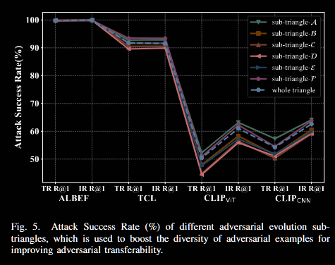

C. 用于对抗性文本生成的对抗性演化三角形
As for the adversarial text generation, previous works generate adversarial texts in an iterative process by only deviating from the final generated adversarial image. Specifically, given the total iterations T and the final adversarial image x ̃T I , the adversarial text x ̃T is generated by deviating from the features of the final adversarial image. Since the final adversarial example completely depends on the source model, the generated adversarial text is only far away from the final adversarial example, resulting in the final multimodal adversarial example overfitting the source model. To address this issue, we propose to deviate from the last adversarial evolution triangle for generating the adversarial text. The evolution triangle consists of the clean image xI , the previous adversarial example x ̃T −1 I, and the current adversarial example x ̃T I . The adversarial text can be calculated as follows:
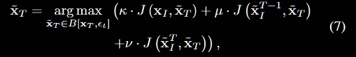
where κ, μ, and ν represent the hyper-parameters used to generate the adversarial text. They are constrained such that κ + μ + ν = 1.0.
对抗文本生成方面，已有工作通常在迭代过程中只围绕“最终生成的对抗图像”来偏离以生成对抗文本。具体而言，给定总迭代步数 T 和最终对抗图像 x~ T，对抗文本 x~T通过偏离该最终对抗图像的特征来生成。由于最终对抗样本完全依赖源模型，这样得到的对抗文本只是在远离该最终样本，导致最终的多模态对抗样本对源模型过拟合、迁移能力不足。
为此，我们提出在生成对抗文本时，改为相对于“上一轮的对抗演化三角形”来偏离。该演化三角形由：干净图像 xI、上一步对抗样本 x~I T−1 与当前对抗样本 x~I 组成。对抗文本按下式计算：
其中 κ,μ,ν为用于生成对抗文本的超参数，满足约束 κ+μ+ν=1.0

D. 理论分析
Here we provide theoretical analysis to show that the proposed method can improve the transferability of adversarial examples compared with the SGA [42]. Wang et al. [58] introduce the Shapley value [50] to analyze the interactions inside adversarial perturbations. They discover that the adversarial transferability and the interaction inside adversarial perturbation have a negative correlation, i.e., the adversarial examples with smaller interactions have better black-box transferability. These observations are also confirmed by the follow-up work like [60; 63; 65]. We give the Shapley interaction indices of the proposed method and the SGA [42] by the following theorem.
这里给出理论分析，以证明相较于 SGA〔42〕，我们的方法能够提升对抗样本的迁移能力。Wang 等〔58〕引入 Shapley 值〔50〕来分析对抗扰动内部的交互。他们发现，对抗性迁移能力与扰动内部交互呈负相关关系，即内部交互越小的对抗样本，其黑盒迁移能力越好。该现象也被后续研究〔60；63；65〕所证实。我们将在下述定理中给出所提方法与 SGA〔42〕的 Shapley 交互指数。
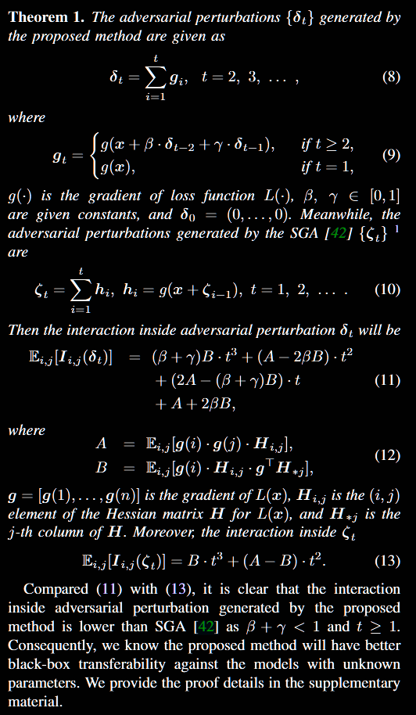
Theorem 1. 由本文方法生成的对抗扰动 {δt}可写为
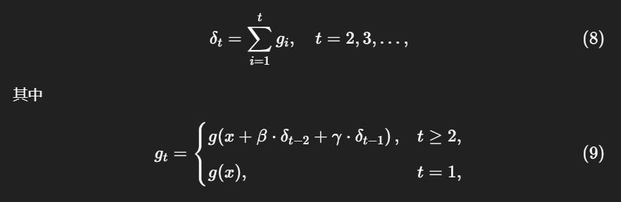
g(⋅) 为损失函数 L(⋅)的梯度；β,γ∈[0,1]为常数；δ0=(0,…,0)。
同时，SGA〔42〕生成的对抗扰动 {ζt}为
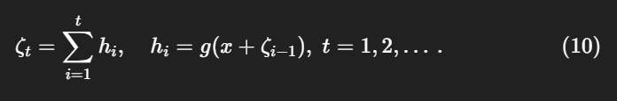
则，扰动 δt内部的交互强度（用 Shapley 交互指数的期望来度量）为
其中
g=[g(1),…,g(n)] 为 L(x) 的梯度，Hi,j 是 Hessian 矩 H的第 (i,j)个元素，H∗j是 H的第j列。
另外，SGA 的扰动 ζt 的交互强度为
对比 (11) 与 (13) 可见：当 β+γ<1且 t≥1时，本文方法产生的内部交互小于 SGA〔42〕。因此，我们的方法在未知参数的未见模型上将具有更好的黑盒迁移能力。更详细的证明在补充材料中给出。

E. 语义对齐AET的对比度空间优化
We generate multimodal adversarial examples by optimizing the maximization of the loss function J of VLP models. Especially given the visual embeddings FI (xI ) ∈ Rd, and the text embeddings FT (xT ) ∈ Rd, where d represents the size of the feature embeddings, the loss function, abbreviated as J, in the original feature space can be calculated as:
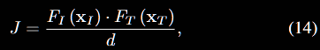
where · represents the dot product of vectors, used to calculate the similarity between each pair of image and text features. Previous works [71; 26] have indicated that image feature embeddings often carry substantial information unrelated to text features. In the original image-text contrast space, only a small subset of feature dimensions within the image embeddings is typically active, while the rest remain inactive and redundant.
（1SGA [42] can be treated as a special case of the proposed method as β = 0 and γ = 1.）
我们通过最大化 VLP 模型的损失函数 J 来生成多模态对抗样本。具体而言，给定视觉嵌入 FI(xI)∈Rd与文本嵌入 FT(xT)∈Rd，其中d表示特征嵌入的维度，则在原始特征空间中的损失函数（记作 J）可计算为：
其中，“⋅”表示向量点积，用于计算每一对图像与文本特征之间的相似度。已有研究〔71；26〕指出，图像特征嵌入中常包含大量与文本特征无关的信息。在原始的图文对比空间中，图像嵌入的特征维度通常只有一小部分是活跃的，其余维度基本不活跃（无效）且冗余。
（补充：SGA〔42〕可视为本文方法的一个特例，当 β=0, γ=1时成立。）

These redundant dimensions can impact similarity calculations, potentially distorting the feature alignment between images and text. The feature distortion may cause the generated adversarial examples to rely highly on the specific victim model, reducing their transferability. Hence, we propose a semantic image-text feature contrast space to generate multi-mode adversarial examples. It maps the original feature space into a semantic corpus subspace by using a semantic projection matrix. As shown in Figure 2 (c), assuming we have a d dimensional semantic representation space Rd, we have N semantic texts U = [c1, c2, . . . , cN ]. The text feature embeddings of those texts can be calculated as follows:
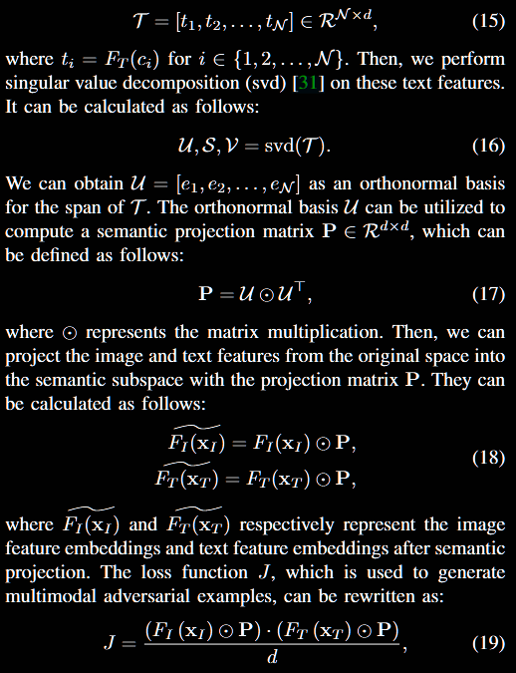

这些冗余维度会影响相似度计算，可能导致图像与文本之间的特征对齐出现扭曲。特征失真会使生成的对抗样本过度依赖特定的受害模型，从而降低其迁移能力。为此，我们提出一种语义图文特征对比空间用于生成多模态对抗样本。该方法通过一个语义投影矩阵将原始特征空间映射到语义语料子空间。
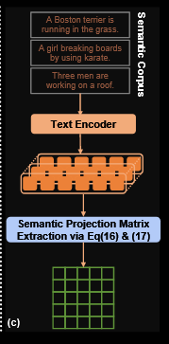
如图2(c)所示，假设我们有一个 d维的语义表示空间 Rd，并有 N 条语义文本。U=[c1,c2,…,cN]. 这些语义文本的文本特征嵌入可以表示为：
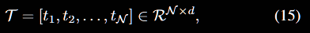
其中，ti=FT(ci), i∈{1,2,…,N}
接下来，我们对这些文本特征执行奇异值分解（SVD）[31]：
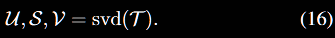
由此可以得到 U=[e1,e2,…,eN]，它构成了 T张成空间的一个正交基。基于该正交基 U，可以计算出一个语义投影矩阵 P∈Rd×d ，其定义如下：
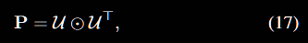

其中，⊙表示矩阵乘法。
然后，我们利用投影矩阵 P 将原始空间中的图像与文本特征投影到语义子空间：
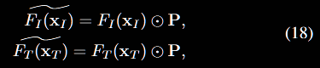
其中，FI(x^I)和 FT(x^T) 分别表示经过语义投影后的图像特征嵌入和文本特征嵌入。
最终，用于生成多模态对抗样本的损失函数 J 可以改写为：
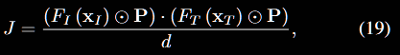

The core of the semantic projection matrix is how to build an effective semantic corpus. In this paper, we construct the semantic corpus by creating a subset of the text-testing dataset, which is generated through random sampling of the complete testing dataset. To better understand the role of the semantic corpus, we analyze the impact of different sampling proportions P = N /M, where N represents the number of samples used to generate the matrix and M represents the number in the entire text dataset.
We adopt ALBEF as the source model to generate the multimodal adversarial examples. TCL, CLIPCNN, and CLIPViT are used as the target models to evaluate the adversarial transferability. We adopt varying proportions of text data from the Flickr30K dataset to generate the projection matrix, i.e., 20%, 40%, 60%, 80%, and 100%. The experiment results are shown in Table I.
Analyses are summarized as follows. First, compared to the baseline DRA [17], which calculates the loss value in the original contrast space, the proposed loss function incorporating varying proportions of text data demonstrates improved adversarial transferability. It demonstrates the effectiveness of the proposed semantic contrast space in improving adversarial transferability. Second, the projection matrices generated from text data with varying proportions yield different levels of improvement in adversarial transferability, with 40% achieving the best improvement. Considering the computational expenses, we set the proportion to 40% for the experiments. In the appendix, we provide a detailed algorithm for the proposed SA-AET.
语义投影矩阵的核心在于如何构建一个有效的语义语料。在本文中，我们通过对完整测试数据集进行随机采样，生成一个子集，从而构建语义语料。为了更好地理解语义语料的作用，我们分析了不同采样比例 P=N/M 的影响，其中 N 表示用于生成投影矩阵的样本数量，M 表示整个文本数据集的总数。
我们采用 ALBEF 作为源模型来生成多模态对抗样本，并使用 TCL、CLIPCNN 和 CLIPViT 作为目标模型来评估对抗样本的迁移能力。实验中，我们从 Flickr30K 数据集中选取不同比例的文本数据来生成投影矩阵，即 20%、40%、60%、80% 和 100%。实验结果如表 I 所示。
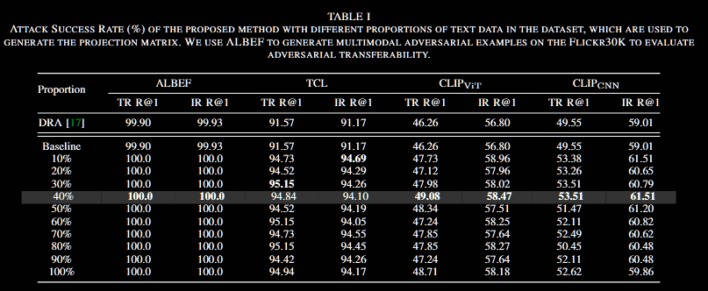
分析总结如下：首先，与在原始对比空间中计算损失值的基线方法 DRA [17] 相比，引入不同采样比例的文本数据所构建的投影矩阵并用于损失函数计算时，能够提升对抗样本的迁移能力。这表明所提出的语义对比空间在提高对抗性迁移能力方面是有效的。其次，不同采样比例的文本数据生成的投影矩阵带来的提升幅度不同，其中 40% 的比例实现了最佳提升效果。综合考虑计算开销，我们在实验中将采样比例设定为 40%。在附录中，我们给出了所提出方法 SA-AET 的详细算法。
五、实验
To evaluate the effectiveness of the proposed method, we conduct extensive experiments across different datasets and VLP models. First, we introduce the detailed experimental setup, including the VLP models, image-text pair benchmark datasets, the settings of adversarial attack, and the evaluation metrics in Section IV-A. Subsequently, we introduce the selection of the optimal hyper-parameters in Section IV-B. Then, we present the comparative experimental results with state-ofthe-art methods on the cross-model adversarial transferability within the image-text retrieval task in Section IV-C. After that, we present the cross-task transferability of multimodal adversarial examples from the image-text retrieval task to other tasks, along with adversarial transferability testing of current state-of-the-art LLMs in Section IV-D and Section IV-E, respectively. Additionally, we present the ablation study of the proposed method in Section IV-F. Finally, we introduce a knowledge transfer-based metric to offer an alternative perspective on the observed improvements in transferability in Section IV-G.
为了评估所提出方法的有效性，我们在不同的数据集和 VLP 模型上进行了广泛的实验。首先，我们在第 IV-A 节介绍了详细的实验设置，包括 VLP 模型、图文对基准数据集、对抗攻击的设置以及评估指标。随后，我们在第 IV-B 节介绍了最优超参数的选择。接着，我们在第 IV-C 节给出了与最新方法的比较实验结果，主要针对图文检索任务中的跨模型对抗性迁移能力。之后，我们在第 IV-D 节和第 IV-E 节分别展示了多模态对抗样本从图文检索任务向其他任务的跨任务迁移性，以及在当前最先进的大语言模型上的对抗迁移性测试。除此之外，我们在第 IV-F 节给出了所提出方法的消融研究。最后，我们在第 IV-G 节引入了一种基于知识迁移的度量方法，以从另一种视角解释所观察到的迁移能力提升。

A. 实验设置
Benchmark datasets. We adopt two widely used imagetext pair datasets as the benchmark dataset to conduct experiments on the image-text retrieval task, i.e., Flickr30K [47] and MSCOCO [41]. The Flickr30K dataset contains 31,783 images, each annotated with five captions. Similarly, the MSCOCO dataset includes 123,287 images, each accompanied by approximately five captions.
For the visual grounding task, we adopt the RefCOCO+ [62] dataset to conduct experiments. RefCOCO+ is a dataset with 141,564 referring expressions linked to 50,000 objects across 19,992 images from the MSCOCO collection. It is widely used to assess grounding models, focusing on how well they can locate objects described by natural language.
For the Image Captioning task, which is another key challenge in visionand-language research, we utilize the MSCOCO dataset. This dataset is widely used because it provides rich images paired with diverse captions.
基准数据集。我们采用两个广泛使用的图文对数据集作为基准数据集，在图文检索任务上开展实验，即 Flickr30K [47] 和 MSCOCO [41]。其中，Flickr30K 数据集包含 31,783 张图像，每张图像配有五条标注文本。类似地，MSCOCO 数据集包含 123,287 张图像，每张图像大约配有五条标注文本。
对于视觉指代（Visual Grounding）任务，我们采用 RefCOCO+ [62] 数据集进行实验。RefCOCO+ 数据集包含 141,564 条指代表达，关联到 19,992 张 MSCOCO 图像中的 50,000 个目标。它被广泛用于评估指代消解模型，重点测试模型在多大程度上能够定位由自然语言描述的目标。
对于图像描述（Image Captioning）任务，这也是视觉-语言研究中的另一项关键挑战，我们同样使用 MSCOCO 数据集。该数据集之所以被广泛采用，是因为它提供了大量图像，并配有多样化的文本描述。

VLP models. We employ two standard architectures of VLP models, i.e., fused and aligned VLP models, to carry out our experiments. In the case of aligned VLP models, CLIP [48] is used for the aligned VLP model. Specifically, we adopt different image encoders for CLIP, including ResNet-101 [24] and ViT-B/16 [13], i.e., CLIPCNN and CLIPViT, respectively. In the case of fused VLP models, we adopt ALBEF [34] and TCL [61] to conduct our experiments. ALBEF incorporates a 12-layer ViT-B/16 as its image encoder, alongside two 6layer transformers dedicated to text and multimodal encoding. Although TCL adopts the same architectural framework, it distinguishes itself by employing different pre-training objectives.
VLP 模型。 我们在实验中采用了两种标准架构的 VLP 模型，即融合型和对齐型 VLP 模型。在对齐型 VLP 模型中，我们使用 CLIP [48]。具体来说，我们为 CLIP 采用了不同的图像编码器，包括 ResNet-101 [24] 和 ViT-B/16 [13]，分别记作 CLIP_CNN 和 CLIP_ViT。在融合型 VLP 模型中，我们采用 ALBEF [34] 和 TCL [61] 来进行实验。ALBEF 使用一个 12 层的 ViT-B/16 作为图像编码器，同时配备两个 6 层的 Transformer，分别用于文本和多模态编码。虽然 TCL 采用了相同的架构框架，但其区别在于使用了不同的预训练目标。
Adversarial attack settings. Following previous works [42; 17; 36], for the text adversarial attack, we set the text perturbation bound εT = 1, with the word list W containing 10 words. For the image adversarial attack, we set the image perturbation bound εI = 8/255 under L∞ norm. Moreover, the number of iteration steps T is set to 10, with each step size α = 2/255. We follow the image augmentation techniques in SGA during its optimization process, enlarging the image dataset by resizing the original images to five different scales: {0.50, 0.75, 1.00, 1.25, 1.50}, utilizing bicubic interpolation. We compare the proposed SA-AET with the following baselines: (1) PGD [44], (2) Bert-Attack [35], (3) Sep-Attack [66], (4) Co-Attack [66], (5) SGA [42], and (6) DRA [17].
对抗攻击设置。参考已有工作 [42; 17; 36]，在文本对抗攻击中，我们将文本扰动范围设为 εT=1，并将词表 WWW 设置为包含 10 个词。在图像对抗攻击中，我们在 L∞范数下将图像扰动范围设为 εI=8/255。此外，迭代步数 TTT 设为 10，每步的步长为 α=2/255。在优化过程中，我们遵循 SGA 的图像增强技术，通过双三次插值将原始图像缩放为五种不同的尺{0.50,0.75,1.00,1.25,1.50}，以扩充图像数据集。我们将所提出的 SA-AET 与以下基线方法进行比较：(1) PGD [44]，(2) Bert-Attack [35]，(3) Sep-Attack [66]，(4) Co-Attack [66]，(5) SGA [42]，以及 (6) DRA [17]。

Evaluation metrics. We adopt the Attack Success Rate (ASR) at the top-1 rank (R@1) as the metric to evaluate the adversarial transferability. It represents the percentage of successful attacks among all generated adversarial examples. A higher ASR indicates a more effective attack with higher transferability.
评估指标。 我们采用在 top-1 排名（R@1）下的ASR作为评估对抗迁移性的指标。该指标表示在所有生成的对抗样本中攻击成功的比例。更高的 ASR 表明攻击更加有效，并且具有更强的迁移能力。

B. 最佳超参数选择
The number of samples m taken from the sub-triangle-A of the adversarial trajectory and scaling factors in Equation 7 are the hyper-parameters. We conduct a series of experiments to determine the optimal value of hyper-parameters and analyze their impact on the overall performance of the proposed method. Specifically, we employ ALBEF to generate multimodal adversarial examples on the Flickr30K dataset and evaluate their transferability to three other VLP models.
从对抗轨迹的子三角区域 A 中采样的样本数 mmm 以及公式 (7) 中的缩放因子是本方法的超参数。我们开展了一系列实验来确定超参数的最优取值，并分析它们对所提方法整体性能的影响。具体而言，我们使用 ALBEF 在 Flickr30K 数据集上生成多模态对抗样本，并评估其在另外三个 VLP 模型上的迁移能力。
Number of samples m taken from the sub-triangle-A of the adversarial trajectory: The results are shown at the bottom of Table II. It can be observed that transfer effects become apparent for both the Image Retrieval and Text Retrieval tasks when the sample size reaches 5. Beyond this point, as the sample size increases, transferability shows fluctuations without any significant enhancement. Considering the balance between transfer effects and computational efficiency, a sample size of 5 is the most effective hyperparameter.
从对抗轨迹的子三角区域 A 中采样的样本数 m：结果如表 II 底部所示。可以观察到，当采样数达到 5 时，无论是在图像检索任务还是文本检索任务中，迁移效果都开始显著体现。超过这一点后，随着采样数的增加，迁移能力虽然出现波动，但并没有带来明显的提升。综合迁移效果与计算效率的平衡，采样数为 5 是最有效的超参数选择。
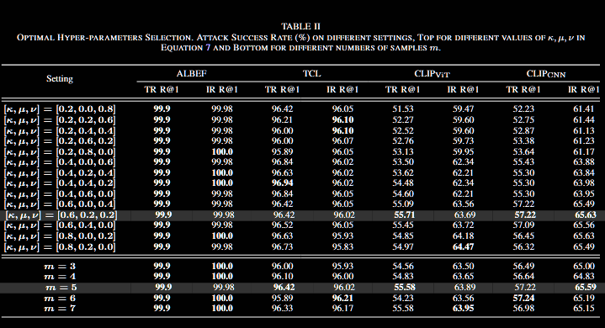

Scaling factors κ, μ, ν in adversarial text generation: In Equation 7, we introduce three hyper-parameters that represent the weights of the clean image, the previous adversarial example, and the current adversarial example, respectively. We stipulate that the proportion of adversarial images cannot be zero, i.e., μ + ν! ̸= 0. Under the above conditions, we assign κ, μ, ν to 14 different sets of values. Using ALBEF as the surrogate model, we generate adversarial examples and evaluate their transferability to the remaining three models. The detailed results are shown at the top of Table II.
Adversarial transferability from ALBEF to TCL shows minimal variation across settings (around 1%), while transferability to CLIP models varies significantly, with a performance gap between 4.18% and 5.0%. Thus, our hyper-parameter selection focuses on maximizing transferability to CLIP models. Increasing κ, which introduces a higher proportion of clean images, initially boosts transferability, but an excessive κ reduces the adversarial ratio, decreasing overall effectiveness. Based on Table II, we select [κ, μ, ν] = [0.6, 0.2, 0.2] for optimal transferability.
对抗文本生成中的缩放因子 κ,μ,ν：在公式 (7) 中，我们引入了三个超参数，分别表示干净图像、前一个对抗样本和当前对抗样本的权重。我们规定对抗图像的比例不能为零，即 μ+ν≠0。在上述条件下，我们将 κ,μ,ν设定为 14 组不同的取值。以 ALBEF 作为替代模型，我们生成对抗样本并评估其在其余三个模型上的可迁移性。详细结果如表 II 上部所示。
从 ALBEF 到 TCL 的对抗迁移性在不同设置下变化较小（约 1%），而在迁移至 CLIP 模型时差异显著，性能差距在 4.18% 到 5.0% 之间。因此，我们的超参数选择重点放在最大化向 CLIP 模型的迁移性上。随着 κ的增加（即引入更高比例的干净图像），迁移性最初有所提升，但当 κ 过大时会降低对抗比例，从而削弱整体效果。根据表 II 的结果，我们选择 [κ,μ,ν]=[0.6,0.2,0.2]以获得最佳迁移性。

C. 跨模型对抗性迁移能力
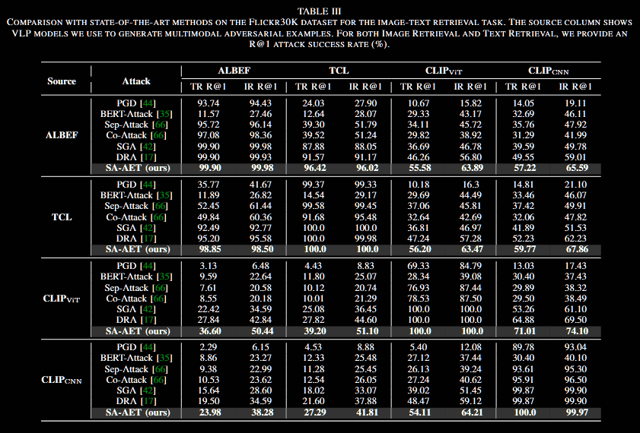
We adopt four widely used VLP models, i.e., ALBEF, TCL, CLIPViT, and CLIPCNN, to conduct comparative experiments on the image-text retrieval task. Specifically, we adopt one of four VLP models to generate multimodal adversarial examples and then use the other three VLP models to evaluate the transferability of adversarial examples. We compare the proposed SA-AET with a series of advanced adversarial attack methods for VLP models on the Flickr30K and MSCOCO datasets. Performance on the Flickr30K dataset. Comparative experimental results on the Flickr30K dataset are shown in Table III. It can be observed that our SA-AET, along with SGA and DRA, consistently outperforms other adversarial attack methods under all white box attack scenarios. Regardless of whether using TR or IR, ASR consistently surpasses 99.8%. Compared with previous works, the proposed SA-AET achieves the best performance of adversarial transferability across different VLP models under all adversarial attack scenarios. For example, when ALBEF is used as the source model to generate multimodal adversarial examples, the advanced SGA method achieves an ASR of 87.88% on TCL, 36.69% on CLIPViT, and 39.59% on CLIPCNN for text retrieval tasks.
我们选取四个常用的 VLP 模型（ALBEF、TCL、CLIPViT、CLIPCNN），在图文检索任务上开展对比实验。具体做法是：依次将其中一个模型作为源模型生成多模态对抗样本，再用其余三个模型评估这些样本的迁移能力。我们在 Flickr30K 与 MSCOCO 两个数据集上，将所提 SA-AET 与多种先进的 VLP 对抗方法进行比较。
Flickr30K 上的性能：表 III 给出了 Flickr30K 的对比结果。可以看到，SA-AET 与 SGA、DRA 在所有白盒攻击场景下均优于其他方法；无论采用 TR（Text Retrieval，文本检索）还是 IR（Image Retrieval，图像检索），ASR均稳定超过 99.8%。与以往方法相比，我们的 SA-AET 在各类攻击场景下均取得了最佳的跨模型迁移性能。以 ALBEF 作为源模型为例，在文本检索任务中，先进的 SGA 方法在 TCL、CLIPViT 与 CLIPCNN 上的 ASR 分别为 87.88%、36.69% 与 39.59%。
For image retrieval tasks, it attains an ASR of 88.05% on TCL, 46.78% on CLIPViT, and 49.78% on CLIPCNN. In contrast, the proposed SA-AET method outperforms SGA with an ASR of 96.42% on TCL, 55.58% on CLIPViT, and 57.22% on CLIPCNN for text retrieval tasks. For image retrieval tasks, SA-AET achieves an ASR of 96.02% on TCL, 63.89% on CLIPViT, and 65.59% on CLIPCNN. Moreover, when applying ALBEF to target CLIPCNN, the proposed SA-AET improves the ASR by 7.67% for TR R@1 and 6.58% for IR R@1, compared to DRA. The results demonstrate the effectiveness of our proposed method in improving the transferability of multimodal adversarial examples on the Flickr30K dataset.
在图像检索任务中，SA-AET 在 TCL 上的对抗成功率（ASR）为 88.05%，在 CLIPViT 上为 46.78%，在 CLIPCNN 上为 49.78%。相比之下，所提的 SA-AET 方法在文本检索任务中超越了 SGA，分别在 TCL、CLIPViT 和 CLIPCNN 上的 ASR 分别为 96.42%、55.58% 和 57.22%。对于图像检索任务，SA-AET 在 TCL 上的 ASR 为 96.02%，在 CLIPViT 上为 63.89%，在 CLIPCNN 上为 65.59%。此外，当 ALBEF 作为源模型用于攻击 CLIPCNN 时，SA-AET 相比 DRA 在文本检索 R@1 上提升了 7.67%，在图像检索 R@1 上提升了 6.58%。这些结果展示了我们提出的方法在提升多模态对抗样本在 Flickr30K 数据集上的迁移能力方面的有效性。
Performance on the MSCOCO dataset. Comparative experimental results on the MSCOCO are shown in Table IV. It can also be observed that compared with previous works, the proposed method achieves the best performance in improving the adversarial transferability for VLP models. Specifically, when using CLIPViT to generate adversarial examples, the advanced SGA method demonstrates an ASR of 43.75% on ALBEF, 44.05% on TCL, and 70.66% on CLIPCNN for text retrieval tasks. For image retrieval tasks, it achieves an ASR of 51.08% on ALBEF, 51.02% on TCL, and 75.58% on CLIPCNN. Conversely, the proposed SA-AET method surpasses SGA, achieving an ASR of 57.64% on ALBEF, 57.3% on TCL, and 83.98% on CLIPCNN for text retrieval tasks. In image retrieval tasks, SA-AET records ASRs of 66.88% on ALBEF, 65.16% on TCL, and 86.72% on CLIPCNN. Additionally, when applying CLIPViT to target TCL, the proposed SA-AET improves the ASR by 5.42% for TR R@1 and 4.1% for IR R@1, compared to DRA. The results highlight the effectiveness of our proposed method in enhancing the transferability of multimodal adversarial examples on the MSCOCO dataset.
在 MSCOCO 数据集上的性能：表 IV 给出了 MSCOCO 数据集上的对比实验结果。可以看到，与以往方法相比，所提方法在提高 VLP 模型的对抗性迁移能力方面表现最佳。具体来说，当使用 CLIPViT 生成对抗样本时，先进的 SGA方法在 ALBEF 上的 ASR 为 43.75%，在 TCL 上为 44.05%，在 CLIPCNN 上为 70.66%（文本检索任务）。对于图像检索任务，SGA 在ALBEF上的ASR为51.08%，在TCL 上为 51.02%，在 CLIPCNN 上为 75.58%。相比之下，所提的 SA-AET 方法在文本检索任务中超越了 SGA，分别在 ALBEF、TCL 和 CLIPCNN 上的 ASR 为 57.64%、57.3% 和 83.98%。在图像检索任务中，SA-AET 在 ALBEF、TCL 和 CLIPCNN 上的 ASR 分别为 66.88%、65.16% 和 86.72%。此外，当将 CLIPViT 作为源模型攻击 TCL 时，SA-AET 相比 DRA 在文本检索 R@1 上提升了 5.42%，在图像检索 R@1 上提升了 4.1%。这些结果突显了我们提出的方法在 MSCOCO 数据集上提升多模态对抗样本迁移能力的有效性。

D. 跨任务对抗性迁移能力
We not only evaluate the transferability of multimodal adversarial examples generated by our proposed method across different VLP models but also conduct experiments to evaluate its effectiveness in transferring across diverse V+L tasks. Specifically, we generate adversarial examples for the ImageText Retrieval (ITR) task and evaluate them on Visual Grounding (VG) and Image Captioning (IC) tasks. As evident from Table V and visual results in Figures 7 and 8, the adversarial examples generated for ITR demonstrate transferability, successfully impacting both VG and IC tasks. Compared to SGA and DRA, adversarial examples generated by SA-AET lead to a substantial decline in metrics for both VG and IC tasks, with a notable drop of 25.7 and 22.6 points in the CIDEr score on the IC task, respectively. This demonstrates the superior effectiveness of SA-AET in transfer attacks, emphasizing its crosstask transferability. Moreover, our transferability consistently surpasses that of all other methods.
我们不仅评估了所提方法生成的多模态对抗样本在不同 VLP 模型间的跨模型迁移能力，还进一步评估其在不同视觉-语言任务间的跨任务迁移能力。具体而言，我们先针对图文检索（ITR, Image–Text Retrieval）生成对抗性样本，再将其用于评测视觉指代（VG, Visual Grounding）与图像描述（IC,Image Captioning）。
如表 V 及图 7、图 8 所示，基于 ITR 生成的对抗样本在 VG 与 IC 上同样产生影响，展现出良好的跨任务可迁移性。与 SGA、DRA 相比，SA-AET 生成的对抗样本使 VG 与 IC 的多项指标显著下降；其中在 IC 任务上，CIDEr 得分分别下降 25.7 与 22.6 分。这说明 SA-AET 在迁移攻击方面具有更强效能，并突出了其跨任务迁移能力。此外，我们的方法在所有对比中均取得一致领先的迁移表现。
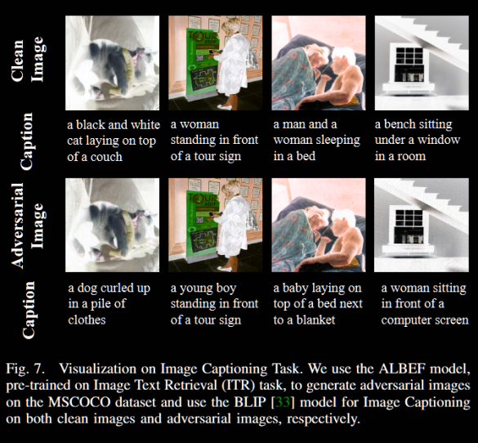
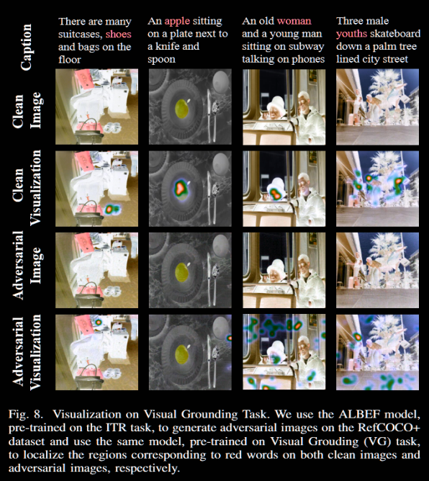
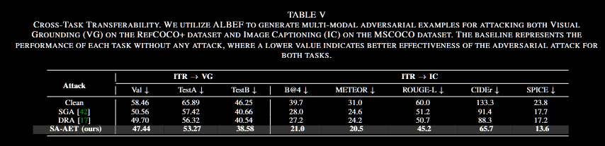

E. 多模态大语言模型的对抗性迁移能力
Multimodal Large Language Models (MLLMs) have recently gained significant attention for their wide range of applications, demonstrating remarkable versatility and effectiveness in handling complex tasks. To further investigate the adversarial robustness of MLLMs, we conduct a series of extension experiments. Using ALBEF as a surrogate model, we generate adversarial examples under constrained perturbation settings, with a magnitude of 16/255 and a single-step perturbation of 0.5/255, iterating over 100 steps. These adversarial examples are then evaluated on advanced MLLMs (e.g., GPT-4 [2], Claude-3 [4]) by prompting them with the query “Describe this image”.
多模态大语言模型（MLLMs）近来因其应用广泛而备受关注，在处理复杂任务方面展现出显著的通用性与有效性。为进一步检验 MLLMs 的对抗鲁棒性，我们开展了一系列扩展实验：以 ALBEF 作为替代模型，在约束扰动设置下生成对抗样本（总扰动幅度 16/255，单步扰动 0.5/255，共迭代 100 步）。随后，我们将这些对抗样本用于评估先进的 MLLMs（如 GPT-4、Claude-3），评测方式为向模型提出统一查询：“Describe this image”。

As shown in Figure 9, it illustrates that adversarial examples generated by our method are capable of deceiving state-of-the-art MLLMs, leading them to produce incorrect responses. In addition to these qualitative results on MLLMs, we further extend our experiments by randomly selecting 100 images from the Flick30K dataset. We generate adversarial images using SGA, DRA, and our method SA-AET, with ALBEF as the surrogate model, under the same perturbation setting (16/255). These adversarial images are then fed into MLLMs, where the query is prompted with “Please describe this image, limited to 50 words”. We rank the generated descriptions against 100 irrelevant texts based on CLIP similarity. If a description does not rank first, we consider it a successful attack. The results are shown in Table VI. It can be observed that our SA-AET achieves the best transferability performance among advanced commercial MLLMs.
如图 9 所示，本文方法生成的对抗样本能够欺骗最先进的 MLLMs，使其产生错误回应。除上述定性结果外，我们进一步开展扩展实验：从 Flickr30K 数据集中随机选取 100 张图像，在相同扰动设置（16/255）下，以 ALBEF 作为替代模型，分别采用 SGA、DRA 与本文的 SA-AET 生成对抗图像。随后将这些对抗图像输入 MLLMs，并以统一查询 “Please describe this image, limited to 50 words” 进行评测。我们把模型生成的描述与 100 条无关文本一起，基于CLIP相似度进行排序；若该描述未排在第一，则认定为一次成功攻击。结果见表 VI：与对比方法相比，SA-AET 在先进商用 MLLM 上取得了最佳的迁移性能。
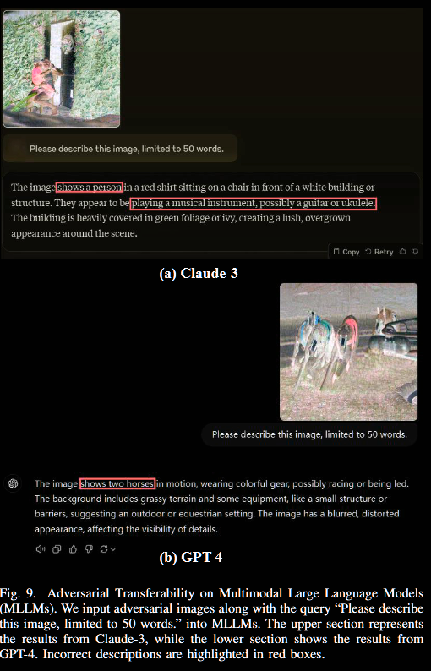
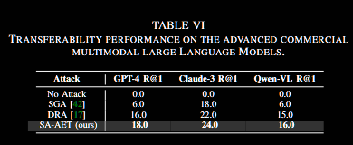

F. 消融实验
Our proposed method builds upon the SGA [42] method and introduces three significant improvements:
- the adversarial evolution triangle for adversarial image generation, 2) the dversarial evolution triangle for adversarial text generation, and 3) the contrast space optimization for semantic-aligned adversarial evolution triangle.
To evaluate the contribution of each element, we conduct ablation studies on the image-text retrieval (ITR) task and evaluate the transferability of multimodal adversarial examples from two different architectures: the fused and aligned architectures, corresponding to ALBEF and CLIPViT, respectively. We then test how well these adversarial examples generalize to other VLP models.
在 SGA[42] 的基础上，我们提出三项关键改进：
- 用于图像扰动的对抗性演化三角；
- 用于文本扰动的对抗性演化三角；
- 用于跨模态语义对齐的对比式空间优化。
我们在图文检索（ITR）任务上进行消融实验，以衡量各组成模块的贡献。为评估可迁移性，我们在两类代表性代理架构上生成多模态对抗样本——融合型（ALBEF）与对齐型双编码器（CLIP-ViT），并进一步测试这些样本在其他视觉-语言模型上的泛化效果。

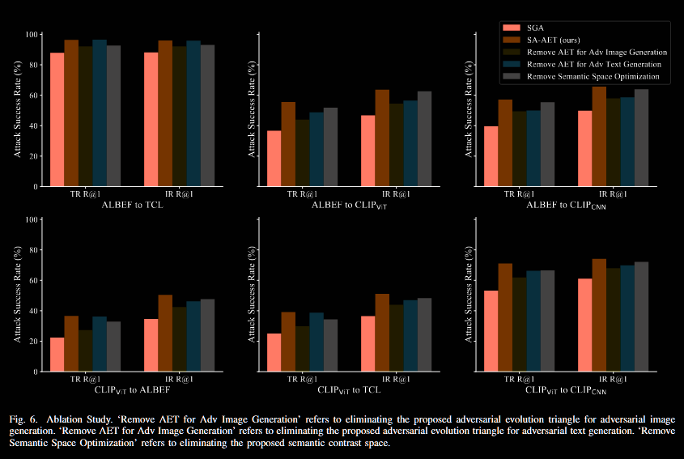
The results of the ablation studies can be seen in Figure 6. In the ablation studies, we compare five methods. The first is SGA [42], which serves as our baseline, followed by SA-AET, representing our complete method. The other three methods are derived from SA-AET by sequentially removing each of the three key contributions we introduce. ‘Remove AET for Adv Image Generation’ refers to eliminating the proposed adversarial evolution triangle for adversarial image generation. ‘Remove AET for Adv Text Generation’ refers to eliminating the proposed adversarial evolution triangle for adversarial text generation. ‘Remove Semantic Space Optimization’ refers to eliminating the proposed semantic contrast space. It is evident from the six sets of transfer attack experiments on ALBEF and CLIPViT that removing any of the improvements from SA-AET results in weaker transfer attacks compared to the full SA-AET method. It demonstrates the effectiveness of each element of our SA-AET.
消融研究结果见图 6。我们在消融实验中比较了五种方法：首先是基线 SGA [42]；其次为完整方法 SA-AET。其余三种方法由 SA-AET 出发，分别移除我们提出的三项关键改进中的一项而得到。其中，“移除用于对抗图像生成的 AET”指去除用于对抗图像生成的对抗性演化三角；“移除用于对抗文本生成的 AET”指去除用于对抗文本生成的对抗性演化三角；“移除语义空间优化”指去除提出的语义对比空间。由在 ALBEF 与 CLIPViT 上进行的六组迁移攻击实验可明显看出：从 SA-AET 中移除任一改进都会使迁移攻击弱于完整的 SA-AET 方法，这表明 SA-AET 的每个组成要素都是有效的。

性能分析
In addition to examining the transfer attack success rates of multimodal adversarial examples generated by various VLP models, we introduce a knowledge transfer-based metric proposed by Liang et al. [38] to offer an alternative perspective on the observed improvements in transferability and to provide insights into the underlying reasons for these enhancements, from the baseline method, SGA [42], to the advanced approaches, DRA [17] and SA-AET. The metric, known as the alpha metric, represents how often the adversarial attack transfers, which can be calculated as follows:
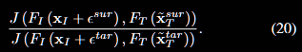
除比较不同 VLP 模型生成的多模态对抗样本在迁移攻击中的成功率之外，我们还引入 Liang 等人 [38] 提出的基于知识迁移的度量，从另一种视角解释迁移能力提升的现象，并揭示这些改进（从基线方法 SGA [42] 到更先进的 DRA [17] 与 SA-AET）背后的原因。该度量称为alpha 指标，用于表征对抗攻击在模型间发生迁移的频率/程度，其计算方式如下：
（如上）

In the above formula, FI and FT represent the image and text encoders of the target VLP model for transfer attacks, respectively, while J (·) denotes the loss function of the VLP model.ϵsur and x~Tsur represent the adversarial image perturbation and adversarial text generated on the surrogate model, respectively, while ϵtar and x~Ttar denote the adversarial image perturbation and adversarial text generated on the target model.
In this context, the alpha metric can be viewed as the difference in loss between the multimodal adversarial examples generated on the surrogate model and its own multimodal adversarial examples.
To measure the alpha metric, we select the Flickr30k dataset and utilize 12 sets of transfer attacks from four chosen VLP models, calculating the metric according to Formula (20). We present the final results in Figure 10. Notably, the x-axis represents the attack success rates of the three methods: SGA, DRA, and SA-AET. These success rates are obtained by averaging the TR R@1 and IR R@1 metrics. The alpha metric is calculated as the average across all Flickr30k data.
在上述公式中，FI和 FT分别代表用于迁移攻击的目标VLP模型的图像和文本编码器，而 J (·) 则表示VLP模型的损失函数。ϵsur 和 x~Tsur分别代表在代理模型上生成的对抗性图像扰动和对抗性文本；而 ϵtar 和 x~Ttar则表示在目标模型上生成的对抗性图像扰动和对抗性文本。
在此背景下，alpha metric可以被看作是“在代理模型上生成的多模态对抗样本”与“目标模型自身的多模态对抗样本”在损失值上的差异。
为了测量alpha metric，我们选用了Flickr30k数据集，并利用从四种VLP模型中选出的12组迁移攻击，根据公式(20)计算该指标。最终结果展示在图10中。值得注意的是，图中的x轴代表了三种方法（SGA, DRA, 和 SA-AET）的攻击成功率，这些成功率是通过平均文本检索（TR R@1）和图像检索（IR R@1）的指标得到的。而alpha metric则是对所有Flickr30k数据计算得到的平均值。
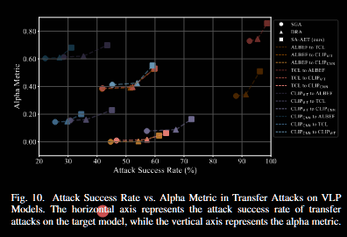
Based on the results presented in Figure 10, we find that SAAET consistently outperforms both SGA and DRA, demonstrating significantly higher attack success rates and alpha metrics across all 12 sets of transfer attacks. Furthermore, the DRA method exhibits favorable performance, with both the attack success rates and alpha metrics for DRA and SA-AET showing substantial improvements over SGA. This finding suggests that our contribution to increasing adversarial transferability in both DRA and SA-AET is effective. While the difference in alpha metrics between DRA and SGA is relatively modest, there is a significant gap between SAAET and the other two methods. The transfer attack success rates of DRA compared to SGA have already reached a high level, making further improvements challenging. However, by introducing semantic-aligned adversarial sub-triangles, we achieve a notable increase in the alpha metric. This indicates that we enhance how often the adversarial attack transfers, thereby further improving adversarial transferability.
由图10可见，SA-AET 在全部 12 组迁移攻击环境中，攻击成功率与α指标均显著优于 SGA 与 DRA，表现最为稳定。DRA 的结果也较为理想：其成功率与 α 均明显高于 SGA，说明 DRA 与 SA-AET 共有的“增强迁移能力”设计是有效的。需要指出的是，尽管 DRA 相比 SGA 的 α 提升幅度相对有限，但 SA-AET 与前二者之间仍存在显著差距。考虑到 DRA 相对 SGA 的迁移成功率已处在较高水平、进一步提升空间有限，引入语义对齐的对抗子三角仍能显著提高 α 指标，表明我们增强了“对抗攻击发生迁移的频率”，从而进一步提升了整体迁移能力。

五、结论
In this paper, we focus on generating highly transferable adversarial examples (AEs) for vision-language pre-training (VLP) models. We find that previous methods focus only on augmenting image-text pairs around current adversarial examples, which offers limited improvements in transferability. To overcome this limitation, we propose leveraging the intersection regions along the adversarial trajectory during optimization, specifically by sampling from adversarial evolution triangles that are composed of clean, historical, and current adversarial examples. It significantly enhances the diversity of AEs, leading to improved transferability. Additionally, we tackle the issue of feature-matching distortion caused by redundant image features in VLP models. Adversarial examples generated in the original image-text feature contrast space are highly dependent on the victim model. We propose a semantic image-text feature contrast space to mitigate this, projecting the original features into a semantically aligned subspace. This projection reduces feature redundancy and enhances the transferability of adversarial examples. Our theoretical analysis validates the effectiveness of the proposed adversarial evolution triangles, and extensive experiments across various datasets and models demonstrate that our method outperforms state-of-the-art adversarial attack methods for VLP models.
本文聚焦于面向视觉–语言预训练模型（VLPs）的高可迁移性对抗样本生成。我们发现，已有方法多在当前对抗样本附近对图文对进行局部增强，迁移能力提升有限。为突破这一瓶颈，我们沿对抗轨迹利用其交叉区域：从由干净样本、历史对抗样本与当前对抗样本构成的对抗演化三角中采样，从而显著提升对抗样本的多样性并增强迁移能力。进一步地，针对 VLP 中冗余图像特征引发的特征匹配扭曲问题，我们提出语义图文对比空间，将原始特征投影到语义对齐的子空间，以降低冗余并减弱对模型的依赖。理论分析验证了对抗演化三角的有效性，且在多数据集、多架构上的大量实验表明，我们的方法在迁移能力方面优于现有最先进对抗攻击。

