Test Report for Banned words

I developed a filter to remove banned words from the leader board for high scorer player names.

I then developed software to test the filter, on the far left is the value inputed, then followed by the result I expected my program to spit on and after that it is what the program actually did output. 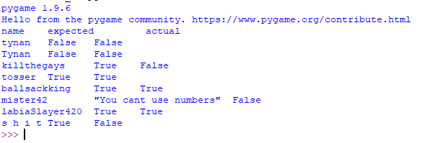

As you can see it has done a pretty good job, the outputs were close to what I anticipated them to be. There are some bad ones such as:

1. Killthegays passed through when it definitely should be a banned phrase
2. Mister42 went through fine when it should have thrown the error “You cant use numbers”
3. S h I t passes through fine when it should be a banned word.