Link to my GitHub repository
https://github.com/AuroraC25/csd-325.git

Flowchart
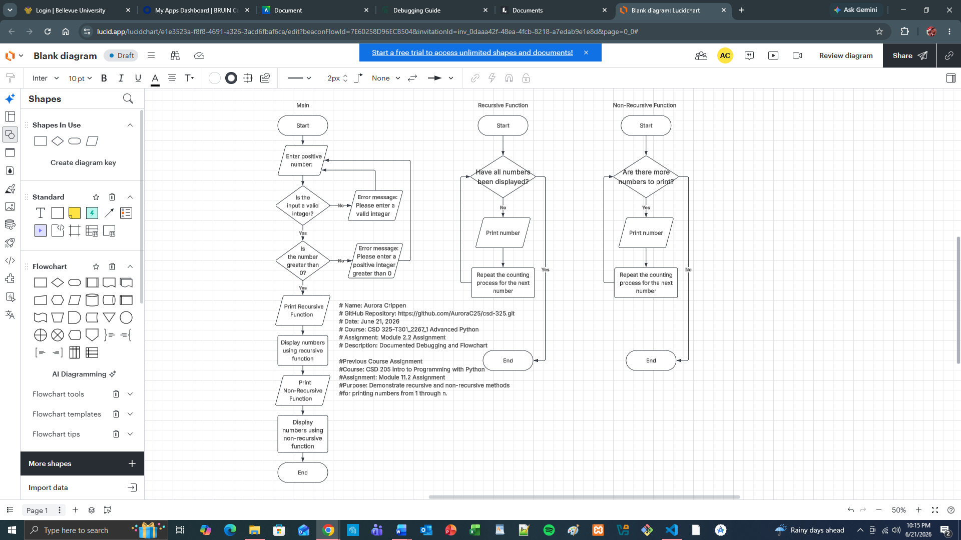

Breakpoint Screenshot
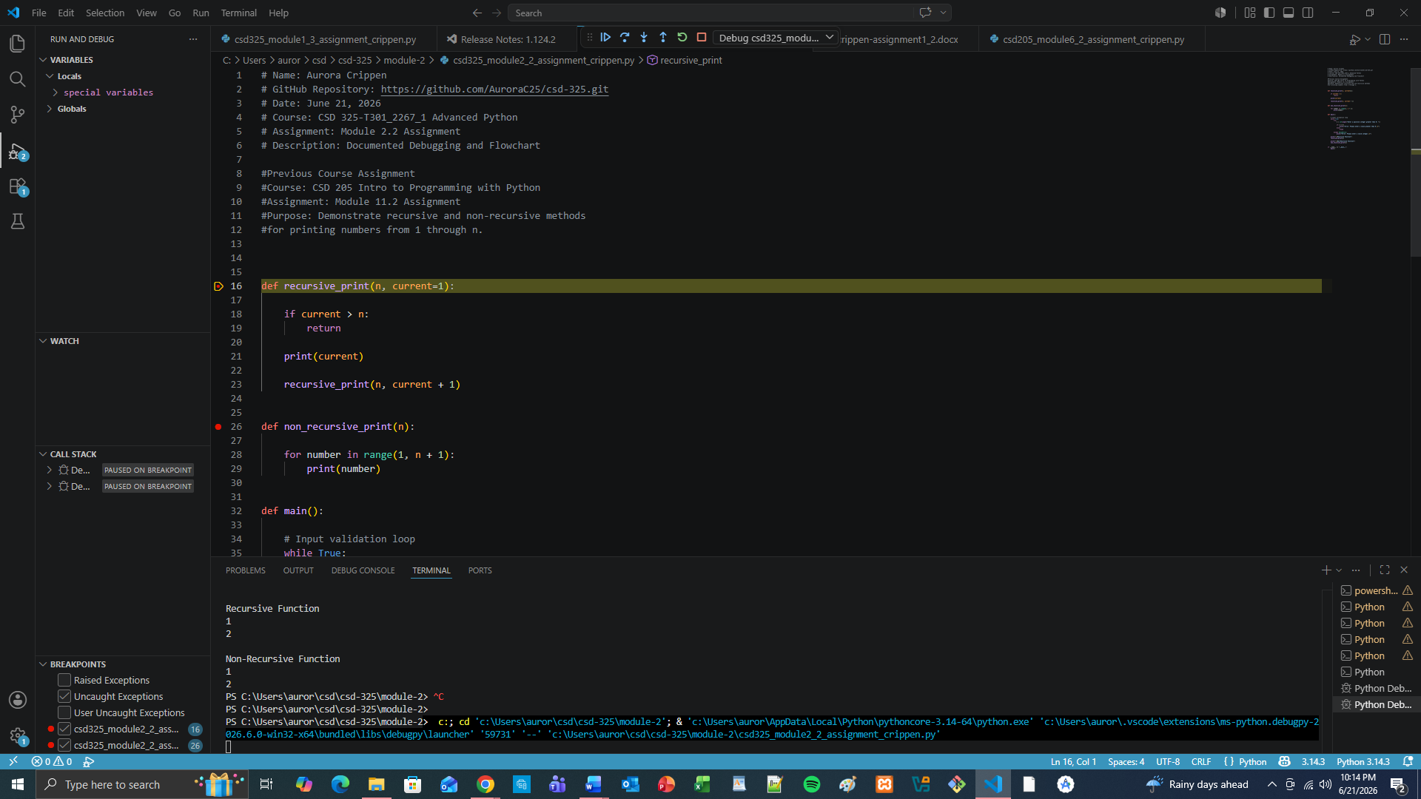
Current Location Screenshot
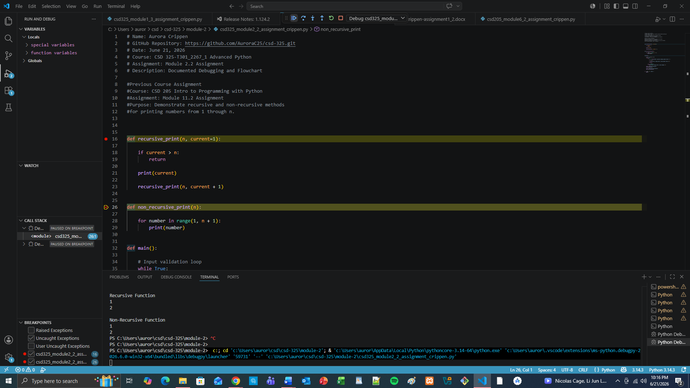
Intentionally Added Error Screenshot
