Link to my GitHub repository
https://github.com/AuroraC25/csd-325.git

Module 10.2 Assignment: GUI ToDo
For this assignment, you have two tasks. The first is to work through a tutorial on building a GUI To Do List, then to modify the program to fit requirements.
- Create (if you haven't already) a directory in CSD-325 named module-10.
- Open a Word document and put your name and assignment number at the top.
- Open the Tkinter-By-Example.pdf file listed in the Reading List.
- Create a Python program to use for the provided example.
- Read through the end of Section 2 in the tutorial and copy the code in Listing 2.2 Our Scrolling To-Do. Paste into your Python program and save to your module-10 directory. Run the program, add a couple of tasks, and take a screenshot of the output and paste into the Word document.
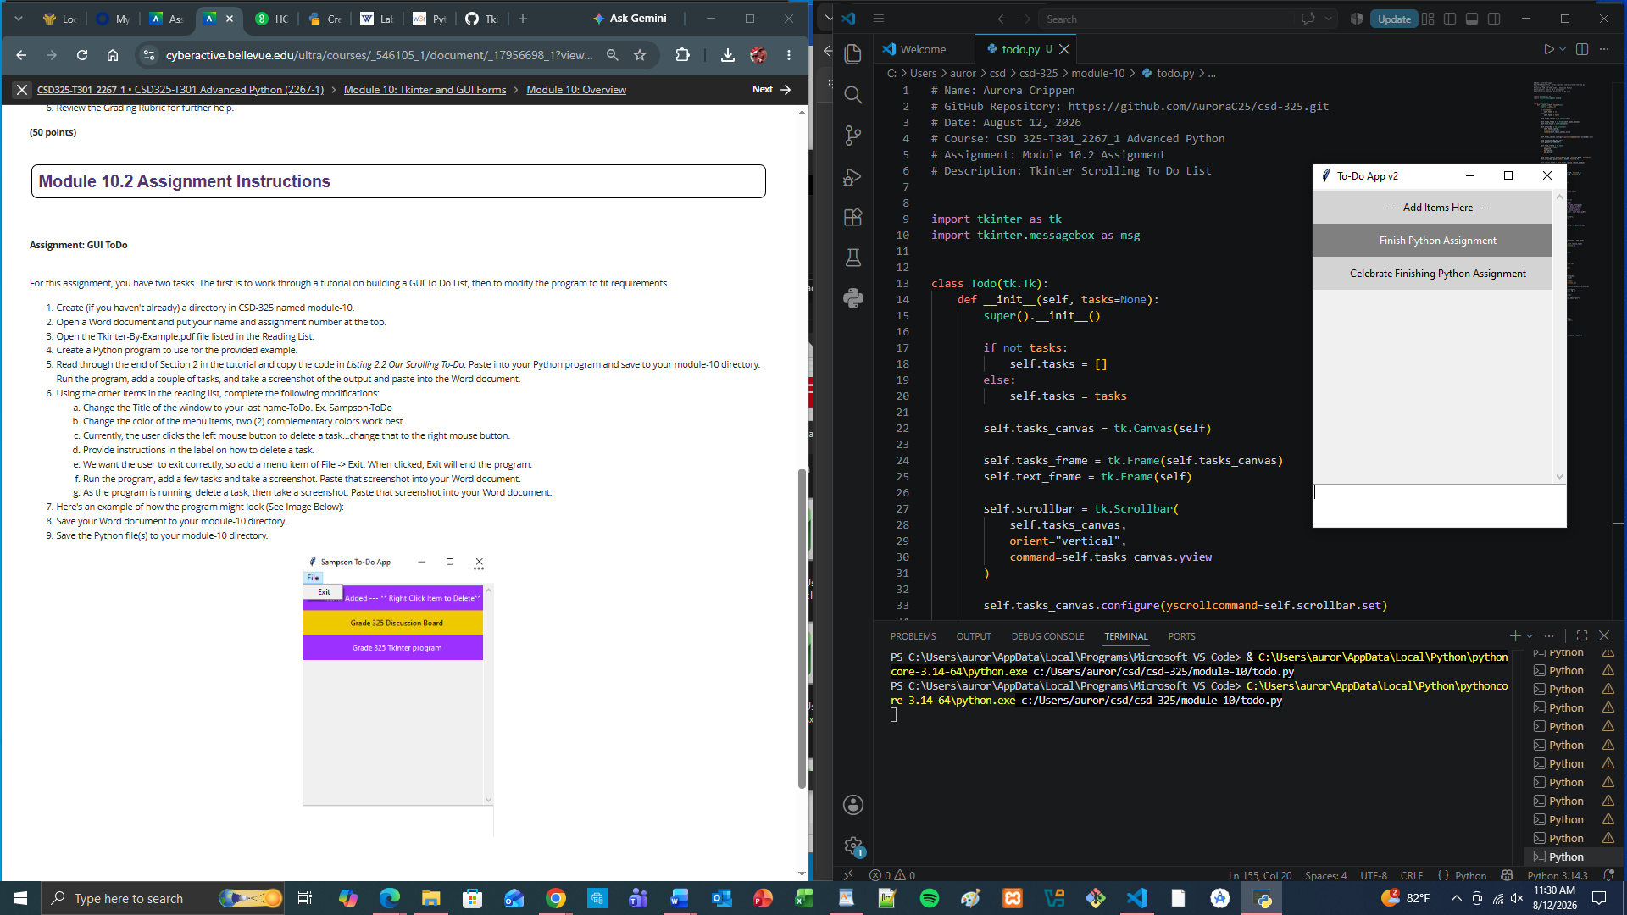

- Using the other items in the reading list, complete the following modifications:
  - Change the Title of the window to your last name-ToDo. Ex. Sampson-ToDo
  - Change the color of the menu items, two (2) complementary colors work best.
  - Currently, the user clicks the left mouse button to delete a task...change that to the right mouse button.
  - Provide instructions in the label on how to delete a task.
  - We want the user to exit correctly, so add a menu item of File -> Exit. When clicked, Exit will end the program.
  - Run the program, add a few tasks and take a screenshot. Paste that screenshot into your Word document.
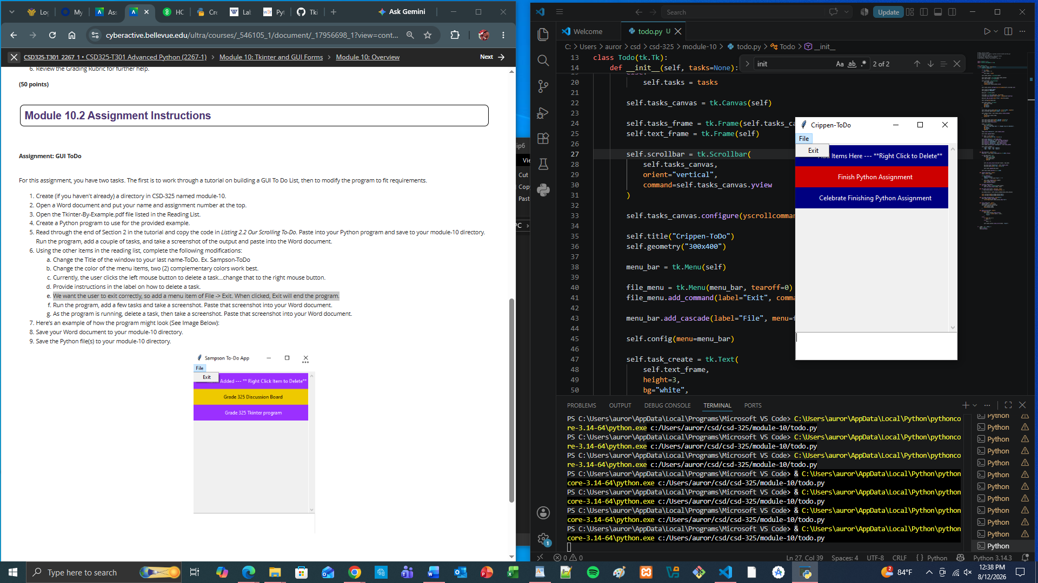
  - As the program is running, delete a task, then take a screenshot. Paste that screenshot into your Word document.
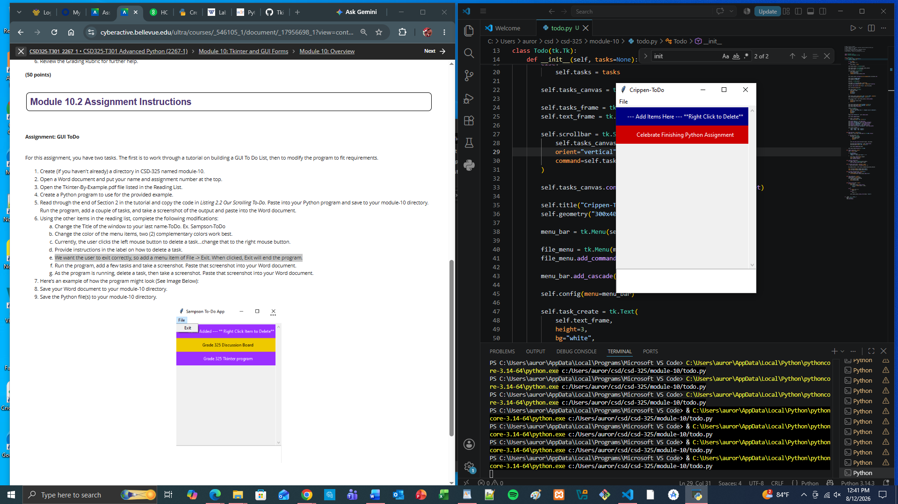

- Here's an example of how the program might look (See Image Below):
- Save your Word document to your module-10 directory.
- Save the Python file(s) to your module-10 directory.

