Link to my GitHub repository
https://github.com/AuroraC25/csd-325.git

Module 11.2 Assignment: Django Basics

a. When you've created the project, (around minute 3:30) stop and open a Command Line Interface and navigate to your demo directory. Do a directory listing (dir in Windows or ls in iOS) and make sure manage.py is visible. Type in the following: python manage.py runserver. Now, open up a browser window and type in the address 127.0.0.1:8000 and take a screenshot of the page. It should look something like the (Image Below):
b. Paste the screenshot into the Word document.
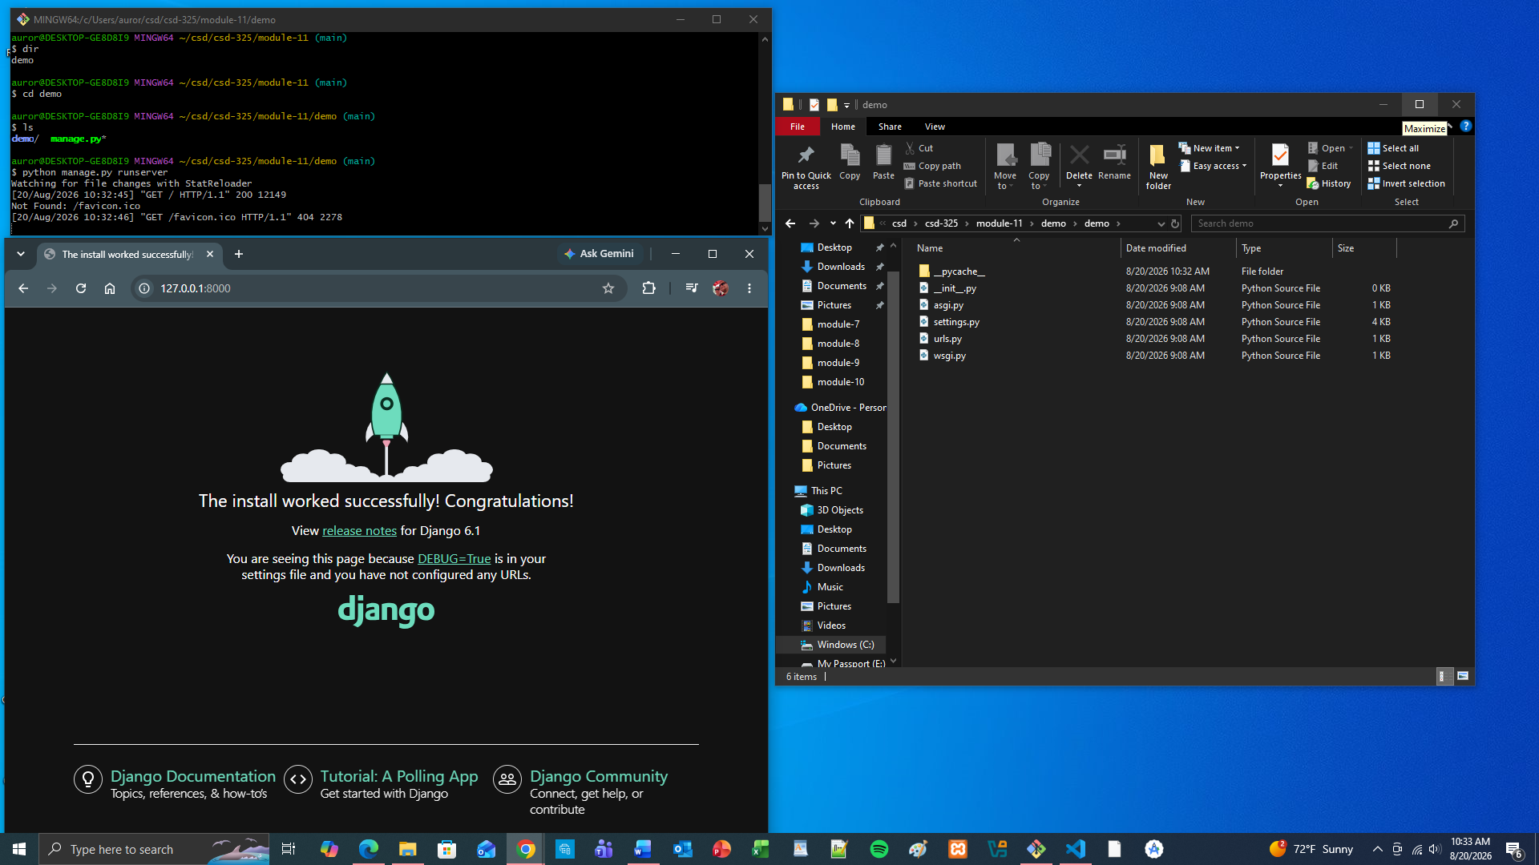
f. If you go out to your local host and see <your last name>" says Hello!, then congratulations! Take a screenshot. Paste that screenshot into your Word document.
