Link to my GitHub repository
https://github.com/AuroraC25/csd-325.git

Flowchart
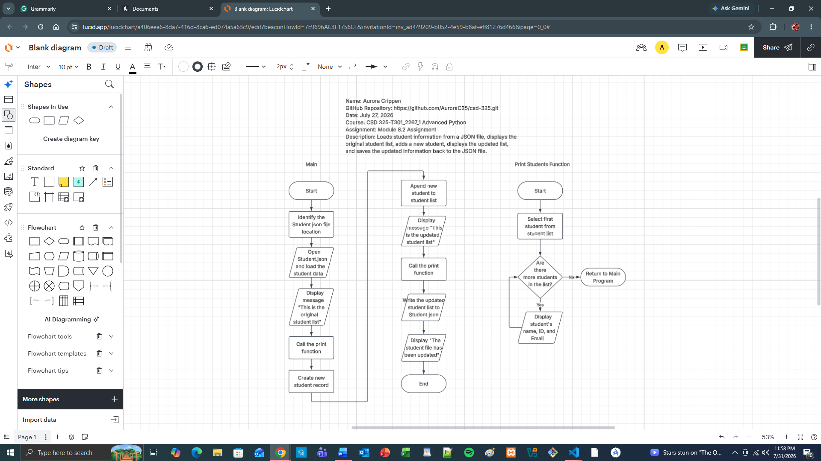

Screenshot 1
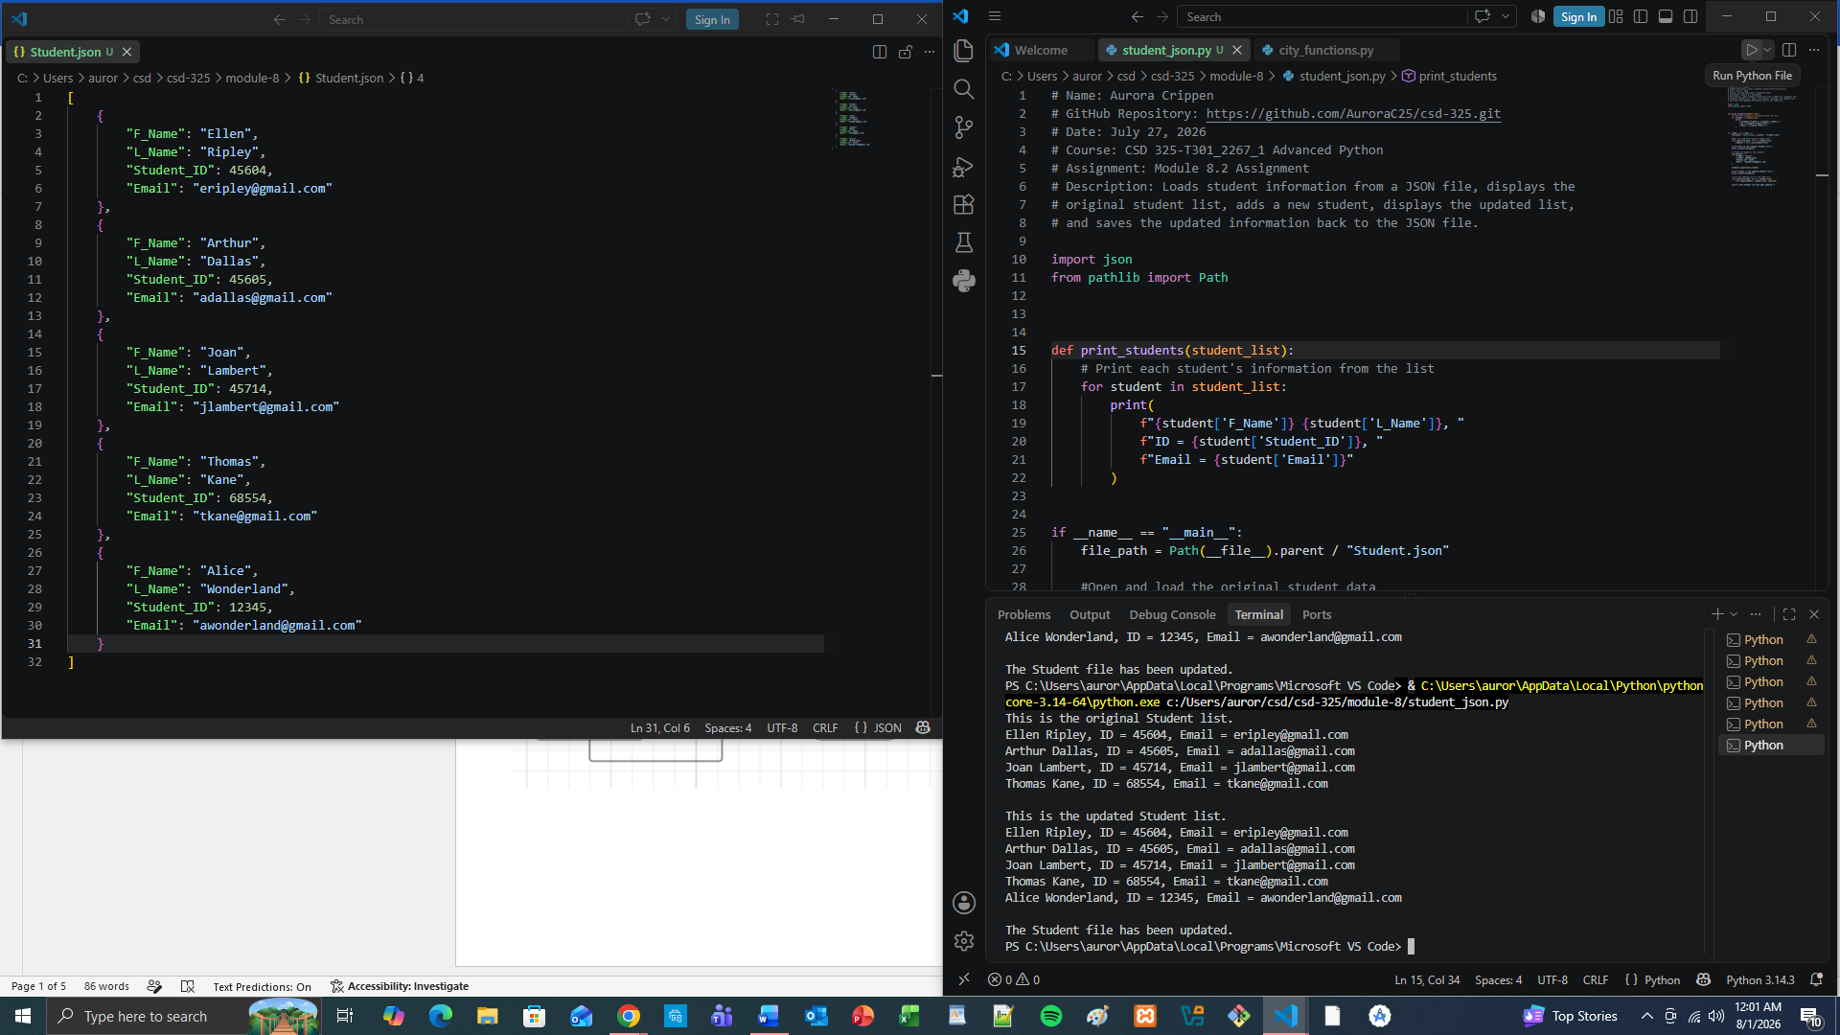

Screenshot 2


VS Code automatically reloaded the modified Student.json file instead of displaying the "file modified outside" notification shown in the assignment example. Because the file was reloaded automatically, no notification dialog appeared to capture.

Student.json file
[
{
"F_Name": "Ellen",
"L_Name": "Ripley",
"Student_ID": 45604,
"Email": "eripley@gmail.com"
},
{
"F_Name": "Arthur",
"L_Name": "Dallas",
"Student_ID": 45605,
"Email": "adallas@gmail.com"
},
{
"F_Name": "Joan",
"L_Name": "Lambert",
"Student_ID": 45714,
"Email": "jlambert@gmail.com"
},
{
"F_Name": "Thomas",
"L_Name": "Kane",
"Student_ID": 68554,
"Email": "tkane@gmail.com"
},
{
"F_Name": "Alice",
"L_Name": "Wonderland",
"Student_ID": 12345,
"Email": "awonderland@gmail.com"
}
]

