Link to my GitHub repository
https://github.com/AuroraC25/csd-325.git

4. API Tutorial
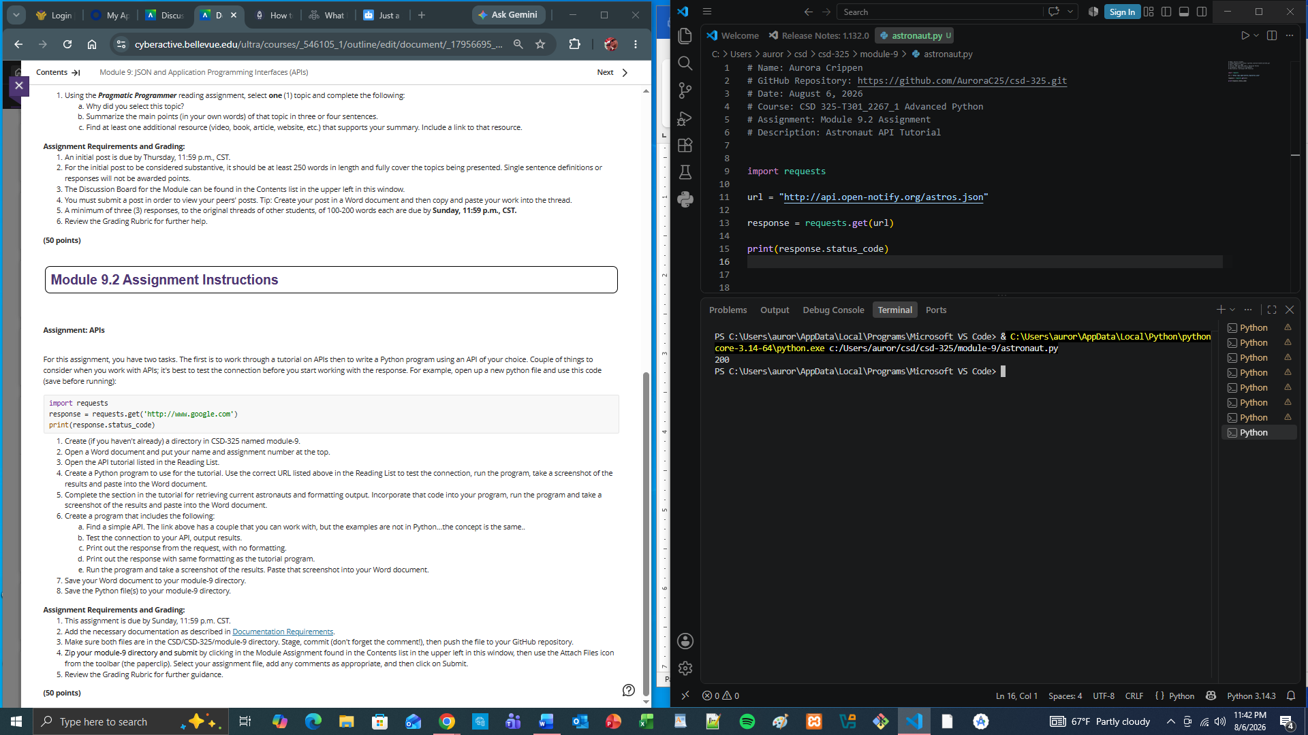

5. Current Astronauts and Formatted Output
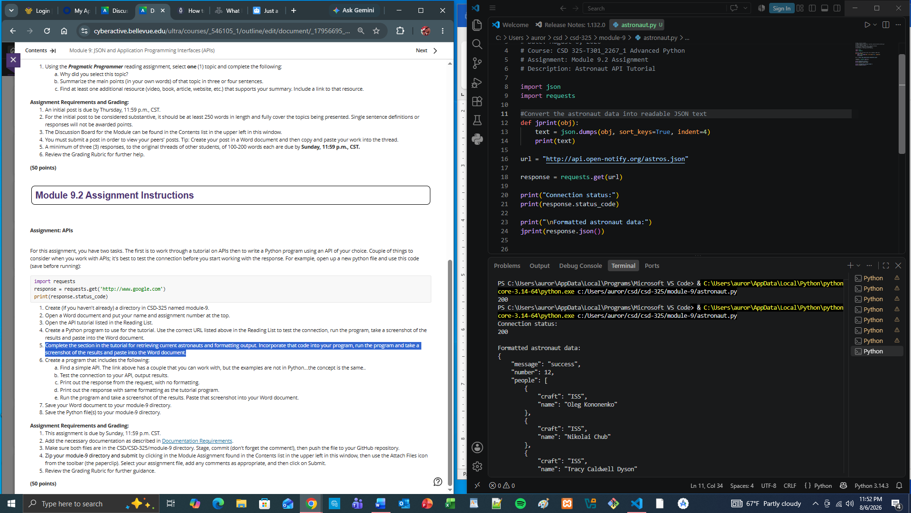

6. PokeAPI
a. https://pokeapi.co/api/v2/pokemon/mew

b. Test the connection
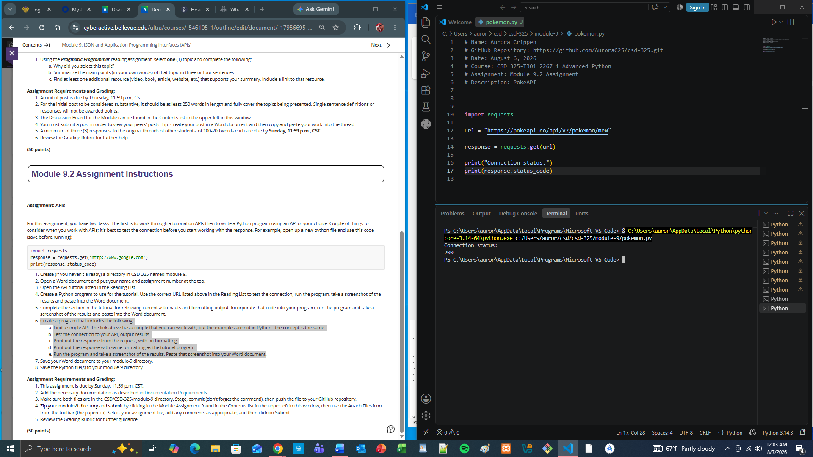

c. Printed response without formatting
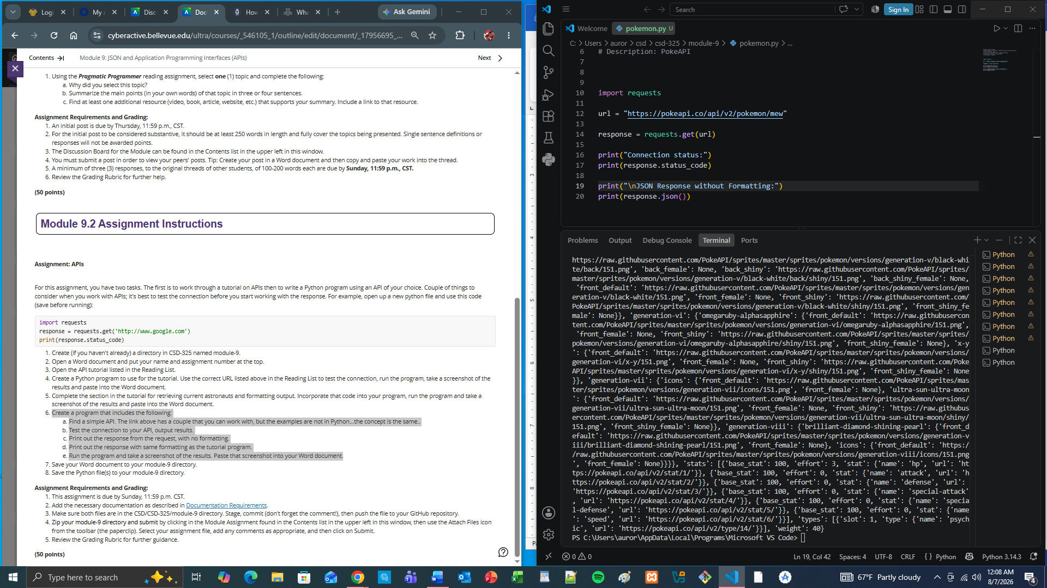

d. Response with Tutorial Formatting
