Link to my GitHub repository
https://github.com/AuroraC25/csd-325.git

Screenshot of my GitHub repository
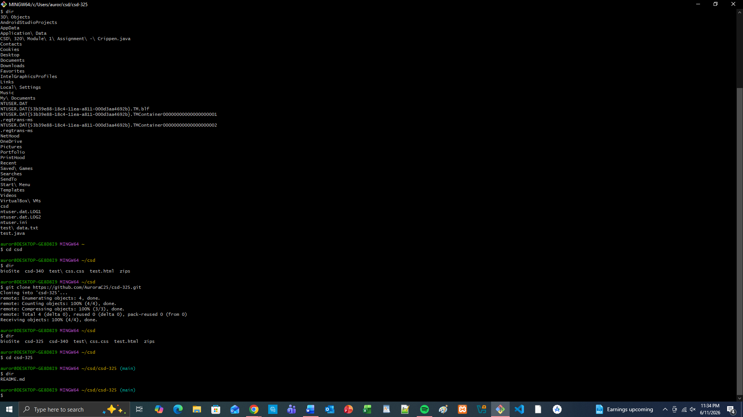

Screenshot of my local directory
