Link to my GitHub repository
https://github.com/AuroraC25/csd-402.git

Module 1.2 Assignment GitHub

Local Directory
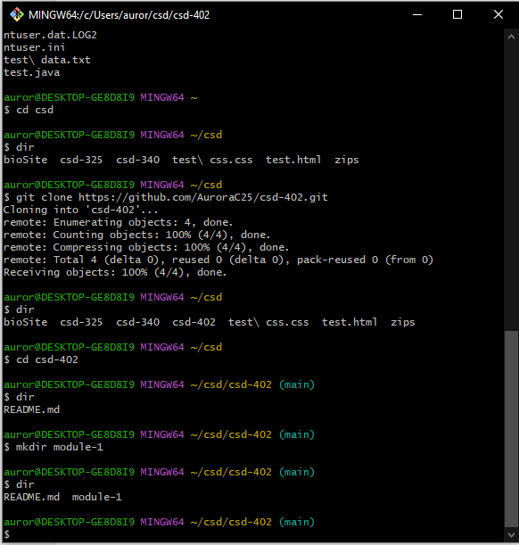

GitHub Repository
