Link to my GitHub repository
https://github.com/AuroraC25/csd-402.git

Module 1.3 Programming Assignment
Java Installed
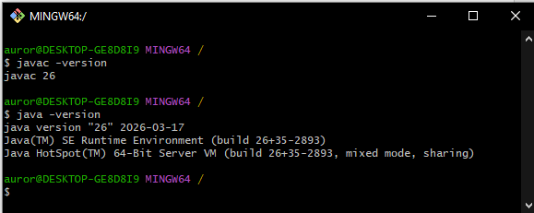

JavaFX Installed
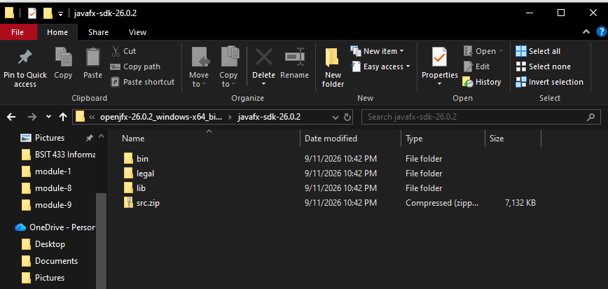

Java IDE Working
