1.Use case diagram

A use case is a step-by-step description of how a user will use the system-to-be to accomplish business goals.

Use case diagram shows relations of the actors and use cases.

<<initiate>>:simple user, initiates the use case to achieve a goal

<<participate>>:participates the use case without initiating

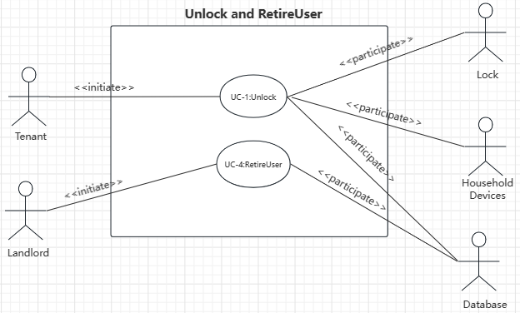

2.Use case schema

|  |  |  |  |
| --- | --- | --- | --- |
| **Use Case UC-1:** | | | **Unlock** |
| **Related Requirements:** | | REQ-1, REQ-2, REQ-3, REQ-4, REQ-5, REQ-6 | |
| **Initiating Actor:** | | Any of: Tenant | |
| **Actor’s Goal:** | | To disarm the lock and enter. | |
| **Participating Actors:** | | Lock, Household Devices, Database | |
| **Preconditions:** | | * The set of valid phone numbers stored in the system database is non-empty. * The system displays the menu of a available functions; at the door keypad the menu choices are “Lock” and “Unlock”. * The door keypad will be backlit when dark for visibility. | |
| **Postconditions:** | | * The system has set the number of lock-phone pairing failures to 0. * The auto-lock timer has started countdown from **autoLockInterval**. | |
| **Flow of Events for Main Success Scenario:** | | | |
| → | 1. **Tenant** arrives at the door and selects the menu item “Unlock”. 2. include::*AuthenticateUser* (UC-7) | | |
| ← | 1. **System** (a) signals to the **Tenant** the lock status, e.g.,“disarmed” (b) signals to the **Lock** to be unlocked. | | |
| ← | 1. **System** signals to the **Timer** to start the auto-lock timer countdown | | |
| → | 1. **Tenant** opens the door, enters the home.[and shuts the door and locks] | | |

|  |  |  |  |
| --- | --- | --- | --- |
| **Use Case UC-4:** | | | **RetireUser** |
| **Related Requirements:** | | REQ-1, REQ-2, REQ-3, REQ-4, REQ-7, REQ-8,REQ-9 | |
| **Initiating Actor:** | | Any of: Landlord | |
| **Actor’s Goal:** | | To retire an existing user account and disable access. | |
| **Participating Actors:** | | Database | |
| **Preconditions:** | | * The set of valid phone numbers stored in the system database is non-empty. | |
| **Postconditions:** | | * The system has removed a user’s account from the database. | |
| **Flow of Events for Main Success Scenario:** | | | |
| → | 1. **Landlord** started the **Database** management system. | | |
| ← | 1. **System** displays the **Database** to the **Landlord**. | | |
| → | 1. **Landlord** deletes a user’s account, saves changes and quit the **System**. | | |

3.Acceptance test

|  |  |  |
| --- | --- | --- |
| **Test-case Identifier:** | TC-1 | |
| **Use Case Tested:** | UC-1 | |
| **Pass/fail Criteria:** | The test passes if the user provides a mobile phone whose phone number is contained in the database, under the limit of less than the allowed number of unsuccessful attempts. | |
| **Input Data:** | Phone identifier | |
| **Test Procedure:** | | **Expected Result:** |
| Step 1. Type in an incorrect phone number | | System beeps to indicate failure;  records unsuccessful attempt in the database;  prompts the user to try again. |
| Step 2. Type in a correct phone number | | System flashes a green light to indicate success;  records successful access in the database;  disarms the lock. |

|  |  |  |
| --- | --- | --- |
| **Test-case Identifier:** | TC-2 | |
| **Use Case Tested:** | UC-4 | |
| **Pass/fail Criteria:** | The test passes if the user retires an existing user account and the system removes it or disables it. | |
| **Input Data:** | Lock device self-operation | |
| **Test Procedure:** | | **Expected Result:** |
| Step 1. Use the account which will be retired to open the door | | System flashes a green light to indicate success;  records successful access in the database;  disarms the lock. |
| Step 2. Retire an existing user account | | The user account is deleted from the database. |
| Step 3. Use the removed account to try to open the door again | | System beeps to indicate failure;  records unsuccessful attempts in the database;  prompts the user to try again. |