team_id: c_aqogom

Aurora Tiffany-Davis, Chengcheng Shao, Natansh Negi, Zelin Sun
Department of Computer Science
North Carolina State University
Raleigh, NC, USA
{attiffan, cshao, nnegi2, zsun12}@ncsu.edu

Abstract—In this project we compared three Database Management Systems (DBMS): MySQL, PostgresQL, and MongoDB. Our findings indicate that MySQL is dominant in the areas of industry support, contributor community strength, and developer interest, while source code quality findings are more complex. Thus, we recommend that most developers strongly consider MySQL. If MySQL lacks the performance or features needed by the application, the developer should weigh the pros and cons of PostgresQL and MongoDB.

Overview
We compare three open source Database Management Systems (DBMS) from four perspectives: industry usage, contributor community, developer interest, and source code quality. We also compare these systems using one "meta" metric.
Results were gathered from websites [1][2][3][4][5][6][10][11][12][17][23][24][25][25][26][27], website APIs [7][8][9], blog posts [13], source code repositories [14][15][16][18], existing literature [21][22], static analysis tools [19][20], and one homegrown tool.
Static analysis tool output and homegrown tool source code and output is available at our GitHub repository.

Approach
Our approach was to examine the question of what DBMS a developer may wish to use, in a very broad way. Key questions were:

How much support does the DBMS have from industry?
To answer this question, we investigated how many companies use the DBMS [1], how many websites use the DBMS [2], and how many open job positions mention the DBMS [3][4][5].

How much support does the DBMS have from open source contributors?
To answer this question, we investigated the number of contributors to the project [6], the number of commits to the project [6], the most recent commit to the project [6], and the trend in weekly commit quantities [7][8][9].

How popular is the DBMS with developers?
To answer this question, we investigated several measures from StackOverflow (the number of questions asked about the DBMS [10][11][12], the percentage of unanswered questions about the DBMS [10][11][12], the trend in questions about the DBMS [13], and the trend in views of questions about the DBMS [13]). We also investigated several other measures (the number of "stars" awarded to the projects using the DBMS on GitHub [14][15][16], the self-reported usage on Stackshare [1], and the trend in questions about the DBMS on Google [17]).

What is the quality of the DBMS source code?
To answer this question, we gathered results on lines of code (Cloc v1.74 [18]). We gathered results from static code analysis tools (CppCheck v1.84 [19] and CppLint v1.3.0 [20], used because they are popular C / C++ static analysis tools, and compared DBMS’s are written mostly in C / C++). We gathered results from a homegrown installation tool (measuring time to install, CPU usage during install, RAM usage during install, disk spaced used by install, and time to launch). We performed a small literature review on the topic of DBMS performance [21][22]. We compared key DBMS features [23][24][25][26]. Finally, we performed a subjective source code quality analysis.

Are our results reasonable?
To answer this question, we referred to another DBMS comparison project available online as a "sanity check" [27]. This comparison takes into account "Number of mentions of the system on websites... General interest in the system... Frequency of technical discussions about the system... Number of job offers, in which the system is mentioned... Number of profiles in professional networks, in which the system is mentioned... Relevance in social networks...". It uses a different (though not mutually exclusive) set of metrics to our industry usage and developer popularity analyses.

Conclusions

How much support does the DBMS have from industry?
MySQL is used by more companies, is used by far more websites, and has more open job positions on Indeed, than either of the other DBMS. From our analysis, MySQL is clearly dominant in industry.
Strong industry support may be helpful when choosing a DBMS, as a developer choosing such a DBMS may have better career options, and a company choosing such a DBMS may have better hiring options.
Details can be seen in Figure 1.

How much support does the DBMS have from open source contributors?
MySQL has had more contributors and more commits than either of the other DBMS. PostgresQL has had the most recent commit, but only by a week's time. MongoDB has the strongest trend in weekly commits over the last year. Taken as a whole, the contributor community metrics lead us to believe that MySQL has the strongest support within the open source contributor community.
Strong community support may be helpful when choosing a DBMS, as such a DBMS may be expected to have bugs addressed, and new features added, well into the future.
Space does not allow us to show all results, however the most striking result, number of contributors, is shown in Figure 2.

How popular is the DBMS with developers?
MySQL has had far more questions asked about it on StackOverflow than either of the other DBMS. MySQL has a lower percentage of unanswered questions on StackOverflow than the other DBMS. MySQL is experiencing a slight downward trend in the percentage of questions asked on StackOverflow, but is still seeing far more questions being asked currently than the other DBMS. MySQL is experiencing a slight upward trend in % views on StackOverflow, and is having more views currently than the other DBMS. On GitHub, there are more repositories using MySQL that have > 100 "stars" than the other DBMS. On StackShare, there are more developers reporting that they use MySQL than the other DBMS. On Google, there is much more interest in MySQL, across the globe, than the other DBMS (and the trendline doesn't indicate that this will change any time soon). From our analysis, MySQL is clearly dominant in terms of developer popularity.
Strong developer popularity may be helpful in choosing a DBMS, as a developer choosing such a DBMS can expect to find answers to many of their questions during development, and can develop with confidence based on "the wisdom of the crowd" standing behind the DBMS. Additionally, a company choosing such a DBMS may have better hiring options.
Space does not allow us to show all results, however the most striking result, number of questions asked on StackOverflow, is shown in Figure 3.

What is the quality of the DBMS source code?
MySQL has fewer issues relative to lines of code than either of the other DBMS, according to both CppCheck and CppLint static analysis tools.
Our custom application for analyzing DBMS installation revealed that PostgresQL has the fastest average installation time, that MongoDB has the lowest average CPU usage during installation, and that there are no significant differences in RAM usage during installation.
Our review of existing performance analyses revealed that different DBMS are performant at different types of queries. However, MongoDB seems to be the most performant in the most areas. One interesting finding is that MongoDB may be less performant at "select". Therefore, MongoDB may perform relatively well in a write-heavy context, but relatively poorly in a read-heavy context.
Our analysis of the feature sets provided by the DBMS revealed that MySQL is a fairly basic relational database management system, while PostgresQL and MongoDB offer a richer feature set. A developer must evaluate the DBMS based upon the features actually needed by the application currently, and upon the features that are likely to be needed in the future.
While our subjective judgement of source code quality showed strengths in each DBMS, we favored MongoDB overall. Areas where MongoDB shine include file organization and variable naming.
When taking all the source code quality analyses into account, we conclude that there is no clear "winner" – a developer must weigh which source code quality metrics are most important to their specific application, and must consider the features offered by each DBMS against the current and future needs of their application.
Space does not allow us to show all results, however the static analysis results summary is shown in Figure 4.

Are our results reasonable?
The comparison we used as a "sanity check", which uses a different (though not mutually exclusive) set of metrics to our industry usage and developer popularity analyses, backs up our results in these areas. MySQL is clearly dominant over PostgresQL and MongoDB in these areas.
Space does not allow us to show the results of this comparison, however (as with other results not shown in this report), much more information is available at our GitHub repository.
References

- Stackshare comparison of MySQL, PostgresQL, MongoDB [Online]. Available: https://stackshare.io/stackups/mongodb-vs-mysql-vs-postgresql.
- Datanyze results for database domain market share [Online]. Available: https://www.datanyze.com/market-share/databases
- Indeed job postings for MySQL [Online]. Available: https://www.indeed.com/q-MySQL-jobs.html
- Indeed job postings for PostgresQL [Online]. Available: https://www.indeed.com/q-postgresql-jobs.html
- Indeed job postings for MongoDB [Online]. Available: https://www.indeed.com/q-mongodb-jobs.html
- OpenHub comparison of MySQL, PostgresQL, MongoDB [Online]. Available: https://www.openhub.net/p/_compare?project_0=MongoDB&project_1=PostgreSQL+Database+Server&project_2=MySQL
- GitHub API hook for MySQL project commit activity [Online]. Available: https://api.github.com/repos/mysql/mysql-server/stats/commit_activity
- GitHub API hook for PostgresQL project commit activity [Online]. Available: https://api.github.com/repos/postgres/postgres/stats/commit_activity
- GitHub API hook for MongoDB project commit activity [Online]. Available: https://api.github.com/repos/mongodb/mongo/stats/commit_activity
- StackOverflow MySQL questions [Online]. Available: https://stackoverflow.com/questions/tagged/mysql
- StackOverflow PostgresQL questions [Online]. Available: https://stackoverflow.com/questions/tagged/postgresql
- StackOverflow MongoDB questions [Online]. Available: https://stackoverflow.com/questions/tagged/mongodb
- Hoffa, Felipe. “These are the real Stack Overflow trends: Use the pageviews” Towards Data Science, 10 July 2018 [Online]. Available: https://towardsdatascience.com/these-are-the-real-stack-overflow-trends-use-the-pageviews-c439903cd1a
- GitHub search results for projects using MySQL [Online]. Available: https://github.com/search?q=MySQL+stars%3A%3E100
- GitHub search results for projects using PostgresQL [Online]. Available: https://github.com/search?q=PostgresQL+stars%3A%3E100
- GitHub search results for projects using MongoDB [Online]. Available: https://github.com/search?q=MongoDB+stars%3A%3E100
- Google Trends comparison of MySQL, PostgresQL, MongoDB [Online]. Available: https://trends.google.com/trends/explore?q=PostgresQL,MongoDB,MySQL
- GitHub Cloc repository [Online]. Available: https://github.com/AlDanial/cloc
- GitHub CppCheck repository [Online]. Available: https://github.com/danmar/cppcheck/
- GitHub CppLint repository [Online]. Available: https://github.com/cpplint/cpplint
- Wilkins, David. "Database Regex Performance" Conocuh Software, 18 December 2013 [Online]. Available: http://conecuh.com/blog/2013/12/18/database-regex-performance/
- Dolgov, Dmitry. "Compare incomparable: PostregSQL vs Mysql vs Mongodb" My thoughts and experiments, 29 December 2015 [Online]. Available: http://erthalion.info/2015/12/29/json-benchmarks/
- MySQL website [Online]. Available: https://www.mysql.com/
- PostgresQL website [Online]. Available: https://www.postgresql.org/
- MongoDB website [Online]. Available: https://www.mongodb.com/
- MongoDB Issue Tracker [Online]. Available: https://jira.mongodb.org/secure/Dashboard.jspa
- DB-Engines ranking of various DBMS [Online]. Available: https://db-engines.com/en/ranking_trend

Results
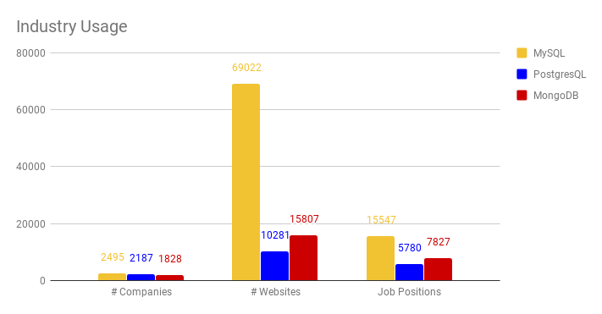
Figure 1
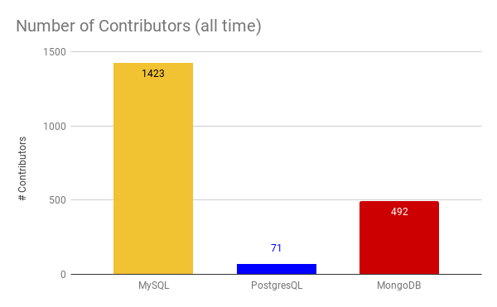
Figure 2

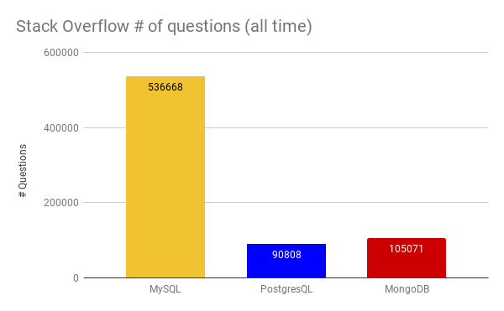
Figure 3

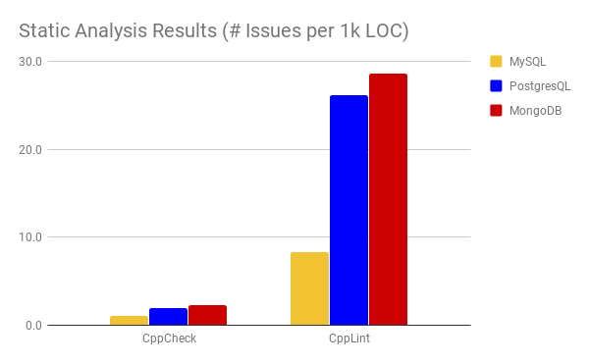
Figure 4

https://github.com/AuroraTD/CSC510

