Design Pattern #1: Center Stage

Summary:

What: The most important information is the largest part of the window, and additional information or tools are smaller and set off to the side.

When: It should be used when there is one thing that is clearly more important than any other information or tools.

Why: It gives the most important information immediate attention while everything else can be assessed by the user later in relation to the main section. It keeps the user from getting confused or sidetracked from the main/important information.

How: Size-wise, it should be bigger than anything else on the page, preferably at least twice as high and/or wide as it’s margins. In regard to color, black text on a white background is the easiest and most common contrast that users have been trained to look for. Use of headlines or standard layouts, such as graphic editors, maps, or diagrams are also useful to Center Stage.

Mock-up:

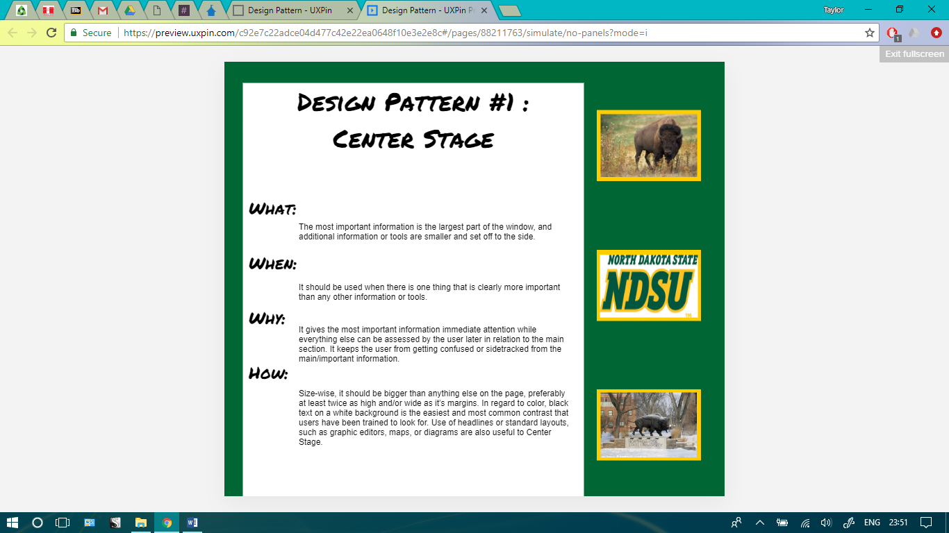

Working Example: