**2020年12月四级写作**

**Writing 1**: For this part, you are allowed 30 minutes to write the topic Changes in the Way of Education. You should write at least 120 words but no more than 180 words.

**Writing 2:** the topic Changes in the Way of Communication

**Writing 3:** the topic Changes in the Way of Transportation

**2020年12月四级翻译**

**翻译1:**

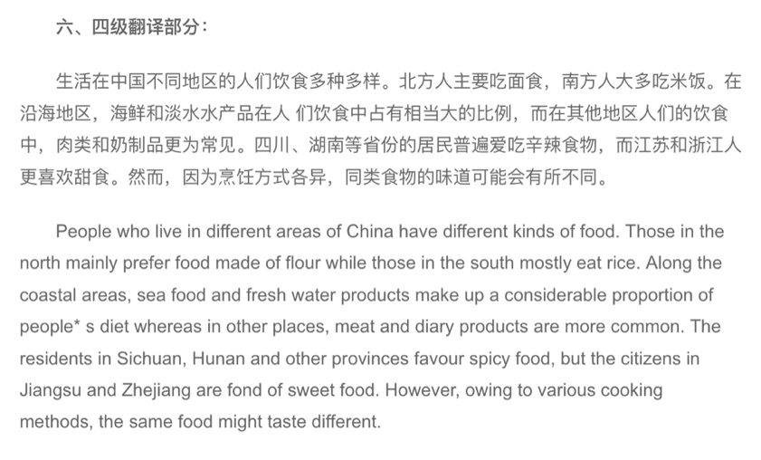

**翻译2**

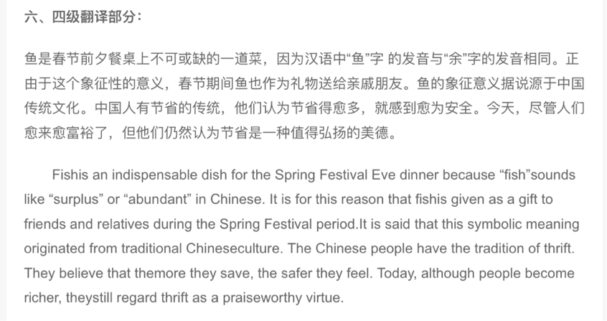

**翻译3**

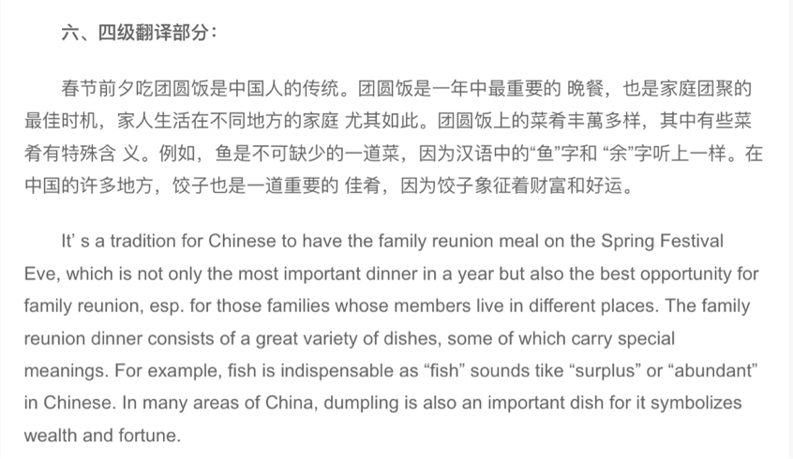

**范文1，2，3**

