Table of Contents
1. Executive Summary
2. Platform Overview
3. Problem Statement
4. Solution Overview
5. Platform Features
6. Onboarding & Personalization System
7. System Architecture
8. Technical Stack
&nbsp;&nbsp;&nbsp;&nbsp;8.1 Frontend
&nbsp;&nbsp;&nbsp;&nbsp;8.2 Backend
&nbsp;&nbsp;&nbsp;&nbsp;8.3 AI & Infrastructure
9. Database Architecture
10. AI System Architecture
11. Security Architecture
12. UI/UX Design System
13. User Workflows
14. Scalability & Performance
15. Future Roadmap
16. Business & Market Value
17. Conclusion
18. Appendices: Summaries & Assessments
Executive Summary
DzidzaAI is an AI-first educational platform designed to transform how learners acquire knowledge through highly personalized, conversational tutoring and automated content generation. It addresses core challenges in modern education—access, personalization, engagement, and assessment quality—by combining state-of-the-art AI models, robust backend services, and a modern, accessible frontend experience.
Problem: Current education systems are constrained by one-size-fits-all instruction, limited access to quality tutors, and inefficient revision and assessment workflows.
Solution: DzidzaAI delivers individualized learning paths, adaptive tutoring sessions, AI-generated quizzes and flashcards, intelligent study planners, and analytics to guide students and educators.
Target Users: Primary, secondary, tertiary students, professional certification candidates, educators, and institutions seeking scalable, data-driven learning support.
Vision: Empower every learner with a personalized AI tutor that scales across curricula and educational contexts while preserving safety, accuracy, and measurable outcomes.
Key Outcomes
Reduced time-to-proficiency through personalized study plans and spaced repetition.
Higher engagement via conversational sessions and dynamic content.
Administrative insights for educators through analytics and reports.
Enterprise-grade security and scalable architecture for institutional adoption.
Platform Overview
What is DzidzaAI?
DzidzaAI is a SaaS platform that blends conversational AI, content generation, and learning science to deliver adaptive education experiences. Core modules include AI Tutor, Chat, Quiz/Exam/Flashcard Generation, Study Planner, Document Processing, and Analytics.
Supported Educational Tiers
Primary & Secondary School
O-Level & A-Level
College & University
Professional Certifications
Business Model
Hybrid SaaS and B2B licensing: freemium consumer tiers, subscription-based premium plans for students, and institutional licensing for schools and universities. Additional revenue from professional certification prep bundles and API/white-label integrations.
Problem Statement
Modern learners face systemic issues that impede effective learning:
Lack of Personalized Learning: Curricula rarely adapt to individual pace, prior knowledge, or learning preferences.
Poor Access to Tutoring: Quality tutoring is unevenly distributed and costly.
Ineffective Revision Systems: Students often lack structured, evidence-based revision like spaced repetition.
Lack of Academic Organization: Many learners struggle with planning, time management, and tracking progress.
Difficulty Generating Study Material: Preparing targeted quizzes, exams, and flashcards is time-consuming for educators.
Curriculum Mismatch: Learning materials are frequently out-of-sync with syllabus requirements.
Poor Student Engagement: Static content and one-way lecture formats lower motivation.
Solution Overview
DzidzaAI solves these problems with an integrated set of AI-driven features:
Conversational AI: Natural language chat and tutoring sessions to help students ask questions, receive explanations, and iterate on concepts.
AI Tutoring: Adaptive problem selection and targeted feedback driven by student model and assessment outcomes.
Personalized Learning: Onboarding and ongoing behavior-based personalization to tailor content and study plans.
AI-Generated Content: Automatic quizzes, exams, flashcards, and summaries aligned to curriculum inputs.
Study Planning: Intelligent schedulers and timetables that integrate with personal calendars and retention strategies.
Analytics: Dashboards for learners and educators with progress metrics, weak-topic detection, and cohort analyses.
Platform Features — Detailed Breakdown
Each feature is described with purpose, how it works, frontend and backend responsibilities, AI integration points, and direct user benefits.
FeaturePurposeHow It WorksFrontendBackendAIUser Benefits
AI Tutor
Deliver real-time adaptive tutoring sessions.
Conversational sessions driven by a student model, curriculum mapping, and dynamic question generation.
Chat UI, session controls, hints, feedback, session history.
Session management, ephemeral storage, transcript persistence, scoring.
LLMs for explanation generation, retrieval-augmented generation (RAG) using vector DB, model-of-student personalization.
Personalized help, instant feedback, reduced time-to-understand.
AI Chat
Casual Q&A, study advice, and research assistance.
Free-form chat with optional context (documents, past sessions, user profile).
Conversational UX, attachments, file upload integration.
Message routing, rate-limiting, context fetching, RAG orchestration.
OpenAI/Gemini for answers; vector search for document context.
On-demand assistance; reduces friction for study queries.
Flashcards
Fast, spaced repetition-based memorization tool.
Auto-generated cards from notes/documents or manual input; schedule via SRS algorithm.
Card review UI, progress indicators, difficulty tagging.
Persistence, spaced repetition scheduling, sync across devices.
LLMs summarize concepts into Q/A pairs; suggest distractors for multiple-choice.
Improved retention; automated content generation saves instructor time.
Quiz Generator
Create practice quizzes tailored to topics and difficulty.
Input topic + coverage; generate multi-format questions with answers and explanations.
Quiz builder UI, preview, attempt mode, timed quizzes.
Question bank, scoring, reporting, export to LMS formats.
LLMs generate plausible questions and answers; quality checks via heuristics.
Targeted practice, immediate feedback, scalable assessments.
Exam Generator
Generate proctored-style exams aligned to syllabus.
Template-driven exam generation with randomized variants.
Exam UI, proctoring hooks (optional), timer, submission.
Secure storage, submission validation, plagiarism scanning.
LLMs draft questions; anti-cheat via similarity detection and proctor signals.
High-quality, varied assessments at scale.
Study Planner
Schedule study sessions optimized for retention and availability.
Combines user calendar, deadlines, and spaced repetition to create a prioritized schedule.
Planner UI, drag/drop slots, calendar sync, notifications.
Scheduler engine, conflict resolution, persistent plans, notifications.
AI suggests optimal study cadence based on mastery and forgetting curve.
Better time management and measurable progress.
Timetable System
Organize regular classes, study blocks, and events.
Recurring slots, calendar sync, class metadata, attendance tracking.
Timetable UI, slot edits, reminders.
CRUD for timetables, conflict detection, optimization endpoints.
AI can propose optimal weekly timetables for workload balance.
Consistent study rhythm and improved productivity.
Focus Sessions
Timed focus intervals with ambient cues and micro-goals.
Pomodoro-style sessions, optional background sounds, telemetry.
Session timer, goals, progress widget.
Session logs, streak tracking, analytics integration.
AI-provided micro-coaching and productivity advice.
Improved concentration and habit building.
Document Uploads & AI Summaries
Process study materials and produce condensed notes.
Upload docs; system extracts text, splits into chunks, and summarizes/contextualizes.
Upload widget, summary viewer, highlights, export.
File storage, extraction workers, chunking and vectorization.
LLMs for summarization; vector store for retrieval and RAG answers.
Faster review of large materials and context-rich chat answers.
Learning Analytics
Provide actionable insights to learners and administrators.
Collect progress metrics and generate reports and alerts.
Dashboards, reports, export options.
Metrics pipeline, aggregation, cohort analysis endpoints.
AI identifies at-risk students and suggests interventions.
Data-driven decisions for learners and educators.
User Dashboard
Centralized hub for tasks, progress, and recommendations.
Aggregates sessions, upcoming tasks, recent activity, and suggestions.
Widgets, notifications, progress rings, quick actions.
Aggregates multiple services, caches summary views.
Personalized recommendations engine for next-study actions.
Clear focus and increased engagement.
Notifications
Inform users about schedules, deadlines, and performance.
Push/email/in-app notifications with user preferences and retry logic.
Preference center, in-app toasts, push prompt.
Notification orchestration, TTL, retry queue, templates.
AI for smart reminders and contextual nudges.
Improved retention and reduced missed sessions.
Authentication & Security
Protect user data and support enterprise policies.
Multi-factor options, session management, role-based access.
Login, signup, OTP flows, single sign-on hooks.
JWT refresh/access tokens, secure cookies, session storage.
AI for fraud detection and anomaly alerts.
Secure, auditable access for individuals and institutions.
Onboarding System
Collect initial profile and learning goals to personalize experience.
Progressive onboarding with autosave, draft persistence, and pre-signup personalization.
Multi-step forms, progress indicators, draft recovery.
Draft store, autosave endpoints, TTL management.
AI maps profile responses to curriculum and recommends study paths.
Faster personalization and higher likelihood of engagement.
Admin Dashboard
Manage users, content, analytics, and system health.
User management, content review, analytics filters, role controls.
Admin UI, bulk actions, audit logs.
Admin APIs, RBAC, audit trails, bulk processing jobs.
AI to highlight anomalous behavior and recommend content improvements.
Operational efficiency and data-driven governance.
Onboarding & Personalization System
Onboarding Workflow
Landing & initial prompt: short survey capturing education level, curriculum, key subjects, goals, and study availability.
Progressive profiling: follow-up micro-questions based on earlier answers (e.g. preferred learning style, strengths, weak topics).
Autosave & draft persistence: partial answers saved server-side with TTL; draft linked to account on signup.
AI mapping: responses passed through personalization engine to generate an initial study path, prioritized subjects, and suggested micro-goals.
Dashboard personalization: recommended widgets, suggested study sessions, and prioritized content loaded into the user dashboard.
Education-level Personalization
The onboarding captures educational tier (e.g., A-Level, University) and maps to curriculum templates. For example:
A-Level: subject modules broken into topics, recommended exam-style practice, time-to-exam scheduling.
University: course/module mapping, lecture notes ingestion, research assistance and assignment support.
Medical/Professional: case-based practice, high-stakes exam simulation, spaced-retention for critical facts.
AI Personalization Logic
Personalization engine uses a mix of rule-based templates and model-based recommendations:
User model tracks mastery per topic, engagement signals, and time availability.
AI suggests study cadence and content formats (explainers, flashcards, quizzes) based on learning profile.
Adaptive difficulty and content selection updated after each assessment and session.
Autosave Onboarding & Draft Linking
Autosave strategy:
Client-side debounce; changes sent to `/api/onboarding/drafts` for anonymous users.
Server drafts have TTL and are linked to account at signup when `draftId` is supplied.
Conflict resolution favors latest complete draft and preserves partial answers for recovery.
Example Experiences
A-Level Student
Onboarding identifies next exam date, core topics (Physics, Maths), and weak areas. AI schedules topic-focused quizzes and daily flashcards prioritized by exam proximity.
University Student
Onboarding maps modules and deadlines. AI suggests weekly study blocks, provides reading summaries, and answers assignment-related queries.
Medical Student
Onboarding focuses on high-yield topics, case-based scenarios, and spaced repetition for critical facts; AI generates exam simulations and clinical vignettes.
Software Engineering Student
Onboarding collects preferred languages, courses, and career goals; AI suggests project-based learning tasks, code-review style quizzes, and practical exercises.
System Architecture
High-Level Overview
DzidzaAI is built as a modular, microservice-capable architecture with a responsive SPA frontend, a Node.js API backend, worker queues for heavy processing, and external AI providers behind an abstraction layer.
Frontend Architecture
React + Vite SPA with route-based code-splitting.
TanStack Router for declarative routing; Zustand for lightweight app state.
Component-driven design system using Tailwind for utility-first styling.
Progressive enhancement with offline cache for drafted onboarding content.
Backend Architecture
Express.js API layer handling auth, user management, onboarding, and analytics.
Modular controllers and services pattern with clear separation: aiService, documentProcessingService, vectorService.
Worker processes (BullMQ) for document extraction, vectorization, large-model calls orchestration, and notification delivery.
AI Architecture
Provider abstraction layer supporting OpenAI, Gemini, and DeepSeek.
Request router with per-request model selection, prompt templates, safety filters, and cost controls.
RAG (Retrieval-Augmented Generation) using a vector store and passage retrieval for grounded answers.
Authentication Flow
User -> SPA -> /auth/signup (email) -> server creates user + OTP -> email OTP -> /auth/verify-email -> server issues accessToken (JWT) + refresh cookie
Tokens: accessToken (short-lived), refreshToken (httpOnly cookie)
Session store for refresh token revocation and audit
API Structure
RESTful endpoints under `/api/*` with JSON bodies and OpenAPI-compatible schema.
Key modules: `/auth`, `/users`, `/onboarding`, `/quizzes`, `/documents`, `/analytics`.
Routing & State Management
Client routing via TanStack Router; guarded routes for onboarding and protected content.
State: ephemeral UI state in React, persisted session/user state in Zustand; server-side canonical state in MongoDB.
Worker & Queue Architecture
Heavy tasks (document parsing, vectorization, long-running AI jobs) run in separate workers coordinated via Redis + BullMQ. Workers can autoscale independently.
Storage Architecture
Primary database: MongoDB for flexible document schemas.
Vector store: managed or self-hosted vector DB (e.g., Pinecone, Milvus, or RedisVector/RedisAI).
Object storage: AWS S3 (or compatible) for document storage and user uploads.
Cache: Redis for short-lived data, session state, counters, and rate-limiting buckets.
Tech Stack
Frontend
TechnologyWhy
ReactLarge ecosystem, component model, wide talent pool.
ViteFast dev server and optimized builds.
ZustandLightweight global state, simple API.
TanStack RouterModern routing with fine-grained control.
Tailwind CSSRapid UI development and consistent design tokens.
Backend
TechnologyWhy
Node.js & ExpressAsynchronous IO, fast iteration, large package ecosystem.
MongoDBFlexible document models for varied academic content.
RedisCaching, rate-limiting, queues coordination.
BullMQRobust job queues with retry/backoff and concurrency controls.
DockerConsistent environments and simplified deployment.
AI
TechnologyWhy
OpenAI / Gemini / DeepSeekMulti-provider abstraction improves reliability and cost control.
Vector DB (Pinecone/Milvus)Efficient semantic retrieval for RAG.
Testing & DevOps
Vitest/Jest for unit tests, Playwright for E2E, Supertest for API integration.
GitHub Actions for CI/CD, container builds, and integration tests.
Database Architecture
Core Schemas
User Schema
Key fields: _id, name, email, hashedPassword, roles, educationLevel, subjects[], academicProfile, onboardingCompleted, preferences, createdAt, updatedAt
Onboarding Schema
Fields: draftId, data (JSON), userId|null, completed(bool), expiresAt — TTL index on expiresAt.
Academic Profile
Fields: mastery per topic, selected curriculum, targetExamDate, studyAvailability, preferredLearningStyle.
Subjects / Courses Schema
Fields: subjectId, name, topics[], syllabusMapping, difficultyTags.
Quizzes / Exams Schema
Questions stored with metadata: questionId, stem, options, correctAnswer, rationale, difficulty, tags, vectorEmbedding(optional).
Flashcards Schema
Fields: cardId, front, back, subject, nextDueDate, easeFactor, interval, reviewHistory.
Analytics Schema
Event-driven metrics: user events, session durations, quiz attempts, pass/fail, topic mastery deltas, cohort aggregates, stored as time-series or pre-aggregated collections.
Relationships & Indexing
Denormalize frequently accessed profile summaries into the user document for read efficiency.
Index on userId, subject, topic, and examDate for query performance.
Vector embeddings stored in vector DB; store pointers and minimal metadata in Mongo for join queries.
Scalability Considerations
Shard MongoDB by tenant/region for enterprise customers.
Use pre-aggregated metrics for analytics dashboards to reduce real-time load.
Offload heavy ML embeddings and similarity lookups to vector DB services.
AI System Architecture
Provider Abstraction & Multi-Provider Support
All AI calls are routed through an abstraction layer (`aiService`) that supports providers like OpenAI, Gemini, and DeepSeek. The router includes policy for model selection, failover, and fallback to cheaper or on-prem models.
Failover & Cost Controls
Primary model selection based on task (explainers use larger models; short answers use smaller models).
Failover chains with configurable retries and fallback providers.
Rate-limiting and costing heuristics to avoid runaway bills.
Prompt Engineering & Safety
Standardized prompt templates stored centrally; tokenized inputs for performance monitoring.
Safety filters and output validators (toxicity, hallucination detection heuristics, source attribution for RAG responses).
Personalization Engine
Maintains per-user model of mastery; updates after quizzes and sessions. Produces recommended next actions and adapts content difficulty.
AI-Generated Content Pipeline
Request for generation (quiz/exam/summary) enters API.
Server-side validation and parameters normalization.
RAG: retrieve supporting context from vector DB.
LLM call to generate draft content.
Validator & degenerate-check: heuristics ensure syntactic correctness and answer keys consistency.
Persist to question bank and surface to UI.
Caching
Cache frequent prompts and generated content (with TTL) in Redis to reduce repeated LLM calls for identical inputs and reduce cost.
Security Architecture
Authentication & Session Management
Short-lived access tokens (JWT) for APIs; Refresh token stored as httpOnly, secure cookie.
Refresh token rotation and revocation lists for logout and device management.
Optional SSO integrations (SAML / OIDC) for institutions.
API Protection & Validation
Input validation with Zod/Joi for all endpoints; strict schema enforcement.
Rate-limiting per IP and per user for write-heavy endpoints like AI calls.
CSRF protection for state-changing requests where cookies are used.
File Upload Security
Virus scanning and content-type validation on upload.
Presigned S3 uploads to avoid direct server storage limits.
Chunked uploads for large files with integrity checks.
AI Output Validation
Ground answers with source passages via RAG; provide citation metadata.
Run factual-consistency checks and automatic flagging for human review of high-stakes content.
Operational Security
Secrets in vault; environment-specific keys; least-privilege IAM for cloud resources.
Monitoring and alerting for anomalous usage patterns and abnormal LLM costs.
UI/UX Design System
Design Principles
Premium minimalism — clean typography, generous spacing, and restrained color palette.
Focus-first layout — content is center stage, controls are contextual and minimal.
Accessibility-first — WCAG 2.1 AA compliance target (keyboard nav, semantic HTML, ARIA labels).
Light & Dark Modes
Two theme palettes with token-driven colors and high-contrast alternatives. No heavy gradients — preference for subtle surface layers and glassmorphism accents where appropriate.
Typography & Spacing
Typeface: system sans stack for performance; headings use a stronger weight for hierarchy.
Spacing system: 4px baseline grid scaled by 4/8/12 units to ensure consistent rhythm.
Component Architecture
Atomic components: buttons, inputs, cards, modals, lists.
Composed patterns: onboarding wizard, quiz builder, document viewer.
Design tokens managed centrally to allow theme and branding changes via variables.
User Workflows
First-time Signup
User visits landing → chooses education tier → begins onboarding wizard.
Anonymous autosave drafts to the server while onboarding.
User completes onboarding and chooses to create account → signup with `draftId` links draft.
OTP verification → user is authenticated and onboarded profile attached to account.
Onboarding
Progressive multi-step flow with autosave, preview of recommended plan, and immediate start actions (first study session or quick quiz).
AI Tutoring
User asks question or starts a topic session.
RAG used to fetch contextual sources and LLM generates structured explanations and practice items.
Feedback loop updates mastery model.
Quiz & Flashcard Generation
User selects topic(s) -> chooses format -> system generates questions/flashcards -> user attempts -> results update mastery and schedule.
Document Uploads
User uploads documents -> worker extracts text -> vectorizes chunks -> user can query documents and generate summaries or quiz items from content.
Scalability & Performance
Scaling Strategies
API horizontally scalable behind a load balancer; stateless services where possible.
Worker fleets scale independently for processing spikes; autoscaling based on queue depth.
Redis caching for hot reads (dashboard summaries, recent sessions).
Vector DB optimized for approximate nearest neighbor (ANN) queries with sharding as data grows.
Performance Optimizations
Cache LLM responses for identical prompts for short TTL to save cost.
Use incremental indexing for document ingestion; stream chunks to vector DB.
Precompute user summary cards for dashboard to avoid heavy joins on request.
Future Roadmap
12–18 Month Horizon
Mobile apps (iOS & Android) with offline flashcard sync.
Voice-based AI tutoring for conversational practice.
Collaborative study groups and shared flashcards.
Advanced analytics and cohort reporting for institutions.
Gamification / badges and reward systems for motivation.
Deep LMS integrations (LTI / Canvas / Moodle).
24+ Months
Adaptive curricula for institutions with teacher-assist workflows.
Localized models for low-latency regional deployments.
Proprietary models fine-tuned for domain-specific curricula.
Business & Market Value
Target Audience
Students (K-12, higher ed) seeking personalization and practice.
Working professionals preparing for certifications.
Educational institutions and learning centers seeking scalable tutoring solutions.
Market & Monetization
Global EdTech market with strong tailwinds; monetization via subscription tiers, institutional licensing, premium content bundles, and API access for third-party integrations.
Competitive Advantages
End-to-end platform combining tutoring, content generation, and analytics.
Multi-provider AI abstraction reduces single-vendor risk.
Onboarding-first personalization that increases retention and lifetime value.
Conclusion
DzidzaAI represents a pragmatic, scalable approach to bringing personalized education to a broad audience. By combining robust engineering, thoughtful UX, and responsible AI practices, the platform can improve learning outcomes while offering a compelling commercial opportunity. With a clear roadmap and enterprise-grade architecture, DzidzaAI is well-positioned to become a trusted academic partner and scalable tutoring marketplace.
Appendix — Summaries & Assessments
Executive Summary
(One-page condensed takeaways)
AspectSummary
ProductAI-powered personalized tutoring, assessment generation, and analytics.
MarketLarge, growing EdTech sector with demand for personalization at scale.
Business ModelFreemium consumer + institutional licensing + API monetization.
Tech ReadinessPrototype/early product with key modules implemented; integration and scaling required for enterprise.
Technical Summary
Architecture and readiness notes
Modular Node.js backend, React frontend, vector retrieval for RAG, AI provider abstraction.
Worker-based processing with Redis/BullMQ for heavy tasks.
Security baseline: JWT + refresh rotation, schema validation, and file upload safeguards.
Product Summary
Comprehensive feature set addressing both learner and educator needs.
Onboarding-first approach increases personalization and retention.
Roadmap prioritizes mobile and voice interactions for broader reach.
Business Summary
Multiple monetization levers and B2B opportunities with institutions and publishers.
Scalable architecture supports global expansion and enterprise contracts.
Final Recommendations
Prioritize OTP/email & onboarding integration testing to secure the conversion funnel.
Implement cost-control and model-fallback policies before heavy user acquisition.
Invest in mobile apps and voice interfaces as the next major growth drivers.
Strengthen analytics and reporting to serve institutional customers.
Production Readiness Assessment
Readiness level: Beta → Production steps required:
Comprehensive security review and threat model.
Operational playbooks for incident response and cost spikes.
Larger scale load testing and autoscaling configurations for worker fleets and vector DB.
Scalability Assessment
Architecture supports horizontal scaling; worker isolation reduces blast radius.
Vector DB and caching must be scaled carefully with monitoring on latency and costs.
Security Assessment
Authentication and session management patterns are robust but require secrets centralization and rotation.
AI safety requires continuous monitoring and human-in-the-loop checks for high-stakes content.
DzidzaAI — © 2026 — Prepared for internal review, investor briefings, and academic evaluation.

Diagrams — System Architecture
High-level architecture diagram (scalable components)
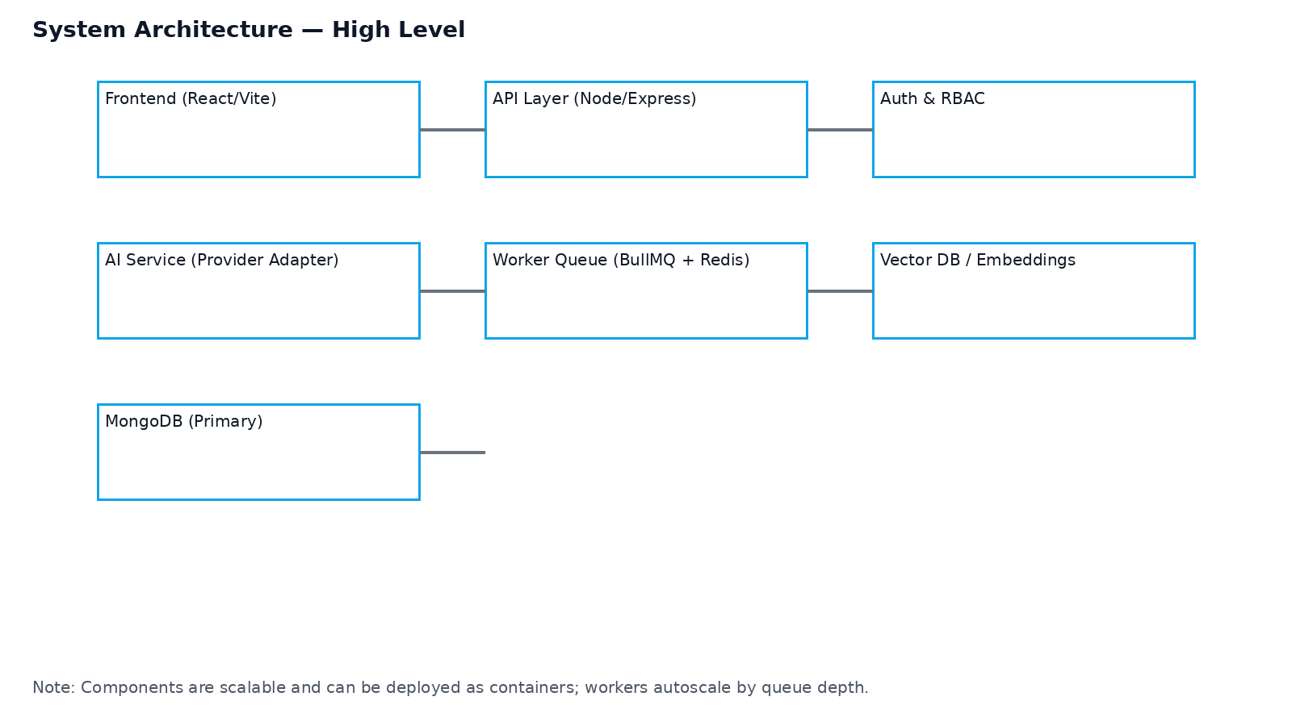

Diagrams — Onboarding Flow
Autosave onboarding flow and draft linking
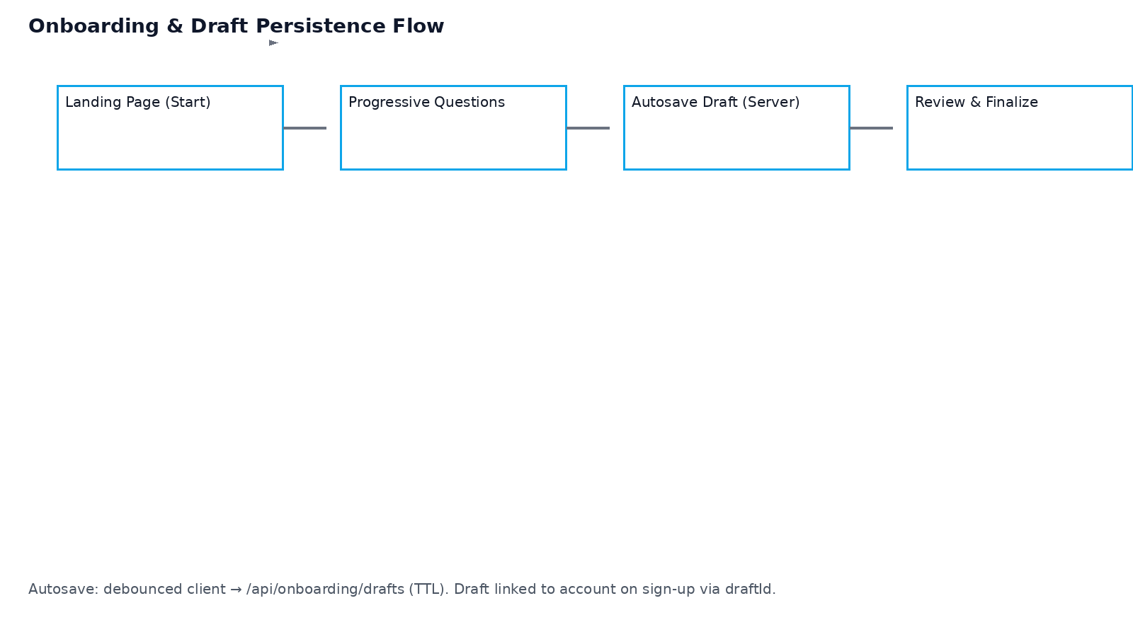

Diagrams — AI Pipeline
RAG pipeline and output validation flow
