Introduction
Quoting from page 23 of the textbook (section 1.5 “Operating System Operations”)

We can now see the life cycle of instruction execution in a computer system. Initial control resides in the operating system, where instructions are executed in kernel mode. When control is given to a user application, the mode is set to user mode. Eventually, control is switched back to the operating system via an interrupt, a trap, or a system call.

System calls provide the means for a user program to ask the operating system to perform tasks reserved for the operating system on the user program’s behalf. A system call is invoked in a variety of ways, depending on the functionality provided by the underlying processor. In all forms, it is the method used by a process to request action by the operating system. A system call usually takes the form of a trap to a specific location in the interrupt vector. This trap can be executed by a generic trap instruction, although some systems (such as MIPS) have a specific syscall instruction to invoke a system call.

When a system call is executed, it is typically treated by the hardware as a software interrupt. Control passes through the interrupt vector to a service routine in the operating system, and the mode bit is set to kernel mode. The system-call service routine is a part of the operating system. The kernel examines the interrupting instruction to determine what system call has occurred; a parameter indicates what type of service the user program is requesting. Additional information needed for the request may be passed in registers, on the stack, or in memory (with pointers to the memory locations passed in registers). The kernel verifies that the parameters are correct and legal, executes the request, and returns control to the instruction following the system call. We describe system calls more fully in Section 2.3.

Problem (25 points)
Solve each of the following problems by writing a S16 assembly language program that uses appropriate S16OS system service requests to satisfy program requirements.

Hints
- Use the SVC machine instructions to make system service calls.
- S16OS system service requests are described in general—and each individual service request is described in gory detail—in S16OperatingSystem.doc.
- EQUs used to define system service requests are “cataloged” for your convenience in the text file SVCDefinitions.txt.
- Every S16 assembly language program may be “packaged” as a pair—a S16 jobstream (a .job file) and an S16 assembly language source file (a .s16 file), but for plain-vanilla applications—like those in this assignment, Problem #2, and like those in most of other outside assignment—the .job file is not absolutely necessary.
- Sometimes the “package” also includes an application-specific configuration file (a .config file), but, again, for plain-vanilla applications, the S16.config file works just fine.

Create a single Word or PDF document that contains both the S16 assembly language source code (the .s16 file) (single-spaced, landscape-oriented, Courier New 10 font) and a “proof” screenshot for each program. Use AnswerSheet1-to-25.txt to answer the “Computational and Critical Thinking Questions”. Attach the Word document and the answer sheet to an email addressed to AHanna@StMaryTX.edu to earn credit for this Problem.

( 1) Input a string into a variable named line and input an integer into a variable n from the user’s terminal then output line n times as n separate lines to the user’s terminal. Hints (1) Use READ_FROM_TERMINAL, WRITE_TO_TERMINAL, and TERMINATE_PROCESS service requests; (2) answer the question “What does "%n" mean when used in a WRITE_TO_TERMINAL format string?”; and (3) see the landscape, line-numbered pages at the end of this document for help getting started with creating the S16 assembly language source file Program1.s16.

Sample Program Dialog for Program 1)

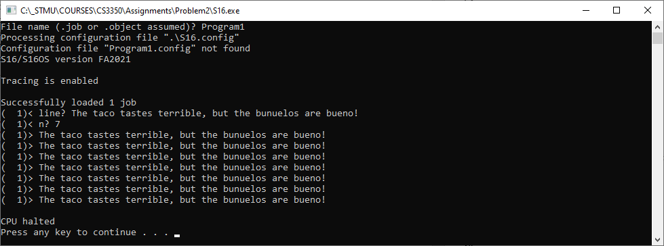

( 2) Three times in a row output the S16OS version of current time to the user’s terminal using the following format. Hint Use GET_CURRENT_TIME, WRITE_TO_TERMINAL, and TERMINATE_PROCESS service requests. Note Sadly, the WRITE_TO_TERMINAL service request does not allow field widths to be specified; instead, the S16 applications programmer is “stuck” with default field widths!

Current time = XX..XX
Current time = XX..XX
Current time = XX..XX

Algorithm
; time := current time
; PRINT "Current time = ",time,ENDL
; time := current time
; PRINT "Current time = ",time,ENDL
; time := current time
; PRINT "Current time = ",time,ENDL
; STOP

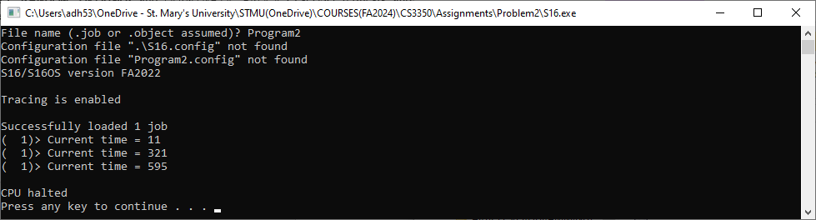

( 3) Input the two integers x and y then output the sum (x+y), the difference (x-y), the product (x*y), the integer quotient (x/y), and the integer remainder (x MOD y) using the following format. Hints (1) Use READ_FROM_TERMINAL, WRITE_TO_TERMINAL, and TERMINATE_PROCESS service requests; and (2) use ADDR for compute the sum, SUBR to compute the difference, MULR to compute the product, DIVR to compute the integer quotient, and MODR to compute the integer remainder.

(x+y) = XX..XX, (x-y) = XX..XX
(x*y) = XX..XX, (x/y) = XX..XX, (x%y) = XX..XX

Algorithm
; INPUT "x? " x
; INPUT "y? " x
; PRINT "(x+y) = ",x+y
; PRINT ", (x-y) = ",x-y,ENDL
; PRINT "(x*y) = ",x*y
; PRINT ", (x/y) = ",x/y
; PRINT ", (x%y) = ",x MOD y,ENDL
; STOP

( 4) Use a while-not-EOF-loop to input zero or more integers from the user’s terminal. Compute the count of the integers input and the sum of the integers input. Output count and sum using the format shown below. Hints Use READ_FROM_TERMINAL, WRITE_TO_TERMINAL, and TERMINATE_PROCESS service requests; (2) on return from every READ_FROM_TERMINAL service request, R0 = SVC_EOF means the user’s terminal input was an interactive EOF typed as the single keystroke Ctrl+Z; and (3) the return code value SVC_EOF is defined in SVCDefinitions.txt. Note Integer input and output again!? The S16 ALU does not support floating-point (real number) operations and S16OS does not support floating-point IO, but does support signed and unsigned integer in decimal (base 10) and hex, character, boolean, and string IO!

count = XX..XX
sum = XX..XX

Algorithm
; count := 0
; sum := 0
; WHILE ( INPUT "x? " x does not return EOF )
; count := count+1
; sum := sum+x
; END
; PRINT "count = ",count,ENDL
; PRINT " sum = ",sum,ENDL
; STOP

( 5) Randomly-choose an uppercase letter c and an integer n ∈ [ 1,7 ] then output a single line that contains 1 instance of c, a comma ',', 2 instances of c, a comma, 3 instances of c, a comma,…, n instances of c, and a period '.'. For examples, (1) when c = 'A' and n = 4, output must be "A,AA,AAA,AAAA." and (2) when c = 'P' and n = 1, output must be "P.". Hints (1) Use WRITE_TO_TERMINAL, GET_RANDOM_INTEGER, and TERMINATE_PROCESS service requests; and (2) answer the question “What are the integer values that correspond to the UNICODE characters 'A' and 'Z'?”.

Algorithm
; c := RandomInt(0,25)+'A'
; n := RandomInt(0,6)+1
; PRINT "c = ",c,ENDL
; PRINT "n = ",n,ENDL
; FOR i := 1 TO n
; FOR j := 1 TO i
; PRINT c
; END
; IF ( i = n ) THEN
; PRINT ".",ENDL
; ELSE
; PRINT ","
; END
; END
; STOP

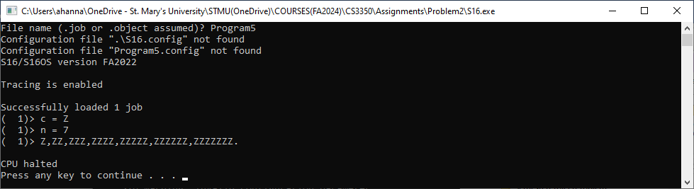

Computational and Critical Thinking Questions (10 points)
1. Program #1 format2 is the label used by Dr. Hanna to name the format string "n? %1i" which is used to prompt the user for the integer value n. What does "%1i" mean?

; INPUT "n? " n
LDAR R15,format2
SVC #SVC_READ_FROM_TERMINAL
STR R1,n

format2 DS "n? %1i"

2. Program #1 What comparison does the CMPR and JMPP instructions make? Use the variable names n and i and one of these comparison operators (< ≤ = > ≥ ≠).

; FOR i := 1 TO n
LDR R1,#1
STR R1,i
FOR EQU *
LDR R1,i
LDR R2,n
CMPR R1,R2
JMPP R1,endFOR
; PRINT line,ENDL
; END
LDR R1,i
INCR R1
STR R1,i
JMP FOR
endFOR EQU *

3. Program #1 (Continuing 2) T or F? The main memory address value assigned to the label FOR is exactly the same main memory address where the opcode of the LDR instruction is stored.

4. Program #2 Which S16 addressing mode is signified by the # in the following statement?

; time = current time
SVC #SVC_GET_CURRENT_TIME

5. Program #3 Which CPU register, R1 or R2, contains the sum (x+y) after the ADDR instruction finishes execution?

; PRINT "(x+y) = ",x+y
LDR R1,x
LDR R2,y
ADDR R1,R2
LDAR R15,format3
SVC #SVC_WRITE_TO_TERMINAL

format3 DS "(x+y) = %1i"

6. Program #3 (Continuing 5) T or F? The LDAR instruction above and the LDR instruction below are functionally-equivalent.

LDR R15,#format3

7. Program #4 Explain how the JMPN instruction tests for an end-of-file condition returned by the READ_FROM_TERMINAL service request.

; WHILE ( INPUT "x? " x does not return EOF )
WHILE EQU *
LDAR R15,format1
SVC #SVC_READ_FROM_TERMINAL
JMPN R0,endWHILE ; EOF = -1
STR R1,x
; count := count+1
; sum := sum+x
JMP WHILE
; END
endWHILE EQU *

8. Program #4 (Continuing 7) When the end-of-file condition does not occur, which CPU register contains the value input for x?

9. Program #5 After the GET_RANDOM_INTEGER service request returns, what is the range of possible values returned in CPU register R15?
A: ( 0,25 ) B: [ 0,25 ) C: [ 1,25 ] D: [ 0,25 ] E: none of these

; c := RandomInt(0,25)+'A'
LDR R15,#25
SVC #SVC_GET_RANDOM_INTEGER

10. Program #5 Explain why the JMP, the S16 unconditional jump to the label endIF in the THEN-clause, is required, but an unconditional jump to endIF in the ELSE-clause is not required.

; IF ( i = n ) THEN
LDR R1,i
LDR R2,n
CMPR R1,R2
JMPNZ R1,ELSE
; PRINT ".",ENDL
LDAR R15,format2
SVC #SVC_WRITE_TO_TERMINAL
JMP endIF
; ELSE
ELSE EQU *
; PRINT ","
LDAR R15,format3
SVC #SVC_WRITE_TO_TERMINAL
; END
endIF EQU *
Program1.job
;----------------------------------------------------------
; Dr. Art Hanna
; Problem #2, Program 1)
; Program1.job
;----------------------------------------------------------
$JOB NAME="Program1" FILE="Program1"
$END

Outline of Program1.s16
;----------------------------------------------------------
; Dr. Art Hanna
; Problem #2, Program 1)
; Program1.s16
;----------------------------------------------------------
CODESEGMENT
;----------------------------------------------------------
; PROGRAM main()
; *Note* main() does not have an activation record because *ALL*
; main() local data is stored as static data
;----------------------------------------------------------
main EQU *

Student translates pseudo-code to S16 assembly language

; INPUT "line? " line
; INPUT "n? " n
; FOR i := 1 TO n
; PRINT line,ENDL
; END
; STOP

;----------------------------------------------------------
DATASEGMENT
;----------------------------------------------------------
; ***Service request number definitions
SVC_GET_CURRENT_TIME EQU 1
SVC_GET_RANDOM_INTEGER EQU 2
SVC_TERMINATE_PROCESS EQU 100
SVC_READ_FROM_TERMINAL EQU 300
SVC_WRITE_TO_TERMINAL EQU 301

; ***Service request return code definitions
SVC_EOF EQU -1 ; Terminal input EOF
SVC_OK EQU 0 ; No error occurred

; *** Static data

Student provides missing data definitions

END

