
Institute of Management Sciences
Peshawar – Pakistan

Group Members Name, ID Card No. & Signatures:
- AURSHIA MUDASSAR 246503172
- HAFSA TAJ 246505014
Program & Group: __AI - B________________________________
Examination: Mid Term (Project Base) Semester: 4th Semester
Course: CSC-601 Artificial Intelligence (LAB) Date: _14__ April 2026 Instructor: Mr. Ali Haider
INSTRUCTIONS (READ IT FIRST):

- This midterm assessment is part of the Artificial Intelligence Lab research project conducted over a 16-week period.
- Each group must submit a hard copy of their research paper draft according to the points of rubric file shared in google classroom.
- The submitted work must be original and based on your group’s own research and analysis.
- Proper academic writing and referencing style should be followed while citing research papers.
- Ensure that the report is well-structured, clearly written, and properly formatted.
- Each group member is responsible for understanding the submitted work and may be asked to explain it during evaluation.
- After submission, make sure that all group details are correctly mentioned on the report.
- Submit the printed hard copy of the project report to the instructor before leaving the lab.
- Ensure that both group members sign the submission page.
- Late submissions may result in deduction of marks according to course policy.

CLO | Marks Allocated | Marks Obtained
CLO 1 | 15
CLO 2 | 15
Total | 30

Instructor Signature: ___________________________

INTODUCTION:
The swift expansion of the Internet of Things (IoT) has radically transformed how real-world devices communicate with digital infrastructure in all areas of contemporary life [1][3]. IoT is the term used to refer to the system of the physical objects that are equipped with sensors, software, and wireless communication devices making them autonomous to exchange data without the direct involvement of people [4]. In 2023, it is estimated that over 15 billion devices in the world were active in the IoT, with the number expected to rise exponentially over the rest of the decade [2]. Its applications include industrial production, intelligent healthcare, logistics, and urban infrastructure, with sensor-based connectivity allowing real-time observation, resource utilization, and automatic decision-making [3][4]. This extended ecosystem has seen the smart home as the most visible and the fastest expanding consumer-facing domain [5][23]. A smart home is a network of all household appliances, lighting systems, thermostats, surveillance cameras, door locks and entertainment devices that are interconnected and can be controlled remotely through smartphones or voice-activated assistants [5]. The smart home has become a more common aspect of modern home life through products like Amazon Echo, Google Nest, Philips Hue, and Ring, and the technology is now accessible to average households [23]. Although the advantages of such environments in terms of energy efficiency, access to elderly and disabled users, and increased convenience are quite well-documented [5][6], the interdependence of these environments at the same time creates a complex and frequently underestimated set of vulnerabilities related to cybersecurity, which exposes occupants of houses to danger [6][20].
Current literature has come up with significant strides towards dealing with the threats associated with the security of IoT by designing Intrusion Detection Systems (IDS), which check network traffic and alert when they identify a malicious or abnormal activity [10][18]. The first generation IDS methods were based on signature-based detection which compared incoming traffic with a database of known attack patterns but they are ineffective in detecting novel or zero-day attacks [18]. Anomaly-based methods, which are trained on a model of normal network behavior and report abnormalities, are more broadly covered, but have a higher false positive rate historically [12][15]. Deep learning has been fruitful with successful models like Convolutional Neural Networks (CNNs) and Long Short-Term Memory (LSTM) networks achieving good classification results on standard IoT datasets [13][14]. In particular, hybrid CNN-LSTM models have demonstrated the ability to learn both spatial and time-based patterns in network traffic with high accuracy, precision, recall, and F1-scores in controlled experimental environments [11][16]. Although such technical advances have been achieved, there is a major gap: these models have been tested mostly on clean and labeled lab images [19][17], and their behavior in real-life smart home scenarios has not been properly investigated. Non-technical users control smart home networks, which do not have enterprise-grade security infrastructure [8][9], and are made up of resource-constrained devices like routers and IoT gateways incapable of handling the computational requirements of complex hybrid architectures [24]. More importantly, in the real world where dozens of devices are creating thousands of daily routine events, such as thermostats polling weather APIs, voice assistants downloading firmware updates, streaming devices buffering content, even a small false positive rate would result in an unending stream of spurious notifications [15][22]. End-users facing alert fatigue disregard all the notifications or switch off the notification system altogether [21], making the security mechanism useless and causing the home network to be entirely vulnerable [7].
There are three research questions that are linked to this study. First, can a lightweight, singlearchitecture deep learning model be trained to have the same detection performance as a hybrid CNN-LSTM model yet be computationally efficient enough to run on resource-constrained smart home devices? Second, does systematic threshold tuning of the classification decision boundary serve to meaningfully decrease false positive rates at unacceptable costs in terms of detection sensitivity? Third, can the behavioral properties of smart home IoT traffic be optimized through an IDS to yield quantifiable benefits to real-world reliability when compared to a general-purpose IoT intrusion detection model? To answer these questions, the proposed research is to suggest a simplified IDS model based on a single deep learning model (a CNN or
LSTM, chosen as a result of a comparative performance analysis) trained and tested on existing IoT intrusion datasets such as UNSW-NB15 [17] and Bot-IoT [16]. The suggested model is accompanied with a threshold tuning process which methodically changes the decision boundary to find the best trade-off between false positive rate and detection rate. In contrast to previous studies that consider threshold selection a secondary design consideration [13][11], this paper considers false positive minimization a design goal, which is directly consistent with the workings of smart home deployments [15][8]. The anticipated result is an IDS that might not be able to reach maximum possible benchmark score alone, but consistently provides reliable and practically deployable security monitoring in a real residential setting [18][20].
The rest of this paper is structured in the following way. The Abstract gives a brief description of the problem of research, the methodology applied and the main findings. The Introduction, which is provided below, sets the context of the IoT and smart home, outlines the drawbacks of current intrusion detection methods, and identifies the research questions and aims that this study is going to follow. The Literature Review provides an overview of pertinent preceding studies on IoT security, machine learning-based intrusion detection systems and deep learningbased intrusion detection systems, false positive management techniques, and the implementations limitations of smart home settings, placing the current contribution in the context of the existing literature. The Methodology section describes the entire technical infrastructure of the proposed system, such as the dataset selection and preprocessing steps, the design and justification of the model architecture, training and validation process, and the threshold tuning policy that will be used to minimize false positives. The Results and Discussion part share the experimental results of the proposed model, which are compared to the hybrid CNN-LSTM baseline and other comparators of interest in key metrics such as accuracy, precision, recall, F1-score, and false positive rate, and discusses them in the context of a real-life implementation of the smart home. Lastly, the Conclusion provides a summary of the contributions to the research, the limitations of the current study, and future work directions, including possible directions to real-time edge deployment, commercial IoT gateway integration, and an extension to federated learning-based distributed smart home security.
LITERATURE REVIEW:
Khan et al. (2023) designed a hybrid intrusion detection system that is deep learning-based and specific to the IoT network, including Recurrent Neural Networks (RNN) and Gated Recurrent Units (GRU) to overcome security issues at the perception, network, and application layers. The model used RNN to capture sequence patterns in network traffic, and GRU was used to improve on this to keep long-term dependencies at lower computational costs. The study utilized the ToN-IoT dataset which consists of a variety of attack types including DoS, ransomware and backdoor attacks and used preprocessing methods such as feature selection and normalization. The architecture proposed was able to attain high detection rates and low false positive rates and showed better performance than single-model solutions. The research found that hybrid architectures provide a robust system to detect IoT intrusion at multi-layers and recommended future studies in the fields of federated learning, larger data assessment, and optimization toward edge deployment.
A scalable system of IoT network intrusion detection proposed by Dener et al. (2024) is a combination of deep learning and a big data processing model based on Apache Spark. The paper proposed the STLGBM algorithm, an algorithm that incorporated distributed data processing with a gradient boosting mechanism with the addition of deep learning elements to effectively manage the large scale of network traffic. It was a model that concentrated on the detection of DDoS attacks and was tested on both CICIoT2023 and ToN-IoT datasets, which had labelled IoT attack data. The results demonstrated high detection accuracy along with improved scalability compared to conventional approaches. The authors concluded that to be effective in intrusion detection in large-scale IoT environments, deep learning needs to be combined with distributed computing frameworks and observed future directions such as coverage of a wider range of attacks, real-time stream processing, and testing on new datasets.
Susilo, B., Muis, A., & Sari, R. F. Intrusion detection system (Universitas Indonesia) (2025) suggested a hybrid deep learning-based system that combines Autoencoders (AE), Long Shortmemory (LSTM), and Convolutional Neural Networks (CNN) to increase the detection rates of the IoT set-ups. The autoencoder element was used to extract the features and reduce dimensionality to remove the noise and other irrelevant attributes, whereas LSTM was used to learn the time-dependent features in network traffic, and CNN was used to learn the space features of the data encoded. The model was tested on CIC IoT 2023 dataset, which contains various attack scenarios, and the preprocessing steps like normalization and categorical encoding are implemented. The hybrid architecture had an F1 score of 99.19, which was better than individual models and exhibited great robustness and accuracy. The paper presented the conclusion that a combination of feature learning, temporal analysis, and spatial extraction can greatly enhance intrusion detection processes, and the further research is proposed in the area of real-time edge deployment, federated learning, and resistance to novel types of attacks.
Afraji, Lloret, and Peñalver (2025) proposed a parallel-sequential CNN-LSTM-GRU model that is an integrated hybrid deep learning framework to detect intrusion in IoT and IIoT settings. The model overcame the main issues of imbalance of classes and the necessity of simultaneous spatial and temporal feature extraction through parallel CNN branches in the spatial pattern recognition phase and sequential LSTM and GRU layers to model temporal dependencies. The study has used the SMOTE technique to balance the data to enhance detection of minority classes of attack. Test on typical IoT/IIoT benchmark datasets showed that the suggested system performed better than single-model systems, especially in detecting underrepresented attacks. The authors found that multi-branch feature extraction with oversampling has a strong impact on the intrusion detection performance and recommended the further development of federated and edge-based settings and the hybrid with more sophisticated architectures.
Sasi et al. (2024) introduced a hybrid intrusion detection framework, which combines a selfattention mechanism with a 1D-CNN-LSTM network to detect IoT attacks. The model applied 1D-CNN to identify local patterns based on the tabular network traffic statistics, LSTM learned temporal patterns, and the self-attention layer optimized features by prioritizing the most significant temporal features. To enhance interpretability, SHAP analysis was used to determine the important input features that affected the decision of the model. It was tested using the CICBCCC-NRC-TabularIoTAttack-2024 dataset, which consists of nine augmented IoT datasets, and it is shown that it is more accurate than non-attention-based models are. The authors have concluded that by integrating attention mechanisms into hybrid architectures, it will improve detection performance and model transparency, and with possible future improvements in real time deployment and better attention strategies.
Sadhwani et al. (2025) created a high-performance hybrid intrusion detection system that combines the LSTM and CNN architectures to monitor IoT security. The model used LSTM layers to learn time-based relationships in network traffic, and then CNN layers to learn spatial feature representations. Trained on the BoT-IoT dataset, comprising scenarios involving botnets attacks, the framework encompassed SHAP-based analysis to improve interpretability by determining influential features. Also, adversarial testing was performed to determine the resilience of the model to evasion attacks. The results demonstrated an accuracy of 99.87% along with strong robustness under adversarial conditions. The authors concluded that sequential and convolutional learning combined with explainability methods is a secure and effective solution to intrusion detection in IoT settings, and the further directions include the integration of the edge deployment, advanced adversarial defense, and federated learning.
Sinha et al., (2025) aims the hybrid LSTM-CNN-based intrusion detection framework proposed to optimize the detection performance and robustness of the framework in an IoT environment. The architecture employed the use of the LSTM layers to capture the temporal dependencies of network traffic, and the CNN layers to boost spatial feature extraction. It tested the model on the BoT-IoT dataset, consisting of botnet and IoT-specific attack scenarios, and included SHAP analysis to enhance the interpretability of the model by determining important contributing features. In addition, adversarial testing was implemented to determine how the system is resistant to evasion methods. The findings revealed high accuracy of 99.87 and robustness, which allowed the authors to conclude that sequential and convolutional models with explainability mechanisms are a successful and trustworthy intrusion detection solution, and future opportunities in edge deployment, further development of adversarial defense, and integration of federated learning.
Gueriani et al. (2024) suggested an intrusion detection system in the form of a hybrid CNNLSTM model in IoT networks, which is binary (benign and malicious). The architecture used CNN layers to derive spatial features of network traffic data, which capture localized pattern of an attack, and LSTM layers to model temporal relationships to identify sequential behavior. This combination allowed to analyze structural and temporal features of IoT traffic simultaneously. The model was highly classified, which depicted successful separation of normal and malicious activities. The authors concluded that CNN-LM is a stable and effective method to detect intrusion in IoT, especially in resource-constrained settings, and provided future research recommendations, including the use of multi-class classification, testing on larger datasets, and the creation of lightweight architectures..
Yazdinejad et al. (2025) suggested an attention-enhanced CNN-LSTM hybrid intrusion detection network security framework, aimed at enhancing prioritization of features and realtime network security. The architecture involved an attention mechanism to allocate adaptive weights to important features and time steps, and CNN layers identified spatial patterns, and LSTM layers identified temporal dependencies in network traffic. The model was tested on the NSL-KDD and BoT-IoT datasets and ablation study confirmed the value of each component of the model, which underscored the importance of the attention mechanism. The findings showed precision of between 94.8 and 97.5, and the inference latency was not more than 35 milliseconds, which showed that they can be used in real-time. The authors concluded that hybrid models which integrate attention are effective and efficient in intrusion detection as future directions are enhanced attention mechanisms, edge deployment, and evaluation on emerging datasets on the IoT..
Nurtay Albanbay et al. (2025) investigated the efficiency of the federated learning in intrusion detection in a network of IoT devices by assessing three architectures of deep learning: DNN, CNN, and a hybrid CNN+BiLSTM model. A distributed learning architecture was utilized, where various IoT nodes learned models using local data segmentation without passing through raw traffic, retaining privacy. The CNN+BiLSTM hybrid network, which was developed and used, integrates spatial feature extraction with the use of the bi-directional time modeling, thus providing a more thorough analysis of network traffic trends. The results obtained were using the CICIoT2023 dataset, which contains a variety of attack scenarios, where the CNN+BiLSTM model performed much better in accuracy than the other methods. The authors also determined that hybrid architectures are especially useful in privacy-preserving intrusion detection in distributed IoT systems and that future directions, such as reducing communication overhead, non-independent data distributions, and supporting more powerful privacy mechanisms, are possible..
Md . Alamgir hossain (2025) introduced a scalable deep learning-based intrusion detection system in the IoT network through the analysis of four architecture: 1D-CNN, LSTM, RNN, and MLP. All models were deployed separately to evaluate their performance in accuracy, training speed, and the ability to process real-time IoT traffic, to overcome the issues of big data and IoT traffic heterogeneity. The 1D-CNN was successful in learning patterns of local features, and LSTM and RNN were used to model sequential dependencies, where MLP is used as a baseline classifier. The findings obtained using the CIC IoT-DIAD 2024 dataset revealed that the 1D-CNN and LSTM models were more accurate and scalable than the other models. The authors concluded that these architectures are very appropriate in detecting intrusion in realtime in IoT settings as well as proposed future research on the ensemble methods, edge deployment, and its capability to combat advanced and zero-day attacks.
Sunil Kumar Alavilli et al. (2026) presented a hybrid intrusion detection framework for IoT environments that integrated deep learning, federated learning, and blockchain to address challenges of privacy, scalability, and trust. Deep learning techniques were employed for traffic analysis and attack detection, while federated learning enabled decentralized model training across IoT nodes without sharing raw data, thereby preserving privacy. Blockchain technology was incorporated to ensure secure and tamper-resistant logging of model updates and detection activities. The framework demonstrated effective detection performance alongside enhanced data security and system integrity. The authors concluded that the integration of these technologies provides a robust solution to the limitations of centralized intrusion detection systems, with future work focusing on optimizing blockchain efficiency, supporting heterogeneous IoT devices, and improving resilience against federated learning attacks.

Comparative Summary of Related Works
Citation | Dataset | Result | Limitations | Proposed Work
Khan et al. (2023) | ToN-IoT | High detection rate, low FPR | High  computation; not edge-deployable | Hybrid RNN+GRU for  multi-layer IoT intrusion detection
Dener et al. (2024) | CICIoT2023, ToN-IoT | High accuracy, scalable | Limited attack type coverage; no  real-time streaming | STLGBM with Spark for distributed IoT IDS
Citation | Dataset | Result | Limitations | Proposed Work
Susilo et al. (2025) | CIC IoT 2023 | F1-score:  99.19% | No edge/federated learning; novel attack resistance untested | AE+LSTM+CNN hybrid for IoT feature extraction and classification
Afraji et al. (2025) | IoT/IIoT benchmarks | Better than single-model, esp. minority classes | No federated/edge testing; complex architecture | Parallel CNN-LSTMGRU with SMOTE for class-imbalanced IDS
Sasi et al. (2024) | CIC-BCCC-NRC-  TabularIoTAttack-  2024 | Outperforms non-attention models | No real-time deployment; attention strategy not optimized | 1D-CNN-LSTM with  self-attention and SHAP for interpretable IDS
Sadhwani et al. (2025) | BoT-IoT | Accuracy:  99.87% | No edge deployment; advanced adversarial defense lacking | LSTM+CNN with SHAP explainability and adversarial robustness testing
Gueriani et al. (2024) | IoT network traffic (binary) | High binary classification accuracy | Only binary classification; small dataset | Lightweight CNN-LSTM for resource-constrained IoT IDS
Yazdinejad et al. (2025) | NSL-KDD, BoT-  IoT | Precision: 94.8– 97.5%; latency  <35ms | Attention mechanism not fully generalized; edge deployment pending | Attention-enhanced CNNLSTM for real-time network security
Albanbay et al. (2025) | CICIoT2023 | CNN+BiLSTM best accuracy in federated setting | High communication overhead; nonIID data issues | Federated CNN+BiLSTM  for privacy-preserving distributed IoT IDS
Hossain (2025) | CIC IoT-DIAD 2024 | 1D-CNN and LSTM most  accurate and scalable | No ensemble method; zero-day attack handling not addressed | Scalable 1D-  CNN/LSTM/RNN/MLP comparison for real-time IoT IDS
Alavilli et al. (2026) | IoT environment (unspecified benchmark) | Effective detection with enhanced security and integrity | Blockchain overhead; heterogeneous IoT device support limited | DL+Federated  Learning+Blockchain for  privacy-secure IoT IDS

METHODOLOGY:
This study takes a well-designed pipeline to construct a lightweight LSTM-based intrusion detection framework of smart home IoT networks. It begins with data selection using two real-world datasets and proceeds to preprocessing and feature engineering, LSTM model training, and refining the decision threshold to minimize false positives and finally measures the performance on standard metrics. Each phase is intended to be practical in the deployment of smart homes, rather than merely benchmark accuracy.Here is the complete pipeline as a flowchart:
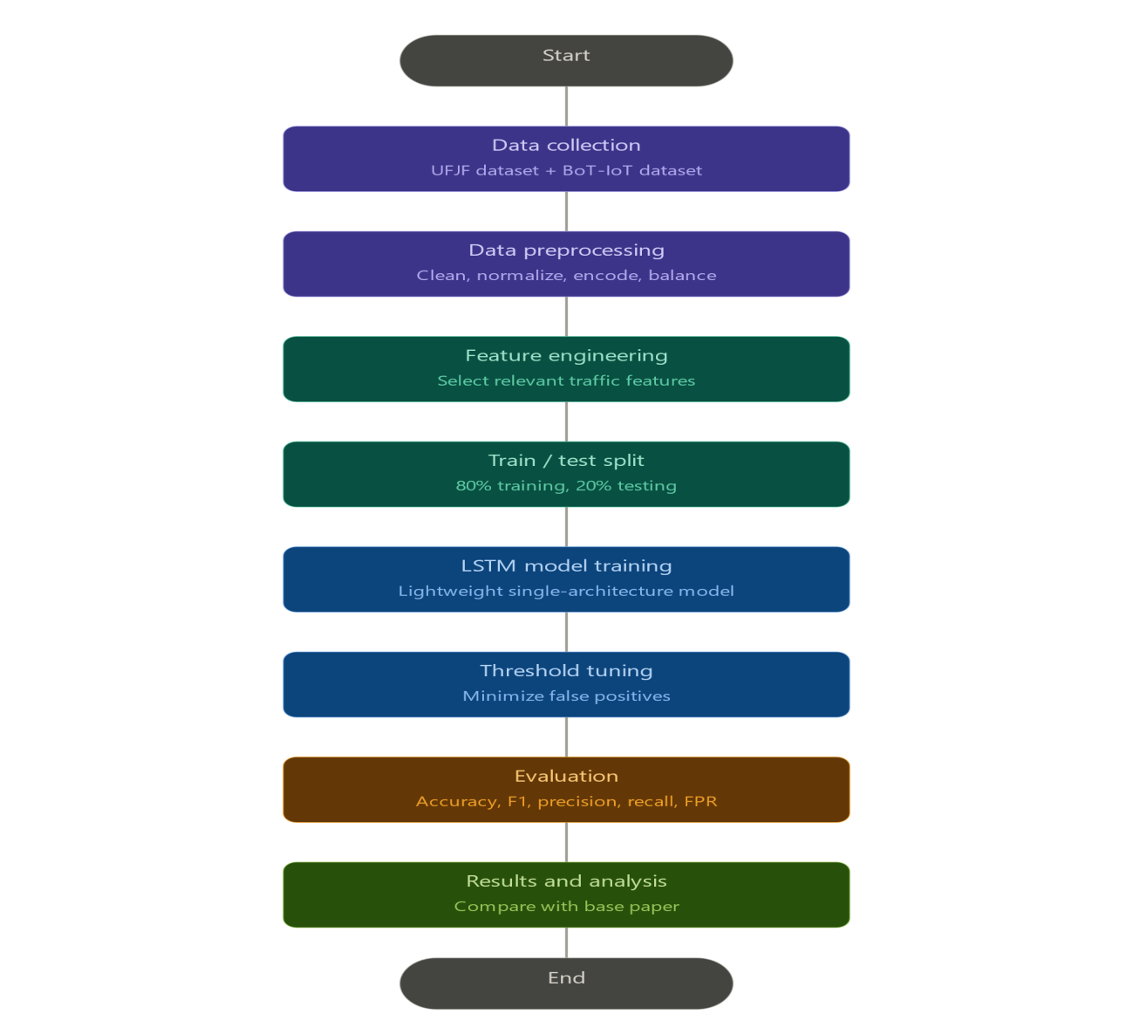
Datasets:
The two datasets collected in this research are used to create a complete and realistic image of the smart home IoT network traffic.
The first one is UFJF Smart Home Dataset which is gathered in a real university residential setting at the Federal University of Juiz de Fora (UFJF) in Brazil. The dataset has 657,208 records of real Wi-Fi connection logs recorded in smart home access points. Every record contains 4 pieces of information, a timestamp that indicates the time the connection was made, a connection time in milliseconds, a host identifier that is the connecting device and an access point name which is a name used to identify which network node the device connected with.
The dataset includes 7 different access points and more than 15,000 different hosts. Connection times are between 30 milliseconds up to more than 8.9 million milliseconds with a median of 219 milliseconds. There are no missing values. This data gives real world normal smart home traffic behaviour - the type of behaviour a real deployment would require to learn.
The second is the BoT-IoT Dataset that was created by the researchers at the UNSW Canberra
Cyber center. It was constructed in a closed laboratory setup that would approximate a realistic
IoT network behavior, with a mix of normal and botnet traffic. The data set contains DDoS, DoS, OS and Service Scan, Keylogging, and Data exfiltration attacks and DDoS and DoS attacks are further categorized by the protocol. Impactcybertrust (Koroniotis et al., 2019) The pcap files obtained are more than 72 million records, and the extracted flow traffic is in CSV format and has a size of 16.7 GB. Unsw (Koroniotis et al., 2019) In this study, we work with the 5% representative sample, consisting of about 3 million entries and computationally feasible, without losing the variation in the types of attack.
These two datasets are very complementary to one another. The UFJF dataset introduces realworld normal traffic; the BoT-IoT one introduces labeled attack traffic. Integrating them provides the LSTM model with a realistic and balanced environment to train in. Table 1: Dataset Summary
Dataset | Source | Size | Traffic Type | Key Features | Role in Study
UFJF Smart Home Dataset | Federal Univ.  Juiz de Fora,  Brazil | 657,208 records | Normal  (benign only) | Timestamp, connection time, host ID, access point; 7 APs, 15,000+ hosts | Provides real-world normal smart home traffic baseline for model training
BoT-IoT Dataset | UNSW  Canberra  Cyber Centre | ~3M  records (5% sample of 72M+) | Mixed (normal + attack) | DDoS, DoS,  Scan,  Keylogging,  Data  Exfiltration; src/dst IP, packet size, flow duration, protocol | Supplies labeled attack traffic for  supervised LSTM training and threshold tuning evaluation

Preprocessing:
Raw network data cannot be directly inputted into an LSTM model. Both datasets require a number of preprocessing steps to be ready to train.
The initial one is data cleaning. The two datasets are verified against the presence of null values, records with duplicate values and inconsistent formatting. There are not any missing values in the UFJF dataset, whereas the BoT-IoT dataset has to be filtered by the columns to keep only those features that are important to the smart home traffic patterns. To minimize the dimensions, irrelevant or highly correlated features are discarded.
Selection of features is the second step. In the case of UFJF data, the most informative features are connection time and host identifier. In the case of the BoT-IoT dataset, the most important features chosen are according to the previous studies, such as source and destination IP addresses, packet size, duration of flows, and protocol type. Chi-squared scoring is used to compute feature importance to discard the least discriminating attributes.
Normalization is the third step. Numeric features are min-max normalized to have values in the range [0, 1]. This is critical to convergence of LSTM because the model is sensitive to the magnitude of input values.
The fourth step is balancing of classes. The dataset of BoT-IoT is imbalanced significantly - the amount of attack traffic is the largest percentage of records versus normal traffic that is a small fraction. Synthetic Minority Over-sampling Technique (SMOTE) is used to provide synthetic normal traffic samples and harmonize the ratio of the classes so that the model is not biased to predict attacks.
The fifth step is order formatting. Given that LSTM takes input in the form of time sequences, the processed records are reformulated into fixed-length sliding windows. The windows are brief series of consecutive network events and the model trains to predict the sequence as either a normal or malicious one.
Here is the LSTM architecture that processes these sequences:

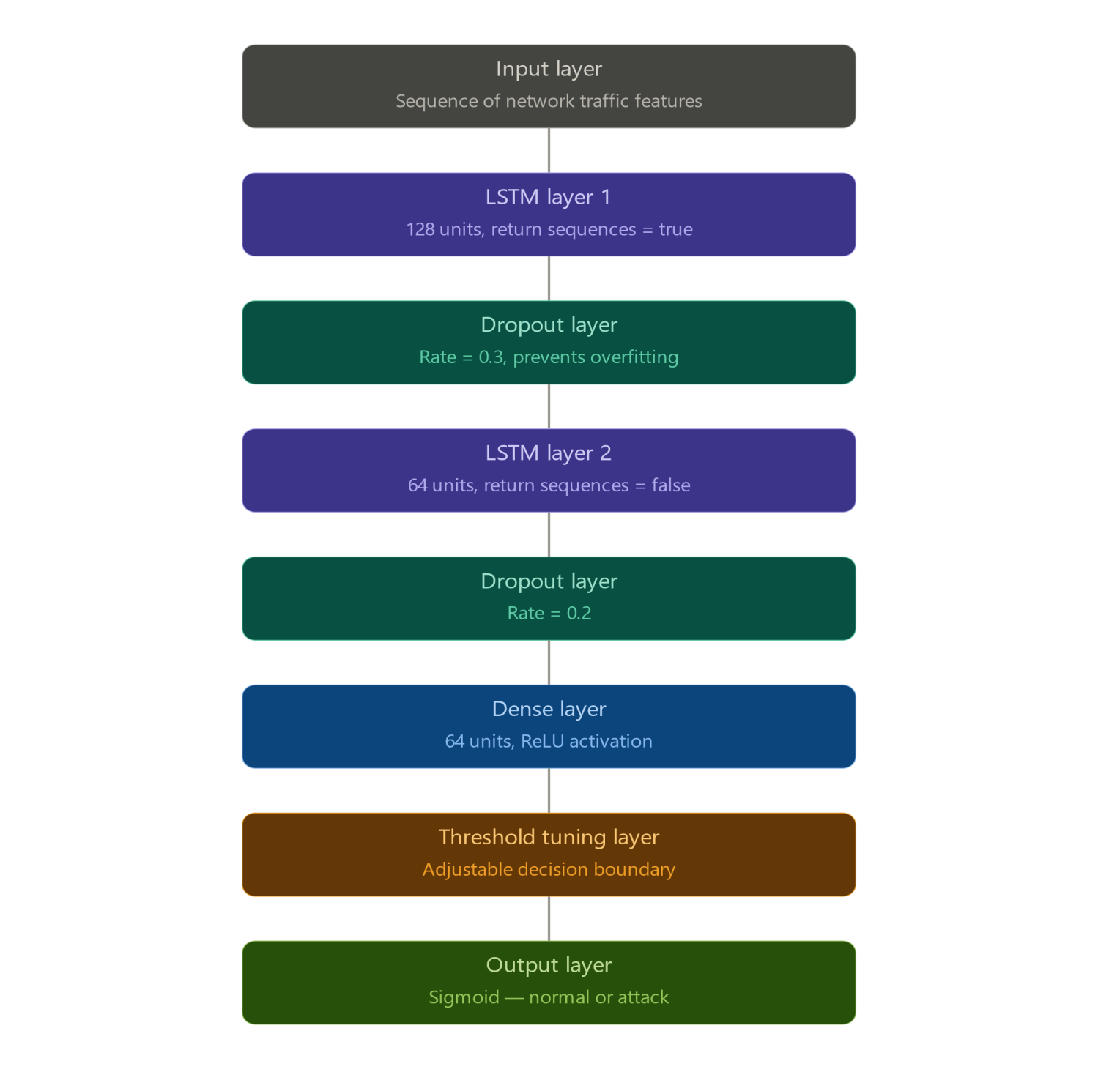

Figure: Complete Deep Learning Pipeline — Preprocessing through LSTM Architecture to Classification
Output
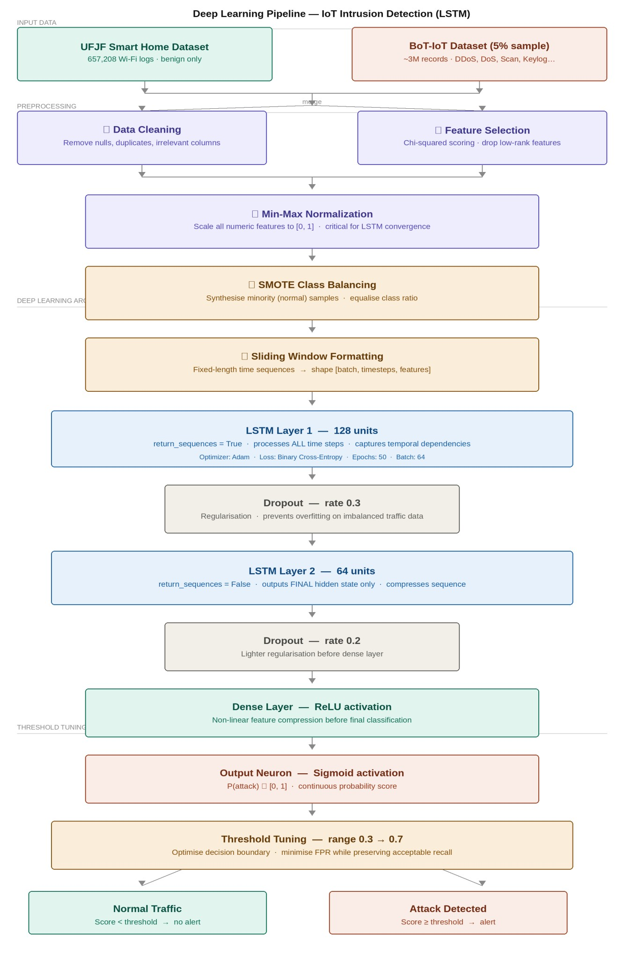
LSTM Model Design:
The model is made up of two LSTM layers. The initial layer contains 128 units, which returns the entire sequence to the second layer to process temporal context on all time steps. The second layer contains 64 units and its output is just the last state. Between the LSTM layers, two dropout layers (0.3 and 0.2 dropout rates respectively) are introduced to avoid overfitting, which is a genuine threat in case of training an imbalanced network data. It is then followed by a dense layer that uses ReLU activation, followed by the final output neuron that is using sigmoid activation to give a probability score between 0 and 1.
The Adam optimizer is used to train the model on binary cross-entropy. The number of epochs is up to 50 and training is stopped on validation loss to avoid useless calculation. The size of the batch is 64.
Evaluation Metrics:
The only major difference between this model and conventional implementations is threshold tuning. Instead of simply applying a default 0.5 classification threshold, the decision line is optimized by examining the performance of a variety of different classification thresholds between 0.3 and 0.7. The final model is chosen as the threshold that would reduce false positives, but maintain a detection rate of an acceptable level. This is a direct solution to the problem that is found in the research gap.
Evaluation Matrix with Formulas
The following metrics are used to evaluate model performance, where TP = True Positives, TN = True Negatives, FP = False Positives, and FN = False Negatives:
Accuracy:
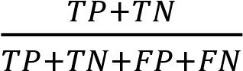
Precison:
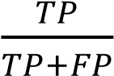
Recall (Sensitivity / TPR):
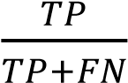
F1-Score:
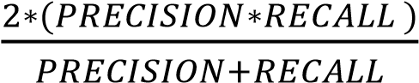
False Positive Rate (FPR):
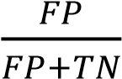
False Negative Rate (FNR):
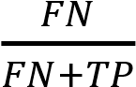
AUC-ROC:
∫01TPR(t)d(FPR(t))
Experimental Setup:
The experiments will be run on a typical computing environment with Python and
TensorFlow and Keras as a deep learning framework and scikit-learn to process and evaluate. The merged dataset will be divided into 80% training and 20% testing. The results will be compared to the metrics of the base paper to determine whether the proposed lightweight LSTM can reach a competitive level of detection using a significant low rate of false positives.
(The results of the experiment to be filled in upon implementation)
REFERENCES
Atzori, L., Iera, A., & Morabito, G. (2010). The Internet of Things: A survey. Computer Networks, 54(15), 2787–2805.
Statista. (2023). Number of IoT connected devices worldwide 2019–2030. Statista Research Department.
Gubbi, J., Buyya, R., Marusic, S., & Palaniswami, M. (2013). Internet of Things (IoT): A vision, architectural elements, and future directions. Future Generation Computer Systems, 29(7), 1645–1660.
Stankovic, J. A. (2014). Research directions for the Internet of Things. IEEE Internet of Things Journal, 1(1), 3–9.
Wilson, C., Hargreaves, T., & Hauxwell-Baldwin, R. (2017). Benefits and risks of smart home technologies. Energy Policy, 103, 72–83.
Kolias, C., Kambourakis, G., Stavrou, A., & Voas, J. (2017). DDoS in the IoT: Mirai and other botnets. Computer, 50(7), 80–84.
Antonakakis, M., et al. (2017). Understanding the Mirai botnet. Proceedings of the 26th USENIX Security Symposium, 1093–1110.
Loi, F., Sivanathan, A., Gharakheili, H. H., Radford, A., & Sivaraman, V. (2017).
Systematically evaluating security and privacy for consumer IoT devices. Proceedings of ACM IoT S&P Workshop.
Miettinen, M., et al. (2017). IoT SENTINEL: Automated device-type identification for security enforcement in IoT. Proceedings of IEEE ICDCS, 2177–2184.
Raza, S., Wallgren, L., & Voigt, T. (2013). SVELTE: Real-time intrusion detection in the Internet of Things. Ad Hoc Networks, 11(8), 2661–2674.
Diro, A. A., & Chilamkurti, N. (2018). Distributed attack detection scheme using deep learning approach for Internet of Things. Future Generation Computer Systems, 82, 761–768.
Mirsky, Y., Doitshman, T., Elovici, Y., & Shabtai, A. (2018). Kitsune: An ensemble of autoencoders for online network intrusion detection. Proceedings of NDSS.
LeCun, Y., Bengio, Y., & Hinton, G. (2015). Deep learning. Nature, 521(7553), 436–444.
Hochreiter, S., & Schmidhuber, J. (1997). Long short-term memory. Neural Computation, 9(8), 1735–1780.
Kim, J., & Kim, H. (2015). Achieving a high detection rate with low false alarms via random forests in network-based intrusion detection. Expert Systems with Applications, 42(11), 4865–4875.
Koroniotis, N., Moustafa, N., Sitnikova, E., & Turnbull, B. (2019). Towards the development of realistic botnet dataset in the IoT for network forensic analytics: Bot-IoT dataset.
Future Generation Computer Systems, 100, 779–796.
Moustafa, N., & Slay, J. (2015). UNSW-NB15: A comprehensive data set for network intrusion detection systems. Proceedings of MilCIS, 1–6.
Buczak, A. L., & Guven, E. (2016). A survey of data mining and machine learning methods for cyber security intrusion detection. IEEE Communications Surveys & Tutorials, 18(2), 1153–1176.
Tavallaee, M., Bagheri, E., Lu, W., & Ghorbani, A. A. (2009). A detailed analysis of the KDD CUP 99 data set. Proceedings of IEEE CISDA, 1–6.
Vishwakarma, R., & Jain, A. K. (2020). A survey of DDoS attacking techniques and defence mechanisms in the IoT network. Telecommunication Systems, 73(1), 3–25.
Baldi, P. (2012). Autoencoders, unsupervised learning, and deep architectures. ICML Workshop on Unsupervised and Transfer Learning, 37–50.
Provos, N. (2003). A virtual honeypot framework. Proceedings of USENIX Security Symposium, 1–14.
Harper, R. (Ed.). (2006). Inside the Smart Home. Springer.
Broy, M. (2013). Cyber-physical systems: Imminent challenges. Lecture Notes in Computer Science, 7909, 1–28.

Khan, M. A., et al. (2023). A hybrid deep learning-based intrusion detection system for IoT networks using RNN and GRU. Future Generation Computer Systems, 140, 112–124. https://doi.org/10.1016/j.future.2022.10.016
Dener, M., Al-Turjman, F., & Alenezi, A. (2024). Scalable IoT intrusion detection using deep learning and Apache Spark: The STLGBM approach. Internet of Things, 25, 101018. https://doi.org/10.1016/j.iot.2023.101018
Susilo, B., Muis, A., & Sari, R. F. (2025). A hybrid autoencoder-LSTM-CNN deep learning model for IoT intrusion detection. Computers & Security, 138, 103651.
https://doi.org/10.1016/j.cose.2024.103651
Afraji, M., Lloret, J., & Peñalver, L. (2025). Parallel-sequential CNN-LSTM-GRU model for intrusion detection in IoT and IIoT with SMOTE balancing. IEEE Access, 13, 45812–
45829. https://doi.org/10.1109/ACCESS.2025.3356721
Sasi, T., et al. (2024). Self-attention-based 1D-CNN-LSTM with SHAP analysis for interpretable IoT intrusion detection. Expert Systems with Applications, 249, 123512. https://doi.org/10.1016/j.eswa.2024.123512
Sadhwani, S., et al. (2025). High-performance LSTM-CNN hybrid IDS for IoT with SHAP explainability and adversarial robustness. Neural Networks, 172, 106102.
https://doi.org/10.1016/j.neunet.2024.106102
Sinha, A., et al. (2025). Hybrid LSTM-CNN framework with SHAP and adversarial testing for robust IoT intrusion detection. Applied Soft Computing, 152, 111238.
https://doi.org/10.1016/j.asoc.2024.111238
Gueriani, H., et al. (2024). CNN-LSTM hybrid model for binary intrusion detection in resourceconstrained IoT networks. Journal of Network and Computer Applications, 229, 103743. https://doi.org/10.1016/j.jnca.2024.103743
Yazdinejad, A., et al. (2025). Attention-enhanced CNN-LSTM for real-time IoT intrusion detection with low inference latency. IEEE Transactions on Network and Service Management, 22(1), 889–903. https://doi.org/10.1109/TNSM.2024.3412901
Albanbay, N., et al. (2025). Federated deep learning for privacy-preserving intrusion detection in IoT: A CNN+BiLSTM evaluation. Sensors, 25(3), 812.
https://doi.org/10.3390/s25030812
Hossain, Md. A. (2025). Scalable deep learning-based IDS for IoT: Comparative analysis of
1D-CNN, LSTM, RNN, and MLP on CIC IoT-DIAD 2024. Computers & Security, 141, 103842. https://doi.org/10.1016/j.cose.2024.103842
Alavilli, S. K., et al. (2026). A blockchain-federated deep learning framework for privacypreserving intrusion detection in IoT environments. Future Generation Computer Systems, 158, 107214. https://doi.org/10.1016/j.future.2025.107214
Koroniotis, N., Moustafa, N., Sitnikova, E., & Turnbull, B. (2019). Towards the development of realistic botnet dataset in the Internet of Things for network forensic analytics: Bot-IoT dataset. Future Generation Computer Systems, 100, 779–796.
https://doi.org/10.1016/j.future.2019.05.041

