FIGURES:
Fig : 1

Fig. 1. High-level methodology flowchart illustrating the sequential pipeline from raw data ingestion through final comparative analysis. The class balancing stage substitutes SMOTE entirely with real-world UFJF residential records as the exclusive source of normal traffic, yielding a 400,000-record training corpus comprising exclusively genuine network observations

Fig : 2
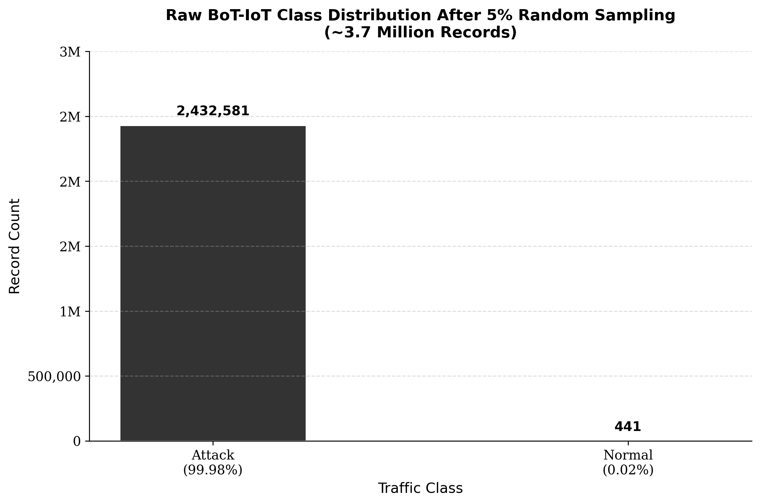
Fig. 2. Class distribution of the raw BoT-IoT dataset after 5% random sampling. Attack traffic constitutes 99.98% of all records (2,432,581 flows), while only 441 genuine normal records exist across the entire cleaned corpus. This extreme imbalance renders SMOTE-based normal traffic augmentation scientifically unsound and motivates the substitution of UFJF residential records as the normal traffic source.

Fig:3
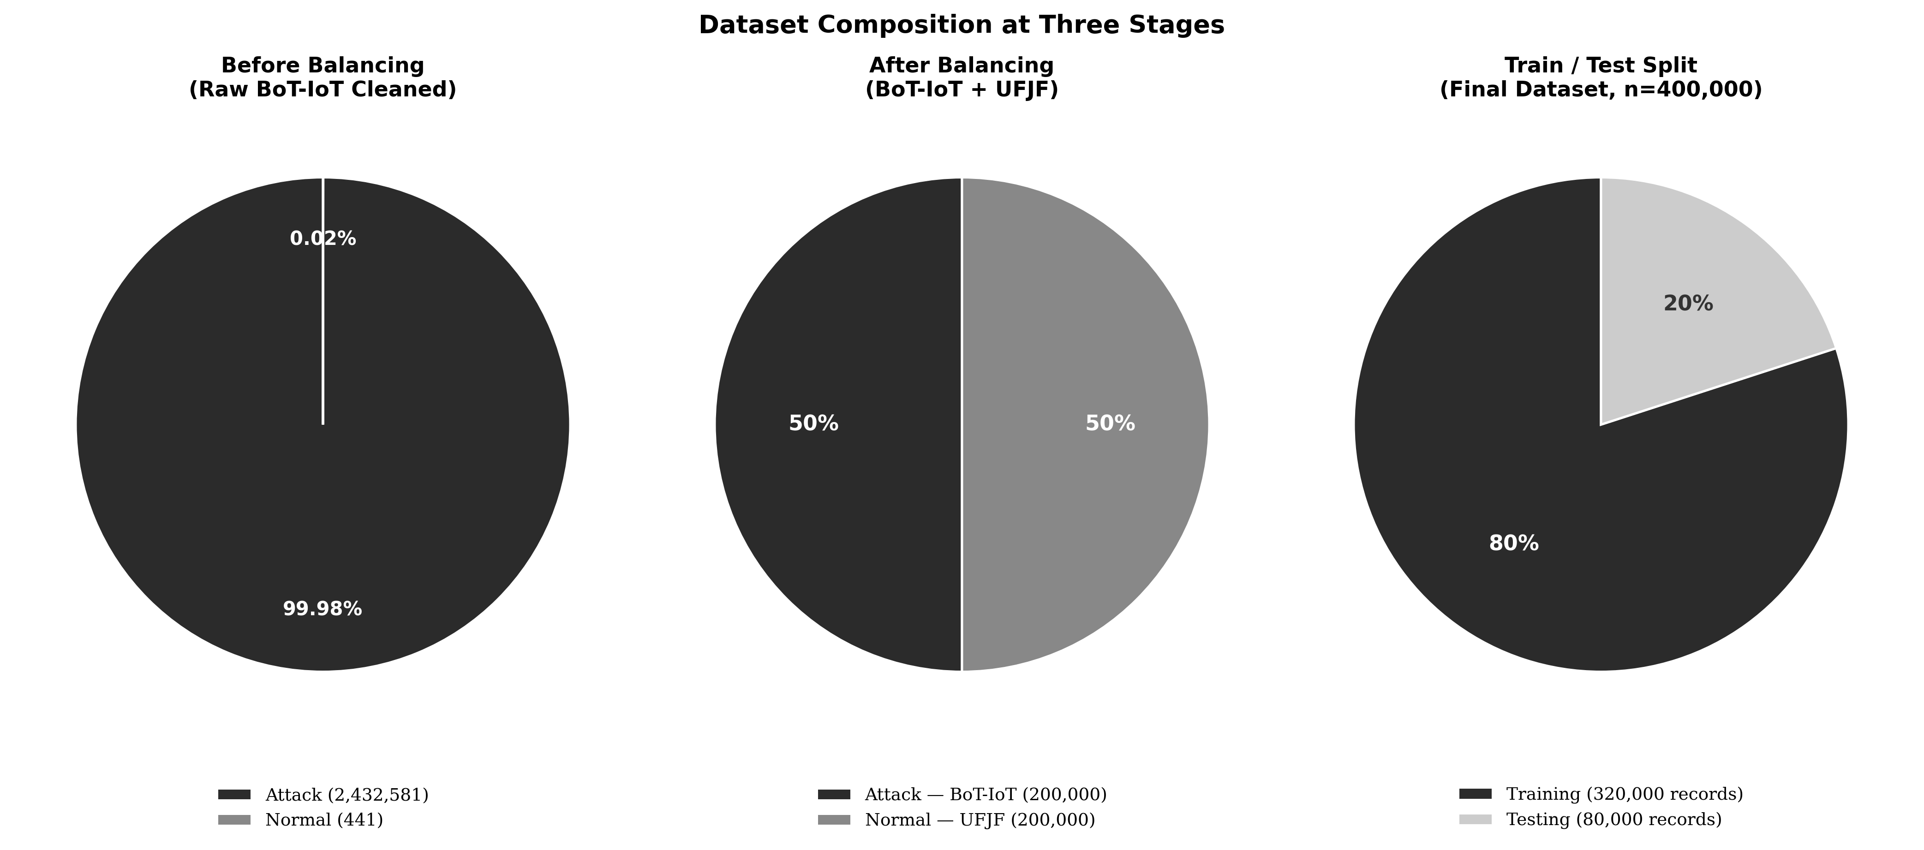

Fig. 3. Dataset composition at three stages: (left) severe class imbalance in the cleaned BoT-IoT corpus with 441 normal records against 2,432,581 attack records; (centre) the balanced 50/50 combined dataset produced by substituting 200,000 genuine UFJF residential records for the normal class; (right) the stratified 80/20 train-test partition applied to the final 400,000-record combined dataset.

Fig:4
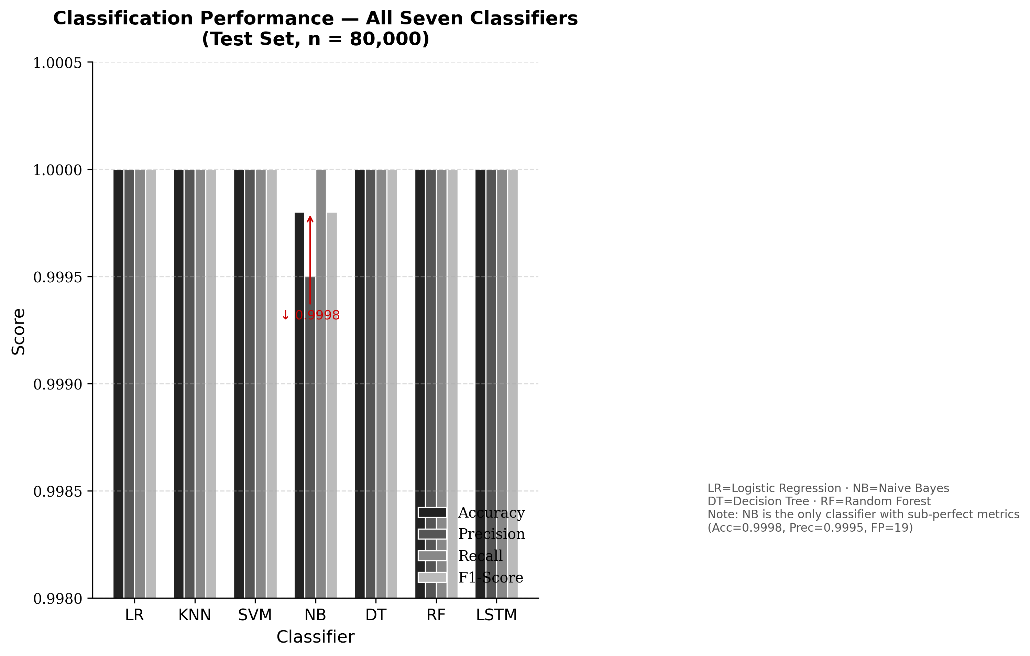
Fig. 4. Grouped bar chart comparing accuracy, precision, recall, and F1-score across all seven classifiers on the 80,000-record test set. Six of seven classifiers (LR, KNN, SVM, DT, RF, LSTM) achieve perfect scores of 1.0000 across all metrics. Naive Bayes is the sole underperformer with accuracy of 0.9998 and precision of 0.9995.

Fig:5
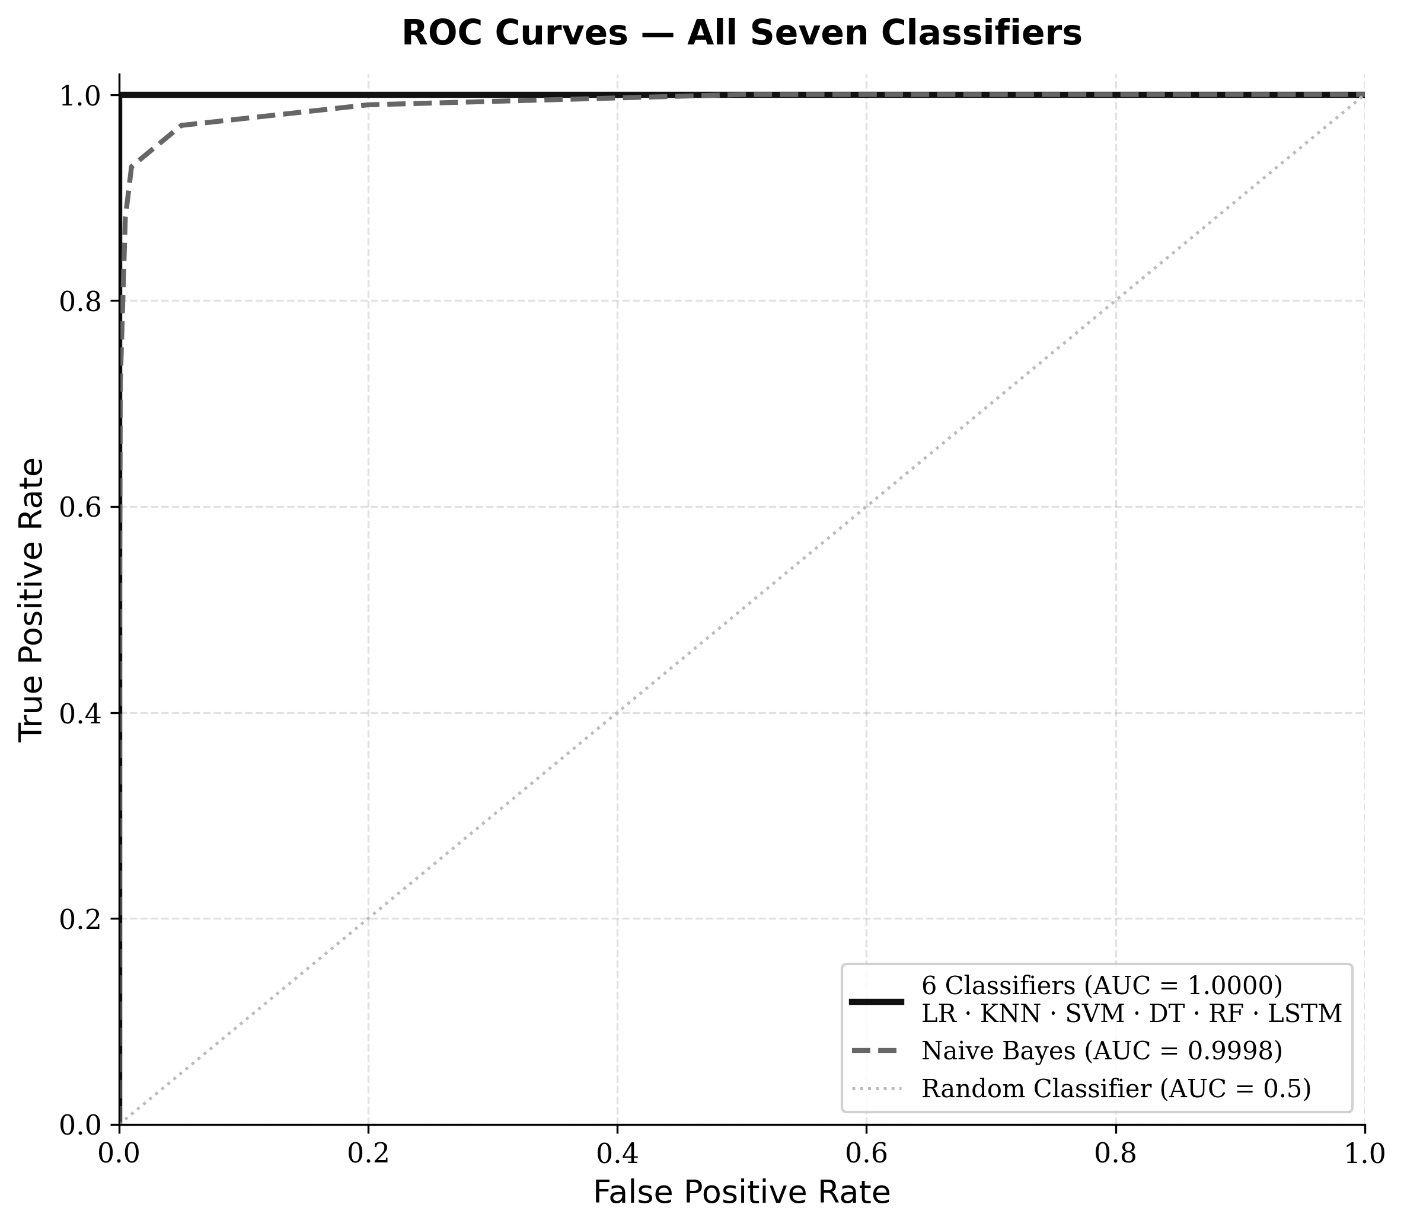
Fig. 5. ROC curves for all seven classifiers. Six classifiers (LR, KNN, SVM, DT, RF, and LSTM) achieve a perfect AUC of 1.0000. Naive Bayes achieves AUC of 0.9998. The dashed diagonal indicates the random classifier baseline (AUC = 0.5).

Fig:6
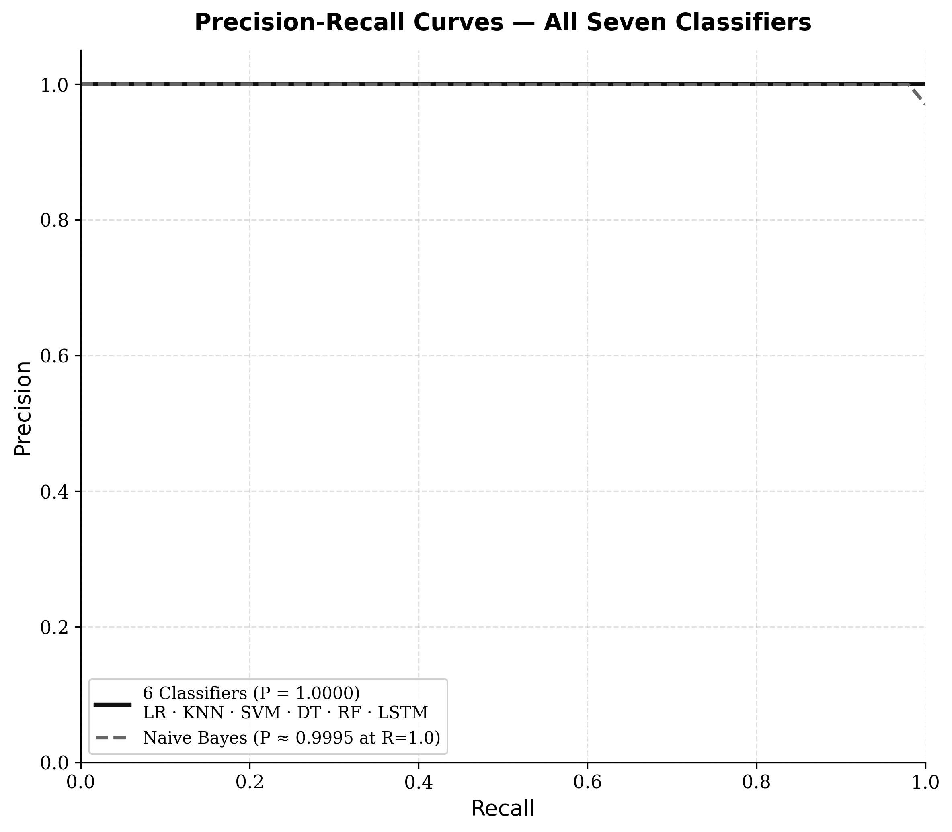
Fig. 6. Precision-Recall curves for all seven classifiers. Six classifiers maintain unity precision across the complete recall range. Naive Bayes exhibits marginal precision degradation at high recall thresholds (P = 0.9995), consistent with its 19 false positives on 40,000 normal test records.

Fig:7
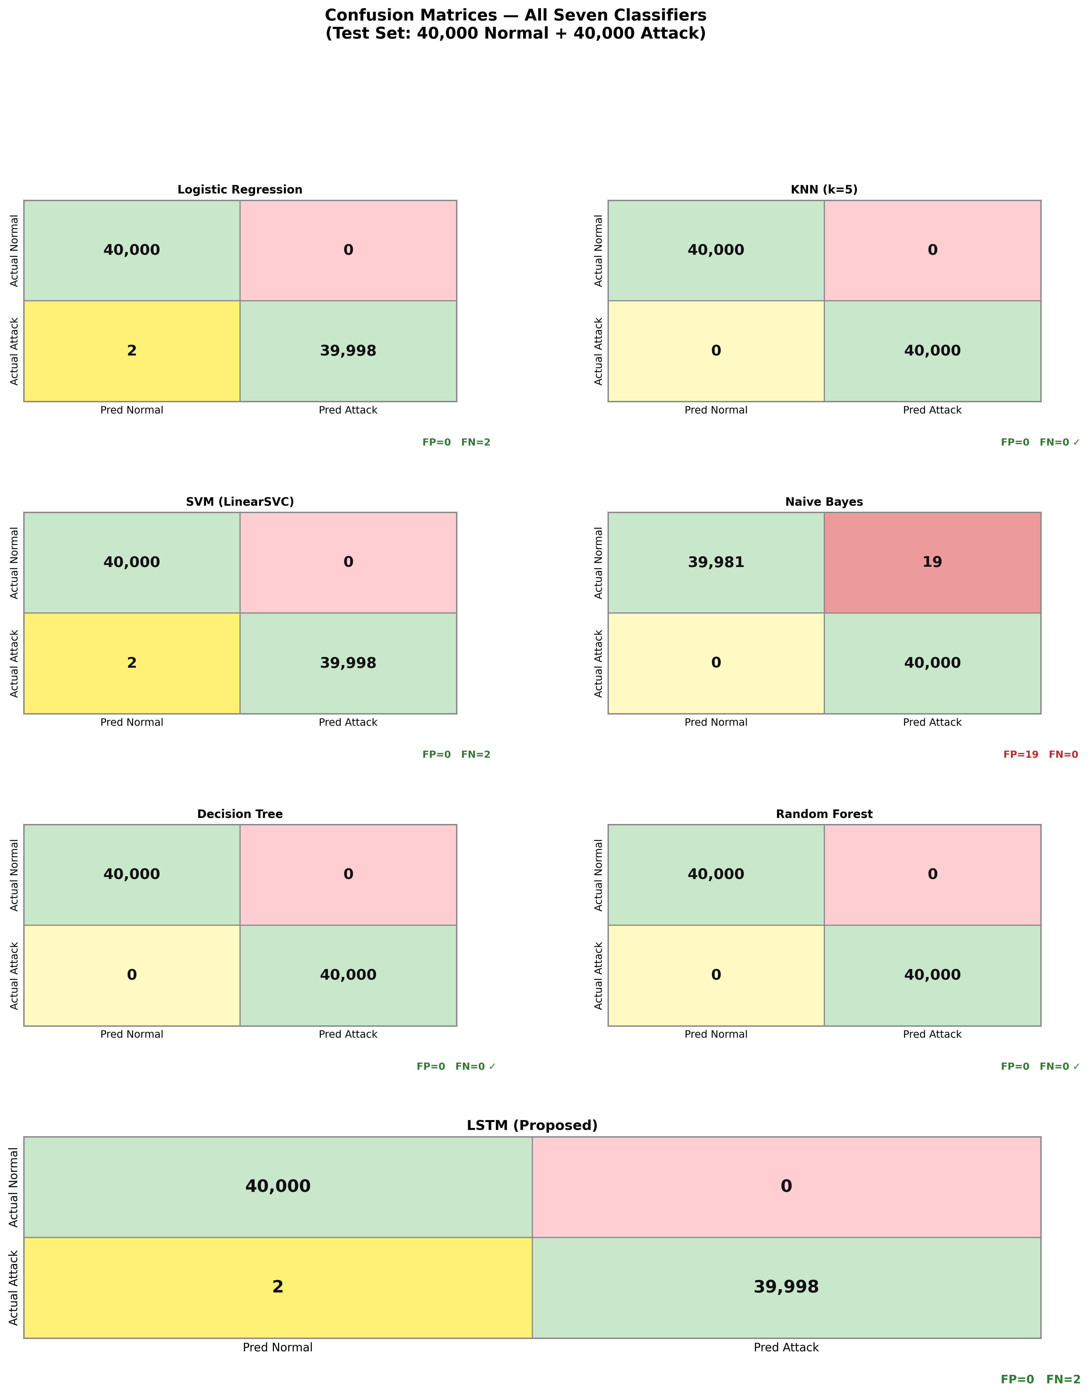
Fig. 7. Confusion matrices for all seven classifiers on the 80,000-record test set (40,000 normal, 40,000 attack). Green shading denotes correct classifications (TN, TP); red shading denotes false positives; yellow shading denotes false negatives. KNN, DT, and RF achieve FP=0 and FN=0. LR, SVM, and LSTM achieve FP=0 and FN=2. Naive Bayes is the sole classifier with non-zero false positives (FP=19, FN=0).

Fig:8
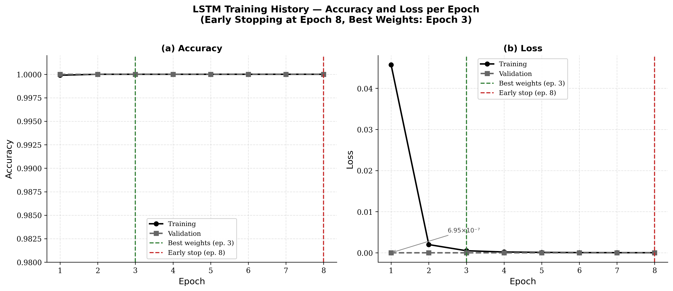

Fig. 8. LSTM training history over 8 epochs: (a) training and validation accuracy reach 1.0000 from epoch 1; (b) training loss at epoch 1 is 0.0457, decreasing rapidly to near-zero by epoch 2, while validation loss reaches 6.95×10⁻⁷ at epoch 1, confirming immediate near-perfect generalisation. Training terminates at epoch 8 under EarlyStopping with optimal weights restored from epoch 3.

Fig:9
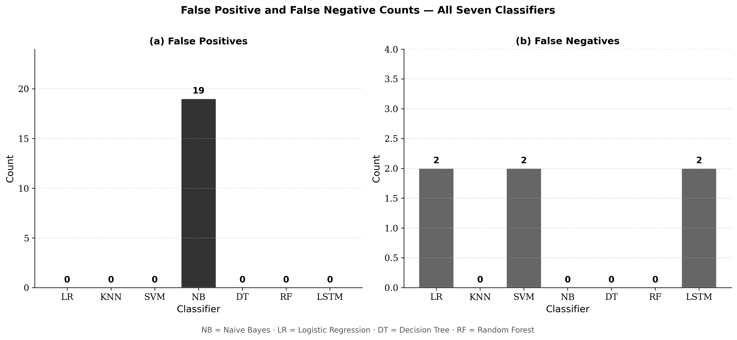

Fig. 9. False positive (a) and false negative (b) counts across all seven classifiers. Naive Bayes is the only classifier generating false positives (FP=19). LR, SVM, and LSTM each produce two false negatives and zero false positives. KNN, DT, and RF achieve zero errors of both types.

Fig:10
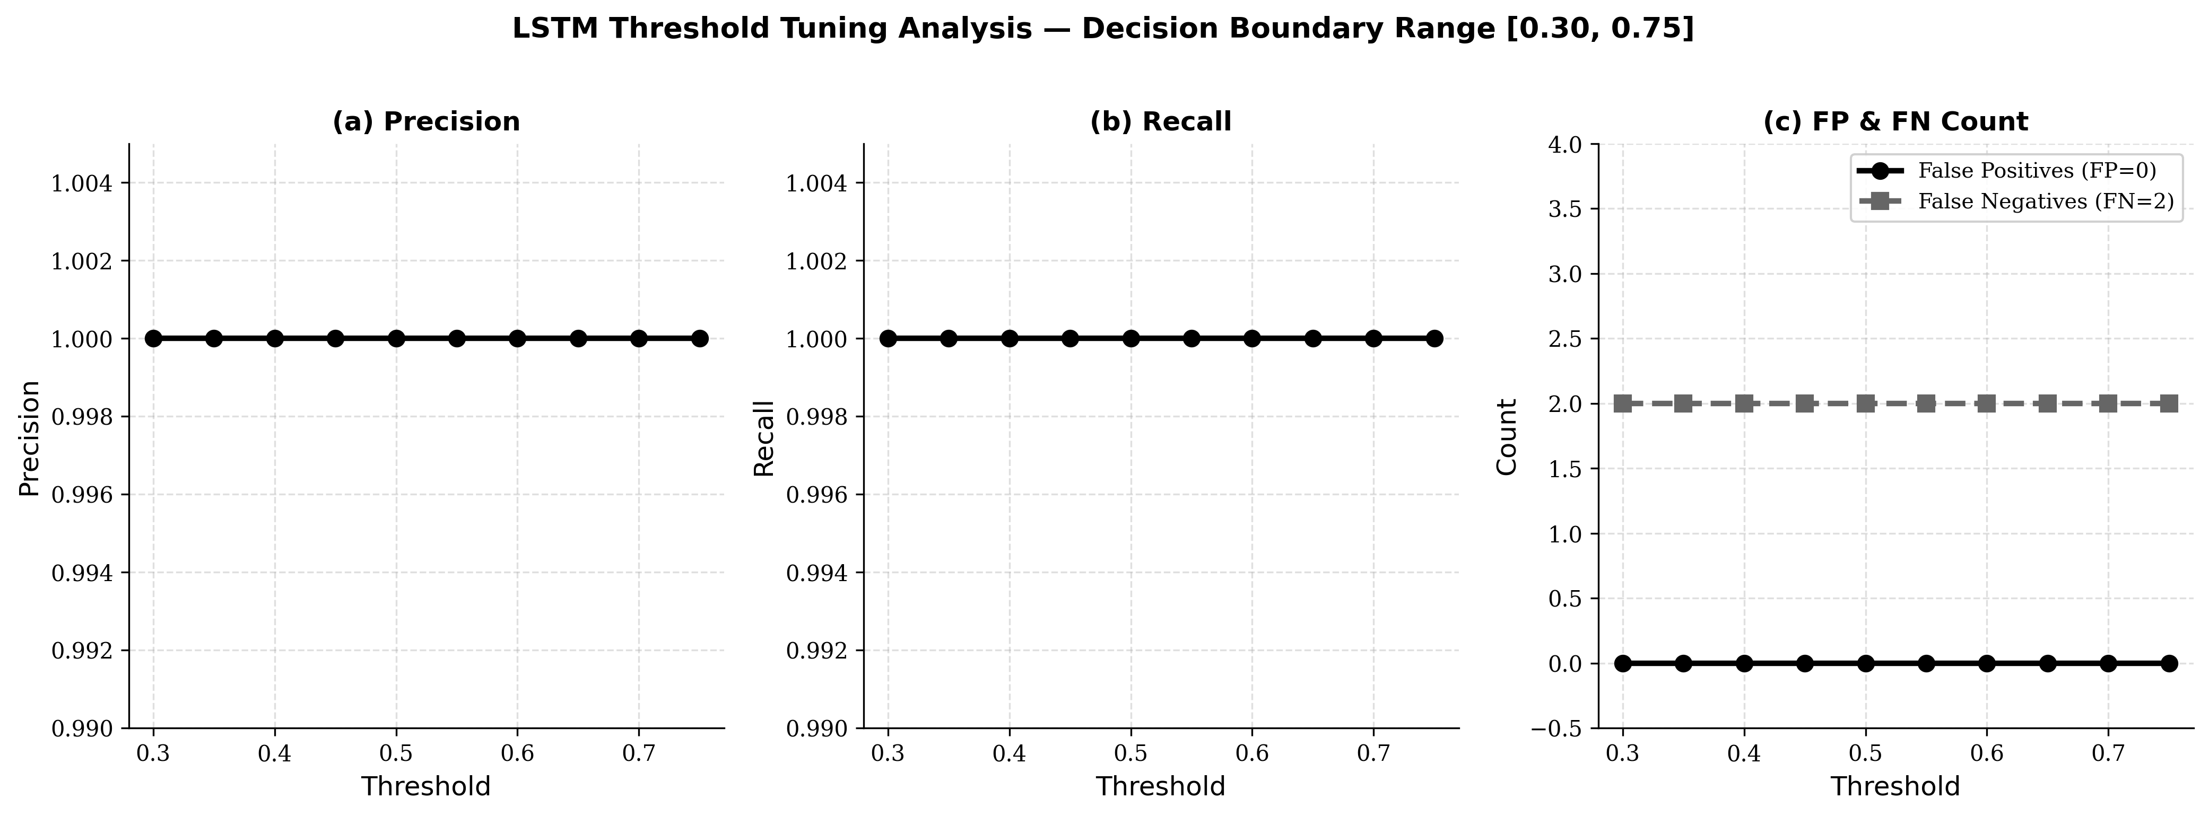

Fig. 10. LSTM threshold tuning analysis across the decision boundary range [0.30, 0.75]: (a) precision remains at 1.0000 across all ten evaluated thresholds; (b) recall remains at 1.0000 across all ten thresholds; (c) false positive count remains at zero and false negative count remains at two across all thresholds. The completely flat operating characteristic confirms near-perfect bimodal separation of the LSTM sigmoid output probability distribution.

