Team

SAD Data Analytics. We were in a bad place when we named it.

We are:

Megan, Sally

Stephen, Ben and Matt



<http://www.canberratimes.com.au/act-news/act-cycling-crash-rate-australias-highest-20161228-gtipop.html> (December 29 2016, viewed July 30 2017)



The ACT has an annual rate of “high threat to life” injuries for cyclists more than double the figure seen in other states – almost seven per 100,000 people. It has also recorded significantly higher serious injuries for cyclists for almost a decade.

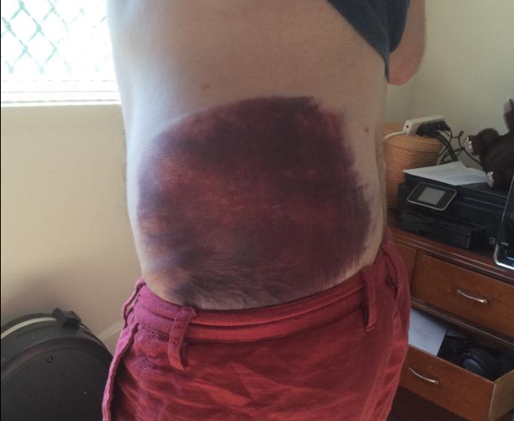

This includes me. This bruise was sure great for looking really tough and making the ambos think I’d ruptured an organ, but took me out of action for a month and made me pass out far too many times.

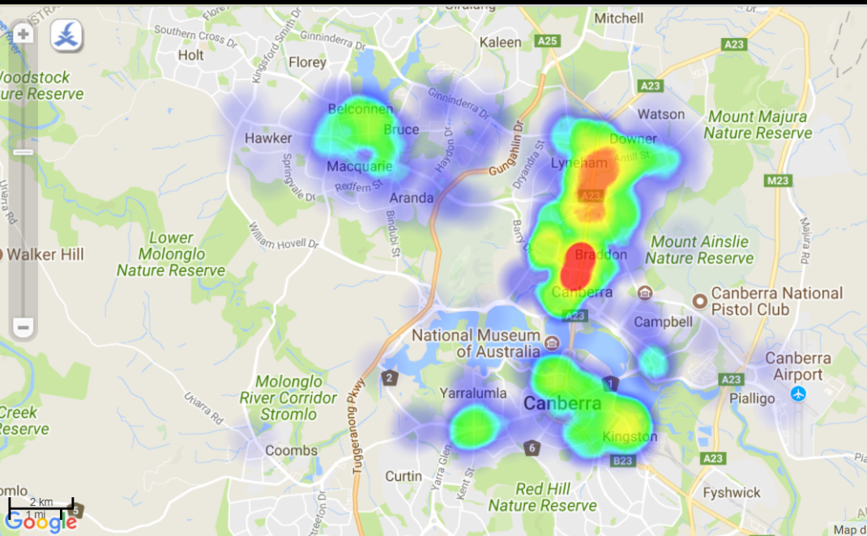

The ACT government has launched live feeds of cycle crash data in 2015 to identify safety hot spots to help prioritise infrastructure upgrades. We’ve taken that data, in addition to other geographic features such as school locations, and created a prototype app as a service that provides warnings when a cyclist is approaching these “dangerzones”, flagging that extra care is required in order to help reduce the likelihood of serious accidents.

**Data Sources**



**Dataset Name**

ACT Cyclist Crashes

ACT School Locations

ACT Bus Stop Locations

Road Signs in the ACT

**Tech**

Matt and Megan

Python in Jupyter Notebooks, including pandas (for data manipulation), geopandas (for having sweet geo information in our pandas dataframes, and being able to do geospatial manipulations), matplotlib (for plotting during dev)

*Matt and Megan go through the Jupyter notebook step-by-step*

we pass our data to...

Sally...

*Sally talk about the Arc stuff*

In ArcGIS Desktop, and using the various data sets, we were able to plot these, selecting the relevant projection and or geographic coordinate systems to get an idea of where the data was present.

We then identified different zones associated with different hazards...for example...we used the location of high accident sites to create a 70m buffer to create the DangerZone. We then looked at school locations, using a similar technique created a hazard zone (where the cyclists might actually constitute the hazard – rather than the other way round).

These zones will be used by the app to provide audio cues when cyclist enter the zones (hazard or danger zones).

who then gets it out to...

App Dev (Stephen and Ben to do that).

*Stephen and Ben talk about the app dev*