Annex E

Commissioning in 6LoWPAN

(This annex forms an integral part of this Recommendation.)

附件E

调试6LoWPAN

（本附件是本建议书的组成部分。）

Abstract 摘要
The commissioning process defines the startup procedure executed by any 6LoWPAN device. This document defines the startup procedure that should be followed by a 6LoWPAN device in any open or secured network.
调试过程定义了任何6LoWPAN设备执行的启动程序。本文档定义了6LoWPAN设备在任何开放或安全网络中应遵循的启动过程。

E.1 Introduction 引言
6LoWPAN is a low-power wireless personal area network(LoWPAN) which is comprised of the IEEE 802.15.4-2006 standard [IEEE 802.15.4] devices. One of the design goals for 6LoWPAN architecture is to ensure minimum human intervention during the provisioning of a sensor device in a PAN. However, a 6LoWPAN device requires a set of pre-deployed information, called a LoWPAN information base(LIB), to find the right PAN, to successfully join with the PAN, and to establish communication within the PAN. A device needs a specific procedure, named a bootstrapping protocol for 6LoWPAN device, to collect information from the LoWPAN bootstrapping server (LBS) and to start communication in a PAN. This procedure needs to be well defined for the interoperability of devices from different vendors. This procedure involves extracting LIB, security credentials, becoming part of an existing network, obtaining a 16-bit short address, and IP settings.
6LoWPAN是由IEEE 802.15.4-2006标准[IEEE 802.15.4]设备组成的低功率无线个人局域网（LoWPAN）。 6LoWPAN架构的设计目标之一是确保在PAN中提供传感器设备的过程中，最少的人为干预。但是，6LoWPAN设备需要一组预先部署的信息，称为LoWPAN信息库（LIB），以找到正确的PAN，成功地与PAN连接，并在PAN内建立通信。设备需要一个特定的过程，称为6LoWPAN设备的自举协议，从LoWPAN自举服务器（LBS）收集信息并启动PAN中的通信。这个过程需要定义好来自不同厂商的设备的互操作性。此过程涉及提取LIB，安全证书，成为现有网络的一部分，获取16位短地址和IP设置。

E.2 Terminology 术语
Active Scan: An active scan is used by a device to locate all coordinators transmitting beacon frames within its personal operating space, which is provided by IEEE 802.15.4. It requests other devices to transmit the beacon frame.
主动扫描：设备使用主动扫描来查找在IEEE 802.15.4提供的个人操作空间内发送信标帧的所有协调器。它请求其他设备发送信标帧。
association: An IEEE 802.15.4 device can be assigned a dynamic 16 bit short address during an association operation with a neighbour device (or router) which is also called the parent device. After getting the short address, a device can communicate with its parent or child by using only the assigned short address.
关联：IEEE 802.15.4设备可以在与邻居设备（或路由器）（也称为父设备）的关联操作期间分配动态的16位短地址。在得到短地址之后，设备可以仅使用分配的短地址与其父母或小孩进行通信。

coordinator: A full-function device (FFD) which is the principal controller of a 6LoWPAN. It is also called a PAN coordinator. It MAY initiate the synchronization of the entire 6LoWPAN by transmitting beacons.
协调器：一个全功能设备（FFD），它是6LoWPAN的主要控制器。它也被称为PAN协调员。它可以通过发送信标启动整个6LoWPAN的同步。

ED Scan: An ED scan allows a device to obtain a measure of the peak energy in each requested channel, which is provided by IEEE 802.15.4.
ED扫描：ED扫描允许设备获取IEEE 802.15.4提供的每个请求信道的峰值能量的测量值。
full-function device (FFD): A device implementing the complete protocol set of IEEE 802.15.4. It is capable of operating as a router (multi-hop packet forwarding) for its associated neighbours.
全功能设备（FFD）：实现IEEE 802.15.4完整协议集的设备。它能够作为一个路由器（多跳分组转发）为其关联的邻居。

neighbour table: A table which has the information of neighbour devices in a personal operating space.
邻居表：在个人操作空间中具有邻居设备信息的表。

LoWPAN bootstrapping information base (LIB): A set of pre-deployed information that is necessary for a particular 6LoWPAN device to find the desired PAN and to successfully join the PAN. This information is categorized into two groups; PAN specific information (PSI), which is the same for every device in a PAN (for example, PAN ID), and device specific information (DSI), which is specific for each particular node (for example short address).
LoWPAN自举信息库（LIB）：特定6LoWPAN设备查找所需PAN并成功加入PAN所必需的一组预先部署的信息。这些信息分为两组，对于PAN中的每个设备（例如PAN ID）以及每个特定节点（例如短地址）特定的设备特定信息（DSI），PAN特定信息（PSI）是相同的。

PSI: PAN specific information inside the LIB, a portion of information, called PSI, is the same for every device in the target PAN. For example, PAN_ID, PAN_Type, etc.
PSI：LIB内的PAN特定信息，称为PSI的一部分信息对于目标PAN中的每个设备是相同的。例如，PAN_ID，PAN_Type等
DSI: Device specific information inside the LIB, other than PSI, there is some information that may vary from device to device. For example, Role_of_Device, Short_Addr, etc.
DSI：除了PSI之外，LIB内的设备特定信息还有一些信息可能因设备而异。例如，Role_of_Device，Short_Addr等
LoWPAN bootstrapping device (LBD): LBD is a device that is to be deployed in the target network. LBD is assumed to have no prior information about the 6LoWPAN within which it is going to join. The only information it has is the EUI-64 address and a ''Join key'' (in the case of a secured PAN).
LoWPAN引导设备（LBD）：LBD是要部署在目标网络中的设备。假定LBD没有关于其将要加入的6LoWPAN的先前信息。唯一的信息是EUI-64地址和一个“加入密钥”（如果是安全的PAN）。
LoWPAN bootstrapping server (LBS): An entity that contains the LIB of each device to be bootstrapped. It indexes this information with the EUI-64 address of each 6LoWPAN device. LBS has two modules in it: network management and account module (NAM) and the authentication module (AM). NAM keeps track of the LIB of each device indexed by the EUI-64 address, whereas AM participates in the authentication process on behalf of the LBD using the LBD's 'Authentication credentials'. Based on the 'LBP Message', the LBS verifies the LBD with the help of the authentication server (in the case of a secured PAN) and sends an ACCEPT message with the necessary information; otherwise it sends a DECLINE message. In the case of a secured PAN, the LBS initiates the authentication mechanism issuing an authentication request into the appropriate format that is acceptable by a particular authentication server. Any challenge or reply message from the authentication server is encapsulated in the 'LIB message' by the LBS and is sent back to the LBD through the LBA.
LoWPAN引导服务器（LBS）：包含要引导的每个设备的LIB的实体。它用每个6LoWPAN设备的EUI-64地址索引这个信息。 LBS有两个模块：网络管理和帐号模块（NAM）和验证模块（AM）。 NAM跟踪由EUI-64地址索引的每个设备的LIB，而AM使用LBD的“认证证书”代表LBD参与认证过程。基于“LBP消息”，LBS在认证服务器的帮助下（在安全的PAN的情况下）验证LBD，并且发送具有必要信息的ACCEPT消息;否则它发送一个DECLINE消息。在安全的PAN的情况下，LBS启动发布认证请求的认证机制为适合特定认证服务器可接受的格式。来自认证服务器的任何询问或答复消息都被LBS封装在“LIB消息”中，并通过LBA被发送回LBD。

LoWPAN bootstrapping agent (LBA): An FFD that has already joined the PAN and thus, it is already a member of the PAN. It is also a neighbour of a new LBD, and thus it helps the bootstrapping LBD by receiving LBP messages from the LBD and forwarding it to the LBS.
LoWPAN自举代理（LBA）：已经加入PAN的FFD，因此它已经是PAN的成员。它也是新的LBD的邻居，因此它通过从LBD接收LBP消息并将其转发给LBS来帮助引导LBD。
被允许加入

open 6LoWPAN: An open 6LoWPAN is a PAN where any device is welcomed.
打开6LoWPAN：一个开放的6LoWPAN是一个任何设备欢迎的PAN。
close 6LoWPAN: A close 6LoWPAN is a PAN where only a pre-defined set of devices are allowed to join based on their EUI-64 address. This account is managed by the LBS. If the close 6LoWPAN is secured, it is called a secured 6LoWPAN.
关闭6LoWPAN：关闭6LoWPAN是一个PAN，其中只有一组预定义的设备根据其EUI-64地址
secured 6LoWPAN: A secured 6LoWPAN is a close 6LoWPAN that also maintains a secured message exchange in the PAN.
受保护的6LoWPAN：受保护的6LoWPAN是一个紧密的6LoWPAN，它也在PAN中保持安全的消息交换。
PAN ID: The 16 bit 6LoWPAN identifier which is administratively assigned to a 6LoWPAN and is unique within the PAN.
PAN ID：管理上分配给6LoWPAN并且在PAN内唯一的16位6LoWPAN标识符。

passive scan: A passive scan, like an active scan, is used by an FFD to locate all coordinators transmitting beacon frames within its personal operating space, which is provided by IEEE 802.15.4. The difference is that the passive scan is a receive-only operation and does not request the beacon frame.
被动扫描：FFD使用被动扫描（如主动扫描）来定位在IEEE 802.15.4提供的个人操作空间内发送信标帧的所有协调器。 不同之处在于被动扫描是只接收操作，并且不请求信标帧。

personal operating space (POS): The area within the reception range of the wireless transmission of an IEEE 802.15.4 packet.
个人操作空间（POS）：IEEE 802.15.4数据包的无线传输接收范围内的区域。

reduced function device (RFD): An IEEE 802.15.4 device of 6LoWPAN which does not have the functionality of the router. That is, it cannot forward IPv6 packets to the next hop device. It can only be the end device of 6LoWPAN.
低功能设备（RFD）：6LoWPAN的IEEE 802.15.4设备，它不具备路由器的功能。 也就是说，它不能将IPv6数据包转发到下一跳设备。 它只能是6LoWPAN的终端设备。
Short Address: A 16 bit address dynamically assigned to a device from the PAN.
短地址：从PAN动态分配给设备的16位地址。

E.2.1 Requirements notation 必要标记
The key words ''MUST'', ''MUST NOT'', ''REQUIRED'', ''SHALL'', ''SHALL NOT'', ''SHOULD'', ''SHOULD NOT'', ''RECOMMENDED'', ''MAY'', and ''OPTIONAL'' in this annex are to be interpreted as described in [IETF RFC 2119].
关键词“必须”，“不得”，“必须”，“应”，“不”，“应该”，“不应该”，“本附录中的“推荐”，“可能”和“可选”应按照[IETF RFC 2119]的规定进行解释。

E.3 Bootstrapping 自举
Bootstrapping is defined as collecting the LIB from the LBS, obtaining security credentials (optional), associating with the right PAN, obtaining a 16-bit short address (optional) and constructing an IPv6 address using an IPv6 prefix. Specifically, this includes the process of starting the network, associating with other nodes, obtaining the unique IPv6 address and constructing security credentials for 6LoWPAN.
Bootstrapping被定义为从LBS收集LIB，获得安全凭证（可选），与正确的PAN关联，获得16位短地址（可选），并使用IPv6前缀构造IPv6地址。具体包括启动网络，关联其他节点，获取唯一的IPv6地址以及构建6LoWPAN的安全凭证。

E.3.1 Resetting the device 重置设备
After the device is started, it first performs a MAC layer reset.
设备启动后，首先执行MAC层重置。

E.3.2 Scanning through channels 扫描通道
During this phase, functions supported by 802.15.4 are used for scanning channels. For getting the information of other devices within the POS, the device should perform a scan. The device can use either an active scan or a passive scan. During the scanning procedure, the device receives beacon frames from other devices.
在此阶段，802.15.4支持的功能用于扫描通道。为了获取POS内其他设备的信息，设备应该执行扫描。该设备可以使用主动扫描或被动扫描。在扫描过程中，设备从其他设备接收信标帧。

E.3.3 LoWPAN bootstrapping mechanism

LoWPAN自举机制
This protocol defines a mechanism to extract the LIB from a currently unknown LBS and it also defines a message format for an LIB message exchange. In this protocol, the LBD exchanges an LBP message with the LBS through its one hop neighbour LBA. So, at the beginning of the LBP, it needs to find an LBA using the 'LBA discovery phase' that is described in clause E.3.3.3.
该协议定义了从当前未知的LBS中提取LIB的机制，还定义了用于LIB消息交换的消息格式。在该协议中，LBD通过其一跳邻居LBA与LBS交换LBP消息。因此，在LBP开始时，需要使用E.3.3.3中描述的“LBA发现阶段”来找到LBA。

E.3.3.1 LoWPAN bootstrapping protocol message format 1 LoWPAN自举协议消息格式
In this clause we define a message format which is necessary for the LBP.
在这一节中，我们定义了LBP所必需的消息格式。

E.3.3.1.1 LBP message LBP消息
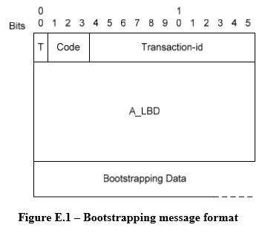
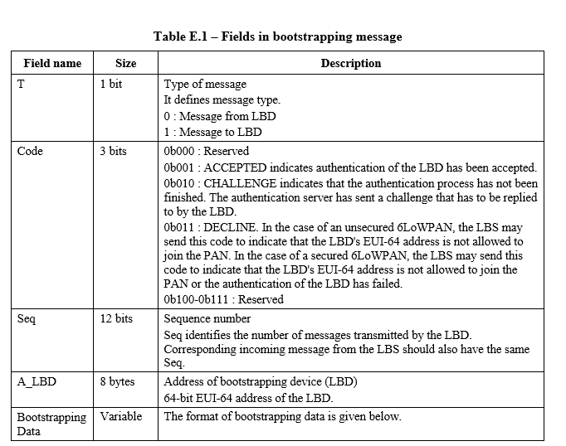
表E.1-引导消息中的字段
字段名称 | 大小 | 描述
T | 1 bit | 消息类型  它定义了消息类型。  0：来自LBD的消息  1：给LBD的消息
Code | 3 bit | 0b000：保留  0b001：接受表示LBD的认证已被接受。  0b010：CHALLENGE表示认证过程尚未完成。 认证服务器已经发送了必须由LBD回复的挑战。  0b011：衰退。 在不安全的6LoWPAN的情况下，LBS可以发送该代码来指示LBD的EUI-64地址不被允许加入PAN。 在安全的6LoWPAN的情况下，LBS可以发送该代码以指示LBD的EUI-64地址不被允许加入PAN或者LBD的认证失败。 0b100-0b111：保留
Seq | 12 bit | 序号  Seq标识由LBD发送的消息的数量。  来自LBS的相应传入消息也应具有相同的Seq。
A_LBD | 8 bytes | 引导设备（LBD）的地址  LBD的64位EUI-64地址。
BootstrappingData | Variable | 引导数据的格式如下

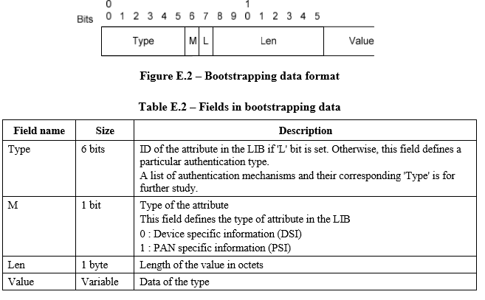

表E.2-引导数据的字段
字段名称 | 大小 | 描述
Type | 6 bits | 如果设置了“L”位，则在LIB中的属性的ID。 否则，这个字段定义一个特定的认证类型。  认证机制及其对应的“类型”列表有待进一步研究。
M | 1 bit | 属性的类型  该字段定义了LIB中的属性类型  0：设备特定信息（DSI）  1：PAN特定信息（PSI）
Len | 1 byte | 以八位字节为单位的值的长度
Value | Variable | 类型的数据

E.3.3.2 LoWPAN bootstrapping information base LoWPAN自举信息库
One of the important goals of the LBP is to receive a set of information from the LBS by a joining LBD. This information comprises of PSI and DSI. The following table shows the attribute name, attribute ID (attr_ID), purpose of the attribute and its type.
LBP的一个重要目标是通过加入LBD从LBS接收一系列信息。 这些信息包括PSI和DSI。 下表显示属性名称，属性ID（attr_ID），属性的用途及其类型。
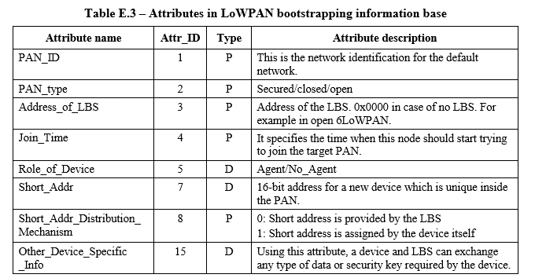
表E.3-LoWPAN引导信息库中的属性
属性名称 | Attr-ID | Type | Attribute description
PAN_ID | 1 | P | 这是默认网络的网络标识。
PAN_type | 2 | P | 安全/封闭/开放
Address_of_LBS | 3 | P | LBS的地址。 0x0000在没有LBS的情况下。 例如在打开6LoWPAN。
Join_Time | 4 | P | 它指定了这个节点开始尝试加入目标PAN的时间。
Role_of_Device | 5 | D | 代理/ 非代理
Short_Addr | 7 | D | 在PAN中唯一的新设备的16位地址。
Short_Addr_Distribution_ Mechanism | 8 | P | 0：短地址由LBS提供  1：短地址由设备本身分配
Other_Device_Specific _Info | 15 | D | 使用此属性，设备和LBS可以交换设备所需的任何类型的数据或安全密钥。

E.3.3.3 LBA discovering phase LBA发现阶段
The LBD has to send an LBP message to the LBS server under the support of an LBA. To find the LBA, it broadcasts an LBA solicitation message within its one hop neighbours and waits for an LBA advertisement. Any device capable of being an LBS/LBA replies to the broadcast specifying its capability as an LBS/LBA. If there is any LBS in its neighbour, the LBD selects that LBS, otherwise it selects one of the LBAs.
LBD必须在LBA的支持下向LBS服务器发送LBP消息。为了找到LBA，它在其一跳邻居内广播LBA请求消息并等待LBA广告。任何能够作为LBS / LBA的设备回复广播，指定其作为LBS / LBA的能力。如果邻居有任何LBS，则LBD选择该LBS，否则选择其中一个LBA。

E.3.3.4 LoWPAN bootstrapping protocol (LBP)

LoWPAN自举协议（LBP）
The LBD sends an LBP message to the LBA, as it does not know the address or path to the LBS of the target PAN. The LBA forwards the LBP message to the LBS on behalf of the LBD. The LBS replies with one or multiple LBP messages destined to the LBA as the LBD is still is not part of the network. If the network is a secured 6LoWPAN and the LBD is an authentic node, we assume that the LBD has the necessary pre-deployed keys and the knowledge of the authentication mechanism necessary to authenticate in a target PAN. In this case, the LBD sends the necessary information in the 'bootstrapping data' field so that the LBS can initiate the authentication process using that 'authentication credentials'. The LBS converts the LBP message into an appropriate authentication request for the particular authentication server and sends it. A reply/challenge from the authentication server, for example an EAP authenticator or AAA server, is encapsulated in the LBP message's 'bootstrapping data' field and is sent back to the LBD through the LBA. The LBA also keeps track of successful authentication, failed authentication and an incomplete conversation of the authentication process, and maintains a 'black list' of malicious devices to avoid repeated attacks. Detecting a malicious device based on these 3 pieces of information and marking that node as 'Blacklisted' belongs to the scope of security policy and out of the scope of this Recommendation.
LBD向LBA发送LBP消息，因为它不知道目标PAN的LBS的地址或路径。 LBA代表LBD将LBP消息转发给LBS。由于LBD仍然不是网络的一部分，因此LBS应答一个或多个发往LBA的LBP消息。如果网络是一个安全的6LoWPAN，并且LBD是一个真实的节点，我们假设LBD具有必要的预部署密钥以及在目标PAN中认证所需的认证机制的知识。在这种情况下，LBD在“引导数据”字段中发送必要的信息，以便LBS可以使用该“认证凭证”启动认证过程。 LBS将LBP消息转换为针对特定认证服务器的适当认证请求并发送。来自认证服务器的回复/询问，例如EAP认证器或AAA服务器，被封装在LBP消息的“自举数据”字段中，并通过LBA被发送回LBD。 LBA还跟踪认证的成功，认证失败和认证过程的不完整对话，并维护恶意设备的“黑名单”以避免重复攻击。基于这3条信息检测恶意设备，并将该节点标记为“黑名单”属于安全策略的范围，不属于本建议书的范围。
The following figure shows a simple example of a bootstrapping mechanism.
下图显示了一个自举机制的简单例子。

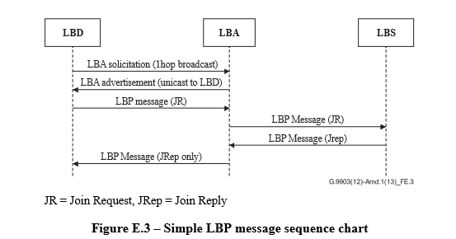

E.3.3.5 LBP in secured 6LoWPAN

安全的6LoWPAN中的LBP
In a secured 6LoWPAN, the LBD must exchange authentication credentials using its join key. Apart from requesting network resources, in the case of a secured network, this process may need to exchange several encrypted messages between the LBD and authentication server. The LBA and LBS serve as a 'secured tunnel' for the authentication message exchange process. Both the LBA and LBS keep account of the last LIB request/reply processed by themselves.
在安全的6LoWPAN中，LBD必须使用其连接密钥交换认证凭证。除了请求网络资源外，在安全网络的情况下，这个过程可能需要在LBD和认证服务器之间交换几个加密的消息。 LBA和LBS用作认证消息交换过程的“安全隧道”。 LBA和LBS都记录自己处理的最后一个LIB请求/回复。
Example: LBP with EAP
示例：使用EAP的LBP
The following figure shows how the LBP works with another authentication protocol like EAP. At first the LBD broadcasts an LIB request (1 hop) to the LBA. The LBA already has a secured route to the LBP so it just unicasts the LIB request to the LBS. The LBS sends an EAP packet prepared with the LBD's authentication credentials and sends it to the authenticator. It is also possible that an LBS entity and authenticator entity resides on a single system. As discussed earlier, the LBS serves as a translator between an LBP and EAP message exchange in this authentication process and finally when AM indicates the success of authentication, it sends all network resources along with the ACCEPTED code. In the case of failure in the authentication process, a DECLINE code is sent to the LBD.
下图显示了LBP如何使用另一个身份验证协议（如EAP）。首先，LBD向LBA广播LIB请求（1跳）。 LBA已经有一条到LBP的安全路由，所以它只向LBS单播LIB请求。 LBS发送一个由LBD的认证证书准备的EAP数据包，并发送给认证者。 LBS实体和认证者实体也可能驻留在单个系统上。正如前面所讨论的，LBS在这个认证过程中充当LBP和EAP消息交换机之间的转换器，最后当AM指示认证成功时，它发送所有的网络资源和ACCEPTED代码。在认证过程失败的情况下，DECLINE代码被发送到LBD。
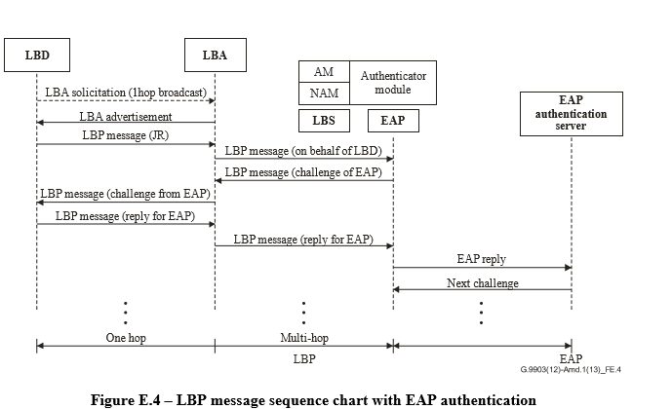

E.3.3.6 Role of entities in LBP 实体在LBP中的作用
Role of LoWPAN bootstrapping device (LBD):
– It selects the LBA using the LBA discovery phase.
– If it does not find an LBA, it gives up after waiting for a certain amount of time.
– If it receives an LBP message with the code ''CHALLENGE'', it must send another LBP message containing the appropriate value against the challenge/query in the bootstrapping data field.
– It MUST increment seq for every new LBP message. For retransmission seq should r emain same.
LoWPAN自举设备（LBD）的作用：
- 它使用LBA发现阶段选择LBA。
- 如果没有找到LBA，等待一段时间后会放弃。
- 如果它收到一个带有“挑战”代码的LBP消息，则它必须发送另一个包含适当值的LBP消息对抗自举数据字段中的询问/查询。
- 它必须为每个新的LBP消息递增seq。重发seq应该保持不变。
Role of LoWPAN bootstrapping agent (LBA):
When the LBA receives an LBP message from the LBD.
- If the LBD is already on the black list, discard.
- If the LBD is new, and 6LoWPAN is an open network:
a) Send 'LBP message' with ACCEPTED along with all PSI from its own LIB.
b) If there is an LBS in the PAN, forward the 'LBP message' to the LBS for DSI.
- If the LBD is old, and 6LoWPAN is an open network:
- If it matches with the last seq no. send the last reply;
b) otherwise discard.
- If the LBD is new, and 6LoWPAN is a secured network:
- forward the LBP message to LBS.
- If the LBD is old, and 6LoWPAN is a secured network:
- If it matches with the last seq no. send the previously saved last LBP message 'for LBD'.
b) If the LBP has completed, discard.
c) If the LBP is 'CHALLENGE' and new seq is next to the last one, forward the message to the LBS.
LoWPAN引导代理（LBA）的作用：
当LBA收到来自LBD的LBP消息时。
1.如果LBD已经在黑名单上，请丢弃。
2.如果LBD是新的，6LoWPAN是一个开放的网络：
a）发送带有ACCEPTED的“LBP消息”以及来自它自己的LIB的所有PSI。
b）如果PAN中有LBS，则将“LBP消息”转发给DSBS的LBS。
3.如果LBD是旧的，而6LoWPAN是一个开放的网络：
a）如果它与最后一个seq no。发送最后一个回复;
b）否则丢弃。
4.如果LBD是新的，6LoWPAN是一个安全网络：
a）将LBP消息转发给LBS。
5.如果LBD是旧的，6LoWPAN是一个安全的网络：
a）如果它与最后一个seq no。发送先前保存的最后的LBP消息“用于LBD”。
b）如果LBP已经完成，丢弃。
c）如果LBP是'CHALLENGE'，并且新的seq在最后一个旁边，则将消息转发给LBS。
When the LBA receives an LBP message from the LBS (for LBD):
– If it is ACCEPTED and a 16-bit short address is the responsibility of the LBA, it calculates and appends the 16-bit short address with the LIB reply.
– Otherwise, if it is ACCEPTED, DECLINED or CHALLENGE, forward it to the corresponding LBD.
– If it is not ACCEPTED or DECLINED, delete the previously saved LBP message and save this LBP message.
– If it is DECLINED based on the security policy, mark it as 'Blacklisted'.
– If there is no activity in some of the flow (LBD-LBS pair), mark the LBD and based on the security policy include it in 'Black list'.
当LBA收到来自LBS（用于LBD）的LBP消息时：
- 如果它是被接受的，并且一个16位短地址是LBA的责任，它将计算并附加16位短地址和LIB应答。
- 否则，如果它被接受，拒绝或挑战，转发给相应的LBD。
- 如果它不被接受或被拒绝，删除先前保存的LBP消息并保存该LBP消息。
- 如果根据安全策略进行了DECLINED，请将其标记为“列入黑名单”。
- 如果某些流（LBD-LBS对）没有活动，则标记LBD并根据安全策略将其包括在“黑名单”中。
Role of LoWPAN bootstrapping server (LBS):
In the case of an open 6LoWPAN:
– If the LBD is 'valid' that means its EUI-64 is in an accepted list or not in the rejection list, it sends an ACCEPTED code and the necessary DSI and 16-bit short address (if the address should be assigned centrally).
In the case of a secured 6LoWPAN:
– The AM of the LBS determines the authentication server for a particular EUI address and sends authentication mechanism initiation with the authentication credentials to that authentication server.
– When it gets a reply from the authentication server, if it is success, it prepares a success reply; if it is failure, it prepares a failure reply; if it is challenge/query, it prepares a processing reply for the LBD and sends it to the LBA.
– When the AM module receives 'success' from the authentication server, it informs 'success' to the NAM and sends the success response to NAM. NAM then sends the DSI along with the response in an LBP message.
LoWPAN引导服务器（LBS）的作用：
在一个开放的6LoWPAN的情况下：
- 如果LBD是“有效的”，这意味着EUI-64在允许列表中或不在拒绝列表中，则发送一个ACCEPTED代码和必要的DSI和16位短地址（如果地址应该集中分配） 。
在安全的6LoWPAN的情况下：
- LBS的AM确定特定EUI地址的认证服务器，并将带有认证凭证的认证机制启动发送到该认证服务器。
- 当它从认证服务器得到答复时，如果成功，则准备成功答复;如果失败，则准备失败回复;如果是质询/查询，则准备针对LBD的处理回复并将其发送到LBA。
- 当AM模块收到来自认证服务器的'成功'时，通知NAM成功，并将成功响应发送给NAM。然后NAM将DSI连同在LBP消息中的响应一起发送。

E.3.4 Assigning the short address分配短地址
During the LBP procedure, the LBD may set a short address either by itself or after receiving the address from the PAN. The short address must be unique in a PAN and may be given by a centralized or distributed way.
在LBP过程中，LBD可以自己设置一个短地址，也可以在收到PAN的地址后设置一个短地址。短地址在PAN中必须是唯一的，可以通过集中或分散的方式给出。
One of the approaches to distribute the short address among the LBDs is in a centralized fashion where a centralized entity (e.g., LBS) assigns a 16-bit short address for an LBD. Allocation of the short address MAY be based on First-Available-Address-First or a randomly chosen one or using any other algorithm.
在LBD中分配短地址的方法之一是以集中式实体（例如LBS）为LBD分配16位短地址的集中方式。短地址的分配可以基于First-Available-Address-First或随机选择的一个或使用任何其他算法。
The distributed approach is another way to assign a 16-bit short address to LBDs. In this approach, the LBA assigns a short address to the joining device, LBD. A hierarchical addressing scheme could be used by the LBA for this purpose. The following figure describes the address calculation scheme. This scheme requires one parameter MC, the maximum number of addresses a LBA can assign. If the present LBD is the first of the children, then it gets the short address by the following formula:
FC = MC × AP + 1
where FC is the LBD address, and AP is the address of the LBA.
If LBD is not the first child of this LBA, it receives the address which is next to the last address assigned by that LBA.
分布式方法是为LBD分配16位短地址的另一种方法。在这种方法中，LBA为加入设备LBD分配一个短地址。为此，LBA可以使用分层寻址方案。下图描述了地址计算方案。该方案需要一个参数MC，即LBA可分配的最大地址数量。如果现在的LBD是第一个孩子，那么通过下面的公式得到短地址：
FC = MC×AP + 1
其中FC是LBD地址，AP是LBA的地址。
如果LBD不是该LBA的第一个孩子，则它接收到该LBA分配的最后一个地址旁边的地址。
For example, if LBA (1) assigned address 6 to its last LBD, it assigns address 7 to its next LBD.
MC = 4
例如，如果LBA（1）将地址6分配给其最后的LBD，则将地址7分配给其下一个LBD。
MC = 4
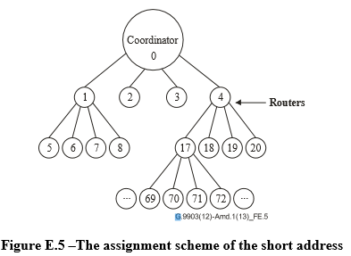

E.3.5 Obtaining IPv6 address 获取IPv6地址
The IPv6 interface identifier of a device can be obtained as described in Section 6 of [IETF RFC 4944]. After having a unique IPv6 interface identifier, the device begins to obtain an IPv6 address prefix. The IPv6 address prefix for a particular 6LoWPAN is stored by the IPv6 router in the 6LoWPAN. ICMPv6 is used to share these parameters. Routers in 6LoWPAN are supposed to broadcast router advertisement (RA) messages periodically. The RA message must contain the prefix option which can be used in the 6LoWPAN. Devices which wish to obtain an IPv6 address prefix may wait for an RA message until RA_WAIT_TIME elapsed. After that, if no RA message is received, they may broadcast a router solicitation message for requesting the RA message.
设备的IPv6接口标识符可以按照[IETF RFC 4944]第6部分的描述获得。拥有唯一的IPv6接口标识符后，设备将开始获取IPv6地址前缀。特定6LoWPAN的IPv6地址前缀由IPv6路由器存储在6LoWPAN中。 ICMPv6用于共享这些参数。 6LoWPAN中的路由器应该定期广播路由器通告（RA）消息。 RA消息必须包含可在6LoWPAN中使用的前缀选项。希望获得IPv6地址前缀的设备可以等待RA消息直到RA_WAIT_TIME过去。之后，如果没有收到RA消息，则可以广播请求RA消息的路由器请求消息。
The router solicitation and RA messages can have additional option fields as described in [IETF RFC 4861]. Source/Target link-layer address option field should contain the EUI-64 address or the combined address with PAN ID and 16-bit short address of the source or target device as below.
路由器请求消息和RA消息可以具有附加的选项字段，如[IETF RFC 4861]中所述。源/目标链路层地址选项字段应该包含EUI-64地址或源或目标设备的PAN ID和16位短地址的组合地址，如下所示。

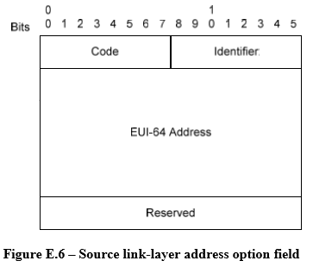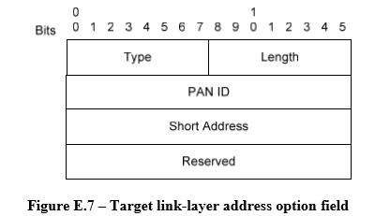
Multiple IPv6 routers could form a single or multiple 6lowpan(s). If there are multiple routers in a 6LoWPAN, the device should consider which one is to be selected as a default router. One possible way of selection is to compare the hop counts travelled of the RA message of each router. The detailed algorithm for the selection is for further study.
多个IPv6路由器可以形成一个或多个6lowpan（s）。 如果在6LoWPAN中有多个路由器，设备应该考虑选择哪一个作为默认路由器。 一种可能的选择方式是比较每个路由器RA消息的跳数。 详细的选择算法有待进一步研究。

E.3.6 Configuration parameters
This section gives default values for some important parameters associated with the 6LoWPAN commissioning protocol. A particular node may wish to change certain parameters.
本节给出了与6LoWPAN调试协议相关的一些重要参数的默认值。 一个特定的节点可能希望改变某些参数。
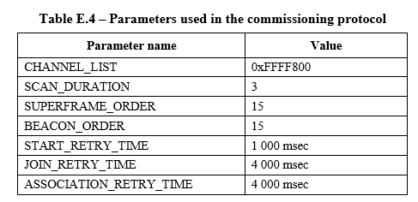

E.4 IANA consideration
For further study.

E.5 Security considerations
IEEE 802.15.4 devices are required to support AES link-layer security. The MAC layer also provides all keying material necessary to provide the security services. It is not defined however, when security shall be used especially when combining with bootstrapping. After the device starts and joins the network, security services such as key management and device authentication should be done automatically. Detailed algorithms for security on bootstrapping, is for further study.
要求IEEE 802.15.4设备支持AES链路层安全性。 MAC层还提供了提供安全服务所需的所有密钥资料。 但是没有定义，特别是当与自举相结合时，应该使用安全性。 设备启动加入网络后，自动进行密钥管理，设备认证等安全服务。 详细的自举引导安全算法有待进一步研究。

