# Notes:

Personal info p1

Profile p1

Interest p2

Job p2

Project p3 1000words…

## Personal information

Name: Austin Bowen

Email: [s3967671@student.rmit.edu.au](mailto:s3967671@student.rmit.edu.au)

Student Number: s3967671

I am 17 years old I left school during grade 11 to learn Programming and IT which I am very interested in and wanting to make a career out of. I am of English descend and was born in Australia and plan on traveling to Japan in the future. I was raised on a 40 acre hobby farm and still have some of my favourite pets, my goats and dog.

## Interest in IT

My interest in IT is along the lines of problem solving in a digital/technical format, programming being my favourite. I gained interest in IT over time as opposed to an initial ‘lightbulb moment.’

RMIT is highly recommended by Open Universities Australia and the intake dates to do the Intro to IT and Intro to Programming courses were available at the time I needed them. Being able to study my courses online is another reason I chose RMIT.

Having perused the information of the IT course I had a basic understanding of what to expect, although I simply trusted that the Intro to IT course would supply me with what I needed to learn and be able to proceed into a bachelor of IT.

## Ideal Job

<https://www.seek.com.au/job/58497098?type=standout#sol=dd4e9224684ec5f5a95ef3b7e088e02eb18e444c>

Job Title: Programmer/Data Analyst

Job Description: Machine Learning, Data Mining, Computational Statistics and Behavioural Analysis are the main jobs to be performed of which provide me a good variety and are appealing.

Skills/Qualifications/Experience: Learn or know: F#, C#, C++  
Visual Studio 2022 or Visual Studio Code IDEs.  
InfluxDB  
Microservices with Dapr  
Microsoft Azure  
Docker and Kubernetes  
.NET Framework, WinForms, .NET 6.0, ASP.NET 6.0 (Web API)

Various levels of experience will be considered

I am currently studying Intro to IT and Intro to Programming. Mum—

Skills/Qualifications/Experience PLAN:

I plan on doing a Bachelor of IT starting next year while obtaining a part time job (traineeship) to get practical experience, and alter my study load as necessary. In my 2nd year of my Bachelor I’ll assess my job to ensure I continue to upskill. I will also research and discuss with Open Universities Australia a dual Bachelor or adding other subjects to the Bachelor. There’s also an option to complete a machine learning course and do a Math Methods or Specialist Maths equivalent. I have the option of completing the Bachelor in 3 years or extending it to 5 years to do other courses along side it while maintaining a part time job.

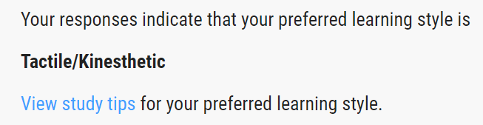Personal Profile:  
Learning Style Test   
<https://www.how-to-study.com/learning-style-assessment/>

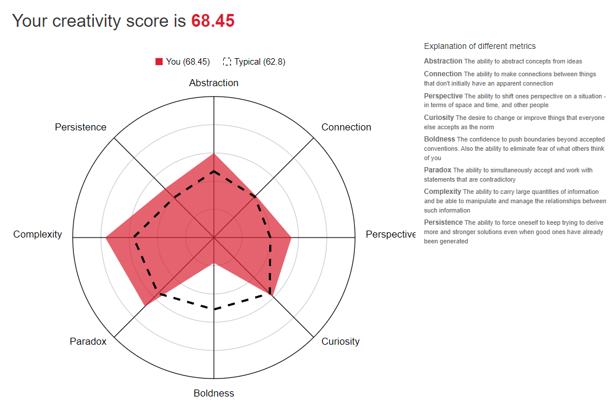Creativity Test  
<http://www.testmycreativity.com/>

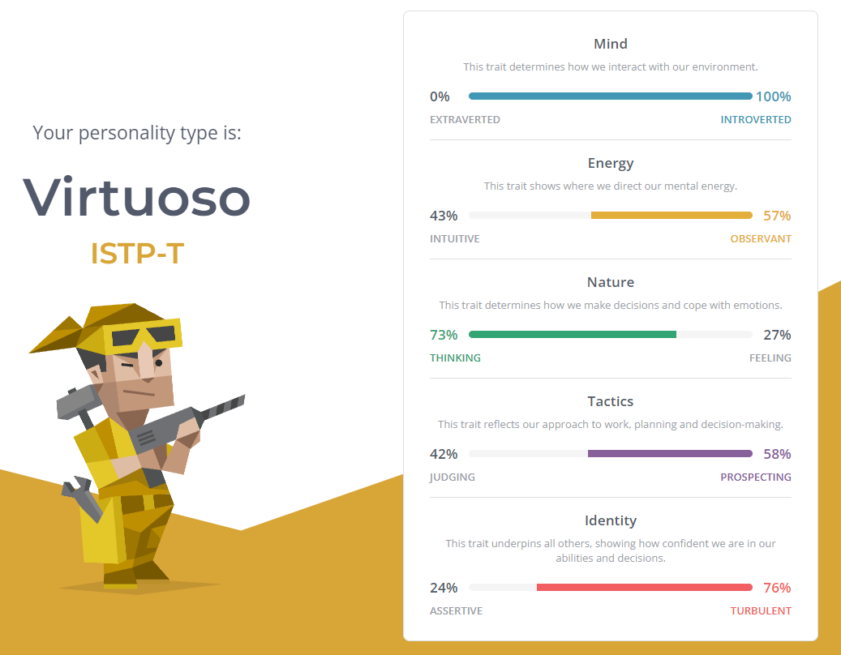Myers-Briggs test   
<https://www.16personalities.com/>

Having participated in 3 different tests, personality, learning style and creativity, gives me the opportunity to identify and validate my needs in a team environment but also to validate all team members. Not just accepting different personalities, but seeing the importance of understanding everybody’s needs for their unique learning styles and team productivity. When forming a team the members varying learning styles and personality traits will be taken into consideration when delegating individual tasks.

## Project Idea

My project idea is for a scanner attached or installed to motor vehicles that will detect various breaches of road rules. I would like to see this available in 2 different forms, one as an attachment and the other being installed during the manufacturing of new vehicles. It will record when another driver of a vehicle breaches a road rule and the video/data is instantly uploaded to the Department of Transport and Main Roads, their insurer, and the authorities/police department.

The scanner will assist in maintaining the safety of our community members by reducing the number of accidents and fatalities. Tailgating is the most common cause of road rage accidents and fatalities in our country. It is reported by

The Conversation <https://www.abc.net.au/news/2022-02-16/tailgating-is-stressful-and-dangerous/100837108>

that in Queensland between 2019 and 2020, there were more than 7,000 injuries and fatalities, and only 3,120 drivers were fined. Their research showed that a fine and demerit points were a deterrent for tailgating.

Sensors and cameras installed on exterior of the car, front, back left and right, with the central computer inside the car. The sensors will calculate your speed and how many seconds are between you other cars and warn you if the gap is less than 2 seconds. It will be able to detect speeding, wreckless driving, failure to indicate, failure to give way and other infractions.

### Tools and Technologies

### Skills required

### Outcome

Reducing road accidents and deaths

## Further Investigation Required:

Patents against similar devices.  
feasible co-operation of insurer, cops and transport  
legality  
rain interference