User documentation

austin mcgill (february 2024)

Contents

Application Overview 1

The Anime Series Option 2

Add Anime Series 3

The Anime Movie Option 5

The Anime List Option 6

## Application Overview

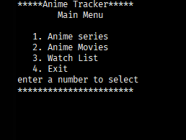This application tracks anime series, movies, reviews, and a watch list. Users can add, update, remove, list, and search anime series, movies, reviews, and a watch list. Start the application by clicking the animeTracker.jar file. The following menu is shown when the application starts.

## The Anime Series Option

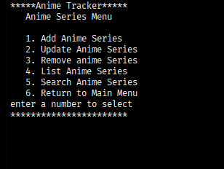From the Main menu select option 1 to add anime series, update anime series, remove anime series, list anime series and search anime series by title. The following menu is displayed when option 1 is selected.

# Add Anime Series

Select option 1 to add a anime series to the database. You will be prompted to enter the data required for a anime series. Below are the fields, values, and error messages.

|  |  |  |
| --- | --- | --- |
| Field | Description | Error Messages  [corrective action in brackets] |
| Anime Title | Required. Anime title. Enter a unique String, that’s the title of the anime series.  (1 – 255 characters) | Row already exists and cannot be added again.  [Enter a different title]  Must provide anime series title  [user must provide a title] |
| Release date | Not required. Date entered in as a string in a (yyyy-mm-dd) format. | Invalid date please enter a year after 1920 and before (the current year + 10)Ex. 34 for the year 2024  [Enter in a year within those years]  Invalid input enter (yyyy-mm-dd)  [enter in digits in this format Ex.1993-01-10] ensure it is also a proper date |
| Total episodes | Not required. Total number of anime series episodes entered as an Integer (1 – 11 characters) | Invalid number of episodes please enter a number between 1 – 3000.  [enter in a integer in between including 1-3000]  Invalid input please enter a number  [only enter integers] |
| Genre | Not required. Enter in a string of genres of the current anime series. (1 – 100 characters) | No error messages able to put in whatever you like including customizing your own genres. |
| Description | Not required. Enter in a string description of the anime series | No error messages able to customize your description including not providing one at all. |

After being prompted to enter data for each field. The error messages mentioned above will appear, or no error message will appear for genre and description. After description has been added or omitted anime series added will be displayed and the anime series will be added to the database.

# The Anime Movie Option

From the Main menu select option 2 to add a movie, update a movie, remove a movie, list movies and search movies by title. The following menu is displayed when option 2 is selected.

# The Anime List Option

From the Main menu select option 3 to add to the anime list, update the anime list, remove from the watch list, list watch list and search watch list by title. The following menu is displayed when option 3 is selected.