User documentation

austin mcgill (february 2024)

Increment 2 Revisions

The following pages were added.

Page 5. Explains how to update an anime series.

Page 6. Explains how to remove and list an anime series.

Page 7. Explains how to search an anime series.

Increment 3 Revisions

The following pages were added.

Page 8. Explains how to add a anime movie

Page 9. Explains how to update a anime movie

Page 10. Explains how to remove a anime movie

Page 10. Explains how to list anime movies

Page 11. Explains how to search anime movies

Contents

Application Overview 3

The Anime Series Option 3

Add Anime Series 4

Update Anime Series 5

Remove Anime Series 6

List Anime Series 6

Search Anime Series 7

The Anime Movie Option 7

Add Anime Movie 8

Update Anime Movie 9

Remove Anime Movie 10

List Anime Movies 10

Search Anime Movie 11

The Anime List Option 11

## Application Overview

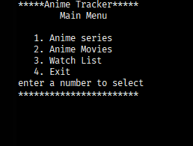This application tracks anime series, movies, reviews, and a watch list. Users can add, update, remove, list, and search anime series, movies, reviews, and a watch list. Start the application by clicking the animeTracker.jar file. The following menu is shown when the application starts.

## The Anime Series Option

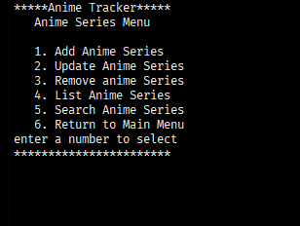From the Main menu select option 1 to add anime series, update anime series, remove anime series, list anime series and search anime series by title. The following menu is displayed when option 1 is selected.

# Add Anime Series

Select option 1 to add a anime series to the database. You will be prompted to enter the data required for a anime series. Below are the fields, values, and error messages.

|  |  |  |
| --- | --- | --- |
| Field | Description | Error Messages  [corrective action in brackets] |
| Anime Title | Required. Anime title. Enter a unique String, that’s the title of the anime series.  (1 – 255 characters) | Row already exists and cannot be added again.  [Enter a different title]  Must provide anime series title  [user must provide a title] |
| Release date | Not required. Date entered in as a string in a (yyyy-mm-dd) format. | Invalid date please enter a year after 1920 and before (the current year + 10)Ex. 34 for the year 2024  [Enter in a year within those years]  Invalid input enter (yyyy-mm-dd)  [enter in digits in this format Ex.1993-01-10] ensure it is also a proper date |
| Total episodes | Not required. Total number of anime series episodes entered as an Integer (1 – 11 characters) | Invalid number of episodes please enter a number between 1 – 3000.  [enter in a integer in between including 1-3000]  Invalid input please enter a number  [only enter integers] |
| Genre | Not required. Enter in a string of genres of the current anime series. (1 – 100 characters) | No error messages able to put in whatever you like including customizing your own genres. |
| Description | Not required. Enter in a string description of the anime series | No error messages able to customize your description including not providing one at all. |

After being prompted to enter data for each field. The error messages mentioned above will appear, or no error message will appear for genre and description. After description has been added or omitted anime series added will be displayed and the anime series will be added to the database.

# Update Anime Series

Select option 2 to update an already existing anime series in the database. Ensure that when updating anime series in the database you use a unique title duplicate titles are not allowed in the database. Once selected you will be prompted to enter the title of the anime series you wish to update. Once you type in the anime series title you will be prompted with all anime series entries stating the current value followed by example: “Enter new title or enter key to skip: ” If skipped the current data in the database is used. It is recommended to run a list anime series first so you can ensure that you know the title of the anime series you want to update.

|  |  |  |
| --- | --- | --- |
| Field | Description | Error messages  [corrective actions in brackets] |
| Enter title of the anime you want to update? | Required. Anime title. Enter a unique String, that’s the title of the anime series.  (1 – 255 characters) | Title already exist must use a different title.  [type in a different anime title or use the same title it had]  No records found  [enter the title of a anime series that exist in the database] |
| current release date is [?]. Enter new release date or enter key to skip: | Not required. Date entered in as a string in a (yyyy-mm-dd) format. | Invalid date please enter a year after 1920 and before (the current year + 10)Ex. 34 for the year 2024  [Enter in a year within those years]  Invalid input enter (yyyy-mm-dd)  [enter in digits in this format Ex.1993-01-10] ensure it is also a proper date |
| Current total episodes is [?]. enter new total episodes or enter key to skip | Not required. Total number of anime series episodes entered as an Integer (1 – 11 characters). | Invalid number of episodes please enter a number between 1 – 3000.  [enter in a integer in between including 1-3000]  Invalid input please enter a number  [only enter integers] |
| Current genre(s) is [?]. Enter new genre(s) or enter key to skip. | Not required. Enter in a string of genres of the current anime series. (1 – 100 characters) | No error messages able to put in whatever you like including customizing your own genres. |
| Current description [?]. Enter new description or enter key to s | Not required. Enter in a string description of the anime series | No error messages able to customize your description including not providing one at all. |

# Remove Anime Series

Select option 3 to delete an anime series that exists in the database by title. It is recommended to run a list anime series to get the title of the anime series you wish to delete.

|  |  |  |
| --- | --- | --- |
| Field | Description | Error messages  [corrective actions in brackets] |
| Enter anime series title to delete: | Enter string (1- 255) characters | Anime series does not exist  [enter a anime title that exist in the database] |

# List Anime Series

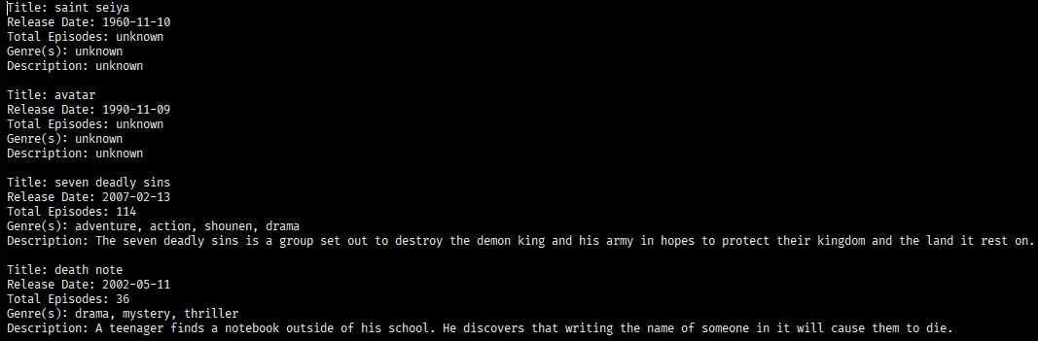Select option 4 to list all the anime series currently in the database.

# Search Anime Series

Select option 5 will allow you to search a specific anime series by title in the database and display its details.

|  |  |  |
| --- | --- | --- |
| Field | Description | Error messages  [corrective action in brackets] |
| Enter title of anime series to search: | Enter unique string to represent title of anime series (1- 255 characters) | No records found  [enter the title of an anime series that’s in the database] |

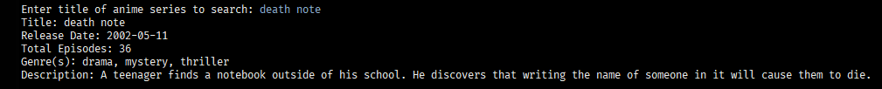

# The Anime Movie Option

From the Main menu select option 2 to add a movie, update a movie, remove a movie, list movies and search movies by title. The following menu is displayed when option 2 is selected.

# Add Anime Movie

Select option 1 to add a anime series to the database. You will be prompted to enter the data required for a anime series. Below are the fields, values, and error messages.

|  |  |  |
| --- | --- | --- |
| Field | Description | Error Messages  [corrective action in brackets] |
| movie Title | Required. Anime title. Enter a unique String, that’s the title of the anime series.  (1 – 255 characters) | Row already exists and cannot be added again.  [Enter a different title]  Must provide anime series title  [user must provide a title] |
| Release date | Not required. Date entered in as a string in a (yyyy-mm-dd) format. | Invalid date please enter a year after 1920 and before (the current year + 10)Ex. 34 for the year 2024  [Enter in a year within those years]  Invalid input enter (yyyy-mm-dd)  [enter in digits in this format Ex.1993-01-10] ensure it is also a proper date |
| Duration | Not required. Total duration of anime movie in minutes as an Integer (1 – 11 characters) | Invalid duration please enter a number between 1 – 3000.  [enter in a integer in between including 1-3000]  Invalid input please enter a number  [only enter integers] |
| Genre | Not required. Enter in a string of genres of the current anime series. (1 – 100 characters) | No error messages able to put in whatever you like including customizing your own genres. |
| Description | Not required. Enter in a string description of the anime series | No error messages able to customize your description including not providing one at all. |

# Update Anime Movie

Select option 2 to update an already existing anime movie in the database. Ensure that when updating an anime movie in the database you use a unique title duplicate titles are not allowed in the database. Once selected you will be prompted to enter the title of the anime movie you wish to update. Once you type in the anime movie title you will be prompted with all anime movie entries stating the current value followed by example: “Enter new title or enter key to skip: ” If skipped the current data in the database is used. It is recommended to run a list movies first so you can ensure that you know the title of the anime movie you want to update.

|  |  |  |
| --- | --- | --- |
| Field | Description | Error messages  [corrective actions in brackets] |
| Enter title of the anime you want to update? | Required. Anime title. Enter a unique String, that’s the title of the anime series.  (1 – 255 characters) | Title already exist must use a different title.  [type in a different anime title or use the same title it had]  No records found  [enter the title of a anime series that exist in the database] |
| current release date is [?]. Enter new release date or enter key to skip: | Not required. Date entered in as a string in a (yyyy-mm-dd) format. | Invalid date please enter a year after 1920 and before (the current year + 10)Ex. 34 for the year 2024  [Enter in a year within those years]  Invalid input enter (yyyy-mm-dd)  [enter in digits in this format Ex.1993-01-10] ensure it is also a proper date |
| Current duration is [?]. enter new duration or enter key to skip | Not required. Total duration of anime movie entered as an Integer (1 – 11 characters). | Invalid number of episodes please enter a number between 1 – 3000.  [enter in a integer in between including 1-3000]  Invalid input please enter a number  [only enter integers] |
| Current genre(s) is [?]. Enter new genre(s) or enter key to skip. | Not required. Enter in a string of genres of the current anime series. (1 – 100 characters) | No error messages able to put in whatever you like including customizing your own genres. |
| Current description [?]. Enter new description or enter key to s | Not required. Enter in a string description of the anime series | No error messages able to customize your description including not providing one at all. |

# Remove Anime Movie

Select option 3 to delete an anime movie that exists in the database by title. It is recommended to run a list anime series to get the title of the anime series you wish to delete.

|  |  |  |
| --- | --- | --- |
| Field | Description | Error messages  [corrective actions in brackets] |
| Enter anime movie title to delete: | Enter string (1- 255) characters | Anime series does not exist  [enter a anime title that exist in the database] |

# List Anime Movies

Select option 4 to list all of the current anime movies in the database.

# Search Anime Movie

Select option 5 will allow you to search a specific anime movie by title in the database and display its details.

# The Anime List Option

From the Main menu select option 3 to add to the anime list, update the anime list, remove from the watch list, list watch list and search watch list by title. The following menu is displayed when option 3 is selected.