1.

|  |  |  |  |  |  |
| --- | --- | --- | --- | --- | --- |
| Name | Location=Munich | Location=Berlin | Major=EE | Major=CS | Approved |
| Luis Davidson | 1 | 0 | 1 | 0 | True |
| Christine del Rey | 0 | 1 | 0 | 1 | False |
| Craig Garcia | 0 | 1 | 0 | 1 | False |
| Rebecca Nunes | 0 | 1 | 1 | 0 | True |
| Mia Mishra | 0 | 1 | 1 | 0 | True |

Umbrella, jacket, burger, mug, cupboard, skirt, scissors, dessert, laptop, steak

2. Apriori Algorithm, minimum support of 2.

|  |
| --- |
| Items |
| umbrella, jacket, burger |
| mug, cupboard, skirt, scissors, dessert |
| laptop, umbrella, jacket, burger |
| umbrella, burger, mug |
| skirt, cupboard |
| mug, dessert, skirt, cupboard |
| mug, dessert, scissors, skirt, cupboard |
| laptop, jacket, steak |
| mug, scissors, skirt, dessert, cupboard |

V

|  |  |
| --- | --- |
| Itemset | Support |
| {Umbrella} | 3 |
| {Jacket} | 3 |
| {Burger} | 3 |
| {Mug} | 5 |
| {Cupboard} | 5 |
| {Skirt} | 5 |
| {Scissors} | 3 |
| {Dessert} | 4 |
| {Laptop} | 2 |
| {Steak} | 1 |

{Steak}.support < 2 so we remove from future applications of the algorithm.

Now we take each item in our list of itemsets and add an item that is not already in the itemset. Since there are a lot of items I will just skip to the end of this step of the algorithm (after removing all itemsets below a threshold of 2).

Note: steak can never be in any of our future itemsets since even alone it does not meet the minimum support.

|  |  |
| --- | --- |
| Itemset | Support |
| {Umbrella, Jacket} | 2 |
| {Umbrella, Burger} | 3 |
| {Jacket, Burger} | 2 |
| {jacket, Laptop} | 2 |
| {mug, dessert} | 4 |
| {mug, scissors} | 3 |
| {mug, skirt} | 4 |
| {mug, cupboard} | 4 |
| {cupboard, skirt} | 5 |
| {cupboard, dessert} | 4 |
| {cupboard, scissors} | 3 |
| {skirt, scissors} | 3 |
| {skirt, dessert} | 4 |
| {scissors, dessert} | 3 |
| {laptop, jacket} | 2 |

This table is all itemsets of length 2 with minimum support of 2.

V

Going to skip some steps because my heard hurts from all of these combinations already… The following table is every itemset with a minimum support of 2 where all the itemsets are expanded as far as possible.

|  |  |
| --- | --- |
| Itemset | Support |
| {umbrella, jacket, burger} | 3 |
| {mug, dessert, skirt, cupboard} | 4 |
| {cupboard, scissors, skirt, mug, cupboard} | 3 |
| {laptop, jacket} | 2 |

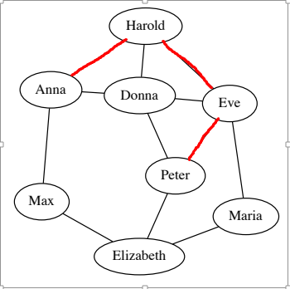

3.

C = # of closed triplets / Number of all triplets

3 pairs or 3 closed triplets

(Anna, Harold, Donna)

(Eve, Harold, Donna)

(Eve, Peter, Donna)

9 possible triplets so C = 3/9 = 1/3

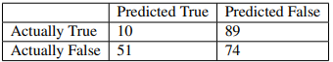

4.

1. Accuracy = (10+74) / (89 + 74 + 10 + 51) = 84/224
2. Precision = 10 / (10+89) = 10/99
3. Recall = 10 / (10 + 51) = 10/61

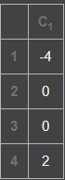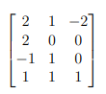

5.

|  |
| --- |
| -1 |
| -1 |
| -4 |
| -2 |

Since both car and cat are tied for best score, they will have a random chance of being chosen: 50% car, 50% cat.

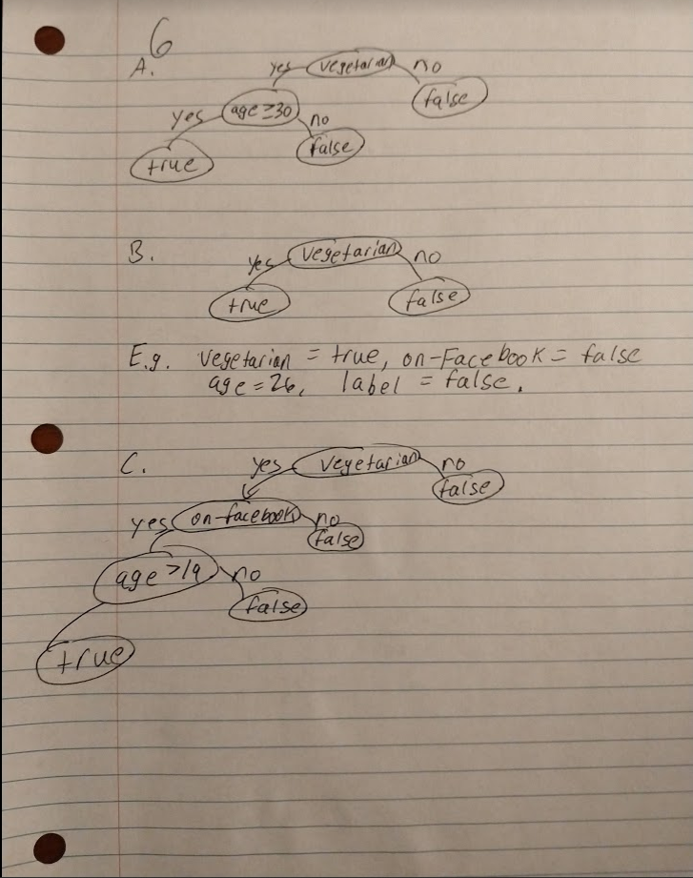

7.

8 x 2 + 2 = 18 vs 17. Error = 17 – 18 = -1

6 x 2 + 2 = 14 vs 17. Error = 17 – 14 = 3

7 x 2 + 2 = 16 vs 18. Error = 18 – 16 = 2

|  |  |  |  |
| --- | --- | --- | --- |
| Prediction | Bonus | Bonus – Prediction | (Bonus – Prediction)^2 |
| 8x2+2 = 18 | 17 | -1 | 1 |
| 6x2+2 = 14 | 17 | 3 | 9 |
| 7x2+2 = 16 | 18 | 2 | 4 |

MSE = (1+9+4)/3 = 14/3

8.

Min numbers (min similarity) are highlighted in red

|  |  |  |  |  |  |  |
| --- | --- | --- | --- | --- | --- | --- |
|  | X1 | X2 | X3 | X4 | X5 | X6 |
| X1 | 1 | -0.0430 | 0.9987 | 0.9997 | -0.0210 | -0.0607 |
| X2 | -0.0430 | 1 | -0.0044 | -0.0295 | 0.9622 | 0.9850 |
| X3 | 0.9987 | -0.0044 | 1 | 0.9996 | 0.0116 | -0.0189 |
| X4 | 0.9997 | -0.0295 | 0.9996 | 1 | -0.0113 | -0.0449 |
| X5 | -0.0210 | 0.9622 | 0.0116 | -0.0113 | 1 | 0.9014 |
| X6 | -0.0607 | 0.9850 | -0.0189 | -0.0449 | 0.9014 | 1 |

|  |  |  |  |  |  |
| --- | --- | --- | --- | --- | --- |
|  | C1 | X2 | X3 | X4 | X5 |
| C1 | 1 | .9850 | .9987 | .9997 | .9014 |
| X2 | .9850 | 1 | -0.0044 | -0.0295 | 0.9622 |
| X3 | .9987 | -0.0044 | 1 | 0.9996 | 0.0116 |
| X4 | .9997 | -0.0295 | 0.9996 | 1 | -0.0113 |
| X5 | .9014 | 0.9622 | 0.0116 | -0.0113 | 1 |

|  |  |  |  |  |
| --- | --- | --- | --- | --- |
|  | C1 | C2 | X3 | X5 |
| C1 | 1 | .9997 | .9987 | .9014 |
| C2 | .9997 | 1 | .9996 | .9622 |
| X3 | .9987 | .9996 | 1 | 0.0116 |
| X5 | .9014 | .9622 | 0.0116 | 1 |

|  |  |  |  |
| --- | --- | --- | --- |
|  | C1 | C2 | C3 |
| C1 | 1 | .9997 | .9987 |
| C2 | .9997 | 1 | .9996 |
| C3 | .9987 | .9996 | 1 |

|  |  |  |
| --- | --- | --- |
|  | C4 | C2 |
| C4 | 1 | .9997 |
| C2 | .9997 | 1 |