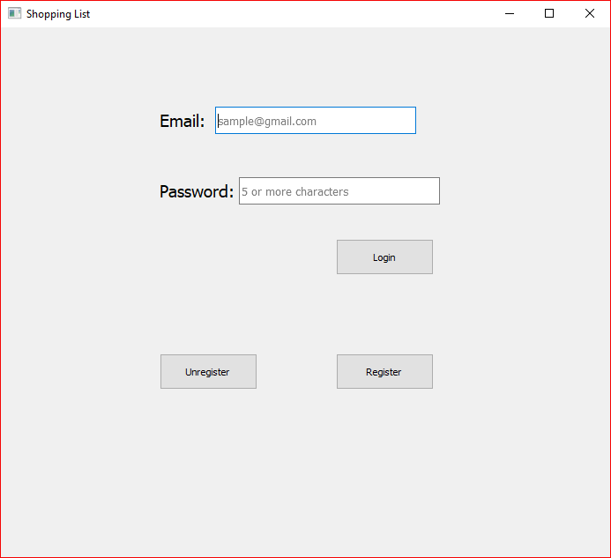The application starts you at the login screen. If you have registered already, simply type in your valid email and password. If email or password is incorrect, you will be alerted which of the two is incorrect. If you have not registered, click on the register button. If you wish to unregister, click on the unregister button.

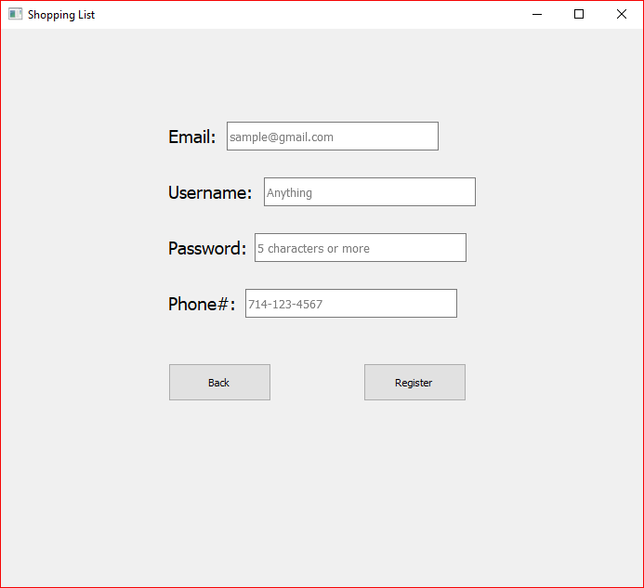The register page asks for your email, username (the name you will be called within the application), password (hashed using Keccac_512 before being stored in database), and a valid mobile phone number. If any inputs are not valid such as an improper email or invalid phone number, the user will be prompted to fix them before attempting to register again.

The unregister page only asks for your email and password. As long as they both match the stored records then you will be unregistered from this application.

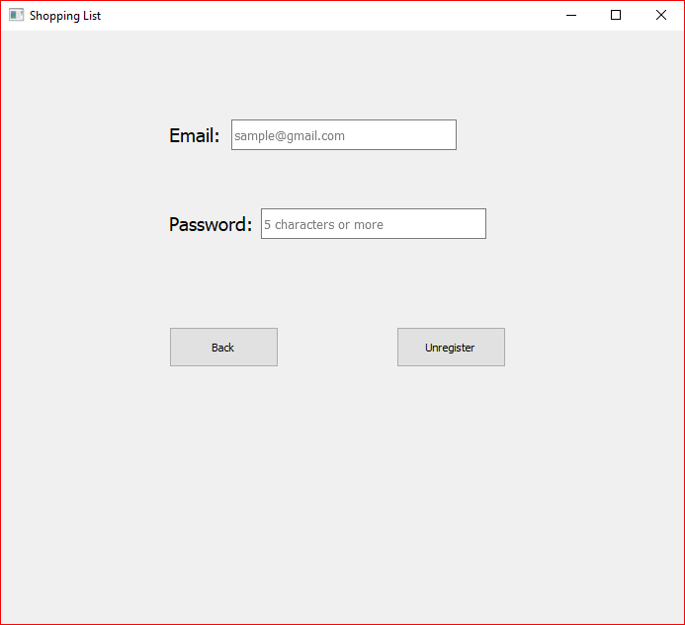

After a successful login, you are greeted with this homepage. At the moment, the application is blank. To start using the application, type in the box next to “Add Item:” whatever you need to go shopping for and press the Add button next to it. This will add the item to the left box down below.

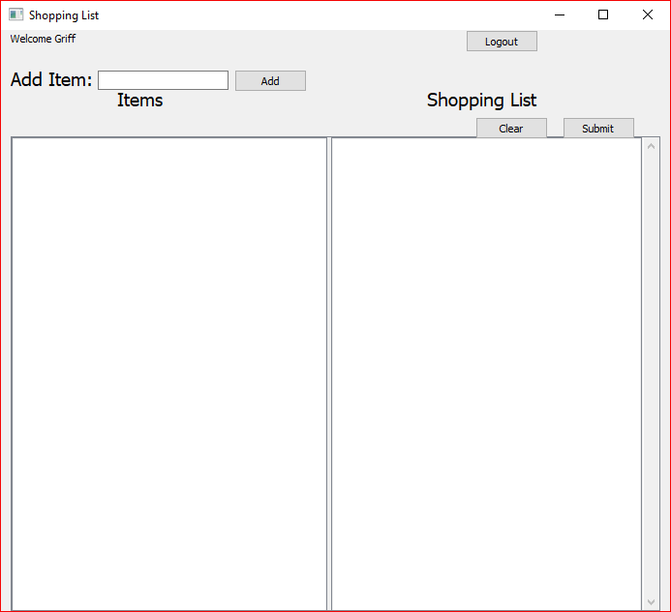

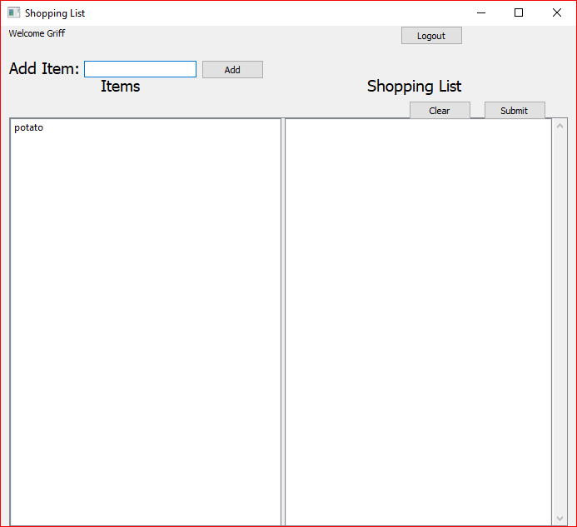If you followed the instructions above correctly, it should look something like this. Your text should go where “potato” currently is. Next, press the text you added (in this case it would be potato).

When you press the accept button, your item will be added to the other box on the right side of the homescreen. If you want to specify how many of that item or the weight of the item you wish to purchase, set it in the “Quantity” and “Weight” sections before pressing the Accept button. You can also press delete if you wish to delete this item permanently from the application or cancel if you wish to do nothing with this item right now. If you press delete, you will be asked if you’re sure before successfully deleting.

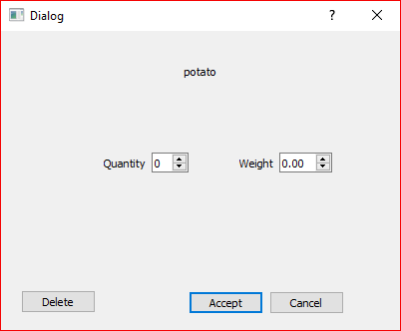

Example of pressing delete button:

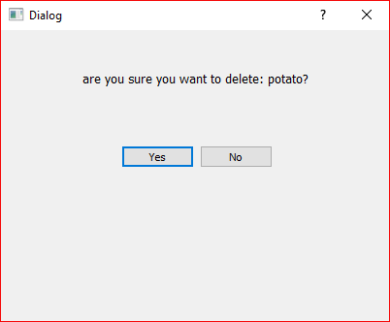

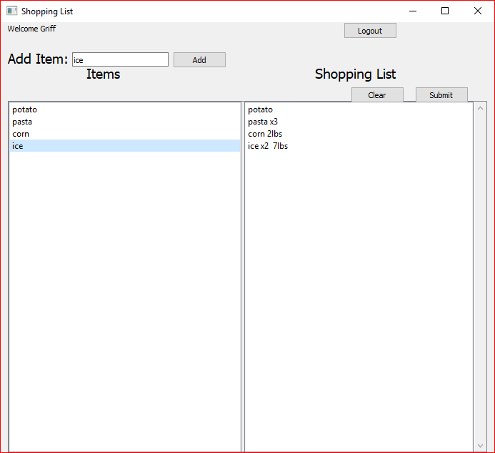Below is an example of all 4 possible inputs at this time: 1. Adding an item with no specified quantity or weight. 2. Adding an item with only quantity. 3. Adding an item with only weight. 4. Adding an item with both quantity and weight specified.

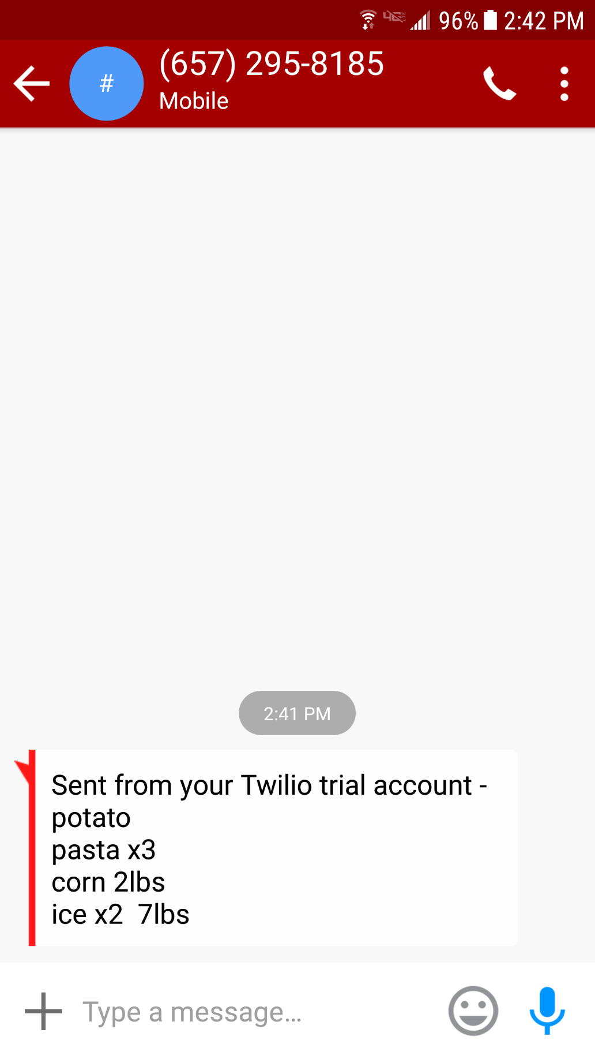When your shopping list is done, press the submit button. The submit button will use Twilio to send a text message to your phone containing all the items added to the right side shopping list box. This is what the text message will look like.

When you’re done with this shopping list, you can either delete one item at a time by clicking on the items and pressing delete just like you would with the left side. You can also press the Clear button next to the Submit button. If you press the clear button, you will be asked if you’re sure.

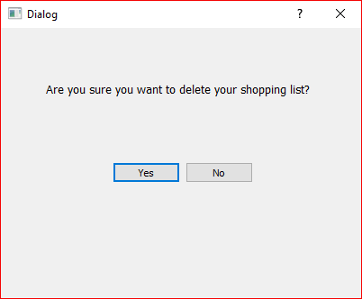

If you press Yes, your shopping list will be cleared and ready to start fresh on a new list.

