Sentiment Intelligence for Mountain Bike Product Reviews:
A Comparative NLP Case Study

Austin Engstrom
DS785 – Data Science Capstone
University of Wisconsin – Superior
August 2026

Abstract
This study compared multiple natural language processing (NLP) approaches for sentiment analysis of long-form mountain bike product reviews. Because no publicly available dataset existed for this application, a custom data collection pipeline was developed to extract review articles and structured metadata from the Pinkbike review archive. Following preprocessing and manual sentiment labeling, a dataset containing 301 review articles was used to evaluate three sentiment analysis approaches: the lexicon-based VADER model, a pretrained RoBERTa transformer model, and a supervised machine learning model using Term Frequency–Inverse Document Frequency (TF-IDF) feature extraction with Logistic Regression. Model performance was evaluated using Accuracy, Balanced Accuracy, Macro F1 Score, and Receiver Operating Characteristic Area Under the Curve (ROC AUC). Although the VADER baseline achieved the highest overall accuracy because of the imbalanced class distribution, the supervised TF-IDF Logistic Regression model consistently achieved the strongest Balanced Accuracy, Macro F1 Score, and ROC AUC, demonstrating superior performance for identifying both positive and non-positive reviews. The pretrained RoBERTa model showed limited transferability to this specialized review domain without task-specific fine-tuning. Examination of model feature weights further demonstrated that the supervised classifier learned meaningful domain-specific terminology associated with product sentiment. These findings demonstrate that domain-specific labeled data and interpretable machine learning techniques can outperform more complex pretrained models when analyzing specialized technical product reviews while also providing actionable insights for business decision-making.

1. Problem Definition
The rapid growth of online product reviews has created a rich source of consumer feedback for manufacturers, retailers, and consumers. While numerical ratings provide a high-level indication of customer satisfaction, the accompanying written reviews often contain detailed insights regarding product performance, design, durability, and user experience. Extracting meaningful information from these long-form reviews through manual analysis is both time-consuming and difficult to scale, particularly when organizations must evaluate hundreds or thousands of reviews across multiple products and brands. As a result, automated natural language processing (NLP) techniques have become an increasingly important tool for transforming unstructured text into actionable business intelligence (Wolf et al., 2020).
Within the mountain bike industry, independent product reviews represent a particularly valuable source of information because they typically provide extensive evaluations of bicycles, components, and accessories under real-world riding conditions. Unlike short consumer reviews found on many retail websites, professional review articles often contain detailed discussions of product strengths, weaknesses, technical specifications, and performance tradeoffs. The length, complexity, and technical vocabulary of these reviews present unique challenges for automated sentiment analysis, making them an ideal domain for evaluating different NLP approaches.
Mountain bike products reviews represent a particularly challenging application for sentiment analysis because reviews frequently include technical terminology, nuanced performance evaluations, and mixed opinions regarding individual product characteristics. Riders often evaluate components based on durability, geometry, suspension performance, weight, and intended riding conditions rather than expressing purely positive or negative opinions. These characteristics make the domain well suited for comparing different NLP approaches and evaluating their ability to interpret specialized technical language.
The primary objective of this project was to determine which sentiment analysis approach most effectively classified sentiment within long-form mountain bike product reviews. To accomplish this objective, three fundamentally different approaches were evaluated: a lexicon-based sentiment analysis method using VADER (Hutto & Gilbert, 2014), a pretrained transformer model based on RoBERTa (Liu et al., 2019), and a supervised machine learning model using Term Frequency–Inverse Document Frequency (TF-IDF) features (Salton & Buckley, 1988) with Logistic Regression. Comparing these approaches provided a systematic comparison of the relative strengths and limitations of traditional rule-based techniques, pretrained transformer models, and domain-specific supervised learning applied to specialized technical text.
Beyond comparing modeling performance, a secondary objective of the project was to develop a complete end-to-end data science workflow capable of supporting future sentiment analysis applications. This included designing an automated data collection pipeline, constructing a structured review dataset, performing exploratory data analysis and feature engineering, developing and evaluating multiple classification models, and interpreting the resulting predictions from a business perspective. Rather than focusing solely on predictive performance, the project emphasized reproducibility, interpretability, and practical applicability for business decision-making.
Model performance was evaluated using a common dataset and compared across multiple classification metrics. Because the manually labeled dataset exhibited substantial class imbalance, overall accuracy alone was insufficient for model selection. Instead, Balanced Accuracy, Macro F1 Score, and Receiver Operating Characteristic Area Under the Curve (ROC AUC) were emphasized to provide a more comprehensive assessment of predictive performance. Together, these metrics enabled a balanced comparison of each modeling approach while accounting for performance on both the majority and minority sentiment classes.
The findings from this project provide practical guidance for manufacturers, retailers, and other organizations seeking to analyze large collections of technical product reviews. By identifying the modeling approach that offers the strongest balance between predictive performance and interpretability, the project demonstrates how sentiment analysis can be incorporated into business intelligence workflows to support product evaluation, competitive benchmarking, and customer insight generation.

2. Data Collection, Cleaning and Preprocessing
The success of any supervised machine learning project depends on the quality of the underlying data. Because no publicly available dataset existed that contained sentiment labels and structured metadata for long-form mountain bike product reviews, a custom data collection and preprocessing pipeline was developed specifically for this project. The pipeline automated the discovery, collection, cleaning, and organization of review articles while producing a structured dataset suitable for exploratory analysis and model development.
The source data for this project consisted of professionally written mountain bike product reviews published on Pinkbike (Pinkbike, n.d.). Pinkbike was selected because it maintains a comprehensive archive of independent product reviews covering bicycles, components, suspension systems, wheels, accessories, and related equipment from a wide range of manufacturers. Unlike many retail websites that primarily contain short customer reviews, Pinkbike review articles provide detailed evaluations written by experienced reviewers, making them well suited for sentiment analysis of long-form technical text.
Data collection was performed using a custom Python-based extraction pipeline developed for this project. The workflow began by identifying all review article URLs from the Pinkbike review archive. Each article was then downloaded using Playwright to render dynamic web content before being parsed with BeautifulSoup. The extraction process captured both the primary review text and structured metadata, including the article title, author, publication date, review tags, retail price, product brand, product category, review type, and other descriptive attributes. The extracted information was stored in a structured CSV dataset for subsequent processing and analysis.
Following collection, the dataset underwent a comprehensive preprocessing stage to improve data quality and ensure consistency across all observations. HTML markup, navigation elements, advertisements, and other non-content elements were removed from each article, leaving only the primary review text for analysis. Publication dates and retail prices were standardized into consistent formats, while missing or inconsistent metadata were corrected through a combination of automated parsing rules and manual validation. Additional extraction logic was developed to improve identification of product names and categories, particularly for reviews involving multiple products or inconsistent tagging conventions.
Variable | Description
title | Review title
author | Article author
publish_date | Publication date
brand | Product manufacturer
product_name | Reviewed product
product_category | Product classification
review_type | Type of review
retail_price | Standardized retail price
article_text | Cleaned review text
sentiment | Manual sentiment label
Table 1. Key Variables Included in Final Analysis Dataset
Several additional features were engineered to support exploratory analysis, statistical summarization, and downstream model development. Structured variables describing product brand, product category, review type, publication date, retail price, article length, and word count were derived from the collected data. Although the supervised sentiment model relied primarily on textual features generated through TF-IDF vectorization, these engineered variables provided important contextual information that supported exploratory analysis and enabled meaningful business interpretations of the results.
Because supervised machine learning requires labeled training data, each review was manually assigned a sentiment label following collection and preprocessing. Reviews were initially classified into positive, mixed, or negative sentiment categories based on the overall tone expressed throughout the article. For binary classification experiments, the mixed and negative classes were combined into a single non-positive category to create the final target variable used during model development. Although this labeling process resulted in a class-imbalanced dataset, it produced a high-quality reference dataset that enabled direct comparison of the three sentiment analysis approaches evaluated in this study.

3. Exploratory Data Analysis and Feature Engineering
Following data collection and preprocessing, exploratory data analysis (EDA) was conducted to better understand the characteristics of the review corpus and identify patterns that could influence model development. The objectives of this analysis were to summarize the distribution of key variables, evaluate the quality and completeness of the dataset, identify potential sources of bias, and generate additional features that would support both predictive modeling and business interpretation. Understanding these characteristics prior to model development helped ensure that subsequent analyses were based on a well-understood and representative dataset.

Characteristic | Value
Review articles | 301
Average article length (words) | 2,238
Median article length | 1,967
Average retail price | $3,423
Median retail price | $1,250
Average article title length | 55.6 characters
Publication date range | 2017 - 2026
Table 2. Descriptive Statistics for Final Review Dataset
As shown in Table 2, the dataset consisted of long-form review articles, with an average length exceeding 2,200 words. The substantial length of these reviews reflects the detailed technical evaluations published by Pinkbike and distinguishes the dataset from shorter customer-generated product reviews commonly used in sentiment analysis research. Retail prices also exhibited considerable variation, ranging from relatively inexpensive accessories to premium bicycles and suspension components, providing broad coverage across multiple product segments.
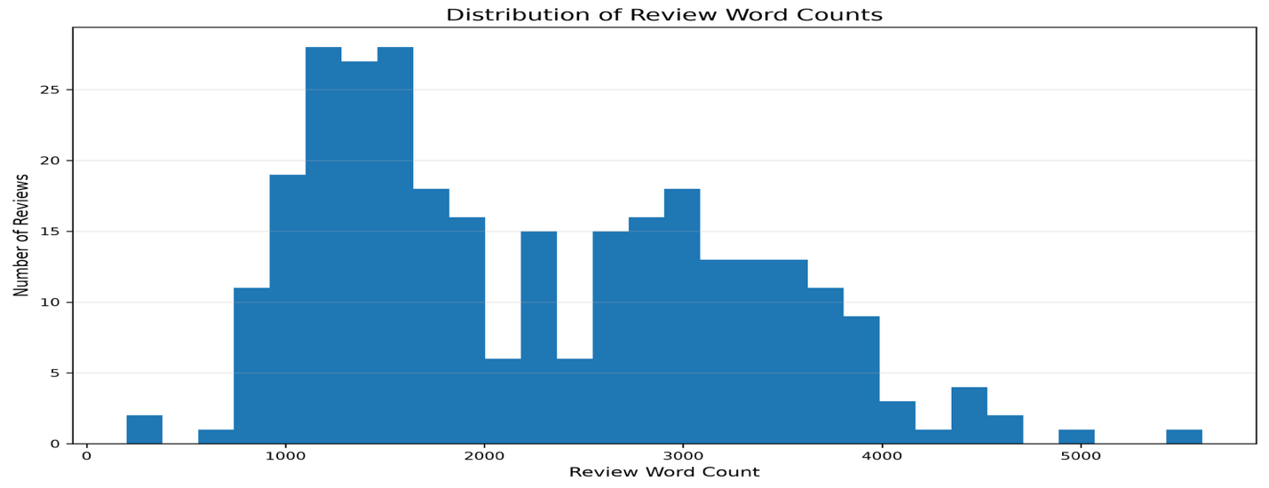
Figure 1. Distribution of Review Article Length
Figure 1 illustrates the distribution of article lengths within the review corpus. Although article lengths varied considerably, the distribution was concentrated around reviews containing approximately 1,500 to 2,500 words, with a smaller number of substantially longer articles extending beyond 5,000 words. This variation reflects the diverse scope of the review archive, where some articles focus on individual components while others provide comprehensive evaluations of complete bicycles or comparative product tests. The prevalence of long-form content distinguished the dataset from traditional sentiment analysis datasets composed of short customer reviews and influenced subsequent modeling decisions. In particular, the transformer-based approach required lengthy reviews to be divided into multiple text segments before inference, while the TF-IDF model was able to represent each review as a single document.

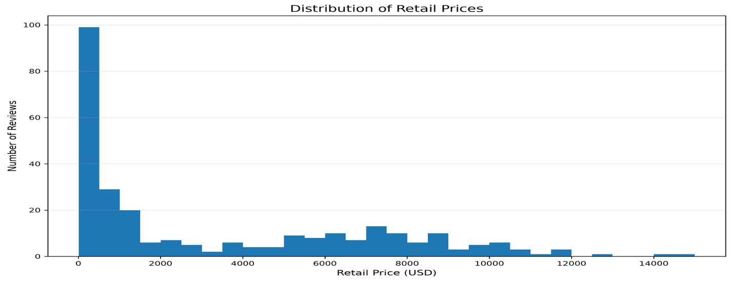
Figure 2. Distribution of Retail Prices
Figure 2 illustrates the distribution of retail prices represented within the review corpus. The distribution is positively skewed, reflecting the inclusion of both lower-cost accessories and premium bicycles and suspension components. Although retail price was not directly incorporated into the TF-IDF feature representation used for supervised classification, it provided valuable contextual information for comparing sentiment across market segments and supported subsequent business-oriented interpretation of the results.
Beyond describing the characteristics of the review corpus, exploratory analysis also guided the development of structured features that enhanced interpretation of the modeling results. Structured variables describing product brand, product category, review type, publication date, retail price, article length, and word count were retained alongside the review text to support comparisons across manufacturers and product segments. Although these variables were not directly incorporated into the TF-IDF feature representation used for supervised classification, they provided important business context for interpreting sentiment patterns and identifying trends across different types of products.
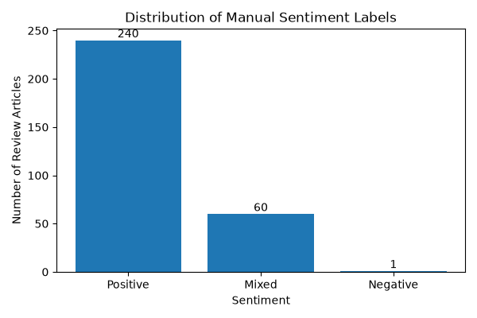
Figure 3. Distribution of Manual Sentiment Labels
Figure 3 illustrates the distribution of manually assigned sentiment labels across the review corpus. The predominance of positive reviews reflects the editorial nature of professional product reviews, where products selected for evaluation are generally considered noteworthy or of high quality. Reviews expressing mixed sentiment were substantially less common, while only one review was classified as negative. Because of this limited representation, the mixed and negative classes were combined to form a single non-positive class for the binary classification experiments conducted in this study.
This class imbalance was an important characteristic of the dataset and directly influenced the model evaluation strategy used throughout the study. While overall accuracy remained useful for comparison, it was insufficient as the primary performance measure because a model predicting only the majority class could still achieve relatively high accuracy. Consequently, Balanced Accuracy, Macro F1 Score, and ROC AUC were emphasized to provide a more informative assessment of model performance across both majority and minority classes.
Overall, the exploratory analysis demonstrated that the final dataset provided broad coverage across mountain bike manufacturers, product categories, and price ranges while preserving the rich contextual information contained within long-form review articles. The resulting dataset was well suited for comparing multiple sentiment analysis approaches and provided the foundation for the sentiment analysis models developed and evaluated in the following section.

4. Model Development and Evaluation
The objective of the modeling phase was to evaluate multiple sentiment analysis approaches of increasing complexity using the manually labeled review dataset developed during the preprocessing stage. Three complementary methods were selected for comparison: a lexicon-based baseline using VADER, a pretrained transformer model based on RoBERTa, and a supervised machine learning model using TF-IDF feature extraction with Logistic Regression. Together, these approaches provided representative rule-based and deep learning baselines for sentiment analysis while differing substantially in their underlying assumptions, computational requirements, and dependence on labeled training data.
To ensure a fair comparison, each approach was evaluated using the same binary sentiment labels and consistent performance metrics. Because the labeled dataset exhibited a substantial class imbalance, model performance was assessed using Balanced Accuracy, Macro F1 Score, and ROC AUC, in addition to overall accuracy. This evaluation framework enabled meaningful comparison across models while accounting for performance on both majority and minority sentiment classes.

4.1 Baseline Sentiment Analysis Models
To establish reference points for comparison, two baseline sentiment analysis approaches were evaluated prior to developing a supervised machine learning model. Together, these approaches represented three common paradigms for sentiment analysis that differed substantially in their underlying assumptions, computational requirements, and reliance on labeled training data. The first baseline employed the lexicon-based VADER sentiment analyzer, while the second utilized a pretrained RoBERTa transformer model. Together, these approaches enabled comparison across rule-based and deep learning paradigms before introducing a domain-specific supervised classifier.

4.1.1 VADER Sentiment Analysis
VADER (Hutto & Gilbert, 2014) was selected as the initial baseline because it provides a lightweight, rule-based approach to sentiment analysis that does not require model training. Each review article was analyzed using the compound sentiment score generated by the VADER lexicon. The compound score provides a normalized measure of overall sentiment ranging from -1 to 1, where larger positive values indicate increasingly positive sentiment and larger negative values indicate increasingly negative sentiment. Standard VADER decision thresholds (Hutto & Gilbert, 2014) were applied to classify each review as positive, neutral, or negative. For comparison with the manually labeled dataset, the neutral and negative predictions were combined into a single non-positive class to produce binary sentiment classifications consistent with the study objectives.

4.1.2 RoBERTa Transformer Model
A pretrained RoBERTa transformer model (Liu et al., 2019) was evaluated as a second baseline to determine whether a modern deep learning architecture could improve sentiment classification without task-specific fine-tuning. Because the review articles substantially exceeded the maximum input length supported by the transformer model, each article was divided into smaller text segments prior to inference. Individual chunk-level predictions were then aggregated to produce a single sentiment prediction for each review article. This chunking strategy enabled the transformer model to process long-form technical reviews while preserving compatibility with its input constraints. No task-specific fine-tuning was performed, allowing the evaluation to assess how effectively a general-purpose pretrained sentiment model transferred to the specialized domain of mountain bike product reviews.

4.2 Supervised Model Development
To evaluate whether a domain-specific supervised learning approach could improve sentiment classification, a machine learning model was developed using the manually labeled review dataset. Each review article was represented as a single document and transformed into a numerical feature vector using TF-IDF (Salton & Buckley, 1988). This representation assigns greater importance to words that occur frequently within an individual document while reducing the influence of terms that appear across many documents, enabling the model to emphasize language that distinguishes positive and non-positive reviews.
A Logistic Regression classifier was selected because of its strong performance on high-dimensional sparse text representations and its ability to produce interpretable classification results. To account for the class imbalance identified during exploratory analysis, balanced class weights were incorporated during model training. The labeled dataset was partitioned into training and testing subsets using a stratified train-test split to preserve the class distribution across both datasets. Model development, hyperparameter optimization, and feature selection were performed exclusively on the training data, while the testing data were reserved for final performance evaluation.
Hyperparameter optimization was conducted using GridSearchCV (Pedregosa et al., 2011) with five-fold stratified cross-validation. The search evaluated multiple combinations of regularization strength, minimum document frequency, maximum document frequency, and n-gram configuration. Model selection was based on Macro F1 Score to emphasize balanced performance across both sentiment classes rather than maximizing overall accuracy alone. The optimal configuration consisted of a regularization parameter (C) of 0.1, balanced class weighting, unigram features, a minimum document frequency of two, and a maximum document frequency of 0.85. This search evaluated 120 unique hyperparameter combinations across five cross-validation folds, resulting in a total of 600 model fits before selecting the final classifier.

5. Results, Insights and Recommendations
Table 3 summarizes the performance of the three sentiment analysis approaches evaluated in this study. Although the VADER lexicon-based model achieved the highest overall accuracy, accuracy alone proved to be a misleading measure because of the substantial class imbalance within the manually labeled dataset. When evaluation emphasized metrics that account for performance across both sentiment classes, the supervised TF-IDF Logistic Regression model consistently achieved the strongest overall results.
Model | Accuracy | Balanced Accuracy | Macro F1 | ROC AUC
VADER | 0.784 | 0.492 | 0.440 | 0.549
RoBERTa | 0.269 | 0.511 | 0.261 | 0.558
TF-IDF + Logistic Regression | 0.656 | 0.597 | 0.564 | 0.665
Table 3. Performance Comparison of Sentiment Analysis
The TF-IDF Logistic Regression model produced the highest Balanced Accuracy, Macro F1 Score, and ROC AUC, demonstrating a greater ability to distinguish between positive and non-positive reviews than either baseline approach. These improvements indicate that a supervised model trained on domain-specific data was better able to identify the language patterns associated with sentiment than methods relying solely on predefined sentiment lexicons or general-purpose pretrained language representations.
The VADER baseline provided competitive overall accuracy despite requiring no model training. However, its lower Balanced Accuracy and Macro F1 Score indicated that the rule-based lexicon struggled to accurately classify the minority non-positive class. This limitation was expected because VADER was designed primarily for general-purpose social media and consumer text rather than long-form technical product reviews containing specialized mountain biking terminology.
The pretrained RoBERTa transformer model produced the weakest overall performance despite representing the most sophisticated modeling approach evaluated in this study. Although transformer architectures have demonstrated state-of-the-art performance across many natural language processing tasks, the absence of task-specific fine-tuning limited the model's ability to generalize to this specialized review domain. The results illustrate that greater model complexity alone does not guarantee improved classification performance when the pretrained language representations differ substantially from the target corpus.
Overall, the comparative evaluation demonstrated that domain adaptation through supervised learning provided greater benefit than increasing model complexity. The TF-IDF Logistic Regression model successfully leveraged the manually labeled review dataset to capture domain-specific language patterns, resulting in more balanced and reliable sentiment classification than either baseline approach.

5.2 Error Analysis and Model Interpretation
Although the comparative evaluation identified the TF-IDF Logistic Regression model as the strongest overall performer, additional analysis was conducted to better understand its classification behavior and interpretability. The final classifier was examined using both its confusion matrix and feature importance scores. These analyses provided insight into the remaining classification errors while identifying the vocabulary that most strongly influenced model predictions. These analyses provided insight into the types of classification errors that remained while also identifying the vocabulary that most strongly influenced model predictions.
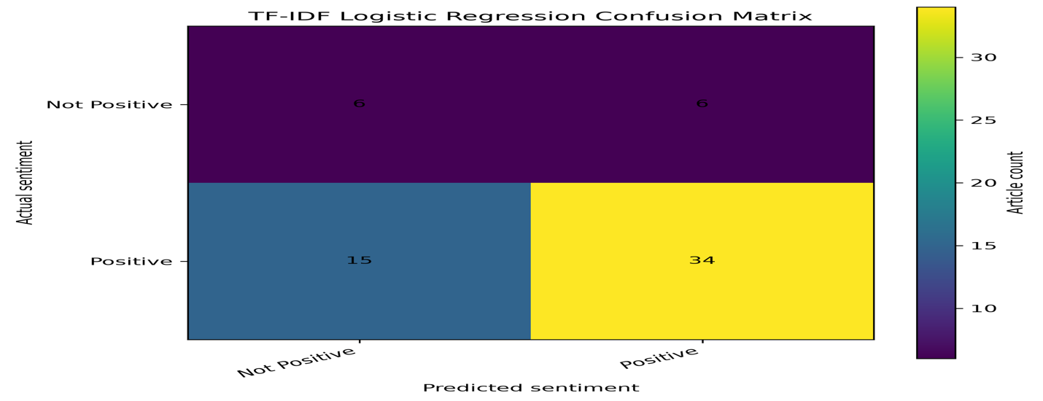
Figure 4. Confusion Matrix for the TF-IDF Logistic Regression Model
Figure 4 demonstrates that the majority of positive reviews were correctly classified, while most remaining classification errors involved non-positive reviews being predicted as positive. This outcome is consistent with the class imbalance observed during exploratory analysis, where positive reviews substantially outnumbered non-positive reviews, making the minority class inherently more difficult to learn. Despite these remaining errors, the model achieved the strongest Balanced Accuracy and Macro F1 Score among the evaluated approaches, indicating that it provided the most reliable overall performance across both sentiment classes.
Unlike transformer models, the TF-IDF Logistic Regression classifier also provides a transparent view of the language influencing its predictions. Examination of the learned feature weights revealed that the model relied on meaningful domain-specific terminology rather than arbitrary or unrelated words. This interpretability represents an important advantage for practical business applications, where understanding why a prediction was made is often as valuable as the prediction itself.
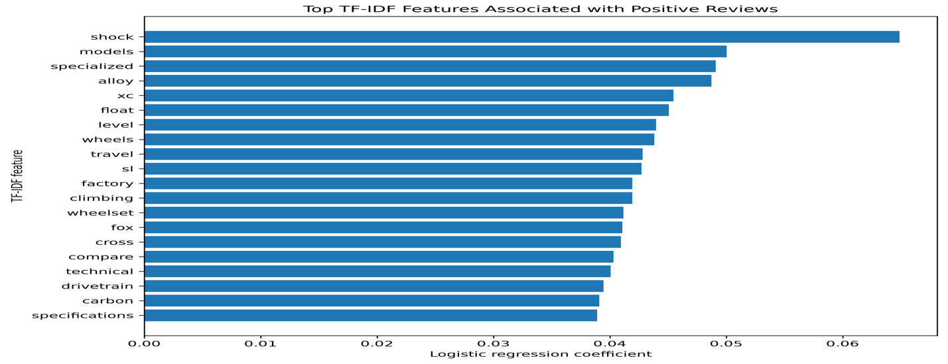
Figure 5. Top TF-IDF Features Associated with Positive Reviews
Figure 5 illustrates the features that contributed most strongly to positive sentiment predictions. Many of the highest-weighted features correspond to technical product terminology, component names, materials, and performance-related vocabulary, indicating that the classifier learned meaningful domain-specific language associated with favorable product evaluations.
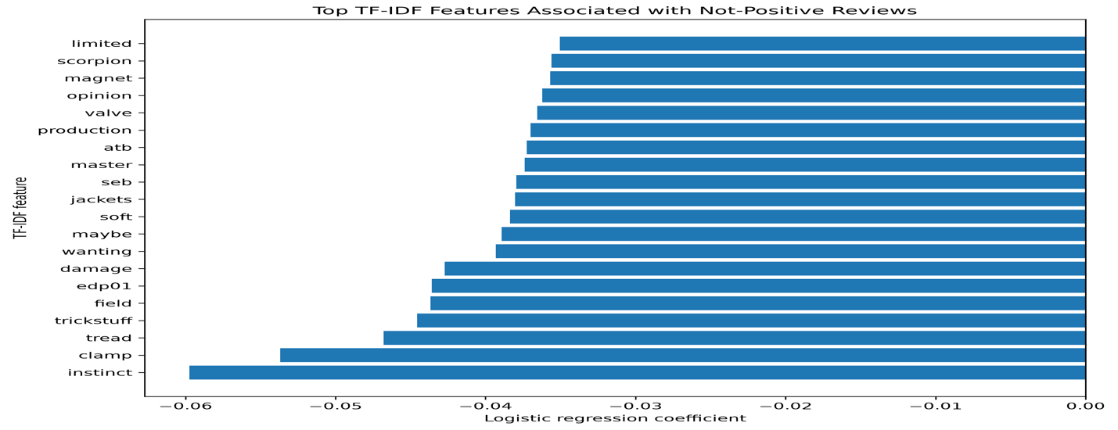
Figure 6. Top TF-IDF Features Associated with Non-Positive Reviews
Figure 6 presents the features most strongly associated with non-positive reviews. Several of the highest-weighted non-positive features describe product limitations, uncertainty, wear, or component-specific issues, reflecting the language commonly used when reviewers discuss weaknesses or opportunities for improvement. The presence of meaningful technical vocabulary in both figures suggests that the classifier relied on relevant product characteristics rather than arbitrary correlations within the training data.

5.3 Business Implications
Beyond identifying the highest-performing sentiment classification model, this study demonstrates how natural language processing can be used to extract actionable insights from long-form product reviews. The supervised TF-IDF Logistic Regression model provides an efficient and interpretable approach for summarizing customer and editorial sentiment at scale while preserving transparency in the language driving each prediction. Organizations can leverage similar techniques to monitor product perception across manufacturers, product categories, and review types without requiring manual review of large volumes of text.
The interpretability of the Logistic Regression model also provides practical advantages over more complex deep learning approaches. Because influential features can be directly examined, product managers and marketing teams can identify the technical characteristics most frequently associated with favorable and unfavorable product evaluations. These insights can support product development decisions, competitive benchmarking, and targeted marketing strategies by highlighting the language customers and reviewers use when discussing product strengths and weaknesses.
More broadly, the results of this study demonstrate that increasing model complexity does not necessarily produce superior performance in specialized domains. Although the pretrained RoBERTa transformer represents a more advanced natural language processing architecture, the TF-IDF Logistic Regression model achieved stronger overall performance because it was trained using domain-specific labeled data. These findings reinforce the importance of selecting modeling approaches that align with the characteristics of the available data rather than if more sophisticated models will consistently produce better results.

6. Conclusion
This study compared three sentiment analysis approaches for classifying sentiment within long-form mountain bike product reviews: the lexicon-based VADER model, a pretrained RoBERTa transformer, and a supervised TF-IDF Logistic Regression classifier. By developing a complete end-to-end natural language processing workflow, the study demonstrated how web-scraped editorial reviews can be transformed into a structured dataset suitable for machine learning and business analysis.
Although the VADER model provided a useful rule-based baseline and the pretrained RoBERTa transformer represented a more sophisticated deep learning architecture, the supervised TF-IDF Logistic Regression model achieved the strongest overall performance when evaluated using Balanced Accuracy, Macro F1 Score, and ROC AUC. These findings demonstrate that domain-specific labeled data can provide greater improvements in predictive performance than increasing model complexity alone, particularly when analyzing specialized technical text.
Beyond model performance, this project demonstrated the practical value of interpretable machine learning for sentiment analysis. Examination of influential TF-IDF features showed that the classifier learned meaningful domain-specific terminology associated with both positive and non-positive product evaluations, providing insights that extend beyond simple sentiment classification. Such interpretability supports practical applications including competitive benchmarking, product development, and large-scale analysis of customer and editorial feedback.
Future work could expand the labeled dataset, incorporate reviews from additional cycling publications, and investigate fine-tuned transformer models trained specifically on technical cycling content. These extensions would provide opportunities to improve predictive performance while evaluating whether domain-adapted deep learning models can outperform traditional supervised machine learning approaches in specialized review domains.
References
Hutto, C. J., & Gilbert, E. (2014). VADER: A parsimonious rule-based model for sentiment analysis of social media text. Proceedings of the International AAAI Conference on Web and Social Media, 8(1), 216–225.
Liu, Y., Ott, M., Goyal, N., Du, J., Joshi, M., Chen, D., Levy, O., Lewis, M., Zettlemoyer, L., & Stoyanov, V. (2019). RoBERTa: A robustly optimized BERT pretraining approach. arXiv. https://arxiv.org/abs/1907.11692
Pedregosa, F., Varoquaux, G., Gramfort, A., Michel, V., Thirion, B., Grisel, O., Blondel, M., Prettenhofer, P., Weiss, R., Dubourg, V., Vanderplas, J., Passos, A., Cournapeau, D., Brucher, M., Perrot, M., & Duchesnay, É. (2011). Scikit-learn: Machine learning in Python. Journal of Machine Learning Research, 12, 2825–2830.
Pinkbike. (n.d.). Mountain bike reviews. https://www.pinkbike.com
Salton, G., & Buckley, C. (1988). Term-weighting approaches in automatic text retrieval. Information Processing & Management, 24(5), 513–523. https://doi.org/10.1016/0306-4573(88)90021-0
Wolf, T., Debut, L., Sanh, V., Chaumond, J., Delangue, C., Moi, A., Cistac, P., Rault, T., Louf, R., Funtowicz, M., Davison, J., Shleifer, S., von Platen, P., Ma, C., Jernite, Y., Plu, J., Xu, C., Le Scao, T., Gugger, S., … Rush, A. M. (2020). Transformers: State-of-the-art natural language processing. Proceedings of the 2020 Conference on Empirical Methods in Natural Language Processing: System Demonstrations, 38–45. https://doi.org/10.18653/v1/2020.emnlp-demos.6

