Analysis of Pull Force Test Results for Crimped Connections
Alejandra Constante and Chris Fitzgerald
Millennium Engineering & Integration Company
Alvin Boutte
NASA Goddard Space Flight Center (GSFC), Greenbelt, MD.

Abstract
Crimped electrical contacts are reliable when strict process controls are followed during manufacturing and accompanied by continuous process verification through pull force testing.
Cable and wire harness assemblies’ standards are developed and refined over time to provide the minimum pull force that a crimp contact must meet before it breaks from the wire. However, in practice the failures occur at a much higher tensile strength than the minimum required. The first section of this paper reviewed 780 pull force test results provided by NASA Centers that were collected and analyzed to determine how the data compare to NASA’s pre-existing requirements from the cable/harness standards NASA-STD-8739.4 and IPC/WHMA-A-620B-S. The measured tensile strength of most of the contact/conductor pairs (i.e., Contact/Wires or C/W) exceeded the minimum pull force values of NASA-STD-8739.4 and IPC/WHMA-A-620 standards by at least 100%. The C/W pair samples’ tensile strength values followed a normal distribution with an average tensile strength value that was at least 182% of the minimum requirement, and all the samples analyzed passed the pull force testing. In addition, the 95% confidence interval of the average tensile strength distributions for several C/W pairs was determined and plotted as error bars to show that the C/W pairs will meet and surpass the requirements. The frequency of pull force testing can be problematic for projects because of the cost and availability of spare contacts for the destructive test. It is possible to reduce the frequency of pull force testing if at the beginning of the production run, the conditions of the crimp tool and materials are verified, and the settings of the tool remain unchanged throughout the process. However, the project needs to understand and evaluate the impact to risk from reducing the frequency of testing prior to implementing process changes.

Background
Crimping is the process of deforming one contact member around other to establish an electrical and mechanical joint between the members. Typically, one of the members is a wire and the other is a cylinder that is deformed around the wire. The reliability of the crimping process depends on the formation of an adequate metallic contact between the wire and the connector and the creation of a permanent crimped termination [3].
For electrical cables and harnesses, each connector is populated with electrical contacts. A reliable crimping process should consider several factors, such as the tool used, the materials being crimped, and the settings of the tool. Each of these factors needs to be controlled to ensure that each crimp connection is made consistently throughout the manufacturing process from beginning to end. This process is validated through a test called pull force testing. An example of a pull force tester machine is shown in Figure 1.
Permanent crimped terminations can be affected by spring-back, which is the tendency of metallic materials to elastically rebound [3]. This effect is more frequently observed on the outer crimped contact (i.e., terminal) than in the wire.
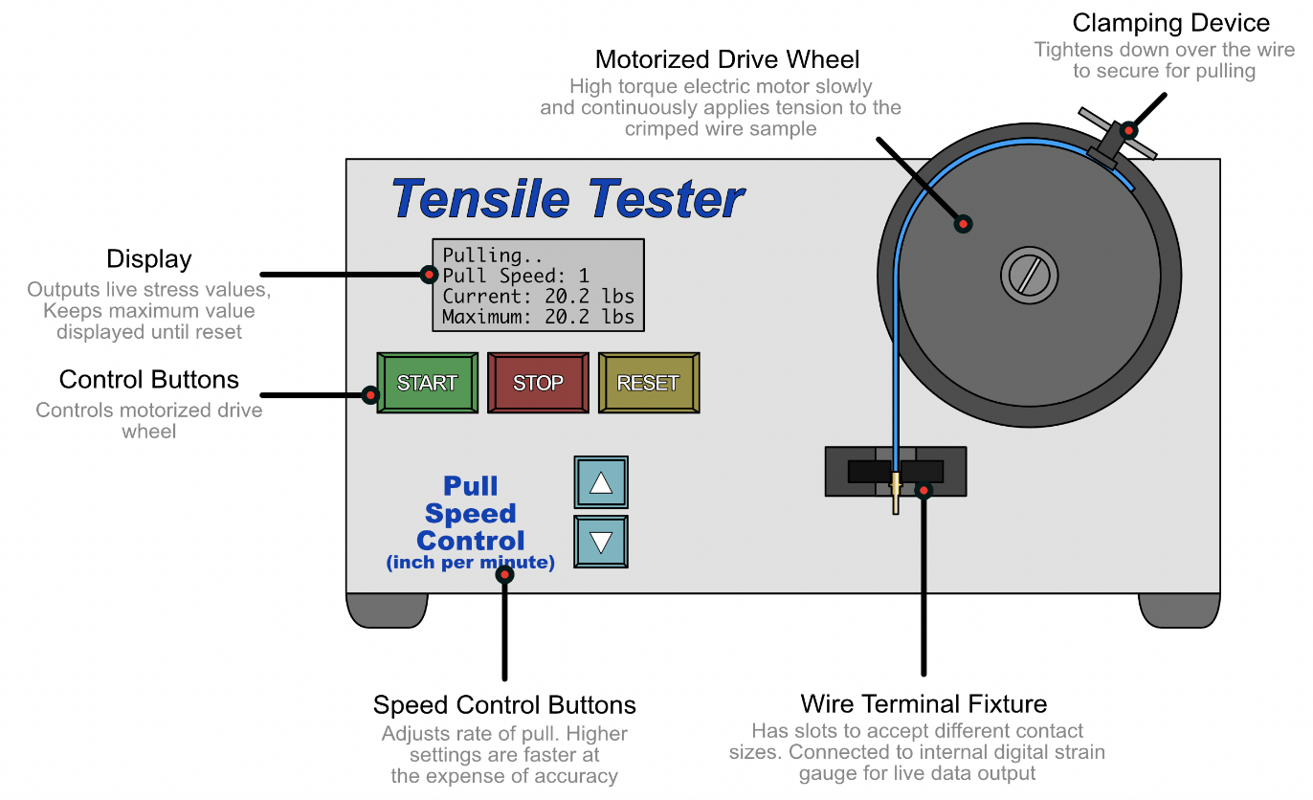
Figure 1 Example of a pull force tensile tester
NASA defines the minimum pull force requirements in NASA-STD-8739.4A [1] Workmanship Standard for Crimping, Interconnecting Cables, Harnesses, and Wiring. Pull force testing, commonly referred to as a ‘pull test’ or ‘tensile test’, is typically conducted before and after the preparation of a crimp termination for flight hardware. This is always performed as a destructive test for flight hardware, such that the test samples are rendered unusable after the test rig separates the contact from the wire. For harness designs with electrical contacts that are not mass produced, full adherence to the existing pull force testing requirements can add excessive costs to the project. The pull test results are recorded in a log sheet for traceability, with pass/fail criteria defined by the applicable standard. For high volume production environments, the results of the pull tests can be statistically analyzed to identify anomalies in the crimping process, such as crimp die wear, tool setting adjustments, and improper tool usage.
An advantage of some pull test machines is that they offer network-connected computer interfaces to assist in operating the machine, as well as data collection tools for statistical analysis [4]. However, NASA missions tend to have a smaller production volume such that both the crimp process and pull force test are often conducted with hand tools and test machines without data collection mechanisms beyond a physical log sheet.
The use of hand crimp tools and manual pull testers requires additional process controls that are needed to maintain consistency and limit the variability of the results.

Hand Crimp Tools
The quality of the finished crimp depends on the tooling setup and its operability with the contacts (i.e., terminals) being crimped. Tool manufacturers provide specification sheets for hand tools with defined parameters such as the manufacturer’s contact type, wire size range, insulation diameter, and strip length. A typical crimp tool for machined contacts is shown in Figure 2.
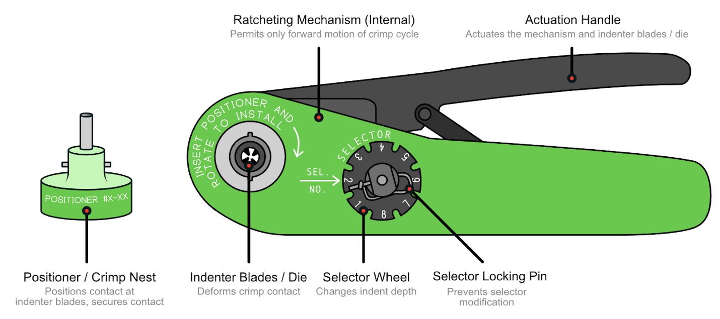
Figure 2 Typical Crimp Tool for Machined Contacts

According to the MOLEX Quality Crimping Handbook, a typical crimping procedure using a hand crimp tool is as follows [5]:
- Identify the appropriate crimp tool for the contact and wire being crimped
- Strip the wire and inspect for damage
- Select the appropriate positioner/color-coded crimp nest for the contact and tool being used and insert the crimp contact
- If a locator bar is used for the crimp design, ensure the locator bar is engaged properly with the contact and the contact is unable to move.
- Insert the wire into the crimp contact
- Engage the ratchet by squeezing the actuation handle, following through for a full cycle
- Inspect for proper crimp location and inspect for damage
Not only does the technician need to operate the tool appropriately for consistent crimping action, but the tool itself also needs to meet certain minimum process control requirements. For example, according to the NASA-STD-8739.4A Change 2, Section (i.e., §) 12.3.1, crimp tools must contain a full-cycle ratcheting mechanism and calibration adjustments may only be made by the tool manufacturer or by a calibration laboratory [1].
For commercial applications and some high reliability applications, the cable/harness standard levied is IPC/WHMA-A-620B, Requirements and Acceptance for Cable and Wire Harness Assemblies, which defines three unique end-product classes reflecting various levels of controls that need to apply to the manufacturing process. For space applications, these controls may not be sufficient for hardware safety, and as a result the aerospace industry has developed an addendum to the original IPC/WHMA-A-620B base document, titled IPC/WHMA-A-620B-S, Space Applications Electronic Hardware Addendum to IPC/WHMA-A-620B. Furthermore, according to IPC/WHMA-A-620B-S §19.6.1, Mechanical Test – Selection, the “crimp tools shall not be used for longer than 30 days between verification testing” [6]. Periodic tool calibration is needed due to the wear-out of the indenter blades (see Figure 4). Calibrated tools should have records and a quick verification method, such as sticker, on the tool.

Requirements for Crimping Process Control
To minimize variation in manufacturing, process controls should be applied to all tools, equipment, and contact/conductor pairs (i.e., Contact/Wires or C/W). The crimp process is validated for each new crimp configuration where tool settings must be determined for a contact/conductor pair. Both, the NASA-STD-8739.4 and the IPC/WHMA-A-620C standards require a three-sample pull test. For example, the NASA-STD-8739.4 § 12.3.5.a states:
- For each new crimp process where a crimp tool setting must be determined for a contact-conductor pair (or a crimp ferrule-conductor combination), a three-sample pull test at each of the different crimp tool settings considered for use are required using the force and pull strength criteria in Table 12-1.
Furthermore, the IPC/WHMA-A-620C Space Applications Requirements §19.7.2, states the following:
“Three test samples shall be prepared for each contact/conductor combination test. A crimp-contact-conductor combination is defined as a specific contact used with a specific wire construction, e.g., if a drawing calls out a combination of single wires and twisted pairs of the same construction, e.g., gauge, strand count, alloy (base metal), and plating, the test samples of the single wire qualifies the tool to be used on the twisted pairs.”
The NASA-STD-8739.4A w/ Change 2, §12.3.5 c, Integrity of Crimped Connections, describes the pull force and pull strength criteria as follows [1]:
- The crimp contacts or ferrules shall be placed in a tensile-testing device with appropriate fixtures, and sufficient force shall be applied to pull the wire out of the assembly or to break the wire or crimped item.
- The head travel speed of the tensile device shall be 25.4 ± 6.3 mm (1.0 ± .25 in) per minute. The holding surfaces of the tensile device clamp may be serrated to provide sufficient gripping and holding ability.
- Crimp pull strengths shall meet the values in Table 12-1 [of NASA-STD-8739.4A]. Wire pull out, wire breaks at the crimp, and contact rupture which occur below the minimum pull strength value are considered test failures.
- For those contact-conductor crimp connections not contained in Table 12-1, the tensile strength of the crimp connection shall be no less than 60 percent of the tensile strength of the wire. Reference the manufacturer’s datasheet for wire tensile strength.
- For crimp ferrule-conductor combinations the wire pulled shall meet the tensile requirement for a single wire of the same gauge being tested in its “properly sized” contact.
- Examination of Test Samples. Each individual test sample shall be inspected to the requirements of 12.3.5.c(3) and the observations should be recorded and maintained for passing units and shall be recorded for failing units.
- The pull strength and break or release condition for test failures shall be recorded.
In addition to these controls, further acceptance and rejection criteria are described in NASA-STD-8739.4A w/ Change 2, § 20.5, Inspection Criteria [1]. Rejectable criteria for crimped connections include improperly located crimp indents, plating problems, discoloration, and out of roundness of the contact barrel. In many cases, these product quality issues can be identified by inspecting contacts before insertion of wire and crimping, which is also a requirement from NASA-STD-8739.4A w/Change 2, § 12.2.1.

Conductors
Wire sizes are specified in units of American Wire Gauge (AWG) or Circular Mil Area (CMA). The wire selection depends on the current needs for the application and the operating environment [6]. A crimped termination is recommended on the following types of wires as shown in Table 1 [7].
Table 1 Maximum Operating Temperature of Common Wire
Wire Type | Use Purpose | Maximum Operating Temperature
Uncoated copper | General purpose | < 100ºC (212ºF)
Nickel Coated Copper | High temperature extremes | < 260ºC (500ºF)
Silver-Coated Copper | High temperature extremes | < 200ºC (392ºF)
Tin-Coated Copper | General purpose, high solderability | <150ºC (302ºF)
Furthermore, the standard SAE AS22759 Rev D. covers insulated single conductor electrical wires made with tin-coated, silver-coated, or nickel-coated copper/copper alloy conductors [8]. This standard has 196 detailed specifications that describe variations of wires according to the insulation type, the coating type, and the type of copper material.

Contacts
Contacts, also known as terminals, are components that terminate a conductor (i.e., wire) that is to be affixed to a wire or a cable to establish an electrical connection [3]. Figure 3 shows the components of a typical machined contact, which comprise a wire barrel, shoulder/locking ring, and the contact area. The wire barrel is where the crimping will take place. These contacts fully contain the end of the wire, preventing conductor strands from becoming loose over time. Examples of machined contacts are shown in Figure 4.
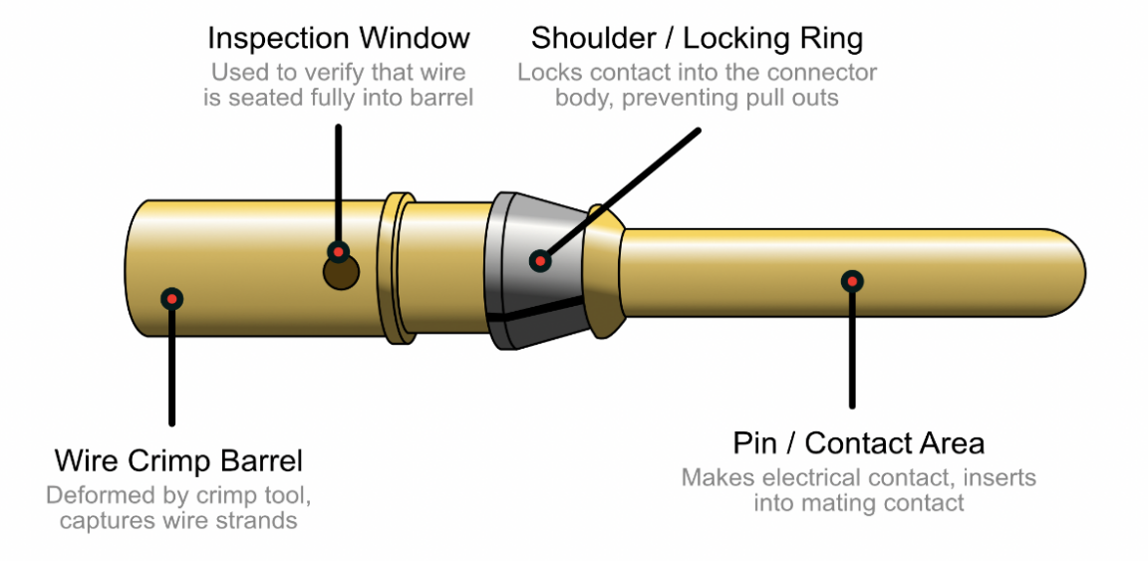
Figure 3 Components of a machined contact
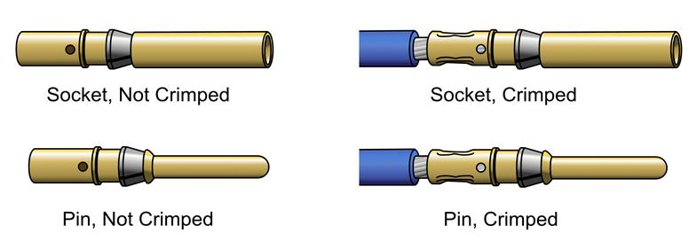
Figure 4 Examples of Machined Contacts
Stamped and formed contacts are inexpensive to manufacture, and often are configured on reels in high volume manufacturing facilities. These contacts are cost-effective, readily available for any manufacturer, and very common across all electronics manufacturing industries. However, the end of the conductor strands, also known as the wire brush, remain exposed after crimping as shown in Figure 5. Therefore, due to the exposed conductor ends, stamped and formed contacts are typically only used for ground systems at NASA because in a microgravity environment, conductor strands have the potential to float inside the system and cause short circuits. For this reason, NASA primarily uses machined contacts for space flight hardware. Additionally, as a result, stamped and formed contacts were excluded from this study.
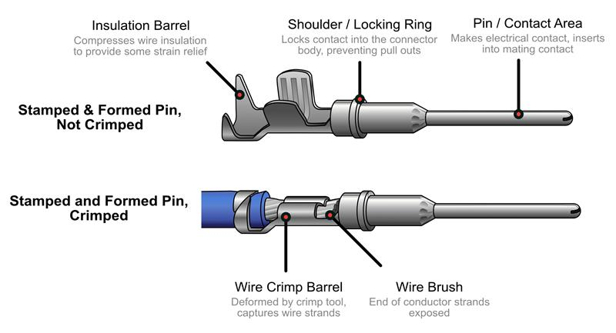
Figure 5 Stamped & Formed Contact Components. The crimped contact is showed at the bottom with exposed wire brush.
Contacts are sized in accordance with the AWG size of the largest diameter wire that the contact can accept. However, adjustable crimp tools allow the modification of the crimp depth of the indenter blades, allowing a larger contact to be crimped to a wire a size or two smaller, e.g., a 20 AWG wire, and then fit into a larger 16 AWG contact. The size of the contact in a crimped connection is irrelevant for crimp pull testing; instead, the size and composition of the wire are the dominant factors in the tensile strength of the connection. Furthermore, it is recommended to select the correct size of wire and contact combination (C/W) pair to avoid excessive compression of the wires that will result in extensive compaction of the conductor stands as shown in Figure 6 [3].
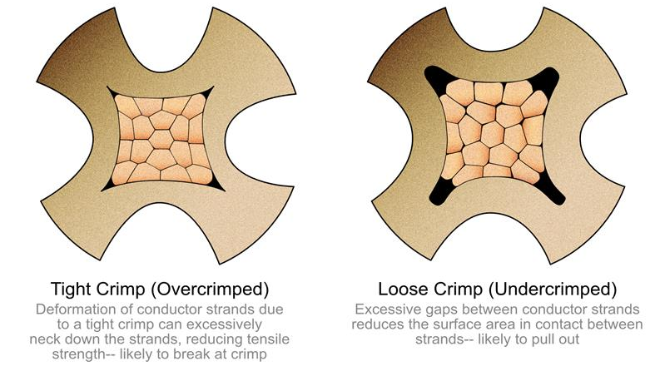
Figure 6 Cross section of machined contacts
This work presents a comparison of the pull test requirements of the NASA-STD-8739.4 Change 2 and the IPC/WHMA-A-620C standard [1] [2]. It is known that the pull force strength requirements in both standards are similar, except for large gauges (e.g., 8 AWG wire size). However, in practice pull force strength test failures occur at significantly higher values. In this paper we are presenting a statistical analysis of the pull test records for past NASA projects and the results of an investigation into recent crimp-related problem failure reports documented at NASA Goddard Space Flight Center (GSFC). The percentage difference between the pull force test values tabulated in the NASA-STD-8739.4 Change 2, Table 12-1 Crimp Tensile Strength and those in the IPC/WHMA-A-620C, Table 19-12 Pull Test Force Values were plotted for the machined contacts silver/tin plated wires and nickel-plated wire as shown in Figure 7 and Figure 8respectively.
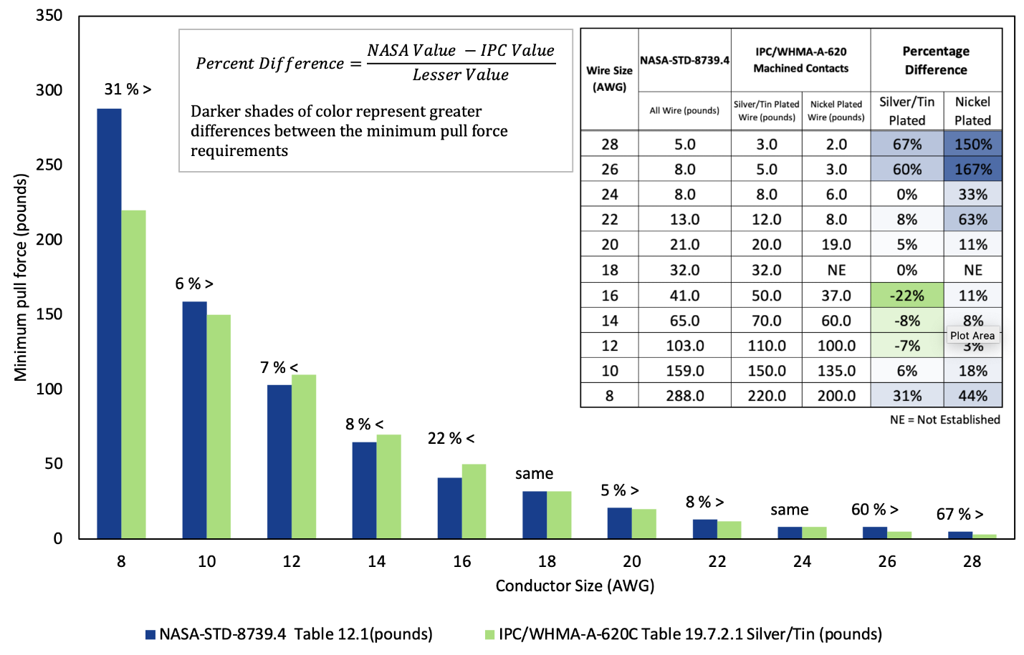
Figure 7 Percentage difference between pull force test results using NASA-STD-8739.4 vs IPC/WHMA-A-620C Silver/tin requirements for pull force testing
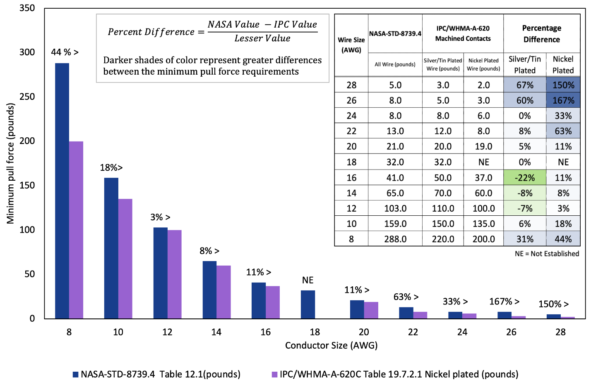
Figure 8 Percentage difference between pull force results using NASA-STD-8739.4 vs IPC/WHMA-A-620C Nickel plated requirements for pull force testing
Nonconformances for crimped terminations are described in sections 5.2 through 5.4 of the IPC/WHMA-A-620C [6]. Within the scope of this standard, nonconformances are called “defects”. A summary of these defects is shown in Table 2.
In this survey, crimp termination defects exhibited in the data were grouped into three major categories, which were defined as follows: (1) related to the materials (2) related to the crimping process (3) related to traceability.

Table 2 Summary of IPC-WHMA-A620C Defects [2]
Barrel type | IPC-WHMA-A-620C Defects | Materials -tool | Crimping Process
Stamped and Formed -Open Barrel | Insulation extends into conductor crimp area (See Fig 5-5) | X | X
Stamped and Formed -Open Barrel | Insulation and conductor transition line is not visible within insulation inspection window (See Fig 5-6) | X | X
Stamped and Formed -Open Barrel | The insulation crimp tabs pierce the insulation. The insulation crimp tabs do not provide support at least 180° around the insulation (Fig 5-10 and Fig 5-11). | X
Stamped and Formed -Open Barrel | The crimp tabs encircle the wire but leave an opening more than 45° on top (Fig 5-14) | X
Stamped and Formed -Open Barrel | The insulation clearance is greater than 2 wire diameters from the end to the contact barrel (Fig 5-15) |  | X
Stamped and Formed -Open Barrel | Insulation extends into the conductor crimp area (Fig 5-19) |  | X
Stamped and Formed -Open Barrel | Deformation of the contact/terminal that affects form, fit, function, or reliability (Fig 5-20) | X | X
Stamped and Formed -Open Barrel | Any loose conductor stands that are outside the crimp area, trapped strands, folded back stands (Fig 5-21) |  | X
Stamped and Formed -Open Barrel | Wire end is less than flush to the end of the conductor crimp area (Fig 5-28) |  | X
Stamped and Formed -Open Barrel | Any conductor stands extending beyond the outer perimeter of the crimp barrel (Fig 5-29, 5-30) | X | X
Stamped and Formed -Open Barrel | The conductor strands extend into the mating area of the contact (Fig 5-31) |  | X
Stamped and Formed -Closed Barrel | Insulation is greater than 2 wire diameters from the entry bellmouth (Fig 5-44) |  | X
Stamped and Formed -Closed Barrel | The wire insulation is not within the insulation crimp area (Fig 5-47-A) |  | X
Stamped and Formed -Closed Barrel | Outer insulation of terminal is not secure on terminal (Fig 5-47-C) |  | X
Stamped and Formed -Closed Barrel | Wire insulation damage exceeds the criteria of 3.5 (Fig 5-47-B) |  | X
Stamped and Formed -Closed Barrel | Wire end is less than flush to the end of the bellmouth. Terminal insulation damaged exposing metal (Fig 5-51-A) | X | X
Machined Contacts | Insulation is greater than 2 wire diameters form the end of the contact barrel (Fig 5-56) |  | X
Machined Contacts | Wire insulation not inserted into the insulation support barrel of the contact (Fig 5-62) |  | X
Machined Contacts | Conductors twisted together before insertion into the contact (Fig 5-67) |  | X
Machined Contacts | Any conductor strands outside of the conductor crimp area (Fig 5-68) |  | X
Machined Contacts | The crimp indent is outside the crimp area (Fig 5-71) | X | X
Machined Contacts | Wire entry end of the barrel is deformed by the crimp area (Fig 5-72) | X
Machined Contacts | Crimp deforms inspection window. Wire is not secure by the crimp. Contact barrel is deformed or bent (Fig 5-73) | X
Machined Contacts | Contact is double crimped (Fig 5-75) | X | X
Termination Ferrule Crimp | Cracks or splits in the ferrule conductor. Individual wire(s) protrude from the insulation sleeve. Ferrule bent (Fig 5-86) | X | X

Methods
Two types of studies were conducted - the first was a survey of the NASA-STD-8739.4 with Change 2 and the IPC/WHMA-A-620B-S requirements for pull force testing and the second was an observational study of crimp-related problem failure reports at NASA Goddard Space Flight Center.

Study 1: Comparison of the pull test requirements of the NASA-STD-8739.4 Change 2 and the IPC/WHMA-A-620B-S standard
The first study is a data analysis based on a sample of pull test logs generated by NASA Goddard Space Flight Center and NASA Marshall Space Flight Center between August 2010 and April 2017. An example of the tensile logs from both NASA Centers is shown in Figure 9 and Figure 10. The test logs contain information about the project, operator, tensile tester, wire and crimp tool identification, and calibration information. In addition, the operator and inspector initials are reported on the forms.
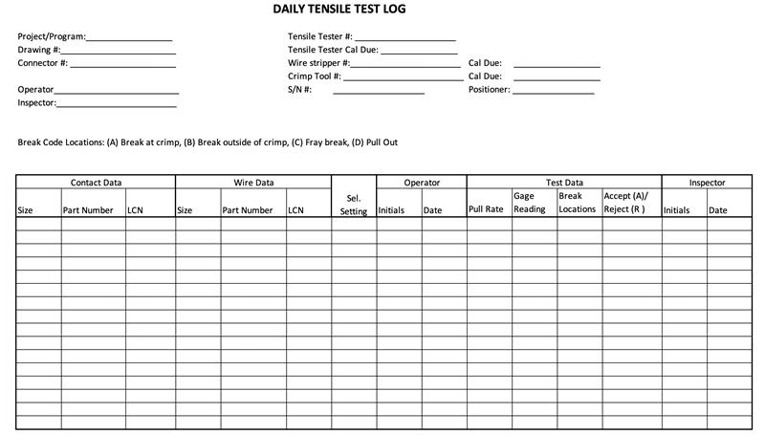
Figure 9 Example of the Tensile Test Logs used by NASA Goddard Space Flight Center
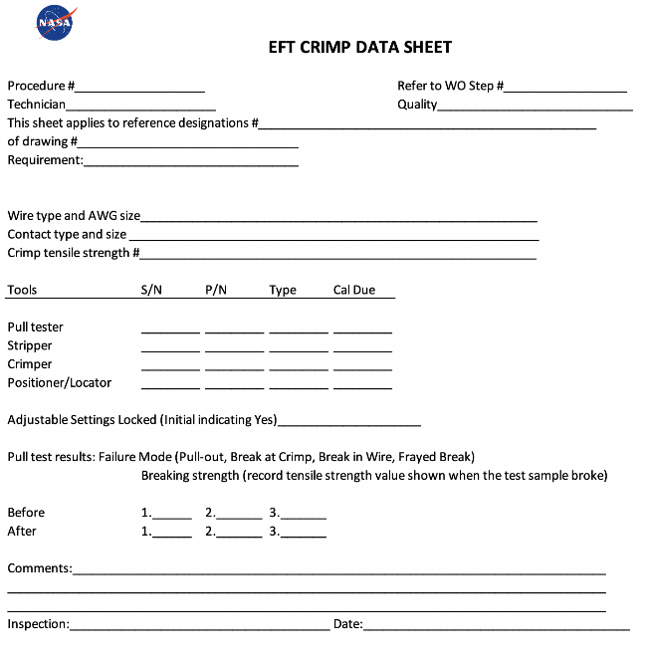
Figure 10 Example of the Tensile Test Logs used by NASA Marshall Space Flight Center
The total number of pull test readings extracted from the logs was 780 as shown in Figure 11 and summarized in Table 3. This table shows the tensile strength of the pull force test data average using the arithmetic mean of the same contact/conductor (C/W) pair combinations (e.g., C20/W20). The average was calculated by adding the tensile strength values of the test readings for similar pair combinations and then divided by the count (e.g., tensile strength values for C20/W20 are ranging from 27.5 to 64.7 lbs. These values were added and divided by the sample size, 138).
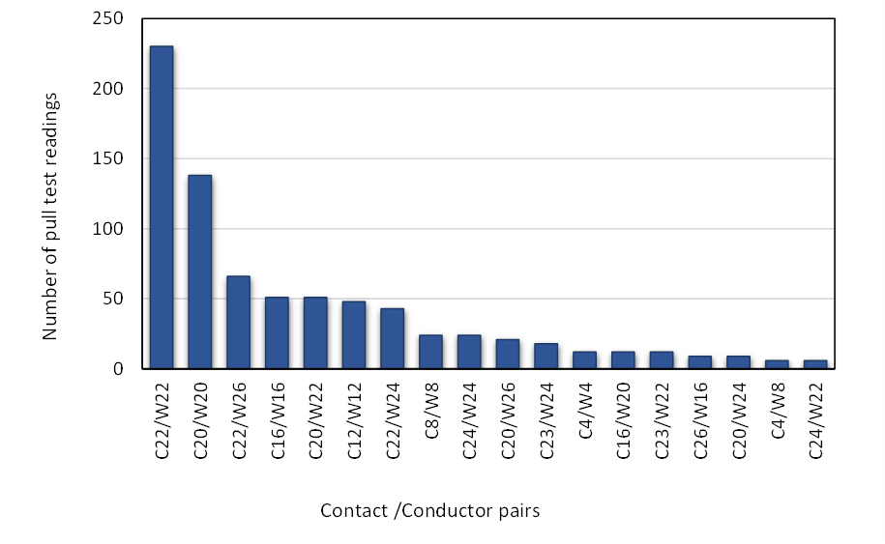
Figure 11 Total number of pull test readings per contact/conductor (C/W) size
The difference in sample size for each contact/conductor pair can be seen in Figure 11. C22/W22 has the largest sample size by a wide margin; however, it would be good to have a similar sample size for the larger diameter wire sizes and the less common contact pairs to increase certainty of the confidence interval. Table 3 also shows the pull force requirements for the NASA-STD-8739.4 and the IPC/WHMA-A-620C standards are listed for comparison. The tensile test log parameters that were used in this study are wire size, wire part number, contact size, contact part number, gauge reading, and accept/reject. Pull force testing results were sorted by conductor size. The contact/conductor (C/W) pair combinations for all the data were sorted by contact size and then by wire size, creating samples of data for each C/W pair. Both the average and the standard deviation of the measured tensile strength were calculated, and the results plotted. Based on the data, additional charts for the C/W pair combinations were made with the standard deviation plotted as error bars as shown in Figure 12, Figure 13, Figure 17, Figure 18, and Figure 19.
Table 3 Summary of averaged tensile strength values and pull force requirements
Contact size (AWG) | Conductor size (AWG) | Contact/Conductor pair | Size of the sample (n) | Average tested value (pounds) | NASA-STD-8739.4A Rqmt (pounds) | IPC/WHMA-A-620C Requirements (pounds)
 |  |  |  |  |  | Silver/tin plated | Nickel plated | Crimp splices | Stamped and formed C/T
4 | 4 | C4 W4 | 12 | 734 | 440 | 400 | 360 | 140 | 400
4 | 8 | C4 W8 | 6 | 385 | 288 | 220 | 200 | 90 | 225
8 | 8 | C8 W8 | 24 | 364 | 288 | 220 | 200 | 90 | 225
12 | 12 | C12 W12 | 48 | 150 | 103 | 110 | 100 | 70 | 110
16 | 16 | C16 W16 | 51 | 64 | 41 | 50 | 37 | 30 | 50
16 | 20 | C16 W20 | 12 | 34 | 21 | 20 | 19 | 13 | 19
20 | 20 | C20 W20 | 138 | 36 | 21 | 20 | 19 | 13 | 19
20 | 22 | C20 W22 | 51 | 29 | 13 | 12 | 8 | 8 | 15
22 | 22 | C22 W22 | 230 | 25 | 13 | 12 | 8 | 8 | 15
23 | 22 | C23 W22 | 12 | 19 | 13 | 12 | 8 | 8 | 15
24 | 22 | C24 W22 | 6 | 26 | 13 | 12 | 8 | 8 | 15
20 | 24 | C20 W24 | 9 | 24 | 8 | 8 | 6 | 5 | 10
22 | 24 | C22 W24 | 43 | 22 | 8 | 8 | 6 | 5 | 10
23 | 24 | C23 W24 | 18 | 14 | 8 | 8 | 6 | 5 | 10
24 | 24 | C24 W24 | 24 | 22 | 8 | 8 | 6 | 5 | 10
20 | 26 | C20 W26 | 21 | 16 | 8 | 5 | 3 | 3 | 7
22 | 26 | C22 W26 | 66 | 16 | 8 | 5 | 3 | 3 | 7
26 | 26 | C26 W26 | 9 | 15 | 8 | 5 | 3 | 3 | 7
For each C/W pair the pull force test results were averaged, the variability calculated, and the results were compared to the requirements of the NASA-STD-8739.4 and IPC/WHMA-A-620C standards. Within the context of this study, the C/W pairs were not distinguished between silver/tin plated and nickel-plated wires used with machined contacts as presented in the IPC/WHMA-A-620C standard because the NASA-STD-8739.4 uses a single requirement for both types of plated wires. Although, stamped and formed contacts are included in the IPC/WHMA-A-620C standard, this study did not consider these kinds of contacts because as mentioned before NASA typically does not use these contacts on space-flight hardware.

Study 2: Investigation on crimp-related problem failure reports
The second study comprised an investigation and analysis of problem failure reports on crimped terminations that were reported in the “Meta” information system at NASA GSFC. Within the sample of Meta problem failure reports, a query was carried out to identify flight hardware where the problem description involved some issues related to crimped terminations. Eighty-four (84) problem failure reports in Meta containing the word “crimp” were identified. Investigation was conducted on the 84 problem failure reports, and 12 reports featured failures related to crimping process variability. Unexpectedly, only two of the initially queried problem failure reports indicated pull test failure.

Results

Study 1: Comparison of the pull test requirements of the NASA-STD-8739.4 Change 2 and the IPC/WHMA-A-620B-S standard
The tensile strength versus the contact/conductor pair combinations was plotted as shown in Figure 12 and Figure 13. The nomenclature of the contact/conductor pairs was defined as Cx/Wy, where x represents the AWG size of the contact and y represents the AWG size of the conductor respectively.
As previously stated, the IPC standard differentiates the requirements for silver/tin plated and nickel-plated wires in contrast to the NASA-STD-8739.4 requirements, which does not. Because the data records were in accordance with NASA-STD-8739.4, there are insufficient data to resolve the plating of the wires tested. Therefore, the silver/tin and nickel-plated wire pull test results were not differentiated when grouped by C/W pairs. Future work may include the separation of the C/W pairs by wire plating.
The average tensile strength of larger conductors, ranging from 4 to 12 AWG, with error bars representing the standard deviation can be seen in Figure 12. Low variability was observed in the larger conductors. However, the average of the measured tensile strength is about 2 times larger than the NASA-STD-8739.4 and the IPC/WHMA-A-620C requirements for the C4W4 data [1, 2].
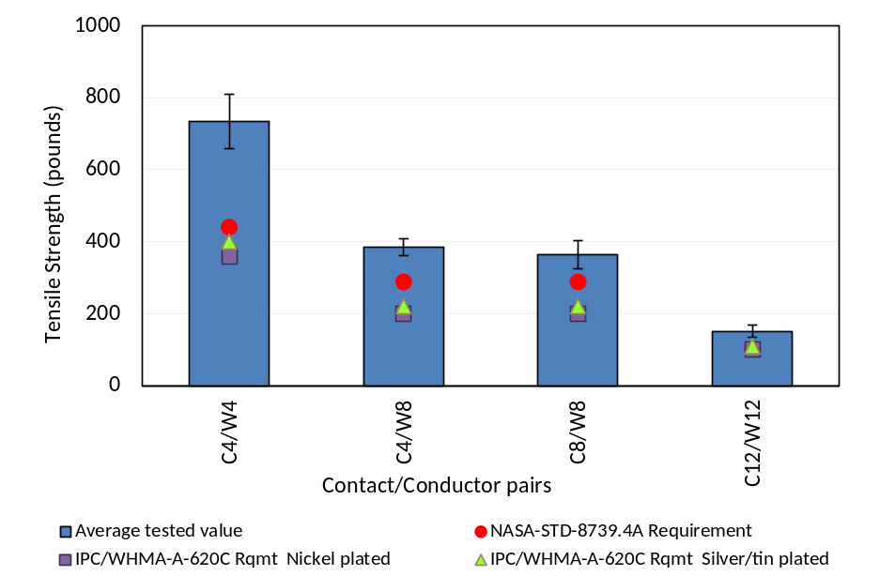
Figure 12 Comparison of pull force testing average (mean) values of physically larger contact/conducts crimped pairs (C/W) to the NASA-STD-8739.4 and IPC/WHMA-A-620C requirements. NASA-STD-8739.4A requirements are defined in Table 12-1. IPC/WHMA-A-620 C requirements per Table 19-12. Error bars represent the standard deviation.
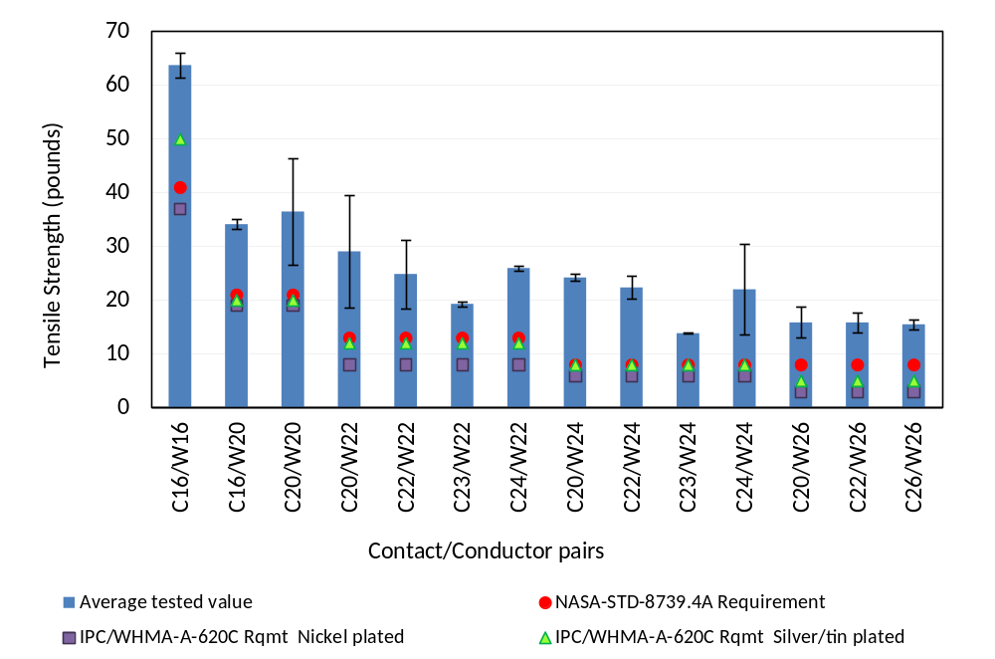
Figure 13 Comparison of pull force testing average results of physically smaller C/W pairs crimped to the NASA-STD-8739.4 requirements and IPC/WHMA-A-620 C requirements. NASA-STD-8739.4A requirements are defined in Table 12-1. IPC/WHMA-A-620 C requirements per Table 19-12. Error bars represent the standard deviation.

The tensile strength for contact/conductor pairs smaller than 12 AWG is shown in Figure 13. The error bars represent the standard deviation. The variability of commonly-used conductors, such as 20 and 24 AWG, is greater than the variability observed in the larger conductors and the data are more spread around the mean. The larger variability is likely due to the diverse of C/W pairs for 20 and 24 AWG combinations (e.g., C16/W20, C20/W20, C20/W24., C22/W24, C23/W24, C24/W24). In addition, the size of the sample for 20 and 24 AWG conductors was significantly larger than the data for smaller conductors as shown in Figure 13.
Figure 14 shows the distribution of measured pull test results for C20/W20 samples. Initial analysis of the results exhibited a shift of the normal distribution versus the calculated average value of the measured samples, which indicated that there was a second peak within the data. Subsequently, it was decided to evaluate the normal distribution of the data around the two peaks independently as shown in Figure 15. However, the broad distribution is due to the analysis containing multiple types of wire composition (silver plated, nickel plated, and high strength copper alloy).
According to the bi-modal distribution shown in Figure 15, all expected values should be beyond the NASA and IPC pull test requirements. Based on the analysis of this survey data, there should be a very low likelihood of the pull test not meeting these requirements.
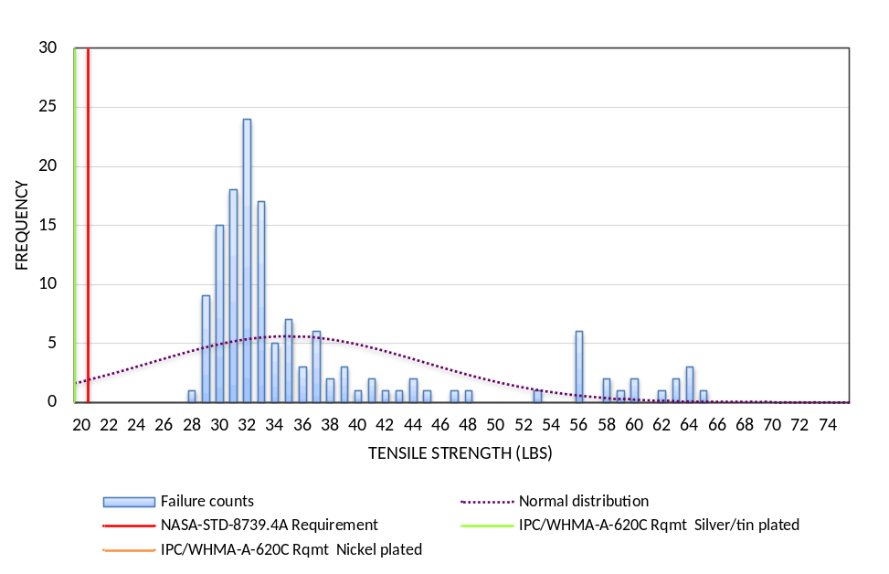
Figure 14 Frequency of failure counts for C20/W20 samples compared to the NASA-STD-8739.4 and IPC/WHMA-A-620C requirements. The normal distribution around the calculated average of 36 lbs. is also shown.
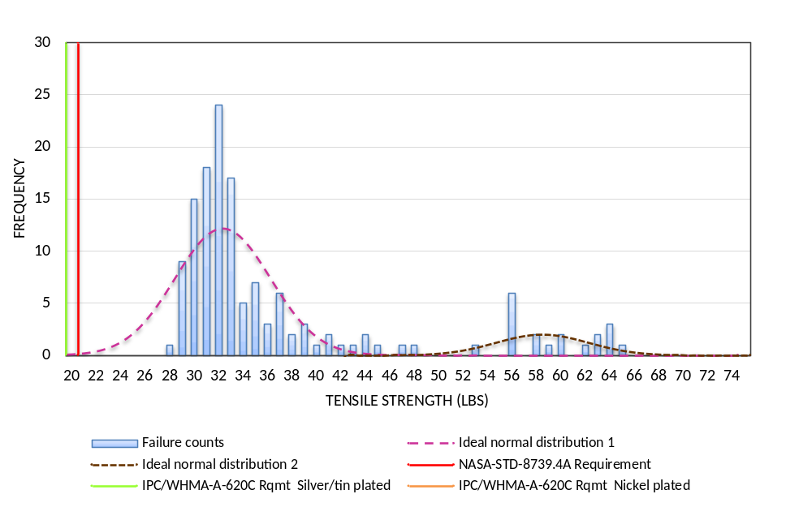
Figure 15 Frequency of failure counts for C20/W20 samples compared to the NASA-STD-8739.4 and IPC/WHMA-A-620C requirements. The bi-modal distributions were estimated using two calculated averages, 32 lbs. and of 59 lbs. respectively.

Figure 16 Percentage of the tensile strength IPC/WHMA-A-620C requirement for silver/tin plated for contact/conductor (C/W) pairs.
The average pull tested values were compared to the IPC/WHMA-A-620C requirements for silver/tin plated, the percentage of the average pull test data to the requirement was determined and plotted as shown in Figure 16. There is a strong possibility that the average pull test values are about 2 times larger than the NASA-STD-8739.4 and the IPC/WHMA-A-620C requirements. All of the contact/conductor pairs analyzed exhibited a two-fold margin beyond the IPC/WHMA-A-620C requirement for silver/tin plated wires as shown in Figure 16. Furthermore, the average test value of smaller wires (i.e., 24 and 26 AWG) showed a three-fold margin.
For wire sizes 20 to 26 AWG sufficient data were available to compare the average tensile strength for various contact sizes as detailed in Figure 17, Figure 18, and Figure 19. Analysis of the 20 to 24 AWG data was carried out to determine if the size of the contact has any effect in the tensile strength results. Error bars in these Figures represent the 95% confidence interval, which shows that the probability of observing a tensile strength value outside the area covered by the normal distribution curve is less than 0.05. The confidence interval for C/W pairs for wire sizes 22, 2, and 26 AWG was calculated using Equation 1, where the t-distribution with a significance level or probability of 0.05 is multiplied by the standard deviation of the tensile strength values, and divided by the square root of the sample size.
$$95\% Confidence Interval={t^{*}}_{0.05}\frac{s}{\sqrt{n}}$$
Equation 1 95 % confidence interval. Where, t*_{0.05} is the t-distribution, s is the standard deviation, and n is the sample size.
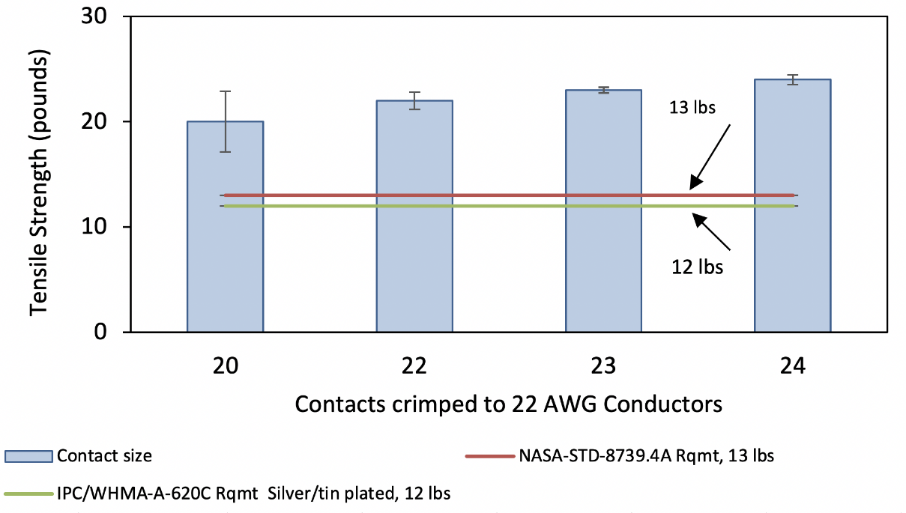
Figure 17 Comparison of pull force testing results of contacts crimped to 22 AWG conductors. The NASA-STD-8739.4 requirement is 13 pounds and the IPC/WHMA-A-620C requirement is 12 pounds.
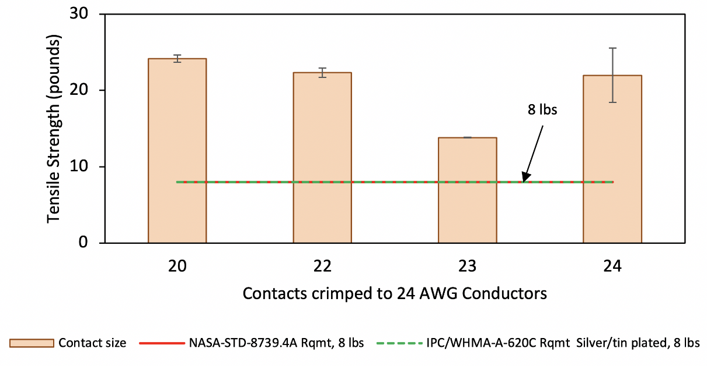
Figure 18 Comparison of pull force testing results of contacts crimped to 24 AWG conductors. The NASA-STD-8739.4 and IPC/WHMA-A-620C requirements are 8 pounds.

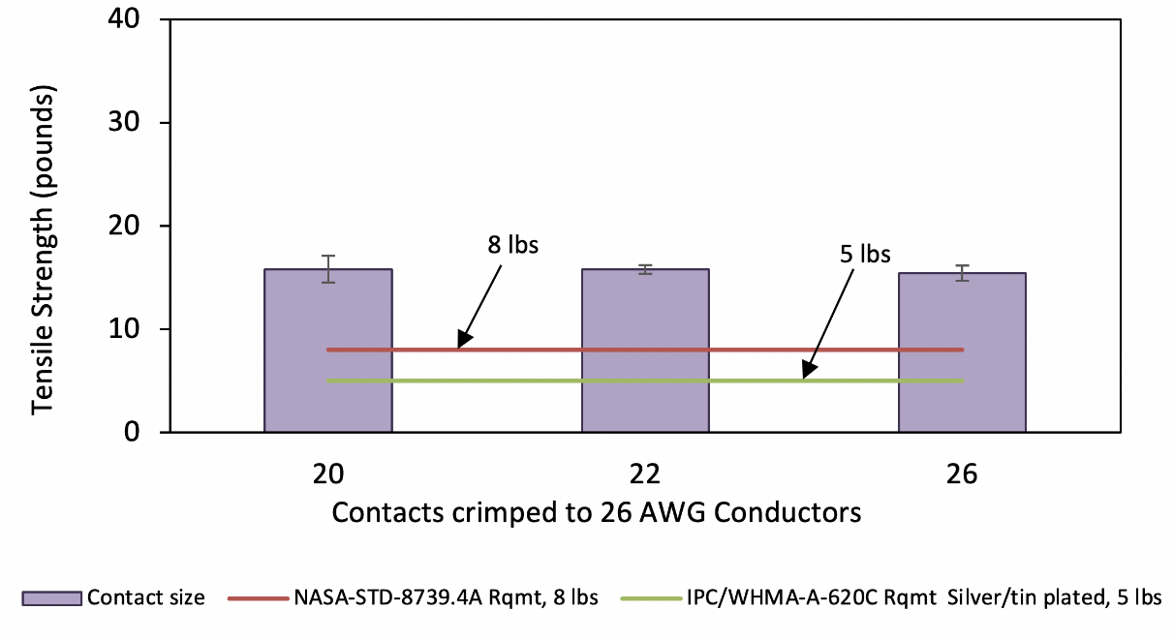
Figure 19 Comparison of pull force testing results of contacts crimped to 26 AWG conductors. The NASA-STD-8739.4 requirement is 8 pounds and the IPC/WHMA-A-620C requirement is 5 pounds.
The NASA-STD-8739.4 § 7.2, Design Considerations, requires the use of high strength copper alloys for AWG 24 and smaller conductors. It should be noted that the distribution of tensile strength values could be skewed due to the usage of multiple wires composition, e.g., AWG 24 and 26 may comprise some high strength copper mixed with regular copper wire.
The pull force of high strength copper alloy wire was compared to that of nickel-coated copper wire. For example, Figure 20 shows that the average tensile strength of 20 AWG high strength copper alloy was 48% larger than nickel-coated copper wire. Error bars on the figure represent the 95% confidence interval.
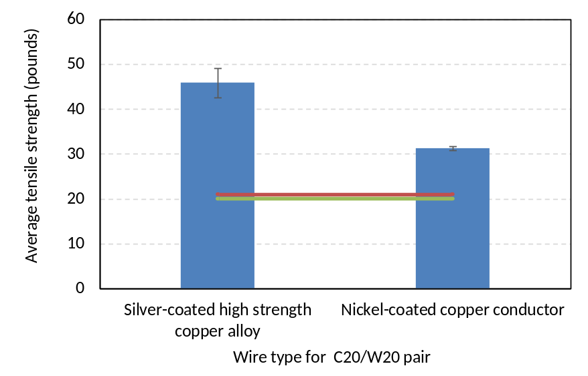
Figure 20 Comparison of pull force testing results for nickel-coated and higher strength copper 20 AWG conductors crimped to 20 AWG contacts

Study 2: Investigation on crimp-related problem failure reports
After reviewing the previous pull test data, we looked within problem failure reports to identify if NASA GSFC projects had any failed pull test records and investigated how they failed to have a better understanding of the failure modes and root causes. A search on the GSFC Problem Failure repository (i.e., Meta) led to the evaluation of 48 problem failure reports related to crimped terminations documented since 2011. These failure reports were analyzed, and their root causes were grouped into one of the three categories defined as follows: 1) Tool/Machine, 2) Material Selection, and 3) Traceability Error. Figure 21 shows that 42% of the failures were related to tool/machine (e.g., poor crimp quality, crimp tool no calibrated, or crimp tool degraded/damaged,). Furthermore, 40% of the failures were related to traceability errors (e.g., no records of tensile test, insufficient extra contacts for tensile test, or missed quality assurance inspection). Materials selection failures correspond to 19% (e.g., incorrect contacts, incorrect connector, or incorrect wire). The root causes correspond with several of the defects listed in Table 2.
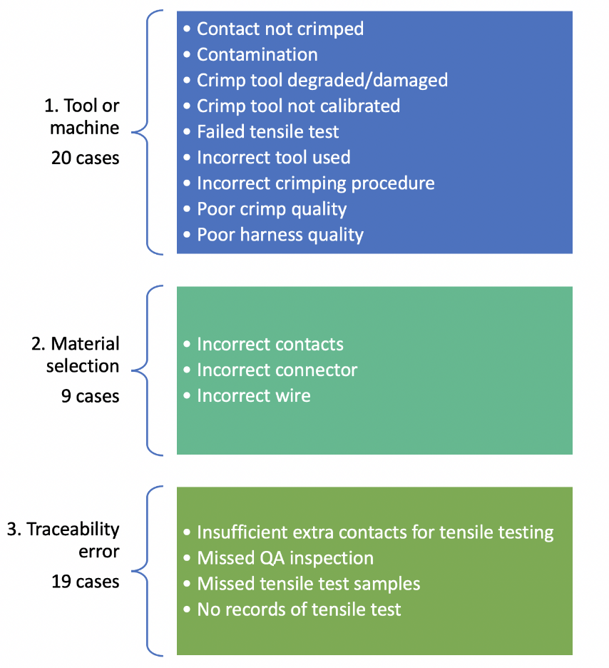
Figure 21 Root cause of the problem failure reports analyzed grouped by category. A total of 48 cases were analyzed
Of the 48 cases, however, in some instances, the nonconformances cited were unrelated to crimp pull test failures (e.g., tools out of calibration, charred wire insulation from thermal stripping, wires and contacts strained during integration to spacecraft, etc.). Because cases like this were not related to the study, they were removed.
We investigated each of the 48 problem failure report cases to evaluate if their root causes were related to or could be detected by pull force testing. Each case was reviewed to determine if the condition of the nonconformance could affect the strength of wire, any samples that did not meet these criteria were removed from the sample pool. In addition, the cases related to traceability were removed because lack of documentation cannot affect the pull force testing results. After 27 unrelated cases were removed from the pool of 48, the 21 remaining cases were more thoroughly investigated by interviewing NASA project personnel that either inspected or participated in review of the problem failure reports. As a result of the interviews with NASA personnel providing a more detailed description of the related cases, a more detailed view of the problem failures allowed us to refine the pool of cases further.
Two filters were able to be applied to the 21 cases. The first inquiry/query was “Can the problem be detected by the pull test?”. The second inquiry/query was “Is the failure mode related to the crimping process?”. After all these queries were carried out, the total count of relevant cases was reduced down to11 as shown in Figure 22. All 11 cases were more thoroughly investigated. Of these cases, only two indicated that crimp tensile testing failures had occurred.
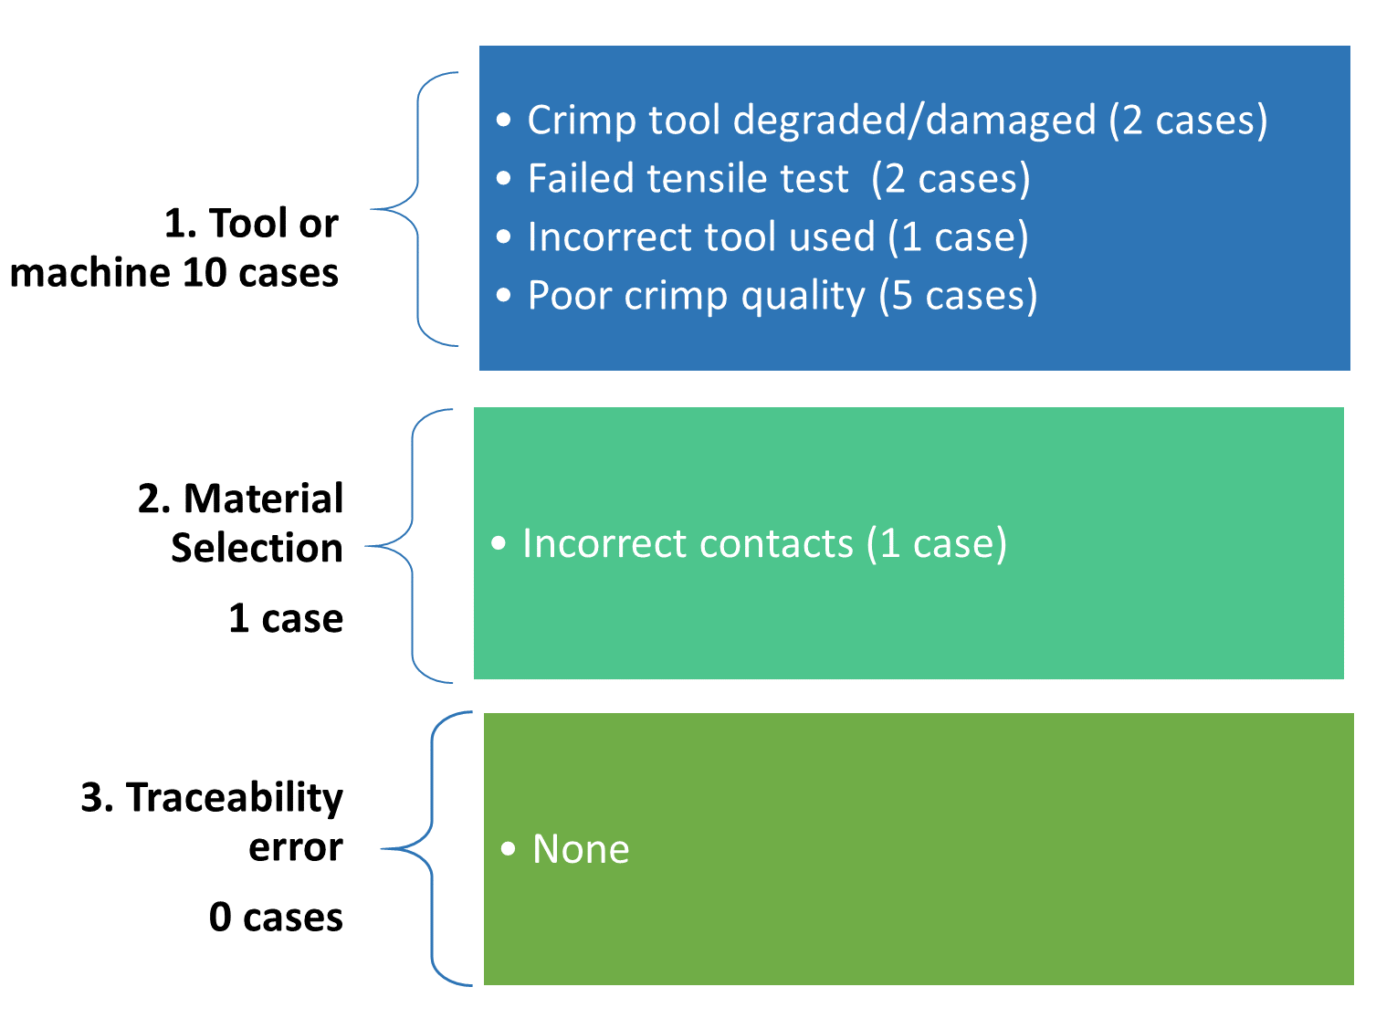
Figure 22 Root cause of the 11 problem failure reports that were thoroughly investigated.
The two pull force test failures occurred within two different NASA flight projects. According to each case’s problem reports, the pull force tests were carried out and the minimum tensile force was not achieved before the contacts pulled or broke off the wire. In the first case, the crimps appeared to have been a temporary means of connecting an electric motor to a test rig for qualification testing. After the part was tested, the crimps were removed (cut off) and to be integrated to the next level assembly later. The pull force test was unnecessarily performed and reported as a failure at the same level of stringency as a flight level configuration, even though the crimps were a part of an engineering test unit that does not have the same pull force test requirement.
In the second case, it was observed that an oversized contact was used in place of the appropriately-sized contact. This was likely due to either a mislabeled materials container or operator error. These wires were subsequently replaced with a thicker gauge of wire to accommodate for the incorrect contact. Operator training for the identification of crimped contact color codes may help prevent errors like.
It was concluded that the pull test is not a mechanism for finding or identifying defects. Pull testing is purely a validation test to confirm that the deformation of the crimp contact is not insufficient or excessive. Additionally, the frequency of pull force testing being performed for any given cable/harness assembly may be too high and can drive costs up if spare contacts aren’t immediately available. Thus, it may be worth pursuing a frequency of testing that satisfies the project’s available supplies while driving down the project risk.

Discussion
The main goal of this study was to statistically analyze past NASA pull test data for crimped terminations and compare against the minimum requirements of the cable/harness manufacturing standards NASA-STD-8739.4 and IPC/WHMA-A-620C-S [1] [13]. This was carried out for the benefit of NASA’s adoption of industry voluntary consensus standards, such as IPC/WHMA-A-620C-S.
Based on the pull test data analyzed, it was found that the average pull test values are about 2 times larger than the NASA-STD-8739.4 and the IPC/WHMA-A-620C requirements, especially for conductors 20 AWG and smaller (e.g., 22 AWG, 24 AWG, and 26 AWG), as shown in Figure 13. It is inferred that the minimum pull test requirements were derived based on tensile strength of various gauges of wire to provide a gap between the low and high end of wire pull test values, which acts as a safety factor.
The comparison of the pull test requirements of the NASA-STD-8739.4 change 2 and the IPC/WHMA-A-620B-S standard was comprised of the analysis of 780 data points that passed the pull force test and met the requirements. It was noticed that the 20 AWG and smaller conductors exhibited larger variability of the data, represented by the error bars. The error bars were larger when they represented the standard deviation of the sample, and smaller when they represented the 95% confidence interval of the sample. The 95% confidence interval indicates that there is a high margin of certainty for a given pull force test results to fall under the normal distribution represented by the C/W pair samples, in this case the 20 AWG data.
The type of conductor material affects the pull testing results. It was observed that when a high strength copper alloy was used for the C20/W20 pair, the IPC silver/tin plated requirement was exceeded by 130%. The NASA-STD-8739.4 requirement to use high strength copper in conductor sizes 24 AWG and smaller may have driven NASA flight projects to design cables and harnesses with high strength copper wherever possible, including when using conductors sized larger than 24 AWG (e.g., 20 AWG).
The investigation on crimp-related problem failure reports considered 48 problem failure reports generated from nonconformances of cables/harnesses during flight hardware manufacturing. The goal of the study was to have a better understanding of the failure modes and root causes associated with the crimping process. After evaluation of the 48 problem failure reports, it was concluded that only 11 of the reports were related to the crimping process, and within these, only 2 were pull force test failures. However, only one of the 2 pull force test failures were associated with flight hardware. In this case, a container of contacts was mislabeled with the incorrect size, and as result an oversized contact was installed. The other case was a temporary crimp configuration for electrical test, which was a non-final configuration for flight and should not have been reported as a flight problem failure report in the NASA GSFC Problem Failure repository (i.e., Meta).
Although the nonconformances observed in the problem failure reports may have affected the tensile strength of the C/W pairs, the nonconformances could not be detected by pull force testing alone. Therefore, pull force testing can only be used as a process control to verify that the tool and the action of crimp is correctly performed, and it cannot be used as a quality assurance verification of the crimped products. The pull force test is not intended to identify malformed contacts, incorrect contacts, or loose strands.
It could be possible to reduce the frequency of pull force testing if at the beginning of the production run (within the scope of the assembly or sub-assembly), the conditions of the crimp tool and materials are verified, and the settings of the tool remain unchanged throughout the process. Furthermore, if the incoming inspection finds that there is a lack of spare contacts for pull force testing, the number of samples for pull force testing could be further reduced and still maintain a relatively high level of confidence in the process. It should be noted that if a pull test fails during any time of the production run, all relevant crimps since the last passing test need to be evaluated for risk or scrapped. It is important for each project to define a reasonable period between pull force tests within the project’s resources and risk tolerance. Therefore, the project must evaluate the impact to risk from reducing the frequency of testing.
If the frequency of pull force testing is being reduced, the frequency of supplemental process control methods should be increased. For instance, the schedules for calibration and maintenance of hand crimp tools/dies could be modified from 1 time/year to 4 times/year. In addition, the work instructions can be more detailed about the crimping process and validate the incoming material and other relevant records.

Conclusion
This analysis on crimp pull force testing has concentrated on past NASA project data from multiple NASA centers. These results may offer some validation into the relaxation or revision of the pull force test requirements, but only assuming good training, process documentation, calibration, and tool verification procedures are in place. The measures to mitigate the risk should be formulated if pull test requirements are relaxed.
If the frequency of pull force testing is being reduced, additional process control methods should be followed, such as incoming material inspection, tool and equipment calibration, and tool verification during crimp process. Periodic training to identify bad practices and lack of attention to details will also help prevent crimped termination defects. An allowance to reduce pull force testing frequency was first introduced in the C-revision of IPC/WHMA-A-620 Space Addendum § 19.7.2, Mechanical Test Methods – Pull Force (Tensile).
For manufacturers of cables or harnesses, the team responsible for the crimping process should plan to meet pull force test needs according to the frequency and number of samples required. The plan should include the purchasing of enough contacts to perform the minimum number of tests. This may require communication between engineering, procurement, and manufacturing.
This paper’s comparison of pull test requirements to technical standards has been conducted with respect to the NASA-STD-8739.4 and IPC/WHMA-A-620 requirements. The requirements were compared with 780 data points retrieved from tensile test logs. All data points met or exceeded the requirements, and no defects were inferred from the records.
Despite the study analyzing 780 data points for pull force testing, and all samples passed, this is an insufficient quantity of data points to identify trends on material properties of wires from different suppliers that may have differing metallurgical composition. Additional access to pull testing logs will provide further analysis of crimped termination data to identify additional process control and opportunities to mitigate risk. A sample size of data at least 1 order of magnitude larger will be required to effectively analyze contact/conductor pairs, distinguishing between silver/tin plated and nickel-plated wires, and how they vary between suppliers. Machine-readable data from tensile logs, or digital data capture of tensile testing can significantly ease the burden of sorting and filtering tensile test data, which is commonly hand-written on a paper log.
However, defects related to incorrect or malformed contacts were observed in the investigation on crimp-related problem failure reports. These crimp-related incidents were evaluated, and many of the conditions identified were determined to be undetectable by a pull force test (e.g., conductor strands not captured in crimp barrel, damaged insulation, traceability errors, etc.). For this reason, the testing procedure cannot be used to detect defects in crimp materials. Instead, the tensile test must only be used as a tool to verify that the tool and the action of crimp is correctly performed.

Acknowledgments
The authors would like to thank the contribution of Robert Cooke, Jonathan Coopersmith, Andrew Glendening, Kelly Goodhue, Lynette Marbley, Garry McGuire, Bhanu Sood, Bo Yang, and Nick Virmani with the construction of this white paper.

References

[1] | NASA, "NASA-STD-8739.4A with Change 2 Workmanship Standard for Crimping, Interconnecting Cables, Harnesses, and Wiring," NASA, Washington, D.C. 20546, 2016-06-30.
[2] | IPC - Wiring Harness Manufacturer's Association, "IPC/WHMA-A-620C Requirements and Acceptance for Cable and Wire Harness Assembly," IPC, Bannockburn, IL, 2017-January.
[3] | ASTM, "ASTM B942-10, Standard Guide for Specification and Quality Assurance for the Electrical Contact Performance of Crimped Wire Termination," ASTM, West Conshohocken, PA, 2010.
[4] | R. Boyd, "How good are your crimps," Quality, vol. 42, no. 1, pp. 62-70, 2003.
[5] | MOLEX, "Quality Crimping Handbook Rev D," Molex, Lisle, IL, 2009.
[6] | IPC - Wiring Harness Manufacturer's Association, "IPC/WHMA-A-620B Requirements and Acceptance for Cable and Wire Harness Assemblies," IPC, Bannockburn, IL, 2012-October.
[7] | IPC - Wiring Harness Manufacturer's Association, "IPC-HDBK-620 Handbook and Guide to IPC-D-620 and IPC/WHMA-A-620," IPC, Bannockburn, IL, 2018 - April.
[8] | SAE International, "(R) Wire, Electrical, Fluoropolymeri-Insulated, Copper or Copper Alloy," SAE International, Warrendale, PA, 2018.
[9] | SAE International, "AS22759/12 Rev A (R) Wire, Electrical, Fluoropolymer-insulated, extruded TFE, nickel-coated copper conductor, 600 Volt, ROHS," SAE International, Warrendale, PA, 2015.
[10] | SAE International, "AS22759/20 Rev A (R) Wire, Electrical, Fluoropolymer-insulated, extruded TFE, silver-coated high strength copper conductor, 1000 Volt, ROHS," SAE International, Warrendale, PA, 2015.
[11] | Military Specifications and Standards, "MIL-DTL-55302-G w/AMENDMENT 4 Detail Specification Connectors, Printed Circuit Subassembly, and Accesories," Military Specifications and Standards, 20188.
[12] | IPC - Wiring Harness Manufacturer's Association, IPC/WHMA-A-620B-S Space Applications Electronic Hardware Addendum to IPC/WHMA-A-620B, Bannockburn, IL: IPC, 2013-June.
[13] | Electronic Components Industry Association, "EIA-364-08C TP-08C Crimp Tensile Strength Test Procedure for Electrical Connectors," EIA, Hendon, VA, 2015.
[14] | ANSI-Electronics Components Industry Association (EIA), "EIA Standard TP-08C Crimp Tensile Strength Test Procedure for Electrical Connectors," ANSI-EIA, Herdon, VA, 2015, August 26.
[15] | ANSI - National Electrical Manufactures Association (NEMA), "ANSI/NEMA WC 27500-2015 Aerospace and Industrial Electrical Cable," NEMA Standards Publication, Rosslyn, VA, 2015.
[16] | IPC - Wiring Harness Manufacturer's Association, "IPC/WHMA-A-620C-S Space Applications Electronic Hardware Addendum to IPC/WHMA-A-620C," IPC, Bannockburn, Illinois, 2018-March.

