CS 242 Manual test plan

1. Get book with correct id. Check output message and output :

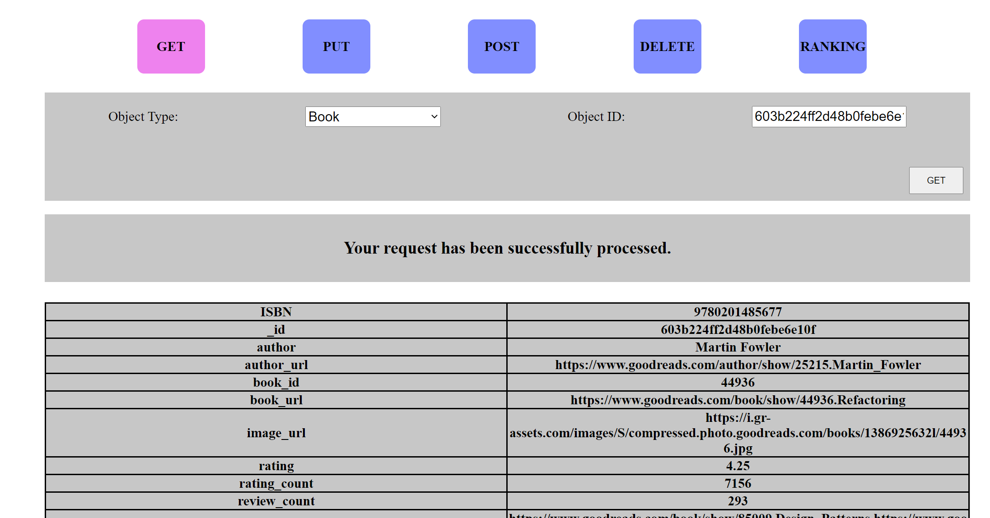

1. Get book with mal-formatted id. Check output message:

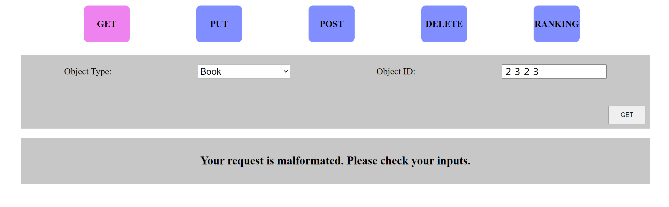

1. Get book with correctly formatted id of non-existing book object. Check output message:

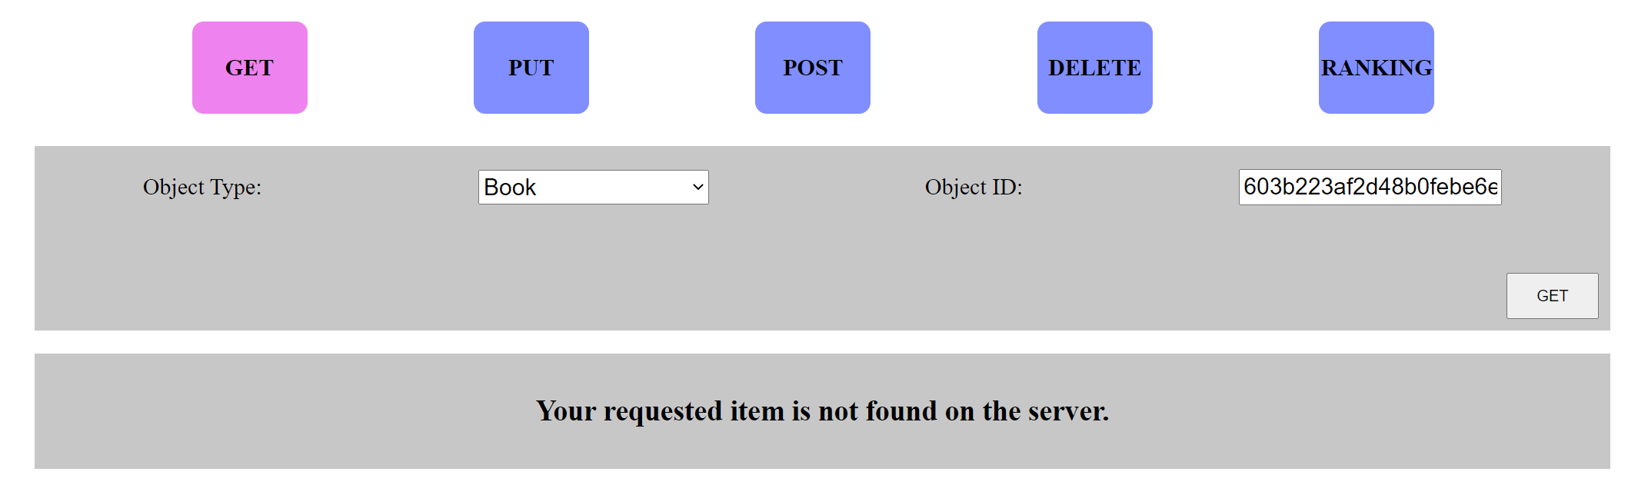

1. Get author with correct id. Check output message and output:

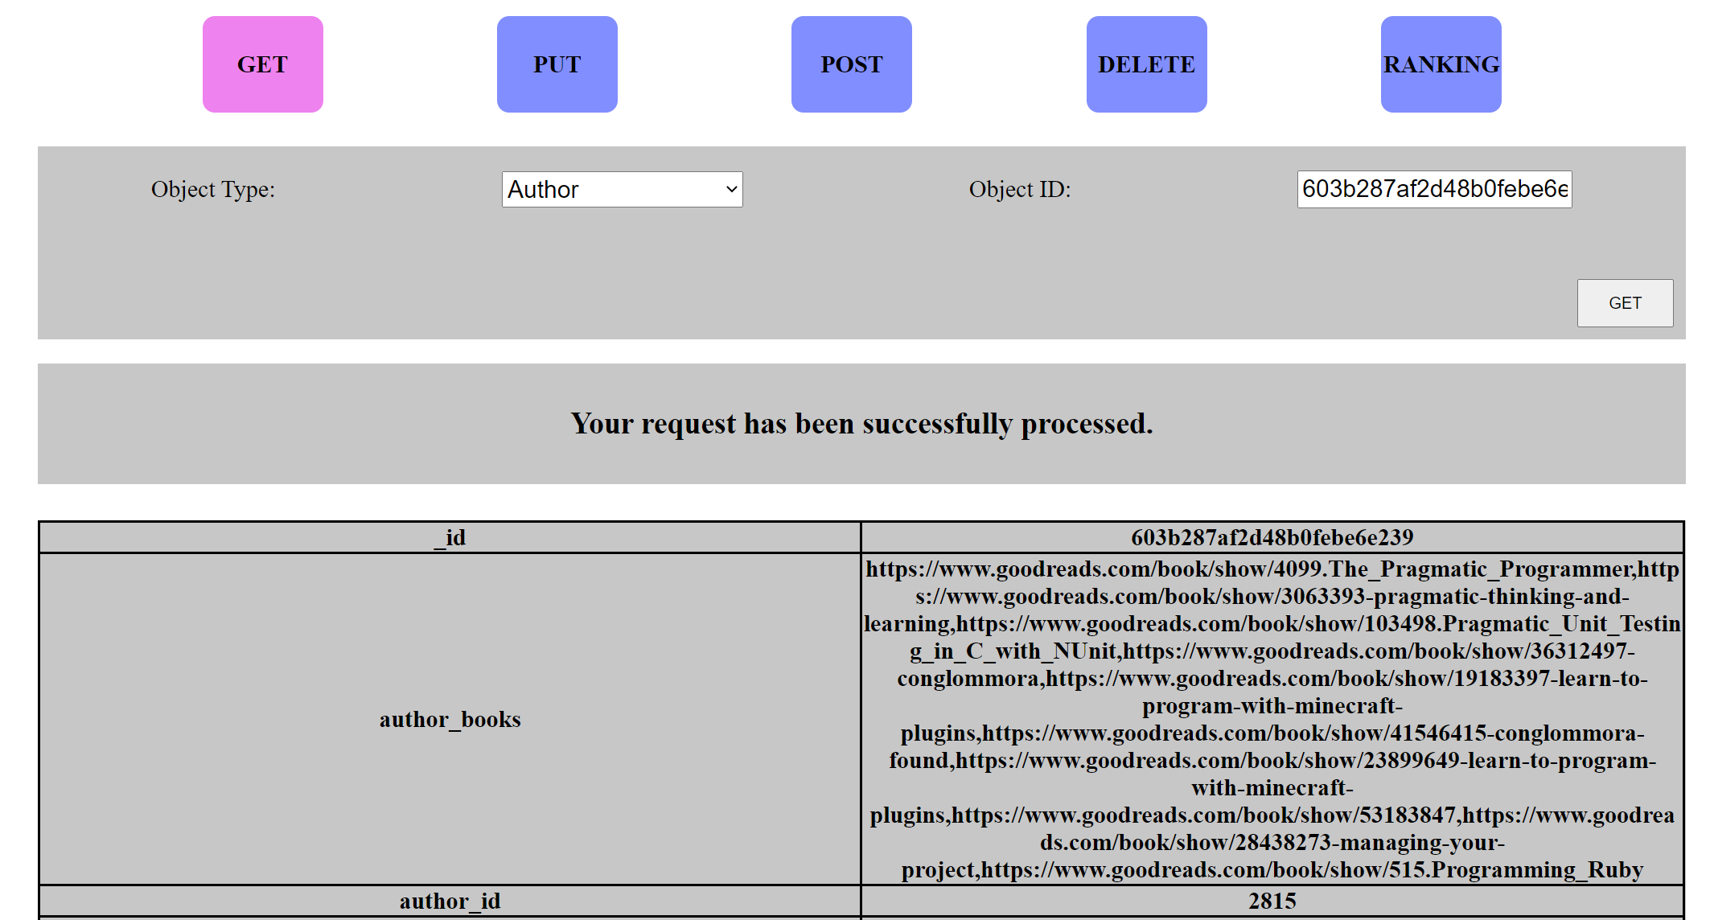

1. Get author with mal-formatted id. Check output message:

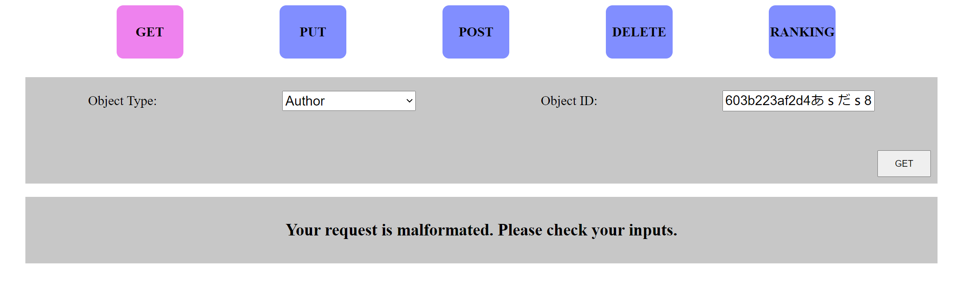

1. Get author with correctly formatted id of non-existing author object. Check output message:

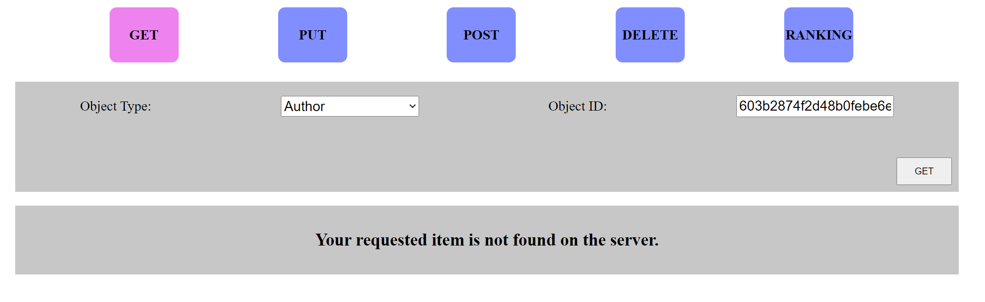

1. Responsiveness of table. The table should stay in the middle. Font size of cell sizes should be reasonable.

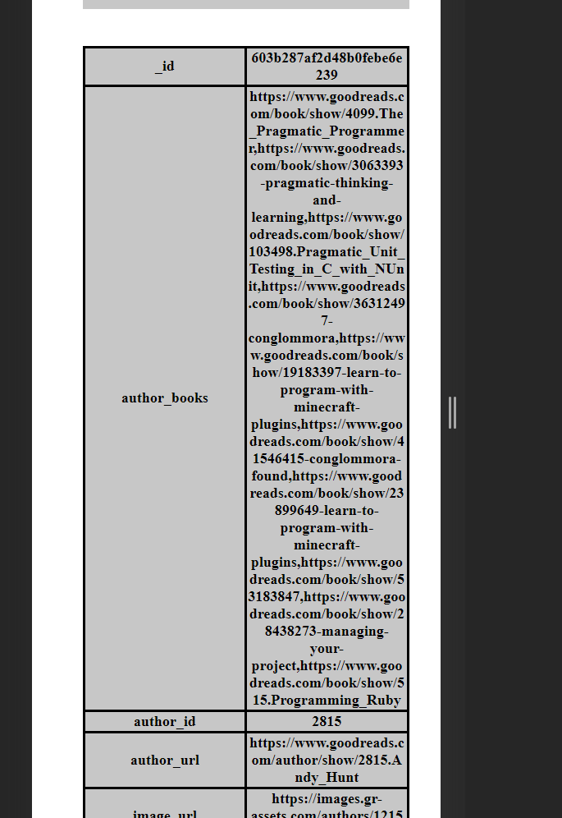

1. Overflow of table cell. The content should be wrapped.

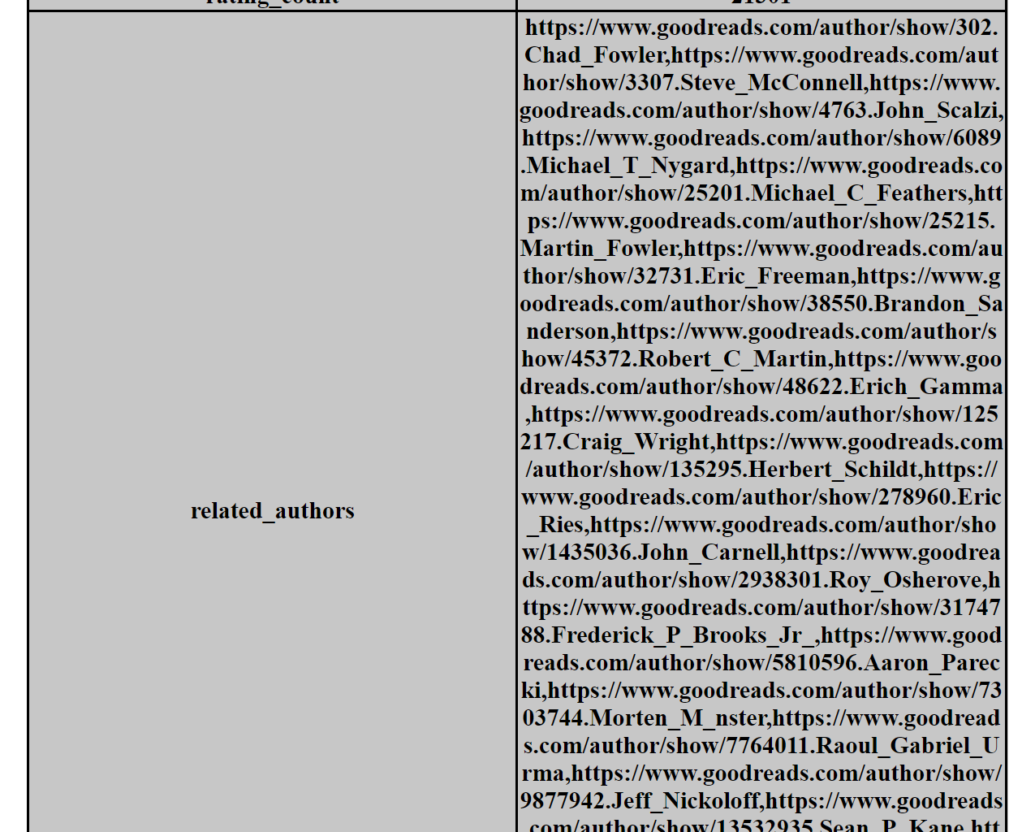

1. Delete a book with correct id:

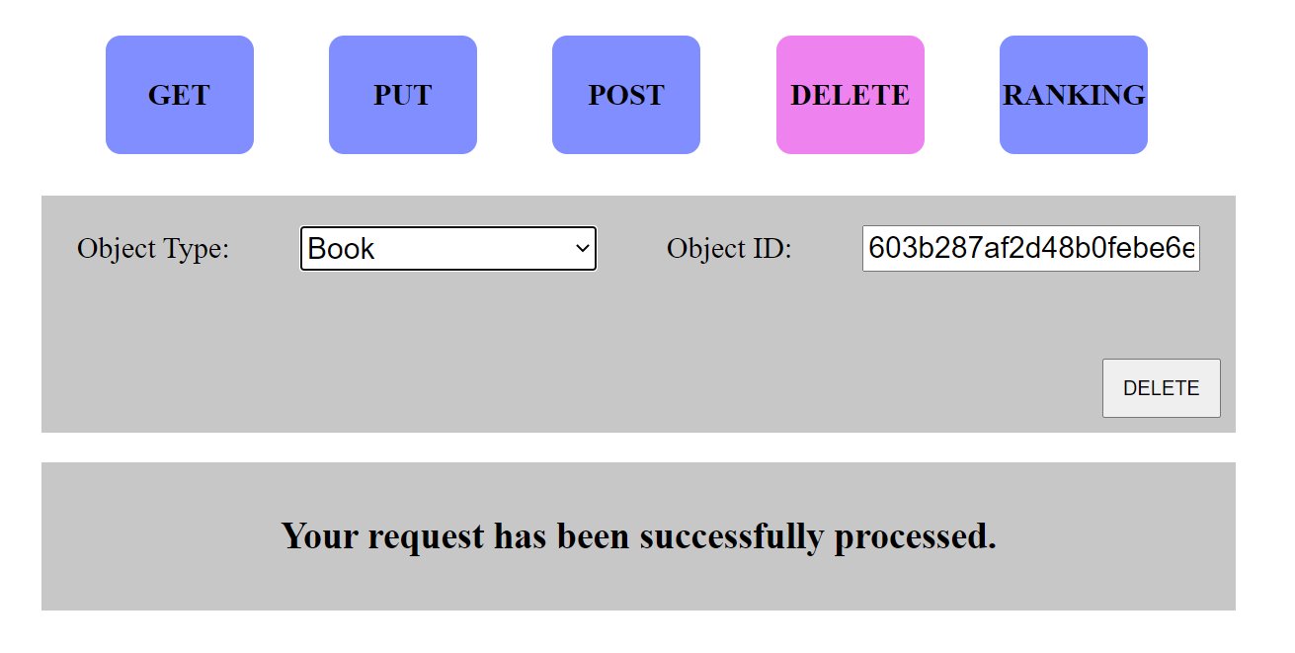

1. Delete a book with wrong id:

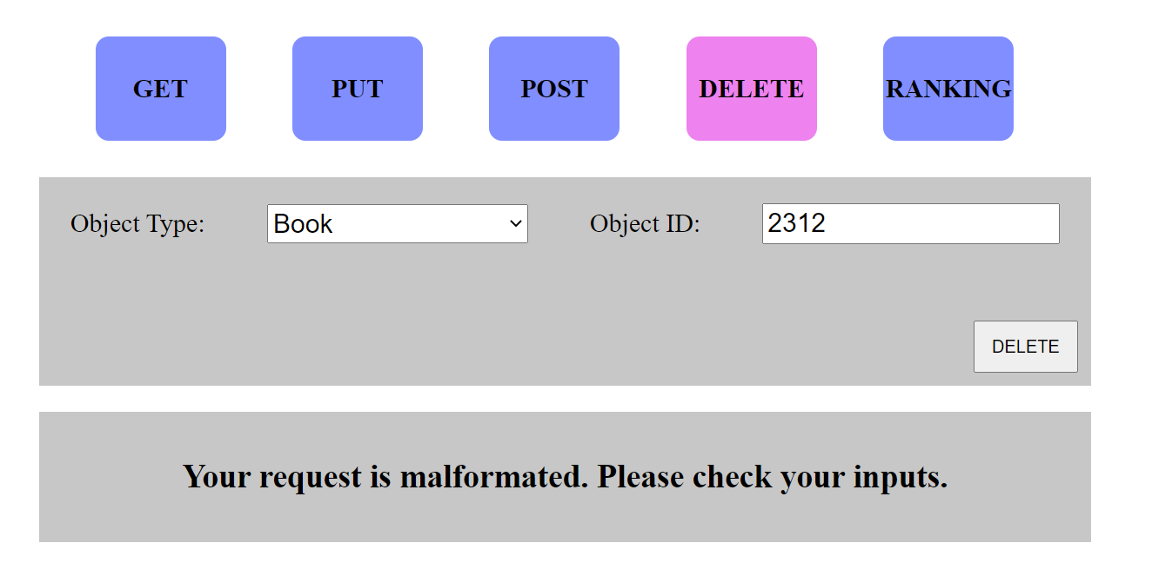

1. Delete an author with correct id:

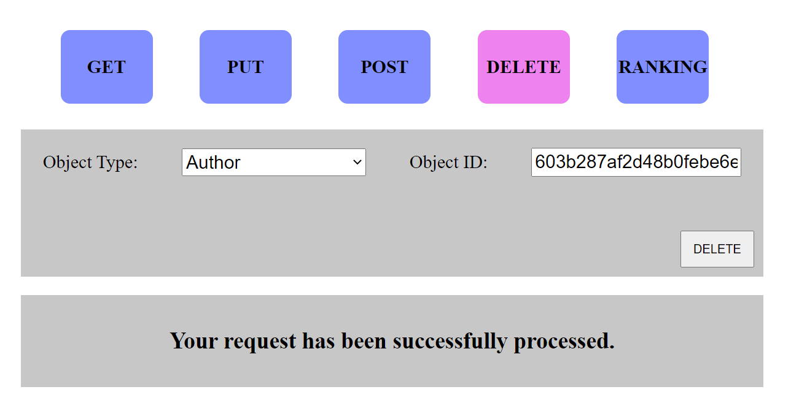

1. Delete an author with wrong id:

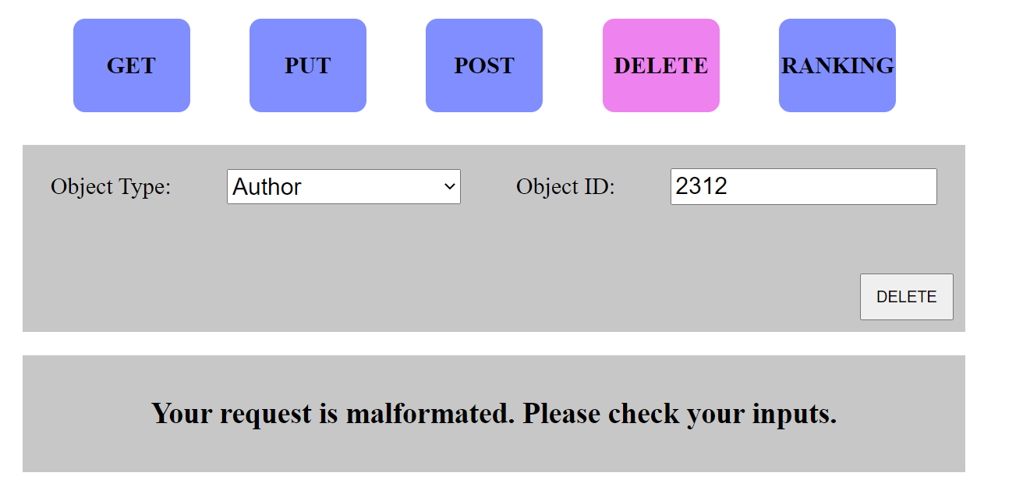

1. UI test: test if the buttons are working



1. UI test: test if form table is responsive and works on mobile sizes

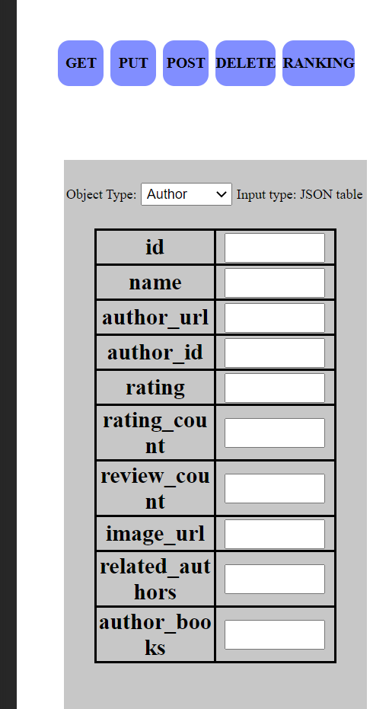

1. Testis rank method get the correct number of output and the correct outputs as well.

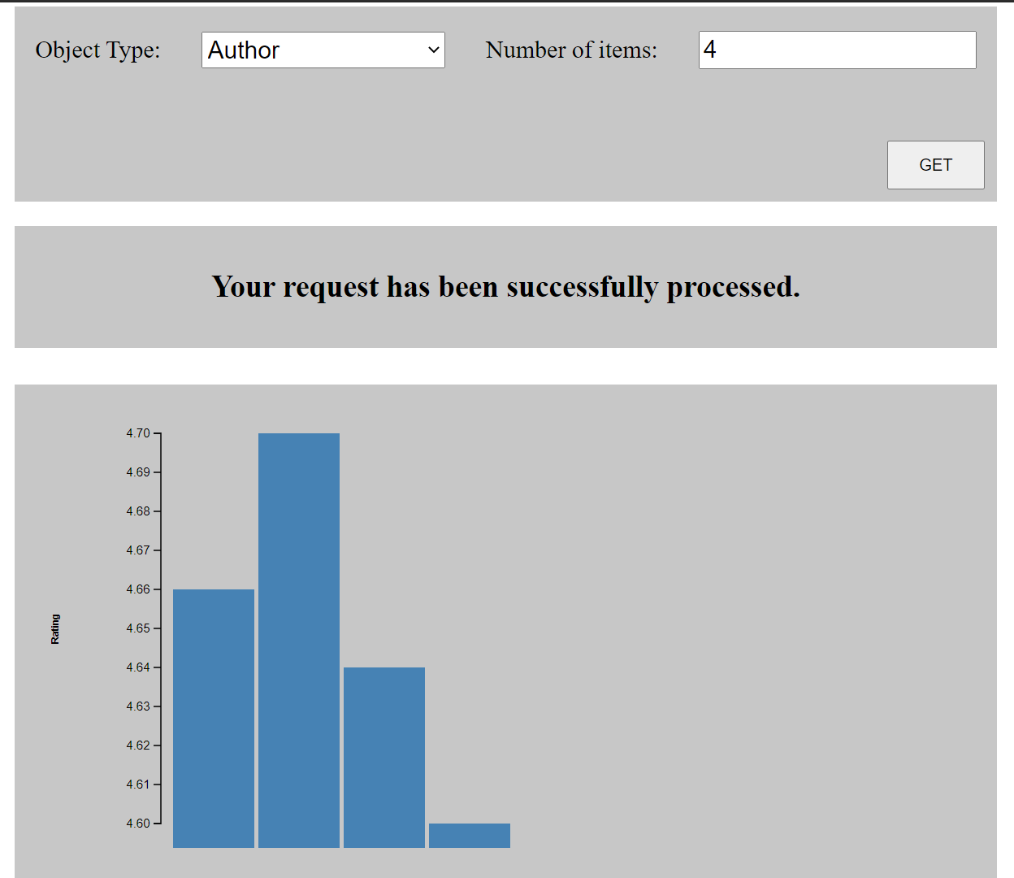

1. Test that the arrangement of bars works with small number and large numbers:

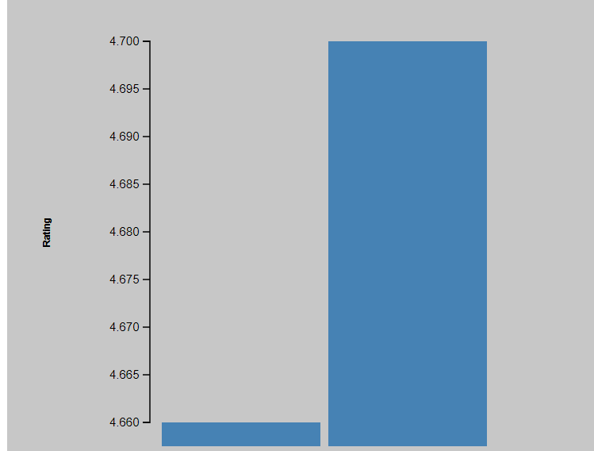 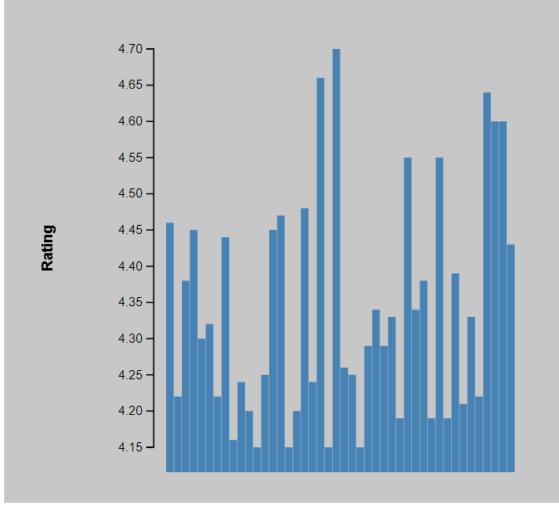

1. Test above on a mobile device:

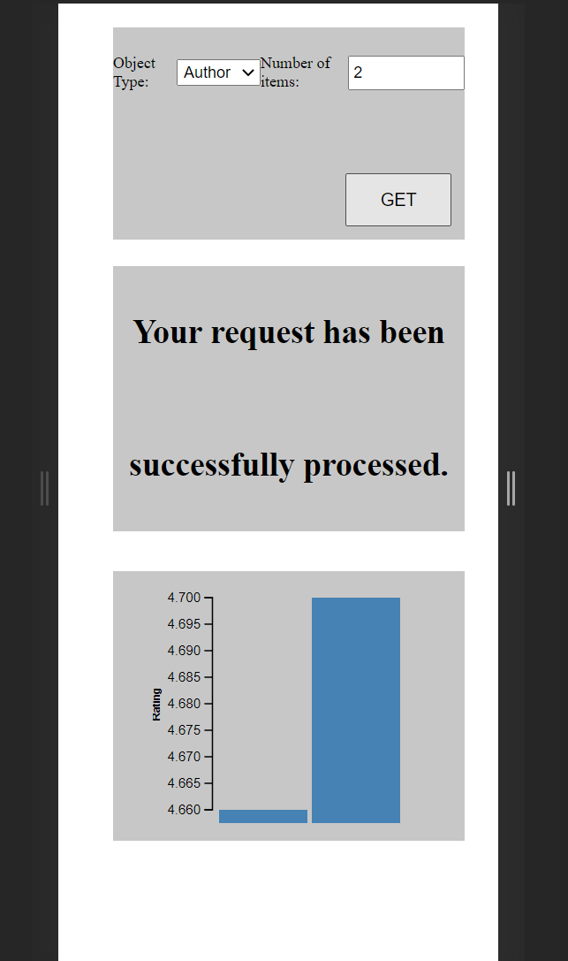 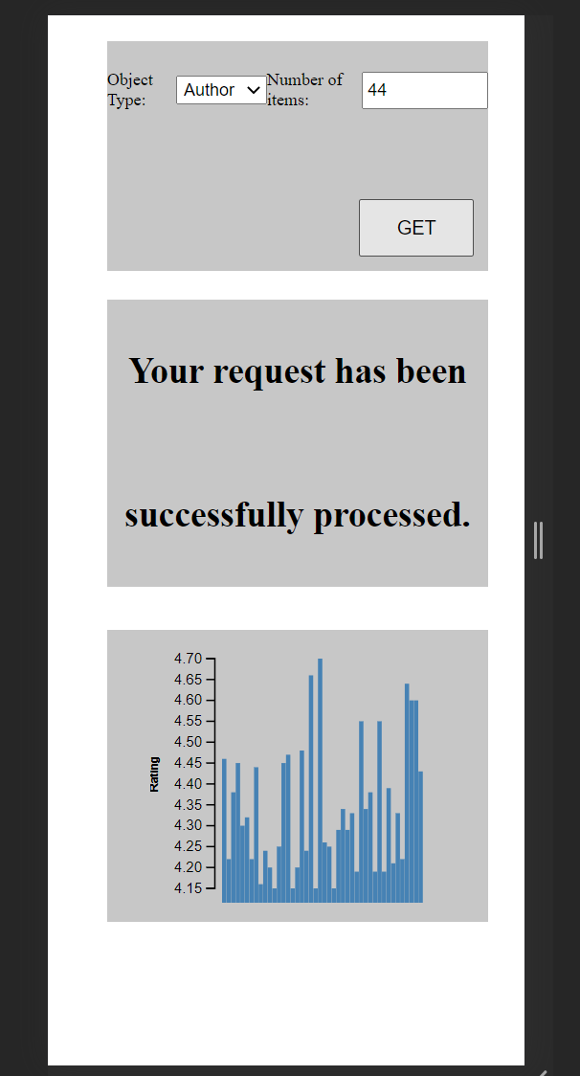

1. Test error handling and message printout

 (200)(400)

(404)

1. Test POST with id that that not point to any object:

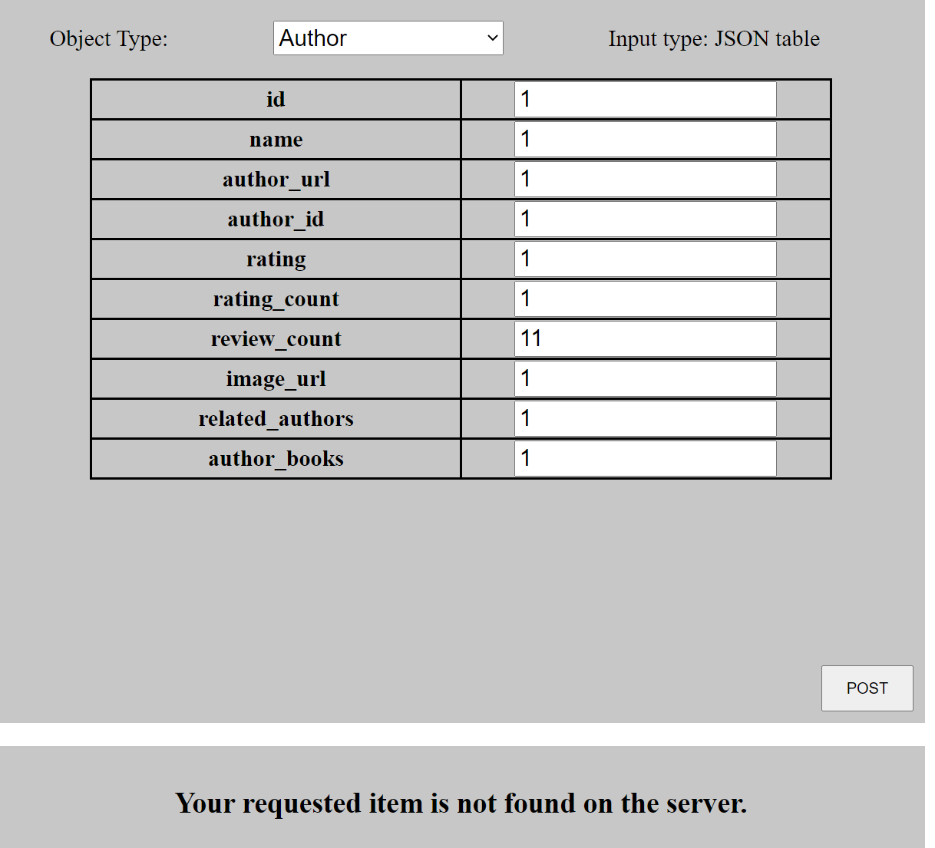

1. Test PUT with id that that not point to any object:

