1. **Programming Language**

C: using Dev C++

1. **Program Functionality**

The first process that the program executes is gather input from the user. It will prompt for the necessary input such as:

CRC mode – either C for computer or V for validate

Input filename

Afterwards, the program will then use that input to access the input file.

First it will run through the file to find the number of HEX characters that are in the file and add it to a global variable. Using that information, it will then create a master array for storing the characters, and a binary array that is four times as large for storing the binary characters (4-bits to a HEX).

A file rewind is required to reset the file for re-reading all of the characters.

After all the input has been stored, there is are if statements to redirect the proceeding steps.

Depending on the choice made by the input, the program may append 16 zeros to the binary array, for proper CRC-16 computation.

Next it will then XOR the entire binary array, there is a pair of if statements to shift the index of the array down. It will stop at exactly N-16 index, to retain the remainder of the CRC computation.

It will then take the last 16 bits from the final iteration and pass (at four bit intervals) a segment into a subroutine composed of if statements which will then proceed to compare them with the string representation of hex characters.

Output all the data.

1. **Missing Functionality**

All binary and Hex output is not restricted by the number of characters.

(ex: limit to 80 chars)

I did add a system(“PAUSE”) due to the extensive output from the program. It does not alter functionality except for an extra key press.

1. **Compiling**

Simple command line compiling.

Compile: CRCfile.c

1. **Testing Output**

Compute:

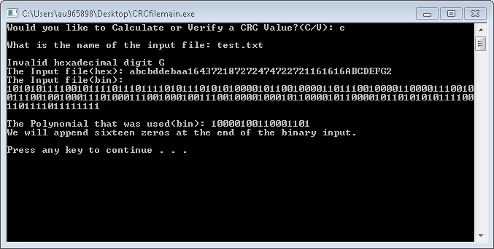

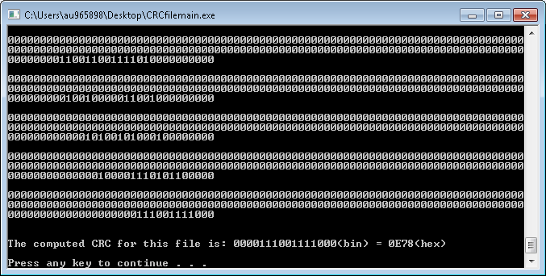

Verify: 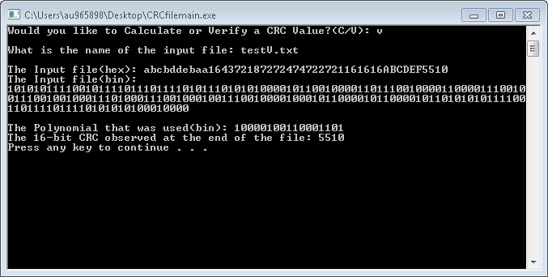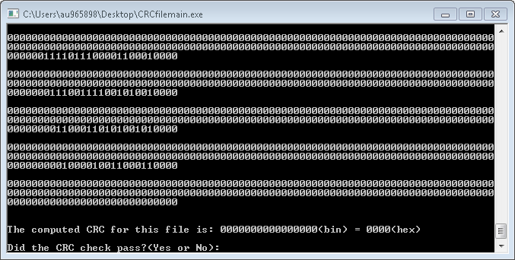

1. **Statement**

All of the contents of Austin L. Lowe. It is all the product of my/his work, and is not copied from another source. All work is original, and all orginzation, coding habits, and logical concepts, found in this code belong to him.