M&A Deal Process — Voice Notes on Typical AI Mistakes
Black text color denotes points that are important and seem easy to address.
Red text color denotes points that are important and seem difficult to address.
Blue text color denotes points that are perhaps not first-order and seem easy to address.
Magenta text color denotes points that are perhaps not first-order and seem difficult to address. We should try to address these, but not as a matter of urgency.
Dark gray text color denotes extraneous information from other projects.

I. Providence
Okay. I'm on the Providence deal now, and I'm trying to understand the most typical mistakes that the AI makes.
1. There seem to be some imprecisions regarding the date of events. In particular, when the deal background states the fourth quarter of a year that gives us a ninety day window instead of an annual window, or when the deal background states that something happens on the week of March the twenty eighth, this gives us a tight seven day window to figure out the date.
2. date_assigned is oftentimes interpolated incorrectly, from the lower bounds and upper bound on the date that can be extracted from deal backgrounds.
3. There seems to be a bunching of events such as when the bidders get contacted versus when they sign non-disclosure agreements or NDAs. Sometimes the AI is bunching these events together whereas they should be separate. They happen at different dates, and they are fundamentally different events because not every contact ends up signing an NDA.
4. And this is important. The AI seems to be duplicating the number of contacts and the number of NDA agreements. And in particular, it's misreads the memorandums that have been offered to bidders who have already signed NDAs as separate NDA agreements by those bidders, and they get double counted. Beyond that, the AI should not be separately reporting nda and nda_signed stages as separate events, nda_signed is sufficient. Once we start estimating these data, I'm worried that we will end up double counting these because at that point, nobody will dig into these individual M&A cases to figure out what's happened and why this double counting has occurred.
5. I understand that event_code=participation_count tries to count the number of bidders at different stages of the process. Such as the number of contacts, the number of NDA agreements, the number of informal (IOI) bids, and so on and so forth. The issue I have with this is that so far, it seems that sometimes participation_count double counts some of the bidders. In this deal, we can see this during the contact stage. participation_count records eleven strategics, eighteen financials, but then it double counts some of the strategics that have been later contacted by the target again. This is a problem. I think that participation_count should be recoverable from the number of contacts and the number of NDAs and the number of informal and formal bids that have previously been recorded in the database. In other words, participation_count is a constructed variable, and it is not a fact that we extract from the deal background.
6. There is probably no need to keep track of targets contacting bidders that have already signed an NDA agreement. That is, it seems important to keep track of initial contacts between targets and bidders that are unsolicited, that are early stage, that happened before NDA agreements. But once those agreements have been signed, it can be assumed that the parties will talk to each other regularly, and there will be tons of these contacts. So, there is simply no need to record all of them, because that's gonna blow up the database.
7. In this deal, and this is the only deal that I've checked so far, the AI seems to be having difficulties distinguishing between the date on which a round deadline has been set and the date on which it has expired. Those are two different dates, and we should clearly define them because these are important for understanding the deal structure.
8. What is the difference between round_index and round_count? They seem to be capturing the same thing. And in particular in this deal, when two bidders get dropped by the target, they get round_count=2. And then when the next round of bidding starts, round_index=2. should not these two columns be combined into one?
9. There seem to be some misalignments between the narrative of the deal background and the ordering of events in the database. Consider round two of bidding. Party C contacts the target and then signs an NDA and then submits an informal bid by July 12, before the remaining parties who have who have been previously accepted into round two. Yet the AI records these events in the opposite order. I think this possibly has something to do with the inability of the AI to assign a precise date or range of dates to round two bids. And the likely reason for that is that the deal background states that these bids happen in late July 2016. That's July 20 to July 31. The deadline of round two is July 20, but one of the bidders submits the bid on July 21. And then the Transaction Committee of the target meets on July 22. This very narrowly limits the timing of round two bids to July 20 to July 22. And that puts anything that party C, the latecomer, does clearly before the actions and bids of its competitors. Things like these, when we have to cross-check across multiple paragraphs for dates and for events, and maybe even for deal terms and contingencies, I think, are difficult for the AI and perhaps they should be flagged for human review.
One addition to this is that it seems that the target has allowed G&W to submit a revised bid on July 26, and then they had another meeting of the Transaction Committee on July 27. So I would say that this revised bid is still a part of round two of bidding, and July 27 is a fair assessment of the deadline.
10. And this one is a bit difficult because I think it requires a certain amount of expertise. I suggest that we record bids that come with the markups to the merger agreement and/or voting agreements as formal offers. However, if such bids come with conditions such as extensive due diligence, exclusivity, or financing requirements, or really anything else that can materially affect the value of the deal or completion certainty, then we have an additional column that collects information on these conditions. I don't want detailed conditions, because I have a different project on that already with Brett and Shreye. What I want is some kind of a flag that says, this deal has heavy conditionality or light conditionality or non conditionality at all. And as a result, even though the offer seems formal because it comes in with all the markups... if or when we want during the estimation stage, we can look at conditionality, and THEN make a decision whether to treat this bid as formal or informal. On the other hand, if a bid comes in without conditionality or with light conditionality, and with all the markups, we can THEN make a decision that this is indeed a formal deal. Another way to reinterpret would be to say that we're still at stage 2 of the process, and it's about informal bids, so all bids, however certain in their conditionality, are to be treated as informal.
This is one of the biggest complications of interpreting these deal backgrounds if you are a deal outsider, since formality of some of these bids is open to interpretation. And hence, we should give ourselves some freedom and flexibility to reinterpret such bids during the estimation process, so that our estimates are robust to different interpretations. I hope this makes sense.
11. This one is tricky and what you would call low-confidence, but useful to think about. And it will also require cross-checking across different paragraphs of deal backgrounds. In this deal, two bidders admitted into round two don't submit bids. Sometimes it is possible to figure out who they are, or who they are not.
In particular, early in the deal background, it is stated that party A, a strategic bidder, signs an NDA. And then it is claimed that at the end of round two, one of the strategic bidders did not submit an IOI. I think a reasonable conclusion here is that since the deal background thought it prudent to mention bidder A initially, it would then continue mentioning this bidder during the bidding stage, and it would then mention that it this bidder dropped out at some point. The fact that the background does not mention this implies, to me, that bidder A has never made it out of round one of bidding. And so indeed the strategic bidder that drops out in round two is unnamed, it's not bidder A.
Why can this be important? because bidder A was the first party that has approached the target, and that eventually led to the initiation of the sale process. If you think about selection, the bidder who approaches can ostensibly be different than other bidders across a number of characteristics. This is why it approaches the target in the first place. And so the fact that this bidder ended up dropping out in round one, when it was likely to be at the top range of valuations initially before it did its round one due diligence... This may be informative for us during estimation.
So this kind of inference requires a bit of cross checking and, I guess, a bit of human judgment.
12. Sometimes a deal background will not mention the start of the next bidding round. However, they should be easy to infer, if the deal background states that the previous round of bidding has finished, and then you see bidders continuing to submit their offers after the target has allowed them to continue bidding and contacted them for an offer update.
Another complication is, how do we learn if a bidding round is final or not? Or viewed as final in the moment? Sometimes, the background does not tell this information even if it declares the start of the new bidding round. And if it does not declare this, it is less likely that there is information about the target accepting final bids only. It is entirely possible that at this point, bids are still called something like letters of intent or LOIs. But they come really late in the process. And so we expect these to have a high degree of formality.
And I think if we are lucky then we will see the target saying, this is the final round of bidding, or that everybody must submit formal committing bids. If we are less lucky, the target can say that it is interested in completing the negotiation of the merger agreement with one of the bidders left in the process, or it can say that it intends to enter into a merger agreement soon. For Providence, this happened after round two (which was announced) and during round three (which was not announced). From here, it should be clear that only formal bids (or formal bids with conditions, which we can later reinterpret as informal if we want) are allowed or are seriously considered by the target at this stage.
This, again, will require us scanning all paragraphs pertaining to a round of bidding for these words to assess finality of the round.
13. This is a small one. But in this particular deal, an investment bank that the target has retained as their financial adviser has two different names. And that's because the original bank that they've contacted has been acquired by a different bank later on. So to my mind, this is a single adviser. And on the off chance that we are gonna see a lot of this IB merger and renaming activity going on, we need to be careful about it.
14. Sometimes you see a bidder submitting an offer that is either informal or what I call in this document "formal with conditions". And later on, usually really close to the end of the process, the bidder reconfirms the same offer. In such cases, the background will say that the bidder has provided a revised markup to the merger agreement or something similar. And, importantly, this revision will have no conditions or very light conditions. And so what used to be informal or a "formal conditional" offer becomes properly formal. And I think this fact needs to be captured, this is bid revision. In the case of Providence, an additional row on August 4 stating that party B has submitted a formal unconditional offer for $24.00/share should be included.
So there is a bit more of this tricky judgment that the AI will have to do. If you know these deal backgrounds and you're an M&A expert, figuring out when an informal bid is revised and becomes formal is obvious, but hopefully the AI can learn to do this.
15. It would be useful to record at the end of the process two separate dates. First, the date when a merger agreement is executed. For Providence, that is August 12. And second, the date when a merger agreement is announced to the public. For Providence, that is August 15. From the perspective of the sale process, it is over by August 12, but the broad public does not know that for three more days.
This is potentially important if we ever end up looking at the market reaction to announcements of M&A. And if we want to tie those to features of the sale process. Of course, information about successful deals trickles into the markets before broad market announcements. But the largest market reaction is still on the announcement date.
So to conclude. To sum up this one deal so far, there are two broad points. The first one, when I read this deal background just now and compared it against the AI-collected database, I did not look at my earlier hand-collected database. Despite this, I came up with basically the same reading of major facts in this deal as before. Some facts and some dates in the hand-collected were incorrect or imprecise, and this is where the AI can do a good job -- although it clearly has its own date collection/interpolation issues. And, of course, the format of the two databases is very different, so it is not straightforward to compare them by hand. But, again, I ended up reading and commenting on major facts in the exact same way as in the hand-collected database. This probably has something to do with the fact that I've read a thousand or so of these backgrounds back in the day. So I know how lawyers who write these think and when they omit things, and what it is that they omit. So, what this tells me is that if there is a way for the AI to learn well from the hand-collected database or from comments in this document + comments I left in the AI-collected spreadsheet, then I would strongly prefer that. The AI is, of course, good at supplementing major facts with supplementary facts that haven't been hand-collected. But major facts in the earlier database, I find them to be quite solid.
The second point, I think a lot of these AI mistakes could easily be caught on careful reading of the deal background, and the reader does not have to be an expert to catch most of these mistakes. I'm gonna continue reading these deal backgrounds, checking them against the AI-collected database and trying to come up with other typical data collection issues. But I do not believe that the pipeline is close to shipping just yet. I also want you, Austin, to manually read these deal backgrounds against the AI collection, because I want you to learn how these documents are structured, how the lawyers think, and how the AI misreads them. This is because in the end of the day, you are the one fine-tuning the AI against the reality. We need to keep adjusting the pipeline until we achieve reasonable consistency in terms of the sequence of events, in terms of double counting, in terms of certain events missing, etc. -- everything that has been mentioned in this Word document so far.

II. Mac Gray
I like this deal because it once again has multiple rounds of bidding, informal and formal, and multiple bidders. And so this could be a good litmus test for the AI-collected database.
1. In this deal, it appears that initially, the target and its investment bank have approached one potential bidder. So this situation is different from other deals in which a bidder expresses an interest in a passive target. This should be reflected in the database as target interest first and foremost rather than bidder interest, I do not think this is properly reflected at the moment. Of course, in the end, the bidder might be interested in a target, which apparently it was the case here, but ultimately the target has made the first move. It's good to keep a sequence of these events.
What's interesting is that for Mac Gray, the target never ended up initiating the sale process on its own, despite approaching that bidder (party A). On June 21, while still thinking about various strategic alternatives for more than a month, the target have been approached with an informal bid by that same party A. This makes the initiation process quite complicated. The target was active initially and approached party A, alerting them to deal possibility. Then it was passive. And eventually, party A came back. Is this a target- or bidder-initiated deal? I don't know, a bit of both. So it is important to keep track of all these interactions so that we can reinterpret the data various ways during estimation.
2. This comment is very similar to comment 3. for Providence. Some of the events seem to be absent from the database. For example, on June 24, 35 financials and 15 strategics has have been contacted by the target. And eventually, these numbers appear in participation_count, but the event itself is not recorded.
For the NDAs, party B and party C are recorded separately from NDAs of other bidders. For those other bidders, 20 NDAs are recorded, 2 strategics and 18 financials. But we have to be careful because for two named bidders, their NDAs have been recorded separately. This only leaves 2 strategics and 16 financials that are unnamed and signed NDAs. So the math has to check out.
Another thing that again goes back to the Providence deal is that there is no clear indication that one of the bidding rounds starts, in this case round one. However, from the context, it is clear that round one started on June 24 when the Transaction Committee met and decided to start the selling process. And the deadline on round one is July 23.
And, as before, there is some duplication of advisers being retained, for more specific details, please refer to the spreadsheet.
3. In the background, there seems to be a pretty clear indication that round two of informal bidding starts on July 25. It even says that the investment bank discussed with the Special Committee a proposed process for the second stage of the ongoing sale process. Moreover, four bidders from stage one were invited to submit additional bids. Initially, round two did not have a deadline, but on August 27, this deadline was announced as September 9. This information should also be in the database.
4. This one is difficult to parse because it is spread over far away paragraphs. On page 32, it says that over the next two months, a total of 20 potential bidders, including 2 strategic bidders, including party A, entered into confidentiality agreements with the targets. As we later learn, party A did not sign an NDA for a good while. This brings us to page 34 where on August 5, party A finally enters into an NDA agreement. The AI, however, records the NDA with party A earlier, when it records 2 unnamed strategics with an NDA. One of them is double-counted earlier, because it is the eventual winner CSC/Pamplona who signs on NDA on July 11. Now, we know that the second one is double-counted, because it is party A on August 5. The appropriate way to record this: CSC/Pamplona's NDA = July 11; party A's NDA = August 5; NO other strategics sign an NDA.
5. I have been thinking about the way in which the AI can best capture bid conditionalities. It goes back to the Providence deal as well. For Mac Gray, we have CSC/Pamplona submitting an indication of interest, and they claim that financing is 100% guaranteed. The AI records this conditionality -- in fact, the lack of it -- as a separate row.
Two comments here. First, ideally we want to have conditions in the same row as the bid itself, this will make it easier to figure out whether the bid is conditional or not. But I understand if this is difficult to ask of the AI, so that conditions will have to just follow the bid in a separate row. Second, I would rather record the lack of financing guarantees than their presence. Their presence keeps the informal bid informal and the formal bid formal. But their lack may prompt us to drop the formal bid to informal during estimation. So, in Mac Gray, party B also submits an indication of interest on a same date as CSC/Pamplona, but does not have firm financing commitments. Party B therefore gets an additional row saying that they don't have financing. Or, instead, an additional column in the same row as the bid.
6. At the very end of the process, party A makes an indication of interest between $18 and $19/share. And it says that this is their best and final offer, and this is the final stage of bidding. This bid is currently recorded as formal. And I think I want to keep it this way. What a range of bids implies, though, is that party A is likely still uncertain about something. Maybe about financing. Maybe they have some remaining due diligence to do. But it is not stated in the background. So, while we can keep this bid as formal, if we see a range of bids on a formal bid during the estimation process, we can always reinterpret a bid like that as informal if needed.
7. This again comes back to conditionalities. In late bidding rounds, we oftentimes see bids conditional on exclusivity. I think we should record this conditionality in the same way we record, or will record from now on, financing or due diligence conditionalities. I think when a bidder has this exclusivity requirement, it should not downgrade its formal bid to an informal bid, neither in a database nor in our estimation later.
8. Some of the high-confidence facts recorded by the AI are not facts at all. For example, there is a claim with assigned_date of September 18, that at least two mixed parties dropped out of the auction. And it refers to a paragraph in the background that does not have this information at all. Later on, on September 24, it becomes clear that out of the three remaining bidders, one was granted exclusivity, and the other two are dropped out by the target. So, the actual date of the dropout event is September 24, and there is certainty that there are exactly two dropped bidders. And we know who they are, party B and party C. And it's the target that drops them. And on top of that, this event occurs later in the timeline, and not on September 18. So my worry is that once in a while, we see these stray facts that are supposedly high-confidence. But they are either entirely invented or poorly interpolated by the AI. We should try to train the AI not to invent things. But also, this implies a lot more human verification work.
9. This is a quick one and reiterates on the comment in the Providence deal. Goodwin Procter, a legal adviser, is recorded to have been retained at the end of the process by the target. Of course, this legal adviser has been present at least since the beginning of the sale process, and this is stated in the deal background. But it is likely that this legal adviser has been advising the target for a lot longer. So it would be good to at the very least record the first instance, May 9, in which this legal adviser is mentioned in the deal background. We want to keep a clear ordering of events.
So to to sum up this deal, again we need to be more careful about collecting facts: the number of NDA agreements; conditionality of offers that will allow us to reinterpret formal bids as informal if needed; some stray facts that the AI either generates or interpolates incorrectly. Once again, while verifying the AI-collected data, I have not looked at the previously hand-collected data that I had. Now I came back to this hand-collected data, and I continue to agree with the major facts documented there. If the AI can be trained to recognize these major facts in the way it was done in a hand-collected database, this would substantially improve the AI-collected data quality.

III. Petsmart
If I recall correctly, this deal is a lot less structured than the deals before. In particular, it does not have well-defined rounds, or not all rounds are well-defined. So it would be interesting to see how the AI can tackle a deal like that.
1. Again, this is a recurring comment. If a deal background tells us that something happens say in the first week of October, that limits the date inference to seven days. if there is also a meeting, let's say, that happens on October 3, and from the context, it is clear that the target will start contacting bidders after that meeting, that further limits the date inference to October 3 - October 7. And, by the way, such a meeting would also indicate that a new round or, in this case, round one of bidding starts on October 3.
2. We have also seen this before. Sometimes rows that include participation_count or rows that keep track of the number of contacts or NDAs with a timestamp, these rows cannot pinpoint the number of bidders precisely. In this example, there are statements like at least 27 bidders have been contacted. The deal background, however, clearly states that 27 is the precise number.
3. This one is may be tricky for the AI to catch and is not a very common situation. The background says that in round one, 6 bidders have submitted IOIs, 3 bidders among them initially indicated price ranges that reached at least $80/share. Buyer Group bid $81-83. Another bidder bid $80-85. Bidder 2 initially bid $78 and LATER increased that to $81-84. Now go back to the initial sentence. Buyer Group and another bidder are only 2 out of 3 bidders who bid at least $80. Bidder 2 is initially below $80. This means that there is one bidder that has still been unaccounted for that has initially bid at least $80. Later on, the background confirms this, saying that they will allow the four bidders who had indicated a price or range at or above $80/share to proceed.
This logic is probably too complicated for the AI to capture, and situations like this are likely uncommon. But a note needs to be be made nonetheless.
4. This is a small quibble, but on November 2, a single bidder submits two bids. The initial one and the revised one. In the database, the AI marks these bids appropriately. But event_order for these bids is reversed, and it makes it hard for a human verifier to read the data and figure out why the order is reversed. I think it would make sense to arrange bids by the same bidder on the same day in the order in which they appear.
5. 15 NDAs have been signed. Six IOIs have been made. 4 of them have been accepted into the final round. What is the reason for the remainder of bidders dropping out? The background says that remaining 2 bidders who have submitted IOIs have been approached by the target's investment bank, and then they have been eliminated. This sounds to me like the target's decision to drop them. For the remaining 9 bidders with NDAs but without IOIs, they haven't been approached by the IB. They haven't stated the reason for dropping out, so that should be recorded as unknown.
6. In this deal, the final round, round two, ended up being extended by two days. The original deadline was December 10, the new deadline became December 12. This doesn't look like a new round of bidding, just a continuation of round two. But it is a meaningful extension, because some bid revisions arrive.
If we want to be really careful about this, we can record deadline revisions. E.g., when round two was announced, the deadline was set at December 10. On December 10, this deadline has changed to December 12, and this is a separate row in the data. Why is this important? Because this can be an indication that the target is unhappy with bids and it has limited committing power or chooses not to commit to the original conditions of the deal process. Of course, in some other deals that we will see, targets will follow the announced deal structure much more closely, either because they find no reason to break commitments or they are in a rush to sell, or something else.
And if we don't want to be really careful about this, we can simply record the final amended deal deadline, which in this case is December 12. But I think it costs us very little to collect these deadline revisions.
7. The AI-collected data reports a consortium formation between Longview, a large shareholder of the target, and the Buyer Group, which became the eventual winner. This is because they have agreed to roll over the equity stake of Longview and signed a confidentiality agreement between each other. This is not a consortium formation. What a rollover of the equity stake achieves is that the bidder can pay the same price per share, but they have to buy fewer target shares because Longview retains its equity stake in the combined company instead of being bought out. So Longview doesn't provide the bidder with financing. It doesn't provide it with additional synergies. At best, it relaxes the bidder's financial constraint to complete a cash acquisition. This is not a consortium formation to me.
Okay. So given the previous two deals and given the fact that this deal was less structured, I am surprised at how much better the AI has managed to collect these data. I think one of the reasons is that when a deal is more structured, the AI is often having difficulties figuring out the beginning and the end of various bidding rounds. In a less structured deal, this is less of a concern. Another thing to note is that at this point, many of the problems that the AI has collecting the data are starting to repeat, and there are fewer genuinely new problems that I encounter. Overall, the AI reading of this deal as well as my new reading of it appears to be very consistent with the earlier hand-collected database.

IV. Penford
This is another less structured deal. In fact, it appears to be even less structured than PetSmart. And this is one of the deals that in Austin's document has been marked as having more formal bids than previously thought.
1. On July 17, Ingredion who became the eventual acquirer has approached the target. And it said that it's interested in acquiring the target. At that point, there was no bid, but for whatever reason, the bidder has cited the target's stock price over some historical period. The AI, probably by mistake, interpreted this as an informal indication of interest. There is no bid here. This is indeed bidder interest which came without a bid. At some point, if you recall, we have discussed recording these differences: a bidder approach with and without a bid.
2. For some reason, the AI could not identify the type of Ingredion who eventually became the winning bidder. This is a strategic company. If the deal background does not state this then somewhere in the same SEC statement, there should be a background/description of the eventual acquirer from which it should be clear whether this is a private equity or a strategic buyer. It is always possible to identify the winner's type.
3. Something to think about. Although I'm sure at the estimation stage, we can filter these rows out. What to record if a potential bidder is contacted by a target, but then the bidder says it's not interested in any potential sale process? I think we should record the contact, and that's that. Right now, there is an additional row in the database that says that the bidder did not advance to the next stage. But at this point, there are no stages because the sale process has not been determined. This is true for SEACOR, party B, party E. On a related note, party G was never even contacted, so it should not receive its own dropout row in the database.
4. I think it is fair to say that, unless the starting date is explicitly stated in the background, round one of bidding starts at the point in time when a target starts the sale process. So this makes some initial bids by Ingredion ($18.25-18.5, then $18.5, then $19) belong to round one. And, of course, from the deal background, we know that those bids are informal.
5. This one is tricky for the AI I would guess, but important. There is a discussion of the board of directors on October 3 where they say, we are looking at the offer by Ingredion of $19/share. We don't think party A can submit a good indication of interest. We don't want to contact party G. And then the background says that after further discussion with input from Deutsche Bank, the directors present at the board meeting unanimously directed management to proceed to negotiate and finalize a definitive agreement within Ingredion. So this to me sounds like a convoluted way of saying that they are moving to round two. Only final bids will be accepted from now on. And, hey, they only have one bidder. So that bidder gets in round two, but they are also not explicitly excluding other bidders who have previously signed NDAs. So to my mind, round two, the final round, starts on October 3.
6. I see that in this case, there is information, in early October, about legal advisers to the eventual winner Ingredion and to a large target shareholder, SEACOR. The AI records these legal advisers, but it doesn't record whom they are legal advisers to. It would be useful to record this information.
7. By the end of the sale process, there was never an explicit mention of a formal offer made by Ingredion, the eventual acquirer. We know that a deal cannot finish without a formal offer. So what can indicate a formal offer? There is a paragraph that says that on October 14, Ingredion has been contacted to confirm the proposed price of $19/share and to finalize the draft merger agreement, etc. All earlier bids by Ingredion have been informal. So this paragraph sounds to me like a final confirmation of a formal offer from them. The AI did not record $19/share on October 14 as a formal offer, but I think it should.
8. This is an example of a deal in which the final round, round two, did not have an explicit deadline, and this differentiates it from some other deals that we've seen before. From this perspective, for deals that do have deadlines, these deadlines need to be carefully recorded. For deals that don't have deadlines, we can just leave them without deadlines, or possibly add a row saying that no explicit deadline has been stated.
A relevant point is that, of course, at the end of the final round, all the remaining bidders who are not winners are getting dropped out. Most of the time because they are unable to make a better bid, but in many cases bidders will not explicitly announce this. And in some clearly stated cases, a target can decide to continue exclusive negotiations with the highest bidder, and so in these cases, the target drops the remaining bidders.
To sum up this deal, I think a lot of the AI mistakes that have happened here, we have already seen them before. There is an odd situation where the winning bidder’s type is not recognized, but most of the critical mistakes that have been made are about the start and the end of different rounds of bidding. And admittedly, in this deal, figuring this out was possibly more complicated than in previous deals. Okay. Another small complication that the AI had is to figure out when Ingredion the eventual winner has made a formal bid. But, overall, the quality of data collection for this deal has been quite decent.

V. Kraton
This is the case that I have not read before. So, I am curious how the deal was structured and whether the AI pinned down its important milestones.
1. As always in these deal backgrounds, participation_count says “at least” a certain number of bidders have been contacted or have signed NDA agreements. But, again, in this deal background, there is clarity that 10 have signed NDA agreements among them 4 financials and 6 strategics. There is also a repeat issue with the number of contacted bidders, 14 has been captured by the AI, but one additional bidder contacted the target company later. And so the total number of contacts is therefore 15. 3 of them are strategic, and the rest are unknown. In fact, if we go a little bit deeper into the background and look at page 35, they say that party H is a financial acquirer and party I is a financial acquirer as well. So among those 15 contacted, at least 2 are financials.
2. Another repeat issue is that the winning bidder’s type is undetermined by the AI. They call the winner Parent in the deal background and they don't disclose who that parent is in the background. Normally this information will be present earlier in the SEC filing. In particular in this filing it is present in the “parties involved in the merger” chapter. And there they say that the parent is a chemical company and therefore a strategic bidder. I think it is critical to figure out the exact types of the winner in each deal, but also ideally the exact types of as many formal bidders as we can. And the AI should very clearly flag all formal bids and all winning bidders who have not received the type.
3. This may sound confusing and complicated, but I don't think it is given how we define rounds. On July 6, the board declared that out of 10 NDA agreements, only 4 bidders, 2 strategics and 2 financials, will continue submitting indications of interest. And verbatim, the board would require updated indications of interest to be received by July 19 that ascribed a greater value to Kraton before making any determination regarding which potential acquirers, if any, should be invited into the second round of the process. Note that JP Morgan, the financial adviser, thinks about the second round as the formal round of bidding. But according to our definition, the second round starts at the point in time when 6 NDA agreements have been dropped out, and 4 of them have been allowed into the second round of the informal process. Hence, the second round starts on July 6, and the formal round of bidding, which I assume comes later in the deal background, is gonna be round three.
4. I'm looking at line 460 where party H, the financial bidder, decided to drop out of the auction. The background says that it was unable to maintain its indicative bid price range and was unable to continue in the process. The AI collects this event as dropout_reason being price_insufficient. I think we need to be a bit more precise about reasons why bidders drop out of the auction. Sometimes they just drop out. Sometimes they drop out by claiming that their valuation is below the market value of the target, and this should be recorded. Sometimes they drop out because their valuation is at their indication of interest. We should record that. And sometimes, like in this case, they drop out because their valuation is below their indication of interest. And, again, this should be recorded. So, there are different possible ranges of final valuations that we can figure out from what a bidder tells us.
5. We've seen this before, but when a bidder, in this case, party A, submits a bid with an earnout, this is not a mixed offer. This still seems to me like a cash offer with an extra contingent payment that will be made in cash upon clearing certain thresholds. these conditions should either be a separate column or a separate row in the database.
6. A small one, and we have seen this before. For the merger agreement date and for the announcement of the merger agreement, there should be two different rows in the database.
To sum up, at this point, a lot of AI mistakes really repeat. There are imprecisions about the number of contacts and NDA agreements and also the types of these bidders. It will require some manual work to understand when new rounds of bidding start and when they end. And the fact that some bidders, and in particular the winner, does not receive a type in the AI reading of deal backgrounds is concerning. We want to be a bit more precise about why bidders drop out of the auction whenever it's not the target who drops them. And, of course, conditionality of bids that will allow us to filter out when a formal bid is in fact formal or possibly informal would be good to have as well. I'm starting to see fewer and fewer new types of bugs.

VI. Meredith
This is yet another deal that I have not read before, with an almost 20-page deal background. Let's see how much complexity there is here.
[Shreye] For Meredith – the ratio bid/ market price is 0.5. I rechecked on SDC as well the prices and bids are correct – but they spun out one division and sold that (Remainco) so here it is going to be low.
[Alex] For Meredith, when did they spin out the division (how many days before the deal announcement)? And what was their stock price one day before and one day after the spinoff?
Ultimately, we want to find the market price of Remainco and see if we can make a reasonable argument that this price is unaffected by ongoing acqusition talks. Alternatively, we want to find the fraction of the price that Remainco was responsible for (let's say, 60% based on the change in the price one day before and one day after the spinoff) and then apply this fraction to the price of the total target 4 weeks before the deal announcement. This alternative is worse, as it values the target as sum of the parts ignoring synergies (positive or negative). If we are uncomfortable with either of these arguments, we might have to drop that deal (we can keep it in the database and use it for descriptive stats, but I will remove it for estimation purposes in the code).
[Shreye] In the case of Meredith, the spin-off was announced contemporaneously with the first deal announcement (deal with Gray first announced May 3, 2021), and was completed post announcement, with the completion of the deal. Gray acquired Local Media Group business, (comprising broadcast stations) of Meredith, the magazines business of Meredith was spun off and acquired by Dotdash. Spin off was completed on 1 Dec 2021, same date as deal completion.
So the businesses spun off were acquired for 42.18 by Dotdash, while the remaining interests (remainco) were acquired by Gray for 16.99,..could we say that remainco was responsible for ~30% of price?
(Fairness opinion in the proxy statement provides a DCF reference range of $8.8 -19.3.for remainco…but that would not be a good reference).
[Alex] Meredith cannot be a part of the estimation, as we simply do not observe the market price for its acquired segment, and it seems difficult to approximate it. (We should probably still keep this deal in the .mat file, because it can be useful for reduced form stuff such as descriptive statistics.)
1. A quick one. On May 20, the board discussed the sale of the target’s business segment. They did not discuss the sale of the entire company, and yet the AI has recorded this as the start of the sale process. This is factually incorrect.
2. All or almost all bids for Meredith are partial. What's worse is that some bids are for a small number of studios (assets) and each bid specifies different studios. And some bids are for one segment of the company. And the company is planning to do a spin-off of their remaining segments. So I think a deal like that, that does not have bids for the entire company, should be flagged by the AI. Ultimately, we are interested in acquisitions of entire companies. It could be the case that the target completes the spin-off much earlier than the rest of their assets get acquired, in which case we will keep this deal in our database. But if the spin-off happens at the same time as the acquisition of the remaining company's assets, there is nothing we can do. We don't really observe the market price of individual segments of a company to know whether the acquisition price for remaining assets is substantially higher or lower than that. This reminds me that I have seen this deal before in a different project and we have decided not to proceed with it for the exact same reason that I've just outlined. I'm adding at the beginning of this subsection my conversations with my co-authors on that project.
3. Just something interesting that caught my attention. This deal background states that Deloitte is the target’s tax adviser. Typically, tax advisers are not stated in deal backgrounds. But as you can imagine, they can impact the deal structure because if they tell the target that we need to sell ourselves in a stock transaction, this will lead to better tax outcomes for the target shareholders. And as a result, to a higher transaction price. So it is possible that the target's management is gonna push for a stock deal.
4. This deal also has a weird bid in which a financial bidder, party D, offers 2.5 billion of cash, but this offer is not for the target's equity. It is for the target's levered assets. So they promise to repay leverage. They promise to pay cash dividends to the existing target shareholders, and they also only want an approximately 50% percent stake in the target. And so this bid is not directly comparable to other bids for the same asset or for the same equity. So we need to know some accounting data for the target in order to figure out how much equity is worth in this offer.
Later in the deal, the background says that the remaining segments of the target will be allocated 1.975 billion of the company's net debt. And so this allows us to subtract the value of the net debt from the enterprise value of each of the offers in order to get their equity values. And then if we divide that by the number of shares outstanding of the company, we get the price per share. The only remaining point is to figure out what is the market value of those shares is once the target has only this segment remaining. This is, of course, problematic because the company will not spend assets off before the completion of the deal.
5. This is not really for this project. But this is something that's relevant to the project on deal terms in that bidders include in their bids that I'm working on. Because I think this deal background is very detailed about deal terms that the other side, the target, inserts into the merger agreement. On page 64, it says that among other terms, the proposed merger agreement included 13 different provisions that the target wanted to implement. And this is a complicated deal because it involves a spin-off and a sale. But there are some other terms that let's just say are quite uncommon. So analyzing something like this could be very interesting in the future. Additional discussions of terms between the target and eventual acquirer of its main division continue in page 65.
6. Party D, a financial bidder, on April 29, submits a dual proposal. One proposal is 2.66 billion, but target shareholders retain 50.2 percent of the company. Another proposal is 2.76 billion, but target shareholders only retain 34 percent of the company. Right now, the AI records this as a range of bids. I think these are separate bids. And given that the target has previously expressed an interest in a cash out, we should record the 2.76 billion, which gives target shareholders a better out. Dual bids in general are a very interesting question in theoretical auctions. There is a good paper by a Kellogg author that studies this question. Although I don't think he's studying it very well.
7. On May 3, the target executed the merger and announced it to the public. The AI should have collected merger agreement signed and the announcement. Instead, it reported that the process has first been terminated and in the next row that a sale process has been publicly announced. It is, of course, not the sale process that has been announced, but it's completion in the form of the merger agreement being executed. This is not the first time I haven't encountered this. So this needs to be fixed in the next version of the AI.
8. At the end of the bidding process, Gray, the eventual winner, started submitting multiple bids. This is already a public stage of bidding after the initial merger agreement has been signed. since party D is trying to steal the deal from Gray. So Gray submits 16.99/share, then 16.55, but they also change some other provisions in the merger agreement, and the target does not like that. And so the bid reverts back to 16.99. The AI does not record this bouncing back and forth. It only records the last NEW bid of 16.55, but it does not record that it has reverted to 16.99. We need to figure out how to be careful about this. One option is to compare the last bid against the next section’s information in the SEC filing, which is normally called the opinion of a target company's financial adviser.
Alright. A very long deal background, which at the end of the day proved to be useless because we will not be able to figure out what the premium over the market price was that the eventual winner Gray has paid. But I think this deal really teaches a lot of valuable lessons. First, you can have a background in which some bids are in dollar terms and some bids are in prices per share. Moreover, these bids can be in terms of enterprise values rather than in terms of equity values. And so we will then need to figure out how much net debt the target company has. Third, this deal has a public round of bidding. where all the bids have to be announced publicly. Fourth, all of those bids are for parts of the company, and we need to be careful keeping track of that. And that's only the major points. There are many small points that I find fascinating here.

VII. Synacor
I haven't read this deal. But, apparently, the intriguing part is that the target attempted to sell itself in multiple different processes. Some earlier processes failed, and only the final one succeeded. I want to see how the AI understands whether there, indeed, have been multiple processes instead of multiple rounds of the same process.
1. I disagree with the way the AI has recorded multiple processes in this background. Consider event 210. This is when company C and the target decided to stop merger negotiations. And this happened in October 2019. There is a 9 month gap between this event and the event of company E approaching the targets in July 2020. This large gap indicates that these are indeed different processes. But the AI does not record this.
Now consider what happens between October 23, 2020 and October 27, 2020. The AI records that a new process has started and the reason for this is that company E has exited its 30 day exclusivity period with the target and it didn't make much progress in negotiating the merger agreement. So at this point, the target decides to start approaching other bidders again. There is only a 4 day gap between the end of the exclusivity agreement for company E and the target approaching the bidders it has approached in the past. On top of that, company E is still in the game. This to me is not the start of the new process. This is instead a standard situation in which many contacts in the same process are renewed upon the expiration of exclusivity for one contact.
I think it is important to understand why the AI has made this judgment. And perhaps it will be useful to flag all deals in which the AI thinks there are multiple sequential processes. for human review.
2. A small one. We need to be careful separating a public announcement of the ongoing sale process and the public announcement of the merger agreement, which denotes a conclusion of the sale process.
3. This is yet another instance where the winning bidder does not get a type. I think this is easy to figure out either from the context, like in this case when the background says that one of the funds of the private equity firm is gonna be providing financing, or it can be figured out from the rest of the SEC filing where it describes the actors.
4. I am not sure if the AI understands what a go-shop is. This is when the target's management and board of directors approach additional bidders after a merger agreement has been signed, to convince its shareholders that it is maximizing their value. This has clearly not happened here.
Overall, a pretty well-recorded deal other than the rather big hiccup that there are multiple sequential processes. The rest of the AI mistakes we've seen multiple times already.

VIII. STEC
This is one of the deals that I have read before. The interesting part here is that very close to the end of the sale process, the winning bidder lowered the offer by a good amount, and it had something to do with the economics of the target’s business. I am curious about how the AI will capture that.
On a somewhat related note. Because we are being very careful about the structure of the sale process, such dramatic drops in offer prices indicate that we need to keep track of the target’s changing stock price throughout the entire sale process. It may well be that the dollar value of the offer has declined, but the premium over and above the market price of the targets is either the same or in some instances, maybe even higher.
1. There seems to be a gap between contacts of the target with potential acquirers from November 2012 to February 2013. This is a 3 month gap. I think this deal background clearly identifies two separate processes. Hopefully, the next version of the AI can capture this.
2. There seemed to be some activist pressure on the target company since December 6, 2012. They did not openly try to make the target sell itself, but they did suggest to the target that selling itself would be one of the options. So I do not think that the sale process here is driven by the activist pressure or is a result of that. But it is still worthwhile to record the presence of an activist who would not be against the sale.
3. This may just be a glitch, but a simple addition of a new member to the target’s board of directors was recorded as a consortium formation. This is, of course, not correct.
4. Some standard problems continue such as the exact number of NDAs is recorded as “at least”. And there is some duplication in the number of contacts, in particular, WDC and company H have already been recorded as contacts earlier in the database, and then this information repeats itself.
5. We have a deal in which a deadline for round one, the informal round, has been announced as May 3, and then some bids came by that deadline, but it doesn't look like the target has done anything decisive on this day or following this day. And the bidders continued making offers without an announcement of the next round. So we have the case of soft deadlines or the case of a soft sale process in which the target does not strictly commit to its structure.
For that reason, I am wondering if it will be useful for us to record when round deadlines have been enforced and when they haven't been. I feel like this is something that is critical for the analysis of sale processes and their optimality.
Of course, eventually, the target had to start dropping out bidders, and they've only done that on May 16 when they started round two of informal bidding.
6. I think this one is complicated. The background says that on May 28, WDC submitted a written second round indication of interest at a price per share of 9.15 in cash. With a markup of the merger agreement and drafts of ancillary agreements, including this and that. This offer has a markup. It has no conditions, and it is submitted pretty much at the end of the bidding process. Even though this is not the final round, even though the target company intends to continue the bidding process, this reads to me as a formal offer.
7. We've seen this multiple times, but the date of the merger agreement and the date of the announcement of the merger agreement need to be separately recorded.
To sum up, this has been a more complicated deal than some of the other deals we've seen before. But I think the AI has done a good job collecting it. Some of the things that we haven't encountered before are soft deadlines of rounds of bidding. So this will amend slightly how we want to record these deadlines, since we wanna record whether they have been soft or not. And, of course, certain formal or informal bids can be really difficult to classify without having a good amount of context. But once again, we mostly see repeat mistakes by the AI at this point.

Summary

Claude's reading — recurring and high-priority issues
Across the eight deals annotated so far (Providence, Mac Gray, Petsmart, Penford, Kraton, Meredith, Synacor, and STEC), the issues below either recur in most deals or are ones marked as important. They are ordered roughly by how often they appear and how much they affect the usable data. This is a living draft and will be refreshed as further deals come in.
1. Round boundaries (start and end of bidding rounds). The single most pervasive problem — present in essentially every deal. The AI struggles to mark when a round begins and ends, especially when the filing does not state it outright. The working rule that resolves most cases: a round starts when the target decides who advances or launches the next stage (typically a board or committee meeting and an invitation to re-bid), and "formal" is defined by our convention rather than the banker's language (e.g., JP Morgan calling round two "the formal round" in Kraton, which by our definition is round three). Fix: infer round starts from board/committee decisions, and record round-start and round-deadline as distinct fields.
2. Multiple processes vs. multiple rounds of one process. Flagged important in Synacor, where the target ran several sequential sale attempts. The AI over-segments: it split one process into separate processes on thin evidence (a 4-day gap after an exclusivity period lapsed, with the exclusive bidder still active) while missing a genuine break (a ~9-month dormancy between a failed negotiation and a fresh approach by new parties). The test is gap length plus continuity of participants: a long dormancy with new actors is a new process; renewing prior contacts right after one bidder's exclusivity expires is the same process. STEC reinforces this with a clean ~3-month contact gap (November 2012 to February 2013) that plainly separates two processes. Fix: flag every deal the AI labels as multiple sequential processes for human review, and apply the gap-plus-continuity test.
3. Date precision and interpolation. Recurs in most deals. Phrasings like a quarter, "the week of March 28," or "the first week of October," combined with cross-paragraph clues (a committee meeting two days after a deadline), let us tighten a wide window to a few days. date_assigned is frequently interpolated incorrectly from the extracted bounds, and deadline-set versus deadline-expired are two different dates. Fix: cross-reference multiple paragraphs before assigning a date, and flag deals that require this for human review.
4. Double counting of contacts / NDAs, and the participation_count variable. Seen in Providence, Mac Gray, Petsmart, and Kraton. participation_count double counts bidders when a party is re-contacted, memoranda sent to existing NDA-signers are misread as new NDAs, and nda versus nda_signed are reported redundantly. Precise totals are usually available even when the text says "at least." Position: participation_count is a constructed variable recoverable from contacts + NDAs + bids, not a fact to extract. Fix: stop emitting participation_count as a primary fact, dedupe re-contacts, and keep only nda_signed.
5. Bid conditionality and the formal / informal boundary. Flagged important repeatedly (Providence, Mac Gray, Kraton, Penford). Record conditionality — financing guarantees, exclusivity, due diligence, earnouts — ideally in the bid's own row (else an adjacent row) as a none/light/heavy flag, so that during estimation a "formal-with-conditions" bid can be reinterpreted as informal. Prefer recording the absence of a financing guarantee over its presence. Note the edge rules you set: exclusivity should not by itself downgrade a formal bid, and an earnout is a cash offer with a contingent payment, not a mixed offer. Also capture bid revisions that turn an informal/conditional bid into a properly formal one.
6. Winner (and formal-bidder) type left undetermined. Three deals (Penford, Kraton, Synacor), and you call it critical. When the filing anonymizes the acquirer ("Parent"), the strategic/financial type is almost always recoverable either from context (in Synacor, a named PE firm's fund providing the financing) or from the "Parties Involved in the Merger" chapter earlier in the same SEC filing. Fix: always resolve, and loudly flag when it cannot, the type of the winner and of every formal bidder.
7. Merger-agreement execution vs public announcement. Five deals (Providence, Kraton, Meredith, Synacor, STEC), and you note it repeats. Three dates are easy to confuse and must be kept distinct: a public announcement of the ongoing sale process, execution (signing) of the merger agreement, and the public announcement of that agreement (which marks the conclusion of the process). The AI keeps mislabeling execution/announcement as the sale process itself being "announced" or "terminated." Fix: emit these as separate events.
8. Adviser handling. Providence, Mac Gray, Penford, Kraton. Advisers get duplicated; retention is recorded only at the end though the adviser appears far earlier (record the first mention); the AI omits whom an adviser represents; and IB mergers/renames create two names for one adviser. Fix: dedupe advisers, record earliest mention and the advised party, and reconcile renamed banks as a single adviser.
9. Missing events and event ordering. Contact events are sometimes absent even though their counts surface in participation_count (Mac Gray, Petsmart); event_order is sometimes reversed for same-day bids, and the database order can contradict the narrative (Providence, Petsmart). Fix: emit the underlying event whenever a count implies it, and order same-bidder / same-day events as they appear in the text.
10. Dropout precision. Distinguish target-driven drops (the target ends talks or grants exclusivity) from bidder-driven exits, and for bidder exits record whether the stated valuation was below market, at their IOI, or below their IOI (Kraton, Penford). Do not create dropout rows for parties never contacted, or for contacts that predate any defined stage.
11. Stray, high-confidence but invented facts. Seen sharply in Mac Gray — a fabricated dropout with a wrong date, citing a paragraph that does not support it. Low frequency but high severity: it implies mandatory human verification even of rows the AI marks high-confidence.
12. Non-comparable and partial bids. Concentrated in Meredith, also Kraton: bids quoted in dollars vs per-share, in enterprise vs equity value, levered-asset offers, dual proposals, earnouts, and bids for only part of the company. Fix: flag any deal that lacks whole-company bids, and capture net debt and shares outstanding so enterprise-value and per-share offers can be normalized.
13. Deadline handling — extensions, soft deadlines, and housekeeping. Two distinct behaviors to record, both signaling the target's (un)willingness to commit to its own structure. First, target-driven extensions: the target actively pushes a round deadline (Providence, Petsmart — Dec 5 to 10 to 12, Mac-Gray) — record these as their own rows. Second, soft/unenforced deadlines, new in STEC: a round-one deadline passes with no decisive target action and is never extended — record whether a deadline was actually enforced or merely soft. Also record "no explicit deadline" where that is the case, and do not misclassify a board-composition change or an equity rollover by a large shareholder as a consortium formation (Petsmart, Synacor, STEC).

Row-by-row database comments (Excel)
This reads the alex_comments column of the Event ledger tab of deals_extracted, row by row. Eight of the 44 deals carry comments — every deal voice-recorded so far, STEC included — for 332 commented rows, of which 33 are bare approvals. Each substantive comment was tagged into recurring themes; the interactive dashboard and the Concern_summary / Concern_matrix / Concern_matrix_pct tabs added to the workbook hold the full charts and counts. The most frequent, most to least:
Round boundaries / round_index (56 rows, all 8 deals). Where a round starts and ends is contested constantly. The working rule — a round starts when the target decides who advances (a board/committee decision), regardless of the banker's labeling — is stated explicitly in Kraton and Providence, with STEC adding its round-2 (May 16) and round-3 start calls; round-deadline-set vs. round-deadline-expired are also conflated repeatedly.
Missing events (39) and duplicate rows (37), all 8 deals. Mirror problems: genuine events (a round announcement, an NDA, a deadline, an amendment) are absent, while IOI rows duplicate their bid rows, advisors are recorded twice, contacts already logged are re-logged (STEC: WDC and Company H), and “mixed-parties” totals duplicate the sum of their S+F parts.
Bidder / winner type & type-labeling (38, all 8 deals). The winner is repeatedly left without a strategic/financial type though recoverable from context or the “Parties Involved in the Merger” chapter; cohort types are usually pin-downable (STEC: of nine, one financial and eight strategic). Flag any winner or formal bidder lacking a type.
participation_count miscounts (37) and row-not-needed / not-an-event (36). “At least N” is almost always an exact number, participation_count double-counts re-contacts (a constructed variable, not a fact), and a large share of rows simply should not exist (an NDA already signed, a bidder that can't set the target's deadline, a board-composition change mislabeled).
Conditionality — drives formal/informal reinterpretation (35, 7 deals) and partial / non-comparable bids (35, 5 deals). Capture a bid's conditions (financing, exclusivity, diligence, regulatory, earnouts, CVRs) as structured data so a “formal-with-conditions” bid can be reclassified as informal during analysis — record the absence of financing, not its presence; an earnout/CVR is cash + contingent, not “mixed.” Partial bids are concentrated: Meredith alone is 20 rows, with Kraton and Synacor adding segment/tender-offer cases.
Wrong / imprecise dates (30) and dropout mis-recording (25). assigned_dates interpolated wrong (Penford Oct 3 recorded as Oct 13; Mac-Gray dropout dated Sep 18 instead of Sep 24), and dropouts recorded for parties never contacted or merely declining an NDA — plus the request to record why, with better names than “price_insufficient” (below market / at IOI / below IOI; target- vs. bidder-driven).
Advisor handling (24), process-initiation (19); and, separately, formal/informal simply mislabeled (17, 5 deals). Advisors get duplicated, dated at the end though long-standing, and mis-attributed (STEC: an unnamed bank recorded as the target's that is actually Company A's). The formal/informal slice is where the database is just plain wrong on the label independent of any condition: an IOI duplicating its bid, a “formal legal letter” still informal, a required formal offer never recorded (Penford's Oct 14 $19), or STEC's WDC $9.15 markup that reads as formal. Just correct labeling.
Long tail: execution-vs-announcement (11, all 8 deals — two rows, always conflated); deadline extensions that are target-adjusted (7, 4 deals — the target actively pushes a deadline, e.g. PetSmart Dec 5→10→12); consortium/rollover mislabels (5); multiple-processes-vs-rounds (3); one soft/unenforced deadline (new in STEC — a deadline that passes with no decisive action and is never extended); and one go-shop misconception.
Which deals suffer most, by share of their rows flagged: Meredith 73.5%, Providence-Worcester and Kraton 71.9%, Mac-Gray 68.7%, Penford 66.0%, Synacor 56.5%, PetSmart 46.7%, STEC 45.7%. By raw count the order is Meredith (50), Mac-Gray (46), Providence-Worcester and Kraton (41), Synacor (35), Penford (33), STEC (32), PetSmart (21). STEC and PetSmart are the lighter deals by share — both well-collected, with more bare approvals and fewer structural complaints.
These corroborate the voice-memo reading and add row-level mechanics. The biggest structural fixes are round-boundary inference and de-duplication (with participation_count demoted to a derived quantity); the biggest value fixes are a structured conditionality field (for reinterpretation) and whole-company-vs-partial normalization. The formal/informal-mislabeled slice is separate and cheaper — it is correctness, not methodology.

Figures (from the interactive dashboard)
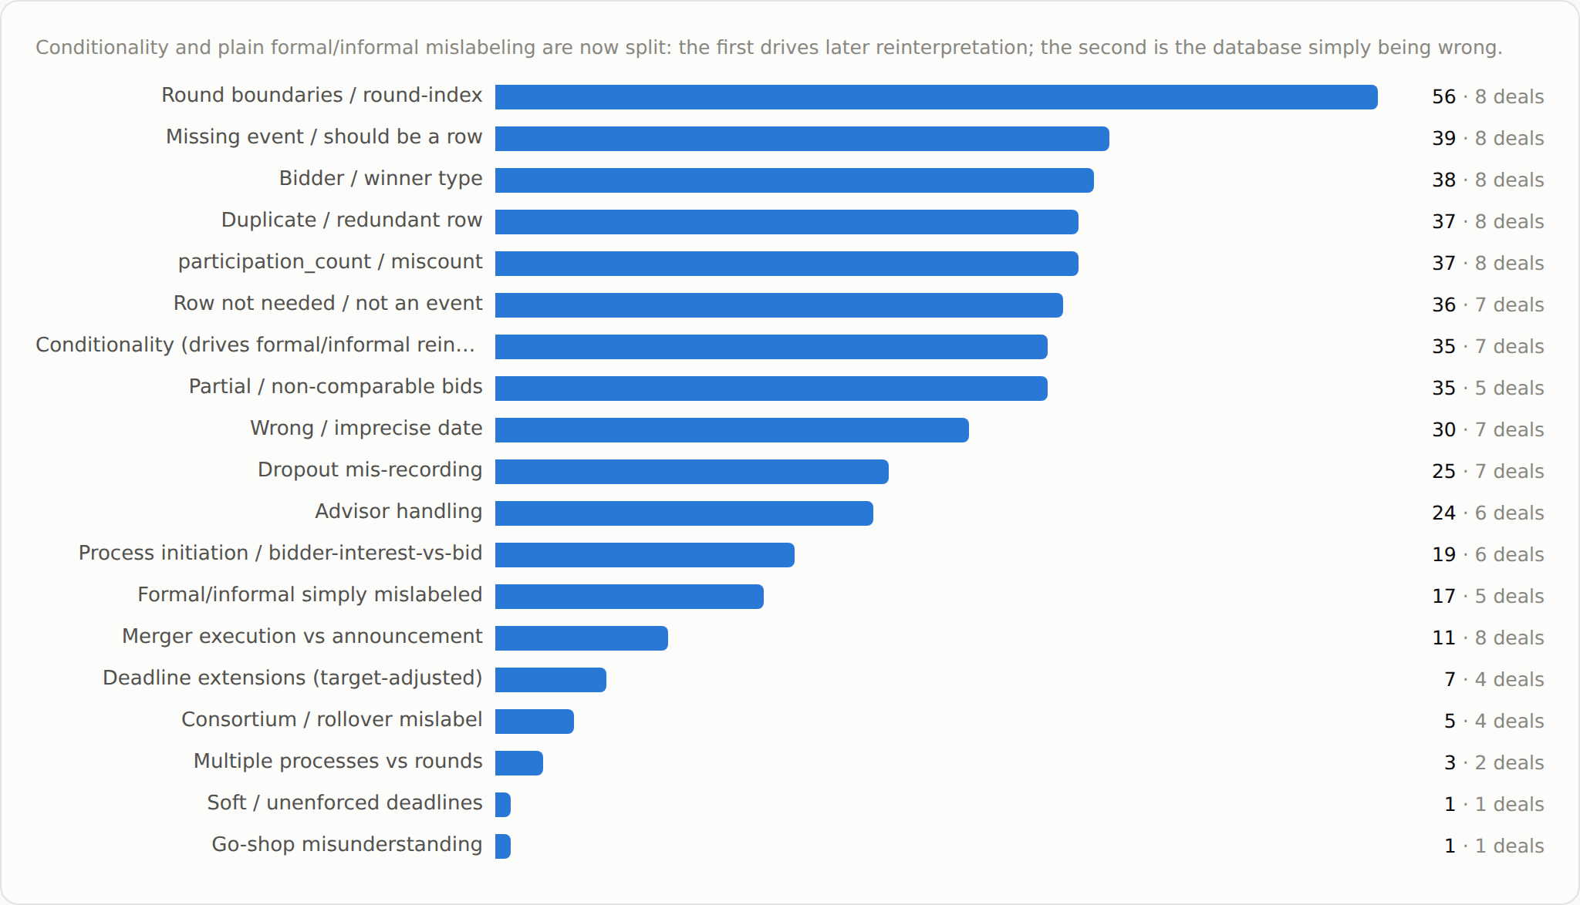
Figure 1. Most frequent concerns across the eight commented deals — comment count, with the number of deals affected at right.
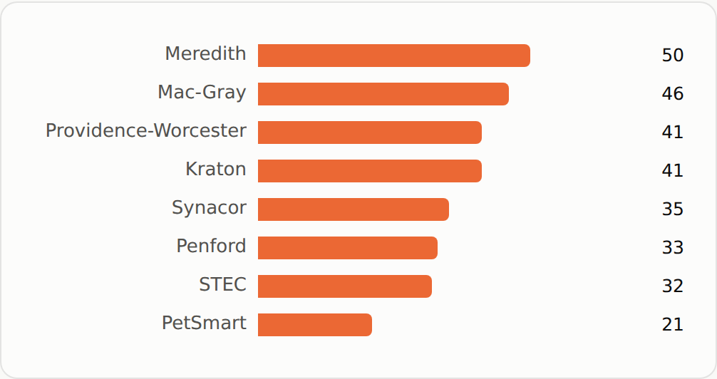
Figure 2. Which deals suffer most, by substantive comment count.
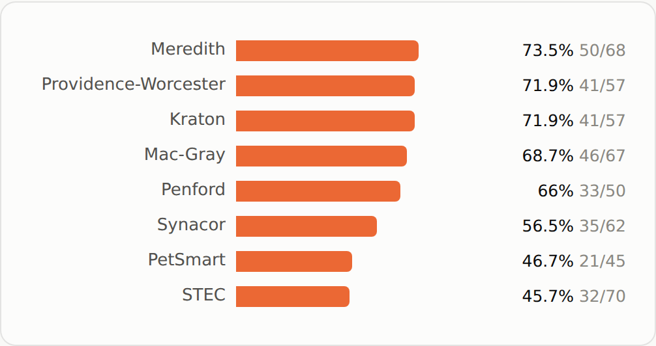
Figure 3. Which deals suffer most, as a share of each deal's ledger rows (normalizes for deal size).
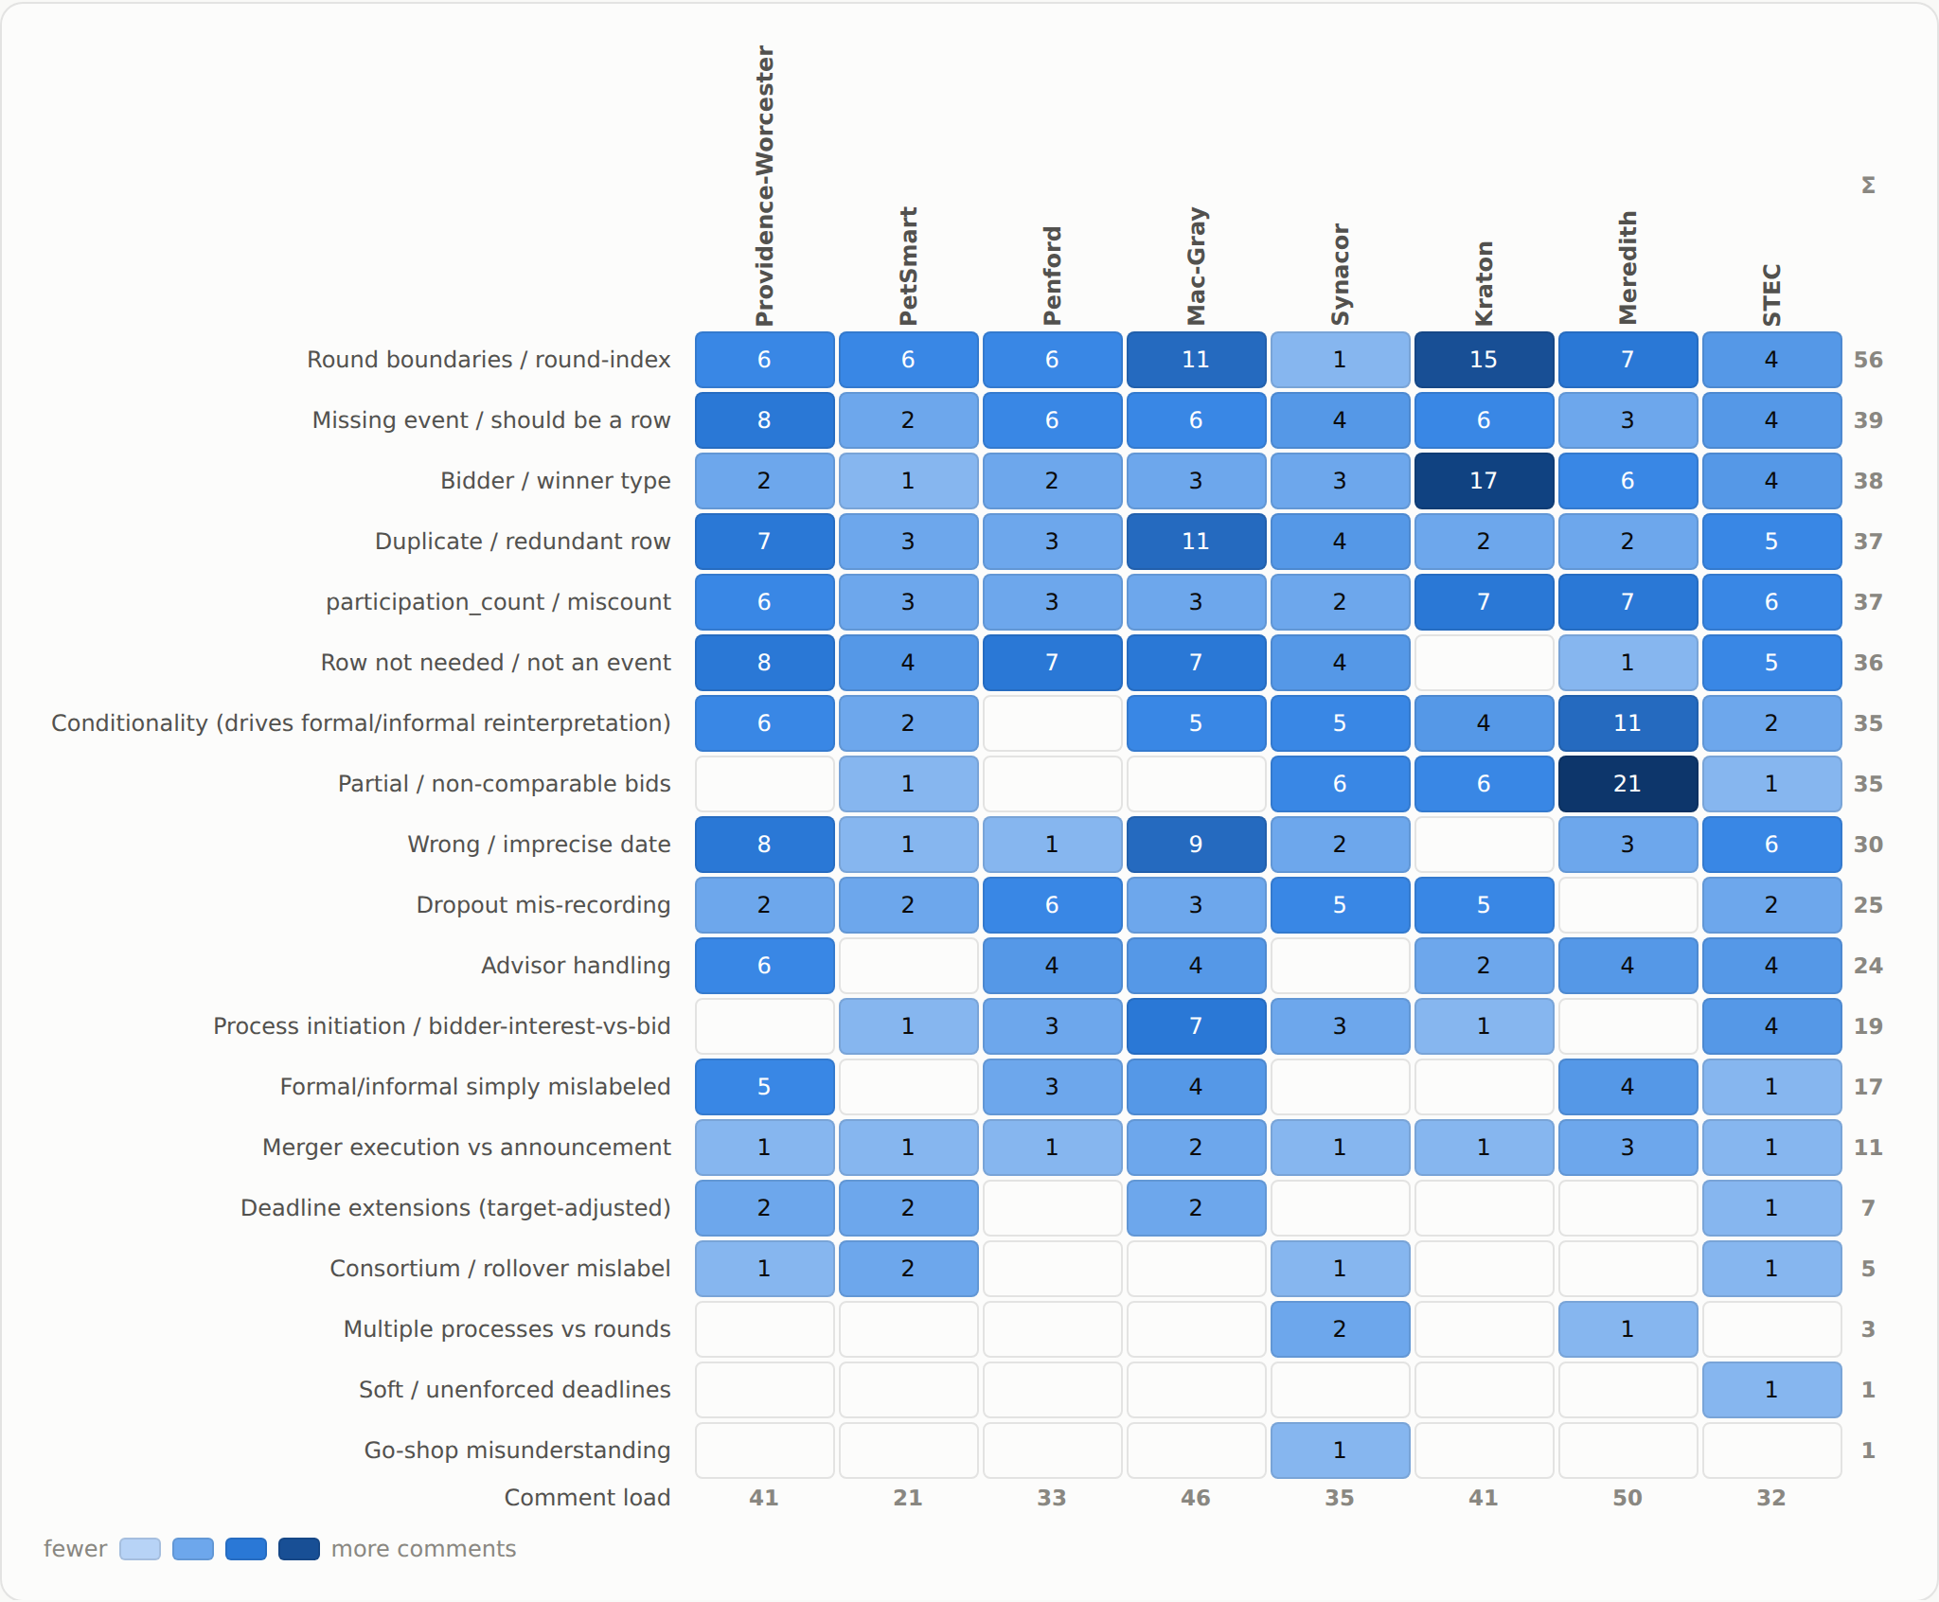
Figure 4. Concern × deal — comment counts (darker = more comments).
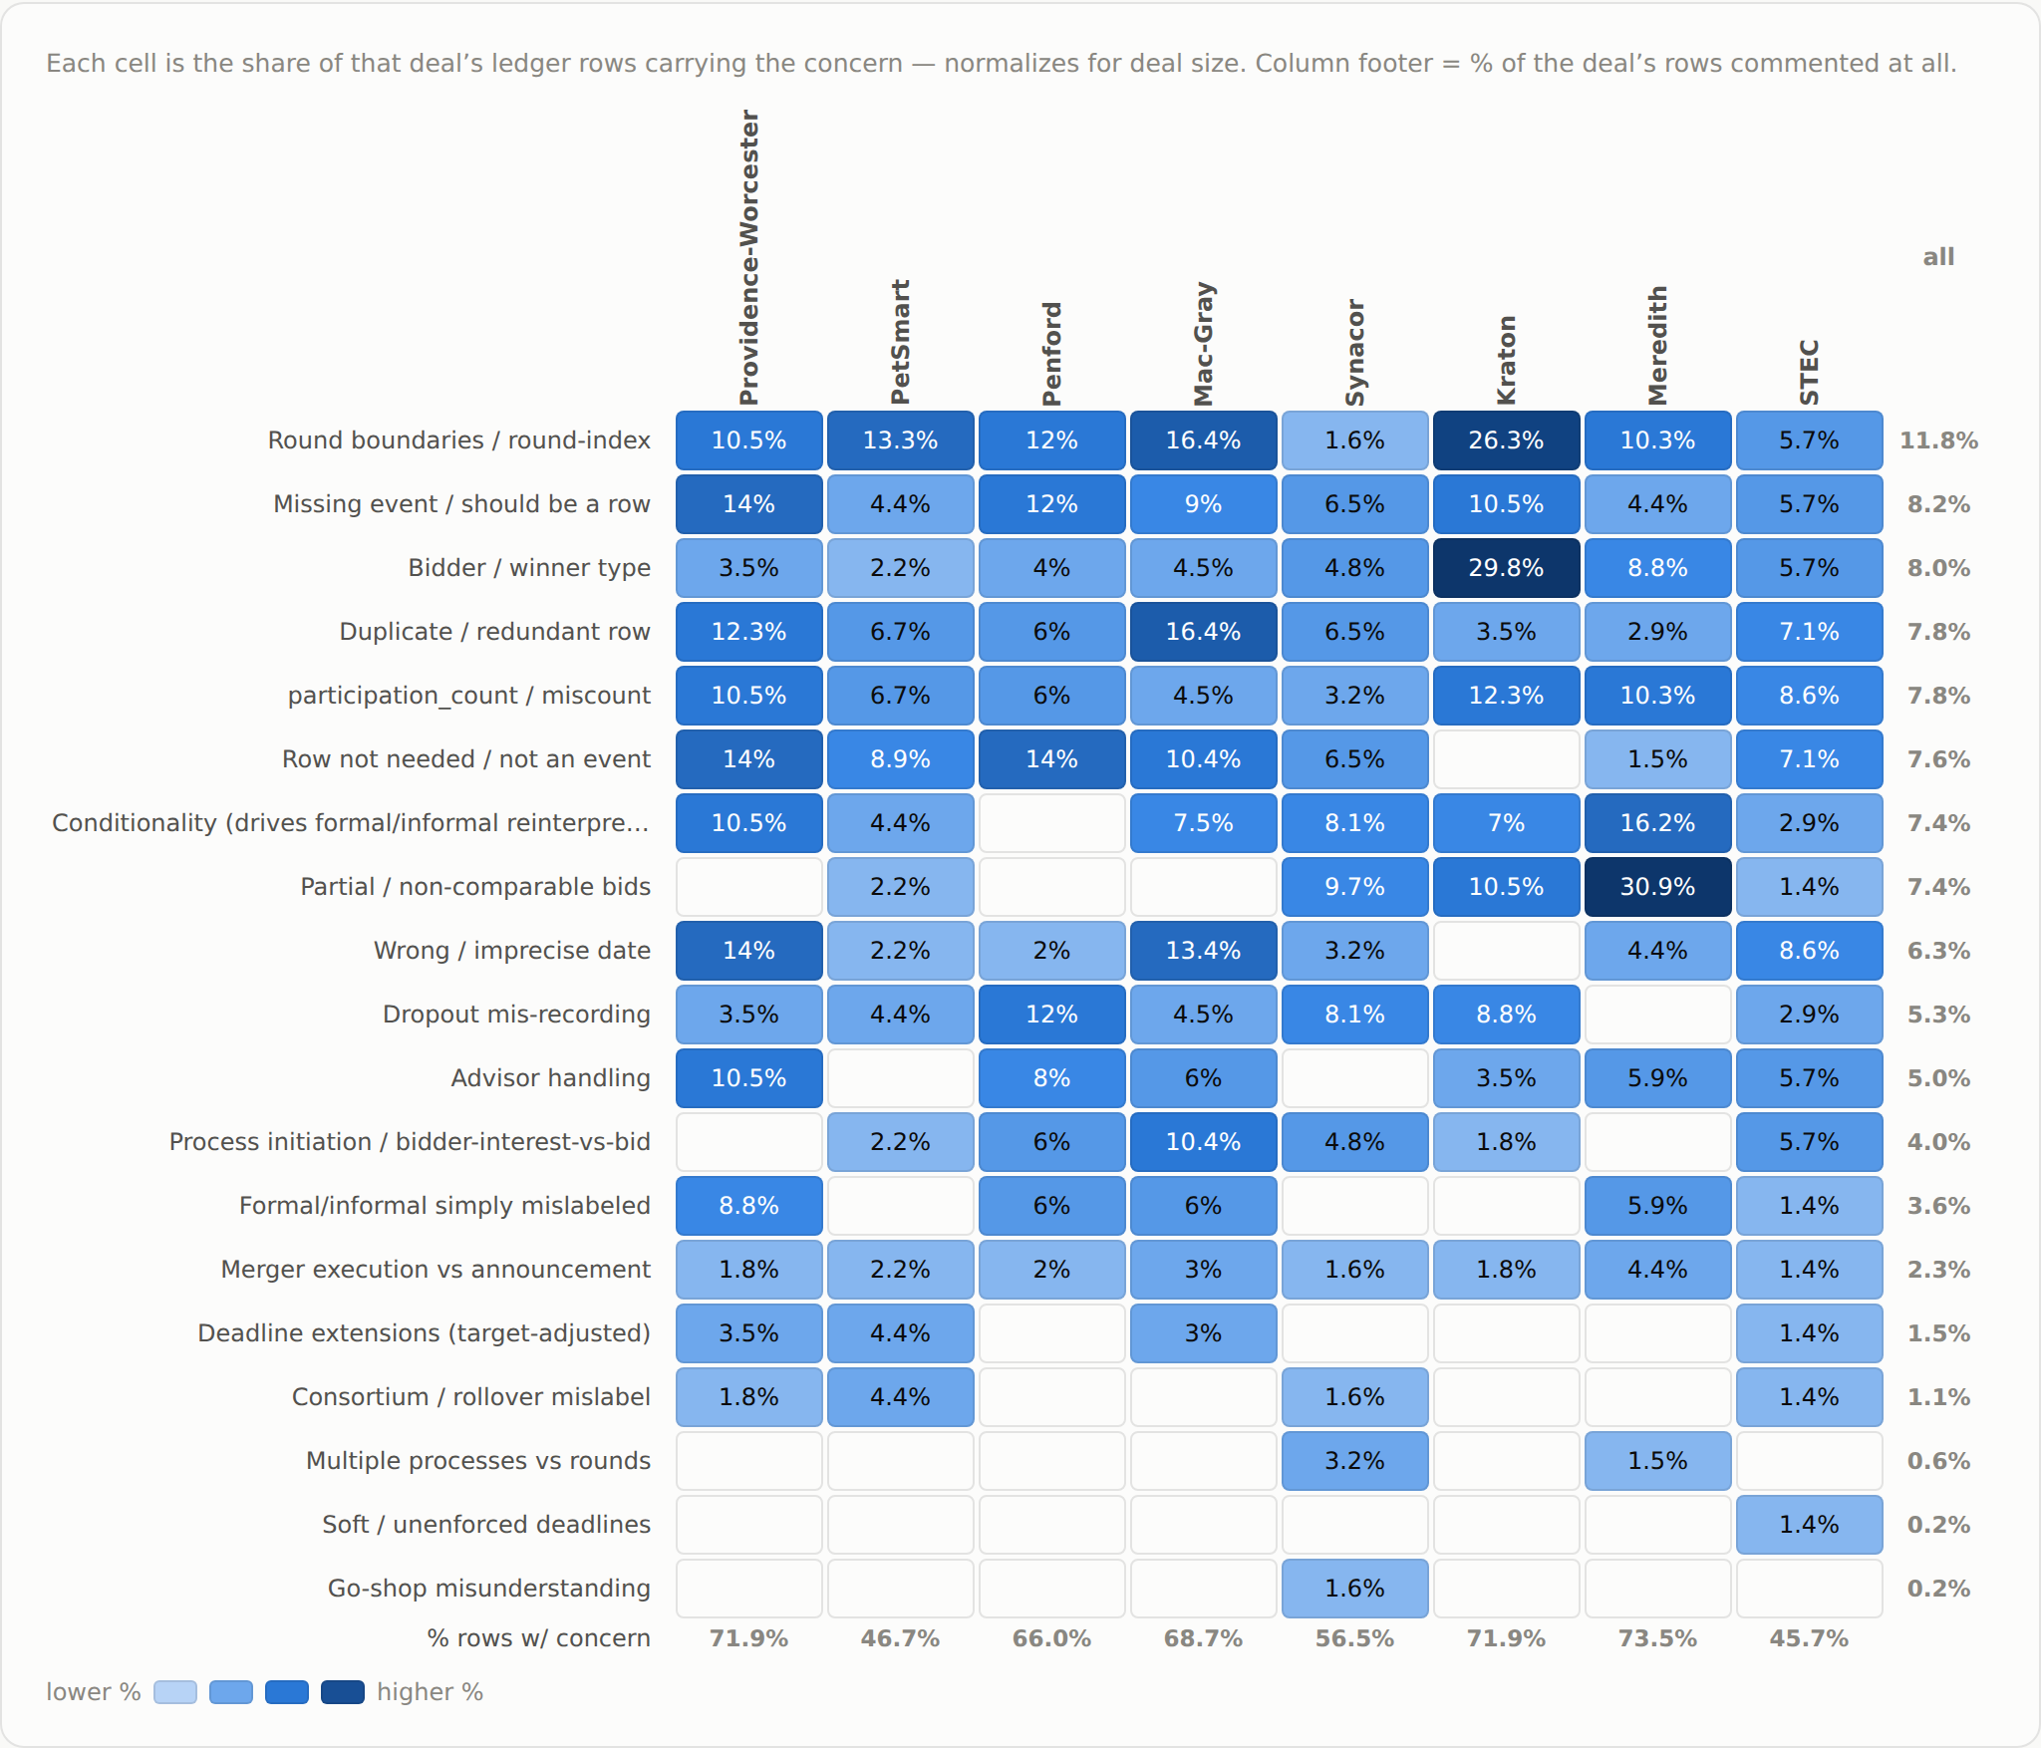
Figure 5. Concern × deal — share of each deal's rows raising the concern.

Alex's summary
I will not repeat most common concerns, those have been summarized after each individual deal. And they have been adequately summarized by the AI in the previous section. I will instead try to provide some constructive ways to deal with most important concerns here.
1. I think it is important to have interactive collaboration with the AI on data collection. I.e., suppose the AI collects data on Kraton. Some facts are easy to establish, and they receive high degree of certainty; therefore the AI moves forward. Some other facts are hard to establish, or we always want to human-check certain facts; in this case, the AI flags these cases to the human IN REAL TIME, e.g. via the interactive Claude Desktop app.
Why is this important? First and most importantly, say the AI is not interactive and misrecords the number of rounds in the deal. Instead of three rounds, two rounds are recorded, so that each bid gets “1” or “2”. Then the human needs to change all of these to “1”, “2”, and “3” throughout the entire deal. The same goes for multiple processes described in a single deal background. Second, the interactive AI will directly send the human to the relevant part of the deal background, saving time (for that reason, we should also record the deal background link, including the page, in the database).
I realize that this will not allow us to run large batches of deals in the background, but until the AI is capable of recording the number of rounds, processes, NDAs, etc. very reliably we will have to rely much more on human verification.
2. I think the AI should ALWAYS flag for human review several types of information:
A. Anything that indicates the possibility of a round ending/another round starting. Anytime a board of directors/target/transaction committee/any other name we have seen so far meets at the deadline or a bit after the deadline of a bidding round, it is likely that they will discuss the sale process, so such a meeting should be flagged. Moreover, if during this meeting or soon after the meeting some bidders are dropped and some bidders are approached again, this indicates the likely start of the next round and, again, should be flagged. Additionally, if there is no officially stated starting date of round 1 in the background, we should assume that this round starts when the target's investment bank first starts contacting bidders. The event of such contacts/NDAs should also be flagged. Finally, sometimes the deal background will claim that the process lasts for two rounds (because they split between informal and formal rounds), but the reality is that there may be more than one informal or formal round. The naming of rounds should not be lifted from the background but instead inferred from the deal process. E.g., Kraton had an interim meeting of the Board during informal bidding, where they dropped some bidders and continued the process; this signifies two rounds of informal bidding.
B. On a related note, any bidding round extension OR the lack thereof following a stated bidding round deadline should be flagged, and the information about extensions or the lack thereof should be recorded, as these are informative about how the target runs the sale process.
C. An unknown type of the winning bidder must always be flagged. My hope is that we can fine-tune this, so that the AI can search for winning bidder type in other sections of the SEC filing (as explained in individual deal comments). Admittedly, this is one of the easiest human verification fixes that does not have to be interactive, but it is not a big deal, in the grand scheme of things, if this issue is reported by the interactive AI in real time.
D. For the same reason, an unknown type of a bidder who submits a formal bid is highly unusual and should be flagged.
E. If the number of NDA agreements signed is uncertain, as an example, say “more than 6” bidders have signed an NDA, and their types are “mixed”, without a good split between strategics and financials, this must be flagged by the AI. It is much more painful to backtrack across the entire deal background to verify these numbers later; real-time interactivity can help.
F. Any uncertainty about why a bidder dropped out/has been dropped out has to be flagged. My hope is that we will fine-tune the AI to be better as discerning reasons, and individual deal comments can help with this. But if this uncertainty still persists, the human should verify.
G. I do not know how bid conditionality will be recorded, but it might make sense to make it human verifiable for the first several deals, until we have an idea whether the AI is reliable in collecting conditions.
H. Exact dates are less interesting to me, but the order of events must be precise because allocating a bid to a wrong round of bidding is not good, see some individual case comments earlier in this document.
I. I assume that the next version of the AI will be good at separating the merger agreement event from the event of a public announcement of this merger agreement. I also assume that the event of a public announcement of the sale process will be differently recorded from the event of a public announcement of the end of the process (i.e., of a merger agreement). This seems easy for the AI to handle, so this will likely not need human verification.
J. We have many duplicate rows. Advisors often get recorded multiple times, and it should be an easy fix to just keep one line per advisor name. Any time an affiliation of an advisor is unclear, this should be flagged for human verification.
K. On the same note of many duplicate rows. For some reason, indications of interest and bids are recorded as separate rows. Why is this necessary? In almost all instances, IOI = informal bid. Admittedly, in the STEC case, an IOI from WDC came with a markup of the merger agreement and without conditions, and came at the end of the process, so it is very reasonable to think about it as a formal offer. For this bid, indeed, the fact that this is an IOI but a formal bid potentially conveys different pieces of information. But another way to deal with this would be to say, anytime an IOI seems like a formal bid because of the markup and no conditions, the AI should flag it for human verification. Then, bid formality is verified, and there is no need to keep separate rows for a single bid anymore. Does this make sense or am I missing another important reason to have IOIs separately recorded?
L. Deals without bids for the entire company and with only partial bids, like Meredith, should absolutely be flagged.
M. Deals which are not price per share should be flagged when it is unclear what the currency of the offer is. E.g., one of the deals had partial bids in $M and full bids in $B, but the AI did not capture this. In the same deal, these bids were, in fact for the enterprise value and not equity value, and this should also be flagged.
3. I will not summarize other issues (e.g., multiple processes in the same filing), as they are less pervasive, and the AI can probably be trained reasonably well to avoid those; if not, these issues should, of course, also be flagged.
With enough fine-tuning (if the AI learns between deals), we can drop some of the checks from obligatory human verification. But as it stands, we will need a good amount of it.

