Installing RStudio

# Install R:

Before installing RStudio, you need to have R installed on your system.

## For Ubuntu:

* 1. Open the terminal.
  2. Update your package list:

sudo apt update

* 1. Install R:

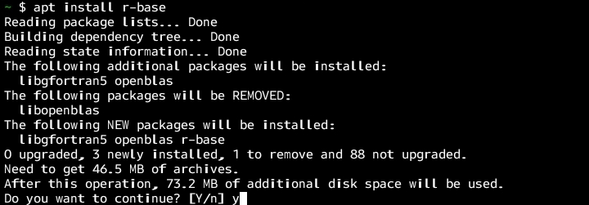

sudo apt install r-base

installing r-base

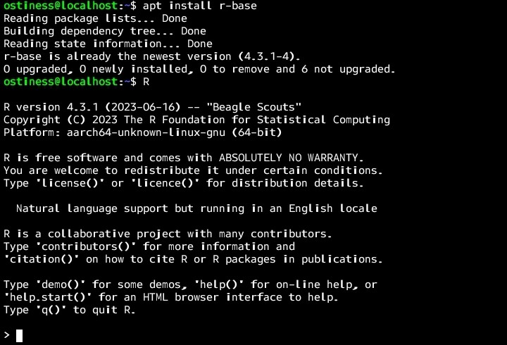

installing r-base

## For Windows:

1. Download the R installer from the [CRAN R Project website](https://cran.r-project.org/).
2. Run the installer and follow the on-screen instructions.

## For macOS:

1. Download the R installer for macOS from the [CRAN R Project website](https://cran.r-project.org/).
2. Run the installer and follow the on-screen instructions.

# Install RStudio:

Once R is installed, you can install RStudio.

## For Ubuntu:

* 1. Go to the [RStudio download page](https://rstudio.com/products/rstudio/download/#download).
  2. Download the package suitable for your Ubuntu version.

.deb

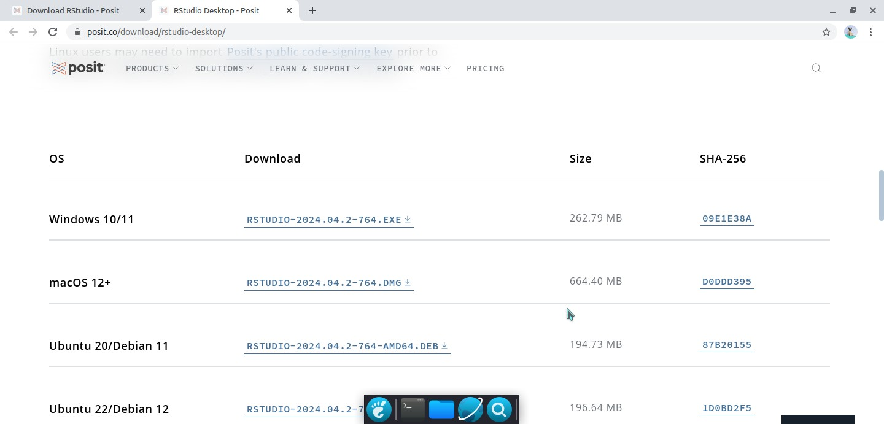

download rstudio

* 1. Install the downloaded package using:

sudo dpkg -i rstudio-x.yy.zz-amd64.deb

* 1. If you encounter dependency issues, run:

sudo apt --fix-broken install

* 1. If your machine is not amd64 or x86_64 I.e it’s maybe arm64, you’ll need to download rstudio from a build site

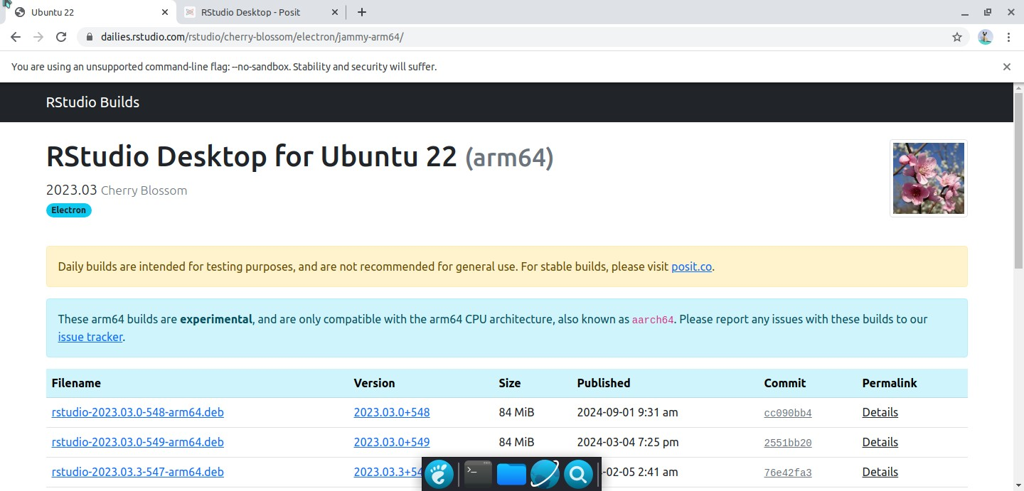

downloading for arm64

* 1. Install the downloaded package using:

sudo dpkg -i rstudio-x.yy.zz-arm64.deb

## For Windows:

1. Download the RStudio installer from the [RStudio download page](https://rstudio.com/products/rstudio/download/#download).
2. Run the installer and follow the on-screen instructions.

## For macOS:

1. Download the RStudio installer from the [RStudio download page](https://rstudio.com/products/rstudio/download/#download).
2. Open the downloaded

.dmg

# Launch RStudio:

file and drag the RStudio icon into your Applications folder.

After installation, you can launch RStudio from your applications menu (on Ubuntu and macOS) or from the Start menu (on Windows).

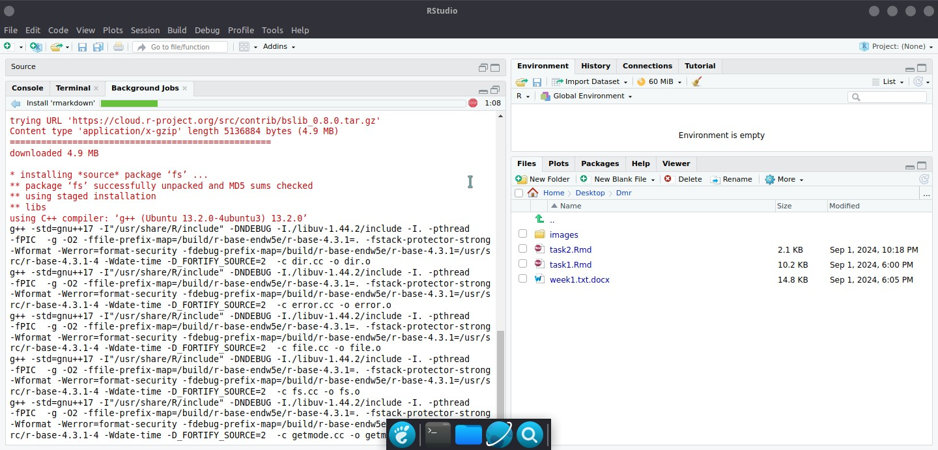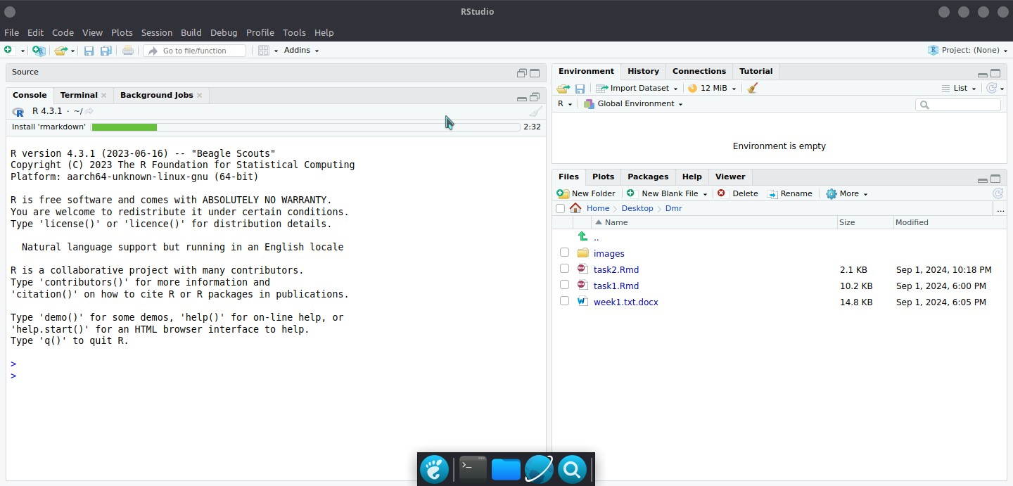

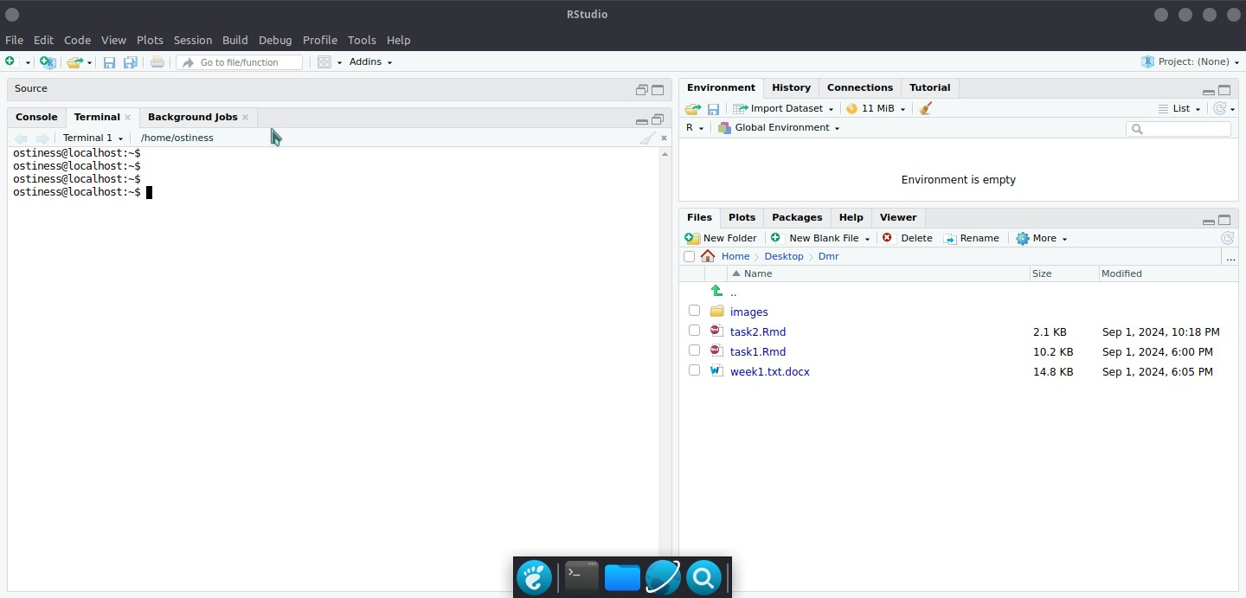

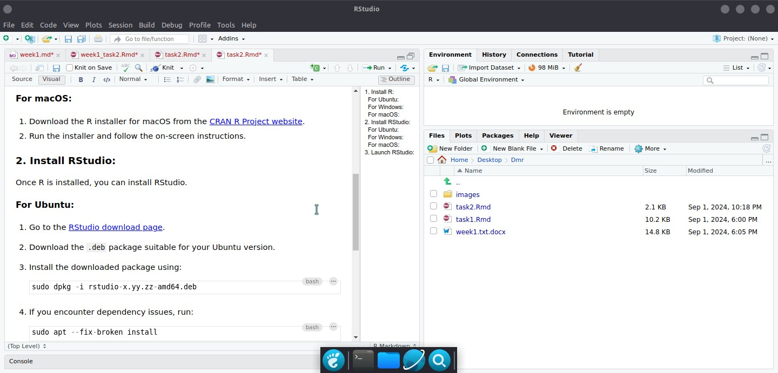

editor

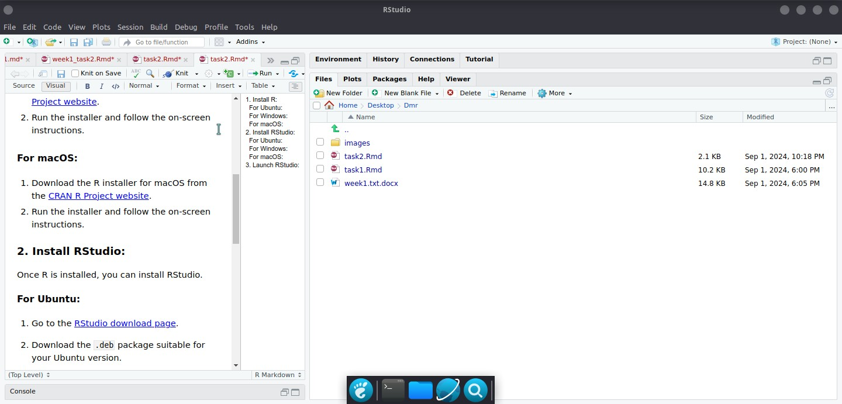

files

Installing Packages

installing required packages for data mining

Risa collaborative project with many contributors.

Type •contributors()" for more information and

"citation()" on how to cite R or R packages in publications.

Type •demo()• for some demos, "help()• for on-Line help, or "help.start()• for an HTML browser interface to help.

Type •q()• to quit R.

* my_packages <- c(•tidyverse•,•broom•,•coefplot","cowplot",•gapminder•,•GGall y","ggrepel",•ggridges•,·gridExtra•,•here•,•interplot·,•margins•,•maps•,•mappr oj","mapdata•,•MASS","quantreg•,•rLang•,•scales•,•survey•,•srvyr•,•viridis",•v iridisLite","devtools","socviz")
* install.packages([my_packages,repos=•http://cran.rstudio.com"](http://cran.rstudio.com/))

ages into '/usr/local/lib/R/site-Library' (as **'Lib'** is unspecified)

Installing pack

also installing the dependencies 'bit', 'askpass', 'bit64', 'highr', 'xfun',' jquerylib', 'tinytex', 'fastmap', 'Later', 'cards', 'Labelled', 'nloptr', 'Rep pEigen', 'credentials', 'sys', 'zip', 'gitcreds', 'ini', 'httpuv', 'xtable','

--

sourcetools', 'sass', 'diffobj', 'blob', 'DBI', 'gargle', 'uuid', 'curl', 'ids ', 'rematch2', 'mime', 'openssl', 'systemfonts', 'textshaping', 'clipr', 'vroo m', 'callr', 'knitr', 'rmarkdown', 'selectr', 'assertthat', 'htmlwidgets', 'ht mltools', 'zoo', 'xts', 'base64enc', 'Lazyeval', 'crosstalk', 'promises', 'bro om.helpers', 'patchwork', 'Lme4', 'coda', 'gert', 'gh', 'rappdirs', 'whisker',

'yaml', 'cachem', 'shiny', 'processx', 'bslib', 'downlit', 'fontawesome', 'ht

tr2', 'xopen', 'brew', 'commonmark', 'brio', 'evaluate', 'praise', 'ps', 'wald o', 'conflicted', 'dbplyr', 'dtplyr', 'forcats', 'googledrive', 'googlesheets4 ', 'haven', 'httr', 'jsonlite', 'modelr', 'ragg', 'readr', 'reprex', 'rstudioa

pi', 'rvest', 'xml2', 'backports', 'useful', 'dygraphs', 'plotly', 'ggstats', 'rprojroot', 'abind', 'arm', 'interactionTest', 'prediction', 'SparseM', 'Matr ixModels', 'minqa', 'mitools', 'RcppArmadillo', 'usethis', 'desc', **'ellipsis',** 'fs', 'memoise', 'miniUI', 'pkgbuild', 'pkgdown', 'pkgload', 'profvis', 'rcmd check', 'remotes', 'roxygen2', 'rversions', 'sessioninfo', 'testthat', 'urlche cker'

--------------------------------------------------

trying URL ["http://cran.rstudio.com/src/contrib/bit_4.0.5.tar.gz"](http://cran.rstudio.com/src/contrib/bit_4.0.5.tar.gz) Content type "application/x-gzip" Length 827745 bytes (808 KB)

downloaded 808 KB

trying URL ["http://cran.rstudio.com/src/contrib/askpass_1.2.0.tar.gz"](http://cran.rstudio.com/src/contrib/askpass_1.2.0.tar.gz) Content type "application/x-gzip" Length 6040 bytes

downloaded 6040 bytes

trying URL ["http://cran.rstudio.com/src/contrib/bit64_4.0.5.tar.gz"](http://cran.rstudio.com/src/contrib/bit64_4.0.5.tar.gz) Content type "application/x-gzip" Length 135091 bytes (131 KB)

downloaded 131

KB

trying URL ["http://cran.rstudio.com/src/contrib/highr_0.11.tar.gz•](http://cran.rstudio.com/src/contrib/highr_0.11.tar.gz) Content type "application/x-gzip" Length 13851 bytes (13 KB)

I

trying URL**'**[**http://cran.rstudio.com/src/cont,tl-47.tar.gz'**](http://cran.rstudio.com/src/cont%2Ctl-47.tar.gz%27)Content type "application/x-gzip" Length 160096 bytes (156 KB)

downloaded 13 KB

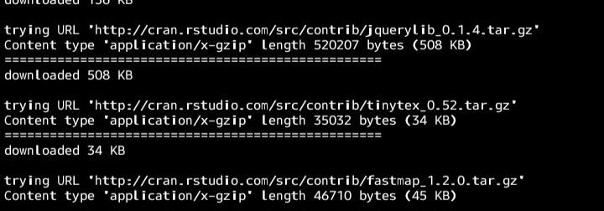

installing packages

trying URL "<http://cran.rstudio.com/src/contrib/askpass_1.2.0.tar.gz>" Content type "application/x-gzip" length 6040 bytes

trying URL "<http://cran.rstudio.com/src/contrib/RcppEigen_0.3.4.0.2.tar.gz>" Content type "application/x-gzip" length 1761745 bytes (1.7 MB)

downloaded 6040 bytes

trying URL "<http://cran.rstudio.com/src/contrib/bit64_4.0.5.tar.gz>" Content type "application/x-gzip" length 135091 bytes (131 KB)

downloaded 131

KB

trying URL "<http://cran.rstudio.com/src/contrib/highr_0.11.tar.gz>"

Content type "application/x-gzip" length 13851 bytes (13 KB)

"

|  |  |  |
| --- | --- | --- |
| downloaded 13 KB |  |  |
| trying URL "<http://cran.rstudio.com/src/contrib/xfun_0.47.tar.gz> Content type "application/x-gzip" length 160096 bytes (156 KB) | | |

downloaded 156 KB

trying URL ["http://cran.rstudio.com/src/contrib](http://cran.rstudio.com/src/contrib) querylib_0.1.4.tar.gz" Content type "application/x-gzip" length 520207 bytes (508 KB)

downloaded 508 KB

trying URL "<http://cran.rstudio.com/src/contrib/tinytex_0.52.tar.gz>"

Content type "application/x-gzip" length 35032 bytes (34 KB)

downloaded 34 KB

trying URL "<http://cran.rstudio.com/src/contrib/fastmap_1.2.0.tar.gz>"

Content type "application/x-gzip" length 46710 bytes (45 KB)

"

-----------------

|  |  |  |
| --- | --- | --- |
| downloaded 45 KB |  |  |
| trying URL "<http://cran.rstudio.com/src/contrib/later_1.3.2.tar.gz> Content type "application/x-gzip" length 63597 bytes (62 KB) | | |

downloaded 62 KB

://cran.rstudio.com/src/contrib/cards_0.2.1.tar.gz" Content type "application/x-gzip" length 198366 bytes (193 **KB)**

downloaded 193 **KB**

trying URL "http

trying URL "<http://cran.rstudio.com/src/contrib/labelled_2.13.0.tar.gz>" Content type "application/x-gzip" length 240347 bytes (234 KB)

downloaded 234 KB

trying URL "[http://cran.rstudio.com/src/contrib/nloptr_2.1.1.tar.gz"](http://cran.rstudio.com/src/contrib/nloptr_2.1.1.tar.gz) Content type "application/x-gzip" length 2236635 bytes (2.1 MB)

downloaded 2.1

MB

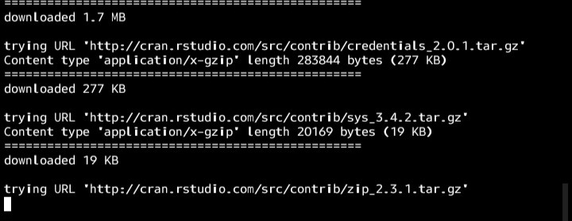

installing packages