??? Introduction to data visualizations in R ???

Akanksha Garlapati

2024-09-09

Table of Contents

# Introduction to data visualizations in R

## Loading packages and datasets

library (tidyverse)

## ── Attaching core tidyverse packages ──────────────────────── tidyverse 2.0.0 ──  
## ✔ dplyr 1.1.4 ✔ readr 2.1.5  
## ✔ forcats 1.0.0 ✔ stringr 1.5.1  
## ✔ ggplot2 3.5.1 ✔ tibble 3.2.1  
## ✔ lubridate 1.9.3 ✔ tidyr 1.3.1  
## ✔ purrr 1.0.2   
## ── Conflicts ────────────────────────────────────────── tidyverse_conflicts() ──  
## ✖ dplyr::filter() masks stats::filter()  
## ✖ dplyr::lag() masks stats::lag()  
## ℹ Use the conflicted package (<http://conflicted.r-lib.org/>) to force all conflicts to become errors

library (modeldata)  
  
library(readxl)  
my_dataset <- read_excel("Animals_and_share _of_US_adults.xlsx")  
View(my_dataset)

## Using scatter plot

We specify dataset to be plotted in ggplot, and the variables and other aesthetics in aes

ggplot(my_dataset, aes(x=Male,  
 y=Female))

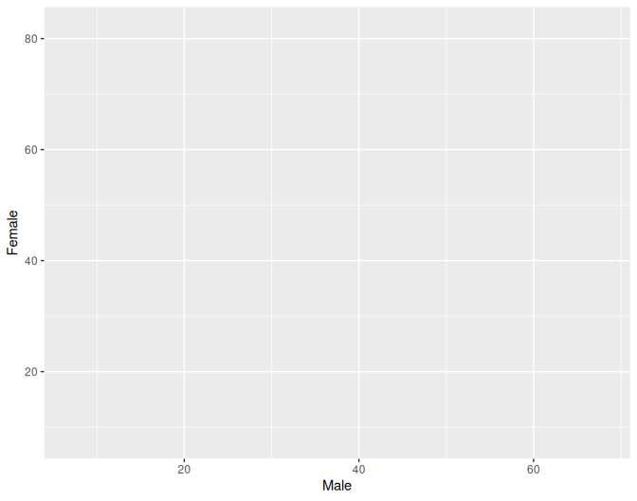

We the add the specification for the type of plot with geom_*

ggplot (my_dataset, aes(x=Male,  
 y = Female ))+  
 geom_point()

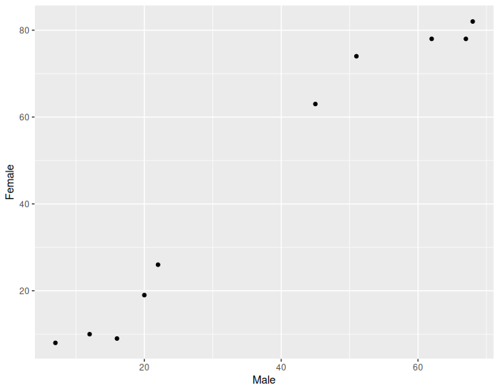

We can then add other things like labels

ggplot (my_dataset, aes(x = Male,  
 y = Female ))+  
 geom_point()+  
 labs(x="Male",  
 y="Female ",  
 title="Cricket Chips",  
 caption= "Source: Mcdonald (2009)")

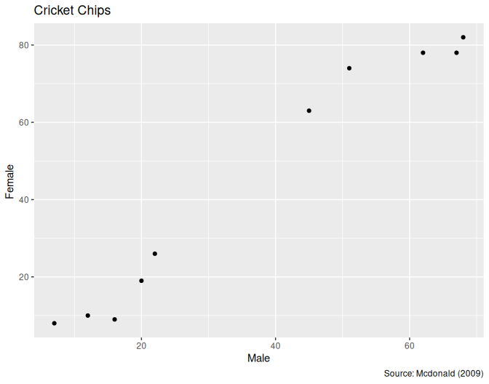

### Specifying other aesthetics

Add color with a variable

ggplot (my_dataset, aes(x=Male,  
 y=Female,  
 color=Animal ))+  
 geom_point()+  
 labs(x="Male",  
 y="Female",  
 title="Cricket Chips",  
 caption= "Source: Mcdonald (2009)")

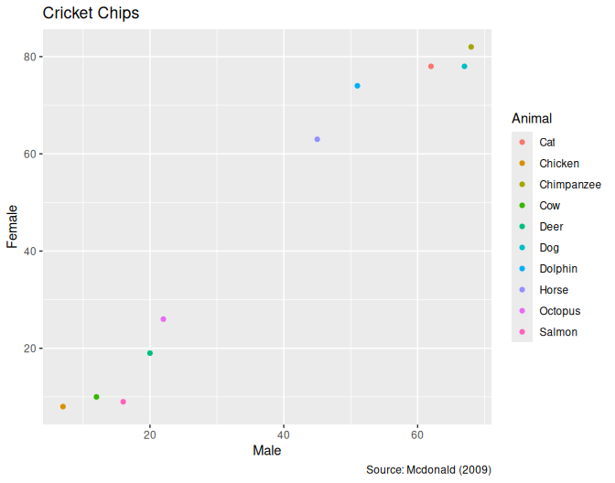

Label color labels

ggplot (my_dataset, aes(x=Male,  
 y=Female,  
 color =Animal))+  
 geom_point()+  
 labs(x="Male",  
 y="Female",  
 color="Animal",  
 title="Cricket Chips",  
 caption= "Source: Mcdonald (2009)")



Add color scaling

ggplot (my_dataset, aes(x=Male,  
 y=Female,  
 color =Animal))+  
 geom_point()+  
 labs(x="Male",  
 y="Female",  
 color="Animal",  
 title="Cricket Chips",  
 caption= "Source: Mcdonald (2009)")



# not found: # soace_color_brewer(palette="Dark2")

### Modifying basic properties

Change plot color

ggplot (my_dataset, aes(x=Male,  
 y=Female,  
 color =Animal))+  
 geom_point(color="Red")+  
 labs(x="Male",  
 y="Female",  
 color="Animal",  
 title="Cricket Chips",  
 caption= "Source: Mcdonald (2009)")

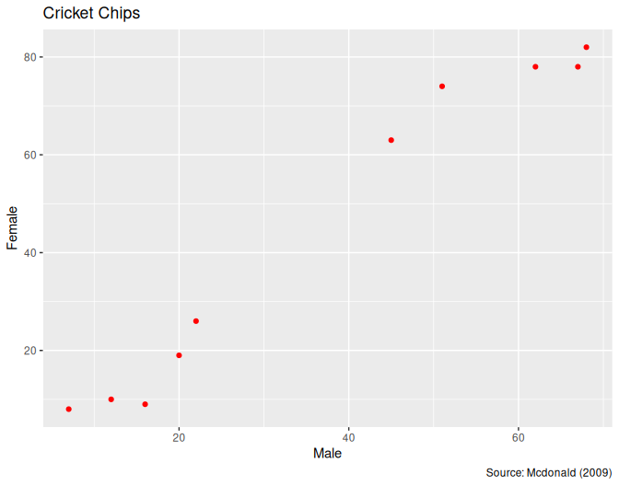

# soace_color_brewer(palette="Dark2")

change plot size

ggplot (my_dataset, aes(x=Male,y=Female,color =Animal))+  
 geom_point(size=2)+  
 labs(x="Male",  
 y="Female",  
 color="Animal",  
 title="Cricket Chips",  
 caption= "Source: Mcdonald (2009)")

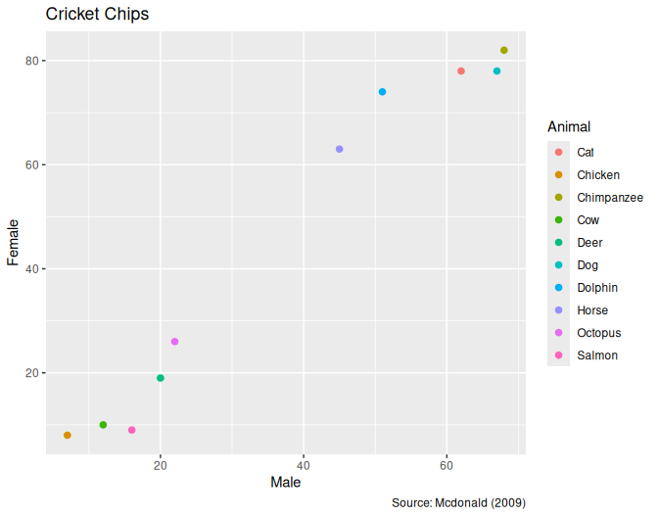

# soace_color_brewer(palette="Dark2")

Adding another plot layer

ggplot (my_dataset, aes(x=Male,  
 y=Female,  
 color =Animal))+  
 geom_point()+  
 geom_smooth()+  
 labs(x="Male",  
 y="Female",  
 color="Animal",  
 title="Cricket Chips",  
 caption= "Source: Mcdonald (2009)")

## `geom_smooth()` using method = 'loess' and formula = 'y ~ x'

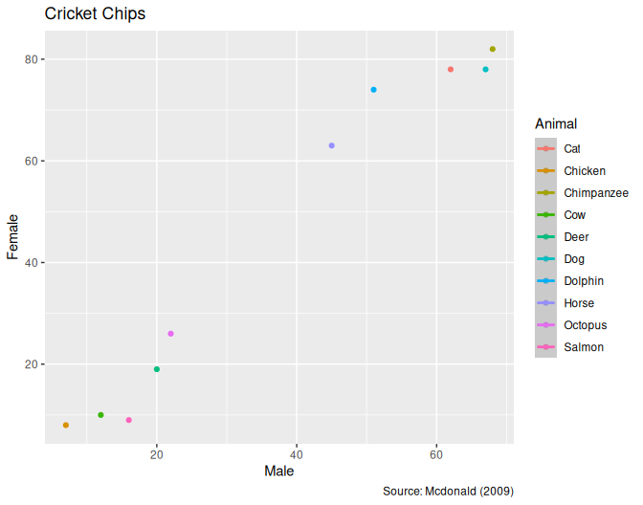

# soace_color_brewer(palette="Dark2")

Add geom_smooth method

ggplot (my_dataset, aes(x=Male,  
 y=Female,  
 color =Animal))+  
 geom_point()+  
 geom_smooth(method="lm")+  
 labs(x="Male",  
 y="Female",  
 color="Animal",  
 title="Cricket Chips",  
 caption= "Source: Mcdonald (2009)")

## `geom_smooth()` using formula = 'y ~ x'



# soace_color_brewer(palette="Dark2")

Remove geom_smooth error approximation

ggplot (my_dataset, aes(x=Male,  
 y=Female,  
 color =Animal))+  
 geom_point()+  
 geom_smooth(method="lm",  
 se=FALSE)+  
 labs(x="Male",  
 y="Female",  
 color="Animal",  
 title="Cricket Chips",  
 caption= "Source: Mcdonald (2009)")

## `geom_smooth()` using formula = 'y ~ x'

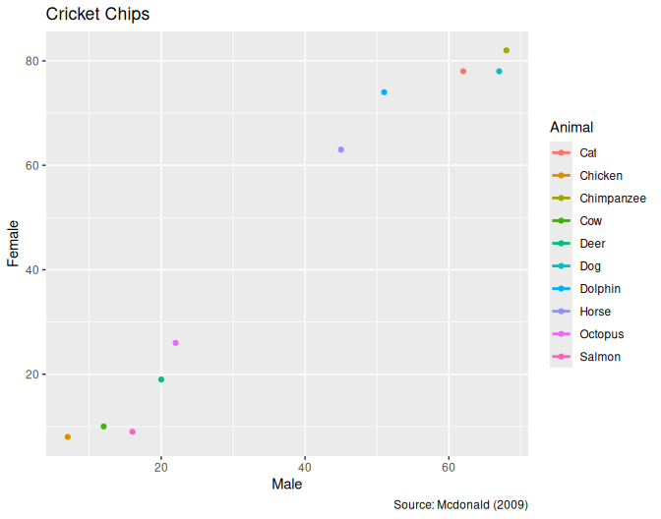

# soace_color_brewer(palette="Dark2")

## Other plots

### Histogram

ggplot (my_dataset, aes(x=Male,  
 color =Animal))+  
 geom_histogram()

## `stat_bin()` using `bins = 30`. Pick better value with `binwidth`.

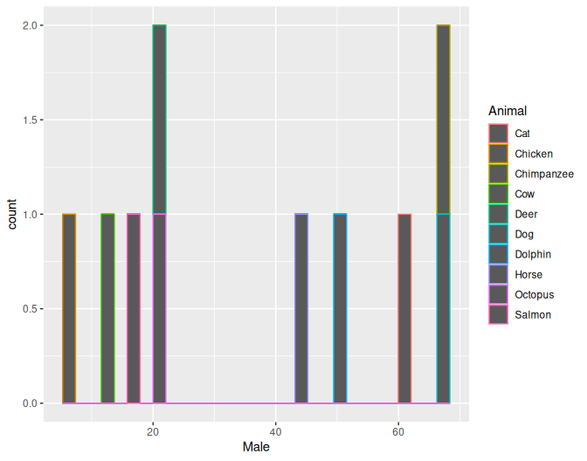

Modifying Histogram bins

ggplot (my_dataset, aes(x=Male))+  
 geom_histogram(bins=15)

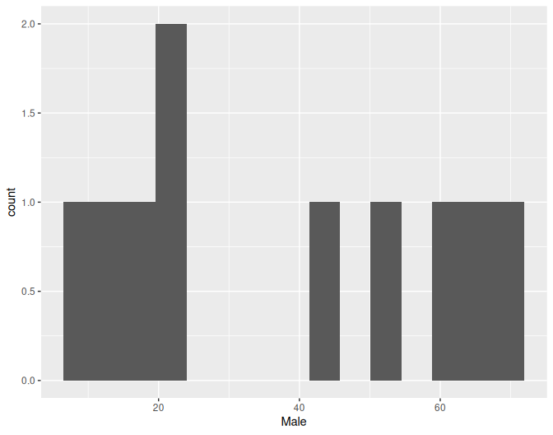

### Frequency polygon

ggplot (my_dataset, aes(x=Male))+  
 geom_freqpoly(bins=15)

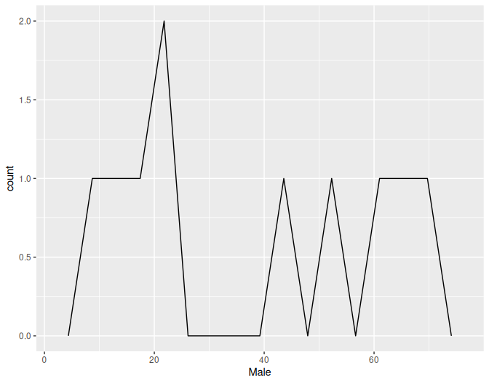

### Bars

ggplot (my_dataset, aes(x=Animal))+  
 geom_bar(color="black",  
 fill="lightblue")

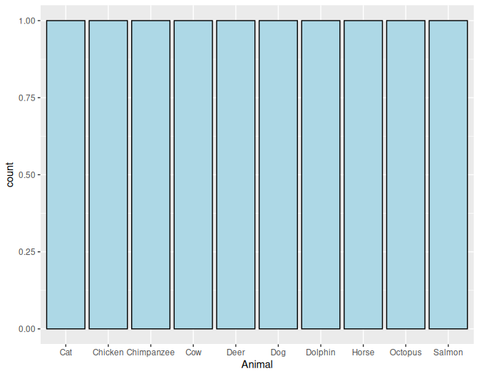

Coloring with classes

ggplot (my_dataset, aes(x=Animal,  
 fill=Animal))+  
 geom_bar()

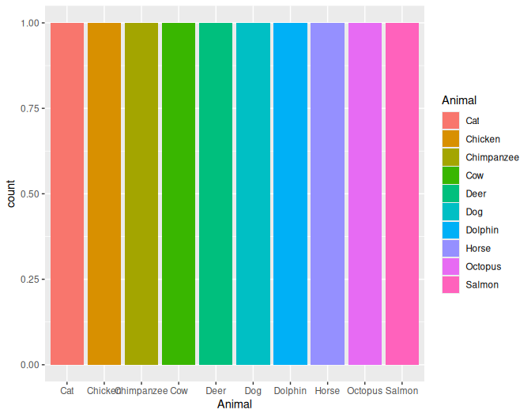

# soace_fill_brewer(palette="Dark2")

Remove legend

ggplot (my_dataset, aes(x=Animal,  
 fill=Animal))+  
 geom_bar()



# soace_fill_brewer(palette="Dark2")

### Box plot

ggplot (my_dataset, aes(x=Animal,y=Female))+  
 geom_boxplot()

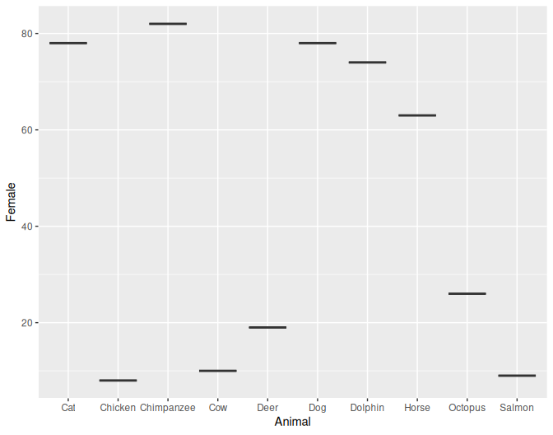

# soace_fill_brewer(palette="Dark2")

## Faceting

ggplot (my_dataset, aes(x=Male))+  
 geom_histogram(bins=15)+  
 facet_wrap(~Animal)

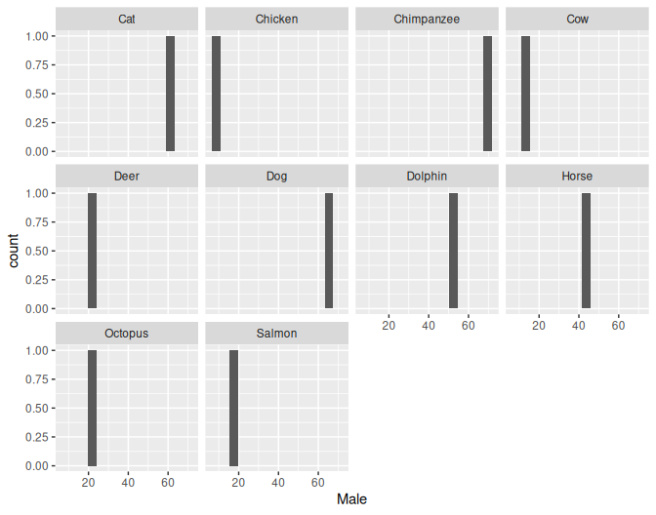

# soace_fill_brewer(palette="Dark2")