title: “Chapter 4” author: “Akanksha” date: “2024-09-23” output: html_document —

### 1. Expected value of $S$

The expected value of $S$ in a binomial distribution is $E\left(S\right)=N⋅p$, where: - $N=25$ (the sample size) - $p$ is the proportion of Democrats in the population

N <- 25  
p <- 0.5   
E_S <- N * p  
E_S

## [1] 12.5

### 2. Standard error of $S$

The standard error (SE) of $S$ in a binomial distribution is $SE\left(S\right)=\sqrt{N⋅p⋅\left(1−p\right)}$.

SE_S <- sqrt(N * p * (1 - p))  
SE_S

## [1] 2.5

### 3. Expected value of $\overset{‾}{X}$

$\overset{‾}{X}$ is the sample average, which is equivalent to $S/N$. The expected value of $\overset{‾}{X}$ is just $p$ because the sample average should estimate the proportion of Democrats.

E_X_bar <- p  
E_X_bar

## [1] 0.5

### 4. Standard error of $\overset{‾}{X}$

The standard error of $\overset{‾}{X}$ is $SE\left(\overset{‾}{X}\right)=\frac{\sqrt{p⋅\left(1−p\right)}}{\sqrt{N}}$.

SE_X_bar <- sqrt(p * (1 - p)) / sqrt(N)  
SE_X_bar

## [1] 0.1

### 5. Plotting the standard error for different values of $p$

To plot the standard error $SE$ for different values of $p$, we can use a sequence of $p$ values ranging from 0 to 1 and plot $SE$ versus $p$.

p_vals <- seq(0, 1, length = 100)  
se_vals <- sqrt(p_vals * (1 - p_vals)) / sqrt(N)  
plot(p_vals, se_vals, type = "l", col = "blue", xlab = "p", ylab = "Standard Error")

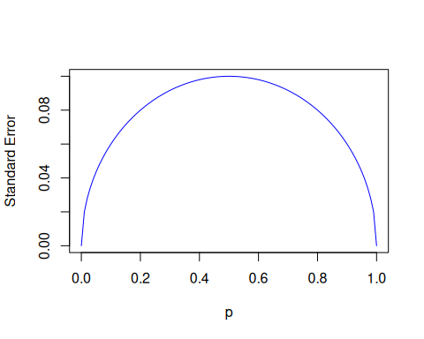

### 6. Plotting for different values of $N$

To extend the previous code to plot for $N=25$, $N=100$, and $N=1000$, you can use a loop.

# Define values for p  
p_vals <- seq(0, 1, length = 100)  
  
# Define the values for N and their corresponding colors  
N_vals <- c(25, 100, 1000)  
colors <- c("red", "green", "blue")  
  
# Create the initial plot with the first set of N = 25  
N <- N_vals[1]  
se_vals <- sqrt(p_vals * (1 - p_vals)) / sqrt(N)  
plot(p_vals, se_vals, type = "l", col = colors[1], xlab = "p", ylab ="StandardError", ylim = c(0, max(se_vals)), main = "Standard Error vs p for Different N")  
  
# Now, add the lines for N = 100 and N = 1000  
for (i in 2:length(N_vals)) {  
 N <- N_vals[i]  
 se_vals <- sqrt(p_vals * (1 - p_vals)) / sqrt(N)  
 lines(p_vals, se_vals, col = colors[i])  
}  
  
# Add a legend to the plot  
legend("topright", legend = c("N=25", "N=100", "N=1000"), col = colors, lty = 1)

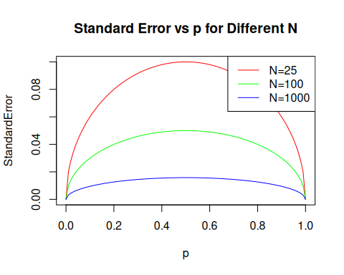

### 7. Expected value of $d$

The difference $d$ is $d=\overset{‾}{X}−\left(1−\overset{‾}{X}\right)$, which simplifies to $d=2\overset{‾}{X}−1$. The expected value of $d$ is $E\left(d\right)=2p−1$.

E_d <- 2 * p - 1  
E_d

## [1] 0

### 8. Standard error of $d$

Since $d=2\overset{‾}{X}−1$, the standard error of $d$ is $SE\left(d\right)=2×SE\left(\overset{‾}{X}\right)$.

SE_d <- 2 * SE_X_bar  
SE_d

## [1] 0.2

### 9. Standard error with $p=0.45$

If $p=0.45$, we can compute the standard error for $d$ with $N=25$.

p <- 0.45  
N <- 25  
SE_X_bar <- sqrt(p * (1 - p)) / sqrt(N)  
SE_d <- 2 * SE_X_bar  
SE_d

## [1] 0.1989975

### 10. Strategy for using $N=25$

Given the standard error computed above, you can evaluate whether the standard error is large relative to the difference and decide if the sample size is sufficient.