Chapter 5

Akanksha Garlapati

2024-09-27

1. **Find the ID of the novel “Pride and Prejudice”** using str_detect:

* library(gutenbergr)  
  library(dplyr)
* ##   
  ## Attaching package: 'dplyr'
* ## The following objects are masked from 'package:stats':  
  ##   
  ## filter, lag
* ## The following objects are masked from 'package:base':  
  ##   
  ## intersect, setdiff, setequal, union
* library(stringr)  
  pride_id <- gutenberg_metadata %>%  
   filter(str_detect(title, "Pride and Prejudice"))  
  pride_id
* ## # A tibble: 7 × 8  
  ## gutenberg_id title author gutenberg_author_id language gutenberg_bookshelf  
  ## <int> <chr> <chr> <int> <chr> <chr>   
  ## 1 1342 Pride an… Auste… 68 en "Best Books Ever L…  
  ## 2 20686 Pride an… Auste… 68 en "Best Books Ever L…  
  ## 3 20687 Pride an… Auste… 68 en "Harvard Classics/…  
  ## 4 26301 Pride an… Auste… 68 en "Best Books Ever L…  
  ## 5 37431 Pride an… Auste… 68 en ""   
  ## 6 37431 Pride an… MacKa… 38839 en ""   
  ## 7 42671 Pride an… Auste… 68 en "Best Books Ever L…  
  ## # ℹ 2 more variables: rights <chr>, has_text <lgl>

1. **Use gutenberg_works()** to filter and find the correct ID for “Pride and Prejudice”:

* pride_id_filtered <- gutenberg_works() %>%  
   filter(str_detect(title, "Pride and Prejudice"))  
  pride_id_filtered
* ## # A tibble: 3 × 8  
  ## gutenberg_id title author gutenberg_author_id language gutenberg_bookshelf  
  ## <int> <chr> <chr> <int> <chr> <chr>   
  ## 1 1342 Pride an… Auste… 68 en "Best Books Ever L…  
  ## 2 37431 Pride an… Auste… 68 en ""   
  ## 3 37431 Pride an… MacKa… 38839 en ""   
  ## # ℹ 2 more variables: rights <chr>, has_text <lgl>

1. **Download the text of “Pride and Prejudice”** using the gutenberg_download function:

* book <- gutenberg_download(pride_id_filtered$gutenberg_id)
* ## Determining mirror for Project Gutenberg from https://www.gutenberg.org/robot/harvest
* ## Using mirror http://aleph.gutenberg.org
* ## Warning: ! Could not download a book at http://aleph.gutenberg.org/1/3/4/1342/1342.zip.  
  ## ℹ The book may have been archived.  
  ## ℹ Alternatively, You may need to select a different mirror.  
  ## → See https://www.gutenberg.org/MIRRORS.ALL for options.

1. **Create a tidy table of words** from the book text using the tidytext package:

* library(tidytext)  
  words <- book %>%  
   unnest_tokens(word, text)

1. **Add a column for the word number** (useful for later plotting):

* words <- words %>%  
   mutate(word_number = row_number())

1. **Remove stop words and numbers** from the words object using anti_join:

* data("stop_words")  
  words_clean <- words %>%  
   anti_join(stop_words, by = "word") %>%  
   filter(!str_detect(word, "^\\d+$"))

1. **Assign sentiment values** to each word using the AFINN lexicon:

* afinn <- get_sentiments("afinn")  
  words_sentiment <- words_clean %>%  
   inner_join(afinn, by = "word")

1. **Plot sentiment score versus word location** and add a smoother:

* library(ggplot2)  
  ggplot(words_sentiment, aes(x = word_number, y = value)) +  
   geom_line() +  
   geom_smooth(method = "loess") +  
   labs(x = "Word Number", y = "Sentiment Score", title = "Sentiment Score vs Location")
* ## `geom_smooth()` using formula = 'y ~ x'
* 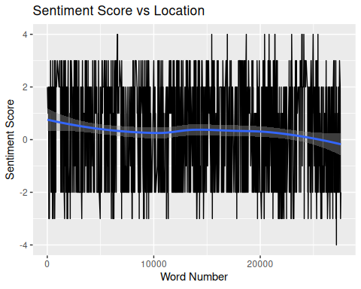

1. **Convert word locations to pages** (assuming 300 words per page) and plot average sentiment by page:

* words_sentiment <- words_sentiment %>%  
   mutate(page = word_number %/% 300)  
    
  page_sentiment <- words_sentiment %>%  
   group_by(page) %>%  
   summarize(avg_sentiment = mean(value, na.rm = TRUE))  
    
  ggplot(page_sentiment, aes(x = page, y = avg_sentiment)) +  
   geom_line() +  
   geom_smooth(method = "loess") +  
   labs(x = "Page", y = "Average Sentiment", title = "Average Sentiment by Page")
* ## `geom_smooth()` using formula = 'y ~ x'
* 