Assignment Workbook

Winter 2020

Revision History

|  |  |  |  |
| --- | --- | --- | --- |
| **Date** | **Issue** | **Description** | **Author** |
| February 7, 2020 | Assignment 2 | Adding Glossary | Abdelkader Ouda |
| February 7, 2020 | Assignment 2 | Adding system actors | Abdelkader Ouda |
| February 8, 2020 | Assignment 2 | Adding system use cases | Abdelkader Ouda |
| February 8, 2020 | Assignment 2 | Adding use case diagram | Abdelkader Ouda |
| March 19, 2020 | Assignment3 | Adding classes | Zhuoran Zhang |
| March 19, 2020 | Assignment3 | Adding class diagram | Zhuoran Zhang |
| March 19, 2020 | Assignment3 | Adding revised classes | Zhuoran Zhang |
| March 19, 2020 | Assignment3 | Adding revised class diagram | Zhuoran Zhang |

Table of Contents

iCLINIC System Glossary 4

1.1 Introduction 4

1.2 Glossary 4

iCLINIC System Actors 5

iCLINIC System Use cases 6

iCLINIC System Use Case Diagram 8

# iCLINIC System Glossary

## Introduction

This document is used to define terminology specific to the problem domain, explaining terms, which may be unfamiliar to the reader of the use-case descriptions or other project documents. Often, this document can be used as an informal *data dictionary*, capturing data definitions so that use-case descriptions and other project documents can focus on what the system must do with the information.

## Glossary

The glossary contains the working definitions for the key concepts in the iCLINIC System.

|  |  |
| --- | --- |
| Term | definition |
| Authentication | Authentication is the process of determining whether someone or something is, in fact, who or what it is declared to be. |
| User account | A user is a person who uses iCLINIC system. Each user should have an account in order to be identified by iCLINIC. To login to an account, a user is typically required to authenticate himself/herself with a password or other credentials for the purposes of accounting, security, logging, and resource management. |
| User friendly interface | It is a computer application screen that makes it easier for novices to use this application. Menu-driven programs, for example, are considered more user-friendly than command-driven systems. Graphical user interfaces (GUIs) are also considered user-friendly. |
| Physicians | A physician is a professional who practices medicine, which is concerned with promoting, maintaining or restoring human health through the study, diagnosis, and treatment of disease, injury, and other physical and mental impairments. |
| Digital ink | Refers to technology that digitally represents handwriting in its natural form. In a typical digital ink system, a digitizer is laid under or over an LCD screen to create an electromagnetic field that can capture the movement of a special-purpose pen, or stylus, and record the movement on the LCD screen. The effect is like writing on paper with liquid ink. The recorded handwriting can then be saved as handwriting or converted to typewritten text using handwriting recognition technology. |
| UI component | UI stands for User Interface. It is a junction between a user and a computer program. An interface is a set of commands or menus through which a user communicates with a program. |
| PDF Document | Portable Document Format (PDF) is a file format used to present and exchange documents reliably, independent of software, hardware, or operating system. |
| Pen-based document | Any document that is created using tablet and stylus as pointing devices in addition to handwriting recognition capability. |
| Windows-based desktop computers | A desktop computer is a personal computer powered by Microsoft Windows operating system in a form intended for regular use at a single location desk/table due to its size and power requirements. |
| Tablet PCs | A tablet PC, commonly shortened to tablet, is a mobile computer with a touchscreen display, circuitry, and battery in a single device. |

# iCLINIC System Actors

The first useful step to analyze the system functionality is to look in the problem statement at the things that interact with the system. In UML use case analysis, these external things are called **actors**. Actors are identified based on the following:

* Actors are always external to the system – they are therefore outside our control.
* Actors interact directly with the system.
* Actors represent roles that people and things play in relation to the system, not specific people or specific things.
* Each actor has a unique name and description.

|  |  |
| --- | --- |
| Actor | Description |
| iCLINIC User | A general user interacting with iCLINIC system. This general user can be a doctor, a nurse, or the system administrator. We will use the name “worker” to refer to a doctor or a nurse. In order to this general user to use iCLINIC, he/she needs to successfully login to the system. |
| iCLINIC Admin | A special type of iCLINIC User who is responsible for ensuring around-the-clock technical maintenance and support. This normally includes maintaining workers accounts and the connectivity issues with the drugs management system. |
| iCLINIC Worker | A special type of iCLINIC User who wish to use iCLINIC system to automate the paper-based processes and to speed up its data entry related tasks. |

# iCLINIC System Use cases

|  |  |
| --- | --- |
| Use Case | Description |
| Authenticate User | iCLINIC shall provide a functionality to authenticate its user by using a pen only. The user taps his name and can "ink" his password in the box. The user can of course also type (typically using the on-screen keyboard) into the box if desired. Once the user has logged in, the set of controls dynamically changes to match the permissions of this account. Note that, each user should be successfully authenticated before using any of iCLINIC functionalities. |
| Manage Worker Account | iCLINIC shall provide the functionality for the system administrator to create user accounts for doctors and nurses to use iCLINIC according to a set of access controls predefined for each user type. The administrator account itself is shipped with the system. |
| Display iCLINIC Board | iCLINIC shall provide the functionality for its workers to show a list of existing patients corresponding to the geographic unit view. |
| Assign Patient | iCLINIC shall provide the ability for its workers to browse through the provided list of patients exist in the iCLINIC Board, select one or more patients and assign himself to them. |
| Display Palette | Display Palette UC shall provide a graphical user interface GUI to help simplify the choosing of documents among large number of potential documents. It's one tablet screen in size so the user can see all choices in one view which consists of a series of buttons for the user to tap on. The Palette shall be able to manage larger number of document choices than can fit on one screen. |
| Display My Board | iCLINIC shall provide the functionality for its workers to show only the active patients list of the logged-on worker, and hence My Board view can be different for doctors and nurses. |
| Manage Document | iCLINIC shall allow the workers to create a new document. It is a text-based document and the works shall be able to modify its contents.  This document will be saved in a PDF format and will be tagged with the patient’s a metadata. This metadata includes Patient ID, Date of creation/imported, the user ID of the creator/importer, Modification date, the user ID of the modifier, Brief description.  This UC includes two UCs Manage Text Insertion and Recognize Drug names. |
| Manage Text Insertion | This is a supplier UC for the Mange Document UC that shall allow the workers to insert different types of text into the new and/or the old documents created by the base UC. This text can be any paragraph that describes treatments, drug orders, or prescriptions. |
| Recognize Drug Names | This is a supplier UC for the Mange Document UC that shall allow iCLINIC to recognize generic and brand drug names during the text insertion process to help auto completion capability. This information will be extracted from a common repository managed by the Drugs Management System. |
| Import Images | This UC provides a tool to import images using a scanner or by browsing the internal stored image files into the application. These imported files will then be converted to PDFs, to become a part of the iCLINIC documents repository. |
| Manage Patient Record | This UC shall allow that workers at iCLINIC to maintain (add, modify) patient records. Patient’s record includes (but not limited to) the following information: ID, name, address, date of birth, height, weight, bloodGroup, BedID, Treatment area. Each patient record will be associated with zero or more treatment records and a set of digital documents. |

# iCLINIC System Use Case Diagram

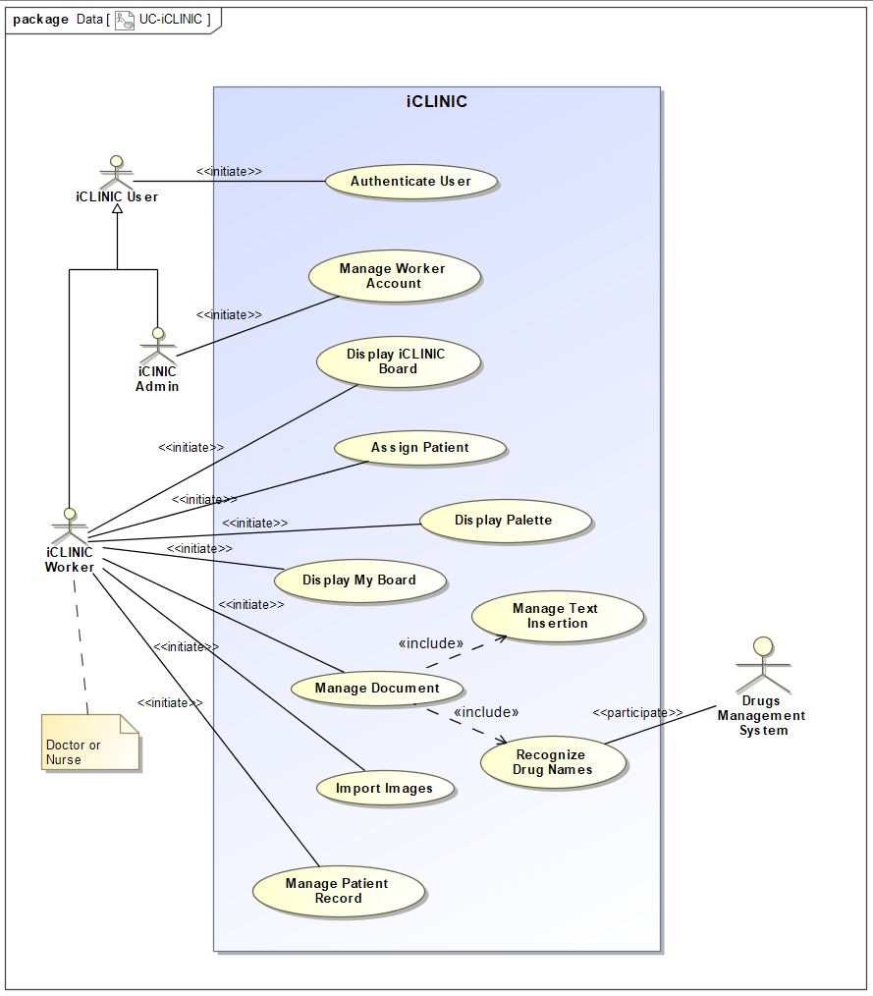

# List of Candidate Classes

|  |
| --- |
| iCLINICBoard |
| iCLINICBoardController |
| MainPage |
| MainPageController |
| Palette |
| MyBoard |
| MyBoardController |
| LoginMenu |
| LoginMenuController |
| DocManager |
| DocManagerController |
| Patient |
| Worker |
| Administrator |
| MetaData |
| Drug |
| Image |
| Document |
| Device |
| AddNewPatient |
| AddNewPatientController |
| EditDeletePatient |
| EditDeletePatientController |
| CreateNewWorker |
| CreateNewWorkerController |
| EditDeleteWorker |
| EditDeleteWorkerController |

# Potential iCLINIC Classes

|  |  |  |
| --- | --- | --- |
| Class Name | Class Type | Brief Description |
| ICLINICBoard | Boundary | The iCLINIC Board provides a list of patients that they can add them to their MyBoard. Holds attributes for Patients. |
| ICLINICBoardController | Control | Controls iCLINIC Board and manages its initialization, display and user interaction. Also informs the user that the patient is added into the personal list of a worker. |
| Palette | Boundary | The Palette class contains GUI for users to choose documents from a large number of selections. The Palette comes with a series of buttons for the user to click on. The GUI is in a tablet size. |
| PaletteController | Control | The class that controls the initialization, display and user interaction of Palette. |
| AddNewPatient | Boundary | The class that allows a GUI for users to add patients into their own lists. the info is stored in Patients Class. |
| AddNewPatientController | Control | This Class controls the initialization, display and user interactions of the user with AddNewPatient GUI. |
| EditDeletePatient | Boundary | This class allows Workers in the system to edit and delete patient within the system. |
| EditDeletePatientController | Control | This controller is responsible for the initialization, display and interaction of the class EditDeletePatient. Also informs the user if the operation (edit, delete) is performed |
| MyBoard | Boundary | This class is for workers to access the patients that are assigned under their own names. |
| MyBoardController | Control | This class is responsible for the initialization, display and user interactions of My Board. |
| LoginMenu | Boundary | This menu allows the system to authorize the workers to use the system. Users can “Ink” their passwords under their chosen IDs |
| LoginMenuController | Control | The Class that is used for controlling LoginMenu, itsinitialization, display and its user interaction. |
| CreateNewWorker | Boundary | Allows the administrator to add new worker into the system. Through a GUI form so that administrators are able to add one new worker at a time |
| CreateNewWorkerController | Control | The controller that manages the AddNewWorker which is the class that adds new workers. Is in charge of the initialization, display and user interactions. |
| EditDeleteWorker | Boundary | This class provides a GUI that administrators can modify or delete a worker’s information through a form. |
| EditDeleteWorkerController | Control | The class is used to manage EditDeleteWorker class and handle its initialization, display and user interactions. Also is responsible to inform user that the operation(Edit, Delete) is successful. |
| DocumentManager | Boundary | The class provides user a GUI to manage the documents (add, edit and delete)that the user has created. |
| DocumentManagerController | Control | The class is in charge of the display and user interaction of the DocumentManager class |
| Patient | Entity | This is the entity class of a patient that contains patients’ information and is used by ICLINICBoard and MyBoard |
| Worker | Entity | This is the entity class of a worker that contains workers’ information that is used by the class AddWorker and EditDeleteWorker |
| Administrator | Entity | This is the class that contains the information of the Administrators |
| MetaData | Entity | This is the class that contains the matadata that is attached to all the files within the repository, which is created by the workers. |
| Drug | Entity | This the entity class of the drug that is registered into the system. This class is controlled by the Drugs Management Syetem. |
| Document | Entity | This the class that holds the contents of the document and the format for it to be converted into pdf. |
| Images | Entity | The class that stores the information’s of the images that are waited to be converted to PDF |
| Account | Entity | The class that stores all the user information including username and password. |
| GeneralUser | Interface | The interface that Workers and Administrators inherits from, this class contains the name of the user and the workerID’s. |

# Potential iPermit class diagrams (entity classes only)

# Revised iPermit class diagram

1. Patient Class

|  |  |  |
| --- | --- | --- |
| Attribute Name | Attribute Type | Brief Description |
| name | String | The name of the patient |
| phone | Integer | The phone number of the patient |
| patientAddress | String | The home address of the patient |
| ID | Integer | The ID of the chosen patient that is distributed after registering |
| gender | String | The physical gender of the patient(Male/Female) |
| dateOfBirth | Date | The birthday of the patient |
| bedNumber | Integer | The bed number of the patient once the patient is |
| height | String | The physical height of the patient |
| weight | String | The weight of the patient |
| bloodType | String | The blood typoe of the patient |
| assignedBy | String | The name of the worker that assigned the patient. |

1. Worker Class

|  |  |  |
| --- | --- | --- |
| Attribute Name | Attribute Type | Brief Description |
| name | String | The real life name of the worker |
| phone | Integer | The phone number of the worker for contacts |
| address | String | The home address of the worker |
| age | Integer | The age of the worker |
| username | String | the username that was created after registered to work |
| password | String | The password for the worker to log into the system |
| createdBy | String | The admin that created this worker account |

1. Administrator Class

|  |  |  |
| --- | --- | --- |
| Attribute Name | Attribute Type | Brief Description |
| name | String | The real life name of the administrator |
| password | Integer | The password that is used to log in to the admin’s account |

1. Document Class

|  |  |  |
| --- | --- | --- |
| Attribute Name | Attribute Type | Brief Description |
| documentName | String | The name of the document |
| documentID | Integer | The ID of the document |

1. Drug Class

|  |  |  |
| --- | --- | --- |
| Attribute Name | Attribute Type | Brief Description |
| drugName | String | The name of the drug |
| drugID | Integer | The ID that the drug is registered in |
| drugType | String | The general type of the drug |

1. MetaData Class

|  |  |  |
| --- | --- | --- |
| Attribute Name | Attribute Type | Brief Description |
| patientID | Integer | The ID of the patient that the document or the Image was linked to |
| creationDate | Date | The creation date of the document |
| modificationDate | Date | The date that this document was modified |
| modifier | String | The person that modified |
| modificationLog | String | The log that shows the times when the user made changes to the system |

1. Image Class

|  |  |  |
| --- | --- | --- |
| Attribute Name | Attribute Type | Brief Description |
| imageID | Integer | The ID of the Image that it is belonged to |
| size | String | The size of the image for organizing the repository |

1. Account Class

|  |  |  |
| --- | --- | --- |
| Attribute Name | Attribute Type | Brief Description |
| username | String | The attributes that stores the name of the user (both worker and admin) |
| password | String | The password that was setup by the workers or the admins |

