Typography

Heading Font: fantasy

Paragraph Font: sans-serif, courier new, monospace

Navigation
Home The Secret Learn More About Me

Content
Home
Have you ever been scared of getting a divorce? What about ending up alone and never finding your partner? You aren’t alone! Lots of people feel this way, and having fears like that is completely realistic.
For every man feeling alone, there is another babe out there who wants love just as much. So, you may ask, how do I find the right babe? And how do I build a relationship that will last through all the hard times? Well let’s find out!
Did you know that a third of men above 20 in the U.S. today have been divorced? And out of that 33%, another third doesn’t ever remarry?
Did you know that 25% of 40-year-olds in the U.S. have never been married? And if that doesn’t surprise you, wait until you realize that 45 years ago it was only 6%
Did you know that at any given time, around 38% of the adult male population in the U.S. is living without a partner, neither married nor living together.

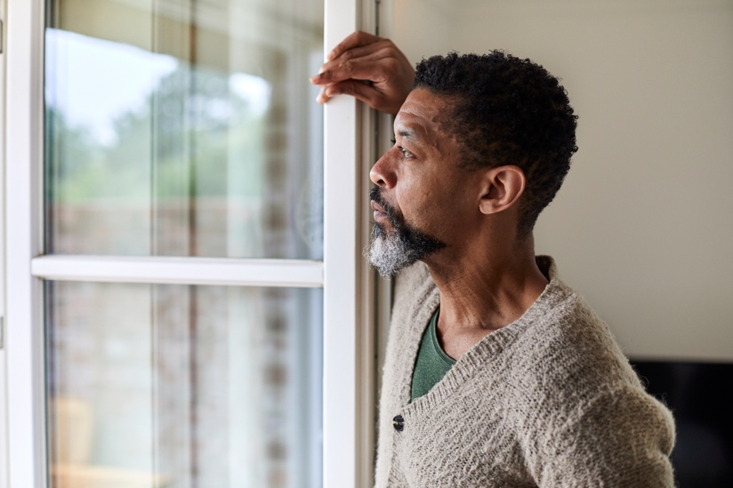
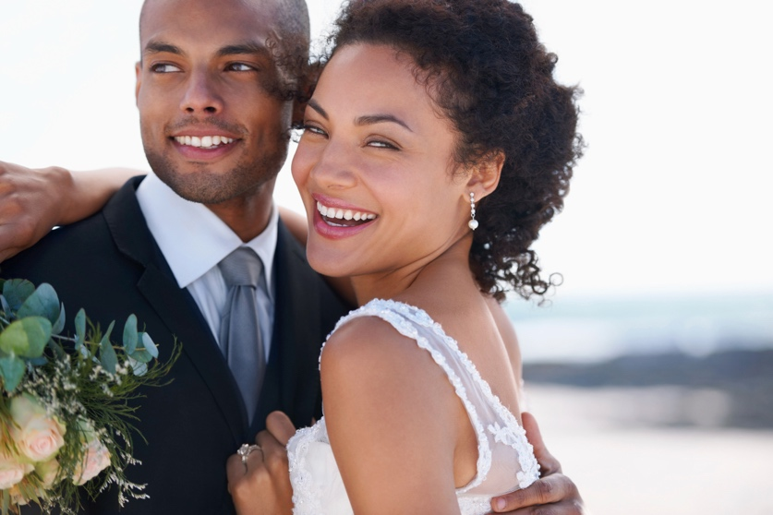
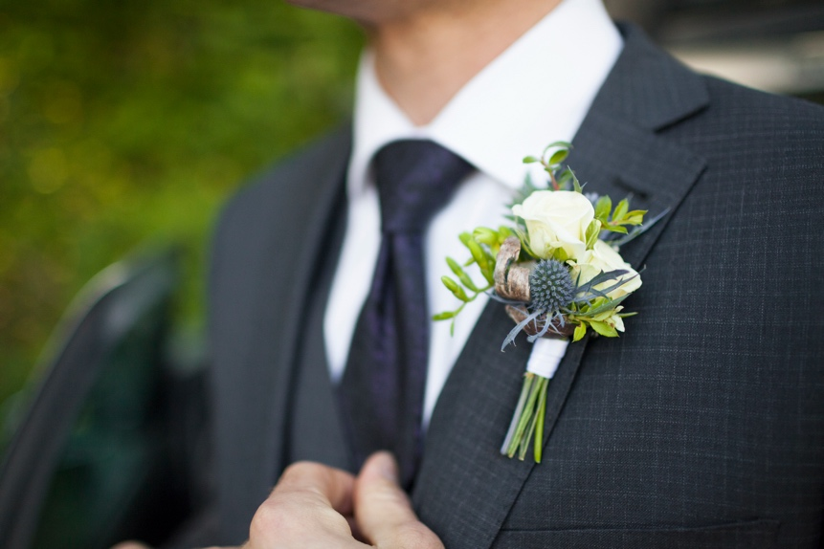

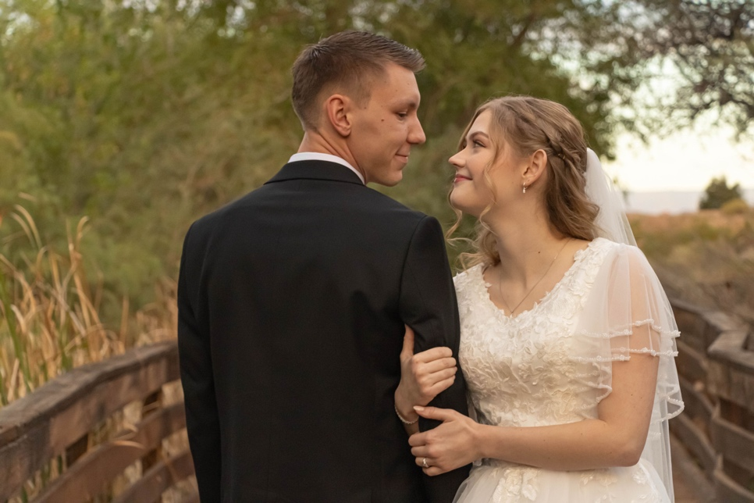


The Secret
It can be difficult to pinpoint one “great secret” when it comes to relationships. It is highly unlikely that you will walk out of one specific conversation and realize that you are suddenly ready for the perfect relationship. It is all about having the patience to build the necessary skills and attitudes necessary to being in a successful relationship with a babe.
There are two parts to building these skills: before the relationship, and during the relationship. Before you get into a relationship, for example, you need to love yourself and who you are as a person. Attempting to build this self-love while learning to love your babe is extremely difficult, and it will either be forgotten while trying to build other skills, or it will take priority over the relationship and both parties will suffer. Now this isn’t to say that the skills you build before a relationship won’t grow during it, because they will- I can promise you that.
I personally tried to fight my way into relationships with babes while being willing to lower my standards or change who I was in order to get a certain babe. It wasn’t until I was okay with who I was- and willing to find a babe who loved me like that- when I found the babe I would someday marry. And after we started dating, my self-confidence slowly grew over time to be so much more than it ever could have been on my own. But I needed to get to where I was first.
Now for the second part- building skills during the relationship. There is no perfect relationship. If you want one, stop it. If you think you have one, wake up. If you have a fight with your babe, don’t give up. The key to making a relationship work is communication and validation. These are skills that you build while in a relationship. You can’t practice listening and communicating if you have nobody to talk to.
When your babe is having a hard time with something- whether it’s you, something that happened with her friends, or something from work, it really doesn’t matter. The way you should respond to your babe is always the same: with validation. Listen to her, show her that you are. Body language is more important than you know. When she is done talking, let her know that you hear her, and understand why she is feeling that way. Don’t immediately jump to the conclusion! Resist that urge, it will only make your babe think that you aren’t hearing her.
I have known many people who have gone through a divorce, and this skill is one of many that they have pinpointed to as the cause. Your relationship with your babe can get very toxic very quick if you don’t know how to validate her feelings. Don’t throw away a perfectly good babe! Learn how to implement this ability in your relationship as soon as possible.
Here is a great video that demonstrates this skill:
It’s not about the nail: https://www.youtube.com/watch?v=-4EDhdAHrOg

The next key skill is learning to communicate. Whenever there is a problem, communicate about it. When your babe does something that hurts you, tell her about it. Key components to healthy communication include:
- Communicate with love, not anger; if you can’t help but be angry, take a minute to calm down and wait to talk
- Listen to understand, not to respond
- Use “I” statements, not “you” statements (example: “I felt hurt when you…”- not “You were so mean to…”)
- Communicate quickly after the incident, don’t wait too long
Think of what other communication skills you can implement!

Building a relationship that lasts is well worth the work it takes. My babe and I are happy in our marriage, but that doesn’t mean that we don’t have struggles every now and then. And I didn’t get a babe right out of the gate either. I failed time and time again trying to get babes that likely knew I had no idea what I was doing. I am so grateful for the skills I have learned over the years that have led me to be in a healthy relationship. I may not know you personally, but I know that you too can find a babe- your forever babe.

To learn more, I recommend you read these books:
- Permission to Feel – Marc Brackett
- The Peacegiver – James Ferrell
- Hold Me Tight – Sue Johnson
- How to Avoid Falling in Love with a Jerk – John Van Epp

Some more info about me:
I was married October 17, 2025, to Kaylyn Ashcraft. We met in High School and were dating for over three years before we got married. But for the record, two of those years were a distance relationship. I love, more than anything, to spend time with my wife. We love to watch tv shows, read books, and go on walks together. I also love to play games with my brothers and collect Lego Star Wars.
If you want to contact me, I would love to talk more!
Message me through LinkedIn or Facebook!
Wireframes

