**Test File**

This is just a sample file, with a picture of a puppy and whatnot.

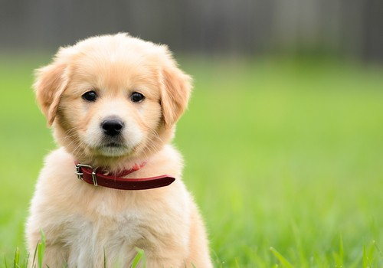

*jonkriz @ Flickr (CC BY 2.0)*Source: <https://www.flickr.com/photos/27587002@N07/5170590074>