國立成功大學
材料科學及工程學系
碩士論文

運用機器學習設計鋰電池電解液分子
Electrolyte molecule design by using machine learning

研究生：吳明修
指導教授：許文東 博士
中華民國 一百零九 年 九 月

中文摘要

Abstract
Electrolyte molecule design by using machine learning
Ming-Hsiu Wu
Wen-Dung Hsu
Department of Materials Science and Engineering
National Cheng Kung University
Hierarchical Green-energy Materials (Hi-GEM) Research Center
SUMMARY
Recently, high-voltage Lithium-ion batteries (LIBs) has gained a lot of attraction because of the potential application in electric vehicles. However, conventional carbonate solvent-based electrolytes are less stable against high-voltage cathodes. In this thesis, machine learning to design new electrolytes for high-voltage Lithium-ion battery have been discussed. We set up different filters for electrolyte molecular selection. Among these filters, the two important parameters for characterizing electrolytes are electron affinity (EA) and ionization energy (IE). Machine learning models are trained to predict IE/EA from molecular structures. Additionally, we develop an algorithm which can automatically modify given molecules by adding functional groups. Next, the machine learning model allows us to screen these generated molecules at a large scale and select ideal molecules. Furthermore, the generative model, variational autoencoder, was applied to carry out inverse design to generate ideal molecules. The machine learning techniques lead to a new way to create brand new functional molecules for electrolyte without doing complicated calculations and costly experiments. The methods could serve as a first step design towards further investigation into other necessary properties of electrolytes for high-performance LIBs.
Keywords: lithium-ion battery, electrolyte, machine learning

Acknowledgements

Table of Contents
Abstract II
Acknowledgements III
Table of Contents IV
List of Tables VI
List of Figures VII
Chapter 1 Introduction 8
Chapter 2 Literature Review 9
2.1 Lithium-ion battery electrolyte 9
2.2 Experiments, first-principles calculation, and machine learning 9
2.3 Molecular design and machine learning 10
Chapter 3 Calculation methods and Machine learning 13
3.1 Introduction to first-principles calculation 13
3.1.1 Introduction to Density functional theory (DFT) 13
3.1.2 The variational principle for ground state 14
3.1.3 Hartree fock theory 14
3.1.4 The Hohenberg-Kohn (HK) theorem 15
3.1.5 The Kohn-Shan equations 16
3.2 The conception of machine learning 17
3.2.1 The introduction of Artificial Neural network 19
3.2.2 Convolution neural network 22
3.2.3 Recurrent neural network (RNN) 24
3.2.4 Autoencoder and Variational autoencoder 25
3.2.5 Data splitting 27
3.3 Molecular representation 27
3.3.1 Extended Connectivity Fingerprint (ECFP) 28
3.3.2 Simplified molecular-input line-entry system (SMILES) 29
3.3.3 Coulombic matrix (CM) 30
3.4 Machine learning model architecture 30
Chapter 4 Results and Discussions 31
4.1 The evaluation of different property predictor 31
Chapter 5 Conclusions 32
Reference 33
Appendix 35

List of Tables

List of Figures

Introduction
In recent years, with a high demand on electric vehicle, developing safe and efficient high-voltage lithium-ion battery become more and more urgent[1]. However, the decomposition of traditional organic electrolyte compounds during charging and discharging significantly impedes the development. Therefore, it is desired to design new electrolyte molecules that can withstand in high voltage to replace alkyl carbonate. In this thesis, we work on designing electrolyte molecules by functional group modification and machine learning method.
Figure 2. 1 The chemical potential of lithium-ion battery

Literature Review

Lithium-ion battery electrolyte
Electrolyte plays an important role in the lithium-ion battery. It serves as the medium that enables lithium ions to move back and forth easily between the cathode and anode. The electrolyte is mainly composed of salts, solvents and additives. The salts can provide a concentration gradient of lithium-ion, which is help for enhancing the movement of lithium-ion between electrodes. LiPF₆ is a widely used lithium salt. The solvents are organic liquids used to dissolve the salts and usually the mixtures of alkyl carbonates dimethyl, diethyl, and ethyl-methyl carbonates (EC, DMC, DEC, EMC, respectively). The additives, such as Propane Sultone (PS) and Vinylene carbonate (VC), are added in small amounts for improve performance and other properties. Electrolyte created in this way only allows ions to move to the electrodes and doesn’t let electrons to pass.
Some important challenges are listed

Experiments, first-principles calculation, and machine learning
Conventional molecules design is a time-consuming, laborious, as well as expert-based mission. The most common method is trial-and-error. Countless material development experiments are often evitable, and whole process is often high investment involved, no matter in time or human power. Historically, the time scale for development of new material, from laboratory to commercial application, is about 15 to 20 years[2]. The number of possible small molecular structures are estimated to be about on the order of 10⁶⁰[3], constituting well-known chemical space. It is almost impossible to explore this space via conventional trial-and-error experimental method. First-principles calculation can provide material developers another approach which circumvents the arduousness of experimentation. By quantum mechanics, physical and chemical properties of these molecules can be exactly obtained through solving Schrodinger equation. First-principles calculation strategy significantly reduces the cost of developing new molecules, though vast chemical space still cannot be efficiently exploited, and virtually only little part of molecules in the world has been investigated until now.
The conception of machine learning has existed for a long time since Arthur Samuel first came up with the phrase “Machine Learning” in 1952. However, the lack of material data significantly impeded the development of machine learning in material science field. During the past ten years, a large amount of data including material structures and its corresponding properties have been accumulated, especially from first-principles calculation. Hence, the power of machine learning has drawn people’s attention away from conventional methods. Recent years have seen a dramatic proliferation of research concerned with unveiling the relationship between material structures and their properties from existing data. Gradually, machine learning become a powerful method for investigating materials at a large scale in the initial stage of material design.

Molecular design and machine learning
In this work, several aforementioned strategies for molecule selection have been utilized, which indeed significantly accelerate the pace of material development. In conventional material design. The properties of specific material or molecular structure could be obtained through experiments or simulations. But the process is not quietly efficient as mentioned above since exploring chemical space at large scale is a daunting task. Another strategy has been proposed – starting with desired molecular properties, and inversely searching for ideal molecular structures[4, 5]. The process is known as inverse design. Inverse design can be approached in many different methods. One of these methods is high-throughput virtual screening (HTVS)[6, 7]. HTVS allow developers or researchers rapidly screen millions of molecules and enable them to identify promising molecules. Candidate molecules will be further evaluated by more expensive methodologies. HTVS methodology has been successful at designing high-performing molecules. For example, in organic photovoltaics, molecules have been screened for their HOMO/LUMO energies and photovoltaic conversion efficiency[8, 9]. For organic light-emitting diodes, molecules have been screened for their singlet-triplet gap and photoluminescent emission[10].
Another approach is harnessing the power of deep generative model. The goal of generative model is learning how to generate data whose distribution is like the original data set. Generative model can be successfully applied in many different domains, such as image regeneration, audio regeneration and even drug discovery and molecule regeneration. There have been three main generative models mainly used in molecular generation: Variational autoencoder (VAE)[11, 12], Generative adversarial network (GAN)[13, 14], and reinforcement learning(RL)[15, 16]. Here, we will not describe the details of the underlying mechanism of each model, but just briefly introduce them. VAE is derived from autoencoder (AE) shown as Figure 2. 3(b). AE consists of an encoder and a decoder. Encoder is responsible for compressing molecular representation into a vector in low-dimensional space, known as latent space. Decoder aims for transform a vector back to original molecular representation. Nevertheless, because the sparse of latent space created by AE make it difficult to exploit the space, a probability distribution has been introduced by VAE in order to fill uncovered latent space. Therefore, a molecule is not mapping as a fixed point in the latent space, but as a probability distribution, usually Gaussian distribution. The continuous representation of molecules in latent space allow us to generate molecule easily by simple operation, such as decoding random sampling vector, perturbing known chemical structure, or interpolating between molecules. Another generative model is GAN. In this frame work, generator competes against discriminator. Generator attempt to generate artificial data from sampling noise space. Discriminator is responsible for determining whether the data is fake or real. The goal of this model is that generator has ability to generate data which discriminator cannot distinguish as fake. As a result, we can generate new molecules from the generator. The last one is reinforcement learning (RL), which has been seen as the most promising model in molecular design recently. The mechanism of RL is that the generator learns how to take action in order to maximize the reward (properties) within an environment (SMILES generation).

Figure 2. 3 Graphical diagram of machine learning application to molecular design. The figure was adapted from Kang et al[27] (a) property prediction, (b) autoencoder, (c) variational autoencoder proposed by Bombarelli et al[21], (d) variational condition autoencoder proposed by Kang et al[27]

Calculation methods and Machine learning

Introduction to first-principles calculation
First-principles calculation is a kind of method of calculating properties directly based on the law of quantum mechanics without introducing fitting parameters or empirical modeling. Starting from the Coulomb interaction between atomic nucleus, electron-atomic nucleus and electrons, this method provides detailed insight into the origin of mechanical, electronic, optical and magnetic properties of materials and molecules. Thanks to the great advancement of the computer performance, the implementation of first-principles calculation for many body systems has become more feasible with lower cost, and thus the method has been widely used for materials research. The method not only promotes a deeper understanding of existing materials, but also can predict properties of new materials for material design.

Introduction to Density functional theory (DFT)
The holy grail in solid state physics is the solution of the time-independent Schrödinger equation. It can be written as
$\hat{Η}Ψ\left(r_{1},r_{2},…,r_{N}{,R}_{1},R_{2},…,R_{M}\right)$= $EΨ\left(r_{1},r_{2},…,R_{1},R_{2},…\right)$
$\hat{Η}$ is the Hamiltonian for a system including N electrons and M nuclei. $Ψ\left(r_{1},r_{2},…,R_{1},R_{2},…\right) is$a wavefunction of coordinates of all electrons and ions.
Hamiltonian $\hat{Η}$ can be written as
$$\hat{Η} = -\sum_{i=1}^{N}{\frac{ℏ^{2}}{2m_{e}}}∇_{i}^{2} -\sum_{A=1}^{M}{\frac{ℏ^{2}}{2m_{A}}}∇_{A}^{2} + \frac{1}{4πϵ_{0}}\frac{1}{2}\sum_{A=1}^{M}{\sum_{B>A}^{M}{\frac{Z_{A}Z_{B}e^{2}}{\left|R_{A}-R_{B}\right|}}} + \frac{1}{4πϵ_{0}}\frac{1}{2}\sum_{i=1}^{N}{\sum_{j>i}^{N}{\frac{e^{2}}{\left|r_{i}-r_{j}\right|}}}-\frac{1}{4πϵ_{0}}\sum_{A=1}^{M}{\sum_{i=1}^{N}{\frac{Z_{A}e^{2}}{\left|R_{A}-r_{i}\right|}}}$$
Here, i and j denote the N electrons while A and B represent the M nuclei. The first two terms are the kinetic energy of the electron and nuclei. The other three terms represent the electrostatic potential energy of nucleus- nucleus, electron-electron, and nucleus-electron interaction.
Born-Oppenheimer approximation was introduced to reduce this equation and separate this problem into the electron-structure problem and the nuclear problem.
The approximation goes that the nuclei move much slower than the electrons because of the larger mass of nucleus. We can consider the electrons moving in the field of fixed nuclei. Therefore, the nuclear kinetic energy is zero and their potential energy is merely a constant. The electronic Hamiltonian can be reduced to
$${\hat{Η}}_{electron} = -\sum_{i=1}^{N}{\frac{ℏ^{2}}{2m_{e}}}∇_{i}^{2} + \frac{1}{4πϵ_{0}}\frac{1}{2}\sum_{i=1}^{N}{\sum_{j>i}^{N}{\frac{e^{2}}{\left|r_{i}-r_{j}\right|}}}-\frac{1}{4πϵ_{0}}\sum_{A=1}^{M}{\sum_{i=1}^{N}{\frac{Z_{A}e^{2}}{\left|R_{A}-r_{i}\right|}}}= \hat{T} + {\hat{V}}_{ee} +{\hat{V}}_{Ne}$$
The solution of the Schrödinger equation is the electronic wave function $Ψ_{electron }$and the electronic energy${ E}_{electron }$. The total energy $E_{ total }$is the sum of ${ E}_{electron }$and the constant nuclear potential term${ E}_{nucleu }.$

The variational principle for ground state
Given a wavefunction $Ψ$, the expectation value of the system energy is
$$E[Ψ] = 〈Ψ|\hat{Η}|Ψ〉$$
We can employ the variational theorem, which states that the energy computed from a guessed wavefunction $Ψ$ is an upper bound to the true-ground state energy${ E}_{0 }$.
$${ E}_{0 }= E[Ψ_{0}]$$

Hartree fock theory
Now, we need to deal with the wave function $Ψ_{ }$, but no one can truly describe this function. In the theory of Hartree fock, Pauli Exclusion Principle is taken into consideration, and the electron ground state wave function is approximated as an antisymmetric product of N orthonormal spin orbitals $Ψ_{i}(r)$, as known Slater Determinant.
$$Ψ_{0} ≈ Ψ_{HF} = \frac{1}{\sqrt{N!}}\left|\begin{matrix}Ψ_{1}(x_{1}) & Ψ_{2}(x_{1}) & ⋯ & Ψ_{N}(x_{1}) \\ Ψ_{1}(x_{2}) & Ψ_{2}(x_{2}) & ⋯ & Ψ_{N}(x_{2}) \\ ⋮ & ⋮ & & ⋮ \\ Ψ_{1}(x_{N}) & Ψ_{2}(x_{N}) & ⋯ & Ψ_{N}(x_{N})\end{matrix}\right|$$
The energy (expectation value of the Hamiltonian operator with $Ψ_{HF}$) can be written
$$E_{HF}\left[Ψ_{HF}\right]=〈Ψ_{HF}\left|\hat{Η}\right|Ψ_{HF}〉=\sum_{i=1}^{N}{Η_{i} + \frac{1}{2}}\sum_{i,j=1}^{N}{\left(J_{ij}-K_{ij}\right)}$$
$$Η_{i} ≡ \int{Ψ_{i}^{*}(x)\left[-\frac{1}{2}∇_{ }^{2}-V_{ext}(x)\right] Ψ_{i}^{ }(x) }dx$$
$Η_{i}$describe the electron kinetic energy and electron-nucleus interaction. And $J_{ij} and K_{ij}$ are coulomb term and exchange term, respectively. The coulomb operator $J_{ij}$ represents the potential an electron experience from the average charge distribution of another electron. The $K_{ij}$ is the exchange contribution to the HF potential.

The Hohenberg-Kohn (HK) theorem
Hohenberg-Kohn theorem reformulate the many-body system in terms of the density and demonstrates that the electron density uniquely determines the Hamiltonian operator and thus all the properties of the system. It proposes two theorems. The first theorem is for any electronic system an external potential $V_{ext}(\overset{⃑}{r})$ is determined uniquely by the ground state electron density $ρ(\overset{⃑}{r})$. The second theorem is the ground state energy can be obtained variationally which means the density that minimize the total energy is the exact ground state density. According to the Hohenberg-Kohn theorem, the total energy can be written as
$$E\left[ρ\right]=E_{Ne}\left[ρ\right]+T\left[ρ\right]+E_{ee}\left[ρ\right]=\int{ρ\left(\overset{⃑}{r}\right)}V_{Ne}\left(\overset{⃑}{r}\right)d\overset{⃑}{r} + F_{HK}\left[ρ\right]$$
$$F_{HK}\left[ρ\right] = T\left[ρ\right]+E_{ee}\left[ρ\right]$$
The energy functional have been separated into a universal part $F_{HK}\left[ρ\right]$ (independent on the system) and a system dependent part $E_{Ne}\left[ρ\right]$. The functional $F_{HK}\left[ρ\right]$ describes the functional for the kinetic energy $T\left[ρ\right]$ and that for the electron-electron interaction $E_{ee}\left[ρ\right]$. And the functional $E_{ee}\left[ρ\right]$ can be decomposed into
$$E_{ee}\left[ρ\right] = \frac{1}{2}\iint{\frac{ρ\left({\overset{⃑}{r}}_{1}\right)ρ\left({\overset{⃑}{r}}_{2}\right)}{r_{12}}}d{\overset{⃑}{r}}_{1}d{\overset{⃑}{r}}_{2} +E_{ncl}^{ } = J[ρ] +E_{ncl}^{ }$$
$J[ρ]$ is the classical electron-electron coulomb potential and $E_{xc}^{true}$ term is the non-classical contribution to electron-electron interaction (self-interaction correction, exchange and Coulomb correlation). But, the explicit form of the functional $T\left[ρ\right]$ and $E_{ncl}^{ }$ becomes the major challenge of density functional theory. HK-DFT is in principle exact but impractical. Later, Kohn-Sham approach attempt to solve this problem.

The Kohn-Shan equations
The theory assumes that ground state density of interacting system is equal to that of some non-interacting system which is soluble but including some approximation. The term $F\left[ρ\right]$ could be reformulated as
$$F\left[ρ\right] =T_{s}\left[ρ\right]+{J\left[ρ\right] +E}_{xc}\left[ρ\right]$$
where$T_{s}\left[ρ\right]$ represents the kinetic energy of non-interacting particles, and $E_{xc}\left[ρ\right]$, the so-called exchange-correlation is defined as
$$E_{xc}\left[ρ\right] ≡ (T\left[ρ\right] - T_{s}\left[ρ\right]) + (E_{ee}\left[ρ\right] - J\left[ρ\right])$$
The exchange and correlation energy $E_{xc}\left[ρ\right]$ contains everything that is unknown. The Kohn-Sham one-particle equations is
$$\left(-\frac{1}{2}∇_{ }^{2}+ V_{ext}(r) + V_{H}(r)+V_{xc}(r)\right)Ψ_{i}^{ }(r) = {ϵ_{i}Ψ}_{i}^{ }(r)$$
Where $Ψ_{i}^{ }(r)$ is KS orbital and $ϵ_{i}$ is KS eigen energy.

The conception of machine learning
Formally, machine learning is the science of getting computers to accomplish a task without a set of rules defined by human. In field of machine learning, the underlying algorithm is selected or designed by human. The machine learning algorithms learn the knowledge or the parameters from data. In other words, a data set is used to train a mathematical model so that when it sees similar data in the future, it knows what to do with it. Models typically take data as an input and then output a prediction of something of interest. As the large amount of data has been accumulated, machine learning gain momentum and gradually become indispensable in many different fields, such as web search, computational biology, finance, robotics, information extraction, and social network. There are mainly four types of machine learning nowadays: supervised learning, unsupervised learning, semi-supervised learning, and reinforcement learning.
The first one is supervised learning, the machine learns from a set of data including example input and example output. Given there are enough input-output data, the machine can learn the relationship between input and output and construct a robust model. From there, the model can be used to predict unknown outputs from known input. In reality, the supervised learning problem can be divided into classification and regression. The aim of classification problem is to determine which category the given input data belongs to. The prediction output is typically discrete type. A classical example is categorizing animal picture into a cat or a dog. As for the problem of regression, the output is continuous type. For example, the model could predict someone’s age from some features. In this work, we have tried to use molecular features to predict their IE/EA. Since the value of IE/EA is continuous type, this study belongs to supervised learning regression problem. The biggest challenge of supervised learning is that it required a large amount of labeled data, but in general labeling the data will entail a large amount of manpower.
The second one is unsupervised learning. Unsupervised learning is for situation where there is only a set of input data but no output target. Therefore, we cannot make predictions. Instead, the most common mothed in unsupervised learning is cluster analysis. Its aim is to find a hidden pattern in data by grouping similar things together.
The next one is semi-supervised learning. In the most of cases the amount of labeled data is scarce, which is not enough to train a good model, and most of data is unlabeled. The ultimate point of unsupervised learning is to make use of unlabeled data to make a better prediction, not just from labeled data.
The last one is reinforcement learning. The central concept of reinforcement learning is based on an “agent” (a computer or robot) that is interacting with an “environment” (here defined as everything that is not the agent). The agent performs actions on the environment (for instance, a robot takes a step forward). Then, the environments will then provide some sort of feedback to the agent, usually in a form called the “reward.”
The agent’s ultimate goal is to maximize the reward. Critically, no one is telling the agent how to maximize the reward or explaining why it gets a reward. the agent needs to figure out how to take actions and observe its environment by itself.

The introduction of Artificial Neural network
The artificial neural network is a kind of machine learning model. It mimics the physiology and functioning of our biological neuron. The basic unit of artificial neural network is neuron. It receives the input from other neuron or external sources and computes an output. Each input ($x$) is multiplied by a weight (w), which is associate with its relative importance to other input. Next, the neuron is applied an activation function ($σ)$ to the sum of its weighted input and a bias ($b$), and the output is y. The purpose of the activation function is to introduce non-linearity into the output of a neuron.
Now that we can combine many neurons into a complicated neural network, also
called multi-layer perceptron. The neural network can consist of an input layer, hidden layers, and an output layer. The input layer provides information from the outside world to the network. No computation is performed in any of the Input neurons – they just pass on the information to the hidden neurons. The hidden layer is responsible for computations and transfer information from the input neurons to the output neurons. The output layer also performs computations and transfer the information from the neural network to the outside. Like this neural network, the information moves in only one direction from the input layer, through the hidden layers to the output layer. There are no cycles or loops in the network. We call feedforward network. Later, another kind of neural network will be introduced, called recurrent neural network where the connections between the nodes form a cycle.

We can start to “train” our neural network. The first step is that we feed input data into the network, and through a series of calculation, the output target is obtained. Secondly, we try to evaluate the difference between the output target we predict and the real one. The measurement of this difference is called lost function or cost function. The details of loss function will be discussed in another section. Now our mission is adjusting the weights and biases in the network to minimize the loss function. Here the iterative algorithm gradient descent is applied to optimize the parameters. The gradient show how much the weights need to change (in positive or negative direction) to minimize the loss function. The gradient descent can be written in mathematical equation
$$w = w - α\frac{∂Loss}{∂w}$$
where w is the weight which needs to be updated, loss is the loss function, and $α$ is the learning rate. We can imagine that the learning rate is like a step size, the amount that the weight is updated. If the gradient is bigger, the learning rate times the gradient is also bigger, which means we can take a larger step to reach the lowest point. On the contrary, if the gradient is smaller, we need to take a little step since we are quite close to the lowest point, otherwise we will miss the point. But how to deal with the term $\frac{∂Loss}{∂w}$ ? For a complex neural network, it is really hard to calculate this term by using Analytical differentiation approach. Therefore, the theory of backpropagation had been proposed to solve this problem. Here, I will demonstrate the conception of backpropagation by using a simple neural network mentioned above. This neural network can be expressed in term of computational graph.
$$z = wx+b$$
$$y = σ(z)$$
$L$and $y_{t}$ correspond to the loss function and the true value. Now, making use of the chain rule of calculus, we can express the gradient of L with respect to the weights and bias as
$$\frac{∂L}{∂w} = \frac{∂L}{∂y}\frac{∂y}{∂z}\frac{∂z}{∂w}$$
$$\frac{∂L}{∂b} = \frac{∂L}{∂y}\frac{∂y}{∂z}\frac{∂z}{∂b}$$
As you can see in the equations above, we calculate the gradient starting from the end of the computational graph and proceed backward to get the gradient of the loss with respect to the weights (or the biases). The evaluation of the gradient $\frac{∂L}{∂b}$ can reuse some calculations ($\frac{∂L}{∂y}\frac{∂y}{∂z}$) performed during the evaluation of the gradient $\frac{∂L}{∂w}$, which is more efficient than the previous approach. This backward process is called backpropagation.

Convolution neural network
Convolution neural network (CNN) is a kind of artificial neural network. It can extract important features from images, and further make prediction or decision. There has been considerable application in the domain of computer vision. CNN mainly consist of convolution layer, pooling layer, and fully connected layer. A Convolution layer contains a several of filters, also called kernels, whose parameters will be learned in the process of training. These filters perform convolution operations as it is scanning the input with respect to its dimensions, as figure.
Next, the pooling layer is used to reduce the spatial dimension, typically applied after a convolution layer. In particular, max and average pooling are two kinds of pooling methods where the maximum and average value is taken, respectively.
In practice, there are multiple convolution layers and pooling layers in a CNN architecture. Finally, the fully connected layer was fed into the result of previous process and make the final classification decision.

Recurrent neural network (RNN)
The purpose of invention of RNN is to make use of sequential data, such as text document and biological data. For a traditional neural network, all inputs (and outputs) are independent of each other. But for many tasks the conventional model is not consistent with real situation anymore. The sequence of data should be taken into account. For example, if we want to predict the next word in a sentence you should consider which words came before it. RNNs allow previous neuron’s outputs to be used as next one’s inputs. Another way to think about RNNs is that they have a “memory” which captures information about what has been calculated before. They are typically as follow
The above diagram shows how an RNN works. By unfolding we simply mean that we express the network at a different point in time. $x_{t}$ is the input at time step t. For example, $x_{t}$could be a one-hot vector corresponding to the word of a sentence. $s_{t}$ is the hidden state at time step t. It’s the “memory” of the network. $S_{t}$is calculated from the previous hidden state and the input at the current step: $s_{t}$= f ($U × x_{t}$ + W $×s_{t-1})$. The function f usually is a nonlinearity such as tanh or relu. $O_{t}$ is the output at step t. $O_{t}$= f ($V×s_{t})$. According to different prediction tasks, there are different type of RNN, namely one to many, many to one, and many to many.

Generative model
In this section, I attempt to introduce some conceptions which are necessary for understanding of the generative model.

Bayes Theorem
Bayes Theorem is a way of finding a probability of the hypothesis when we know a certain probability of an evidence. Given a hypothesis H and evidence E, Bayes' theorem states that the probability of the hypothesis before getting the evidence is P(H) and the probability of the hypothesis after getting the evidence is P(H|E). It can be denoted as
$$P(H|E) = \frac{P(E|H)P(H)}{P(E)}$$
where $P(H)$ is called prior probability, $P(E)$ is called evidence probability, $P(E|H)$ is likelihood probability, and $P(H|E)$ is posterior probability.

Entropy
In the information theory, Shannon introduced the idea of information entropy in his 1948 paper "A Mathematical Theory of Communication" and defined entropy as a measure of the average information content associated with a random outcome. An intuitive understanding of information entropy relates to the amount of uncertainty about an event associated with a given probability distribution. Entropy H for an event X with n possible outcomes and probabilities $(p(x_{1}),...,p(x_{n}))$ is defined as
$$H(X) = H(p(x_{1}),...,p(x_{n})) = -\sum_{i =1}^{n}{p(x_{i})}\log{p(x_{i})}$$

cross entropy
The next one is cross entropy. cross-entropy is commonly used to quantify the difference between two probability distributions. Usually the "true" distribution (the one that our machine learning algorithm is trying to match) is expressed in terms of a one-hot distribution. And it can be defined as
$$H(p,q) =-\sum_{i =1}^{n}{p(x_{i})}\log{q(x_{i})}$$
where $p(x)$ is the original probability, and$q(x)$ is the approximating probability.

Kullback-Leibler Divergence
Kullback-Leibler Divergence (KL divergence) is also a measure of quantifying the difference between two probability distributions and KL divergence is always non-negative. With KL divergence we can calculate exactly how much information is lost when we approximate one distribution with original distribution. It can be denoted as
$$D_{KL}\left(p | \left|q\right)=-\sum_{i =1}^{n}{p\left(x_{i}\right)}×(log{p\left(x_{i}\right)}-\log{q\left(x_{i}\right)}\right) ≥ 0$$
The more common way to see KL divergence written is as follows:
$$D_{KL}\left(p | \left|q\right)=-\sum_{i =1}^{n}{p(x_{i}}\right)\log{\frac{p\left(x_{i}\right)}{q\left(x_{i}\right)}} ≥ 0$$

Autoencoder
Autoencoder is a kind of machine learning model. It consists of an encoder and a decoder, as figure shown, and their architecture can be neural networks. An encoder is responsible for catching important feature from the data and compressing the data into a fix-dimension vector or a point in multi-dimensional space. The space is called latent space; The mission of a decoder is to reconstruct the data from a vector in the latent space. In the ideal situation an encoder should grasp all the important information and a decoder should reconstruct the data perfectly. Any information of the data should not be lost in the process of encoding and decoding.
So, how to train an autoencoder? We feed the model with data, comparing the data the decoder reconstructs with the initial data and backpropagate the error through the architecture to update the weights of the networks. Once the autoencoder has been trained, we could take a point randomly from that latent space and decode it to get new data. However, lack of regularity (or well-organized) of the latent space largely impede the performance of new data generation. Therefore, the emergence of variational autoencoder (VAE) attempt to solve this problem.

Variational autoencoder
For VAE, the data is not encoded as a point in latent space anymore, instead as a distribution over latent space. The encoder of a VAE yields an approximate posterior distribution $q_{θ}(z|x)$, and is parametrized on a neural network by weights collectively denoted $θ$. Similarly, the decoder of VAE yields a likelihood distribution $p_{ϕ}(x|z)$, and is parametrized on a neural network by weights collectively denoted $ϕ$. The latent distribution $p(z)$ is often designed as Gaussian distribution so that an encoder has to be trained to learn the mean$σ$, and the covariance matrix $μ$, that describe the Gaussian distribution, and then a point is sampled to yield the input of decoder, as figure shown. How to define the loss function of VAE? Let’s us think out about the KL divergence between the approximate posterior distributions $q_{θ}(z|x)$ and the real posterior distributions $p(z|x)$, it can be denoted as
$$D_{kL}(q_{θ}(z|x)||p(z|x)) = -\int{q_{θ}(z|x)}\log\left(\frac{p(z|x)}{q_{θ}(z|x)}\right)dz ≥ 0$$
applying Bayes’ theorem to the above equation yields,
$$D_{kL}(q_{θ}(z|x)||p(z|x)) = -\int{q_{θ}(z|x)}\log\left(\frac{p_{ϕ}(x|z)p(z)}{q_{θ}(z|x)p(x)}\right)dz ≥ 0$$
after a series of simplification,
$$\log{p(x)} ≥ \int{q_{θ}(z|x)}\log\left(\frac{p(z)}{q_{θ}(z|x)}\right)dz + \int{q_{θ}(z|x)}\log{p_{ϕ}(x|z)}dz$$
or
$$\log{p(x)} ≥ -D_{kL}(q_{θ}(z|x)||p(z)){+ Ε_{\sim q_{θ}(z|x)}\left[\log{p_{ϕ}(x|z)}\right] }$$
the right-hand side of the above equation is the Evidence Lower Bound (ELBO) also known as the variational lower bound. Our goal is to maximize the ELBO and then maximize the log probability of our data. The ELBO can be separated into two different terms – regularization term (the distribution different between the approximate posterior and the latent distribution) and reconstruction term (a measure of the difference between the data the decoder reconstructs with the initial data).
Given $p(z)$ is a standard normal distribution (N(0,1)), we get
$$-D_{kL}(q_{θ}(z|x)||p(z)) = \frac{1}{2} \left[1 + \log{(σ^{2})-σ^{2}-μ^{2}}\right]$$
when combined with ELBO, the objective function we need to maximize is
$$\frac{1}{2} \left[1 + \log{(σ^{2})-σ^{2}-μ^{2}}\right] + Ε_{\sim q_{θ}(z|x)}\left[\log{p_{ϕ}(x|z)}\right]$$
and we can regard loss function as the negative of objective function,
$$L = -\frac{1}{2} \left[1 + \log{(σ^{2})-σ^{2}-μ^{2}}\right] -Ε_{\sim q_{θ}(z|x)}\left[\log{p_{ϕ}(x|z)}\right]$$
Our mission is to seek the optimal network parameters $(θ^{*}, ϕ^{*})$ that minimize $L$
$$(θ^{*}, ϕ^{*}) = {argmin}_{(θ,ϕ)} L(θ,ϕ)$$
Actually, if we want to improve the performance of generation, two properties should be fulfilled – continuity (two close points sample from latent space should share the similar feature) and completeness (a point sampled from the latent space should give “meaningful” content once decoded). By introducing the conception of distribution, the two properties are obtained with the regularization term.

Data splitting
The ultimate goal of training a machine learning model is to predict every instance precisely. How to efficiently make use of the data we have? Usually, the data are split into three different set – training set, validation set, and testing set. Training set is for tuning the parameters (weights and biases) in a machine learning model. Validation set is to provide an unbiased evaluation of a model while tuning model hyperparameters, such as the number of hidden layers, learning rate, and the number of epochs. The last one, testing set, is to provide an unbiased evaluation of a final model fit on the training dataset. The common ratios used are 70% training, 15% validation, 15% test and 80% training, 10% validation, 10% test.
Another important data splitting skill is k-fold cross-validation which is a statistical method to estimate the performance of machine learning models. It is commonly used for comparing and selecting a machine learning model for a given predictive problem because it has a lower bias than the other methods. We also use this technique to evaluate the performances of our different property predictors. In the procedure, a specific value for k is chosen, which refers to the number of groups that a given data sample is to be split into. For example, if k = 10, then it will be called 10-fold cross-validation. After splitting the dataset into k groups, one of groups is taken as the testing set, while the remaining groups are regarded as training set. The results of a k-fold cross-validation is often the mean of the metric score for the testing sets.

Molecular representation
Recent years machine learning has been regarded as a burgeoning method for the application to molecular design. Machine learning model has been used as property predictor aiming to predict molecular properties from its structure by learning implicit relation between them. The model could accurately predict thousands of molecules within minutes. Previous works have successfully integrated this technology into molecule screening pipelines[17, 18]. In machine learning framework, molecular structures are transformed into digital representation that serve as input for machine learning model. Two ideal attributes for molecular representation are uniqueness and invertibility. Uniqueness means that a specific molecule can only be represented by a unique molecular representation. Invertibility means molecular representation can be transformed back to a specific single molecule. Actually, not every representation has both two properties. There are mainly two types of representation, including 3D geometry and 2D molecular graphs. The latter can be further subdivided into four categories: string-based, image-based, tensor, and others. In the following, we will briefly describe the Extended Connectivity Fingerprint (ECFP)[19], Simplified molecular-input line-entry system (SMILES)[20], and coulombic matrix[17] methods.

SYBYL

Extended Connectivity Fingerprint (ECFP)
ECFP is a topological fingerprint which originally is used for analysis of molecular characterization, substructure and similarity. Nowadays, it is also adopted to perform machine learning and statistical analysis of molecules. It basically has four steps: 1. Assign each atom with an identifier 2. Atom identifiers are augmented with information from the atom neighborhood 3. Delete the duplicated substructure 4. Hash list of identifiers into a fixed-length bit vector. It does not have the attribute of invertibility. Divided molecular substructure cannot be recombined together into original molecule exactly. Furthermore, due to the fixed length bit vector, each bit may represent multiple substructures, which often leads to the difficulty on analysis. It is worth mentioning that initially each binary bit represents whether the substructure exists in a molecule or not, but herein this study the bit is replaced with the number of the substructure in molecule, as so-called ECFPNUM. ECFPNUM is further used for molecular representation since it is more suitable for property prediction than ECFP.

Simplified molecular-input line-entry system (SMILES)
SMILES is a molecular representation in the form of a line notation for describing the molecular structure by using ASCll characters. For example, a benzene is denoted in the form of SMILES as c1ccccc1. It is the most popular representation in the field of machine learning, since it follows particular grammar syntax and can be directly applied into natural language processing (NLP) models. In practice, because many machine learning algorithms cannot process characters(strings) as input directly, it has to be converted into numeric form. The way to standardize converting SMILES into numeric form is first setting every different character as an atom-type. Then for a given molecule every character of its SMILES is converted into bit-vectors formed by the atom-types. The bit-vectors then combined follow the sequence of characters appearing in its SMILES to form a binary matrix which can directly operate as machine learning input. This scheme is known as one-hot encoding. Invertibility is a main advantage of SMILES, since one-hot encoding representation can be converted back to original molecules directly. SMILES, however, also suffers drawback at the same time. One molecule can have multiple SMILES representations. The non-uniqueness SMILES stem from the arbitrary starting atom in a molecule can be used to construct its SMILES. Some cheminformatic packages, such as RDKit[21], have the function to canonize the SMILES. However, Bjerrum et al argues that the latent space created from canonical SMILES may have problem, since only specific grammar syntax has been learned, instead of general underlying rule of molecule structure[22].

Coulombic matrix (CM)
Coulombic matrix (CM) is a molecular representation to describe the electrostatic interaction between atoms in a molecule. It is calculated by the equation (1).
$M_{ij}^{Coulomb}=\left\{\begin{aligned}0.5Z_{i}^{2.4} for i = j \\ \frac{Z_{i}Z_{j}}{R_{ij}} for i ≠ j\end{aligned}\right.$ (1)
The diagonal element is the polynomial fit of the potential energy of atom itself (self-energy), while the off-diagonal elements correspond to the energy of coulombic interaction between pairs of different atoms in the molecules. The CM can be obtained by performing quantum mechanical calculations. Through the machine learning correlation between molecular structure and its CM could be revealed. Thus, the learned model has exhibited strong ability to predict molecular electronic properties. CM also suffers from a number of issues. Different number of atoms in a molecule lead to different size of coulombic matrix. The solution is to pad by the vacancy of matrix of little molecule. Another issue is that different atom labeling scheme lead to different CM. A simple solution to this is to simply sort the matrices in the order of specific atomic property.

Data
There are only few online accessible databases containing EA and IE values, such as Material Project (MP)[23]and National Institute of Standards and Technology (NIST). MP has about 35336 molecular structures and its corresponding IE and EA values (not every molecule labeled both EA and IE) which are acquired through quantum mechanical calculation (continuously updated). The computational details are Anion (-1), cation (+1), and neutral structures are optimized separately in vacuum with the B3LYP DFT functional and the 6-31+G* basis set. And then vacuum frequency calculation is performed on all three structures to ensure that molecular structures reached a potential energy surface minima (no imaginary frequencies). Then single point calculation is performed on each optimized structure with the same basis and functional but also with an implicit solvent environment of dielectric = 78.3553 using the IEFPCM method. The IE is determined as
$$IE = E(cation) - E(neutral)$$
and the EA is determined as
$$EA = E(neutral) - E(anion)$$
Besides, MP provides user a convenient Application Programming Interface (API), so users can easily access the molecular data according to their need. NIST also stores molecular EA and IE values which are acquired by experiments. As NIST do not provide any API, it is hard for users to collect large number of data, and thus web crawling must be involved in automatic collection workflow. Additionally, QM9[17, 24] includes 133885 molecular SMILES and its corresponding Highest Occupied Molecular Orbital (HOMO) and Lowest Unoccupied Molecular Orbital (LUMO). The HOMO and LUMO can be roughly mapped to EA and IE, since there is high correlation between IE/HOMO and EA/LUMO. In terms of dipole moment and stability of molecule structure, as we know, there is a dipole moment database in NIST. At the same time, we are looking for chemical properties which can quantitative describe the stability of molecule. Furthermore, in order to train deep generative model, collecting a large number of molecules is necessary. In our work, six million molecular SMILES data from ZINC[25] is collected to train the deep generative model. ZINC is a free database of commercially-available compounds and contains over 750 million molecules that can be downloaded efficiently.

Results and Discussions

The evaluation of different property predictor
Here we build up four different property predictors. For the first model, the input of the model is ECFPNUM and the architecture is a three-hidden-layers fully connected neural network (NN). The second one’s input is the combination of ECFP and SYBYL, and the architecture is as same as the first one. The third model takes one-hot encoding SMILES as model’s input, and the architecture of the model is three-hidden-layer bi-directional GRU. The last model’s input is three-layers convolution neural network (CNN) jointing with a five-layers fully connected neural network. The data was collected from Material Project (MP)[23] which contains 21165 molecular structures and their corresponding values of IE and EA in the solvent state. In order to objectively evaluate the performance of different models. 10-fold cross-validation has been performed. The Adam are selected as optimization algorithm for the model training and the loss function is mean absolute error (MAE). The batch-size is 32 for all the experiments. Additionally, we attempt to study whether training two different models to predict IE and EA separately could have better performance than training one model to predict IE and EA together. And we are also curious about whether normalizing the value of IE/EA as the output of a model could enhance the prediction performance of a model. Therefore, we test our four different property predictors under four different conditions, namely IE/EA prediction separately without normalization (sep_w/o_nor), IE/EA prediction together without normalization (tog_w/o_nor), IE/EA prediction separately with normalization (sep_w_nor), and IE/EA prediction together with normalization (tog_w_nor). The property predictor performance is evaluated by mean absolute error (MAE) and root mean square error (RMSE) on the test set.

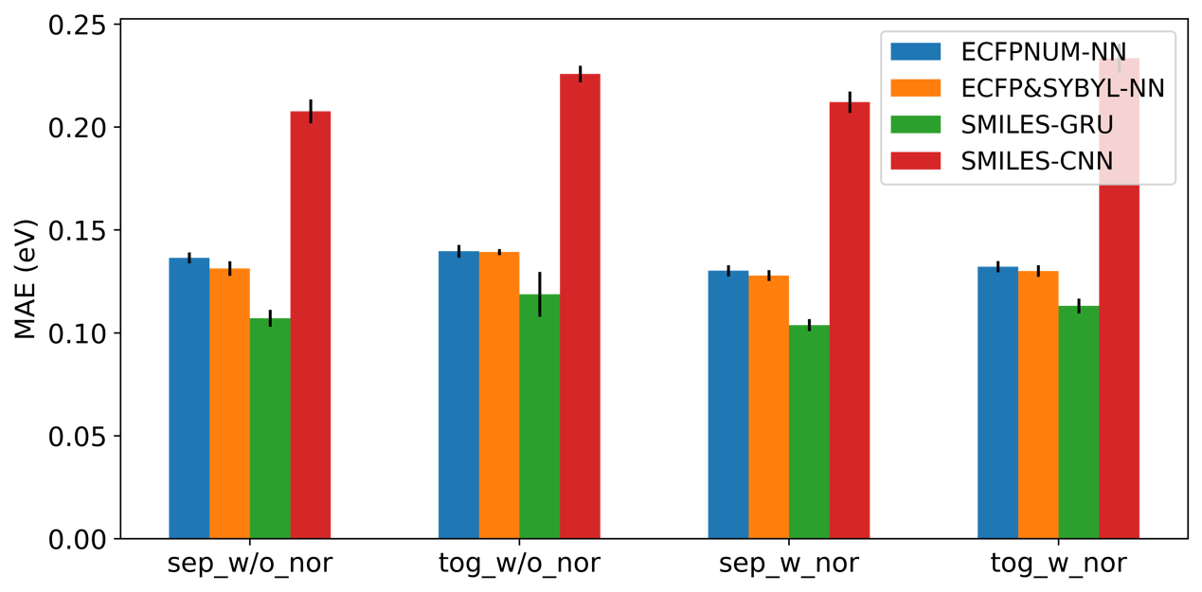
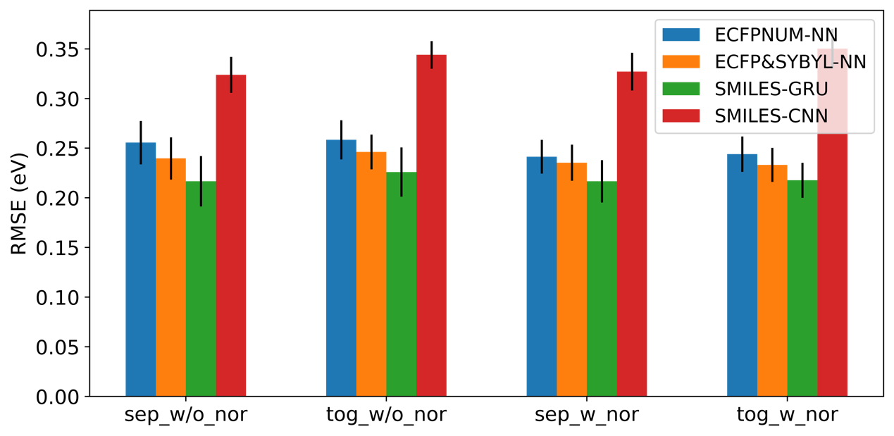

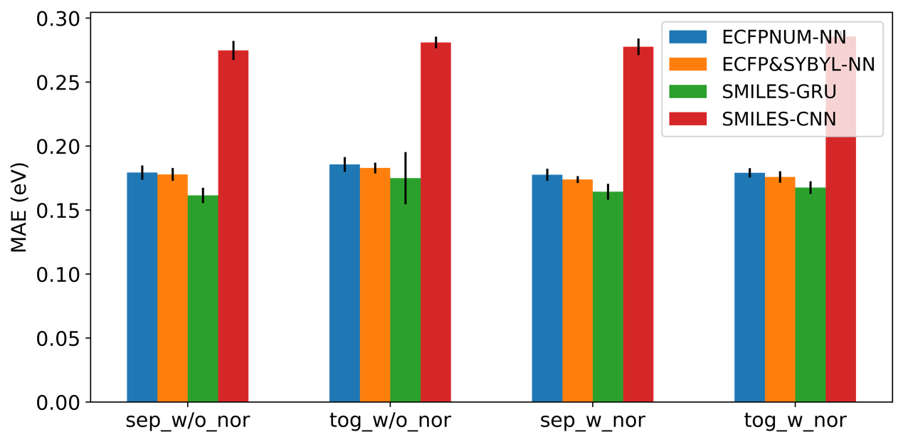
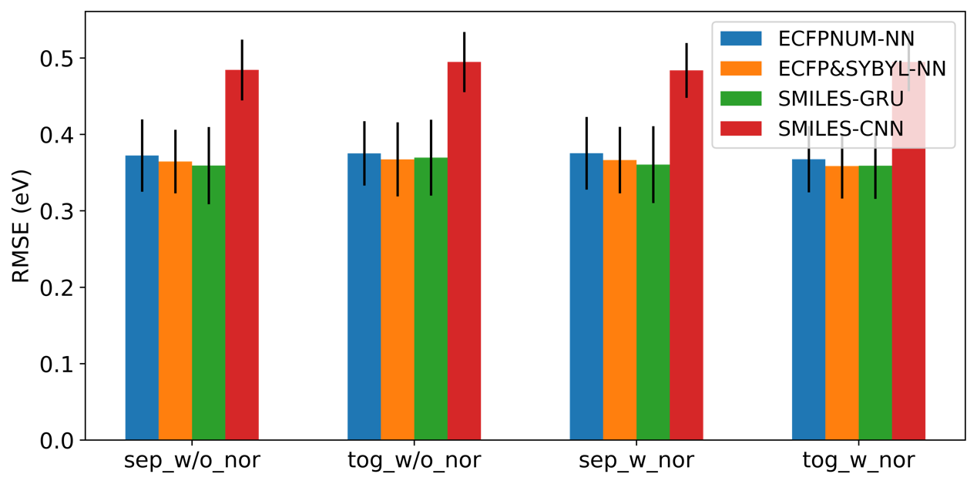
The result shows that one-hot encoding SMILES representation with bi-directional GRU model (SMILES-GRU) almost outperforms the other models for the IE prediction, but for the EA prediction the SMILES-GRU is not obviously beyond ECFPNUM-NN and ECFP&SYBYL-NN. Generally speaking, the prediction performance order is SMILES-GRU > ECFP&SYBYL-NN > ECFPNUM-NN > SMILES-CNN. Next, we find that training two different models to respectively predict IE and EA certainly increase the prediction performance a little bit. As for whether normalizing the value of IE/EA as the output of a model in the process of training, the result reveals that normalizing the data do not affect the performance of a model. Nevertheless, normalizing the data can dramatically reduce the training time. Training a bi-directional GRU model with data normalization only requires 100 epochs to converge, while without data normalization, it probably requires 200 epochs. Here we make a brief conclusion that separately training the models for IE/EA prediction and doing data normalization is an efficient strategy for training a property predictor. For the case of separately training the models for IE/EA prediction and doing data normalization, the mean MAE and the mean RMSE of the SMILES-GRU is 0.10 eV and 0.21 eV respectively for the IE prediction in ten-fold cross validation. As for the EA prediction, the mean MAE and the mean RMSE is 0.16 eV and 0.36 eV. Furthermore, this test reveals a fact that the performance of IE prediction is better than that of EA prediction. While the mean MAE difference between IE and EA is only about 0.06 eV, the mean RMSE difference is 0.15 eV, which means for the EA prediction the prediction error could vary much widely than IE prediction on different molecules, since the metric RMSE gives a relatively high weight to large errors. These errors are still large if one wants to do molecular selection which need the errors smaller than 0.1 eV or less. Thus, the models just provide us a tool to do the first screening of molecules from large-scale candidates. The more exact value should rely on more expensive verification method, such as first-principle calculations or experimental measurements.

The different between Gaussian09 and Q-chem
The first-principles calculation software Q-chem is utilized for the determination of IE/EA in the Material Project database[23]. If we try to validate the prediction result by the machine learning model, we have to use the same software to determine the IE/EA. However, we do not have this software available in our laboratory, and we attempt to utilize Gaussian09 as an alternative to Q-chem. In this section my work focuses on comparing the discrepancy between two commercial computational chemistry software – Q-chem and Gaussian. We randomly select 37 molecules from the MP database. Following the computation details of IE/EA calculation in MP database[23], we calculated the energy level of IE/EA by using Gaussian09. The calculation result is compared with the value of IE/EA calculated by Q-chem. The MAE is around 0.22 eV and 0.30 eV for IE and EA respectively.

Molecular generation from functional group modification
We develop an algorithm which can automatically add functional groups on a given molecule. The algorithm has been detailed in the section. Here, we respectively add three functional groups, which can be different or same, on the six different element atoms, namely S, N, P, B, C and O. Consequently, this algorithm generates 76614337 distinct molecules. We use three different property predictors (ECFPNUM-NN, ECFP&SYBYL-NN and SMILES-GRU) to screen these generated molecules. In order to replace common electrolyte molecule ethylene carbonate (EC) in high-voltage lithium-ion battery, the ideal molecule should be more stable than EC, in other words, the ideal molecule’s IE is higher than 8.44 eV (EC’s IE) and EA should be lower than 0.547 eV (EC’s EA).
the molecules’ Based on electrochemical stability window,

Molecular generation from Variational autoencoder
Since VAE has been introduced into molecular design in 2016 by Bombarelli et al, over forty works has been proposed by using different deep generative model and some variation of them. In this work, to design ideal molecules for electrolyte, two proposed models have been adapted to our generative model for designing electrolyte molecules. The first one is chemical VAE (chemvae), proposed by Bombarelli et al[11](Figure 2. 3(c)), and the other one, named conditional-molecular-design-ssvae (SSVAE), is proposed by Kang et al[26](Figure 2. 3(d)). In the frame of chemvae(Figure 2. 4), SMILES is transformed into a one-hot representation (x), and convolution neural network (CNN) is used as encoder to map x to latent space, z, with Gaussian distribution. The RNN decoder is to transform z back to one-hot representation, x. Additionally, another neural network, named property predictor, is mapping z to molecular properties. shows the structure of the model. The continuous representation of molecules in latent space allows us to generate molecule easily by simple operation, such as decoding random sampling vector, perturbing known chemical structure, or interpolating between molecules. This work also introduces the Gaussian process model to guide the search of ideal molecules efficiently in latent space. In Bombarelli’s model three components (encoder, decoder, and property predictor) were trained simultaneously. In this study, a small portion of the data used in this work is obtained from MP with IE/EA label and many other unlabeled molecules whose SMILES are from ZINC, hence the VAE and properties predictor cannot be trained simultaneously. A new approach is that VAE model can be trained by all the molecular SMILES from MP and ZINC first. After finishing VAE training, the encoders from VAE are extracted and combined with property predictor neural network for the next step of training MP data containing molecular SMILES and its corresponding properties. In order to preserve VAE system, in the process of training this property predictor, all the parameters in the encoder need to be freezed and only optimize the parameters of property predictor. However, the prediction performance of this model is not good enough to compare with our previous trained property predictors, since the parameters of encoder cannot be optimized accordingly. In Bombarelli’s original work, all the training data are labeled, but in our case the labeled data only counts a small portion of training data. The paper shows that latent space created by autoencoders jointly trained with the property prediction task shows a gradient by property values; molecules with high specific property values are located in one region,
Figure 2. 4 The structure of chemvae

and molecules with the low values are in another. Autoencoders that were trained without the property prediction task do not show a discernible pattern with respect to property values. It seems like encoder, decoder and property predictor if trained together molecules mapped in the latent space show property related distribution. Evidently, the chemvae model is not suitable for our case, since the molecules labeled with IE/EA only counts a small portion of all data in our case.
Figure 2. 5 The structure of SSVAE

In reality, small portion of molecules labeled with their properties is a very common situation in most database because the cost of acquiring properties is very expensive. Kang et al try to solve this problem and proposed conditional-molecular-design-ssvae (SSVAE)[26]. The model combined semi-supervised learning and conditional autoencoder together and allows us to directly generate new molecules whose properties are close to a predetermined target condition without any extra optimization procedure. In this frame work, the labeled data are used for building a property predictor which introduces the gaussian distribution in order to address the intractability of y. The missing y of unlabeled data are predicted by this property predictor. Next, the RNN encoder maps x and y to the latent space z, similarly introducing the gaussian distribution. Lastly, RNN decoder maps y and z to original x. The structure of SSVAE is shown in Figure 2. 5. In this work, MP data with IE/EA label and a large number of molecular SMILES from ZINC are used together to train the SSVAE model. Once the model is trained, we attempt to evaluate the ability of molecule generation. Based on setting a target IE/EA value, 1000 molecules from the decoder of SSVAE mode are generated then, screened by our previous mentioned SMILES(RNN) property predictor. Figure 2. 6 demonstrates that the value of IE distribution of all the original data and the generated molecules whose IE value were predicted by property predictor. Although the result is not as good as the paper reported [27], the trend of distribution is consistent with the increase of IE values. In this study, IE value is set to 4, 5 and 6 eV. The tolerance for the screening is 0.2 eV. The success rates are 15.3%, 22.9%, and 15.2% for 4, 5, and 6 eV, respectively.
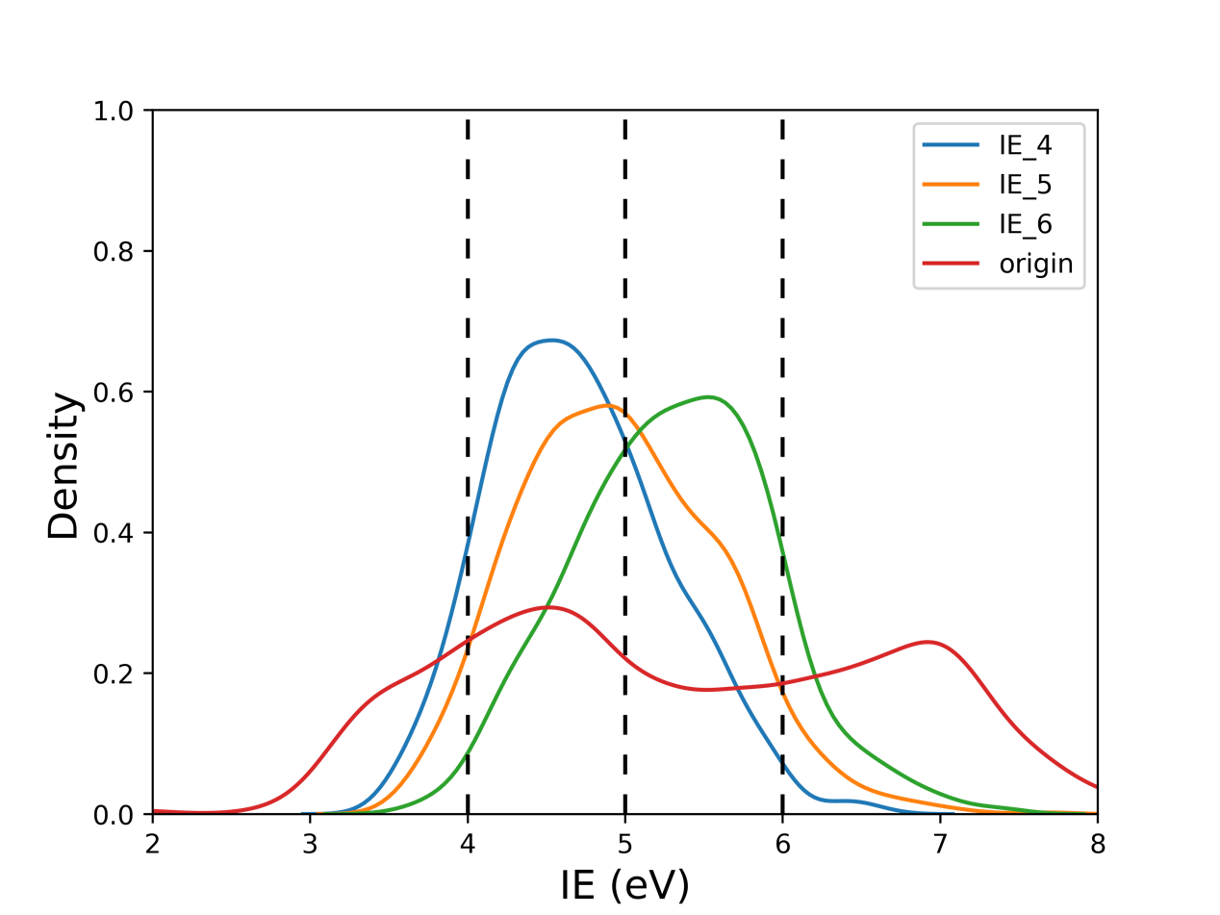

Conclusions
In this work, the power of advanced machine learning technology has been harnessed to design brand new electrolyte molecules which are suitable for high-voltage lithium-ion battery electrolyte. The energy level of IE/EA of molecules is regarded as a metric to gauge the potential of candidate molecule. Three property predictors which have ability to map molecular structure to its chemical properties (IE/EA) rapidly have been built. Among them, SMILES (one-hot encoding) with RNN has better prediction performance than the others. Furthermore, in order to carry out inverse design, the proposed generative model is adapted to our application. So far, new molecules with predetermined property values can be automatically generated. Nevertheless, unlike the other fields such as particular in speech recognition and computer vision, the scarcity of labeled data in material and molecular database significantly impedes the development of machine learning in this field. In addition, even though machine learning exhibits phenomenal prediction ability, the difficulty of interpreting machine learning models makes people hard to unveil the real latent relation between the molecule and its corresponding properties. Undoubtedly, machine learning in molecules and material design deserve more material or molecular knowledge involved. All in all, this work is expected to pave the way for resolutions to the aforementioned problems and electrolyte molecular design.

Reference
1. Sun, Y., N. Liu, and Y. Cui, Promises and challenges of nanomaterials for lithium-based rechargeable batteries. Nature Energy, 2016. 1(7): p. 16071.
2. Maine, E. and E. Garnsey, Commercializing generic technology: The case of advanced materials ventures. Res. Policy, 2006. 35(3): p. 375-393.
3. Virshup, A.M., et al., Stochastic voyages into uncharted chemical space produce a representative library of all possible drug-like compounds. J Am Chem Soc, 2013. 135(19): p. 7296-303.
4. and, C.K. and David N. Beratan*, Inverse Strategies for Molecular Design. J. Phys. Chem., 1996. 100(25): p. 10595-10599.
5. Zunger, A., Inverse design in search of materials with target functionalities. Nature Reviews Chemistry, 2018. 2(4): p. 1-16.
6. Broach, J. and J. Thorner, High-throughput screening for drug discovery. Nature, 1996. 384(6604): p. 14-16.
7. Discovery of small molecule cancer drugs: Successes, challenges and opportunities - Hoelder - 2012 - Molecular Oncology - Wiley Online Library. 2019.
8. Xiao, D., et al., Inverse Design and Synthesis of acac-Coumarin Anchors for Robust TiO2 Sensitization. J. Am. Chem. Soc., 2011. 133(23): p. 9014-9022.
9. S. A. Lopez, B.S.-L., J. de Goes Soares, A. Aspuru-Guzik, Design principles and top non-fullerene acceptor candidates for organic photovoltaics. Joule, 2017. 1(4): p. 857–870.
10. Gómez-Bombarelli, R., et al., Design of efficient molecular organic light-emitting diodes by a high-throughput virtual screening and experimental approach. Nature Materials, 2016. 15(10): p. 1120-1127.
11. Gómez-Bombarelli, R., et al., Automatic Chemical Design Using a Data-Driven Continuous Representation of Molecules. ACS Central Science, 2018. 4(2): p. 268-276.
12. Kingma, D.P. and M. Welling, Auto-Encoding Variational Bayes. 2013.
13. Goodfellow, I.J., et al., Generative Adversarial Networks. 2014.
14. Kadurin, A., et al., druGAN: An Advanced Generative Adversarial Autoencoder Model for de Novo Generation of New Molecules with Desired Molecular Properties in Silico. Mol Pharm, 2017. 14(9): p. 3098-3104.
15. Olivecrona, M., et al., Molecular de-novo design through deep reinforcement learning. Journal of Cheminformatics, 2017. 9(1): p. 1-14.
16. Popova, M., O. Isayev, and A. Tropsha, Deep reinforcement learning for de novo drug design. Science Advances, 2018. 4(7): p. 7885.
17. Rupp, M., et al., Fast and accurate modeling of molecular atomization energies with machine learning. Phys Rev Lett, 2012. 108(5): p. 058301.
18. Hansen, K., et al., Machine Learning Predictions of Molecular Properties: Accurate Many-Body Potentials and Nonlocality in Chemical Space. J Phys Chem Lett, 2015. 6(12): p. 2326-31.
19. Rogers, D. and M. Hahn, Extended-Connectivity Fingerprints. 2010.
20. Weininger, D., SMILES, a chemical language and information system. 1. Introduction to methodology and encoding rules. J. Chem. Inf. Comput. Sci., 2002. 28(1): p. 31-36.
21. Landrum, G., RDKit: Open-source cheminformatics.
22. Sattarov., E.J.B.a.B., Improving Chemical Au- toencoder Latent Space and Molecular De novo Generation Diversity with Heteroencoders. arXiv e-prints:1806.09300, June 2018.
23. Qu, X., et al., The Electrolyte Genome project: A big data approach in battery materials discovery. Computational Materials Science, 2015. 103: p. 56-67.
24. Blum, L.C. and J.-L. Reymond, 970 Million Druglike Small Molecules for Virtual Screening in the Chemical Universe Database GDB-13. J. Am. Chem. Soc., 2009. 131(25): p. 8732-8733.
25. and, J.J.I. and B.K. Shoichet*, ZINC − A Free Database of Commercially Available Compounds for Virtual Screening. J. Chem. Inf. Model., 2004. 45(1): p. 177-182.
26. Kang, S. and K. Cho, Conditional Molecular Design with Deep Generative Models. Journal of Chemical Information and Modeling, 2018. 59(1): p. 43-52.

Appendix

