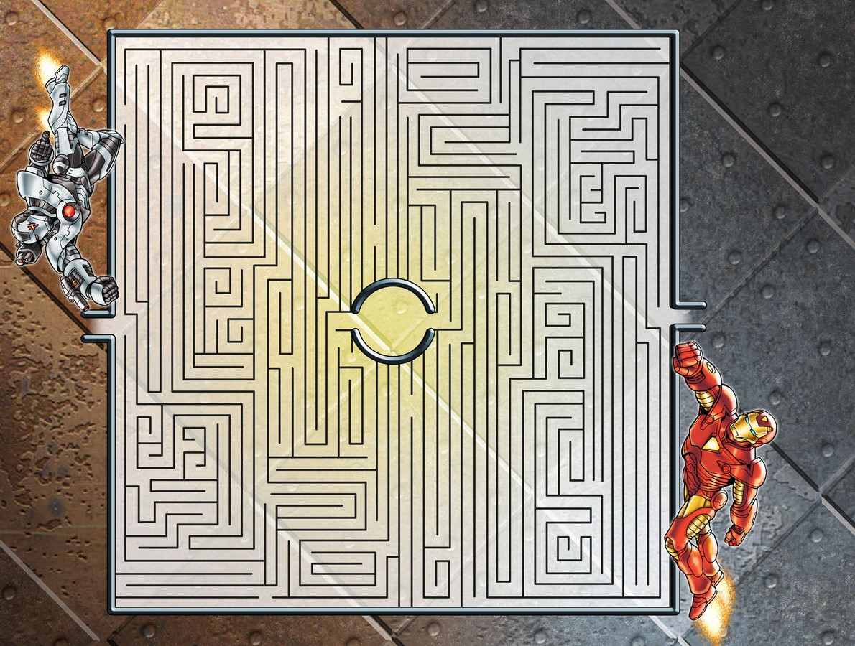

User Manual Version 1.0

Mazes and men

Mazes and men

-------------------------------------------------------

contents

**TABLE OF CONTENTS**

Game Introduction …………………………………………………………..2

Mazes Explanation ………………………………………………………….3

Enemy Explanation ...…..…………………………………………..............4

Bonus Room Explanation…………………………………………………...5

Mazes and men

-------------------------------------------------------

Introduction

**GAME INTRODUCTION**

“Mazes and Men” is text graphics game about traversing through mazes (with a chance to make it to a bonus room) and, through the use of dice rolls, fighting enemy men. As a player you will be challenged to traverse through a maze in under a certain time limit. If you succeed, you will be forced to roll the dice and try to defeat the enemy. If the sum of your rolls is greater than or equal to the enemy’s level/power, you will win the fight. Failing to make it through the maze under the time limit or failing to defeat an enemy will result in losing the game.

Mazes and men

-------------------------------------------------------

Mazes

**MAZES EXPLANATION**

The mazes will be displayed on the screen with the use of text. At the start of the maze there will be an ‘X’ and at the end a ‘O’. The goal of the maze is to use the arrow keys to navigate the ‘X’ to the ‘O’. If your time to complete the maze is less than or equal to the time limit, then, pending your face off with the enemy, you will find a bonus room. However, if you don’t beat the maze in under half time but still succeed, you will advance onward to face the enemy.

Mazes and men

-------------------------------------------------------

enemies

**ENEMY EXPLANATION**

The enemies will be displayed on the screen with the use of text. After you successfully make it through the maze you will be faced against an enemy. The enemy will be displayed as well as a prompt to press any key to roll the dice. The game will randomly generate your dice roll and determine the outcome versus the enemy’s level/power. A winning roll will advance you onward while a losing roll will end the game. If you were eligible for the bonus room after traversing the maze you will advance to the bonus room and if not, you will advance to the next level’s maze.

Mazes and men

-------------------------------------------------------

bonus room

**BONUS ROOM EXPLANATION**

The bonus room is a special event that can occur multiple times (or none!) in your game. You will find bonus rooms when you satisfy two conditions: you make it through the level’s maze with at least half of the time limit remaining and you defeat that level’s enemy. The bonus room will display three boxes, each of which showing a number. As a player, you must press the corresponding key to one of the boxes, you will open it. The game will randomly choose which box is the winner and if you open the winner, you will gain a bonus level, essentially skipping a maze and enemy!