Student Attendance Tracker

User Reference Manual





By team TRC: Harold Smith, Matt Rawson, Zach Minnix, Yingjun Liao, Austin Bower

Table of Contents

Introduction 3

Purpose 3

Description 3

First Time Use 4

Navigating the Software 5

Welcome 5

Register 5

Login 5

Add Course 5

Take Attendance 5

Check Attendance 5

Possible Errors 6

Index 7

# Introduction

## Purpose

At the time of this software’s inception our school (Concord University) handled taking roll either by passing around a roll sheet or by doing roll call. However, this method of taking attendance is time consuming and distracting. We have created this software in an attempt to mitigate the potentially adverse impacts of the taking attendance.

## Description

Once the professor has set up the software and selected which class they wish to take attendance for students simply swipe their card and their attendance for the day is recorded. Student Attendance Tracker utilizes a standard Magstripe card reader to read the student’s information off of their student ID card. The professor then has the option to go back and look at or edit the attendance data for any student.

# First Time Use

When you use the software for the first time you will be greeted with the welcome screen. From there you have two options: sign in with the default account or register a new account. The default username is “default” and the default password is “default”. You are advised to not use the default account for actual usage due to the lack of security of using default login credentials.

When you select the register option you will be taken to a screen with a form to fill out. If you fill out the form with valid information and a unique username that is not already taken you will be given a success message and returned to the welcome screen. Otherwise if you have filled out the form incorrectly or have selected a username that is already taken you will see an appropriate failure message and you will stay on the register screen.

Once you have registered and logged in you will see your home screen. The home screen will give you options to add a course, remove a course, take attendance, check attendance, and log out. Before you can take or check attendance you must add a course. Once you’ve added a course you can add students to the course.

# Navigating the Software

This section will detail, describe, and explain each screen that you will see as well as how each screen is connected to the others (i.e. what screens can lead you to the current screen and what screens the current screen can lead to).

## Welcome

The welcome screen is displayed when the software is started up and when someone logs out. From here you can navigate to the login screen or the register screen. This screen also displays the version that is running.

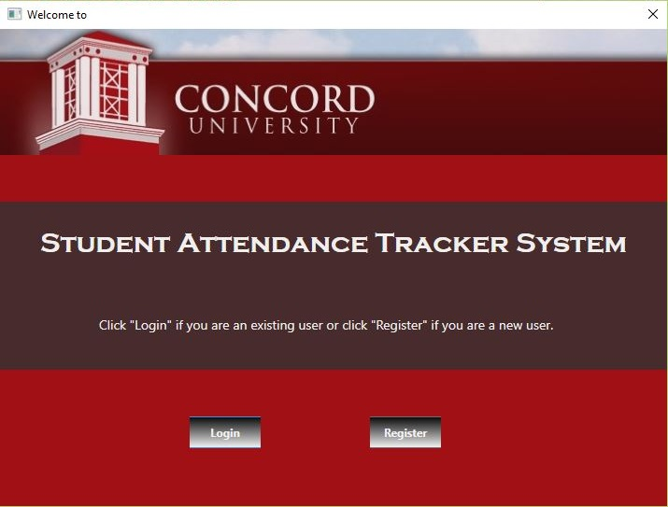

1- Welcome screen screenshot

## Register

The register screen is displayed when the user selects the register option from the welcome screen. From here the user can submit their filled out registration form in order to register a new account. The user can also cancel the registration form to return to the welcome screen.

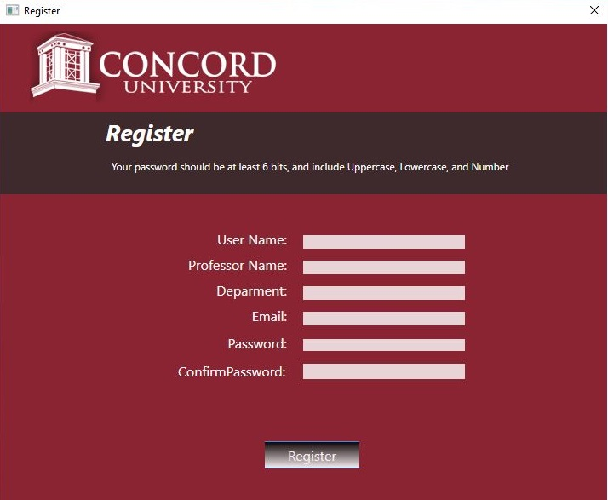

2- Register screen screenshot

## Login

The login screen is displayed when the user selects the login option from the welcome screen. From here the user can enter in their login credentials in order to log in to their account and proceed to their home screen. The user can also go back to the welcome screen from here.

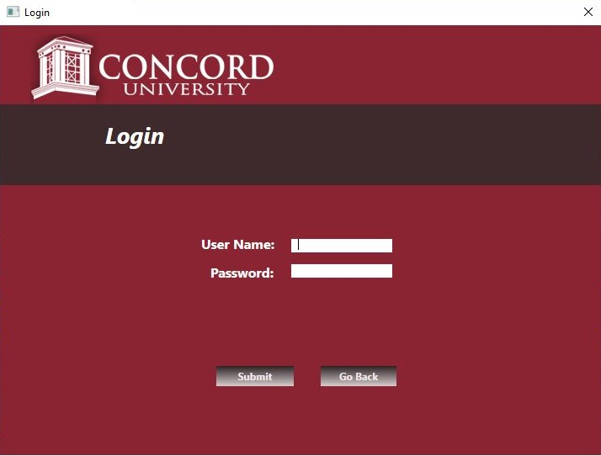

3- Login screen screenshot

## Home

The home screen is displayed when the user enters valid login credentials and submits them on the login screen. From here the user can follow the process line to select add course, add student, take attendance, check attendance, update total attendances and logout (which returns to the welcome screen).

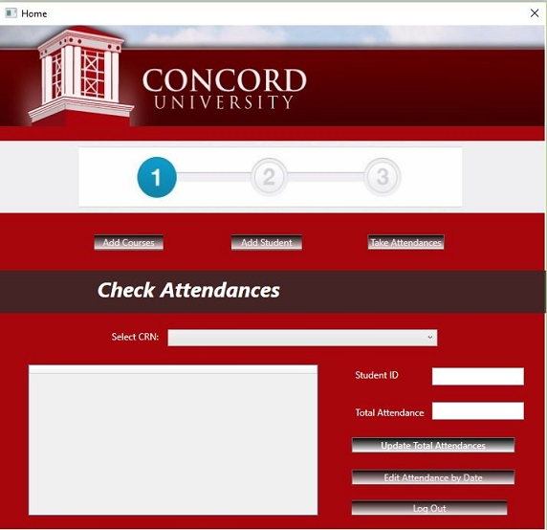

4- Home screen screenshot

## Add Course

The add course screen is shown when the user selects add course from the home screen. From here the user can add a new course and add students to the course. The user can also return back to the home screen.

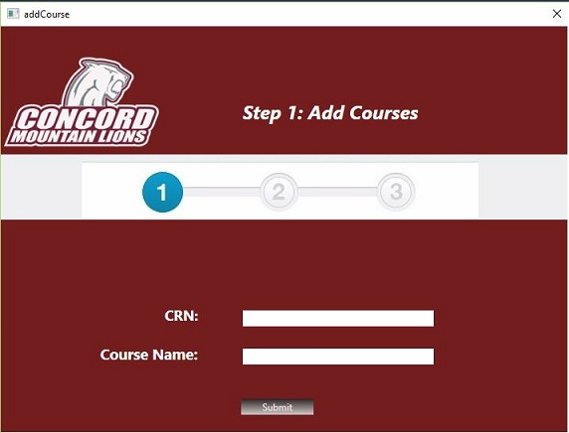

5- Add course screenshot

## Add Student

The add student screen is shown when the user selects add course from the home screen. From here the user can add a new course and add students to the course. The user can also return back to the home screen.

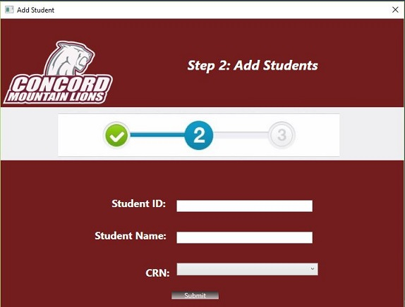

6- Add student screenshot

## Take Attendance

The take attendance screen is shown when the user selects take attendance from the home screen. From here the user can select a course to take attendance for which will immediately allow students to swipe their student ID card for their daily attendance to be recorded. The user can also return back to the home screen.

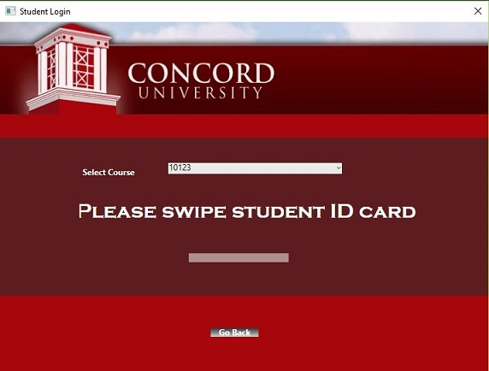

7- Check attendance screenshot

## Check Attendance

The check attendance screen is shown when the user selects check attendance from the home screen. From here the user can look at and edit the attendance records for any student. The user can also return back to the home screen.

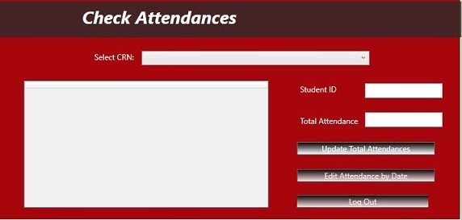

8- Check attendance screenshot

## Edit Attendance by Date

The check attendance screen is shown when the user selects check attendance from the home screen. From here the user can look at and edit the attendance records for any student. The user can also return back to the home screen.

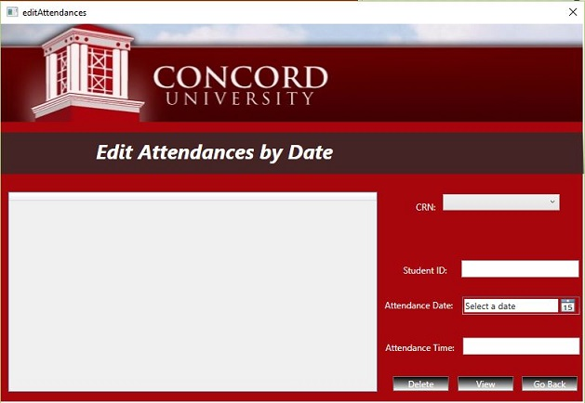

9- Edit attendance by date screenshot

# Possible Errors

# Index