Student Attendance Tracker

Technical Reference Manual

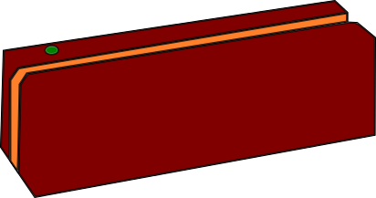



By team TRC: Harold Smith, Matt Rawson, Zach Minnix, Yingjun Liao, Austin Bower

**Table of Contents**

Introduction 3

Purpose 3

Description 3

File Information 4

Welcome Screen 4

Description 4

Functions 4

UI Elements 4

Possible Errors 4

Index 5

# Introduction

## Purpose

At the time of this software’s inception our school (Concord University) handled taking roll either by passing around a roll sheet or by doing roll call. However, this method of taking attendance is time consuming and distracting. We have created this software in an attempt to mitigate the potentially adverse impacts of the taking attendance.

## Description

# File Information

## Welcome Screen

### Description

### Functions

### UI Elements

### Possible Errors

# Index